# Cloud Application Environment - CAE

### What is CAE?

#### A Container Platform for Cloud Native Applications

CAE is a platform designed to support application architectures and technologies consistent with today's industry trends. Right now, CAE is running on Platform 3.

The CAE platform will offer capabilities that differ significantly from previous GIS platform offerings like CCIX and the current LAE platform. Clients will be able to:

interact with the platform programmatically deploy and manage micro-service applications

package applications in Docker containers for portability choose the right technology for the job

### References:

#### Application Patterns:

[Twelve-Factor App](http://12factor.net/): An excellent reference describing the characteristics of modern applications designed to run as services on a cloud platform. LAE 3 will provide the capabilities necessary to run this style of application.

[Micro-services](http://martinfowler.com/articles/microservices.html): A discussion by Martin Fowler on the characteristics of micro-service based applications, contrasting them with typical monolithic applications.

[Cloud Native](https://apps.na.collabserv.com/communities/service/html/communitystart?communityUuid=16385b8a-636b-4acb-aec3-ce7fa6465879): A great site describing what cloud native means in general and to Cisco enterprise applications.

#### Platform Tools and Technologies:

[Docker Containers](https://www.docker.com/what-docker): The format for packaging your applications

[Kubernetes](http://kubernetes.io/docs/): The scheduler to running your applications on a cluster of servers

[OpenShift v3](https://docs.openshift.com/container-platform/): Enterprise features on top of Kubernetes, allowing many teams to securely share the Kubernetes cluster CAE: Cisco customizations extending OpenShift for integration with Cisco application management processes

# Platform Architecture

[Basic Cluster Overview](https://wiki.cisco.com/display/CAEUSER/Basic%2BCluster%2BOverview)

[Multiple Clusters for High Availability and Lifecycle Separation](https://wiki.cisco.com/display/CAEUSER/Multiple%2BClusters%2Bfor%2BHigh%2BAvailability%2Band%2BLifecycle%2BSeparation) [HTTPs Request Flow](https://wiki.cisco.com/display/CAEUSER/HTTPs%2BRequest%2BFlow)

# Basic Cluster Overview

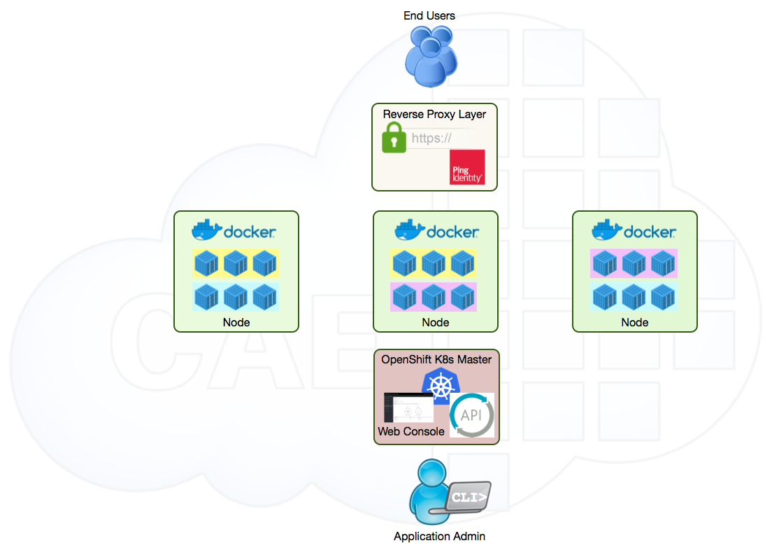CAE is a set of nodes (virtual machines) capable of running Docker containers

OpenShift Kubernetes (K8s) is used to manage the nodes as a cluster where:

multiple development teams can leverage the cluster container instances can be scaled across nodes in the cluster

REST API, CLI and Console are exposed for management

A Reverse Proxy Layer

exposes services to end users

provides single single sign on can traverse the DMZ

# Multiple Clusters for High Availability and Lifecycle Separation

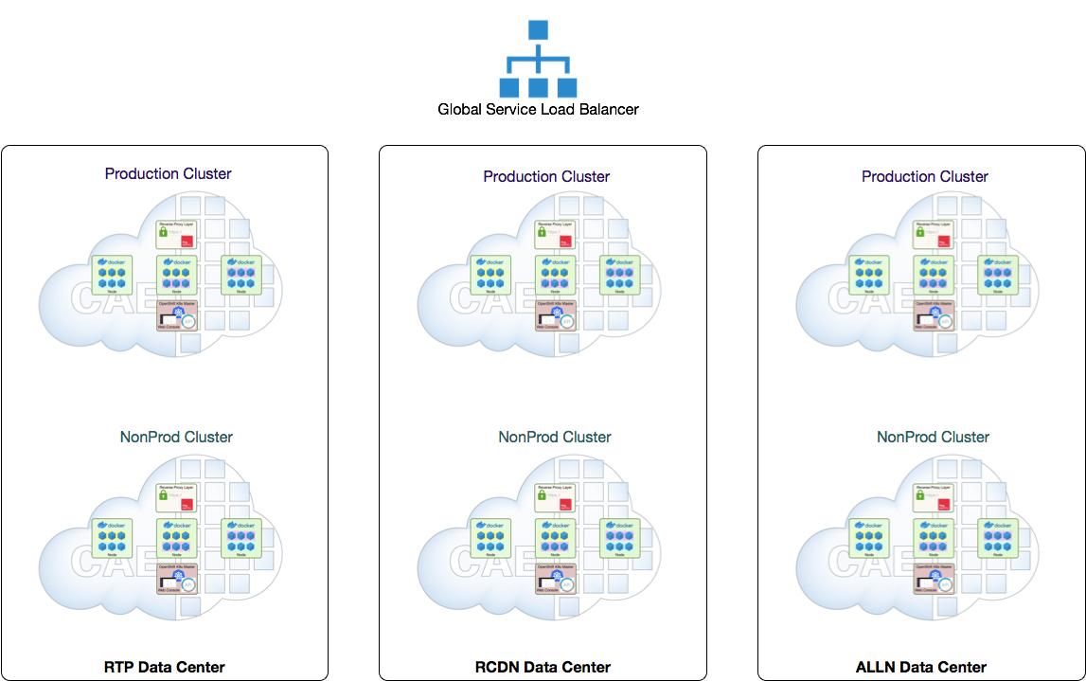Multiple, independent CAE Clusters are deployed across the data centers

In each of the three IT data centers there is a production cluster and a non-production cluster.

Non-production clusters will be patched and upgraded prior to production clusters, providing a window for app testing.

For high availability, services should be deployed to multiple data centers. This means deploying the service multiple times. It won't be done auto- magically.

Services in multiple data centers can be load balanced using the Global Service Load Balancer (GSLB). The GSLB can be configured in either Active-Active or Active-Passive configurations.

Each cluster provides its own console and api at a URL like:

https://cae-[ prd | nprd ]-[ rtp | rcdn | alln ].cisco.com

Examples:

[https://cae-prd-alln.cisco.com/](https://cae-prd-rtp.cisco.com/console/catalog) <https://cae-nprd-rtp.cisco.com/>

# HTTPs Request Flow

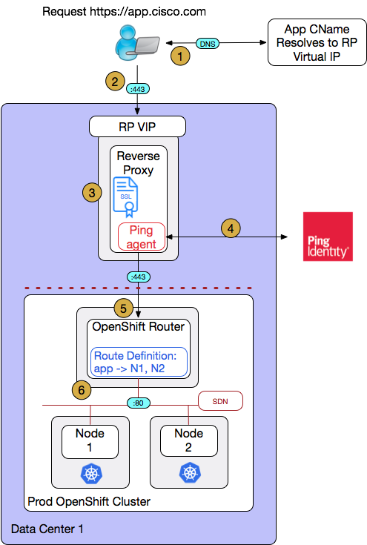There are several infrastructure components required to route user traffic to a service's Pods.

1. User/client initiates a request for the application url, which is resolved by GSLB or DNS. The IP address of CAE Reverse Proxy is returned.
2. The User/client then establishes an https connection to the Reverse Proxy.
3. The Reverse Proxy will present the service's certificate for validation, terminate the SSL connection and insert X- Forwarded-For header with client IP address as the value.
4. Ping agent will then authenticate the user
5. The request is re-encrypted and forwarded to the OpenShift Router. For external applications, this is where the DMZ is traversed.
6. The OpenShift Router uses the hostname portion of the URL to determine which service the request is for and load balances traffic to the Pods for that service.

\*All of the infra components are deployed in a highly available configuration. Omitted from this diagram for clarity.

# Frequently Asked Questions

This document helps answer some of CAE users' frequently asked questions.

|  |  |
| --- | --- |
| **FAQs** | **Answers** |
| What are CAE capabilities? | 1. Multi data center 2. SSO 3. Deploy containerized applications using the technology of your choice 4. Project level Quotas 5. Fully Programmable infra (CLI, API, Console) 6. Powered by Docker and Kubernetes 7. Native Blue/Green Deploys |
| Where can I order a CAE Project? | [Application Centric Cloud - ACC](http://citeis.cisco.com/) |
| What are CAE GSLB (Global Site Load Balancing) Configuration Options? | Cisco IT’s CAE (Cloud Application Environment) offers three GSLB configurations. CAE was designed as a cloud native platform, therefore none of these options provides *cross-data-center* session affinity.  **Active/Active**  Incoming traffic is split between two data centers in either a *round- robin or round-trip-time (RTT)* fashion.  *Round-robin* splits traffic most evenly between the data centers and is the recommended option.  *RTT* is used for client proximity-based routing but since the RCDN and ALLN data centers are so close together, this does not work well. When used between ALLN or RCDN and RTP, RTT could be ok.  Provides no session affinity – i.e. app traffic will not consistently be sent to the same DC/CAE cluster  This is recommended for [stateless](https://stackoverflow.com/questions/5436069/what-are-the-differences-between-stateless-and-stateful-systems-and-how-do-they) (aka cloud native) applications that don’t require session affinity  **Active/Passive**  Incoming traffic is always sent to one primary data center. If the application in that data center or the entire data center becomes unresponsive, all traffic is sent to the backup data center.  Provides session affinity: while traffic goes to the primary data center, client requests will hit the same CAE cluster (to ensure requests arrive at the same instance of an application, the CAE Route must be configured to support session affinity).  Note: this provides unbalanced load distribution between the data centers. Resources in the passive data center will be unused during normal operations.  This is recommended for [stateful](https://stackoverflow.com/questions/5436069/what-are-the-differences-between-stateless-and-stateful-systems-and-how-do-they) apps that that require session affinity.  **Additional Notes**  Due to dependency on DNS, uncontrolled endpoints (i.e. partner  /external laptops) may not exhibit expected routing behavior. GSLB runs on the Citrix Netscaler product. |
| Can I get a POC project? | We do not currently offer a free, temporary project. All projects must be associated with an application in the ESP Application Portfolio. For POC purposes, you can request a project with a small quota and delete it after your POC is complete in order to minimize costs. |

|  |  |
| --- | --- |
| What are the benefits of migrating an application from another platform to CAE? | More choices of technologies, runtimes and client chosen versions. Since CAE is container platform, easy to deploy and run micro services type applications, native blue green style deployments.  Running both web and non-web apps |
| How is CAE different from LAE? | 1. LAE doesn’t offer large apps VS CAE no limit except project level quotas 2. LAE limited few technologies and strict versions Vs CAE don’t’ have any restrictions 3. CAE Fully Programmable Vs LAE partially 4. LAE based on 1st generation container technology Vs CAE build on industry standard container technologies (docker, Kubernetes) 5. LAE OAM Vs CAE Ping |
| What is CAPI? | [Understanding CAPI](https://wiki.cisco.com/display/CAEUSER/Understanding%2BCAPI) |
| How do I create a CAE Project? | Register App in ACC & Order CAE Project |
| How do I access and manage my CAE Project? | Accessing Your CAE Project |
| How do I add CAE Project Admins | ACC allows you to add Administrator, these admins can update ESP data as well as required EMAN monitoring. To add you as a  Project admin in CAE console say in RCDN visit [https://cae-prd-rcdn.](https://cae-rcdn.cisco.com/console/project/demo-rcdn/membership?tab=User) [cisco.com/console/project/demo-rcdn/membership?tab=User](https://cae-rcdn.cisco.com/console/project/demo-rcdn/membership?tab=User) and at the bottom of the page, add user CCID and select project-admin option. This will allow them to access CAE projects. |
| How is the application Cost calculated in CAE? | Application cost is charged based on the selected amount of RAM, CPU, and NAS Storage via ACC. Detail of the cost is at [CAE Cost](https://wiki.cisco.com/display/CAEUSER/CAE%2BCost) |
| What is GSLB? | [Understanding GSLB](https://wiki.cisco.com/display/CAEUSER/Understanding%2BGSLB) |
| How to create GSLB? | [Create GSLB](https://wiki.cisco.com/display/CAEUSER/Create%2BGSLB) |
| What is a dockerfile and how to create one? | [Write Dockerfiles](https://wiki.cisco.com/display/CAEUSER/Write%2BDockerfiles) |
| What is a pod and how to create one? | [Download oc client](https://wiki.cisco.com/display/CAEUSER/Download%2Boc%2Bclient)  [Deploy using json/yaml file](https://wiki.cisco.com/pages/viewpage.action?pageId=84578119) |
| What is a route and how to create one? | [Create a Route](https://wiki.cisco.com/display/CAEUSER/Create%2Ba%2BRoute) |
| What is a job and how to create one? | [Jobs](https://wiki.cisco.com/display/CAEUSER/Jobs) |
| What are scheduled jobs? | [Scheduled Jobs](https://wiki.cisco.com/display/CAEUSER/Scheduled%2BJobs) |
| What can I do when my route isn't working? | Make sure your routes haven't been created with a same name as any other route within the DC or a different DC.  Check for annotations using  $oc describe route  <route\_name>  If annotations read: route creation failed/check StackStorm, contact a CAE or ACC team member to check StackStorm execution for you. |
| Why am I not able to connect to containers.cisco.com? | Telnet or Netcat to containers.cisco.com on the respective port. Check if it is a connection refused or host not found.  Contact a CAE team member and address the issue whilst asking to check for contracts for a networking issue. |
| What to do if route is throwing a 400 error? | Chances are, there is a PING identification issue. Contact a CAE/Ping team member to look into the issue. |
| What to d if route is throwing a 500 error? | There is something wrong with your route itself and how it was deployed. Check your deployment one more time and most importantly check the service on your pod/route. |

|  |  |
| --- | --- |
| Does CAE require SSO authentication on all applications or is there a way to turn it off? | By default, when an application or service is exposed via a Route in CAE, Ping SSO is enabled. For legitimate business reasons, it is possible to disable Ping authentication. Once your Route and its Ping policy are created, you can modify the Ping policy using Ping Policy Management Tool (PMT). It is strongly encouraged to get InfoSec approval before disabling Ping authentication.  Documentation for the Ping Policy Management Tool can be found here:  [How to manage WAM Policies using PMT (Policy Management Tool)](https://wiki.cisco.com/pages/viewpage.action?pageId=114767108) |
| Do all apps get deployed to the DMZ by default (therefore reachable from the Internet) or, is there something that needs to be configured to obtain external access? | In order for your application to be accessible from the internet, it must be deployed in an external prod project. When creating your project using ACC, create your ACC app, then create a profile of type "Prod," then create a project within it as type 'external'. Please note: External Non-Prod projects are -not- accessible to the internet. External Non-Prod is where apps are developed and tested before being exposed to the internet. Refer to the [diagram](https://wiki.cisco.com/download/attachments/86439290/projAccess.png?version=1&amp;modificationDate=1518575171000&amp;api=v2) for more details. |
| If we have to request a VM in CAE – is there a way to request..? | In CAE one can deploy Docker container but not the dedicated VM. Please e-mail us to [cae-onboard@cisco.com](mailto:cae-support@cisco.com) updating your application needs of VM, We will get back to you with the suggestions on how to incorporate that into the containers. |
| Can I deploy the image from Docker Hub in my CAE project? | As of today, IN CAE environment, we are blocking all Docker registry except [containers.cisco.com](http://containers.cisco.com/) and [registry.access.redhat.com](http://registry.access.redhat.com/)  . You can pull the image from Docker hub locally and after tagging push this to your ECH repository. This allows you to deploy the image. For more details on this refer to [Wiki- Build using Docker](https://wiki.cisco.com/display/CAEUSER/Build%2Busing%2BDocker%2Band%2BPush%2Bto%2BContainer%2BRegistry)  Note, Images directly pulled from docker hub often expect to run as root and this may not work in CAE environment without modification. Refer to [open shift guidelines](https://docs.openshift.com/container-platform/3.7/creating_images/guidelines.html#openshift-specific-guidelines).  Also, ECH (containers.cisco.com) provides information on image vulnerabilities. Developers/Deployment team can resolve the vulnerabilities before deploying the image. |
| why we have the restriction of not being able to run containers as root? | By default, CAE runs containers using an arbitrarily assigned user ID. This provides additional security against processes escaping the container due to a container engine vulnerability and thereby achieving escalated permissions on the host node. Refer to [Building](https://wiki.cisco.com/display/CAEUSER/Building%2BEffective%2Band%2BEasy-to-Use%2BImages) [Effective and Easy-to-Use Images](https://wiki.cisco.com/display/CAEUSER/Building%2BEffective%2Band%2BEasy-to-Use%2BImages) for more details. |

# How-To

### Table of Content

[Create Dockerfile](https://wiki.cisco.com/display/CAEUSER/Write%2BDockerfiles) [Build using Docker](https://wiki.cisco.com/display/CAEUSER/Build%2Busing%2BDocker%2Band%2BPush%2Bto%2BContainer%2BRegistry)

[Push to ECH](https://wiki.cisco.com/display/CAEUSER/Build%2Busing%2BDocker%2Band%2BPush%2Bto%2BContainer%2BRegistry) Build using ECH

[Trigger using Bitbucket](https://wiki.cisco.com/display/CAEUSER/Trigger%2BECH%2BBuild%2Bfrom%2BBitbucket) [New Build Dockerfile](https://wiki.cisco.com/display/CAEUSER/Build%2Busing%2BECH) [Fix Vulnerabilities](https://wiki.cisco.com/display/CAEUSER/Fix%2BVulnerabilities%2Bin%2BImages)

[Build using Jenkins](https://wiki.cisco.com/display/CAEUSER/Build%2Busing%2BJenkins%2Band%2BPush%2Bto%2BECH) [Deploy on CAE](https://wiki.cisco.com/display/CAEUSER/Deploy%2Bon%2BCAE)

[Download oc](https://wiki.cisco.com/display/CAEUSER/Download%2Boc%2Bclient) [using yaml/json file](https://wiki.cisco.com/pages/viewpage.action?pageId=84578119)

[Route creation](https://wiki.cisco.com/display/CAEUSER/Creating%2BRoute)

[Deploy in multiple Data centres](https://wiki.cisco.com/display/CAEUSER/Deploy%2Bin%2Bmultiple%2BData%2Bcentres) [Create GSLB](https://wiki.cisco.com/display/CAEUSER/Create%2BGSLB)

[Configure Pod](https://wiki.cisco.com/display/CAEUSER/Configure%2BPod)

[Set resource limits](https://wiki.cisco.com/display/CAEUSER/Quotas%2C%2BLimit%2BRanges%2C%2BRequests%2Band%2BScopes) [Scale up/down](https://wiki.cisco.com/pages/viewpage.action?pageId=85091674)

[Redeploy Pod | Build trigger | Image stream](https://wiki.cisco.com/display/CAEUSER/Redeploy%2BPod%27s)

[Health Probes - Container (pods) Health Checks Using Probes | Liveliness probes | Readiness probes](https://wiki.cisco.com/display/CAEUSER/Health%2BProbes%2B-%2BContainer%2B%28pods%29%2BHealth%2BChecks%2BUsing%2BProbes) [Blue/Green & A/B Stack](https://wiki.cisco.com/pages/viewpage.action?pageId=86155337)

[Connect to mysql pod](https://wiki.cisco.com/display/CAEUSER/Connect%2Bto%2Bmysql%2Bpod) [Connect to MongoDB](https://wiki.cisco.com/display/CAEUSER/Connect%2Bto%2BMongoDB) [Create secrets](https://wiki.cisco.com/display/CAEUSER/Deploy%2Bon%2BCAE%2Busing%2BSDaaS%2BPipeline%2Band%2BImage%2BPull%2BSecrets)

[Connect to Enterprise Oracle DB](https://wiki.cisco.com/display/CAEUSER/Connect%2Bto%2BEnterprise%2BOracle%2BDatabase) [Connect to ldap](https://wiki.cisco.com/display/CAEUSER/LDAP%2BConnection)

[Create configMap](https://wiki.cisco.com/display/CAEUSER/Create%2BConfigMaps) CronJob

[Jobs](https://wiki.cisco.com/display/CAEUSER/Jobs)

[Schedule jobs](https://wiki.cisco.com/display/CAEUSER/Scheduled%2BJobs)

[Claim PV | Verify PV | Detach PV](https://wiki.cisco.com/pages/viewpage.action?pageId=83961298) [CAPI](https://capi.cisco.com/)

[CAE Roles](https://wiki.cisco.com/display/CAEUSER/User%2BRoles%2Band%2BBindings)

[Image creation best practices](https://wiki.cisco.com/display/CAEUSER/Building%2BEffective%2Band%2BEasy-to-Use%2BImages) [Service Accounts](https://wiki.cisco.com/display/CAEUSER/Service%2BAccounts)

[Capture auth\_user/remote\_user from SSO/Ping](https://wiki.cisco.com/pages/viewpage.action?pageId=99436910) [Service Discovery using Consul](https://wiki.cisco.com/display/CAEUSER/Service%2BDiscovery%2BUsing%2BConsul)

[View multi-line log in Splunk/Clip](https://wiki.cisco.com/pages/viewpage.action?pageId=225423030)

### Related articles

[How-To](#_bookmark0)

# Write Dockerfiles

A Dockerfile is a text file with instructions written in a format understood by the docker daemon. It contains all the commands, in order, needed to build a given image.

This document contains best practices and methods for creating effective and easily usable Dockerfiles. The objective is to - Understand the purpose/scope of Dockerfiles and the relevant syntax/commands

Learn best practices for writing Dockerfiles Practice using a working example

## Why Dockerfiles?

There are a bunch of ready-to-use images available on Docker Hub and other container registries. However, the real use case of Docker

would be to build an image with our required applications and configurations inside. We can use the existing images from Docker Hub as a base for our own images, but will have to add our own required configurations and packages on top of it. **Writing a Dockerfile is a more consistent and repeatable way of building YOUR OWN images!**

A Dockerfile is nothing but the source code for building Docker images. A Dockerfile must start with capital “D” (or end in .dockerfile).

**The Syntax**

Let us first start with the the overall flow, which goes something like this:

1. You create a Dockerfile with the required instructions.
2. You save it in the same path as your application source files.
3. Then you use the docker build command to create a Docker image based on the Dockerfile that you created in step 1.

Here's a sample Dockerfile for a small NodeJS web application -

FROM node:7-alpine

LABEL maintainer ["dhsanghv@cisco.com"](mailto:dhsanghv@cisco.com)

ENV PROJECT\_DIR=/app WORKDIR $PROJECT\_DIR

COPY package.json $PROJECT\_DIR RUN npm install

COPY . $PROJECT\_DIR

ENV MEDIA\_DIR=/media \ NODE\_ENV=production \ APP\_PORT=3000

VOLUME $MEDIA\_DIR EXPOSE $APP\_PORT

HEALTHCHECK CMD curl --fail http://localhost:$APP\_PORT || exit 1

ENTRYPOINT ["./entrypoint.sh"] CMD ["start"]

Relax! You're not expected to understand or be able to write Dockerfiles at this point. Let's first figure out what the commands mean -

**FROM** - For setting base image; should be the first line of the Dockerfile; can be used multiple times in the file though;

**MAINTAINER** - Author of the dockerfile;

**RUN** - Lets you execute a command on top of an existing layer and create a new layer with the results of command execution. For example, if there's a precondition to install PHP before running an application, you can run appropriate commands to install PHP on top of a base image (say, Ubuntu) like this:

FROM ubuntu

RUN apt-get update && apt-get install php5

**CMD** - Specifies intended command for the image, doesn't execute during build time;

There can be only one CMD instruction in a file; if you add more, the last one takes effect

**LABEL** - You can assign metadata in the form of key-value pairs to the image using this instruction; for example, LABEL version = "1.1"

Each LABEL instruction creates a new layer in the image, so it's best to use as few as possible

**EXPOSE** - To make your container listen on specified ports;

**ENV** - Set environment variables in the container;

**COPY** - Copies files/directories from a specified source to a destination (in the filesystem of the container);

**ADD** - Similar to COPY with a couple of added features (*remote URL support in source field* and *local-only tar extraction*); using COPY is recommended over ADD due for readability; Eg.:

ADD <http://www.site.com/app.tar.gz>/usr/src

**ENTRYPOINT** - To set the primary command for the image; ENTRYPOINT is used to specify the default app that you want to run; the CMD will then provide only the list of parameters to that entrypoint application. Example:

ENTRYPOINT ["/bin/cat"] CMD ["/etc/passwd"] CMD "Hello World!" ENTRYPOINT echo

The best practice is to use ENTRYPOINT together with CMD

**VOLUME** - To enable access to a location on the host system from a container; just pass the path of the location to be accessed. Example, VOLUME

/data/db

**USER** - Used to set the UID (or username) to be used when running the image. Example, USER daemon

**WORKDIR** - Used to set the currently active directory for other instructions such as RUN, CMD, ENTRYPOINT and ADD; Example:

WORKDIR /user

WORKDIR /home

RUN pwd

Output: /user/home

**ONBUILD** - Adds a trigger instruction to be executed when the image is used as the base for some other image; it behaves as if a RUN instruction is inserted immediately after the FROM instruction. Example:

ONBUILD RUN rm -rf /usr/temp

## Best Practices for writing Dockerfiles

Here's a summary of some things you need to keep in mind when authoring your Dockerfiles (irrespective of technology or complexity). To double click on these items, refer to [this document](https://wiki.cisco.com/display/CAEUSER/Building%2BEffective%2Band%2BEasy-to-Use%2BImages).

Write .dockerignore file Reuse images

Run only one process per container

Understand Docker caching! Use COPY and RUN commands in proper order to utilize that. Merge multiple RUN commands into one

Remove temp/unnecessary files after each step

Use appropriate base images (alpine versions should be enough) Set WORKDIR and CMD

Use ENTRYPOINT when you have more than one command and/or need to update files using runtime data

Use exec inside wrapper scripts Prefer COPY over ADD

Specify default environment variables, ports and volumes inside Dockerfile Support arbitrary user IDs

**Note**

It is highly recommended that you go through the document on [Building Effective Images](https://wiki.cisco.com/display/CAEUSER/Building%2BEffective%2Band%2BEasy-to-Use%2BImages) for maintaining the quality and usability of Cisco IT images.

## Working Example

Let's write a Dockerfile for a simple python flask app. You can find the code for this app here - [https://gitscm.cisco.com/users/dhsanghv/repos](https://gitscm.cisco.com/users/dhsanghv/repos/python-dockerfile-alln/)

[/python-dockerfile-alln/](https://gitscm.cisco.com/users/dhsanghv/repos/python-dockerfile-alln/)

#### Step 1: Write simple python app -

app.py

from flask import Flask app = Flask( name )

@app.route('/') def hello\_world():

return 'Flask Dockerized'

if name == ' main ': app.run(debug=True,host='0.0.0.0')

requirements.txt

Flask==0.10.1

#### Step 2: Write Dockerfile to create an Image from the app

Dockerfile

FROM ubuntu:latest

LABEL MAINTAINER dhsanghv

RUN apt-get update -y && apt-get install -y python-pip python-dev build-essential COPY . /app

WORKDIR /app

RUN pip install -r requirements.txt ENTRYPOINT ["python"]

CMD ["app.py"]

#### Step 3: Build your Image

docker build -t pythonapp .

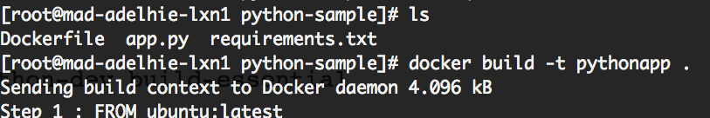

#### Step 4: Run your Image

docker run -d -p 5000:5000 pythonapp



You can use the docker ps command to check details about your running container



Your python app is now running as a docker container!

To verify, you can go to your browser and hit <hostname>:<port>.

## What's Next

How to [Build using Docker and Push to ECH](https://wiki.cisco.com/display/CAEUSER/Build%2Busing%2BDocker%2Band%2BPush%2Bto%2BContainer%2BRegistry)

**Learn More about** [**Building Effective Docker Images**](https://wiki.cisco.com/display/CAEUSER/Building%2BEffective%2Band%2BEasy-to-Use%2BImages)

**Build a Docker Image**

This document will take you through the process of building your docker image and pushing it to the official Cisco IT container registry - the [Enterp](https://wiki.cisco.com/display/CAEUSER/ECH%2BUser%2BGuides) [rise Container Hub (ECH)](https://wiki.cisco.com/display/CAEUSER/ECH%2BUser%2BGuides).

You can build your image in the following ways -

[On your local docker daemon or on a remote host's docker daemon](https://wiki.cisco.com/display/CAEUSER/Build%2Busing%2BDocker%2Band%2BPush%2Bto%2BContainer%2BRegistry) [Via a build tool like Jenkins](https://wiki.cisco.com/display/CAEUSER/Build%2Busing%2BJenkins%2Band%2BPush%2Bto%2BECH)

[Directly on ECH](https://wiki.cisco.com/display/CAEUSER/Build%2Busing%2BECH)

For learning what Dockerfiles are and how to write them, go to [How to Write Dockerfiles](https://wiki.cisco.com/display/CAEUSER/How%2Bto%2BWrite%2BDockerfiles).

# Build using Docker and Push to Container Registry

For learning what Dockerfiles are and how to write them, go to [How to Write Dockerfiles](https://wiki.cisco.com/display/CAEUSER/How%2Bto%2BWrite%2BDockerfiles).

This document will take you through the process of building your docker image and pushing it to the official Cisco IT container registry - the [Enterp](https://wiki.cisco.com/display/CAEUSER/ECH%2BUser%2BGuides) [rise Container Hub (ECH)](https://wiki.cisco.com/display/CAEUSER/ECH%2BUser%2BGuides).

You can build your image in the following ways -

[on your local docker daemon or on a remote host's docker daemon](#_bookmark1) [via a build tool like Jenkins](https://wiki.cisco.com/display/CAEUSER/Build%2Busing%2BJenkins%2Band%2BPush%2Bto%2BECH), or

[directly on ECH](https://wiki.cisco.com/display/CAEUSER/Build%2Busing%2BECH)

### Build using Docker

In this document we will focus on building it on a running docker instance in a local/remote host.

Let's write a Dockerfile for a simple python flask app. You can find the code for this app here - [https://gitscm.cisco.com/users/dhsanghv/repos](https://gitscm.cisco.com/users/dhsanghv/repos/python-dockerfile-alln/)

[/python-dockerfile-alln/](https://gitscm.cisco.com/users/dhsanghv/repos/python-dockerfile-alln/)

#### Step 1: Write simple python app

**app.py**

from flask import Flask app = Flask( name ) @app.route('/')

def hello\_world():

return 'Hello CAE Users' if name == ' main ':

app.run(debug=True,host='0.0.0.0')

Flask==0.10.1

**Step 2: Write Dockerfile to create an Image from the app**

**Dockerfile**

**requirement.txt**

FROM ubuntu:latest

LABEL MAINTAINER dhsanghv

RUN apt-get update -y && apt-get install -y python-pip python-dev build- essential

COPY . /app WORKDIR /app

RUN pip install -r requirements.txt ENTRYPOINT ["python"]

CMD ["app.py"]

**Step 3: Build your Image**

**SHELL**

docker build -t pythonapp .



**Step 4: Run your Image**

**SHELL**



docker run -d -p 5000:5000 pythonapp

You can use the docker ps command to check details about your running container



Your python app is now running as a docker container!

To verify, you can go to your browser and hit ***<hostname>:<port>***

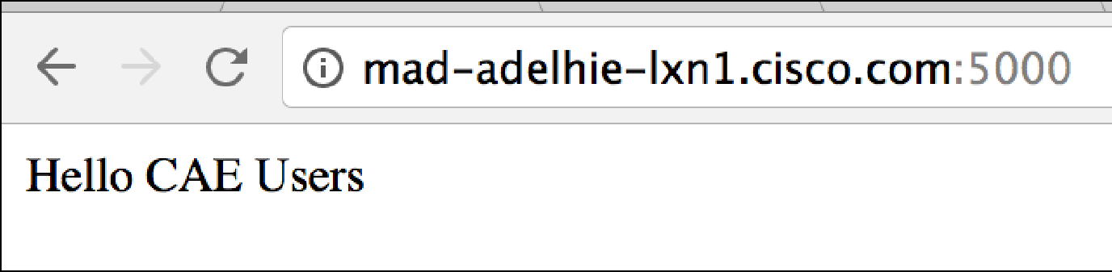

### Push to Enterprise Container Hub

Before you go to this step, please make sure you have a public/private ECH repository to push the image to and have an encrypted password generated by ECH to access it via remote hosts.

**Step1: Login to ECH (**[**https://containers.cisco.com**](https://containers.cisco.com/)**)**

**SHELL**

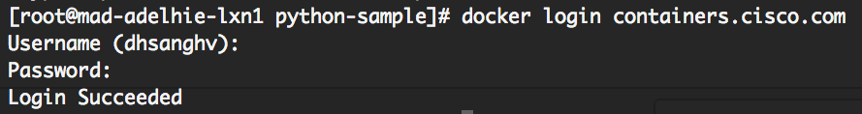

docker login containers.cisco.com

**Step 2: Tag your docker image**

*Use the* docker images *command to get the Image ID for your docker image.*

**SHELL**



docker tag <ImageID> <ECH\_repo\_name\_with\_tag>

#### Step 3: Push your docker image

**SHELL**

docker push <ECH\_repo\_name\_with\_tag>

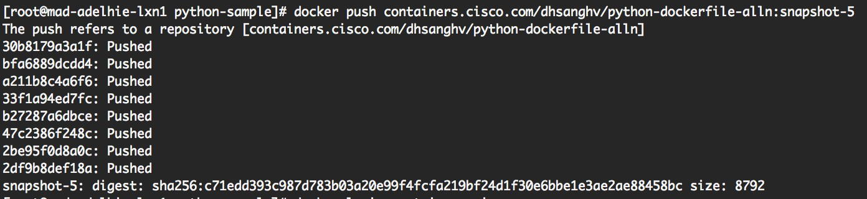

You can log in to [https://containers.cisco.com](https://containers.cisco.com/) using your browser and verify the newly pushed image.

# Build using Jenkins and Push to ECH

For learning what Dockerfiles are and how to write them, go to [How to Write Dockerfiles](https://wiki.cisco.com/display/CAEUSER/How%2Bto%2BWrite%2BDockerfiles).

This document will take you through the process of building your docker image using Jenkins and pushing it to the official Cisco IT container registry - the [Enterprise Container Hub (ECH)](https://wiki.cisco.com/display/CAEUSER/ECH%2BUser%2BGuides).

You can build your image in the following ways -

[on your local docker daemon or on a remote host's docker daemon](https://wiki.cisco.com/display/CAEUSER/Build%2Busing%2BDocker%2Band%2BPush%2Bto%2BContainer%2BRegistry) [via a build tool like Jenkins](#_bookmark2), or

[directly on ECH](https://wiki.cisco.com/display/CAEUSER/Build%2Busing%2BECH)

### Resources

Bitbucket Repo: <https://gitscm.cisco.com/users/dhsanghv/repos/python-dockerfile-alln/>

Jenkins Repo: <https://ci3.cisco.com/job/IT-GIS-Data_Center_and_Platform_Services/job/CAE-POCs/job/pythonapp/> ECH Repo: <https://containers.cisco.com/repository/dhsanghv/python-dockerfile-alln>

### Step 1: Create generic Jenkins Job

Create the usual Jenkins freestyle job providing the GIT repo clone URL.

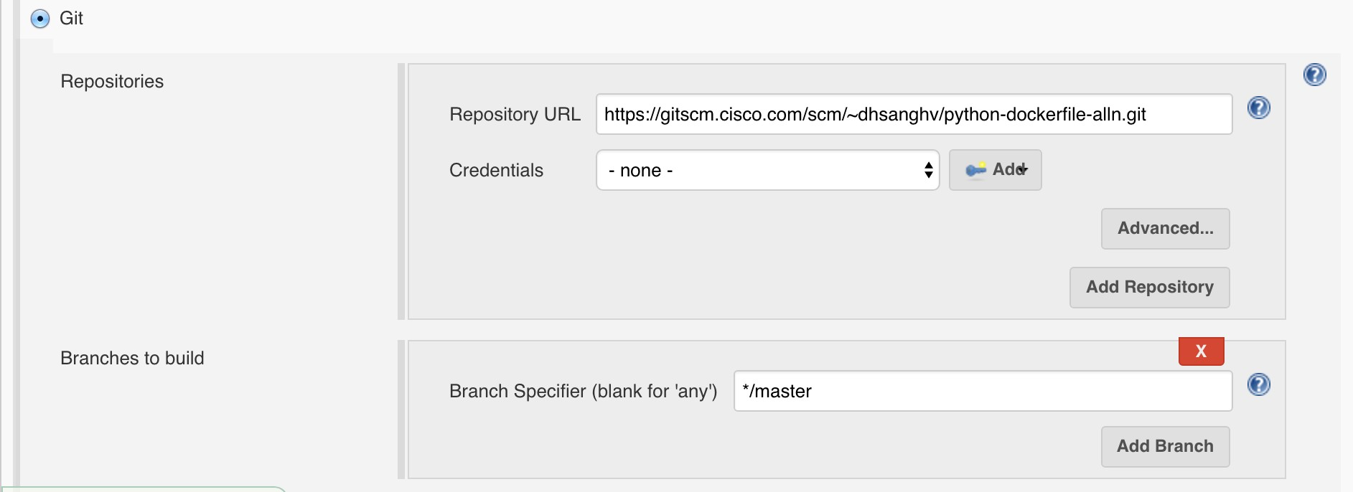

### Step 2: Add Docker build arguments

Scroll down on the job configuration page and click on the dropdown button that says "Add Build Step". Select the "Execute Shell" option.

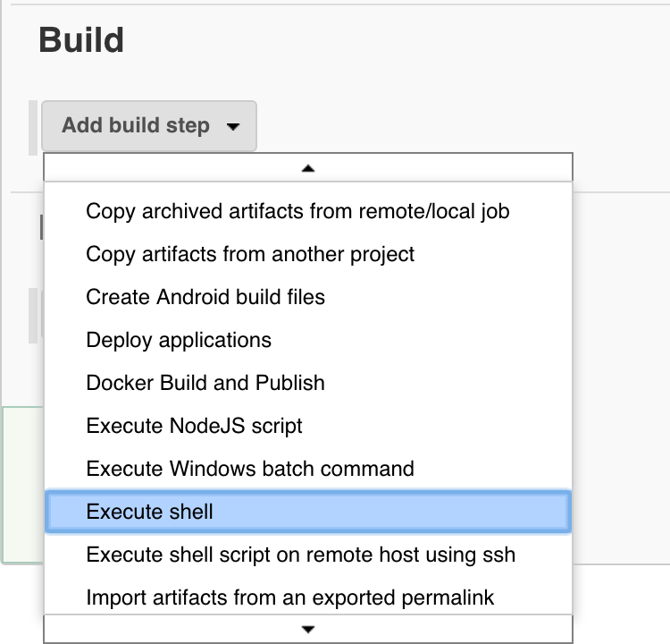

You can then add shell commands to build your image, tag it, login to ECH and push it to your ECH repo as shown below:

**Command**

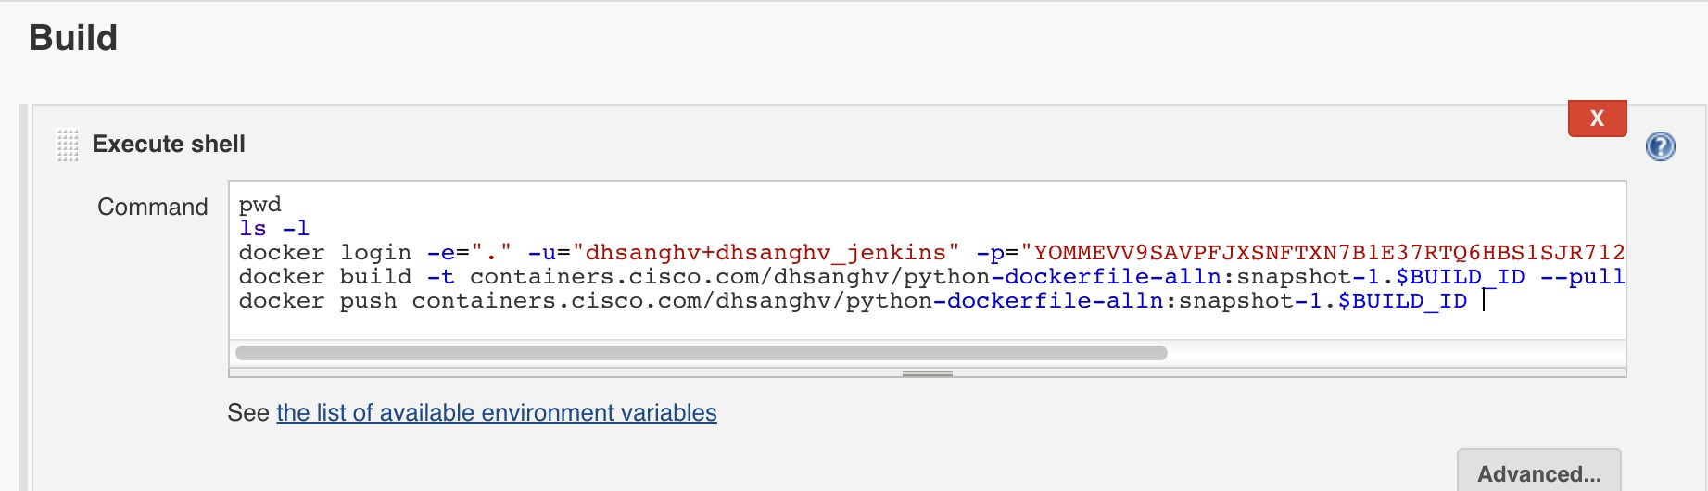

pwd ls -l

docker login -e="." -u="<Robot Account>" -p="<Robot Token>" containers. cisco.com

docker build -t <ECH\_Repo>:<Tag> --pull=true $WORKSPACE docker push <ECH\_Repo>:<Tag>

**Note**

For creating a robot account and robot token, go to the Settings section of your Organization or Personal Account. Please make sure this robot account has write access on your application's ECH repo.

### Step 3: Build your Jenkins Job

Now save the job configurations and click on "Build Now".

You can check the progress of the build on the console output. Once the build is completed, log on to [https://containers.cisco.com](https://containers.cisco.com/) to verify the pushed image.

# Build using ECH

For learning what Dockerfiles are and how to write them, go to [How to Write Dockerfiles](https://wiki.cisco.com/display/CAEUSER/How%2Bto%2BWrite%2BDockerfiles).

This document will take you through the process of building your docker image and pushing it to the official Cisco IT container registry - the [Enterp](https://wiki.cisco.com/display/CAEUSER/ECH%2BUser%2BGuides) [rise Container Hub (ECH)](https://wiki.cisco.com/display/CAEUSER/ECH%2BUser%2BGuides).

You can build your image in the following ways -

[on your local docker daemon or on a remote host's docker daemon](https://wiki.cisco.com/display/CAEUSER/Build%2Busing%2BDocker%2Band%2BPush%2Bto%2BContainer%2BRegistry) [via a build tool like Jenkins](https://wiki.cisco.com/display/CAEUSER/Build%2Busing%2BJenkins%2Band%2BPush%2Bto%2BECH), or

[directly on ECH](#_bookmark3)

**Prerequisite**

An account on Enterprise Container Hub, containers.cisco.com and have access to create a repository.

Task: Build a docker image in ECH (Enterprise Container Hub) My image requirements are:

* 1. Base OS be redhat like. i.e centos and the version be 7:latest
  2. I want the OS image to be fully upgraded to the latest version.
  3. I will run a webserver in the image, so i need to have apache installed on it.
  4. I will also want linux network tools in case i need to troubleshoot network related issues from within the host while in development.

Based on my requirements, i have written a Dockerfile in my local machine as:

**Dockerfile**

FROM centos:7

MAINTAINER sasharm4, with base centos:7 as provided by centos.org

RUN yum -y --setopt=tsflags=nodocs update && \

yum -y --setopt=tsflags=nodocs install httpd && \

yum -y --setopt=tsflags=nodocs install net-tools && \ yum clean all

EXPOSE 8080

there are multiple ways to build an image based on the Dockerfile above, but as part of this "How to" we are going to build directly on ECH.

1. Log in to containers.cisco.com and click on "Create New Repository"



1. 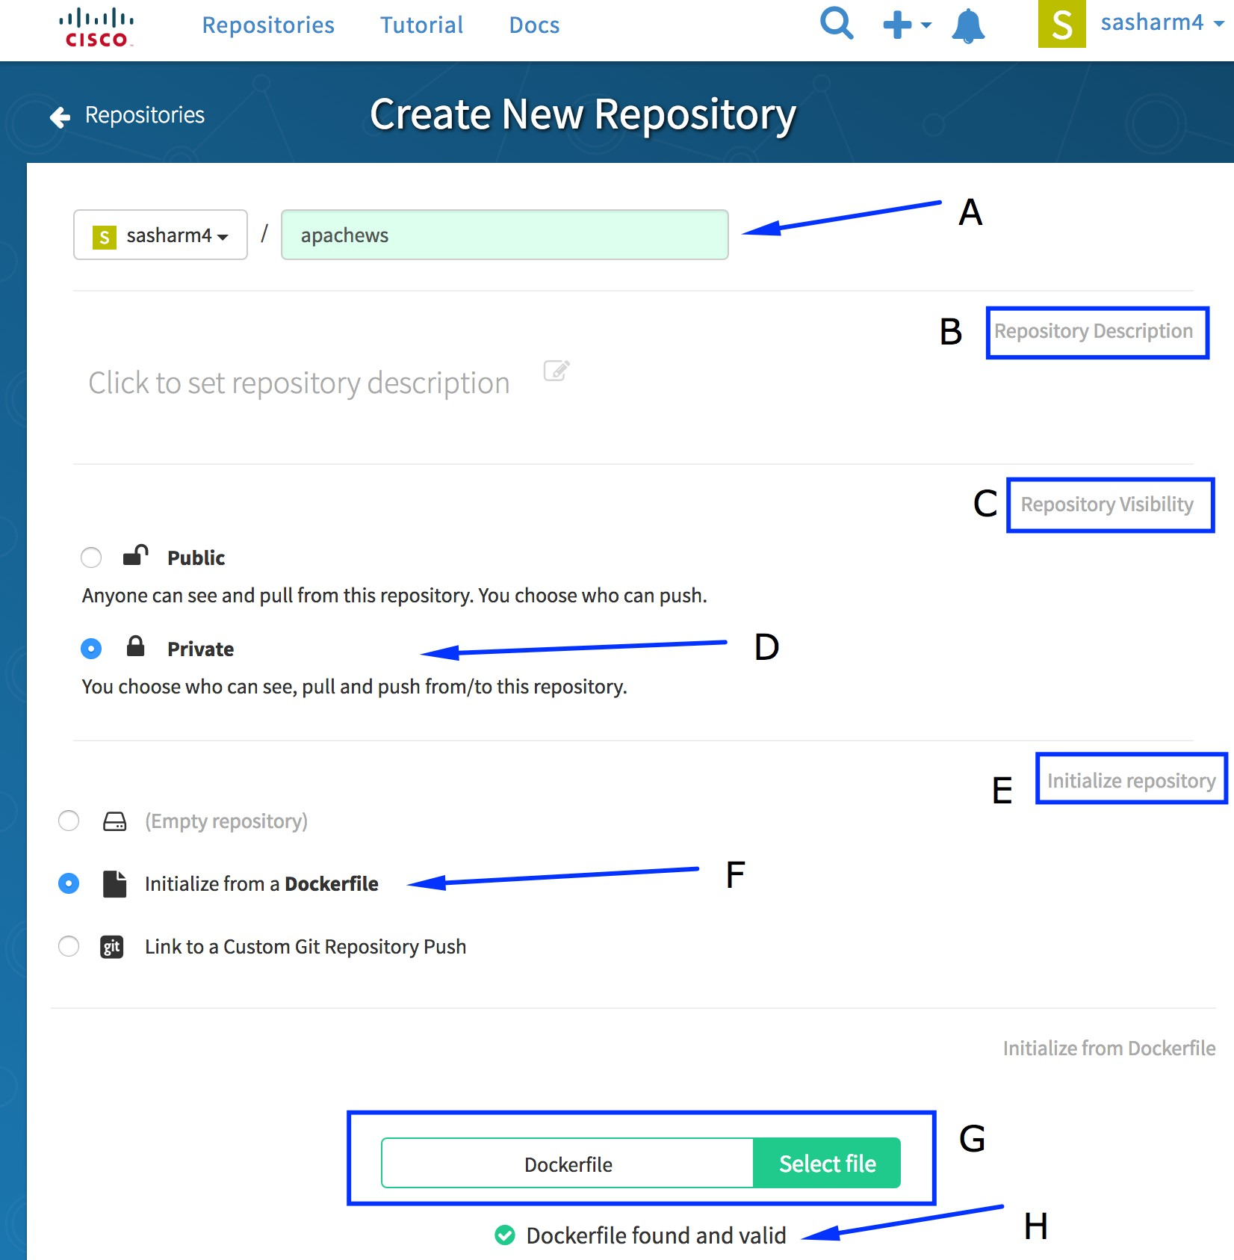Setup the Dockerfile following the onscreen form as follows:

A: Give the repository a name that matches the image that you want to. E.g; apachews as my image repo will have a apache webserver image

B: Optional repository description. It could say something like "My awesome centos image that has httpd and net-tools installed for my

frontend UI webserver"

C: One of the Public or Private.

D: In my example, i have set the repository to be private.

E: As part of this "How to", we are going to create/initialize a repository from an already written Dockerfile. F: Select appropriate method of initializing a repository.

G: Click "Select File" and it will prompt to upload a Dockerfile from your local machine. H: After uploading the Dockerfile, ECH will validate and report.

1. 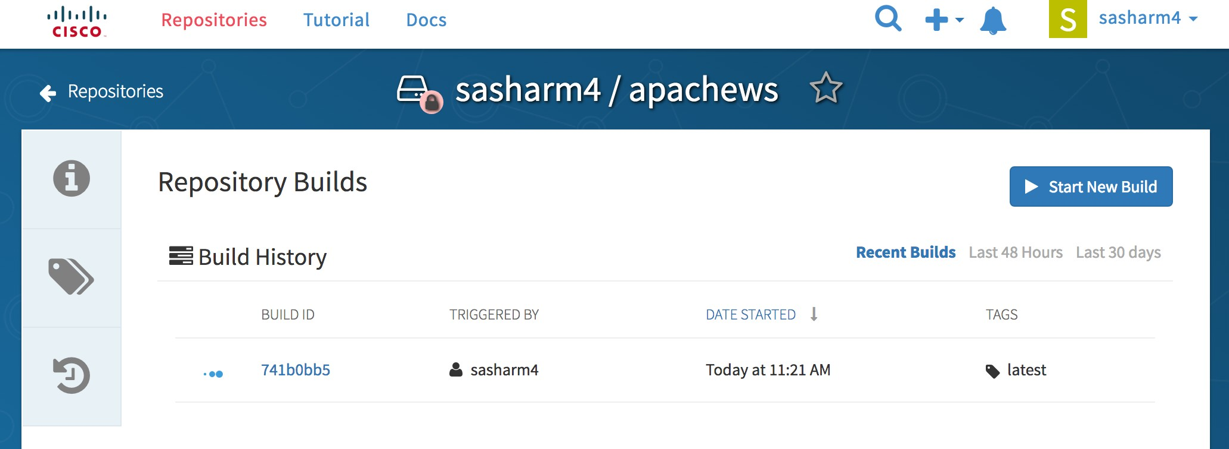Then submit the form by clicking on "Create Private repository" from the bottom left corner of the form. This will start a manual build trigger on the Dockerfile and ECH will start a build of the image.
2. Once the Image is built, it will be shown by a green tick mark to the left of the "Build ID"

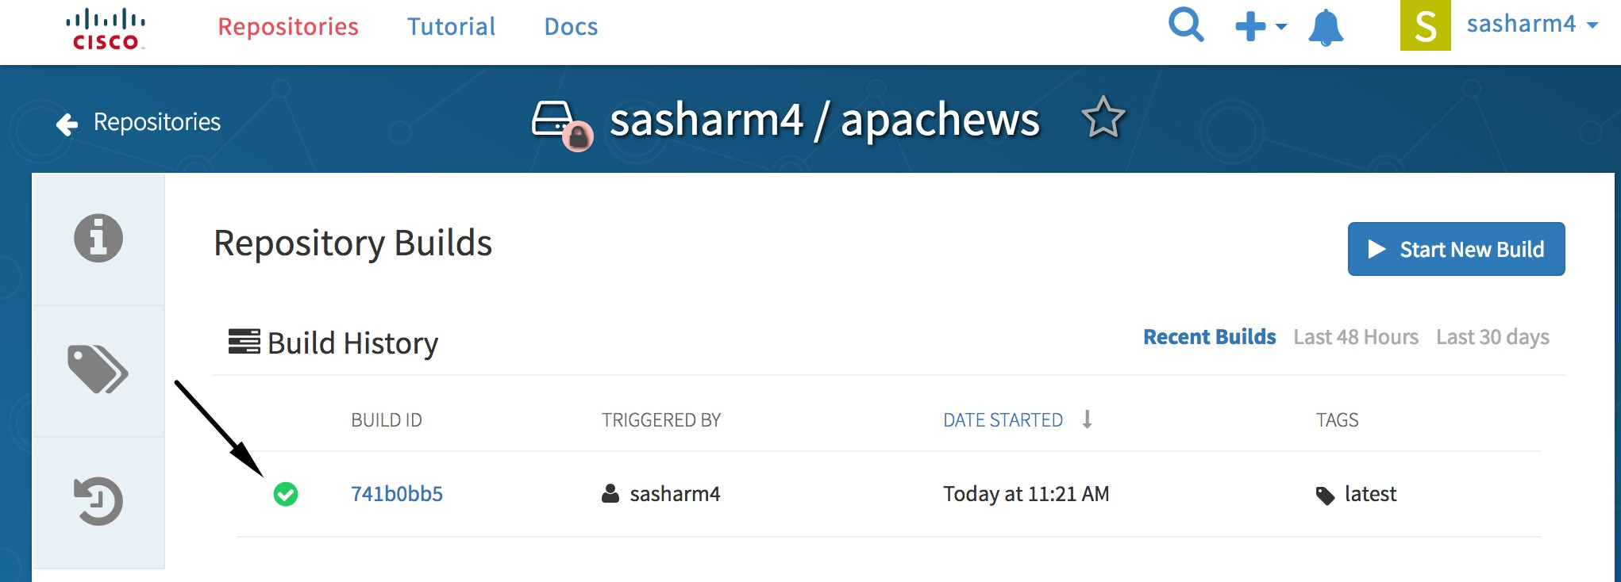

1. 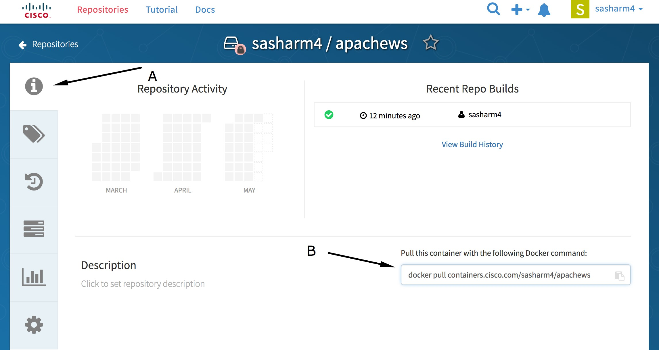After the build is successful, you can access your image as:

A: Navigate to the repository home and click on the repository and information by clicking on the icon. B: The docker image location and the path to pull the image.

1. I can now pull the built image to my local laptop for testing, to be used as a base for deploying my code, etc.

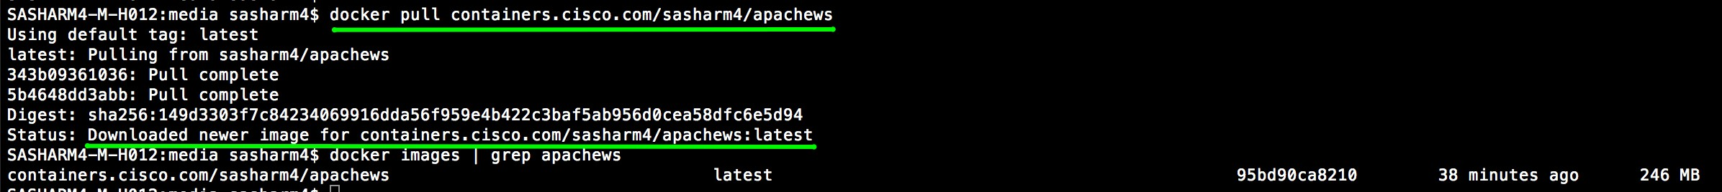

# Trigger ECH Build from Bitbucket

Step 1: Login to containers.cisco.com and select your repo. Step 2: Click on Build Button

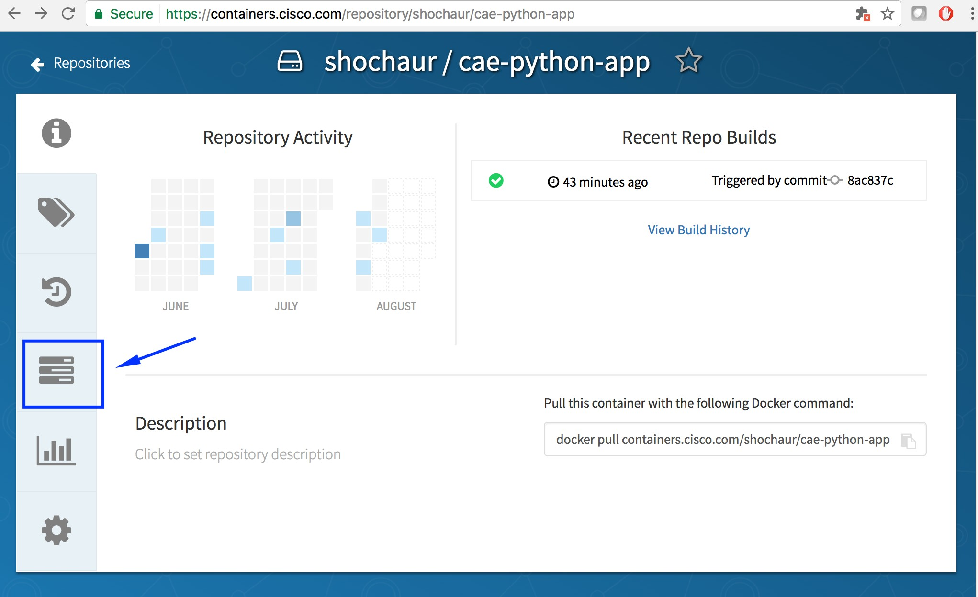

Step 3: Click on **Create Build Trigger** and select **Custom Git Repository Push**

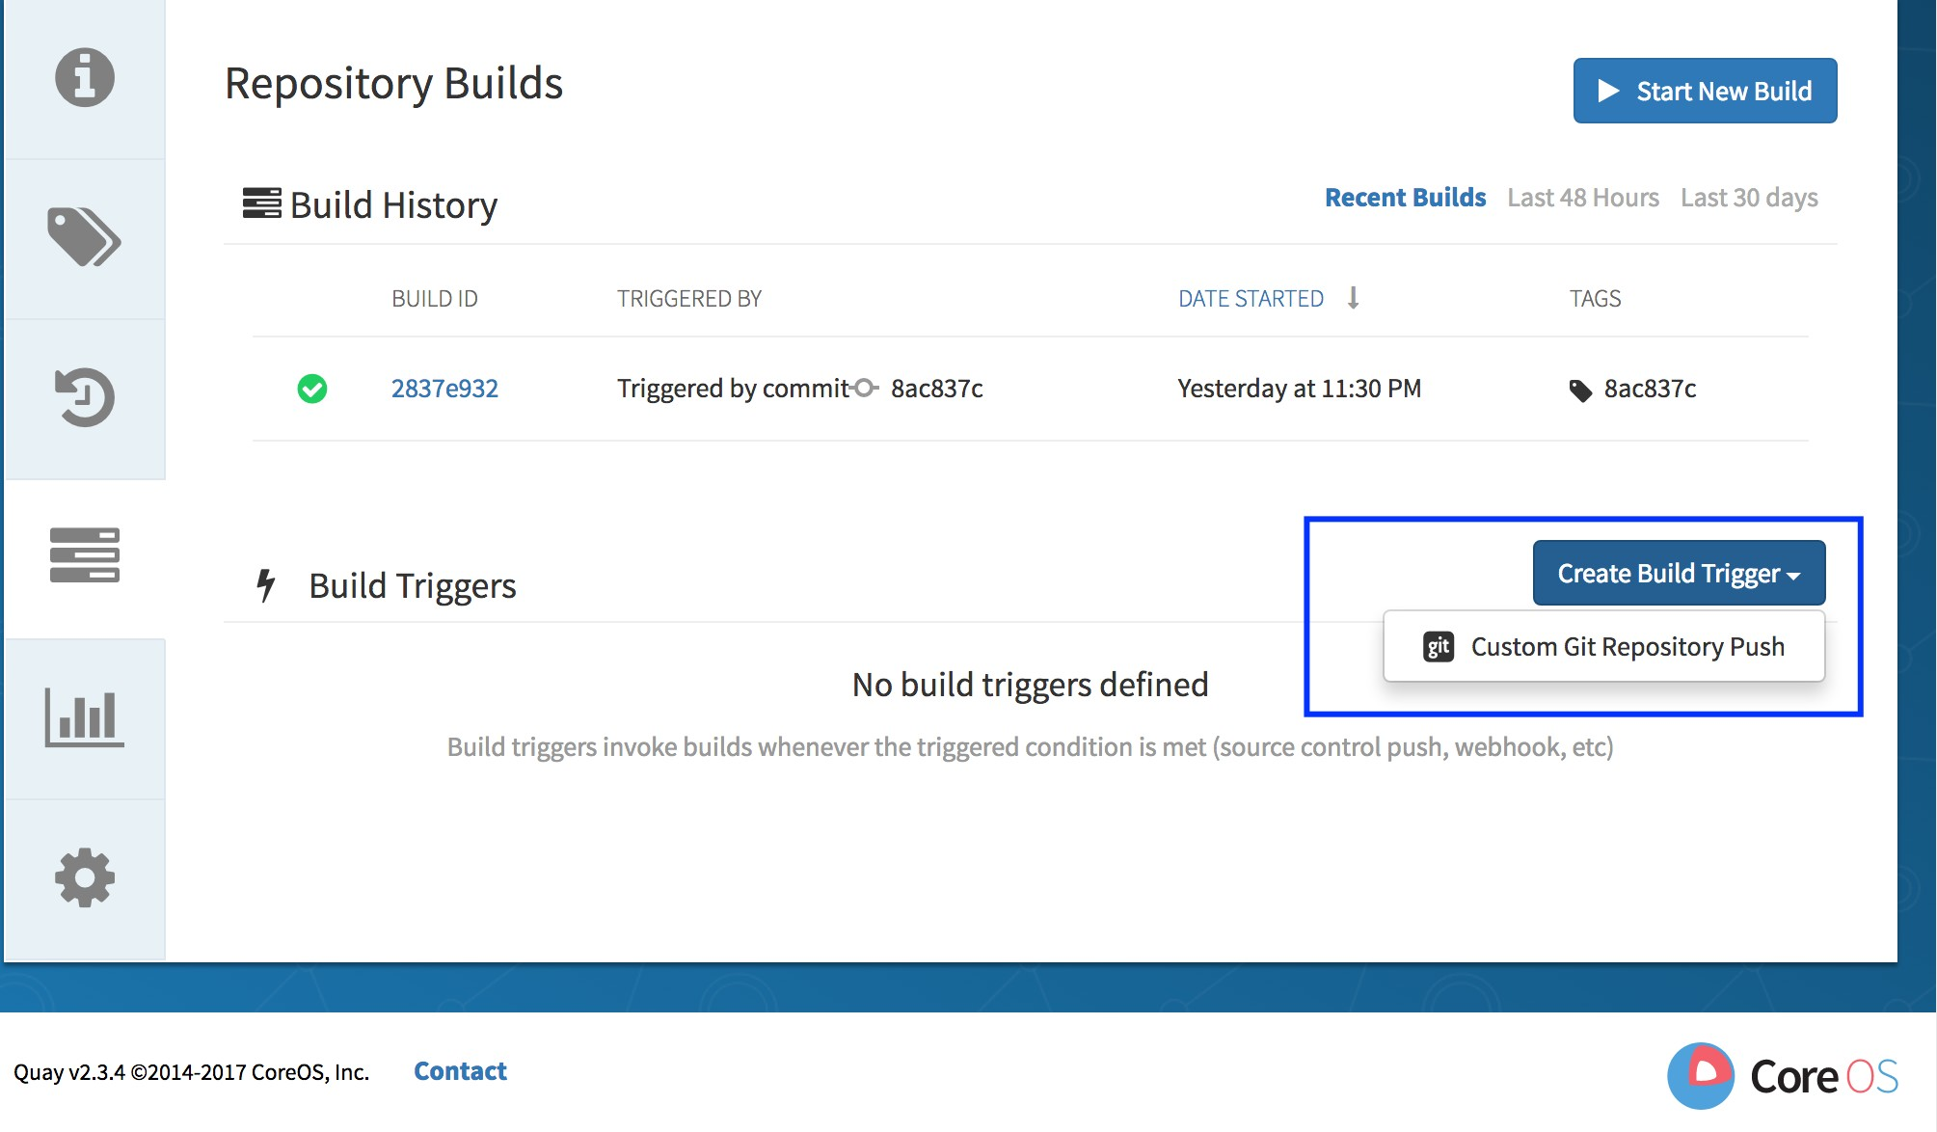

Step 4: Goto gitscm.cisco.com Select repo Click on **Clone** Select **HTTP** Copy Http clone url

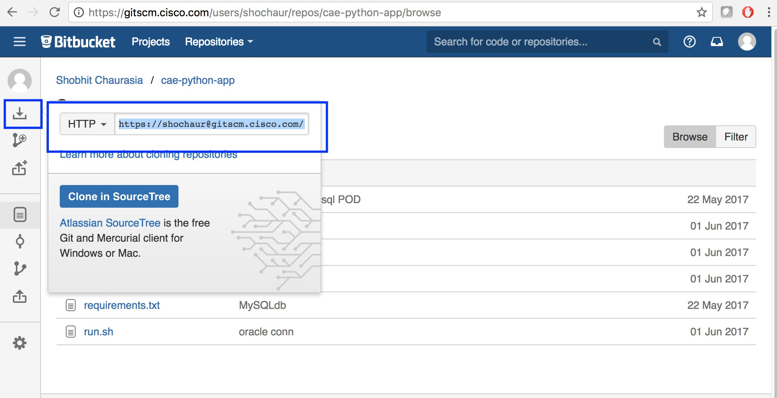

If you are using "SSH" type then replace "/~" with ":" in ssh url before entering in Setup Build Trigger. Example: Copied one : [ssh://git@gitscm.cisco.com/~shochaur/cae-python-app.git](ssh://git@gitscm.cisco.com/%7Eshochaur/cae-python-app.git)

**Change to** : [ssh://git@gitscm.cisco.com:shochaur/cae-python-app.git](ssh://git@gitscm.cisco.com/%7Eshochaur/cae-python-app.git)

Step 5: Goto ECH and paste the above url in **Enter Repository** field **Continue**

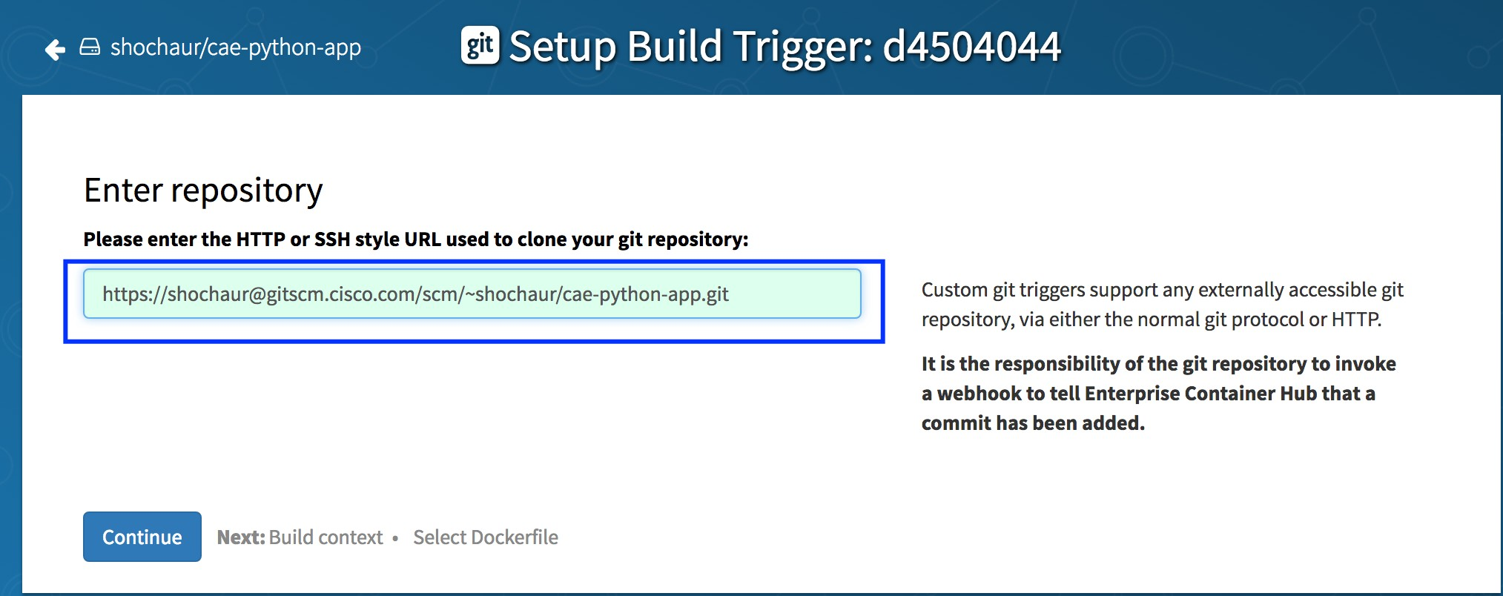

Step 6: Enter build context directory **Continue**

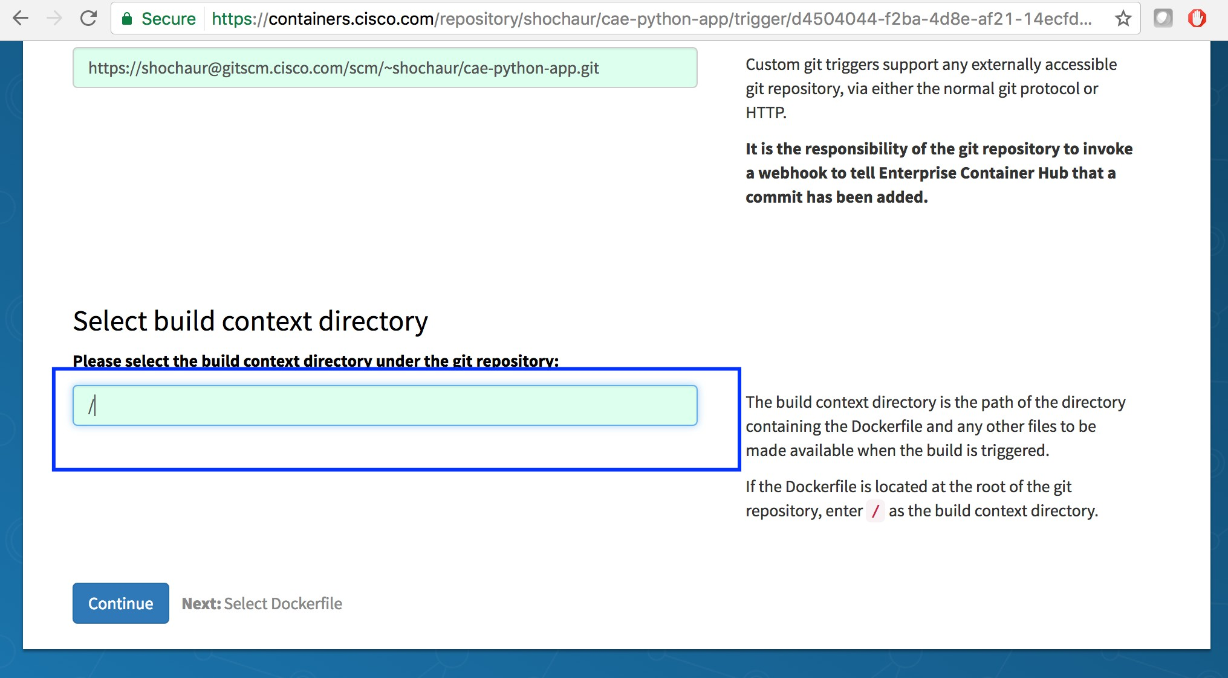

Step 7: Enter Dockerfile path **Continue**

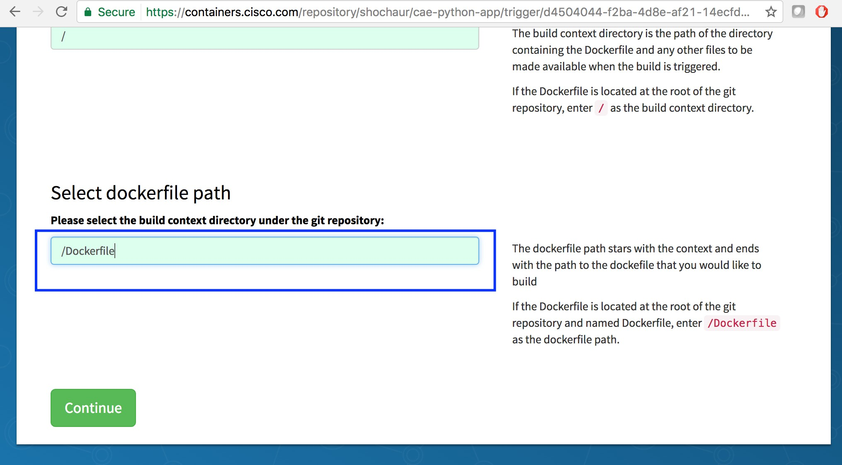

Step 8: Copy SSH public key and Webhook Endpoint URL

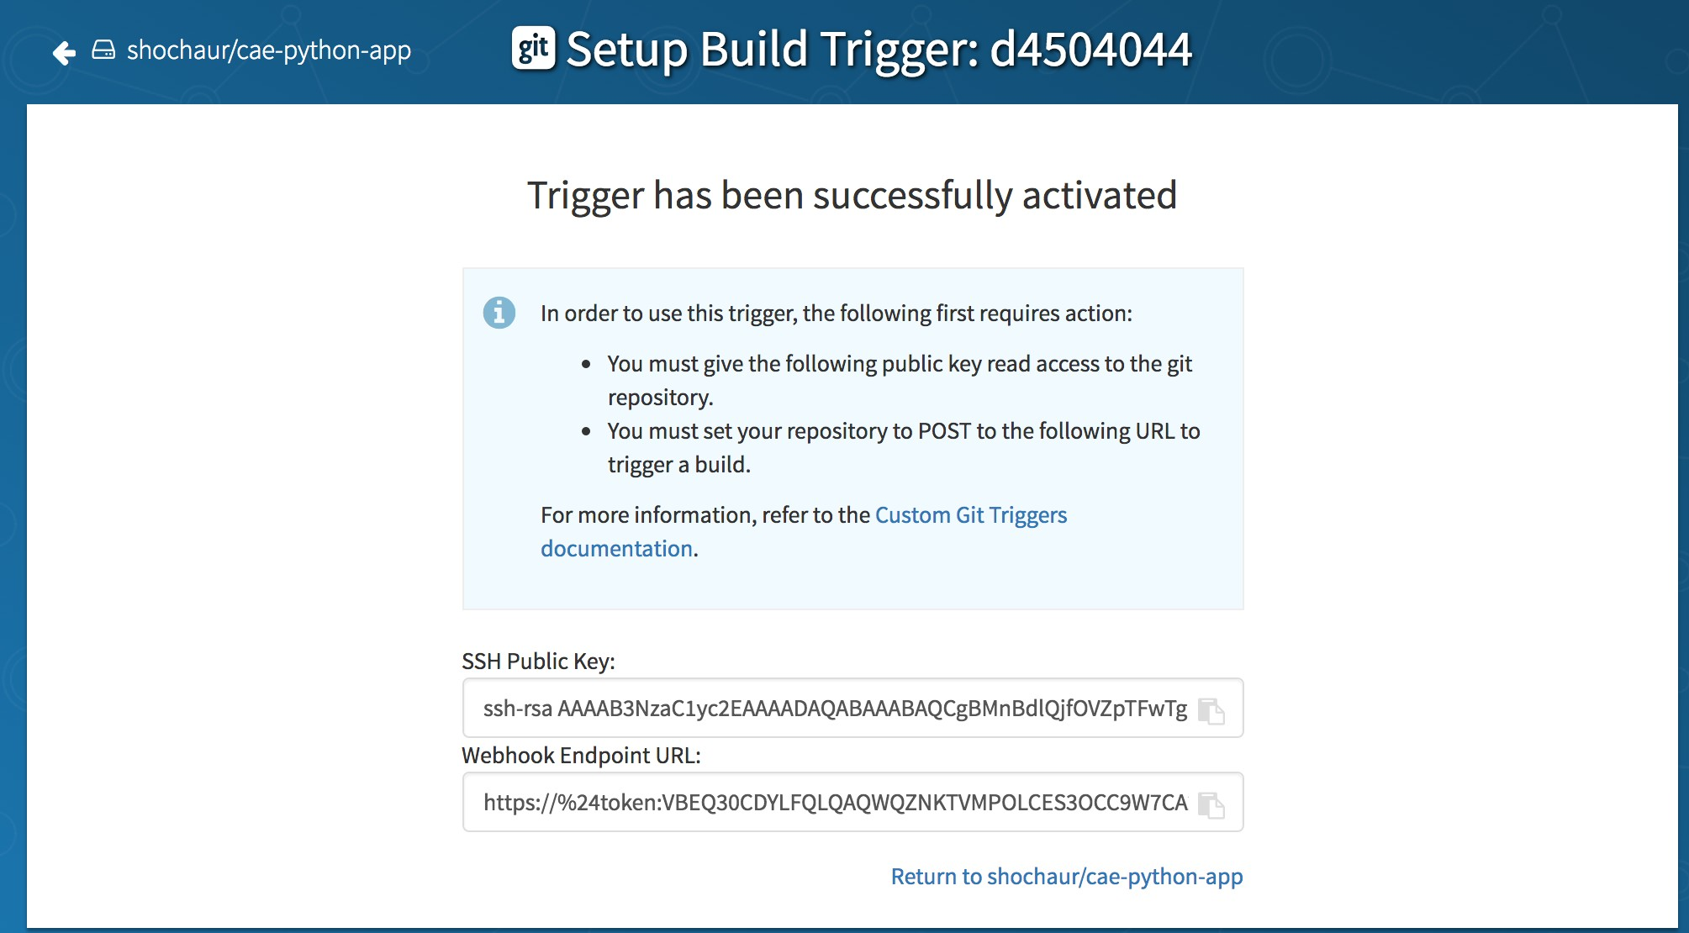

Step 9: Goto gitscm **Settings Access keys Add key**

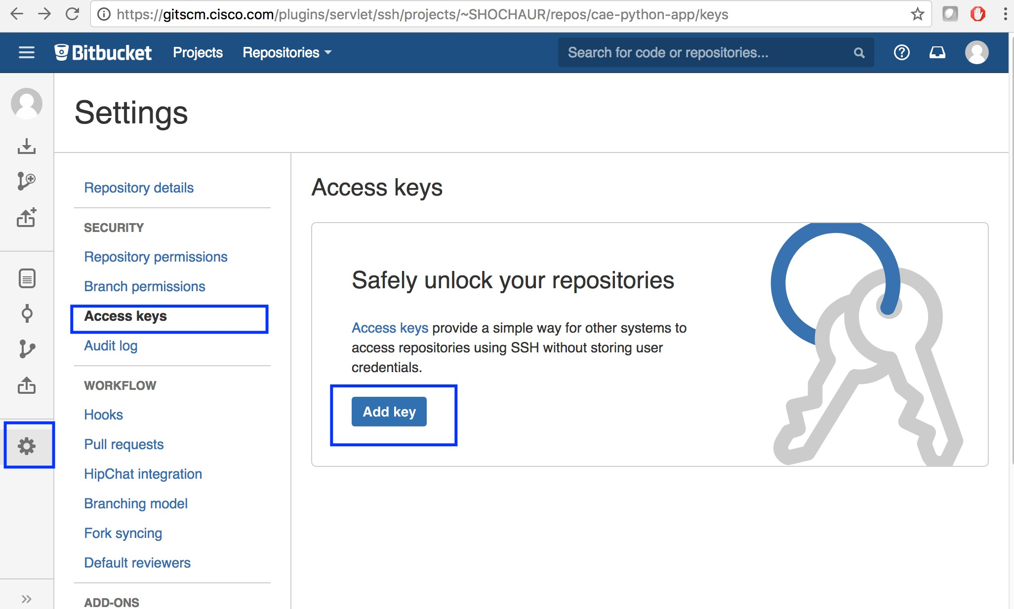

Step 10: Paste SSH public key **Add key**

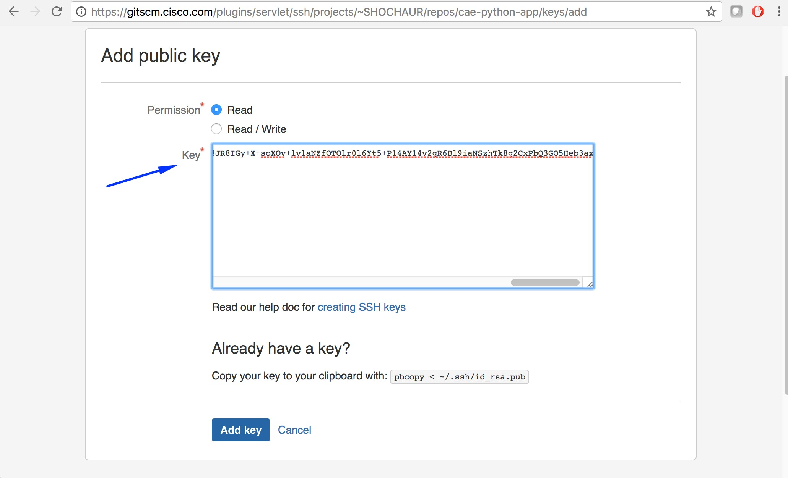

Step 11: Click on Settings **Hooks Http Request Post Receive Hook Enabled**

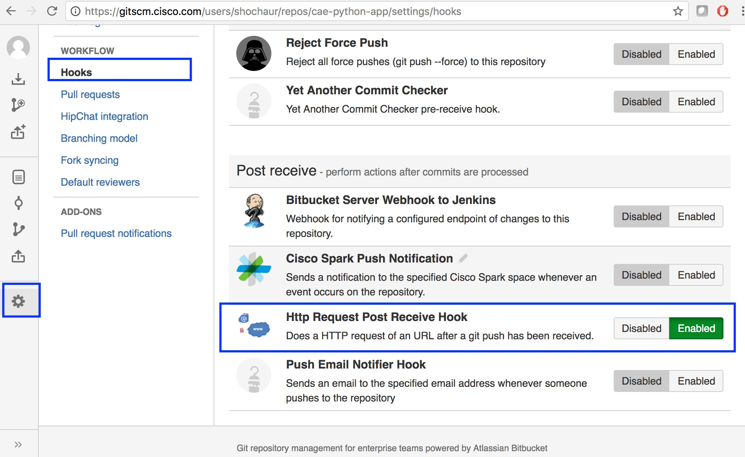

Step 12: Select **Method : POST** , **URL : Webhook Endpoint URL**, **Authentication : CEC credentials Save**

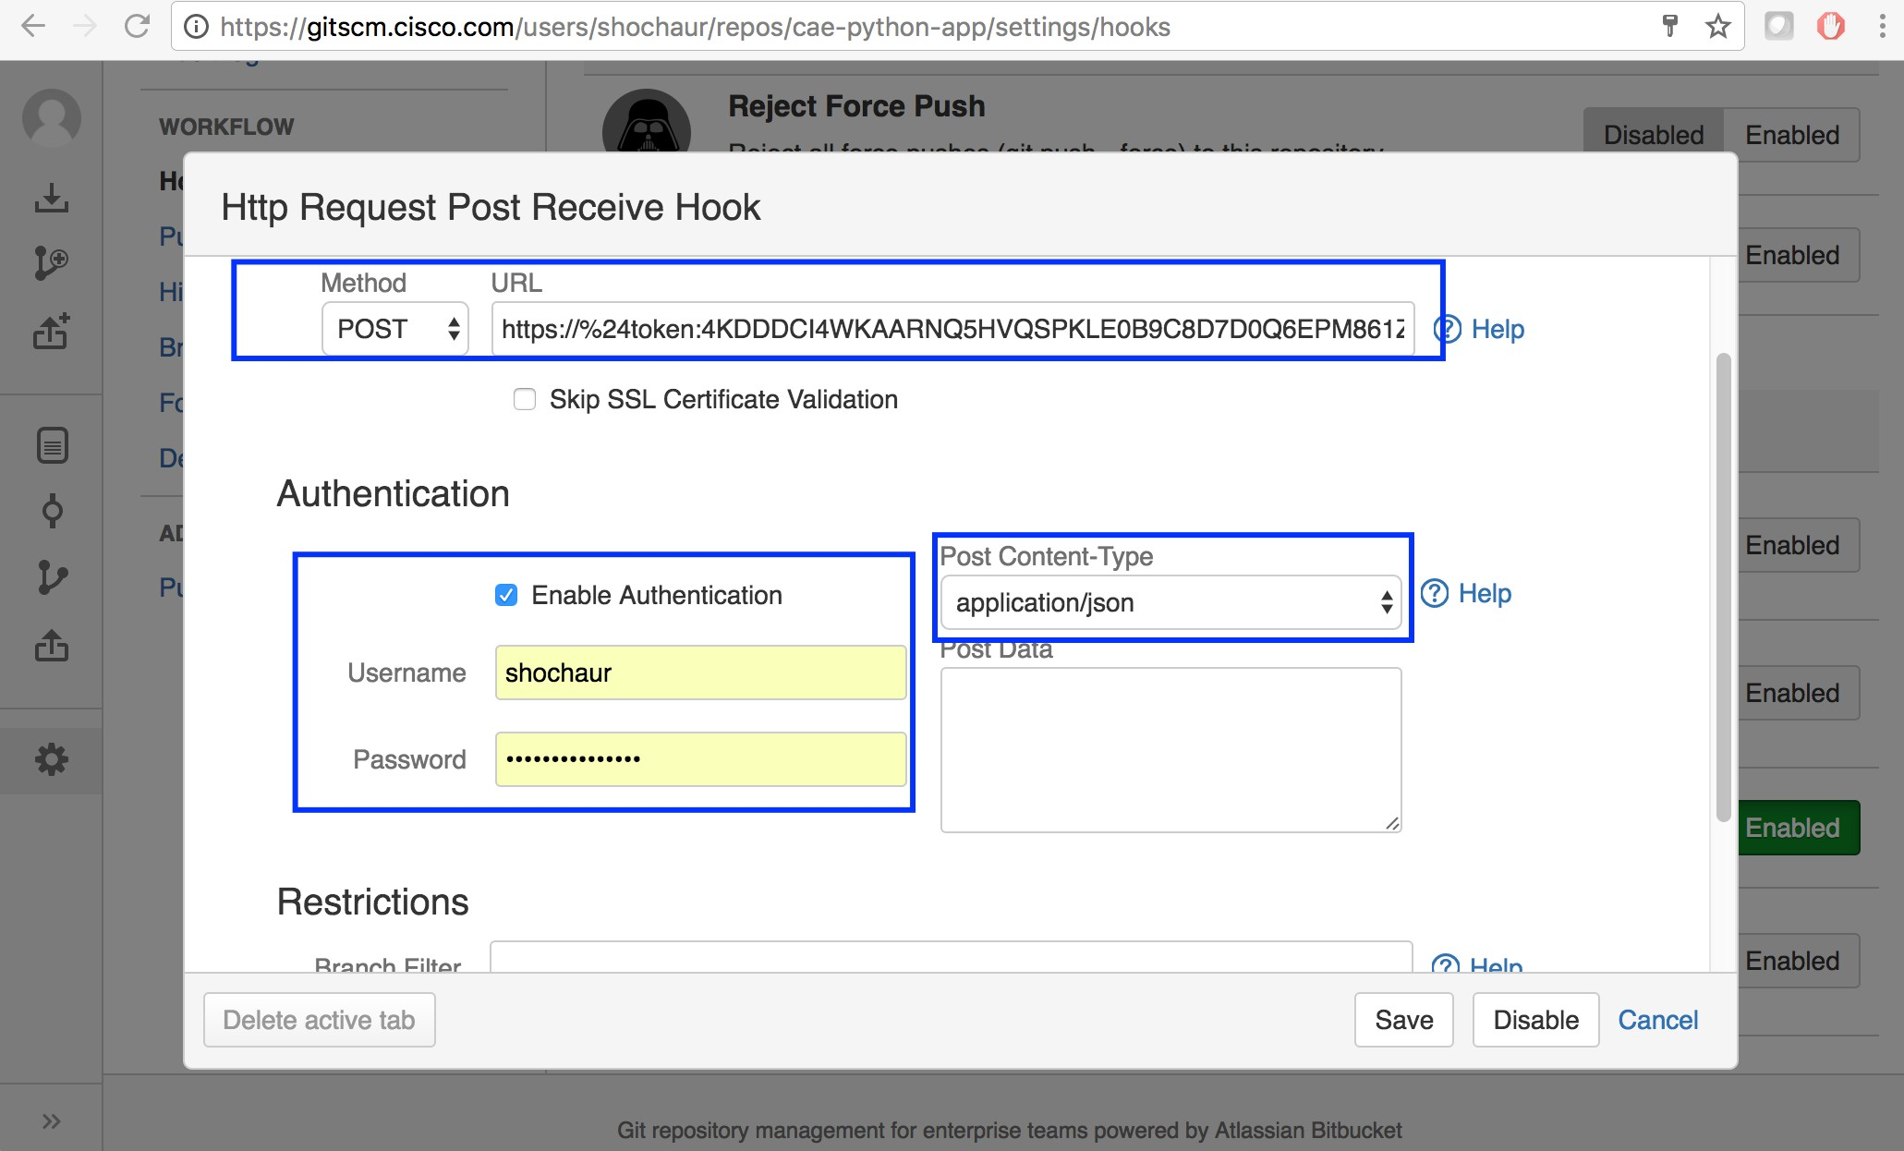

Step 13: Goto ECH Build Settings Run Trigger Now

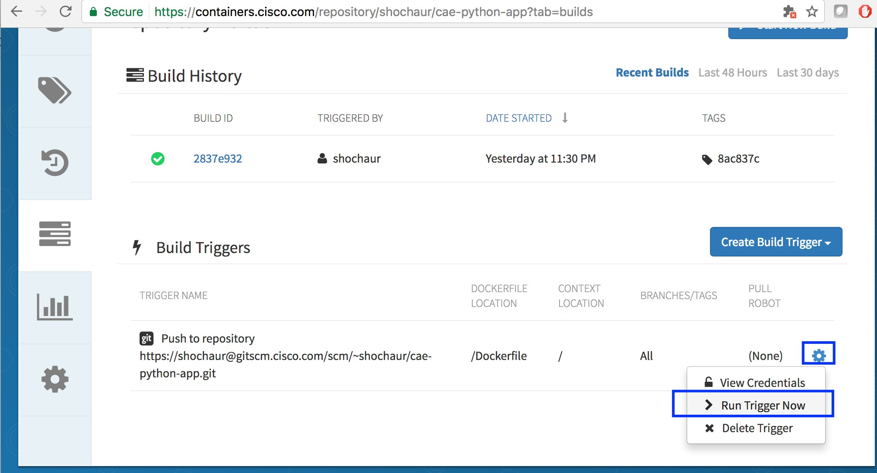

Step 14: Pass commit ID Start Build

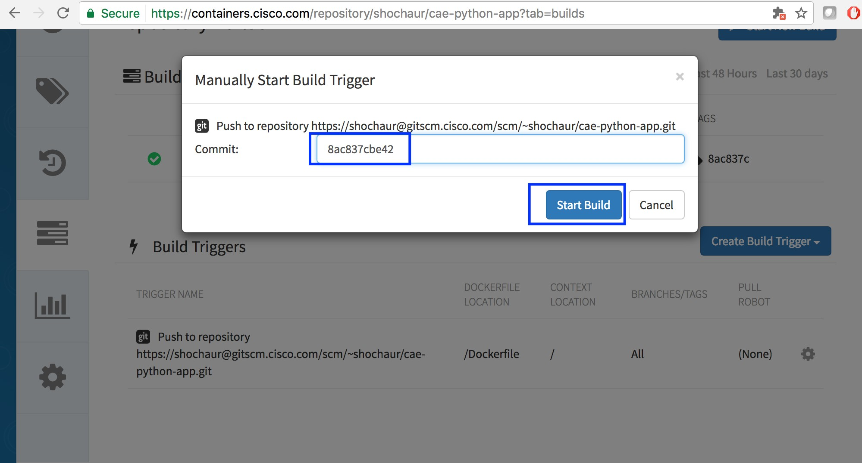

Built Successful:

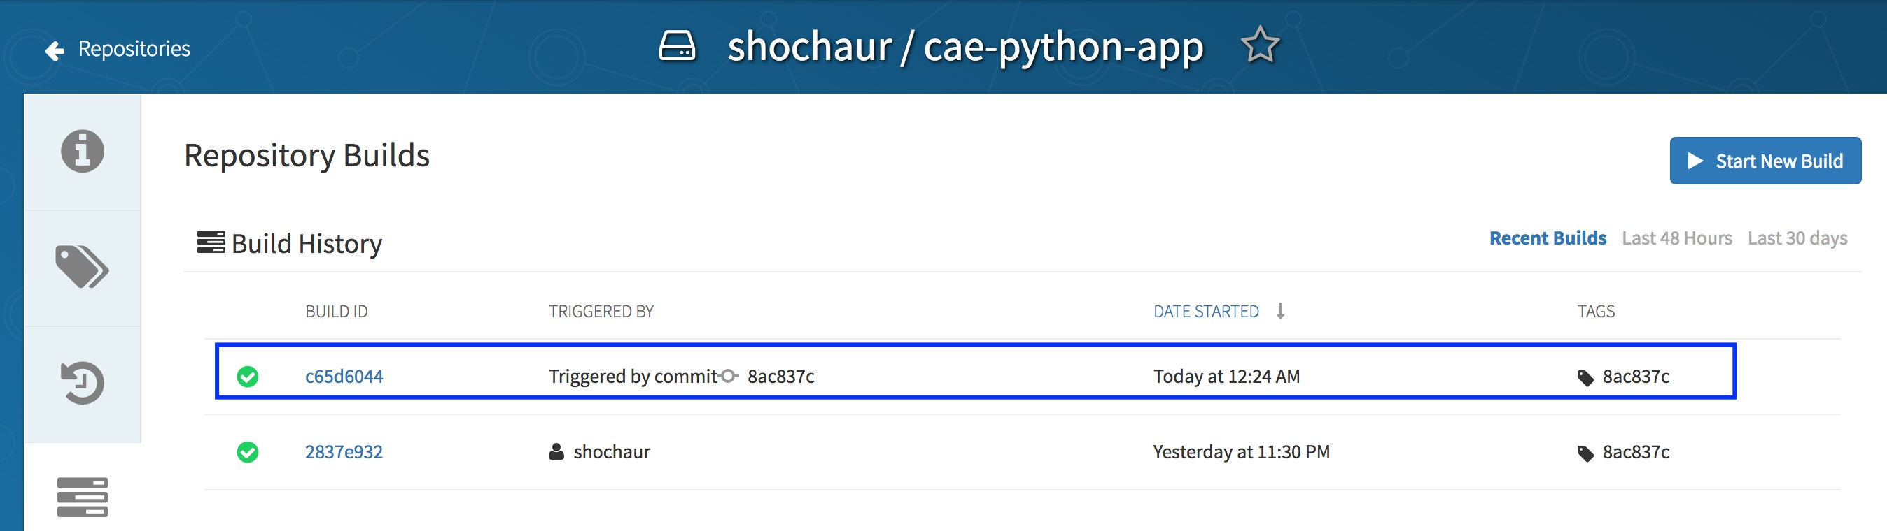

# Building Effective and Easy-to-Use Images

When creating container images to run on CAE, there are a number of best practices to consider as an image author to ensure a good experience for consumers of those images. Because images are intended to be immutable and used as-is, this document would help ensure that your images are small in size and easy to use on the CAE container platform.

Our objective -

*We want to minimize* image size and number of layers.

*We want to maximize* build cache usage and Dockerfile readability.

*We want to* make working with our containers *a pleasant experience*

**Wait, but Why?**

Smaller images = reduced build time and easy portability Smaller images = smaller attack surface for vulnerabilities Readable Dockerfile = free beer from co-workers

Image layers are filesystem difference. They add up quickly, with big consequences.

### In Short

As discussed in [How to Write Dockerfiles](https://wiki.cisco.com/display/CAEUSER/Write%2BDockerfiles), there are several Dockerfile rules to follow in order to ensure that your image is at par with industry standards -

Write .dockerignore file Reuse images

Run only one process per container

Understand Docker caching! Use COPY and RUN commands in proper order to utilize that. Merge multiple RUN commands into one

Remove temp/unnecessary files after each step and avoid installing unnecessary packages Use appropriate base images (alpine versions should be enough)

Set WORKDIR and CMD

Use ENTRYPOINT when you have more than one command and/or need to update files using runtime data (OPTIONAL) Use exec inside wrapper scripts

Prefer COPY over ADD

Specify default environment variables and ports inside Dockerfile Support arbitrary user IDs

Add HEALTHCHECKS

### In Detail

Let's understand each of the above in detail. We'll start with a crappy Dockerfile and improve it as we go along.

crappy dockerfile

FROM ubuntu ADD . /app

RUN apt-get update RUN apt-get upgrade -y

RUN apt-get install -y nodejs ssh mysql RUN cd /app && npm install

# this should start three processes, mysql and ssh # in the background and node app in foreground

# crappy is an understatement here! CMD mysql & sshd & npm start

**write .dockerignore file**

When building an image, Docker has to prepare a context first - gather all files that may be used in the process. Default context contains all files in a Dockerfile directory. Usually, we don't want to include .git directory, downloaded libraries and compiled files there. The . dockerignore file looks exactly like .gitignore. For example -

.git/ node\_modules/ dist/

#### reuse images

Wherever possible, we recommend that you base your image on an appropriate upstream image using the FROM statement. This ensures your image can easily pick up security fixes from an upstream image when it is updated, rather than you having to update your dependencies directly. In addition, use tags in the FROM instruction (for example, ubuntu:16.04) to make it clear to users exactly which version of an image your image is based on. Using a tag other than latest ensures your image is not subjected to breaking changes that might go into the latest versio n of an upstream image.

#### single process containers

Technically, you CAN start multiple processes inside a Docker container. You CAN put database, frontend and backend applications, ssh, supervisor into one docker image. But you SHOULDN'T because:

long build times (change in e.g. frontend will force whole backend to rebuild) very large images

hard logging from many applications (no more simple stdout) wasteful horizontal scaling

problems with zombie processes - you have to remember about proper init process Let's remove unnecessary packages from our Dockerfile.

FROM ubuntu:16.04 ADD . /app

RUN apt-get update RUN apt-get upgrade -y

# we should remove ssh and mysql, and use # separate container for database

RUN apt-get install -y nodejs RUN cd /app && npm install

CMD npm start

# ssh mysql

#### merge RUN commands

Each RUN command adds a new layer to your image. Let's optimize our example. We're merging all RUN commands into one, and removing apt- get upgrade, as it makes our build non-deterministic (we rely on our base image updates):

FROM ubuntu:16.04 ADD . /app

RUN apt-get update \

&& apt-get install -y nodejs \ && cd /app \

&& npm install CMD npm start

#### use docker caching

This is probably the MOST important item on the list!

Docker reads the ***Dockerfile*** and runs the instructions from top to bottom. Every instruction that is successfully executed creates a layer which can be reused the next time this or another image is built. It is very important to place instructions that will rarely change at the top of your ***Docker file***. Doing so ensures the next builds of the same image are very fast because the cache is not invalidated by upper layer changes.

For example, if you are working on a ***Dockerfile*** that contains an ADD command to install a file you are iterating on, and a RUN command to yum install a package, it is best to put the ADD command last:

FROM foo

RUN yum -y install mypackage && yum clean all -y ADD myfile /test/myfile

This way each time you edit ***myfile*** and rerun docker build, the system reuses the cached layer for the yum command and only generates the new layer for the ADD operation.

If instead you wrote the ***Dockerfile*** as:

FROM foo

ADD myfile /test/myfile

RUN yum -y install mypackage && yum clean all -y

Then each time you changed ***myfile*** and reran docker build, the ADD operation would invalidate the RUN layer cache, so the yum operation would need to be rerun as well.

This is what our Dockerfile looks like now -

FROM ubuntu:16.04

RUN apt-get update && apt-get install -y nodejs ADD . /app

RUN cd /app && npm install CMD npm start

**TL;DR**

**Invalidating cache of a single layer invalidates all subsequent layers. Fewer cache invalidations means smaller images!**

#### remove temp/unnecessary files after each step

So, let's assume we updated apt-get sources, installed few packages required for compiling others, downloaded and extracted archives. We obviously don't need them in our final images, so better let's cleanup.

In our example we can remove apt-get lists (created by apt-get update) FROM ubuntu:16.04

RUN apt-get update \

&& apt-get install -y nodejs \ # added lines

&& rm -rf /var/lib/apt/lists/\*

ADD . /app

RUN cd /app && npm install CMD npm start

#### use appropriate base images

We are using an ubuntu base image. But we dont' really need a general purpose OS base image when all we want is to run a node application. We can use a specialized image with node installed on a lightweight OS like Alpine -

FROM node:7-alpine ADD . /app

RUN cd /app && npm install CMD npm start

#### use WORKDIR and CMD

WORKDIR command changes default directory, where we run our RUN / CMD / ENTRYPOINT commands.

CMD is a default command run after creating container without other command specified. It's usually the most frequently performed action. Let's add them to our Dockerfile.

FROM node:7-alpine WORKDIR /app

ADD . /app

RUN npm install

CMD ["npm", "start"]

#### use ENTRYPOINT

It's not always necessary, because entrypoint adds complexity. Entrypoint is a script or an executable, that will run instead of a command, and receive the command as arguments. It's a great way to create runnable Docker images:

#!/usr/bin/env sh

# $0 is a script name,

# $1, $2, $3 etc are passed arguments # $1 is our command

CMD=$1

case "$CMD" in "dev" )

npm install

export NODE\_ENV=development exec npm run dev

;;

"start" )

# we can modify files here, using ENV variables passed in

# "docker create" command. It can't be done during build process. echo "db: $DATABASE\_ADDRESS" >> /app/config.yml

export NODE\_ENV=production exec npm start

;;

\* )

# Run custom command. Thanks to this line we can still use # "docker run our\_image /bin/bash" and it will work

exec $CMD ${@:2}

;;

esac

Save it in your root directory, named entrypoint.sh. Usage in Dockerfile:

FROM node:7-alpine

WORKDIR /app ADD . /app

RUN npm install

ENTRYPOINT ["./entrypoint.sh"] CMD ["start"]

Now we can run this image in an executable-like way:

docker run our-app dev docker run our-app start

docker run -it our-app /bin/bash - this one will work too

#### use exec inside wrapper scripts

As you can see in example entrypoint, we're using exec. Without it, we would not be able to stop our application grecefully (SIGTERM is *swallow ed* by bash script). Exec basically replaces the script process with a new one, so all signals and exit codes work as intended.

#### prefer COPY over ADD

COPY is simpler. ADD has extra logic for downloading remote files and extracting archives. See more [here](https://wiki.cisco.com/display/CAEUSER/How%2Bto%2BWrite%2BDockerfiles).

FROM node:7-alpine WORKDIR /app

COPY . /app RUN npm install

ENTRYPOINT ["./entrypoint.sh"] CMD ["start"]

Avoid ADDing large files. Use CURL wherever possible. Delete large file after use.

Important:

**We can optimize our COPY and RUN commands further by putting least frequent changes at the top of our Dockerfiles to leverage caching.**

**In our example, code will change often, and we don't want to reinstall packages each time. We can copy package.json before rest of the code, install dependencies**, **and then add other files. Let's apply that improvement to our Dockerfile:**

FROM node:7-alpine WORKDIR /app

COPY package.json /app RUN npm install

COPY . /app

ENTRYPOINT ["./entrypoint.sh"] CMD ["start"]

#### ENV variables and PORTs

We probably need some environment variables to run our container. It's a good practice to set default values in the Dockerfile. Also, we should expose all used ports.

FROM node:7-alpine

# env variables required during build ENV PROJECT\_DIR=/app

WORKDIR $PROJECT\_DIR

COPY package.json $PROJECT\_DIR RUN npm install

COPY . $PROJECT\_DIR

# env variables that can change # port settings

# and defaults for our application ENV NODE\_ENV=production \

APP\_PORT=3000 EXPOSE $APP\_PORT

ENTRYPOINT ["./entrypoint.sh"] CMD ["start"]

#### support arbitrary USER IDs

By default, OpenShift Origin runs containers using an arbitrarily assigned user ID. This provides additional security against processes escaping the container due to a container engine vulnerability and thereby achieving escalated permissions on the host node.

For an image to support running as an arbitrary user, directories and files that may be written to by processes in the image should be owned by the root group and be read/writable by that group. Files to be executed should also have group execute permissions.

#### add HEALTHCHECKS

We can start docker container with option --restart always. After container crash, docker daemon will try to restart it. It's very useful if your container has to be operational all the time. But what if container is running, but not available (infinite loop, invalid configuration etc)?. With HEALT HCHECK instruction we can tell Docker to periodically check our container health status. It can be any command, returning 0 exit code if everything is OK, and 1 in other case.

You can learn more here - <https://blog.newrelic.com/2016/08/24/docker-health-check-instruction/>

So, here's our final Dockerfile:

FROM node:7-alpine

LABEL maintainer "[dhsanghv@cisco.com"](mailto:dhsanghv@cisco.com)

ENV PROJECT\_DIR=/app WORKDIR $PROJECT\_DIR

COPY package.json $PROJECT\_DIR RUN npm install

COPY . $PROJECT\_DIR

ENV NODE\_ENV=production \ APP\_PORT=3000

EXPOSE $APP\_PORT

HEALTHCHECK CMD curl --fail http://localhost:$APP\_PORT || exit 1

ENTRYPOINT ["./entrypoint.sh"] CMD ["start"]

### Some language specific pointers

Python

Use ONBUILD for ADD requirements.txt and pip install etc.

NodeJS

.dockerignore npm-debug.log cache node\_modules

Go

use scratch

compile, then copy binary

# Create Base Images for CAE

This post takes you through the process and basic requirements to create official, non-s2i, secure base images for the Cloud Application Environment (CAE).

#### Base Image Requirements

Should be thin, lightweight and have minimal layers Must pass ECH security scan

Should be built on top of an official RHEL container base image Should not contain any S2I scripts or build scripts of any kind

Must not install any unnecessary utilities/programs inside the container

Developers are working in much the same way as a race car mechanic would. The goal is to strip all the unnecessary weight off the race car leaving just the bare essentials. Same goes for our Docker images. Do we need every Linux command, library, etc inside of our container to run a Hello World script? Probably not. Why not install just the bare essentials required to run the application that's inside your container.

Now let's go through the Dockerfiles of each base image.

#### Tomcat 8 / RHEL 7 Base Image

A secure, non-s2i tomcat8/rhel7.2 based image which can be used as a base image for j2ee tomcat apps.

**Size:** 407.9 MB

**Vulnerabilities** – Passed

**Image**: <https://containers.cisco.com/repository/dhsanghv/tomcat-rhel>

**Dockerfile**: <https://github.com/giggityuser/tomcat-rhel-base>

**Dockerfile**

# RHEL based container with Java and Tomcat FROM containers.cisco.com/cntbase/rhel7.2 [MAINTAINER Dhairya Sanghvi <dhsanghv@cisco.com>](mailto:dhsanghv@cisco.com) # Install prepare infrastructure

RUN yum -y update && \ yum -y install wget && \ yum -y install tar

# Prepare environment

ENV TOMCAT\_VERSION 8.0.39

ENV JAVA\_HOME /opt/java

ENV CATALINA\_HOME /opt/tomcat

ENV PATH $PATH:$JAVA\_HOME/bin:$CATALINA\_HOME/bin:$CATALINA\_HOME/scripts # Install Oracle Java8

RUN wget --no-check-certificate --no-cookies --header "Cookie: oraclelicense=accept-securebackup-cookie" \

[http://download.oracle.com/otn-pub/java/jdk/8u101-b13/jdk-8u101-linux-x64.](http://download.oracle.com/otn-pub/java/jdk/8u101-b13/jdk-8u101-linux-x64) tar.gz && \

tar -xvf jdk-8u101-linux-x64.tar.gz && \ rm jdk\*.tar.gz && \

mv jdk\* ${JAVA\_HOME}

# Install Tomcat

[RUN wget http://apache.rediris.es/tomcat/tomcat-8/v${TOMCAT\_VERSION}/bin](http://apache.rediris.es/tomcat/tomcat-8/v%24)

/apache-tomcat-${TOMCAT\_VERSION}.tar.gz && \

tar -xvf apache-tomcat-${TOMCAT\_VERSION}.tar.gz && \ rm apache-tomcat\*.tar.gz && \

mv apache-tomcat\* ${CATALINA\_HOME} RUN chmod +x ${CATALINA\_HOME}/bin/\*sh WORKDIR /opt/tomcat

EXPOSE 8080

EXPOSE 8009

CMD ["tomcat.sh"]

As the Dockerfile comments suggest, this base image uses the official openshift rhel7 image

makes the required basic installations (wget, jdk, tomcat)

exposes the http and debug ports and specifies the RUN command.

#### How to use this Base Image

Refert to [this wiki page](https://wiki.cisco.com/display/CAEUSER/Deploy%2Bon%2BCAE%2Busing%2BSDaaS%2BPipeline%2Band%2BImage%2BPull%2BSecrets) for instructions on how to use this tomcat base image.

# Download oc client

The oc client is a command line utility that can be run on you own pc. It allows you to connect to the CAE clusters and issue commands without having to use the UI Console or the REST API. It is very handy for viewing the state of your projects and applications.

Multiple versions of the oc client can be downloaded from the URL below.

Installation of the oc client is easy. Follow the instructions on [OpenShift's Documentation Site](https://docs.openshift.com/container-platform/3.9/cli_reference/get_started_cli.html#installing-the-cli)

Download latest release of oc : <https://cisco.box.com/v/oc-client-download>

|  |  |
| --- | --- |
| RTP Cluster | [https://cae-prd-rtp.cisco.com](https://cae-rtp.cisco.com/) (Prod), [https://cae-np-rtp.cisco.com](https://cae-rtp.cisco.com/) (Non-Prod) |
| Allen Cluster | [https://cae-prd-alln.cisco.com](https://cae-alln.cisco.com/) (Prod), [https://cae-np-alln.cisco.com](https://cae-rtp.cisco.com/) (Non-Prod) |
| Richardson Cluster | [https://cae-prd-rcdn.cisco.com](https://cae-rcdn.cisco.com/) (Prod), [https://cae-np-rcdn.cisco.com](https://cae-rtp.cisco.com/) (Non-Prod) |

use "oc" to login and use project:

oc login [<](https://cae-rcdn.cisco.com/)cluster URL>

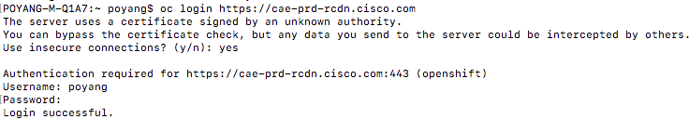

oc project <project\_name>



# Deployment

[Deploy on CAE](https://wiki.cisco.com/display/CAEUSER/Deploy%2Bon%2BCAE)

[Use Image Pull Secrets to Deploy from a Private Repository](https://wiki.cisco.com/display/CAEUSER/Use%2BImage%2BPull%2BSecrets%2Bto%2BDeploy%2Bfrom%2Ba%2BPrivate%2BRepository) [B/G Deployments](https://wiki.cisco.com/pages/viewpage.action?pageId=125702570)

[Blue/Green Deployment (B/G Deployment) Out of Box](https://wiki.cisco.com/pages/viewpage.action?pageId=86155337) [Deploying Stateful Databases](https://wiki.cisco.com/display/CAEUSER/Deploying%2BStateful%2BDatabases)

[Deploy in multiple Data centres](https://wiki.cisco.com/display/CAEUSER/Deploy%2Bin%2Bmultiple%2BData%2Bcentres)

[Deploy on CAE using SDaaS Pipeline and Image Pull Secrets](https://wiki.cisco.com/display/CAEUSER/Deploy%2Bon%2BCAE%2Busing%2BSDaaS%2BPipeline%2Band%2BImage%2BPull%2BSecrets) [Deploy using json/yaml file](https://wiki.cisco.com/pages/viewpage.action?pageId=84578119)

[Redeploy Pod's](https://wiki.cisco.com/display/CAEUSER/Redeploy%2BPod%27s)

[Update Deployment Image](https://wiki.cisco.com/display/CAEUSER/Update%2BDeployment%2BImage)

# Deploy on CAE

By now, your Docker Image is successfully built, pushed to ECH and ready for deployment. If not, then please follow below steps and again hit this link:

[Create Dockerfile](https://wiki.cisco.com/display/CAEUSER/How%2Bto%2BWrite%2BDockerfiles) Push image to ECH

So, your image should be ready to deploy. Before deploy, let's cover some points on how many clusters and in how many ways we can deploy our image.

Cluster in CAE

CAE has 3 cluster i.e. RTP , Allen and Richardson. Unlike in other architecture, all these 3 clusters are production cluster and are live. Depending on your requirement, you can create your project as non-prod or prod or custom like DR / AB stack etc in any one of the cluster or in multiple clusters. To connect to these cluster, CAE has 3 different URLs as below:

|  |  |
| --- | --- |
| RTP Cluster | [https://cae-prd-rtp.cisco.com](https://cae-rtp.cisco.com/) (Prod), [https://cae-np-rtp.cisco.com](https://cae-rtp.cisco.com/) (Non-Prod) |
| Allen Cluster | [https://cae-prd-alln.cisco.com](https://cae-alln.cisco.com/) (Prod), [https://cae-np-alln.cisco.com](https://cae-rtp.cisco.com/) (Non-Prod) |
| Richardson Cluster | [https://cae-prd-rcdn.cisco.com](https://cae-rcdn.cisco.com/) (Prod), [https://cae-np-rcdn.cisco.com](https://cae-rtp.cisco.com/) (Non-Prod) |

## Deploy in CAE Clusters

Pods can be deploy in one of the cluster. Same can be done in multiple clusters and load balance those using GSLB. There are multiple ways you can deploy image in CAE cluster :

* oc newapp
* using json/yaml file
* oc dc

# Use Image Pull Secrets to Deploy from a Private Repository

### Background

When you deploy a Pod/Container to CAE, CAE must pull that image from the Enterprise Container Hub. By default repositories in ECH are private and CAE can't access the image. You have two options:

1. Make your repository public - Lazy, insecure approach 
2. Use an Image Pull Secret - Preferred, secure approach

### Using an Image Pull Secret

Since you are not lazy and security is important to you, here are the steps to using and Image Pull Secret

1. Create a robot account in ECH.
   1. Navigate to your personal or organization directory in ECH
      1. https://containers.cisco.com/user/<your\_userid>
      2. https://containers.cisco.com/organization/<your\_org>
   2. Click on this robot guy,  on the left side of the screen
   3. Click on the 'Create Robot Account' button on the top right of the screen
   4. Give your robot account a name and description and Click 'Create robot account' button
   5. (Optional) Select the Repositories you want the robot account to have access to and assign the Read Permission, Click 'Add Permission' button.
2. Assign the robot account, access to your repository
   1. If you skipped the optional step e above, or if you come back later, you can grant your robot account access to repositories
   2. Navigate to a specific repository
   3. Click on the  icon on the left side of the screen
   4. Under the User and Robot Permissions section of the page, give your robot account Read access to the repository
3. Retrieve your robot account's Kubernetes Secret
   1. Return to your organization or user directory in ECH
   2. Click on the robot guy icon again . 
   3. Click on your robot account's name
   4. Select Kubernetes Secret tab from the pop-up window
   5. Download or copy the robot-name-secret.yaml file. It will look something like:

apiVersion: v1 kind: Secret metadata:

name: org-walle-pull-secret data:

.dockerconfigjson: asdfasdfasdfasdfHsKICAgICJjb250YWluasdfCAgICAgImF1dGgiOiACB9Cn0=... type: [kubernetes.io/dockerconfigjson](http://kubernetes.io/dockerconfigjson)

1. Create the Secret in your OpenShift Project
   1. via cli
      1. oc login cae-<cluster>.cisco.com
      2. oc create -f robot-name-secret.yaml --namespace=<your-project-name>
   2. Or use some deployment pipeline to create the secret in your project
2. Reference the Secret in the spec section of your deployment file. It will look something like:

apiVersion: v1

kind: Pod metadata:

name: somepod spec:

containers:

* name: web

image: containers.cisco.com/<org-or-user>/somerepo imagePullSecrets:

* name: org-walle-pull-secret

Now when CAE deploys your Pod, it will use the secret to authenticate against ECH and have access to pull your images.

# B/G Deployments

Blue-green deployments are a proven approach to reducing downtime caused while upgrading an environment. This is done by creating a parallel environment on which the new deployment can be installed. If a problem is detected, and after the new deployment is verified, traffic can be switched over with the option to rollback.

B/G in CAE is slightly different when compared to LAE. Unlike LAE , you don't need two prod applications to acheive B/G but you will have two services ( blue/green , prod/prd1) within same project and a route to switch the traffic b/w two services ,which will also be added to Global GSLB.

Detailed Information about B/G on CAE (openshift 3) can be found here: [Blue-Green](https://docs.openshift.com/container-platform/3.9/dev_guide/deployments/advanced_deployment_strategies.html#advanced-deployment-strategies-blue-green-deployments) Comparison between LAE and CAE B/G Routes.

In CAE , you will have three GSLB's (Global , Blue , Green) and respective members in each DC.

Also there will be similar set of test GSLB's and routes which will be used pre-cutover to validate the application Once after cutover you can ignore the test GSLB's and routes

|  |  |
| --- | --- |
| **LAE** | **CAE** |
| myapp[.cloudapps.cisco.com](http://bre.cloudapps.cisco.com/) | Global GSLB : [https://myapp.cloudapps.cisco.com](https://myapp.cloudapps.cisco.com/) Members : [https://myapp-bluegreen-prod-alln.cisco.com](https://imdrol-bluegreen-prod-alln.cisco.com/) [https://imdrol-bluegreen-prod](https://imdrol-bluegreen-prod-alln.cisco.com/)-[rcdn.cisco.com](https://imdrol-bluegreen-prod-alln.cisco.com/) [https://imdrol-bluegreen-prod-rtp.cisco.com](https://imdrol-bluegreen-prod-alln.cisco.com/)  Above Member Routes are used to switch the traffic between blue and green service. As shown in below picture |
| myapp[1.cloudapps.cisco.com](http://bre1.cloudapps.cisco.com/) (blue) | Blue GSLB : [https://myapp1.cloudapps.cisco.com](https://myapp1.cloudapps.cisco.com/) Members : [https://cae-myapp1-alln.cisco.com](https://cae-myapp-alln.cisco.com/) [https://cae-myapp1-rcdn.cisco.com](https://cae-myapp-rcdn.cisco.com/)  [https://cae-myapp1-rtp.cisco.com](https://cae-myapp-rtp.cisco.com/)  Above Member Routes always sends traffic to ONLY Blue Service . |
| myapp2[.cloudapps.cisco.com](http://bre1.cloudapps.cisco.com/) (Green) | Green GSLB : [https://myapp2.cloudapps.cisco.com](https://myapp1.cloudapps.cisco.com/) Members : [https://cae-myapp2-alln.cisco.com](https://cae-myapp-alln.cisco.com/) [https://cae-myapp2-rcdn.cisco.com](https://cae-myapp-rcdn.cisco.com/)  [https://cae-myapp2-rtp.cisco.com](https://cae-myapp-rtp.cisco.com/) |
| myapp.cisco.com ( cname/Vanity URL) Applicable only if you have cname/Vanity URL | Cname GSLB : [https://myapp.cisco.com](https://myapp.cisco.com/) [https://cn-myapp-prod-alln.cisco.com](https://cn-myapp-prod-alln.cisco.com/) [https://cn-myapp-prod-rcdn.cisco.com](https://cn-myapp-prod-rcdn.cisco.com/) |

Create two services (blue and green or prod and prd1 ) .

Note: For Migrating applications we are pre-provisioning the services and routes within same project.

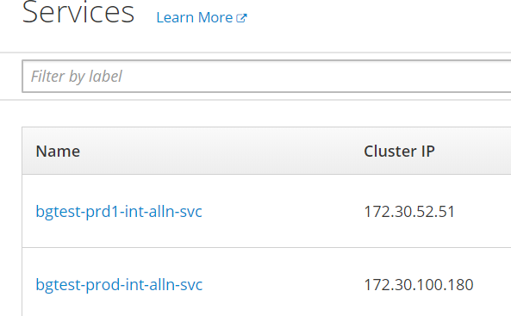

While Creating Route , you can see "Alternate Services" where you can choose another service to split the traffic.

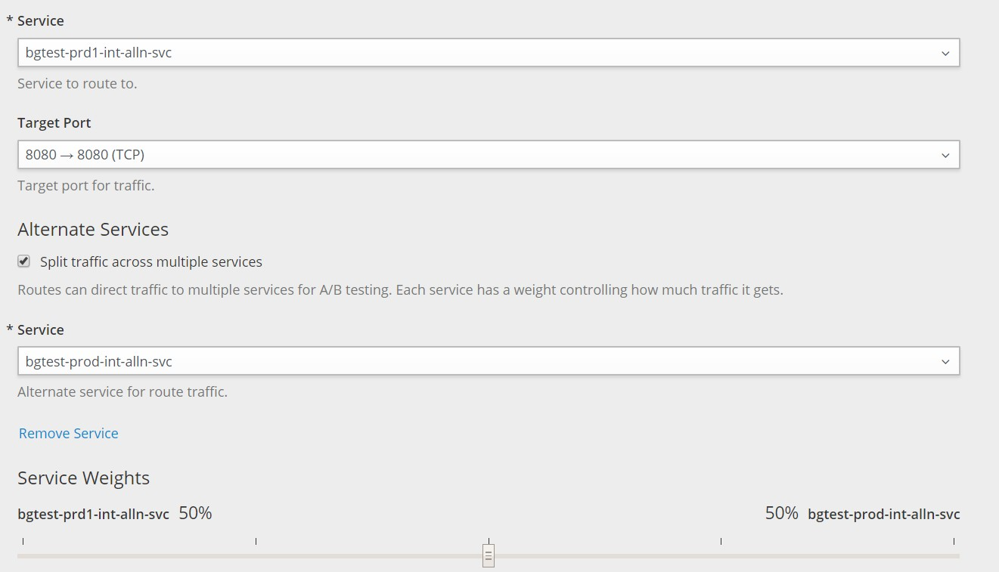

Once after route creation you can see below , traffic is split b/w both services.

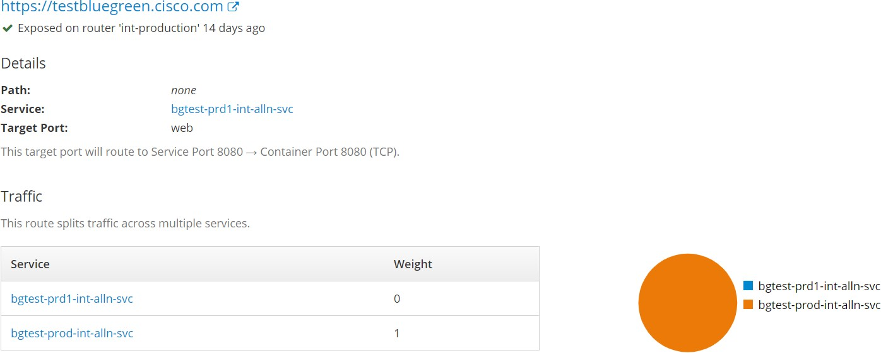

Deploy code on Blue or Green apps using SDaaS

For Migrating applications:

If you already have a SDaaS stacks in LAE then you will have same setup in CAE.

If you do not have SDaaS stack , use below link to create SDAAS Stack

[https://apps.na.collabserv.com/wikis/home/wiki/Wb8cb3976719c\_4ecd\_a053\_6989d80bb789/page/SDaaS%20Provisioning%20for%20Cloud%](https://apps.na.collabserv.com/wikis/home/wiki/Wb8cb3976719c_4ecd_a053_6989d80bb789/page/SDaaS%20Provisioning%20for%20Cloud%20Application%20Environment) [20Application%20Environment](https://apps.na.collabserv.com/wikis/home/wiki/Wb8cb3976719c_4ecd_a053_6989d80bb789/page/SDaaS%20Provisioning%20for%20Cloud%20Application%20Environment)

As part of SDaaS deployment , you need to generate config yaml's using [web tool](https://wiki.cisco.com/pages/createpage.action?spaceKey=GISCONT&amp;title=lae2cae.cisco.com) .

In order to deploy both services into same project ,you need to do one-time change in Udeploy configuration Update the Udeploy configuration parameters for second project/application to change the target project

Applications -> Click on lifecycle (prd1) -> Configuration -> Environment Properties -> Project Details -> Change the projects to prod from

DON'T CHANGE THE PROFILE NAMES , IT SHOULD REMAIN SAME.

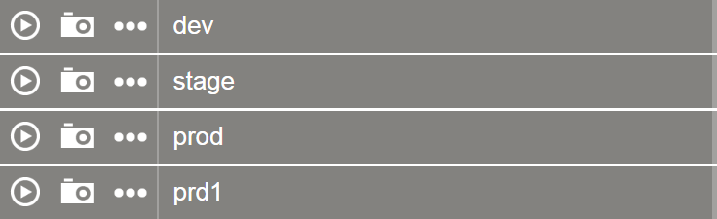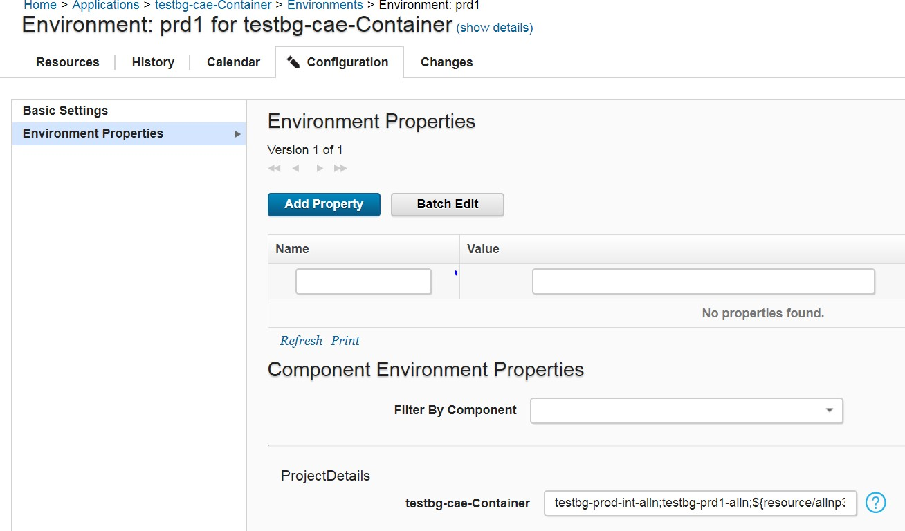

Update the prd1 project name with prod as below and save the configuration.

Before : **testbg-prd1-int-alln**;testbg-prd1-alln;${resource/allnp3-prd},**testbg-prd1-int-rcdn**;testbg-prd1-int-rcdn;${resource/rcdnp3-prd}

After : **testbg-prod-int-alln**;testbg-prd1-alln;${resource/allnp3-prd},**testbg-prod-int-rcdn**;testbg-prd1-int-rcdn;${resource/rcdnp3-prd}

Note: Make sure only to update Project Name , **DONOT** change the profile name. (As Highlighted above).

By applying above change , deployments done in both prod and prd1 will go to prod. You can see both prod and prd1 pods running in same project (prod).

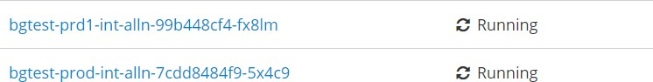

For B/G , you can switch the entire traffic to prod(blue) as shown below and then deploy the latest code to prd1 (green).



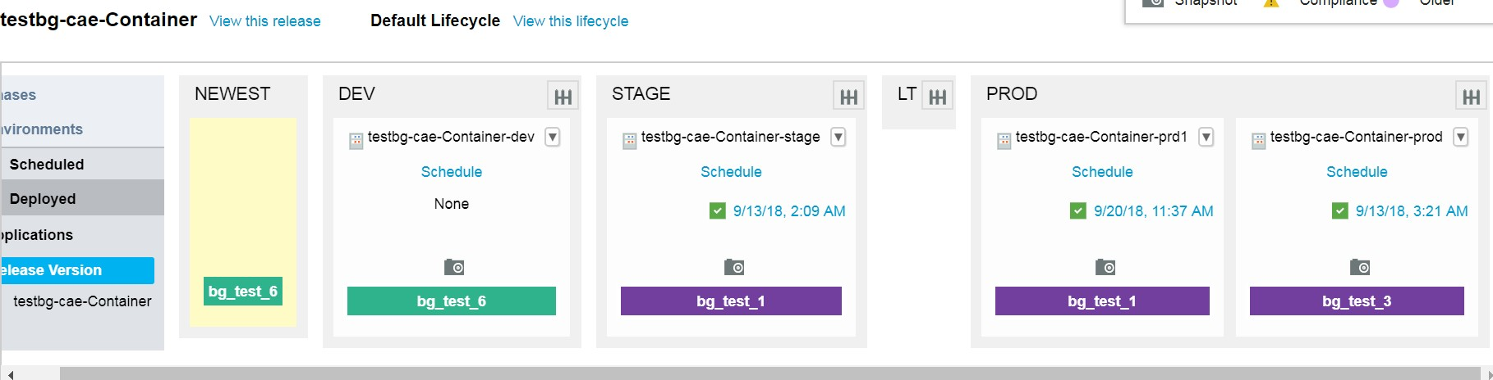

Once after deploying to prd1(green) , you can use green GSLB/Members to test the application.

If your latest code on Green is working as expected then you can switch the entire traffic to Green by updating the yaml as below using the OC Client.

Change the traffic to blue ( prod) to 0 and enable traffic to Green (prd1) to 1. ( Apply the same changes on both DC's) Deploy the code to Blue (prod) by using urelease/udeploy and test the application with blue GSLB/Members

You can change the weight to 1 and 1 for both services if you want to equally split the traffic.

**Route**

apiVersion: v1 kind: Route metadata:

annotations:

citeis.cisco.com/execution\_id: 5b9a26a6c26013116a6f0fd9 citeis.cisco.com/route\_event: "true" citeis.cisco.com/route\_status: success

creationTimestamp: 2018-09-13T08:58:14Z name: bgtest-bluegreen-int-alln-test namespace: testbg-prod-int-alln resourceVersion: "50109574"

selfLink: /oapi/v1/namespaces/testbg-prod-int-alln/routes/bgtest- bluegreen-int-alln-test

uid: 25d109ef-b733-11e8-a677-fa163e3eff7b spec:

alternateBackends:

- kind: Service

name: bgtest-prod-int-alln-svc

weight: 0 Update

the Weight to 1

host: bgtest-bluegreen-alln.cisco.com port:

targetPort: web tls:

termination: edge to:

kind: Service

name: bgtest-prd1-int-alln-svc

weight: 1 Update

the Weigh to 0 wildcardPolicy: None

status: ingress:

- conditions:

- lastTransitionTime: 2018-09-13T08:58:14Z status: "True"

type: Admitted

host: bgtest-bluegreen-alln.cisco.com routerName: int-production wildcardPolicy: None

**Blue/Green Deployment (B/G Deployment) Out of Box**

**Please refer to the** [**Advanced Deployment Strategies**](https://docs.openshift.com/container-platform/3.6/dev_guide/deployments/advanced_deployment_strategies.html#advanced-deployment-strategies-blue-green-deployments) **from Openshift for your deployment design.**

Below are options & examples of Blue/Green Deployment.

1. App Hosted On Single Data Center - RTP or RCDN or ALLN



1. App Hosted On Multi Data Center - RCDN & ALLN



1. App Hosted On Multi Data Center - RTP, RCDN & ALLN



# Deploying Stateful Databases

* 1. [Introduction](#_bookmark4)
  2. [Concepts](#_bookmark5)
     1. [Petsets / Stateful Sets](#_bookmark6)
        1. [What are PetSets?](#_bookmark7)
        2. [When to use PetSets?](#_bookmark8)

1. [Technical Limitations](#_bookmark9)
   1. [Storage](#_bookmark10)
   2. [Ingress IP Space](#_bookmark11)
   3. [OS Level Tuning (Sysctls)](#_bookmark12)
2. [Approaches](#_bookmark13)
   1. [Services with NFS Storage](#_bookmark14)
      1. [Summary](#_bookmark15)
      2. [Pros](#_bookmark16) [3.1.3Cons](#_bookmark17)
   2. [PetSets with NFS Storage](#_bookmark18)
      1. [Summary](#_bookmark19)
      2. [Pros](#_bookmark20)
      3. [Cons](#_bookmark21)
   3. [Services with Local Storage](#_bookmark22)
      1. [Summary](#_bookmark23)
      2. [Pros](#_bookmark24)
      3. [Cons](#_bookmark25)
   4. [PetSets with Local Storage](#_bookmark26)
      1. [Summary](#_bookmark27)
      2. [Pros](#_bookmark28)
      3. [Cons](#_bookmark29)
3. [Recommendation](#_bookmark30)

### Introduction

The purpose of this documentation is to outline the different approaches our clients can take to deploy stateful clustered databases on CAE. This document is constantly evolving, as the technology to support this use case is constantly changing, and becoming better.

### Concepts

#### Petsets / Stateful Sets

* + 1. **What are PetSets?**

In CAE, most pod management abstractions group them into disposable units of work that compose a micro service. Replication controllers for example, are designed with a weak guarantee - that there should be N replicas of a particular pod template. The pods are treated as stateless units, if one of them is unhealthy or superseded by a newer version, the system just disposes it.

foo.default.svc.cluster.local

|service|

/ \

| pod-asdf | | pod-zxcv |

A PetSet/Stateful Set, in contrast, is a group of stateful pods that require a stronger notion of identity. The document refers to these as “clustered applications”.

\*.foo.default.svc.cluster.local

| mysql-0 | <-> | mysql-1 | [pv 0] [pv 1]

The co-ordinated deployment of clustered applications is notoriously hard. They require stronger notions of identity and membership, which they use in opaque internal protocols, and are especially prone to race conditions and deadlock. Traditionally administrators have deployed these applications by leveraging nodes as stable, long-lived entities with persistent storage and static ips.

The goal of PetSet/Stateful Sets is to decouple this dependency by assigning identities to individual instances of an application that are not anchored to the underlying physical infrastructure. For the rest of this document we will refer to these entities as “Pets”. Our use of this term is predated by the “Pets vs Cattle” analogy.

Relationship between Pets and Pods: PetSet requires there be {0..N-1} Pets. Each Pet has a deterministic name - PetSetName-Ordinal, and a unique identity. Each Pet has at most one pod, and each PetSet has at most one Pet with a given identity.

* + 1. **When to use PetSets?**

A PetSet ensures that a specified number of “pets” with unique identities are running at any given time. The identity of a Pet is comprised of: a stable hostname, available in DNS

an ordinal index

stable storage: linked to the ordinal & hostname

These properties are useful in deploying stateful applications. However most stateful applications are also clustered, meaning they form groups with strict membership requirements that rely on stored state. PetSet also helps with the 2 most common problems encountered managing such clustered applications:

discovery of peers for quorum startup/teardown ordering

Only use PetSet if your application requires some or all of these properties. Managing pods as stateless replicas is vastly easier. Example workloads for PetSet:

Databases like MySQL or PostgreSQL that require a single instance attached to an NFS persistent volume at any time Clustered software like Zookeeper, Etcd, or Elasticsearch that require stable membership.

### Technical Limitations

#### Storage

With the release of CAE 3.4 We are able to provide Dynamic Storage Provisioners, a new way to provision and consume storage. We are currently working on two custom storage provisioners (NFS, Local Storage), and hope to have them released soon. PetSets have a dependency on them for complete automation work, but can be worked around. Once completed these provisioners will make the provisioning process for both clients as well as backend administrators much easier and efficient by enabling storage provisioning as the client requests it. In the meantime local storage provisioning will be allocated on a per use case basis, and involves a degree of manual work. NFS storage Persistent Volumes is currently only available in preset sizes.

#### Ingress IP Space

With the release of CAE 3.3, we are able to introduce Ingress Traffic Routing. No longer are your applications limited to only Web Traffic (443) but can be consumed by clients on any port. However this is currently a limited resource. We only have a small pool of available IPs in this release, and as such will only be enabled on special/unique use cases. We understand this is a highly sought after feature and are hoping to be able to expand the IP pool range in the near future.

#### OS Level Tuning (Sysctls)

With the release of CAE 3.4, we are now able to offer limited customization of sysctls for performance tuning. The following are available: kernel.shm\_rmid\_forced,

net.ipv4.ip\_local\_port\_range, net.ipv4.tcp\_syncookies.

We hope to expand this list as in future releases, as kubernetes supports better isolation mechanisms.

### Approaches

#### Services with NFS Storage

* + 1. **Summary**
    2. **Pros**

**3.1.3Cons**

* 1. **PetSets with NFS Storage**
     1. **Summary**
     2. **Pros**
     3. **Cons**
  2. **Services with Local Storage**
     1. **Summary**
     2. **Pros**
     3. **Cons**
  3. **PetSets with Local Storage**
     1. **Summary**
     2. **Pros**
     3. **Cons**

1. **Recommendation**

**Deploy in multiple Data centres**

Deploy your app in multiple data centres or clusters make application highly available , load balance the traffic and high resiliency. Depending on your application requirement, you can deploy in any combination of clusters. Since each cluster is independent of each other, you have to deploy same application in different clusters. [Click here](https://wiki.cisco.com/display/CAEUSER/Deploy%2Bon%2BCAE) to see how can you deploy in one cluster then same steps can be followed to deploy in others. In our demo, I have created these three application in all 3 clusters.

|  |  |
| --- | --- |
| **Cluster** | **App URL** |
| RCDN | <https://hello-rcdn.cisco.com/info.php> |
| ALLN | <https://hello-alln-1.cisco.com/info.php> |
| RTP | <https://hello-rcdn-2.cisco.com/info.php> |

[Next](https://wiki.cisco.com/display/CAEUSER/Create%2BGSLB), we will create a global server load balancer (GSLB) to load balance traffic among these clusters.

# Deploy on CAE using SDaaS Pipeline and Image Pull Secrets

**Repositories referenced in this tutorial**

Source Code: [https://gitscm.cisco.com/users/dhsanghv/repos/j2ee-dockerfile-sample/](https://gitscm.cisco.com/users/dhsanghv/repos/j2ee-dockerfile-sample/browse) Build Management: <https://ci-stg.cisco.com/job/dhairya-poc/job/java-dockerfile-app/> Image Repo: <https://containers.cisco.com/repository/it_gis_aws/tomcat8-rhel7>

CAE Namespace: [https://lae3-alln-int-idev01.cisco.com/console/project/java-secrets](https://lae3-alln-int-idev01.cisco.com/console/project/java-secrets/) [alln idev] App Creation Files: <https://gitscm.cisco.com/users/dhsanghv/repos/secrets_repo/>

#### Step 1: Dockerfile and Git Push

Create a simple Dockerfile for your tomcat based java application similar to the one below -

# Base Image

FROM [containers.cisco.com/it\_gis\_aws/tomcat8-rhel7](http://containers.cisco.com/it_gis_aws/tomcat7-rhel7)

# Maintainer MAINTAINER dhsanghv

# Copy Deployment File (can use ADD as well in place of COPY) COPY ./target/\*.war /opt/tomcat/webapps/

RUN echo "Building Image, Bro!" # Port Setup

EXPOSE 8080

# Recursively grant ownership of the directory /opt/tomcat, and all files and subdirectories, to user root (or a user created by you via useradd command).

RUN chown -R root:root /opt/tomcat &&\ chmod -R g+rw /opt/tomcat

# Main Command

CMD ["/opt/tomcat/bin/catalina.sh", "run"]

Note the use of the recommended RHEL tomcat base image. This is a non-S2I tomcat8/rhel7.2 based image. Size – 407.9 MB

Vulnerabilities – 0 High, 0 Medium, 0 Low [Learn More](https://wiki.cisco.com/display/CEP/CAE%2BUsers%2BGuide)

Keep the Dockerfile in the same location as your pom.xml. Commit and push to your [git repo](https://gitscm.cisco.com/users/dhsanghv/repos/j2ee-dockerfile-sample/browse).

#### Step 2: Create ECH repo

Login to [https://containers.cisco.com](https://containers.cisco.com/) using your CEC credentials.

Create an empty private/public repository in a user account or an organization account and note the docker pull URL.

For Jenkins to be able to push to this repo, you will need to **create a robot account with write permissions** on the ECH repo created above. Just go to **Account Settings >> Robot Accounts >> Create Robot Account.**

ECH will generate a robot token which will be used as a password for external login via Jenkins and other tools. The login method can be found in the **Docker Login** section of your robot account.

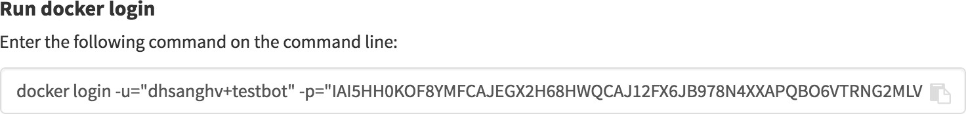

#### Step 3: Jenkins build and push to ECH

Use the regular Jenkins job configuration for code checkout and maven build with one additional step described next.

Please ensure you have restricted the build to a Node which has docker installed on it. Send an email to [code-support@cisco.com](mailto:code-support@cisco.com) to find out more.

On the job configuration page, scroll down to the **Add Post-Build Step** section and select **Execute Shell.**

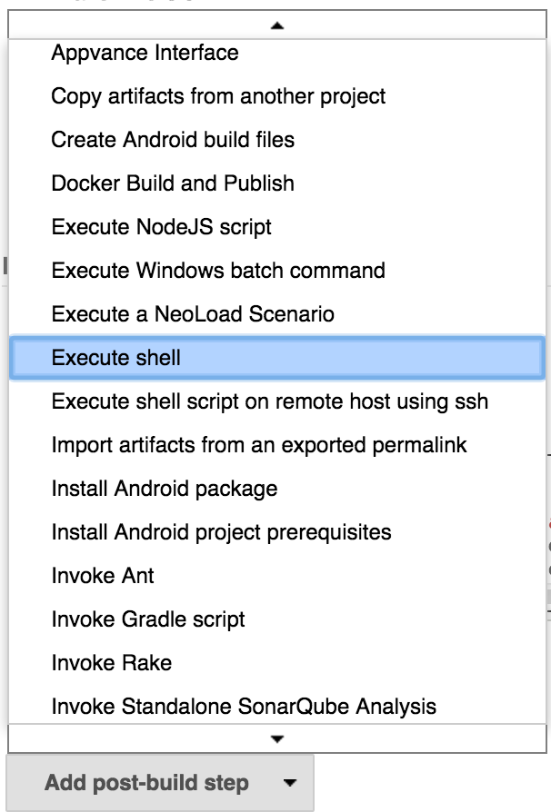

You can provide the shell commands to login, docker build and docker push to ECH in the Execute Shell section.

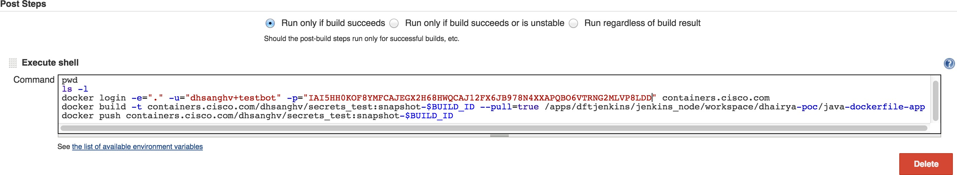

Save the configs and click on **Build Now**. Jenkins will build the .war and then initiate the steps in the Dockerfile to build an image. The final docker push command will push the built image on to the ECH repo created in Step 2. ECH lets you view and resolve the security vulnerabilities in your image once it is pushed to your repo. It is advised to remove the High and Medium vulnerabilities before starting Step 4 of deploying to the CAE platform.

#### Step 4: Submit Kubernetes Secret to Openshift Cluster

Create an Openshift namespace (project) via ACC.

Now go back to ECH >> Account Settings >> Robot Accounts >> [your robot account name] >> Kubernetes Secrets

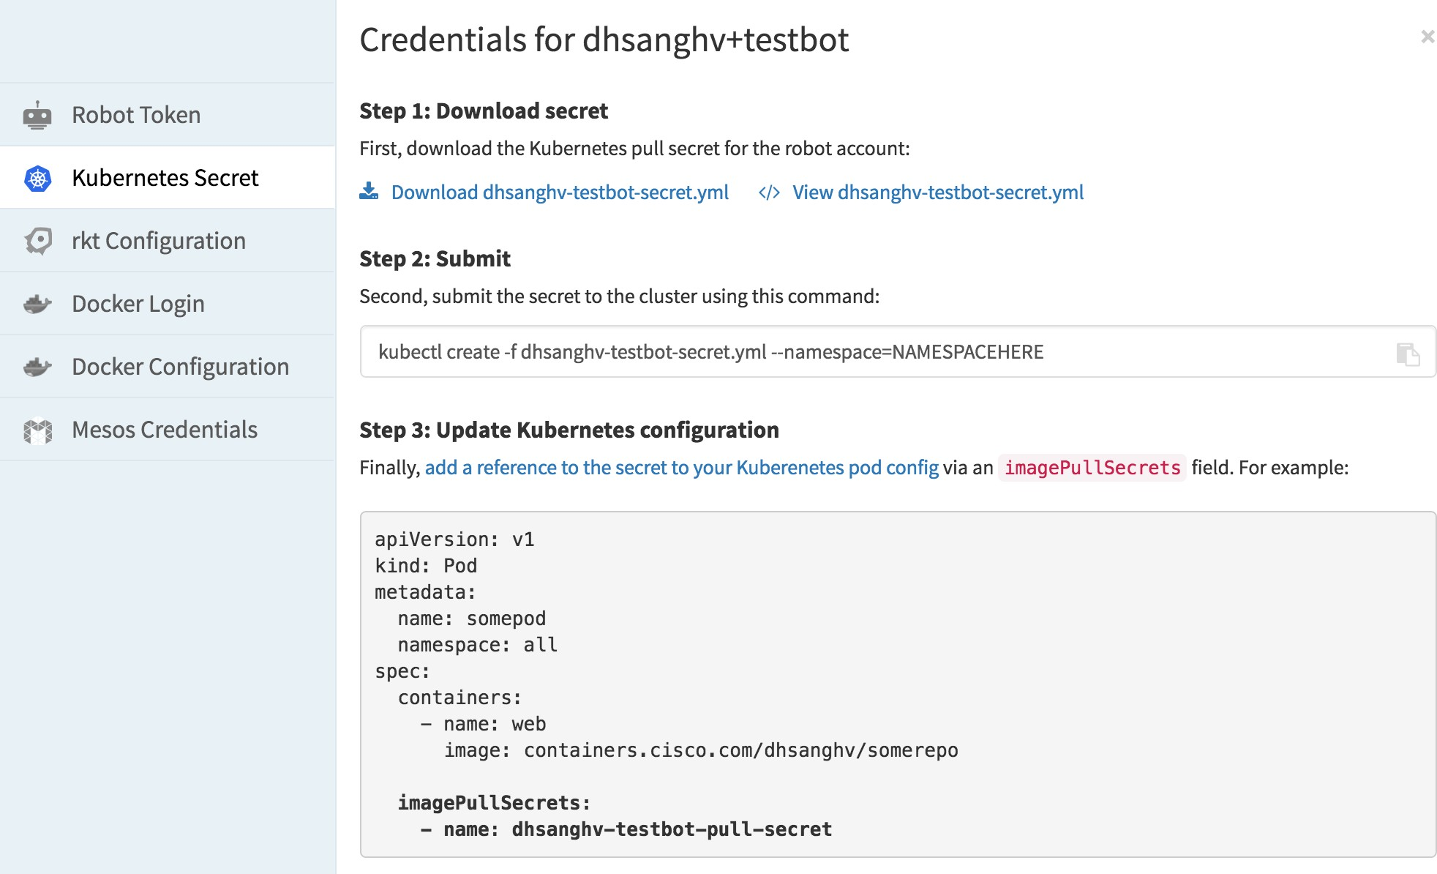

Download the YAML file described here and execute the following command from your command line by replacing the relevant values -

oc create -f dhsanghv-testbot-secret.yml --namespace=java-secrets

This will submit the secret to the Openshift cluster.

Secret API objects reside in a namespace. They can only be referenced by pods in that same namespace.

Now, it's time to create an application on CAE!

#### Step 5: Deploy Image to CAE

Before we create the app in our existing CAE namespace (in my case, *java-secrets*), let's define a Deployment Config and a Kubernetes Service. Download the JSON files [secrets-dc.json](https://gitscm.cisco.com/users/dhsanghv/repos/secrets_repo/browse/secrets-dc.json) and [secrets-svc.json](https://gitscm.cisco.com/users/dhsanghv/repos/secrets_repo/browse/secrets-svc.json) in [this repo](https://gitscm.cisco.com/users/dhsanghv/repos/secrets_repo/) on gitscm.cisco.com. These files are the basic minimum configs for creating a Deployment and Service on Openshift. They contain references to the location of the base image, deployment method, ports to be exposed, etc.

Please note the reference to our previously submitted **image pull secret** in the deployment config file (secrets-dc.json) -

"imagePullSecrets":{

"name": "dhsanghv-testbot-pull-secret"}

Now switch to your oc client and run the following commands for creating your app (named "secrets" in my case).

oc create -f <path-to-file>/secrets-dc.json oc create -f <path-to-file>/secrets-svc.json

Your Openshift Console UI will now reflect a Service and a Deployment Config created for your project. It's time to deploy the app now and check deployment logs -

oc deploy secrets --latest -n java-secrets

To test the application, you can expose your service by creating a route -

oc expose service/secrets

Summary of Step 5 -

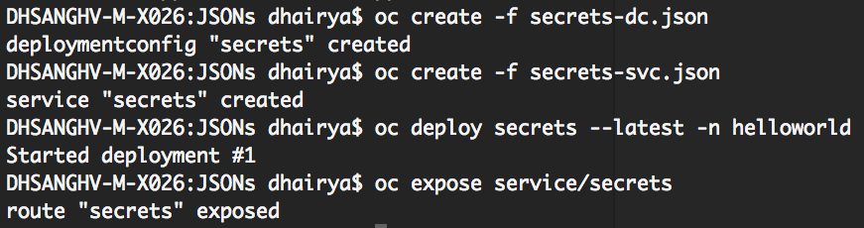

Congratulations! You have successfully deployed your application on CAE. If everything works fine, your running app should look like this - [http://s](http://secrets-java-secrets.laeapps-idev-alln-int.cisco.com/javaee7-simple-sample/) [ecrets-java-secrets.laeapps-idev-alln-int.cisco.com/javaee7-simple-sample/](http://secrets-java-secrets.laeapps-idev-alln-int.cisco.com/javaee7-simple-sample/)

# Deploy using json/yaml file

Openshift runs containers inside Kubenetes pods, and to create a pod from a container image, OSE needs a pod resource definition. Within your pod definition, which is a yaml file, you will need to specify your image name. Your image has to be a containers.cisco.com image. Here's an example of a very simple and basic pod definition that is running a nginx image:

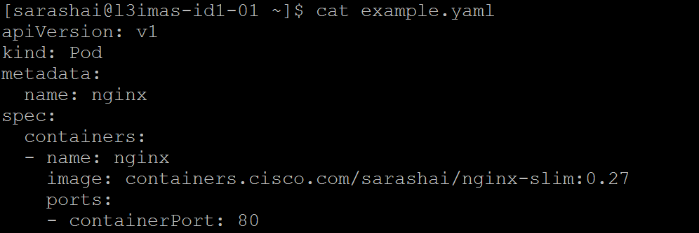

This pod resource definition has attribute **"kind"** with value **"Pod"**. It contains a single **"container"** whose name is **"nginx"** and that references the **"image"** which is a container image named **"containers.cisco.com/<your\_image\_path>"**. The container also contains a single **"ports"**, which listens to TCP port **80**.

#### Deploying Your Pod

Step 1**:** Login to the cluster.



Step 2: Select the project.



Step 3: Spin up using oc create command. You can see here the nginx pod got created.

oc create -f <your\_yaml\_file>

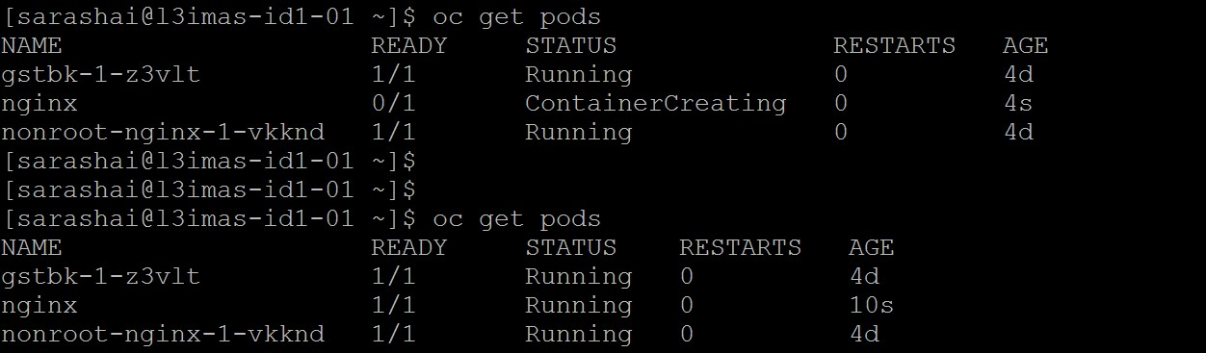

# Redeploy Pod's

Note:

1. Deployment Config has to be configure with rolling restart strategy
2. Configure health check with readiness and liveness probes This will help to avoid down time during scale up/down of pods

1. Redeploy pods with existing image (restart pods), This is just like restarting JVM!(application) Example

MKARADIG-M-C01K:~ mkaradig$ ./oc deploy dc/cae-ramp2 --latest=true Started deployment #13

Use 'oc logs -f dc/cae-ramp2' to track its progress.

1. Redeploy pods with new image (latest)

GUI

Example CLI

Image Streams

An *image stream* comprises any number of [Docker-formatted container images](https://docs.openshift.com/enterprise/3.2/architecture/core_concepts/containers_and_images.html#docker-images) identified by tags, Image streams can be used to automatically perform an action like build or deployment, when new images are created. Builds and deployments can watch an image stream to receive notifications when new images are added and automatically trigger build or deployment

Image Stream Object Definition Example

apiVersion: v1 kind: ImageStream metadata:

name: cae-ramp2 namespace: mnm-rtp

selfLink: /oapi/v1/namespaces/mnm-rtp/imagestreams/cae-ramp2 uid: eb5c9c85-406d-11e7-a25c-005056bc7b99

resourceVersion: '151265188'

generation: 644

creationTimestamp: '2017-05-24T10:44:10Z' labels:

app: cae-ramp2 annotations:

[openshift.io/image.dockerRepositoryCheck](http://openshift.io/image.dockerRepositoryCheck): '2017-05-28T14:30:15Z' spec:

tags:

- name: dev annotations: null from:

kind: DockerImage

name: 'containers.cisco.com/mkaradig/cae-ramp:dev' generation: 644

importPolicy: {}

- name: latest annotations: null from:

kind: DockerImage

name: 'containers.cisco.com/mkaradig/cae-ramp:dev' generation: 644

importPolicy: {} status:

dockerImageRepository: '172.25.152.150:5000/mnm-rtp/cae-ramp2'

tags:

- tag: latest items:

- created: '2017-05-28T14:30:15Z'

dockerImageReference: >-

containers.cisco.com/mkaradig/cae-ramp@sha256:6a61b6e0d9fa614e9e7ac8e37dc2390f20b10a55dfadc50cbd02cc3693358e59 image: >-

sha256:6a61b6e0d9fa614e9e7ac8e37dc2390f20b10a55dfadc50cbd02cc3693358e59 generation: 644

Create Image streams.

Example

oc import-image IMAGESTREAM[:TAG] [options]

MKARADIG-M-C01K:~ mkaradig$ ./oc import-image --from=containers.cisco.com/mkaradig/cae-ramp:dev mystream:dev --confirm

The import completed successfully.

Name: mystream

Namespace: mnm-rtp Created: 1 seconds ago Labels: <none>

Annotations: openshift.io/image.dockerRepositoryCheck=2017-05-29T07:50:37Z Docker Pull Spec: 172.25.152.150:5000/mnm-rtp/mystream

Unique Images: 1

Tags: 1

dev

tagged from containers.cisco.com/mkaradig/cae-ramp:dev

* containers.cisco.com/mkaradig/cae-ramp@sha256:7d24a9c7e5fc71d6993e429cfe0ae27cf57fb0b49cf842c61e5fc69977db0f2c 1 seconds ago

Verify Image streams

MKARADIG-M-C01K:~ mkaradig$ ./oc get is/mystream

NAME DOCKER REPO TAGS UPDATED

mystream 172.25.152.150:5000/mnm-rtp/mystream dev 2 minutes ago

Configure deployment config (new-app) using Image Streams Note :?

MKARADIG-M-C01K:~ mkaradig$ ./oc new-build --image-stream=mystream:dev --name=myapp -n mnm-rtp

error: you must specify at least one source repository URL, provide a Dockerfile, or indicate you wish to use binary builds

MKARADIG-M-C01K:~ mkaradig$ ./oc new-app --image-stream=mystream:dev --name=myapp -n mnm-rtp

--> Found image fa00fbe (About an hour old) in image stream mystream under tag "dev" for "mystream:dev"

* This image will be deployed in deployment config "myapp"
* Port 8080/tcp will be load balanced by service "myapp"

\* Other containers can access this service through the hostname "myapp"

* WARNING: Image "mnm-rtp/mystream:dev" runs as the 'root' user which may not be permitted by your cluster administrator

--> Creating resources with label app=myapp ... deploymentconfig "myapp" created

service "myapp" created

--> Success

Run 'oc status' to view your app.

Just note newapp “myapp" got created by ImageStream (IS) “mystream” along with Deployment Config(DC) “myapp”

Configure Deployment Config (DC) “myapp” with auto deployment when image change in ImageStream i.e.: enable image change trigger auto MKARADIG-M-C01K:~ mkaradig$ ./oc get dc/myapp

NAME REVISION DESIRED CURRENT TRIGGERED BY

myapp 1 1 1 config,image(mystream:dev)

MKARADIG-M-C01K:~ mkaradig$ ./oc describe dc/myapp Name: myapp

Namespace: mnm-rtp Created: 7 minutes ago Labels: app=myapp

Annotations: [openshift.io/generated-by=OpenShiftNewApp](http://openshift.io/generated-by%3DOpenShiftNewApp) Latest Version: 1

Selector: app=myapp,deploymentconfig=myapp Replicas: 1

Triggers: Config, Image(mystream@dev, auto=true) Strategy: Rolling

Template:

Labels: app=myapp deploymentconfig=myapp

Annotations: openshift.io/container.myapp.image.entrypoint=["/bin/bash","httpd-foreground"]

[openshift.io/generated-by=OpenShiftNewApp](http://openshift.io/generated-by%3DOpenShiftNewApp) Containers:

myapp:

Image: containers.cisco.com/mkaradig/cae-ramp@sha256:7d24a9c7e5fc71d6993e429cfe0ae27cf57fb0b49cf842c61e5fc69977db0f2c Port: 8080/TCP

Volume Mounts: <none> Environment Variables: <none> No volumes.

Deployment #1 (latest):

Name: myapp-1 Created: 7 minutes ago Status: Complete

Replicas: 1 current / 1 desired

Selector: app=myapp,deployment=myapp-1,deploymentconfig=myapp Labels: app=myapp,[openshift.io/deployment-config.name=myapp](http://openshift.io/deployment-config.name%3Dmyapp) Pods Status: 1 Running / 0 Waiting / 0 Succeeded / 0 Failed

Events:

FirstSeen LastSeen Count From SubobjectPath Type Reason Message

--------- -------- ----- ---- ------------- -------- ------ -------

7m 7m 1 {deploymentconfig-controller } Normal DeploymentCreated Created new replication controller "myapp-1" for version 1

MKARADIG-M-C01K:~ mkaradig$ ./oc describe dc/myapp|grep Triggers

Triggers: Config, Image(mystream@dev, auto=true)

Just note triggers Image has been set to auto=true;, If not please set it true!(enable auto deployment whenever image changes)

orals set to auto

MKARADIG-M-C01K:~ mkaradig$ ./oc set triggers dc/myapp --auto=true

deploymentconfig "myapp” updated

MKARADIG-M-C01K:~ mkaradig$ ./oc describe dc/myapp|grep Triggers

Triggers: Config, Image(mystream@dev, auto=true)

Test Auto Deployment!

Auto deployment by ImageStream configuration is depend upon the “importPolicy” attribute in ImageStream Config

We can set a tag to query external registries at a scheduled interval to synchronize tag and image metadata by setting the --scheduled=true fl ag with the oc tag command

OR

—alias=true by oc tag command OR

We can set **importPolicy.scheduled** to **true** in the tag’s definition of IS(ImageStream)

Example

apiVersion: v1 kind: ImageStream metadata:

name: ruby spec:

tags:

- from:

kind: DockerImage

name: openshift/ruby-20-centos7 name: latest

importPolicy: scheduled: true

Let us test by oc command

1. Find out last deployment

MKARADIG-M-C01K:~ mkaradig$ ./oc get is/mystream

NAME DOCKER REPO TAGS UPDATED

mystream 172.25.152.150:5000/mnm-rtp/mystream dev 2 hours ago

1. Find out last deployed image ID

MKARADIG-M-C01K:~ mkaradig$ ./oc describe is/mystream|grep sha

* containers.cisco.com/mkaradig/cae-ramp@sha256:7d24a9c7e5fc71d6993e429cfe0ae27cf57fb0b49cf842c61e5fc69977db0f2c

1. Push new image to containers.cisco.com

1. Run “oc” tag command to deploy new image

MKARADIG-M-C01K:~ mkaradig$ ./oc tag --alias=true containers.cisco.com/mkaradig/cae-ramp:dev mnm-rtp/mystream:dev Tag mystream:dev set up to track containers.cisco.com/mkaradig/cae-ramp:dev.

1. Validate again deployment time stamp, image ID & App URL! MKARADIG-M-C01K:~ mkaradig$ ./oc get is/mystream

NAME DOCKER REPO TAGS UPDATED

mystream 172.25.152.150:5000/mnm-rtp/mystream dev 2 minutes ago

MKARADIG-M-C01K:~ mkaradig$ ./oc describe is/mystream|grep sha

* containers.cisco.com/mkaradig/cae-ramp@sha256:36136ff2ac1511444b1d61854a191cd7dfed752db24ceb8709249b3bf9f33246 containers.cisco.com/mkaradig/cae-ramp@sha256:7d24a9c7e5fc71d6993e429cfe0ae27cf57fb0b49cf842c61e5fc69977db0f2c

There are other options to automate deployments by having webhook & u-deploy

# Update Deployment Image

To update deployment image for the running application.

#### CAE Open-shift Console

Login to ECH and in the respective repository Tag select Docker Pull (by digest) option of the required build.

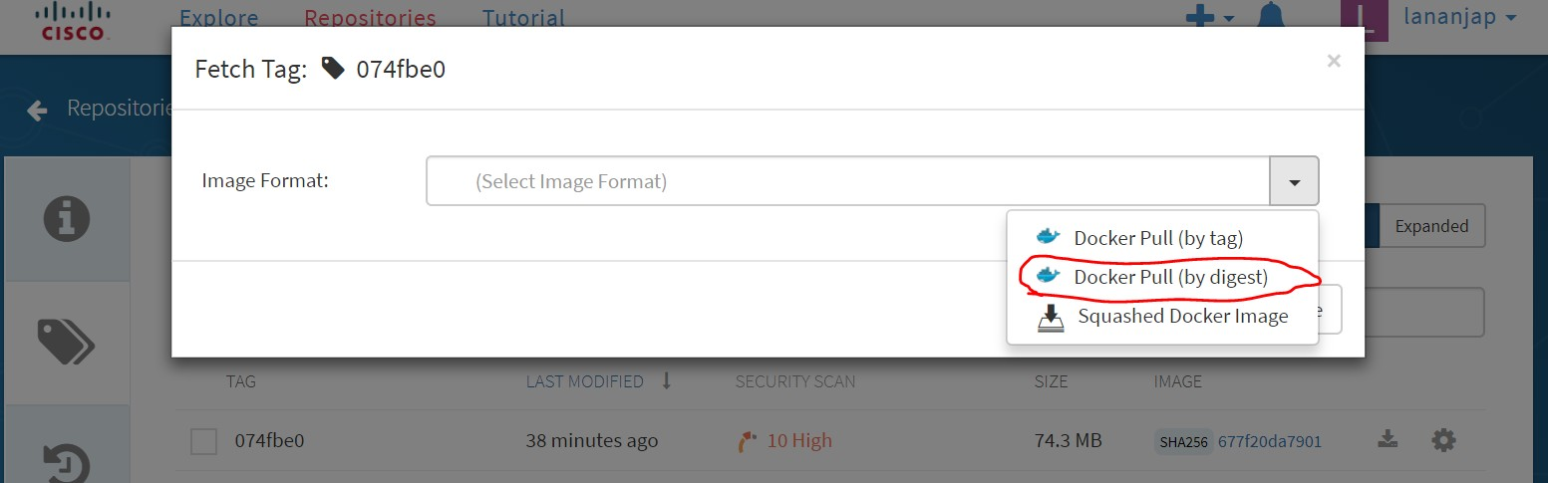

Copy SHA string from the Image format

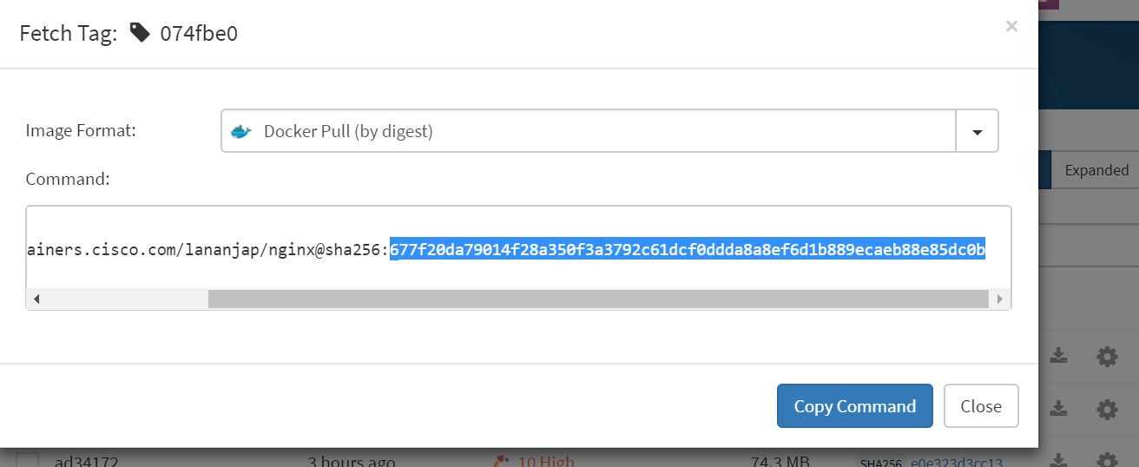

Login to CAE console and access your running deployment through the project. Select Edit YAML option as shown in the picture.

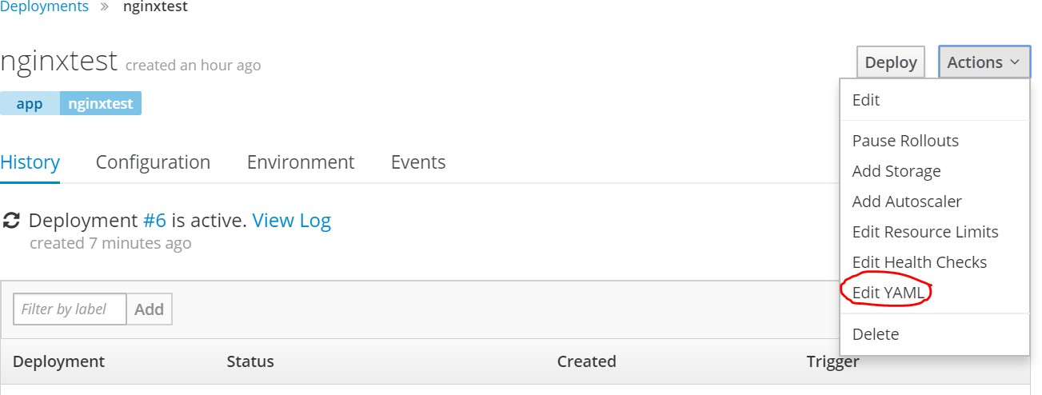

Search for the Container image information and replace the SHA string copied from ECH

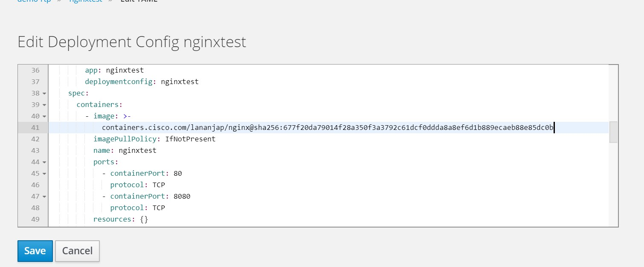

Saving this YAML file will trigger a new deployment utilizing the new image. No need to update any route. Prior configured HTTPS link should show your modified changes.

#### OC Command

Login to ECH with your encrypted password

*[misha@vm-lananjap-003 ~]$ docker login* [*containers.cisco.com*](http://containers.cisco.com/) *Username (*lananjap*):*

*Password:*

*Login Succeeded Login to OC console*

*[misha@vm-lananjap-003 ~]$* oc *login* [*cae-prd-rtp.cisco.com*](http://cae-rtp.cisco.com/) *Authentication required for https://cae-prd-rtp.cisco.com:443 (openshift) Username:* lananjap

*Password:*

*Login successful.*

Obtain Docker Repo info from oc get command (node in this example application name is nginxtest)

*[misha@vm-lananjap-003 ~]$* oc *get is/*nginxtest *NAME DOCKER REPO TAGS UPDATED*

nginxtest *172.25.152.150:5000/demo-*rtp*/*nginxtest *70828ac 6 minutes ago*

Copy the ECH image tag information (refer to the Console example for ECH instead of selecting "Docker Pull (by digest)" select "Docker Pull (by tag)". Execute "oc tag" command to update the tag. Note info "demo-rtp/nginxtest:70828ac" obtained from oc get command and tag (ad34172) in container.cisco... is obtained from ECH.

*[misha@vm-lananjap-003 ~]$* oc *tag --alias=true containers.cisco.com/lananjap/nginx:ad34172 demo-*rtp*/*nginxtest*:70828ac Tag* nginxtest*:70828ac set up to track containers.cisco.com/lananjap/nginx:ad34172.*

This command triggers updating deployment with the image specified in tag. Cross verify your HTTPS link which should reflect your updated content.

# Configure Pod

Before you begin,You need to have a running Pod in atleast one of the CAE clusters. This page contains how can we configure pods regarding rebuilding , connecting to databases, connecting to layer 7 etc.

This configuration can be achieved *using oc cli or editing yaml or through openshift console.*

Below are the steps for each configuration with demo, not limited to: [Set resource limits](https://wiki.cisco.com/display/CAEUSER/Quotas%2C%2BLimit%2BRanges%2C%2BRequests%2Band%2BScopes)

[Scale up/down](https://wiki.cisco.com/pages/viewpage.action?pageId=85091674)

[Redeploy Pod | Build trigger | Image stream](https://wiki.cisco.com/display/CAEUSER/Redeploy%2BPod%27s)

[Health Probes - Container (pods) Health Checks Using Probes | Liveliness probes | Readiness probes](https://wiki.cisco.com/display/CAEUSER/Health%2BProbes%2B-%2BContainer%2B%28pods%29%2BHealth%2BChecks%2BUsing%2BProbes) [Blue/Green & A/B Stack](https://wiki.cisco.com/pages/viewpage.action?pageId=86155337)

[Connect to mysql pod](https://wiki.cisco.com/display/CAEUSER/Connect%2Bto%2Bmysql%2Bpod) Create secrets

[Connect to Enterprise Oracle DB](https://wiki.cisco.com/display/CAEUSER/Connect%2Bto%2BEnterprise%2BOracle%2BDatabase) [Connect to ldap](https://wiki.cisco.com/display/CAEUSER/LDAP%2BConnection)

Connect to wsg [Create configMap](https://wiki.cisco.com/display/CAEUSER/Create%2BConfigMaps)

# Create a Route

### Overview:

While services allow for network access between pods inside an OSE instance, routes allow for network access to pods from users and applications outside the OSE instance. A route connects a public-facing IP address and DNS host names to a internal-facing service IP. The router service is by default based on open-source software HAProxy.

### Creating Route using json/yaml syntax:

Step 1: Login to cluster, select projects and select Service name whose Route you want to create.

oc get svc



Step 2: Create a json/yaml file : "*helloworld-route.yaml"*

kind: "Route" apiVersion: "v1" metadata:

name: "helloworld" labels:

component: "helloworld"

spec:

host: "helloworld-rcdn[.cisco.com](http://tigrcdngrafana.cisco.com/)" to:

kind: "Service" name: "helloworld"

port:

targetPort: "8080-tcp"

tls:

insecureEdgeTerminationPolicy: Allow termination: edge

Step 3: Create using oc command.

oc create -f <route yaml file>



Step 4: Hit the url on browser and verify.

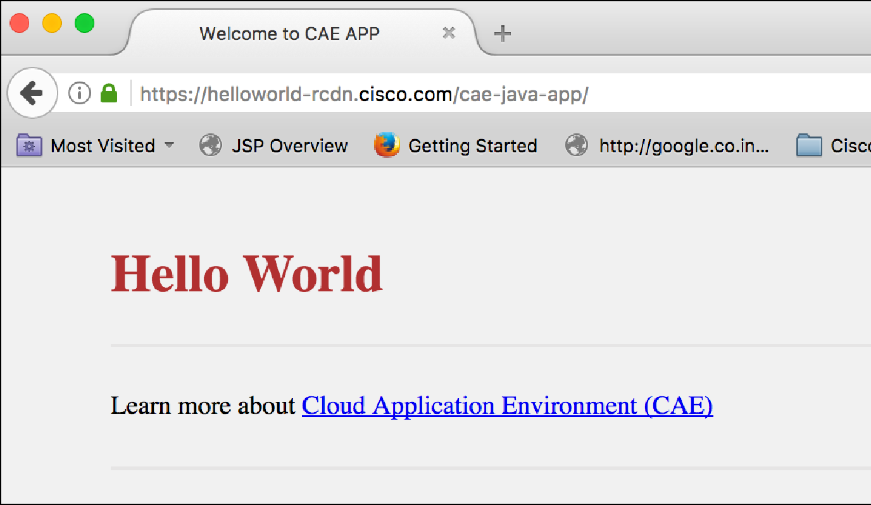

### Create Route from console:

Step 1: Login to the cluster, select projects and select Pod whose Route you want to create.

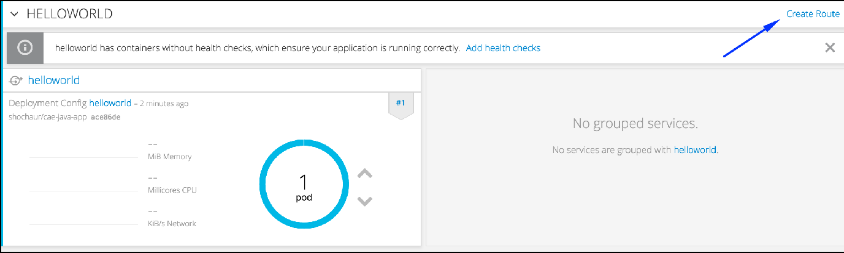

Step 2: Fill the Name, Hostname, Service and Target Port field.

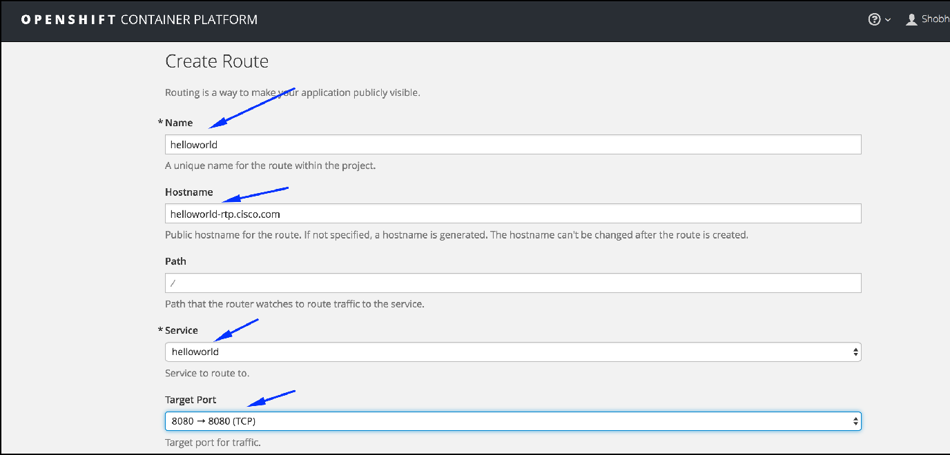

Step 3: Select the Edge Router.

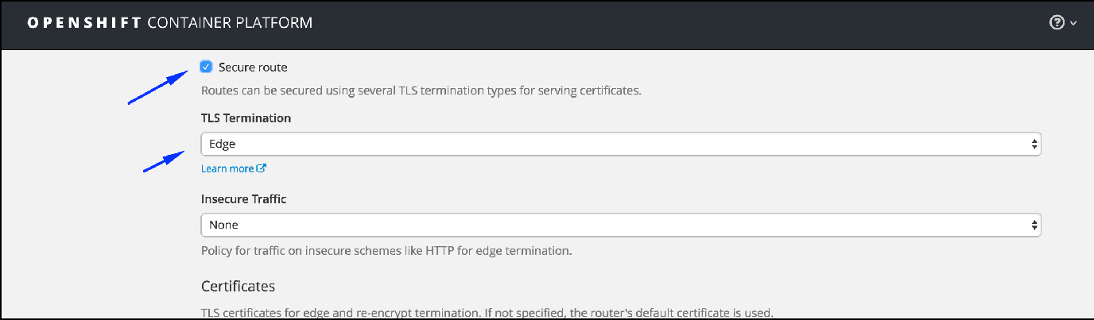

Once Route creates successfully , hit the URL in browser. In my case, it is <https://helloworld-rcdn.cisco.com/cae-java-app>



# Capture auth\_user/remote\_user from SSO/Ping

**Applications written in the following languages need to access the 'auth\_user' field from the request headers to get the id of the logged in user.**

**JAVA**

String user = request.getHeader('auth\_user');

**PYTHON**

import requests

user = request.headers('auth\_user')

**PHP**

$headers = get\_headers($url);

$user = $headers['auth\_user'];

**NodeJS**

var user = request.headers['auth\_user'];

**Apache**

AUTH\_USER

**Perl**

#!/usr/bin/perl -wT use strict;

use CGI qw(:standard);

use CGI::Carp qw(warningsToBrowser fatalsToBrowser);

print header;

print start\_html("Environment");

$auth\_user = $ENV{"auth\_user"}

Infra supplied images like Tomcat and JBoss are currently being tested and once done, application developers will be able to read the logged in user's name by accessing the 'remote\_user' environment variable. Till then, developers will have to parse the request headers to retrieve the necessary information as shown above.

# Connect to Enterprise Oracle Database

This is an example of python connecting to Enterprise Oracle Database. Step 1: Download oracle client and install it.

**SHELL**

oracle-instantclient11.2-basic-11.2.0.4.0-1.x86\_64.rpm

rpm -ivh oracle-instantclient11.2-basic-11.2.0.4.0-1.x86\_64.rpm

Step 2: Download cx\_Oracle module and install it.

**SHELL**

cx\_Oracle-6.0b2-py27-1.x86\_64.rpm

rpm -ivh cx\_Oracle-6.0b2-py27-1.x86\_64.rpm

Step 3: Define environment variables in Dockerfile

**SHELL**

ENV LD\_LIBRARY\_PATH=/usr/lib/oracle/11.2/client64/lib/ ENV ORACLE\_HOME=/usr/lib/oracle/11.2/client64/

ENV LD\_LIBRARY\_PATH=/usr/lib/oracle/11.2/client64/lib/

Step 4: Connect to DB strings.

**SHELL**

connection = cx\_Oracle.connect('<username>/<password>@<hostname>:<port>

/<sid>.cisco.com')

cursor = connection.cursor()

querystring = "select ename,sal from emp where sal=2" cursor.execute(querystring)

row = cursor.fetchone()

Step 5: Deploy the pod, create route and hit the URL.

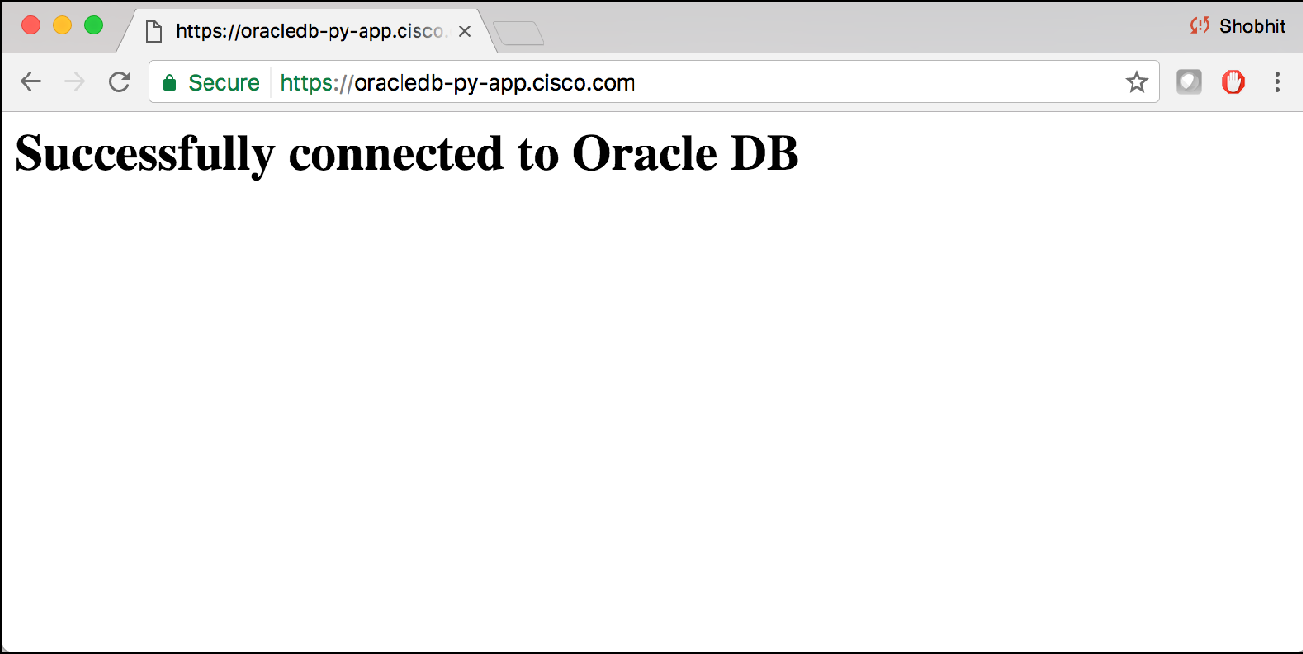

# Connect to MongoDB

1. Create a MongoDB Pod using yaml file.

Yaml file below is the one used to create MongoDB pod.

**pod.yaml**

apiVersion: v1 kind: Pod metadata:

name: mongodb-service namespace: cae-proj-ch4 labels:

name: mongodb-service

spec:

containers:

* name: mongodb-service

image: registry.access.redhat.com/openshift3

/mongodb-24-rhel7

ports:

env:

* containerPort: 27017 protocol: TCP
* name: MONGODB\_USER

value: user

* name: MONGODB\_PASSWORD

value: password

* name: MONGODB\_DATABASE

value: test

* name: MONGODB\_ADMIN\_PASSWORD

value: password

volumeMounts:

resources:

limits:

cpu: 500m memory: 256Mi

requests:

cpu: 10m memory: 16Mi

* + mountPath: "/var/lib/mongodb" name: "pv"

volumes:

* + name: "pv" persistentVolumeClaim:

claimName: "mongo-claim"

**Note**

**Make sure that you increase the cpu and memory limits from default to above mentioned parameters.**

1. Create a service for MongoDB pod

**service.yaml**

{

"kind":"Service",

"apiVersion":"v1", "metadata":{

"name":"mongodb"

},

"spec":{

"ports":[

{

"port":27017, "targetPort":27017

}

],

"selector":{

"name":"mongopod"

}

}

}

1. **Create app that connects to above mysqldb and expose the route**

Here is a [sample python flask app](https://gitscm.cisco.com/users/rvishwna/repos/cae-python-flask-mongodb/browse) which makes use of this monogdb service.

This is the conncection string example.

**Connection URL**

**client = MongoClient('mongodb://user:password@'+os.environ['MONGODB\_SERVICE\_HOST']+':27017/test')**

# Connect to mysql pod

**Step 1:** Create a mysql db pod on CAE using json file

Below is the json file used to create mysql pod. In the below example database "quotes" is created with user "ose" and password "openshift" :

**mysql-pod.json**

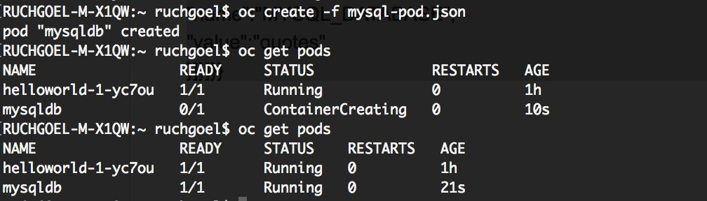

{

"apiVersion":"v1",

"kind":"Pod", "metadata":{

"name":"mysqldb", "labels":{

"name":"mysqldb"

}

},

"spec":{ "containers":[

{

"name":"mysqldb", "image":"openshift3/mysql-55-rhel7", "ports":[

{

"containerPort":3306

}

],

"env":[

{

"name":"MYSQL\_USER",

"value":"ose"

},

{

"name":"MYSQL\_PASSWORD",

"value":"openshift"

},

{

"name":"MYSQL\_DATABASE",

"value":"quotes"

}]}]}}

Let's add some tables in the database.

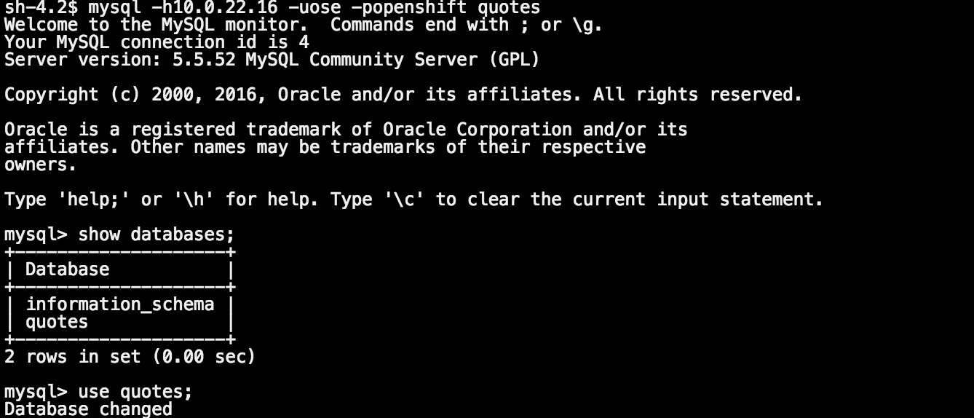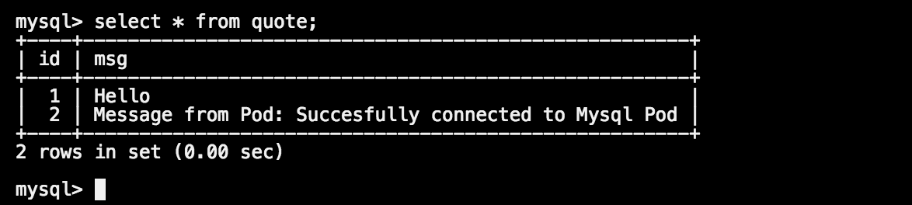

**Step 2:** Create service for the mysql db

**mysql-svc.json**

{

"kind":"Service",

"apiVersion":"v1", "metadata":{

"name":"quotedb"

},

"spec":{

"ports":[

{

"port":3306, "targetPort":3306

}

],

"selector":{

"name":"mysqldb"

}

}

}

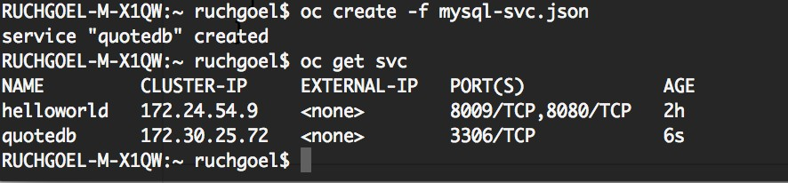

* 1. Create app that connects to above mysqldb and expose the route

The following is an example python code that connects to the quotedb service created for the mysqldb pod :

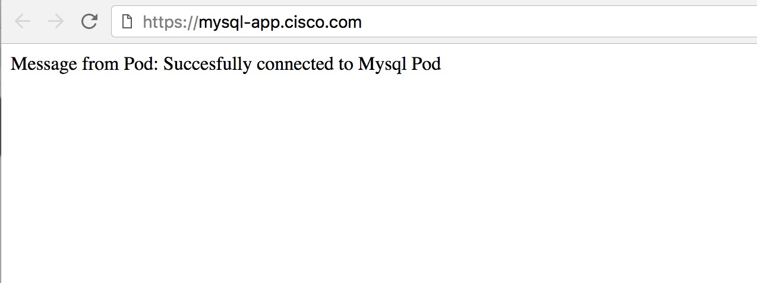

db\_connection = MySQLdb.connect(host=os.environ['QUOTEDB\_SERVICE\_HOST'], user='ose', passwd='openshift')

cursor = db\_connection.cursor() cursor.execute('USE quotes')

cursor.execute("SELECT msg FROM quote WHERE id = 2")

**Note**

**QUOTEDB\_SERVICE\_HOST is <Service\_name>\_SERVICE\_HOST**

# Create ConfigMaps

ConfigMaps are used to keep configuration artifacts should be decoupled from image content in order to keep containerised applications portable. Below oc command to create configmap.

oc create configmap <confogmap\_name> [options]

### Different ways to create ConfigMaps:

**Option 1)** Create from Directories:

In this example, I have directory names *"database"* having 2 files in it.

* + 1. . *mysql.properties* having mysql database related config.

2). *user.properties* having user credentials.

To create configmap using all files under *database* directory :

oc create configmap mysql-config --from-file=database/



Verify above config:

oc describe configmap mysql-config

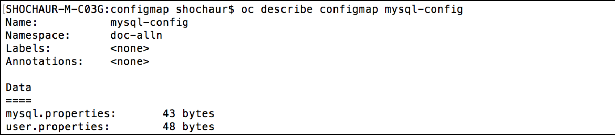

oc get configmap mysql-config -o yaml

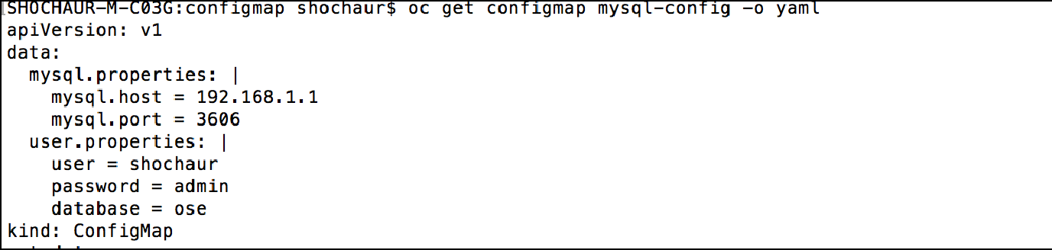

**Option 2)** Creating from Files:

Same above mysql example and here we will create configmap directly from files:

oc create configmap mysql-config-2 --from-file=database/mysql.properties --from-file=database/user. properties



Verify:

oc get configmap mysql-config-2 -o yaml

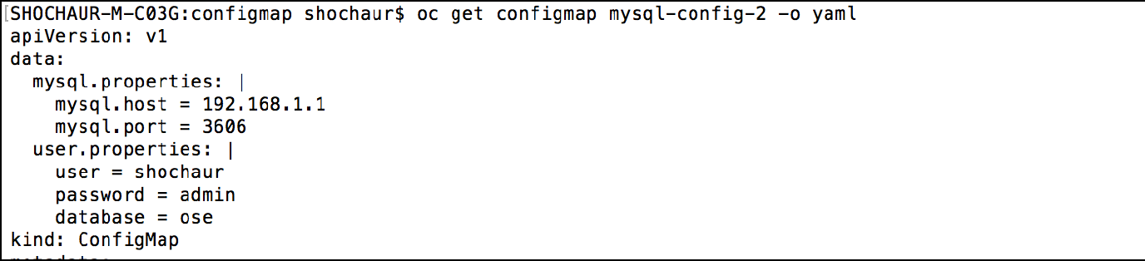

**Option 3)** Creating from Literal Values:

oc create configmap mysql-config-3 --from-literal=mysql.host=192.168.1.1 --from-literal=mysql. port=3606



Verify:

oc get configmap mysql-config-3 -o yaml

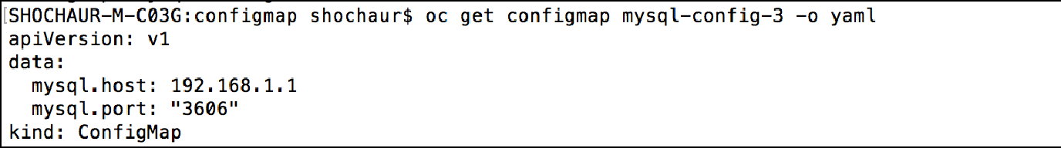

### Use ConfigMap in Pods:

ConfigMaps can be used as environment variables in Pod definition, as example:

Step 1) Create a configmap:

oc create configmap special-config --from-literal=special.how=very --from-literal=special.type=charm



Step 2) Verify the same:

oc get configmaps special-config -o json

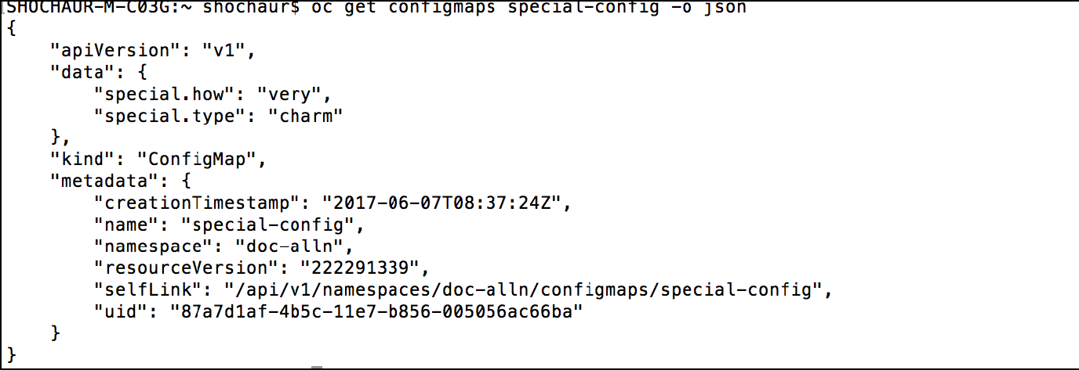

Step 3) Define Pod definition and use configmap properties as environment variables:

**pod.yaml**

apiVersion: v1 kind: Pod metadata:

name: configmappod spec:

containers:

- name: configmappod

image: containers.cisco.com/shochaur/busybox command: [ "/bin/sh", "-c", "env | grep SPECIAL" ] env:

- name: SPECIAL\_LEVEL\_KEY

valueFrom: configMapKeyRef:

name: special-config key: special.how

- name: SPECIAL\_TYPE\_KEY

valueFrom: configMapKeyRef:

name: special-config key: special.type

restartPolicy: Never

Step 4) Create Pod using this definiton:

**SHELL**

oc create -f examplecon.yaml

Step 5) Login to Pod and in logs we can see these 2 configmap properties are consumed as environment variable:

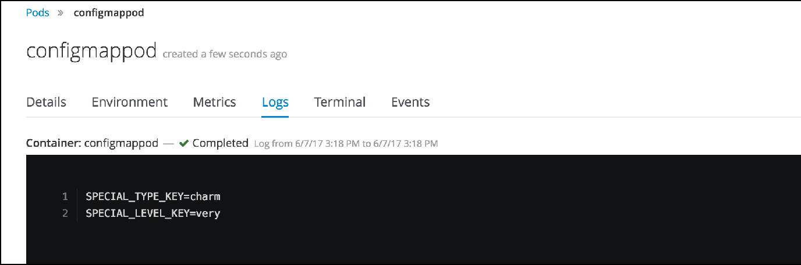

# Create GSLB

Once you deploy application in multiple clusters, you can goto ACC and create GSLB to load balance traffic among clusters. Step 1: Login to citeis.cisco.com and Select **Global SLB** under Global Resource Tab

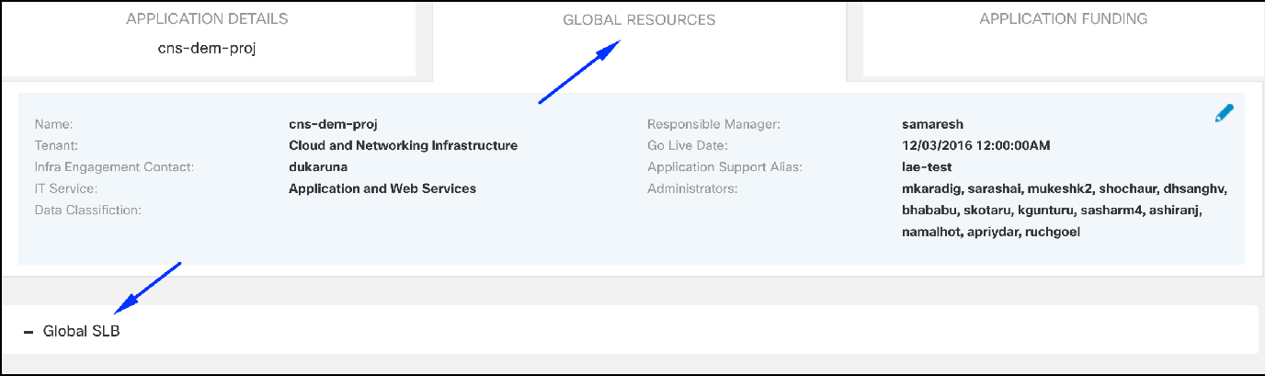

Step 2: Fill required fields like unique DNS name, Algorithm etc.

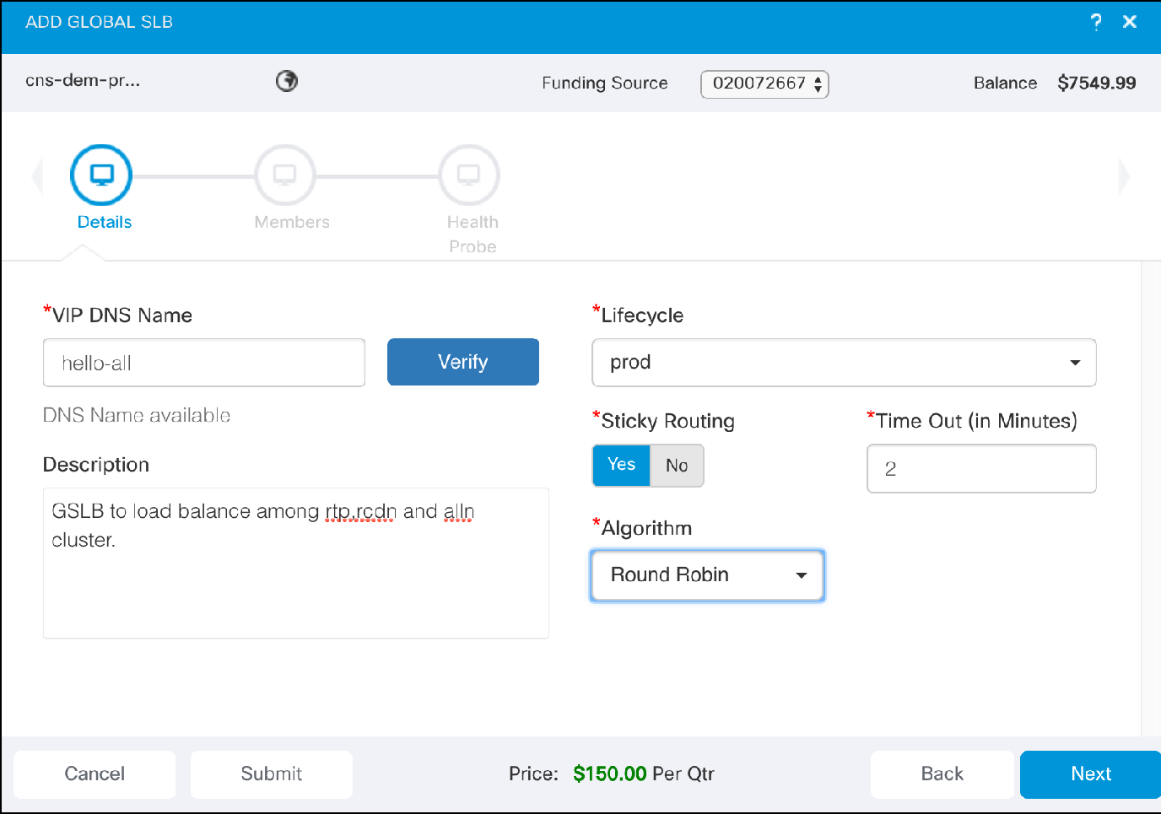

Step 3: Add the required URLs for load balance.

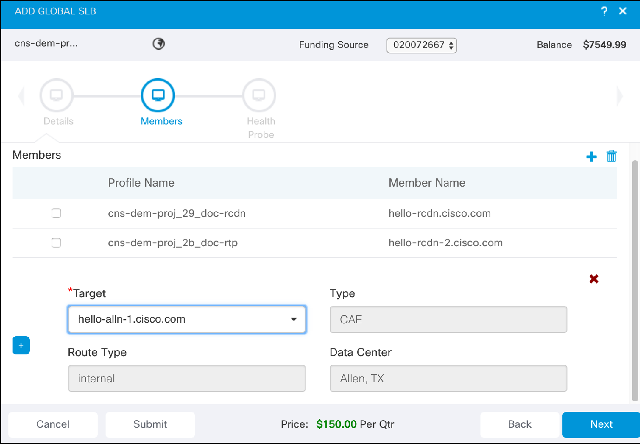

Step 4: Select Health probe URL

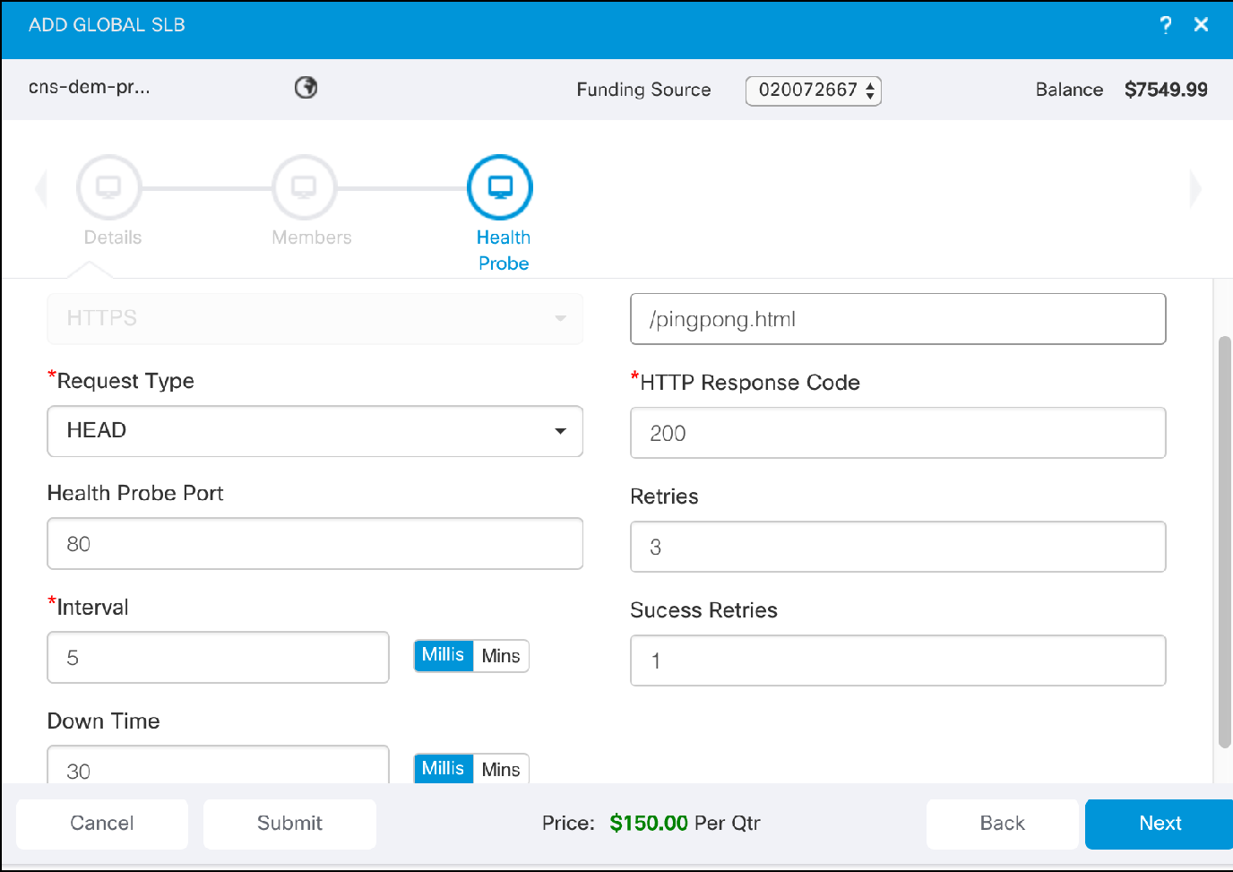

As per above example, Screenshot of hello-world page, hit by GSLB URL and get served by one of the cluster.

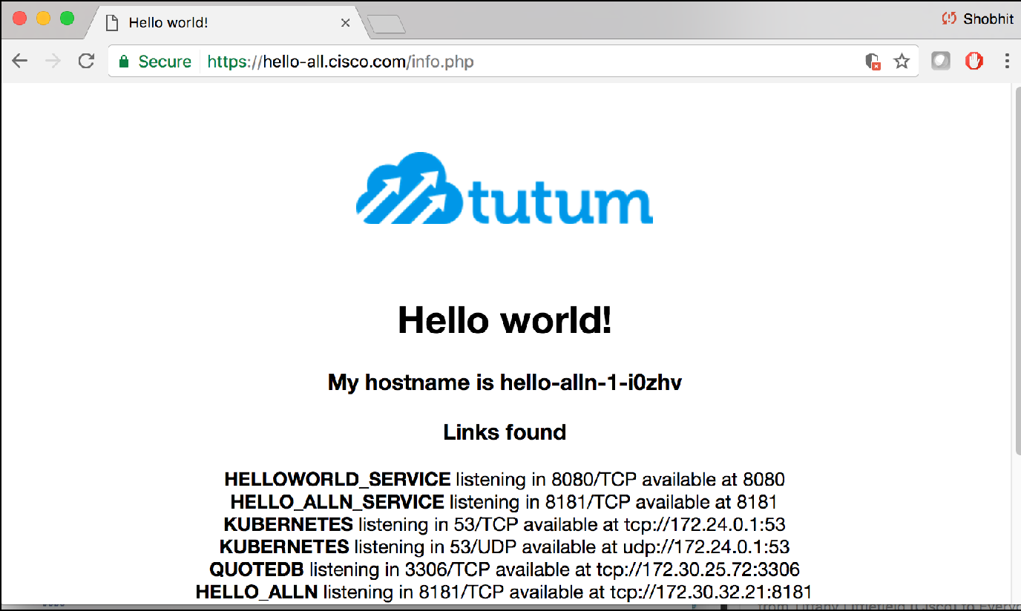

# Fix Vulnerabilities in Images

When you push an image to ECH, the ECH runs a vulnaribilty scan on the builds and reports the bugs/issues and possible fixes for them. To maintain the integrity and security standards of the components, it is mandatory to fix the known sevs and bugs.

For this exercise we will take an image that i had deployed to ECH and has some known bugs/sevs and issues. I have a basecentos image that was deployed to ECH. I can view the details of the images for the latest tag:

1. 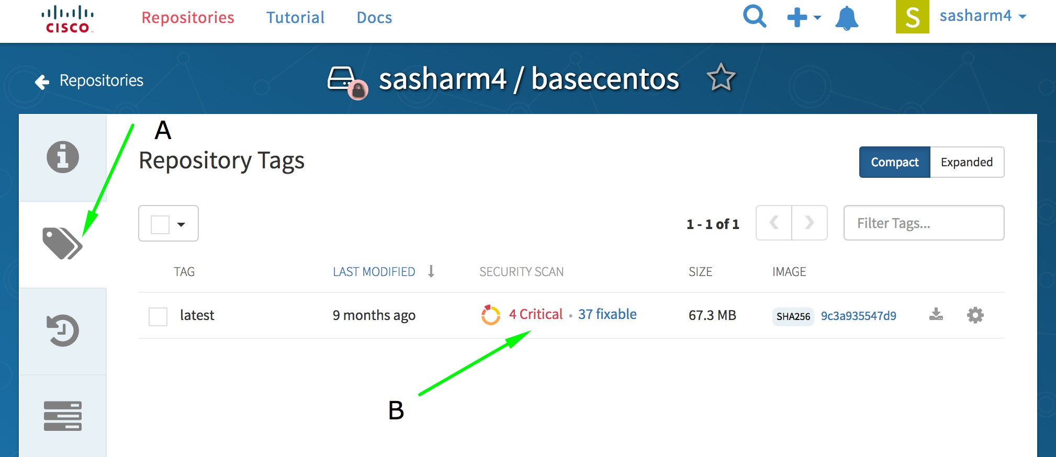Navigate to ECH Home -- <repository>

A: Navigate to the "Repository Tags"

B: We can see that the current, latest tag of the image has 4 critical and 37 fixable sevs reported. Click on the reported issues (as marked by B above) and it will take you to the detailed page:

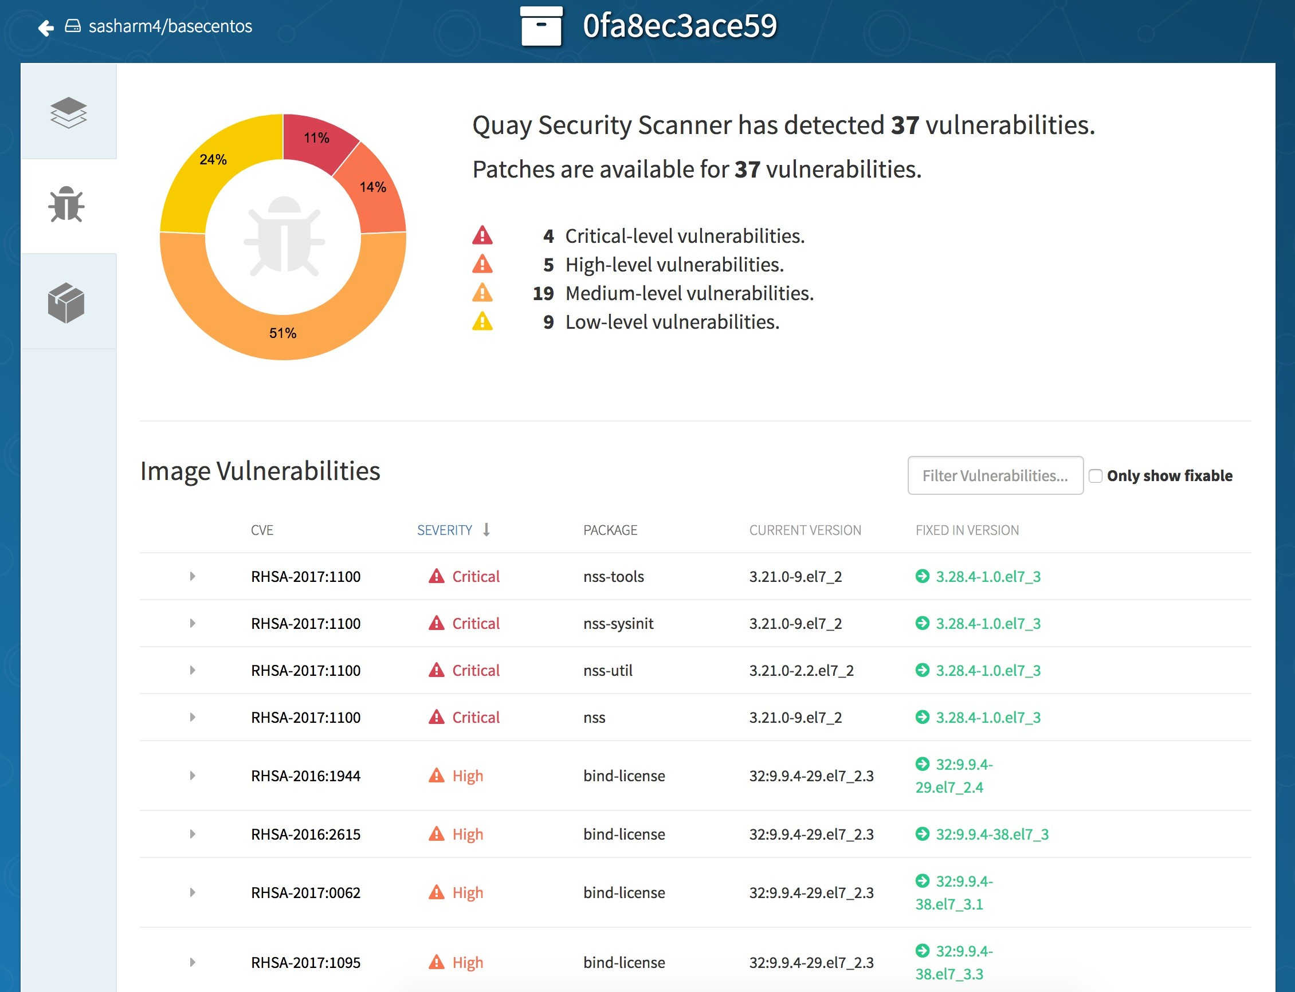

1. We can see from the detailed page that the fixes are available as updated packages from the baseOS.
2. There are many ways to rebuild the image with fixes. This particular image is a base centos Image that will be used to create other images.

So, we can update the packages of the image to the latest version where the severities are fixed. Let's pull the image locally

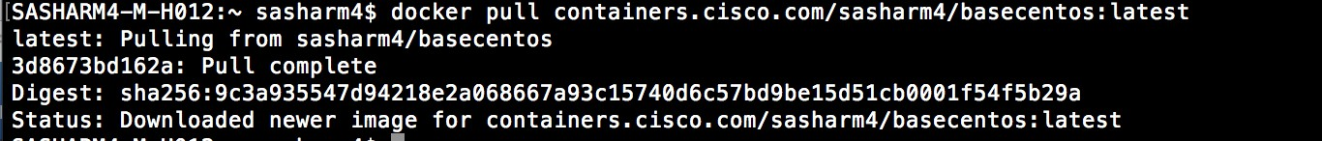

1. Based on the same docker image that has vulnerabilities, lets write a Dockerfile to update the packages:

**Dockerfile**

SASHARM4-M-H012:cae\_wiki\_docs sasharm4$ cat Dockerfile FROM containers.cisco.com/sasharm4/basecentos:latest

MAINTAINER sasharm4 for fixes on basecentos RUN yum -y --setopt=tsflags=nodocs update && \

yum clean all

1. Now, build the image with updated packages preserving the tag it had as:

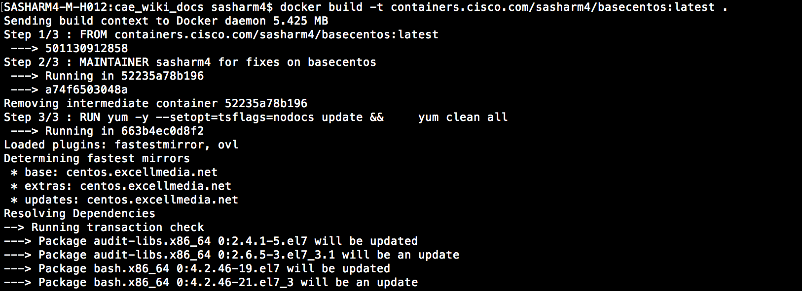

1. As seen above the image will be built with an update to the packages. You will see a success message.

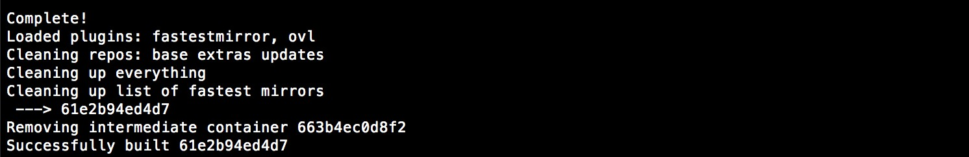

1. Now, we can push the same image to replace the affected tag of the image to ECH

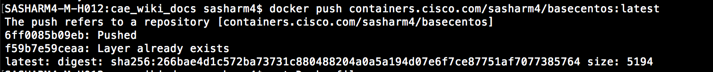

1. 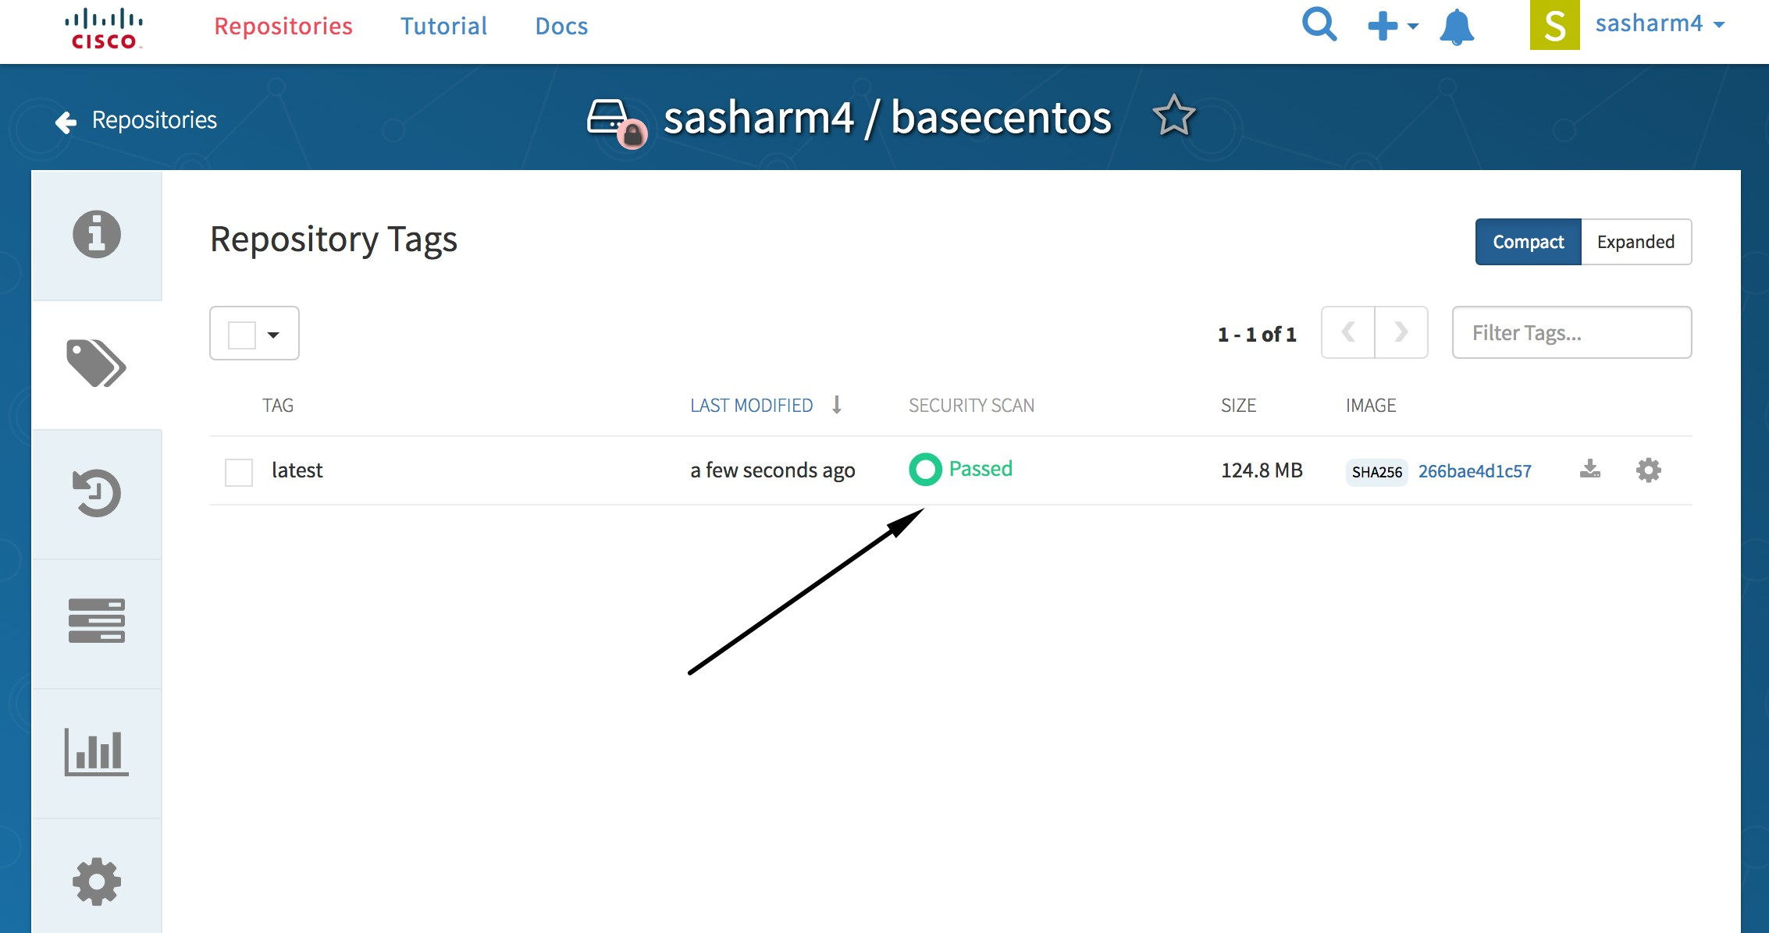Now, if you return to your ECH page where we have seen the vulnerabilities as in step 1, and 2, we can now see that:

If you notice the size of the image, it has increased due to new packages and updated packages. (Note to self: Need to work on size optimization during updates of the packages for lower image size.)

# Health Probes - Container (pods) Health Checks Using Probes

A probe is a Kubernetes action that periodically performs diagnostics on a running container. There are two types of probes each serving a different purpose

Liveness Probe:

A liveness probe checks if the container(pod) in which it is configured is still running, if the liveness probes fails container(pod) will get killed automatically & restart depend upon restart policy set ( always, etc)

Readiness Probe:

A readiness probe determines if a container(pod) is ready to service requests!,If the readiness probe fails. container(pod) will not receive any request from proxy even though a container is running!

The exact timing of a probe is controlled by two attributes

**initialDelaySeconds:**How long to wait after the container starts to begin the probe

**timeoutSeconds:**How long to wait for the probe to finish (default: 1). If this time is exceeded, OpenShift Container Platform considers the probe to have failed.

Both probes can be configured in three ways:

HTTP Checks

The kubelet uses a web hook to determine the healthiness of the container. The check is deemed successful if the HTTP response code is between 200 and 399. The following is an example of a readiness check using the HTTP checks method:

Example 1. Readiness HTTP check

...

readinessProbe: httpGet:

path: /healthz port: 8080

initialDelaySeconds: 15

timeoutSeconds: 1

...

A HTTP check is ideal for applications that return HTTP status codes when completely initialized.

Container Execution Checks

The kubelet executes a command inside the container. Exiting the check with status 0 is considered a success. The following is an example of a liveness check using the container execution method:

Example 2. Liveness Container Execution Check

...

livenessProbe: exec:

command:

* cat
* /tmp/health initialDelaySeconds: 15

timeoutSeconds: 1

...

TCP Socket Checks

**SHELL**

The kubelet attempts to open a socket to the container. The container is only considered healthy if the check can establish a connection. The following is an example of a liveness check using the TCP socket check method:

Example 3. Liveness TCP Socket Check

...

livenessProbe: tcpSocket:

port: 8080

initialDelaySeconds: 15

timeoutSeconds: 1

...

A TCP socket check is ideal for applications that do not start listening until initialization is complete. Example

Readiness Probe:

**SHELL**

oc set probe dc/myapp --readiness --get-url=http://localhost:8080/probe. txt --timeout-seconds=10 --initial-delay-seconds=15

deploymentconfig "myapp" updated

**Liveness Probe:**

oc set probe dc/myapp --liveness -- echo ok --timeout-seconds=10 --initial- delay-seconds=15

deploymentconfig "myapp" updated

**Verify:**

oc describe dc/myapp|grep Liveness

Liveness: exec [echo ok --timeout-seconds=10 --initial-delay-seconds=15] delay=0s timeout=1s period=10s #success=1 #failure=3

oc describe dc/myapp|grep Readiness

Readiness: http-get http://:8080/probe.txt delay=15s timeout=10s period=10s #success=1 #failure=3

**SHELL**

**How to remove:**

**SHELL**

oc set probe dc/myapp --remove --readiness —liveness

**Jobs**

**What is a Job?**

A *job* creates one or more pods and ensures that a specified number of them successfully terminate.When a specified number of successful completions is reached, the job itself is complete.

A job will track the progress of the assigned task and then will update with the status: active, succeeded, or failed.

Deleting a Job will cleanup the pods it created.

A few use cases for using a job:

Batch Process That need to run at regular intervals Distributed processing of very large data sets

Long running process for system maintenance

**Creating a Job**

A job configuration consists of the following key parts:

A pod template, which describes the application the pod will create.

An optional **parallelism** parameter, which specifies how many pod replicas running in parallel should execute a job. If not specified, this defaults to the value in the **completions** parameter.

An optional **completions** parameter, specifying how many concurrently running pods should execute a job. If not specified, this value defaults to one.

The following is an example of a **job** resource:

**job.yml**

apiVersion: batch/v1 kind: Job

metadata: name: pi

spec:

parallelism: 1

completions: 1 template:

metadata: name: pi

spec:

containers:

- name: pi

image: containers.cisco.com/sasharm4/perl

command: ["perl", "-Mbignum=bpi", "-wle", "print bpi(2000)"] restartPolicy: Never

A few key points here…

1. **parallelism**: Optional value for how many pod replicas a job should run in parallel; defaults to **completions**.
2. **completions**: Optional value for how many successful pod completions are needed to mark a job completed; defaults to one.
3. **template:** Template for the pod the controller creates.

We can use the above example (which just counts Pi to 2,000 digits) to see how to create a job. I have saved the example as job.yml and use o c create to create the job:

**How to create job**

#Make sure you are logged into one of the cae clouds, where your project exists.

#Make sure you are in correct project,verify it using oc project command #Using above job.yml to create job

(1)

#In this example, my project is in cae-rcdn cloud.

:>oc login cae-rcdn.cisco.com

Authentication required for https://cae-rcdn.cisco.com:443 (openshift) Username: mukeshk2

Password:

Login successful.

(2)

#I am using my doc-rcdn CAE project

:>oc project doc-rcdn

Now using project "doc-rcdn" on server "https://cae-rcdn.cisco.com:443".

(3)

#Using above job.yml to create job

:>oc create -f job.yml job "pi" created

#Once the pod is completed; you can see the status of the job

:>oc get jobs

NAME DESIRED SUCCESSFUL AGE

pi 1 1 27m

4m

Completed 0

#view completed pods of a job

:>oc get pods --show-all | grep pi

pi-xub56 0/1

**View complete jobs**

SuccessfulCreate Created pod: pi-xub56

mukeshk2@MUKESHK2-M-C08S:[~

Normal

-------

{job-controller }

1

-------------

----

-----

Message

Reason

--------

------

11s

Type

---------

--------

11s

SubobjectPath

From

Count

LastSeen

1 Running / 0 Succeeded / 0 Failed

Pods Statuses: No volumes.

Events:

FirstSeen

#Checking status/details of job created mukeshk2@MUKESHK2-M-C08S:[~]

:>oc describe jobs/pi Name: pi

Namespace: wordpress-dhairya

Image(s): containers.cisco.com/sasharm4/perl

Selector: controller-uid=e782ca02-3c5d-11e7-9f4c-005056acae57 Parallelism: 1

Completions: 1

Start Time: Fri, 19 May 2017 12:09:27 +0530

Labels: controller-uid=e782ca02-3c5d-11e7-9f4c-005056acae57 job-name=pi

**Check on the status of the job using this command:**

**Output of the job**

#View the logs to see the output of the job

:>oc logs pi-xub56 3.1415926535897932384626433832795028841971693993751058209749445923078164062

862089986280348253421170679821480865132823066470938446095505822317253594081

28481117

450284102701938521105559644622948954930381964428810975665933446128475648233

786783165271201909145648566923460348610454326648213393607260249141273724587

00660631

558817488152092096282925409171536436789259036001133053054882046652138414695

194151160943305727036575959195309218611738193261179310511854807446237996274

95673518

...

...

#deleting a job

:>oc delete jobs/pi job "pi" deleted

For additional information on jobs, visit: <https://docs.openshift.com/container-platform/3.4/dev_guide/jobs.html>

**How to delete a job**

<https://kubernetes.io/docs/concepts/workloads/pods/pod-lifecycle/#restart-policy>

# LDAP Connection

Here, we will connect to ldap using pythonand fetch user details like First Name, Last Name, Email and Title. Step 1: Your image must have python-ldap module installed. In rhel 7.2 :

**SHELL**

yum -y install python-ldap

Step 2: Connecting parameters, this code will look for user "shochaur" and retrieve first/last name, email id and title from AD.

**Connection Details**

l = ldap.initialize('ldap://ds.cisco.com:389') l.simple\_bind("<gen\_id>@cisco.com", "<password>") baseDN = "OU=Cisco Users,DC=cisco,DC=com" searchScope = ldap.SCOPE\_SUBTREE

loguser = "shochaur" searchFilter = "cn=" + loguser

result = l.search\_s(baseDN, searchScope, searchFilter, ['givenName','sn','title','mail'])

Step 3: Push the code to one of the cluster, create route and hit URL.

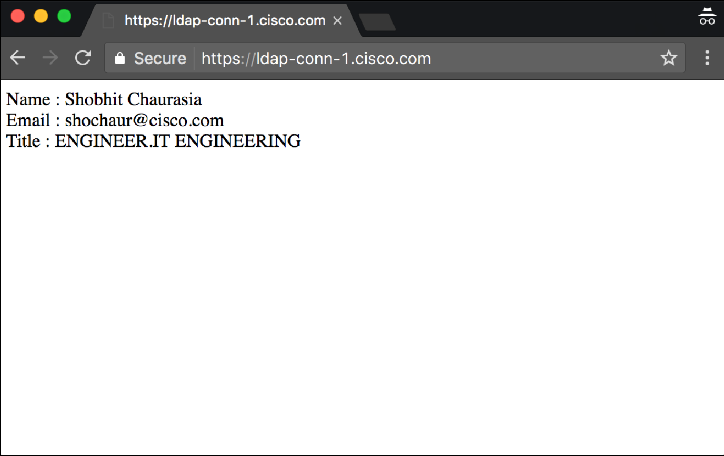

# Persistent Volume Claim(PVC)

### Overview

A **PersistentVolume** object is a storage resource in an OpenShift cluster. Storage is provisioned by an administrator by creating **Persistent Volume** objects from storage class.

Storage can be made available to you by laying claims to the resource.

You can make a request for storage resources using a **PersistentVolumeClaim** object; the claim is paired with a volume that generally matches your request.

### Requesting Storage

You can request storage by creating **PersistentVolumeClaim** objects in your projects. **Right now, we only support ReadWriteOnce as accessModes.** In the future, we will support other access modes.

Note: RWO doesn't supports rolling deployments. App teams need to stop the pod and redeploy or change the policy from Rolling to Recreate in deployment yaml.

Important Read:

* 1. Storage is Cinder, a Block-Storage.
  2. The storage system is Ceph-Standard
  3. Unlike NFS, the Block-Storage is Read-Write-Once(RWO). The PV and PVC created on CAE(Platform3) is not sharable.
  4. Cannot order PVC with RWX or ROX
  5. An Application Pod with a RWO PVC can not scale
  6. Use StatefulSets to deploy Scalable Application, the deployed pods will have Pod+PVC mode; each pod will have its own PVC
  7. If application must need data share, Please contact storage team for assistance

**Note:- If you are using old CAE(cae-rtp/cae-rcdn/cae-alln); please don't include** storageClassName: "standard" line in the below pvc.yml

**pvc.yml**

apiVersion: "v1"

kind: "PersistentVolumeClaim" metadata:

name: "my-claim1" spec:

storageClassName: "standard" accessModes:

- "ReadWriteOnce" resources:

requests: storage: "1Gi"

**Claiming PV**

#Let’s create persistent volume claim using above pvc.yml file.

#Make sure you are logged into one of the cae clouds, where your project exists.

#Make sure you are in correct project,verify it using oc project command #Using above pvc.yml to create PVC

(1)

#In this example, my project is in cae-idev-prd-rtp cloud.

:>oc login https://cae-idev-prd-rtp.cisco.com

Authentication required for https://cae-idev-prd-rtp.cisco.com:443 (openshift)

Username: mukeshk2 Password:

Login successful.

(2)

#I am using my mukeshk2-pg CAE project

$ oc project mukeshk2-pg

Now using project "mukeshk2-pg" on server "https://cae-idev-prd-rtp.cisco. com:443".

(3)

#Using above pvc.yml to create claim.

:>oc create -f pvc.yml persistentvolumeclaim "my-claim1" created

# To see pvc details

$ oc get pvc

NAME STATUS VOLUME CAPACITY ACCESSMODES AGE

my-claim1 Bound pvc-d3d34724-806e-11e8-b75e-fa163e5b80d8 1Gi RWO 9s

$ oc get pv

NAME CAPACITY ACCESSMODES

RECLAIMPOLICY STATUS CLAIM REASON AGE

pvc-d3d34724-806e-11e8-b75e-fa163e5b80d8 1Gi RWO

Retain Bound mukeshk2-pg/my-claim1 4m

Few key points here....

**(1)Access Modes:**

A PersistentVolume can be mounted on a host in any way supported by the resource provider. For example, NFS can support multiple read

/write clients, but a specific NFS PV might be exported on the server as read-only. Each PV gets its own set of access modes describing that specific PV’s capabilities.

The access modes are:

ReadWriteOnce – the volume can be mounted as read-write by a single node ReadOnlyMany – the volume can be mounted read-only by many nodes ReadWriteMany – the volume can be mounted as read-write by many nodes

In the CLI, the access modes are abbreviated to: RWO - ReadWriteOnce

ROX - ReadOnlyMany RWX - ReadWriteMany

### Volume and Claim Binding

A PersistentVolumeClaim is a request for a resource with specific attributes, such as storage size. In between the two is a process that matches a claim to an available volume and binds them together. This allows the claim to be used as a volume in a pod. OpenShift Container Platform finds the volume backing the claim and mounts it into the pod.

### Claims as Volumes in Pods

A PersistentVolumeClaim is used by a pod as a volume. OpenShift Container Platform finds the claim with the given name in the same namespace as the pod, then uses the claim to find the corresponding volume to mount.

Now we have persistent volume claim available, Let’s use it in deployment. Pod Definition with a Claim

**Pod with pvc**

apiVersion: "v1" kind: "Pod" metadata:

name: "mypod" labels:

name: "frontendhttp" spec:

containers:

* name: "myfrontend" image: "nginx" ports:

- containerPort: 80 name: "http-server"

volumeMounts:

- mountPath: "/var/www/html" name: "pvol"

volumes:

* name: "pvol" persistentVolumeClaim:

claimName: "my-claim1"

More information at

<https://docs.openshift.com/container-platform/3.9/dev_guide/persistent_volumes.html>

# PVC Audit and Security Policy

The CAE team periodically scans the cloud environment looking for various security policy violations. If you are reading this, the PVC audit has probably found some problem in your project.

OpenShift allows persistent data to be stored in persistent volumes (PV). Users claim a persistent volume by creating a persistent volume claim (PVC) and then referencing this PVC in deployments. Openshift's API permits a user to delete a PVC even if there are pods still referencing the PVC and using the PV. This allows the PV to be returned to the ready pool, and eventually be assigned to another PVC.

If this happens, then both the old pods and the new pods are accessing the same PV. This could cause a problem if the two pods conflict when using the storage. If the pods are part of different projects, then this can lead to a data leakage security problem.

To prevent this from occuring, the CAE team scans the environment looking for PVCs that are referenced by running pods, buyt the PVC does not exist in the project(ie has been deleted). When discovered, the pods will be deleted and them, an email sent to the users of that project.

The last line of the notification email describes the exact cloud, project, pod and claim that was found to be in violation.

Example-- Cloud: [cae-prd-alln.cisco.com](http://cae-alln.cisco.com/), Namespace: guestbook-dev, pod neo4j-db-1-1smk6 is using pvc neo4j-data and the claim does not exist

After the pod is killed, Openshift will probably attempt to restart the pod. However, without the PVC in the project, the pod will remain in a pending state until the project administrators correct the problem.

To avoid this issue in the future, make sure to stop any pods before deleting the PVCs they use.

# Understanding GSLB

### This document is going to explain the uses of GSLB and how it is implemented within the CAE Platform.

The Global Server Load Balancer, known as GSLB, is a tool that helps improve load times of an application running on CAE Platform, by directing users to the nearest server. The GSLB DNS server helps with the load balancing process, where a request is made and based upon the geographical location of the requester's IP and a DNS response is sent back.

For example:

A user tries to access the domain address of their application running on the CAE platform. The DNS request is going to be sent to the GSLB DNS server.

This GSLB DNS server will send the request to the server located closest to the requester's location, and redirects it there. User gets connected to the nearest server and gets access to their application.

With clients wanting access to their applications from anywhere and anytime, GSLB helps reducing the response time and loading the application as swiftly as possible.

GSLB has its own dynamic DNS server. Depending upon which Data Center the application is stored in, Cisco's DNS servers respond to the DNS queries made by clients by matching them to the DNS server closest to their geographical area. However, there are also internal load balancers that balance the incoming requests among web servers, in order to make request traffic flow cleaner.

# Understanding CAPI

The Cisco IT Cloud API provides convenient access to all programmable resources in the Cisco IT eco-system.

The API is modeled after Amazon’s AWS APIs. This should make them easy to understand and pick up by anyone who has worked with AWS. Functions are abstracted and technical details are hidden where possible and focus is on ease of use. At the same time, the API aims to be transparent. Where technical details *are* relevant they’ll be available to the user. The [SLA](https://capi.cisco.com/index.html#_service_level_agreement) associated with each resource covers the most important technical requirements.

Cisco IT Cloud APIs are *mostly* RESTful. Mostly, because not all AWS APIs concepts are easily mapped onto a pure RESTful model. But it’s close. Resources are located at a base URL like /apps and the HTTP methods POST, GET, PUT and DELETE are used to perform typical CRUD operations on those resources.

One can get a list of applications by using the GET method. If no applications exists, then the request response will contain an empty list. A user can get other responses such as 200, 401, 403, and 500 responses, where each HTTP code indicates a specific response. For instance, the HTTP code 200 indicates an OK response and returns the list of applications. One can then use the GET /apps/{id} endpoint to retrieve the details for the application. A 401 code could indicate an authentication error, while a 500 code could indicate an internal server error.

Similarly an user can get an application, create a profile, list profiles, get profiles, and delete them. An user can also get the activity status, view users, containers, create and modify projects using the GET and POST methods.

The CAPI also provides DNS and GSLB APIs. The DNS APIs support create and delete operations. Updates of existing records aren’t supported. The same can be accomplished by deleting and re-creating a record. On the other hand, Server Load Balancer services (SLB) includes Web Application Firewall (WAF) and Reverse Proxy.

For more information, a detailed documentation is available [here](https://capi.cisco.com/index.html#_listapplications).

# Scale Up/Down Pods

We can do scale up/down by login to Openshift Console or by “cli”.

**Note**

1. Deployment Config has to be configure with rolling restart strategy
2. Configure health check with readiness and liveness probes (This will help avoid down time during scale up/down of pods)

### Option 1: Using Openshift Console

Step 1 : Login to openshift console using CEC credentials.

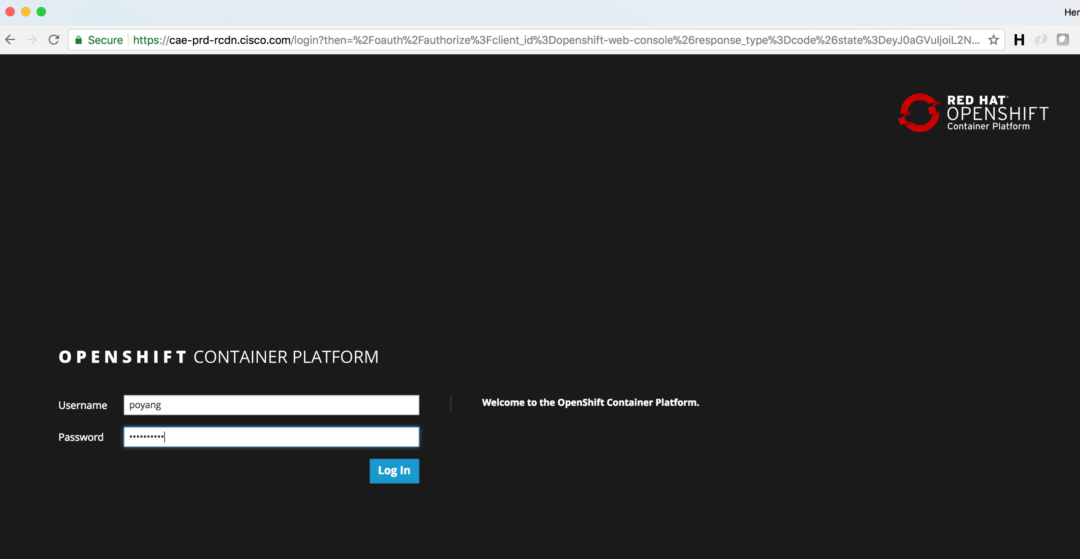

Step 2: Search and select your project.

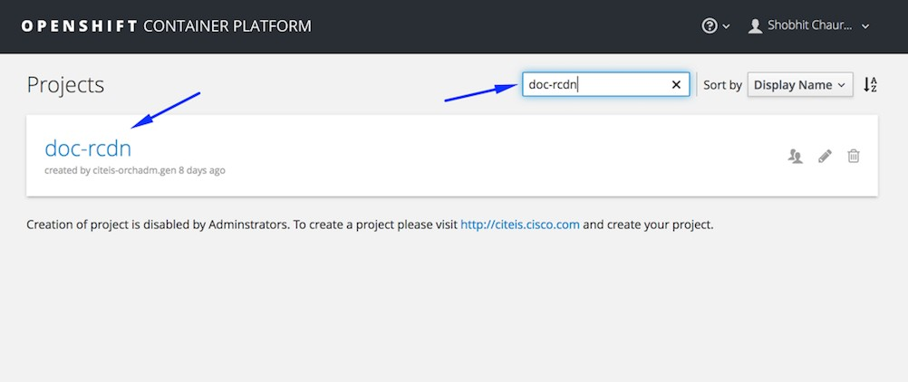

Step 3: Click on Up arrow to scale up your pod.

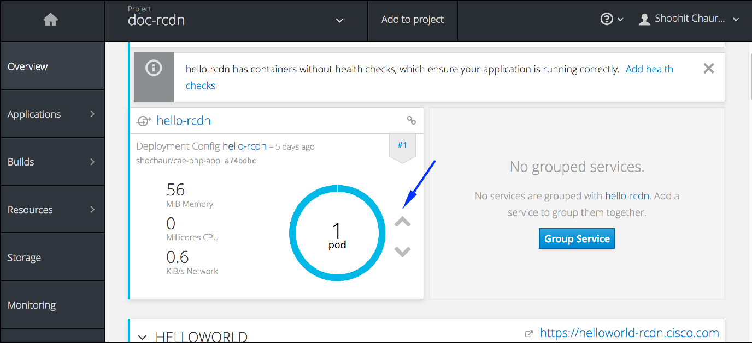

Now as we can see , Pod count has scaled up to 2.

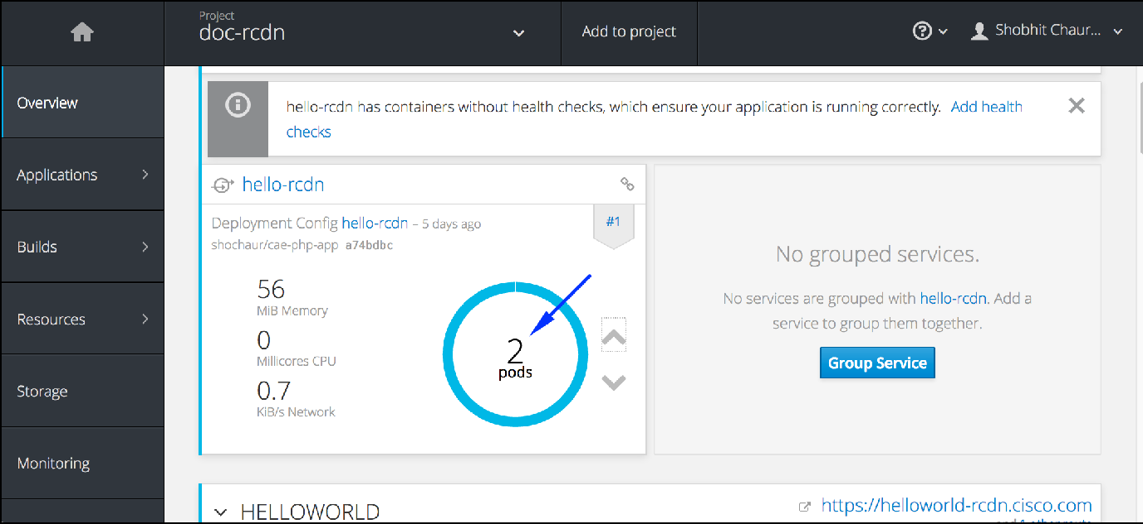

Step 4. Click on down arrow to scale down pod count.

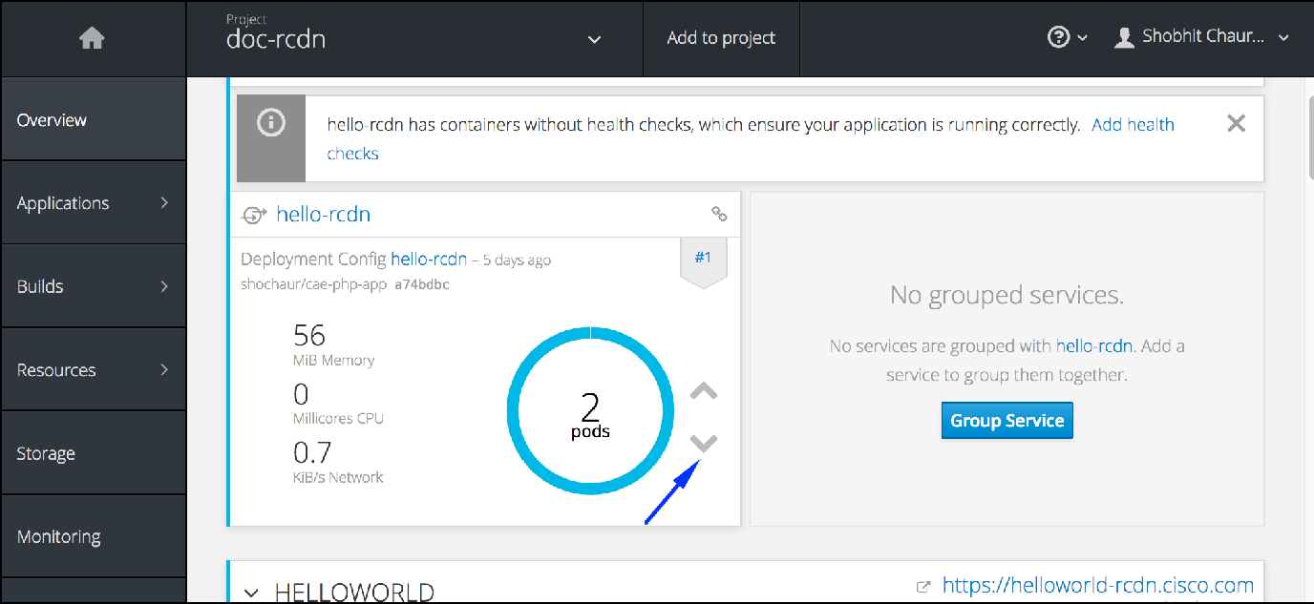

Pod has successfully scaled down to 2.

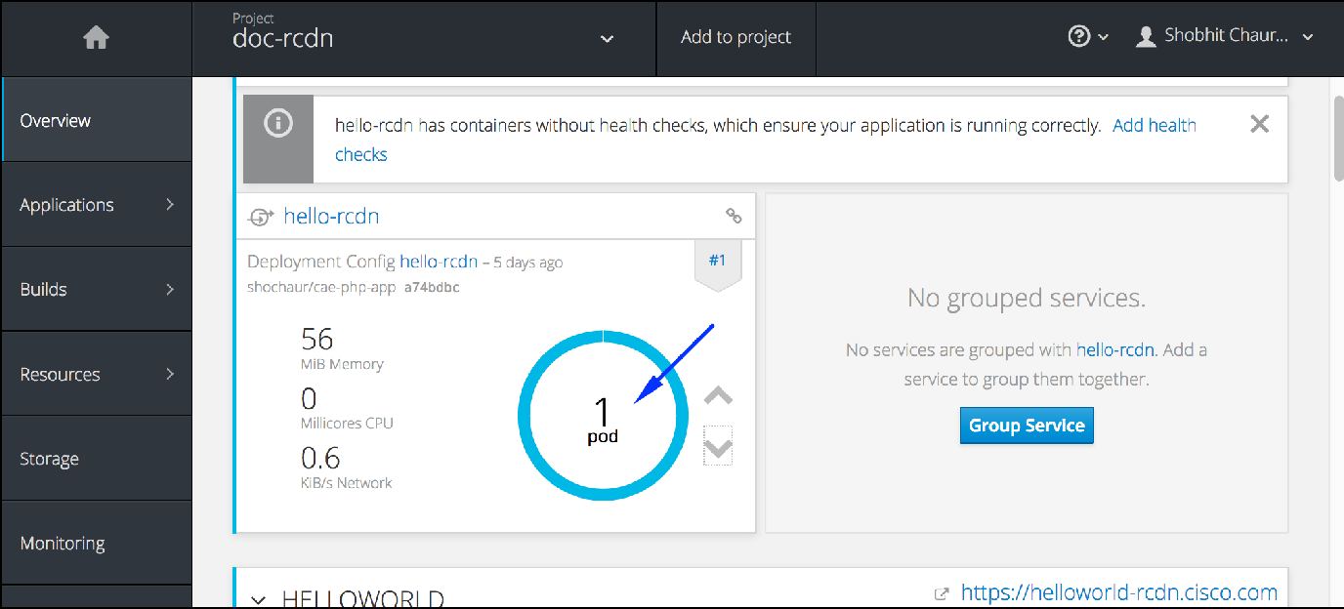

### Option 2. Using CLI

Step 1: Login to respective master host & Change to your project

**SHELL**

oc login cae-prd-rtp.cisco.com

Authentication required for https://cae-prd-rtp.cisco.com:443 (openshift) Username: mkaradig

Password:

Login successful.

You have access to the following projects and can switch between them with 'oc project <projectname>':

\* mnm-rtp stage-train

Using project "mnm-rtp".

|  |  |  |  |  |  |
| --- | --- | --- | --- | --- | --- |
| Step 2: Get respective Deployment config |  | | | | |
|  |  |  |  |  |  |
|  |  | **SHELL** |  |  |  |
| oc get dc |  |  |  |  |  |
| NAME | REVISION | DESIRED | CURRENT | TRIGGERED BY |  |
| cae-ramp2 | 12 | 2 | 2 | config,image(cae-ramp2: |  |
| dev) |  |  |  |  |  |
| caerock-blue | 1 | 2 | 2 | config,image(caerock- |  |
| blue:dev) |  |  |  |  |  |
| caerock-green | 1 | 2 | 2 | config,image(caerock- |  |
| green:dev) |  |  |  |  |  |
| mukesh-nginx | 6 | 0 | 0 | config,image(mukesh- |  |

|  |  |  |  |  |  |  |  |
| --- | --- | --- | --- | --- | --- | --- | --- |
| nginx:nginx-8)  mukesh-nodestaller | | 1 | 1 | | 1 | | config,image(mukesh- |
| nodestaller:nodejs-10) | | | | | | | |
| mukesh-oneid oneid:V1.2)  roadshow-repo | | 1  1 | 1  0 | | 1  0 | | config,image(mukesh-  config,image(roadshow- |
| repo:latest) | |  |  | |  | |  |
| oc get dc/cae-ramp2 | |  |  | |  | |  |
| NAME | REVISION | DESIRED | | CURRENT | | TRIGGERED BY | |
| cae-ramp2 | 12 | 2 | | 2 | | config,image(cae-ramp2:dev) | |

Step 3: Find out current replicas count.

**SHELL**

oc describe dc/cae-ramp2 |grep Replicas Replicas: 2

Replicas: 0 current / 0 desired

Replicas: 0 current / 0 desired

Replicas: 0 current / 0 desired

Step 4: Change to replicas to 3

**SHELL**

oc scale dc/cae-ramp2 --current-replicas=2 --replicas=3 deploymentconfig "cae-ramp2” scaled

This way, a Pod can be scale down/up , few examples. Scale to 1:

oc scale dc/cae-ramp2 --replicas=1 deploymentconfig "cae-ramp2” scaled

Scale to 0:

**SHELL**

**SHELL**

oc scale dc/cae-ramp2 --replicas=0 deploymentconfig "cae-ramp2” scaled

Scale to 2:

oc scale dc/cae-ramp2 --replicas=2 deploymentconfig "cae-ramp2” scaled

**SHELL**

**Pod Autoscaling**

Pod autoscaling is automatically scale up/down of pods (increase or decrease the scale of a replication controller) based on metrics collected from the pods.

You can create a horizontal pod autoscaler with the "oc autoscale" command and specify the minimum and maximum number of pods you want to run, as well as the CPU utilization your pods should target.

### Option 1: Using openshift console

Step 1. Login to openshift console and select the project. Step 2. Click on Application and select deployments.

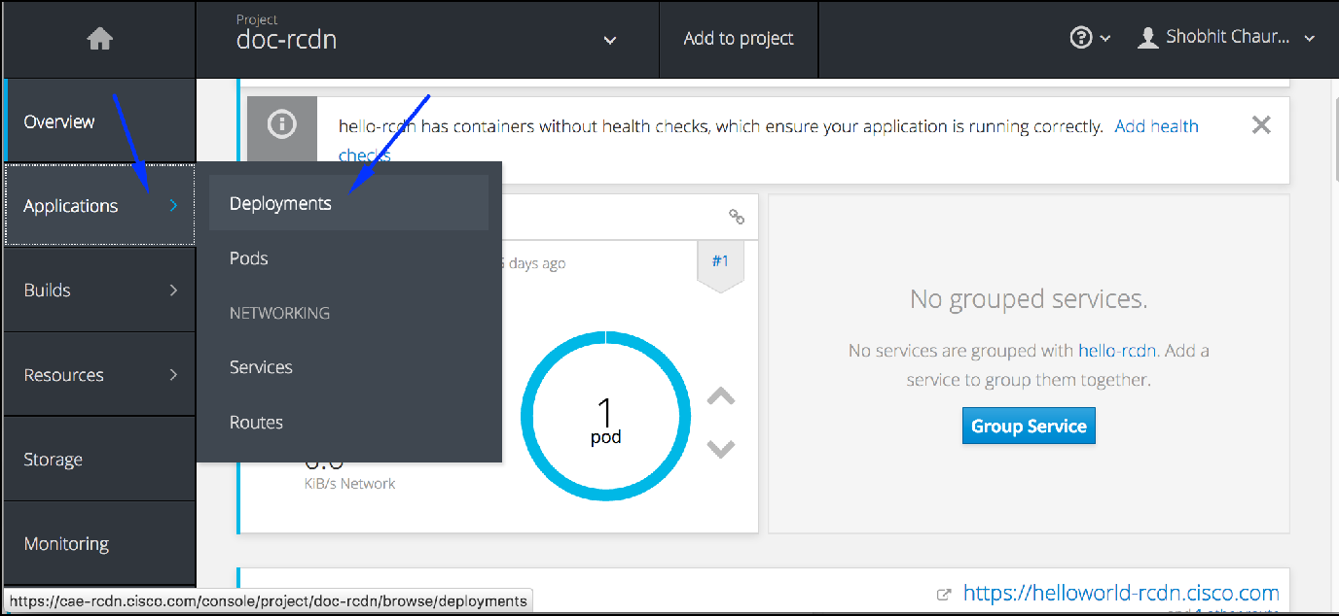

Step 3. Select dc.

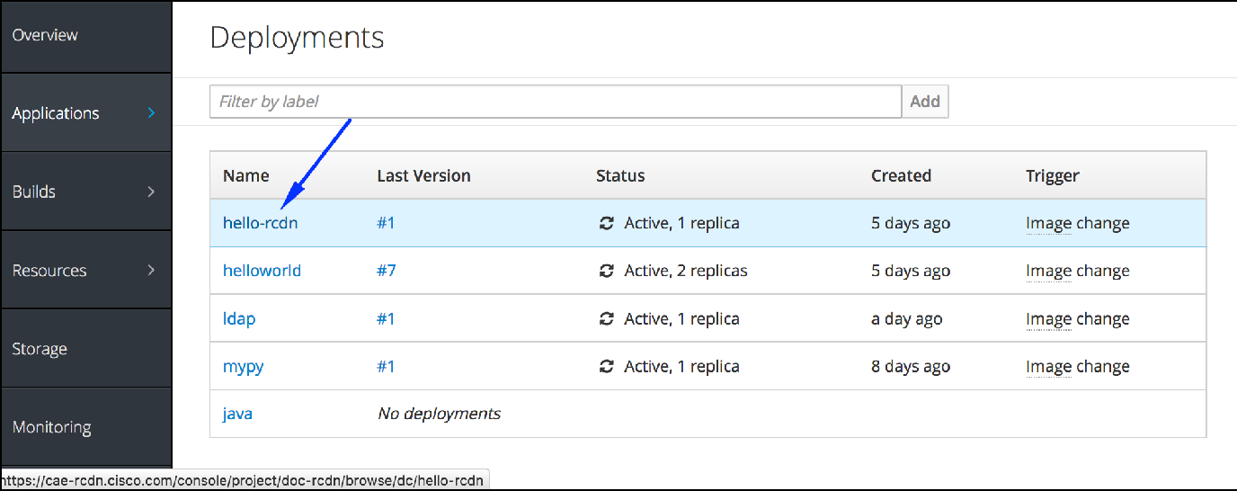

Step 4. Click on Actions and select Add Autoscaler.

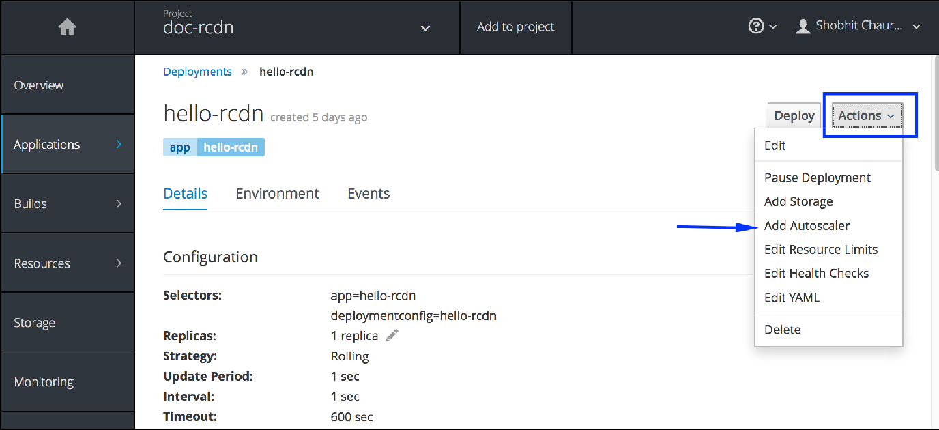

Step 5. Fill the required fields.

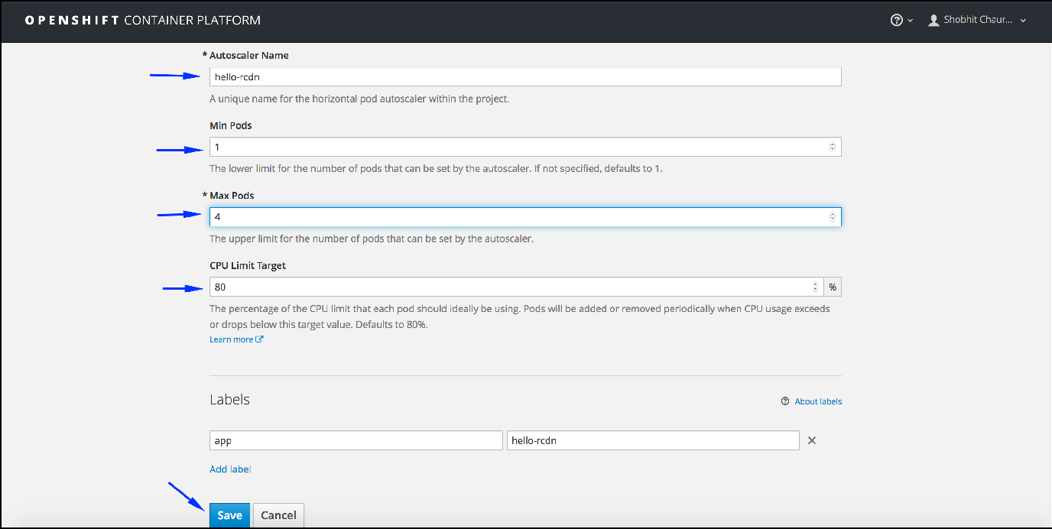

Verify above settings in deployments overview.

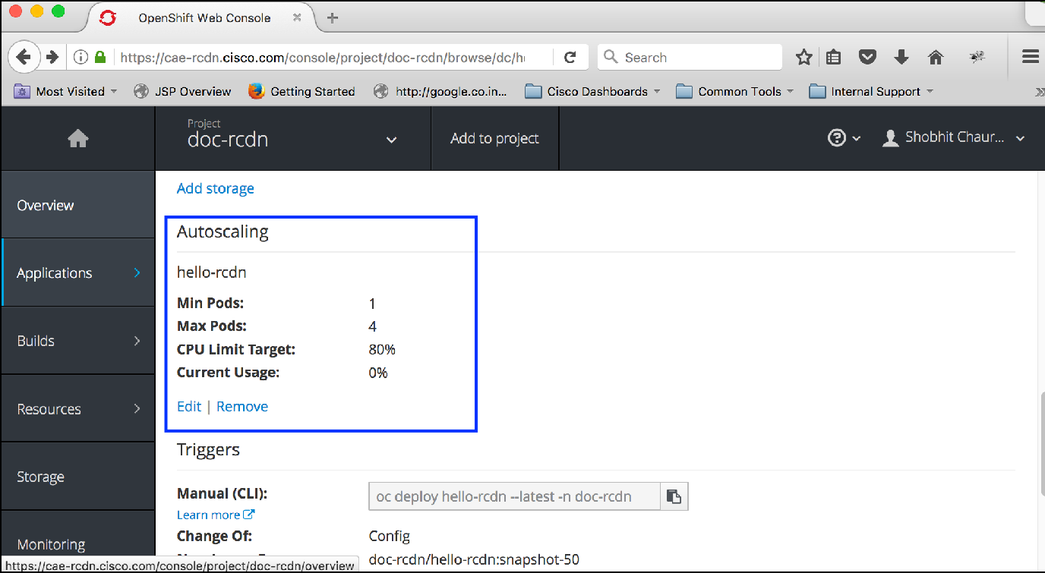

### Option 2: Using CLI

oc autoscale dc/cae-ramp2 --min 1 --max 4 deploymentconfig "cae-ramp2” autoscaled

Horizontal Pod Autoscaler Object Definition:

**pod yaml**

apiVersion: extensions/v1beta1 kind: HorizontalPodAutoscaler metadata:

name: frontend

spec:

scaleRef:

kind: DeploymentConfig name: frontend apiVersion: v1 subresource: scale

minReplicas: 1

maxReplicas: 10 cpuUtilization:

targetPercentage: 80

*Look at auto scaler object*

##### SHELL

###### oc get hpa

NAME REFERENCE TARGET CURRENT MINPODS MAXPODS AGE

cae-ramp2 DeploymentConfig/cae-ramp2 80% 0% 1

4 9m

oc describe hpa/cae-ramp2 Name: cae-ramp2 Namespace: mnm-rtp Labels: <none> Annotations: <none>

CreationTimestamp: Mon, 29 May 2017 12:00:35 +0530 Reference: DeploymentConfig/cae-ramp2

Target CPU utilization: 80% Current CPU utilization: 0% Min replicas: 1

Max replicas: 4 Events:

-------

FirstSeen LastSeen Count From SubobjectPath Type Reason Message

--------- -------- ----- ---- ------------- -------- ------

11m 11m 2 {horizontal-pod-autoscaler } Normal

##### DesiredReplicasComputed Computed the desired num of replicas: 0, on a base of 1 report(s) (avgCPUutil: 0, current replicas: 4)

10m 10m 1 {horizontal-pod-autoscaler } Warning FailedComputeReplicas failed to get CPU utilization: failed to get CPU consumption and request: metrics obtained for 1/4 of pods (sample missing pod: mnm-rtp/cae-ramp2-12-emrr3)

10m 10m 1 {horizontal-pod-autoscaler } Warning FailedGetMetrics failed to get CPU consumption and request: metrics obtained for 1/4 of pods (sample missing pod: mnm-rtp/cae-ramp2-12-emrr3)

10m 10m 2 {horizontal-pod-autoscaler } Normal DesiredReplicasComputed Computed the desired num of replicas: 0, on a base of 4 report(s) (avgCPUutil: 0, current replicas: 2)

13m 8m 2 {horizontal-pod-autoscaler } Normal SuccessfulRescale New size: 1; reason: All metrics below target

13m 7m 9 {horizontal-pod-autoscaler } Normal DesiredReplicasComputed Computed the desired num of replicas: 0, on a base of 2 report(s) (avgCPUutil: 0, current replicas: 2)

13m 7m 4 {horizontal-pod-autoscaler } Normal DesiredReplicasComputed Computed the desired num of replicas: 0, on a base of 2 report(s) (avgCPUutil: 0, current replicas: 1)

12m 5m 8 {horizontal-pod-autoscaler } Normal DesiredReplicasComputed Computed the desired num of replicas: 0, on a base of 1 report(s) (avgCPUutil: 0, current replicas: 1)

Remove auto scaler

**SHELL**

oc delete hpa/cae-ramp2 horizontalpodautoscaler "cae-ramp2" deleted

# Scheduled Jobs

### Overview

A *cron job* builds on a regular [job](https://wiki.cisco.com/display/CAEUSER/Jobs) by allowing you to specifically schedule how the job should be run.

Cron Jobs are effective way to schedule a routine background job at a specific time and/or day on an on-going basis

###### Why Use Cron Jobs:

If you have a membership site, where accounts have expiration dates, you can schedule jobs to regularly deactivate or delete accounts that are past their expiration dates.

You can send out daily newsletter e-mails.

If you have summary tables (or materialized views) in your database, they can be regularly updated with a scheduled job. For example you may store every web page hit in a table, but another summary table may contain daily traffic summaries.

You can expire and erase cached data files in a certain interval.

You can auto-check your website content for broken links and have a report e-mailed to yourself regularly.

You can schedule long-running tasks to run from a command line script, rather than running it from a web script. Like encoding videos, or sending out mass e-mails.

You can even perform something as simple as fetching your most recent Tweets, to be cached in a text file. Batch Process that need to run at regular intervals

Long running process for system maintenance

### Creating a Cron Job

A cron job configuration consists of the following key parts: A schedule specified in [cron format](https://en.wikipedia.org/wiki/Cron).

A [job template](https://wiki.cisco.com/display/CAEUSER/Jobs) used when creating the next job.

An optional deadline (in seconds) for starting the job if it misses its scheduled time for any reason. Missed jobs executions will be counted as failed ones. If not specified, there is no deadline.

**ConcurrencyPolicy**: An optional concurrency policy, specifying how to treat concurrent jobs within a scheduled job. Only one of the following concurrent policies may be specified. If not specified, this defaults to allowing concurrent executions.

Allow allows Scheduled Jobs to run concurrently.

Forbid forbids concurrent runs, skipping the next run if the previous has not finished yet.

Replace cancels the currently running job and replaces it with a new one.

An optional flag allowing the suspension of a scheduled job. If set to true, all subsequent executions will be suspended.

The following is an example of a **CronJob** resource:

**cronjob.yml**

apiVersion: batch/v2alpha1 kind: CronJob

metadata: name: pi

spec:

schedule: "\*/1 \* \* \* ?" jobTemplate:

spec:

template: spec:

containers:

- name: pi

image: containers.cisco.com/sasharm4/perl

command: ["perl", "-Mbignum=bpi", "-wle", "print bpi(2000)"] restartPolicy: Never

Few key points here...

1. **schedule**: Schedule for the job. In this example, a job will run every minute.

Refer the cron syntax at <https://en.wikipedia.org/wiki/Cron#Overview>

1. **command**: command which will run as per schedule

**Post cron job creation MUST action**

Cron jobs leaves Completed/Error Pods behind everytime it execute cron, which accumulate lot of pods and results in project inaccessi ble. Hence once you create cron jobs, make sure you delete completed/error pods as part of routine cleanup. This is MUST action for each cron.

**How to create cron job**

#Make sure you are logged into one of the cae clouds, where your project exists.

#Make sure you are in correct project,verify it using oc project command #Using above cronjob.yml to create cron job, which will run every minute.

(1)

#In this example, my project is in cae-prd-rcdn cloud.

:>oc login cae-prd-rcdn.cisco.com

Authentication required for https://cae-prd-rcdn.cisco.com:443 (openshift) Username: mukeshk2

Password:

Login successful.

(2)

#I am using my doc-rcdn CAE project

:>oc project doc-rcdn

Now using project "doc-rcdn" on server "https://cae-prd-rcdn.cisco.com: 443".

(3)

#Using above cronjob.yml to create scheduled job, which will run every minute.

:>oc create -f cronjob.yml cronjob "pi" created

Created job pi-1843103557

SuccessfulCreate

{scheduled-job-controller }

1

12s

Created job pi-1918928712

SuccessfulCreate

-------

{scheduled-job-controller }

1

1m

-------------

----

-----

Message

Type

---------

--------

1m Normal

12s

Normal

SubobjectPath

From

Count

LastSeen Reason

--------

------

pi-1918928712, pi-1843103557

Active Jobs: Events:

FirstSeen

Last Schedule Time: Fri, 19 May 2017 12:59:00 +0530

<none>

containers.cisco.com/sasharm4/perl

<unset>

<unset>

<unset>

Image(s): Selector: Parallelism: Completions: No volumes.

Labels:

#Describe the above created cron job

:>oc describe job pi Name: pi

Namespace: wordpress-dhairya

Schedule: \*/1 \* \* \* ? Concurrency Policy: Allow Suspend: False

Starting Deadline Seconds: <unset>

**Checking details of cron job**

#Checking the status of the cron job

:>oc get cronjobs

NAME SCHEDULE SUSPEND ACTIVE

pi \*/1 \* \* \* ? False 3

LAST-SCHEDULE

Fri, 19 May 2017 13:00:00 +0530

mukeshk2@MUKESHK2-M-C08S:[~]

mukeshk2@MUKESHK2-M-C08S:[~]

#You can see now,pod pi-1918928712-0z504 is completed it's run

:>oc get pods

NAME

RESTARTS

READY

STATUS

AGE

pi-1843103557-ahzea 0/1 ContainerCreating 0 1m

pi-1918928712-0z504 0/1 Completed

0 2m

**Checking status of cron job**

**Deleting a cron job**

|  |  |  |
| --- | --- | --- |
| :>oc get pods |  | |
| NAME | READY | STATUS |
| RESTARTS AGE |  |  |
| pi-1843103557-ahzea | 0/1 | ContainerCreating |
| 0 1m |  |  |
| pi-1918928712-0z504 | 1/1 | Running |
| 0 2m |  |  |

#deleting a cron job

:>oc delete cronjob/pi cronjob "pi" deleted

#verify if the cronjob deleted or not mukeshk2@MUKESHK2-M-C08S:[~]

:>oc get cronjob

No resources found.

**Read more about scheduled job at** <https://docs.openshift.com/container-platform/3.5/dev_guide/cron_jobs.html>

# Service Discovery Using Consul

###### Contents:

* 1. Why use service discovery?
  2. Introduction to Consul
  3. Consul on CAE
  4. Conclusion

**1. Why use service discovery?**

Let’s imagine that you are writing some code that invokes a service that has a REST API or Thrift API. In order to make a request, your code needs to know the network location (IP address and port) of a service instance. In a traditional application running on physical hardware, the network locations of service instances are relatively static. For example, your code can read the network locations from a configuration file that is occasionally updated.

In a modern, cloudbased microservices application, however, this is a much more difficult problem to solve as shown in the following diagram.

Service instances have dynamically assigned network locations. Moreover, the set of service instances changes dynamically because of autoscaling, failures, and upgrades. Consequently, your client code needs to use a more elaborate service discovery mechanism. There are two main service discovery patterns: [clientside discovery](http://microservices.io/patterns/client-side-discovery.html) and [serverside discovery](http://microservices.io/patterns/server-side-discovery.html).

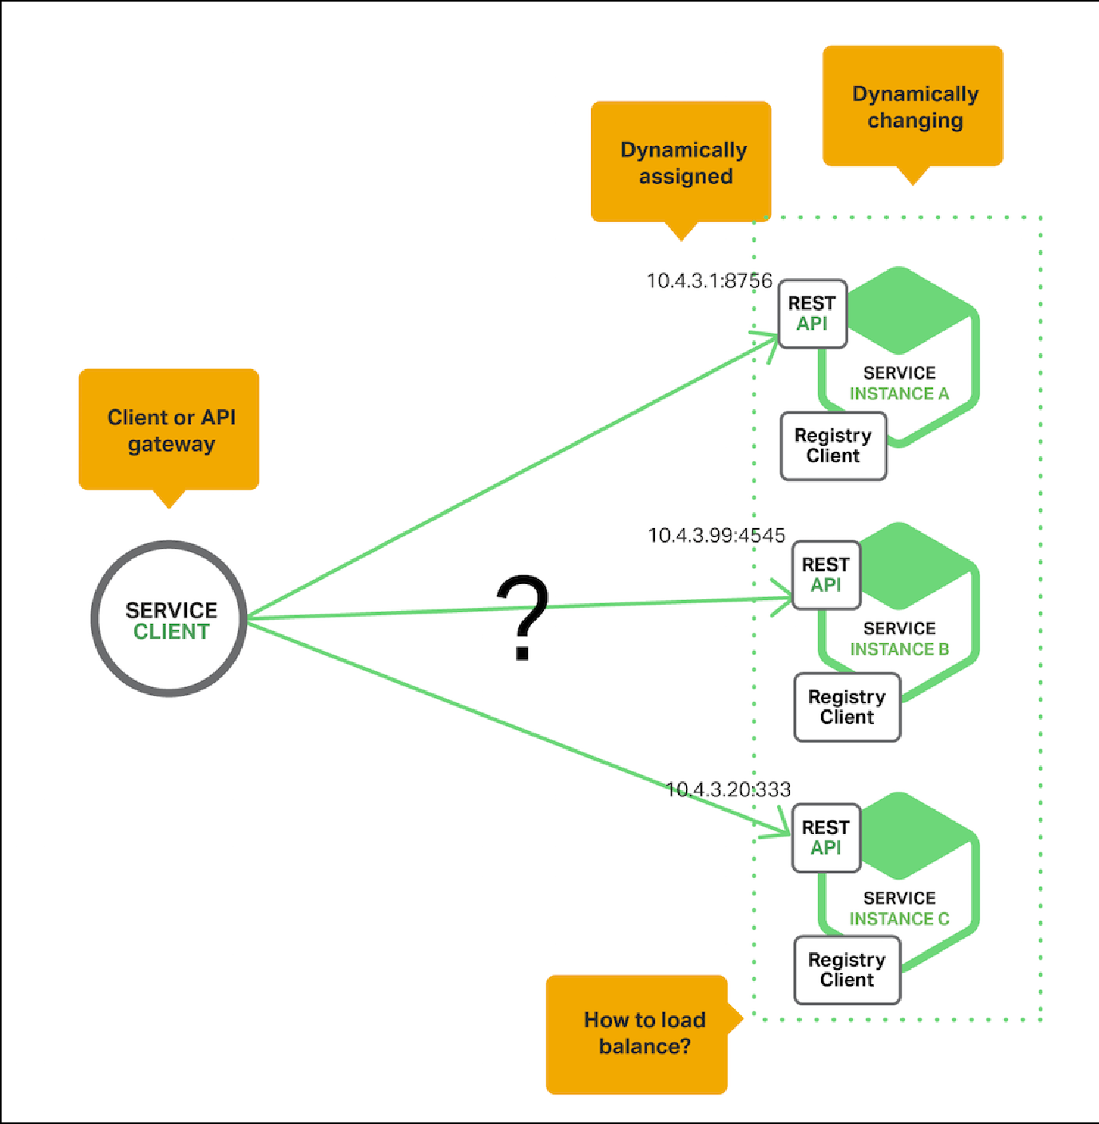

Consul is a distributed, highly available, datacenter-aware, service discovery and configuration system. It can be used to present services and nodes in a flexible and powerful interface that allows clients to always have an up-to-date view of the infrastructure they are a part of.

Consul provides many different features that are used to provide consistent and available information about your infrastructure. This includes service and node discovery mechanisms, a tagging system, health checks, consensus-based election routines, system-wide key/value storage, and more. By leveraging consul within your organization, you can easily build a sophisticated level of awareness into your applications and services.

In this guide, we will introduce you to some of the basics of using consul. We will cover the general procedures necessary to get consul running on CAE to test it out.

### Consul on CAE

In this guide, we will be getting familiar with using consul to build out a system of service discovery and configuration for CAE infrastructure.

For our demonstration, we will be configuring three servers and one client. Servers are used to handle queries and maintain a consistent view of the system. The client is also a member of the system, and can connect to the servers for information about the infrastructure. Clients may also contain services that will be monitored by consul.

For the purposes of this guide, and this series as a whole, we will be configuring 4 pods. The first three will be consul servers as described above. The last one will be a consul agent that acts as a client and can be used to query information about the system.

The details of our cluster is here:

|  |  |  |
| --- | --- | --- |
| **Podname** | **IP Address** | **Role** |
| consul-0 | 10.0.7.253 | server |
| consul-1 | 10.0.3.137 | server |
| conusl-2 | 10.0.10.115 | server |
| new-node | 10.0.3.125 | client |

**Note:** All of the above IPs are demonstration purposes only.

### Usage

Clone this repo:

**SHELL**

git clone https://gitscm.cisco.com/sujchinn/repos/consul-on-cae.git

Change into the consul-on-cae directory:

cd consul-on-cae

#### Generate the Consul Gossip Encryption Key

**SHELL**

[Gossip communication](https://www.consul.io/docs/internals/gossip.html) between Consul members will be encrypted using a shared encryption key. Generate and store an encrypt key:

**SHELL**

GOSSIP\_ENCRYPTION\_KEY=$(consul keygen)

#### Create the Consul Secret and Configmap

The Consul cluster will be configured using a combination of CLI flags, TLS certificates, and a configuration file, which reference Openshift configmaps and secrets.

Store the gossip encryption key and TLS certificates in a Secret:

oc create secret generic consul \

--from-literal="gossip-encryption-key=${GOSSIP\_ENCRYPTION\_KEY}"

Store the Consul server configuration file in a ConfigMap:

**SHELL**

**SHELL**

oc create configmap consul --from-file=configs/server.json

#### Create the Consul Service

Create a headless service to expose each Consul member internally to the cluster:

**SHELL**

oc create -f services/consul.yaml

#### Create the Consul StatefulSet

Deploy a three (3) node Consul cluster using a StatefulSet:

**SHELL**

oc create -f statefulsets/consul.yaml

Each Consul member will be created one by one. Verify each member is Running before moving to the next step.

|  |  |  |  |  |  |  |
| --- | --- | --- | --- | --- | --- | --- |
|  | | | | |  |  |
|  |  |  |  | **SHELL** |  |
|  | oc get pods |  |  |  |  |  |
|  | NAME | READY | STATUS | RESTARTS | AGE |  |
|  | consul-0 | 1/1 | Running | 0 | 50s |  |
|  | consul-1 | 1/1 | Running | 0 | 29s |  |
|  | consul-2 | 1/1 | Running | 0 | 15s |  |

#### Verification

At this point the Consul cluster has been bootstrapped and is ready for operation. To verify things are working correctly, review the logs for one of the cluster members.

oc logs consul-0

#### Accessing the Web UI

**SHELL**

The Consul UI does not support any form of authentication out of the box. To access the web UI, create a route in openshift to the consul Servic e in a new terminal.

**SHELL**

oc create -f routes/consul-ui-test.yaml

**Replace the route name** [**https://consul-ui-test.cisco.com**](https://consul-ui-test.cisco.com/) **in the yaml file with route name you want to create.**

Visit [https://consul-ui-test.cisco.com](https://consul-ui-test.cisco.com/) in your web browser.

#### Adding a new node/service

Store the Consul server configuration file in a ConfigMap:

**SHELL**

oc create configmap new-node-config --from-file=new-node/configs/server. json

Add a new pod within the namespace using the new-node.yaml file.

oc create -f new-node/new-node.yaml

Now a new node and service should be registered with the cluster. Verify that new node is in Running status and verify on the UI if you are able to see new node and service.

**SHELL**

STATUS RESTARTS AGE

Running 0 2d

Running 0 2d

Running 1 2d

Running 0 22h

oc get pods

NAME READY

consul-0 1/1

consul-1 1/1

consul-2 1/1

new-node-1-q4gs4 1/1

**SHELL**

### Conclusion

You should now have a basic idea of how consul works. This tutorial provides a basic use case of Consul on CAE but it is limited to one Datacenter.

###### References:

[**https://technologyconversations.com/2015/09/08/service-discovery-zookeeper-vs-etcd-vs-consul/**](https://technologyconversations.com/2015/09/08/service-discovery-zookeeper-vs-etcd-vs-consul/)

**Quotas, Limit Ranges, Requests and Scopes**

CAE lets admins and users manage resource aggregates at different control levels. These resources could include **objects counts** like pods, services, secrets, ingress services etc., **compute resources** like memory & CPU, and **storage resources** like persistent volumes.

Using quotas and limit ranges, cluster administrators can set constraints to limit the number of objects or amount of compute resources that are used in your project. This helps cluster administrators better manage and allocate resources across all projects, and ensure that no projects are using more than is appropriate for the cluster size.

As a CAE user, you can set requests and limits on compute resources at the **project** and **pod** level.

The following document highlights the method to view and configure application resource constraints for CAE users.

---

**Object Definitions**

*[See the references section at the end of this doc for further reading]*

###### Quotas

A resource quota, defined by a ResourceQuota object, provides constraints that limit aggregate resource consumption per project. It can limit the quantity of objects that can be created in a project by type, as well as the total amount of compute resources that may be consumed by resources in that project.

Quotas are scoped to a given project in CAE

Following is a list of resources manageable by a quota - Compute Resources: CPU, Memory

Object Counts: Pods, Replication Controllers, Secrets, Services, Persistent Volume Claims (Storage), ConfigMaps, Resource Quotas, Image Streams etc.

Ingress: No. of ingress services

###### Limit Ranges

By default, pods run with unbounded CPU and memory limits. This means that any pod in the system will be able to consume as much CPU and memory on the node that executes the pod. Admins/Users may want to impose restrictions on the amount of resource a single pod in the system may consume.

A limit range, defined by a **LimitRange** object, enumerates compute resource constraints in a project at the pod, container, image, image stream, and persistent volume claim level, and specifies the amount of resources that a pod, container, image, image stream, or persistent volume claim can consume.

Limit Ranges are scoped to a given project in CAE

###### Requests and Limits

When allocating compute resources, each container may specify a request and a limit value each for CPU and memory. **Quotas can restrict any of these values.**

Requests are used for scheduling your container and provide a minimum service guarantee. Limits constrain the amount of compute resource that may be consumed on your node.

If the quota has a value specified for **requests.cpu** or **requests.memory**, then it requires that every incoming container make an explicit request for those resources. If the quota has a value specified for **limits.cpu** or **limits.memory**, then it requires that every incoming container specify an explicit limit for those resources.

*Example pod yaml file -* apiVersion: v1 kind: Pod metadata:

...

spec:

containers:

- image: containers.cisco.com/dhsanghv/ccix2lae-ui@sha256: 3889b50e677f9304e2a87a47eb6ffd1e519bda2546adb76cea028f596b86030e

imagePullPolicy: IfNotPresent name: ccix2lae-ui

ports:

...

###### resources: limits:

**cpu: 100m memory: 64Mi**

**requests: cpu: 100m**

**memory: 64Mi**

Scheduling is based on resources requested, while quota and hard limits refer to resource limits, which can be set higher than requested resources. The difference between request and limit determines the level of **overcommit**; for instance, if a container is given a memory request of 1Gi and a memory limit of 2Gi, it is scheduled based on the 1Gi request being available on the node, but could use up to 2Gi; so it is 200% overcommitted.

It is essential to note that setting request values for compute resources at a pod level has no effect in CAE. Requests are defined based on Limits using Overcommit Ratios set by CAE admins. *More on this in the 'View and Modify' section of this document.*

###### Scopes

Adding a scope to a quota restricts the set of resources to which that quota can apply. Scopes can be Terminating, NotTerminating, BestEffort or NotBestEffort.

|  |  |
| --- | --- |
| **Scopes** | **Description** |
| Terminating | Affects pods that have an active deadline. These pods usually include builds, deployers, and jobs. |
| NotTerminating | Affects pods that do not have an active deadline. These pods usually include your applications. |
| BestEffort | Affects pods that do not have resource limits set. These pods have a best effort quality of service. |
| NotBestEffort | Affects pods that have at least one resource limit set. These pods do not have a best effort quality of service. |

A **BestEffort** scope restricts a quota to limiting pods. A **Terminating**, **NotTerminating**, or **NotBestEffort** scope restricts a quota to tracking pods, memory and CPU.

Scopes cannot be viewed or modified by CAE users.

###### Quality of Service Tiers

A compute resource is classified with a *quality of service* (QoS) based on the specified request and limit value for the container/pod in question. T he three QoS tiers are BestEffort, Guaranteed and Burstable.

|  |  |
| --- | --- |
| **QoS Tier** | **Description** |
| BestEffort | Provided when a request and limit are not specified. |
| Guaranteed | Provided when a request is specified that is less than an optionally specified limit. |
| Burstable | Provided when a limit is specified that is equal to an optionally specified request. |

The quality of service for compute resources cannot be viewed or modified by CAE users.

**Access and Access Levels**

Now that we know the terminology used in CAE for quotas and limits, let us understand what you, as a developer/user, can access and modify in your project.

###### Quotas

* CAE users CAN NOT modify object counts for any project on CAE, including their own.
* CAE users CAN modify compute resources (memory and CPU) for their projects (via ACC or Cisco IT Cloud API).
* CAE users CAN make Persistent Volume Claims (PVCs) and modify few aspects of their own PVCs, eg., access modes (RWO/RWX), storage capacity, mount path etc.
* CAE users CAN NOT modify the ingress quota (as of Aug 2017)

###### Requests/Limits

* CAE users CAN modify requests and limits for the compute resources of their pods/containers (). If you don't select while creating project on ACC, a default value will be provided which can be modified using either ACC/CAPI or by editing the pod yaml config as shown above in the "Requests and Limits" section.

###### Scopes

* CAE users CAN NOT modify quota scopes at any level of the container platform.

## View and Modify

There are three primary ways in which a user can view or modify permissible quota metrics on CAE - via ACC

via OC command line interface/console

via Cisco IT Cloud API ([https://capi.cisco.com](https://capi.cisco.com/))

###### View/Modify Project Quota

*via ACC:*

You can **view and modify** your project level quotas on ACC during provisioning or any time later in your app's lifecycle. Go to your ACC Application >> App Profile >> Platform Services >> Cloud Application Environment. Here you can view your existing project or create a new project.

By default, a total CPU of 1 core (1000 millicores or 1000m) and a total RAM of 2 GB (also written as, 2 Gi) is provisioned for users, if they don't select custom values.



These values can be modified by going to the small menu on the right and clicking on "Modify Quota". In the example shown in the image below, I am trying to modify the default project level compute resources for my project by dragging the progress bars.

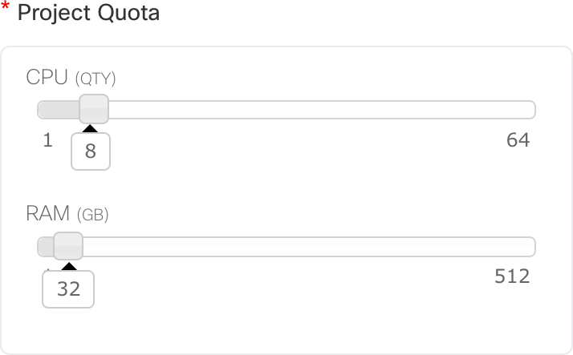

**Note: The resource limits of 64 CPU cores and 512 GB RAM are hard limits set by the cluster administrators for each namespace, and cannot be modified by the end user.**

*via OC command line interface/console:*

CAE users can **view but not modify** the project quotas via the OC CLI. View Quota Names: oc get quota -n <project-name>

View Quota: oc describe quota <quota-name>

View Quota Spec: oc export quota <quota-name>

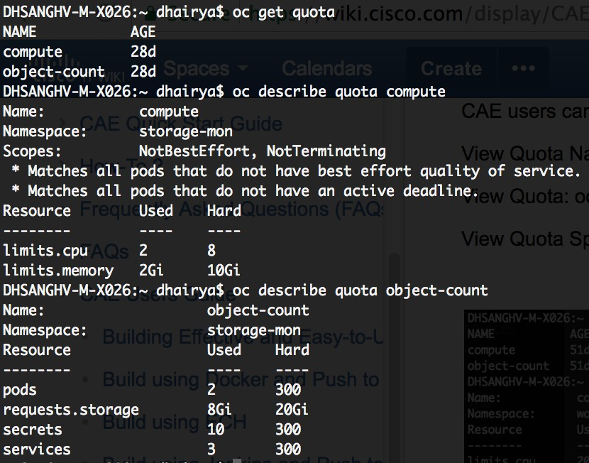

**Note: The object-count limits of 300 for pods, secrets and services are hard limits set by the cluster administrators for each namespace, and cannot be modified by the end user.**

CAE users can **view but not modify** the project quotas via the Openshift Console. Just log on to your openshift console project and go to Resou rces >> Quota. This page illustrates the available and used resource quota for your project, including object counts and scopes.

*via Cisco IT Cloud API:*

Refer <https://capi.cisco.com/>to learn how to generate the oauth access token.

Use the PATCH API -

curl -X PATCH \ [https://capi.cisco.com/v1/containers/projects/{](https://capi.cisco.com/v1/containers/projects/a9488883-04b9-4678-89c8-d9232c9db44e){project}} \

-H 'accept: application/vnd.cia.v1+json' \

-H 'authorization: Bearer {{access\_token}}' \

-H 'cache-control: no-cache' \

-H 'content-type: application/vnd.cia.v1+json' \

-H 'postman-token: 1550ff60-a6fc-743a-4781-c779835f28e5' \

-H 'profile: {{profile}}' \

-d '{

"quota": {

"cpu": 2.0,

"memory": 2.0

},

"defaults": {

"cpu": 0.5,

"memory": 0.5

}

}

'

**View/Modify Pod Requests/Limits**

As mentioned earlier, setting request values for compute resources at a pod level has no effect in CAE. Requests are defined based on Limits using Overcommit Ratios set by CAE admins.

CAE administrators can control the level of overcommit and manage container density on nodes by configuring the masters to override the ratio between request and limit set on developers' containers (viewable in the pod yaml). In order to enforce this, we have set overcommit ratios in the master-config.yaml file of all our CAE environments as shown below -

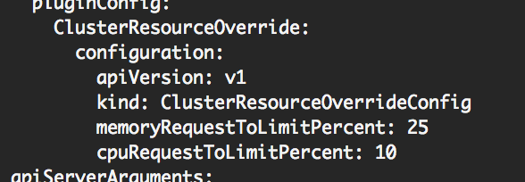

(1-100) If a container memory or CPU limit has been specified or defaulted, the memory or CPU request is overridden to the above percentage of the limit.

Note that these overrides have no effect if no limits have been set on containers. A LimitRange object with default limits (per individual project) needs to be created in order to ensure that the overrides apply.

*via ACC:*

You can **view and modify** your pod/container level requests and limits on ACC during provisioning or any time later in your app's lifecycle. Go to your ACC Application >> App Profile >> Platform Services >> Cloud Application Environment.

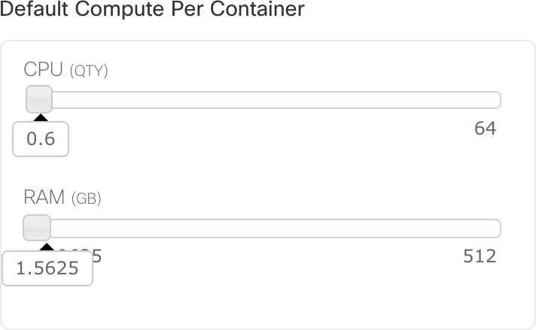

**Note: Individual Pod/Container Limits for CPU and memory usage should not exceed 6 CPU cores and 60GB RAM.**

*via OC command line interface/console:*

You can **view and modify** your pod/container level requests and limits using the OC CLI. Just edit the Deployment Config at the {spec}:

{spec}:{containers}:{resources} key:

oc get dc

oc edit dc/<dcname>

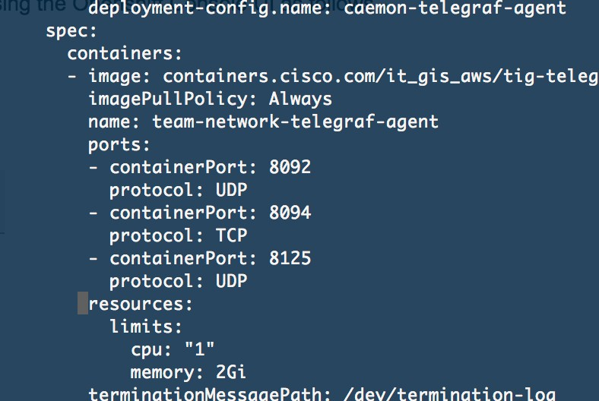

You can **view and modify** your pod/container compute requests and limits using the Openshift Console UI as follows - Go to Applications >> Deployments >> <deployconfig-name>.

Select the Actions dropdown and choose Edit YAML.

You can edit the compute resources for your pod in this yaml file inside the {spec}:{spec}:{containers}:{resources} key -

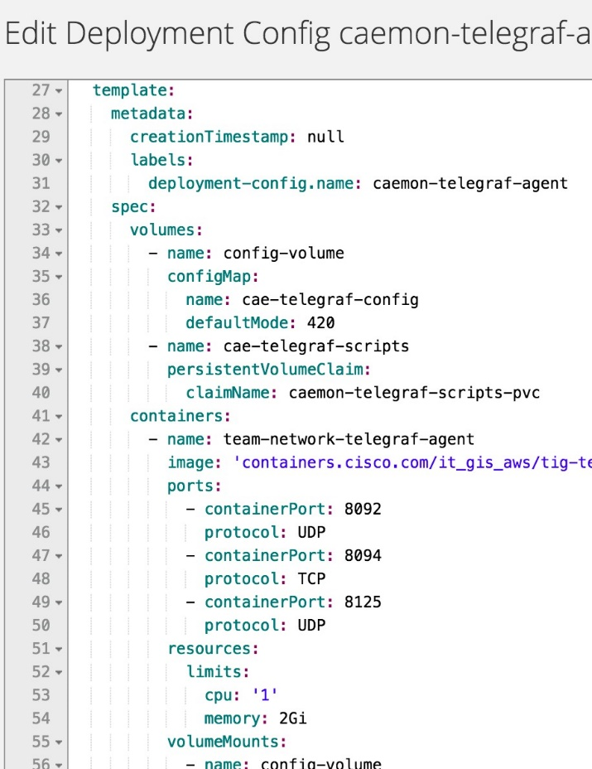

**Note**

CPU is measured in units called millicores. Each node in a cluster inspects the operating system to determine the amount of CPU cores on the node, then multiplies that value by 1000 to express its total capacity. For example, if a node has 2 cores, the node’s CPU capacity would be represented as 2000m. If you wanted to use 1/10 of a single core, it would be represented as 100m.

Memory is measured in bytes. In addition, it may be used with SI suffices (E, P, T, G, M, K, m) or their power-of-two-equivalents (Ei, Pi, Ti, Gi, Mi, Ki).

References: <https://docs.openshift.com/container-platform/3.4/dev_guide/compute_resources.html>

# Service Accounts

It is common for resources in CAE to make independent API calls without any explicit request via a regular user's credentials. For example - Replication controllers make API calls to create or delete pods.

Applications inside containers could make API calls for discovery purposes. External applications could make API calls for monitoring or integration purposes.

###### Service accounts provide a flexible way to control API access without sharing a regular user’s credentials.

By default, OpenShift creates three service accounts per project for **building, deploying** and **running** an application -

|  |  |
| --- | --- |
| **Service Account** | **Usage** |
| **builder** | Used by build pods. It is given the **system:image-builder** role, which allows pushing images to any image stream in the project using the internal Docker registry. |
| **deployer** | Used by deployment pods and is given the **system:deployer** role, which allows viewing and modifying replication controllers and pods in the project. |
| **default** | Used to run all other pods unless they specify a different service account. |

All service accounts in a project are given the **system:image-puller** role, which allows pulling images from any image stream in the project using the internal Docker registry.

**Create Service Account**

Service accounts are API objects that exist within each project. They can be created or deleted like any other API object.

oc create serviceaccount caesvcac

oc describe service account caesvcac

As soon as a service account is created, two secrets are automatically added to it: an API token

credentials for the internal Docker registry

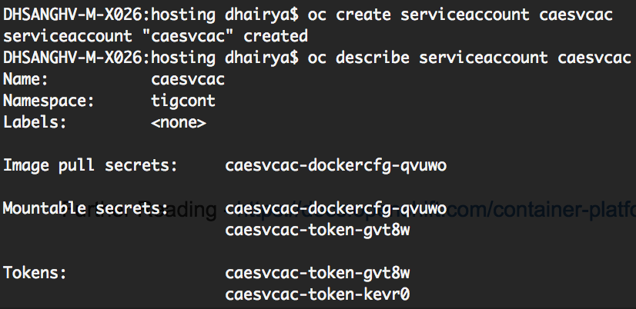

The generated API token and Docker registry credentials do not expire, but they can be revoked by deleting the secret. When the secret is deleted, a new one is automatically generated to take its place.

#### Manage Service Accounts

Every service account has an associated user name that can be granted roles, just like a regular user. The user name is derived from its project and name.

system:serviceaccount:<projectname>:<serviceaccountname>

For example, to add the **view** role to the **caesvcac** service account in the **tigcont** project:

oc policy add-role-to-user view system:serviceaccount:tigcont:caesvcac



Every service account is also a member of two groups:

**system:serviceaccounts** - Includes all service accounts in the system.

**system:serviceaccounts:<project>** - Includes all service accounts in the specified project.

For example, to allow all service accounts in all projects to view resources in the **tigcont** project:

oc policy add-role-to-group view system:serviceaccounts -n tigcont

To allow all service accounts in the **caemon** project to edit resources in the **tigcont** project:

oc policy add-role-to-group edit system:serviceaccounts:caemon -n tigcont

*Further Reading -* [*https://docs.openshift.com/container-platform/3.4/dev\_guide/service\_accounts.html*](https://docs.openshift.com/container-platform/3.4/dev_guide/service_accounts.html)

# TIG Provisioning and Installation (CLIENT)

###### Contents

* 1. [Introduction](file:///C:\Machine%20Learning\Test\PDF\ilovepdf_split-range\CAE%20Wiki%20Pages-1-150-121-150.docx#_bookmark1)
  2. [Provisioning a CAE project within your CAE application](file:///C:\Machine%20Learning\Test\PDF\ilovepdf_split-range\CAE%20Wiki%20Pages-1-150-121-150.docx#_bookmark2)
  3. [Setting up InfluxDB](file:///C:\Machine%20Learning\Test\PDF\ilovepdf_split-range\CAE%20Wiki%20Pages-1-150-121-150.docx#_bookmark3)
  4. [Setting up Telegraf](file:///C:\Machine%20Learning\Test\PDF\ilovepdf_split-range\CAE%20Wiki%20Pages-1-150-121-150.docx#_bookmark4)
  5. [Setting up Grafana](file:///C:\Machine%20Learning\Test\PDF\ilovepdf_split-range\CAE%20Wiki%20Pages-1-150-121-150.docx#_bookmark5)
  6. [Setting up Chronograf and Kapacitor](file:///C:\Machine%20Learning\Test\PDF\ilovepdf_split-range\CAE%20Wiki%20Pages-1-150-121-150.docx#_bookmark0)
  7. Links

###### Introduction

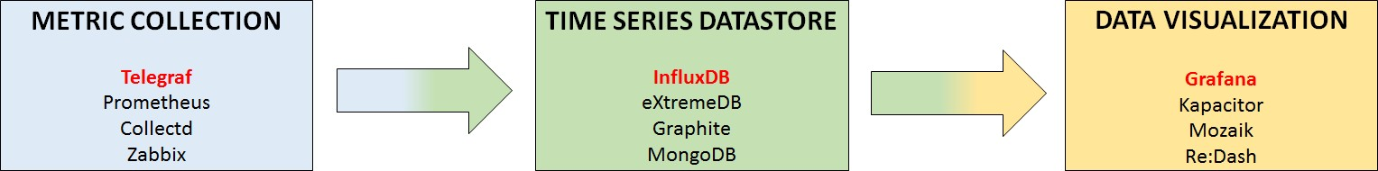

CAE offers the Telelegraf-InfluxDB-Grafana technology stack for monitoring and alerting on your infrastructure. The stack works as follows, Telegraf is the agent which collects the metrics from nodes, InfluxDB stores the metrics collected in the form of time-series data, and Grafana visualizes the data in the form of graphs, and provides alerting configuration for the same. These technologies are completely independent of each other, and can be replaced by other technologies as per your requirement. We have documented the installation and configuration of the TIG stack, and shall be providing a best effort support for the same.

Support Style - Best [Effort](mailto:tig-core@cisco.com) [Support](mailto:tig-core@cisco.com) Mailer - [tig-core](mailto:tig-core@cisco.com)

###### Provision a CAE project within your CAE application.

Go to [*citeis.cisco.com*](http://citeis.cisco.com/) and choose the *My Applications* tab.

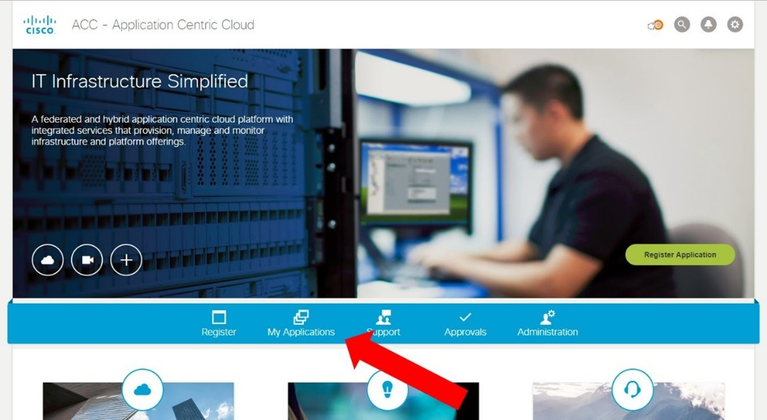

Choose the application in which you want to install TIG.

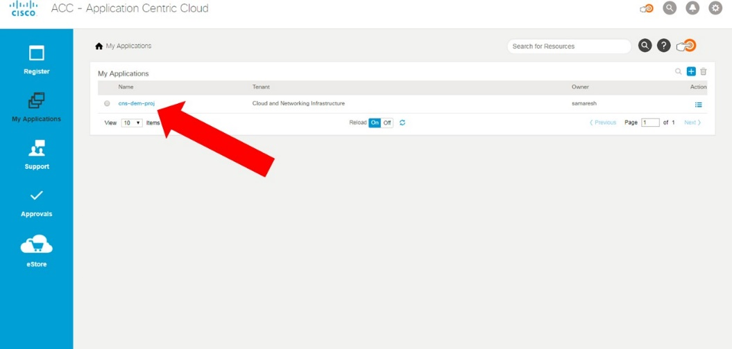

Pick a profile based on cluster and lifecycle or create a new one.

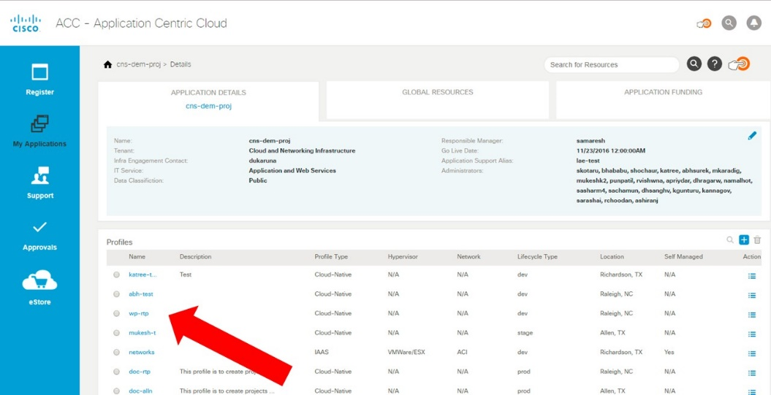

Inside the profile, click on *Platform Service* and select *Cloud Application Environment*

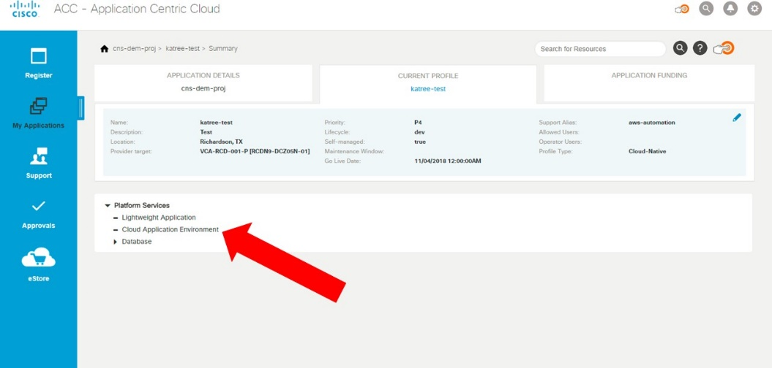

Click on the *“+” sign* on the right side of *CAE Projects* tab to create a new project.

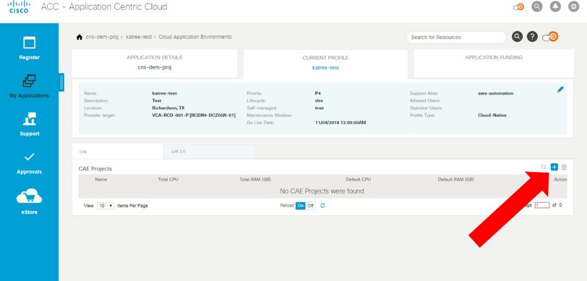

Enter the Project details. Refer to [Quotas, Limit Ranges, Requests and Scopes](https://wiki.cisco.com/display/CAEUSER/Quotas%2C%2BLimit%2BRanges%2C%2BRequests%2Band%2BScopes) to setup quotas. (Do not leave any quotas at zero. For help on quota estimations, reach out to [tig-core](mailto:tig-core@cisco.com) team.)

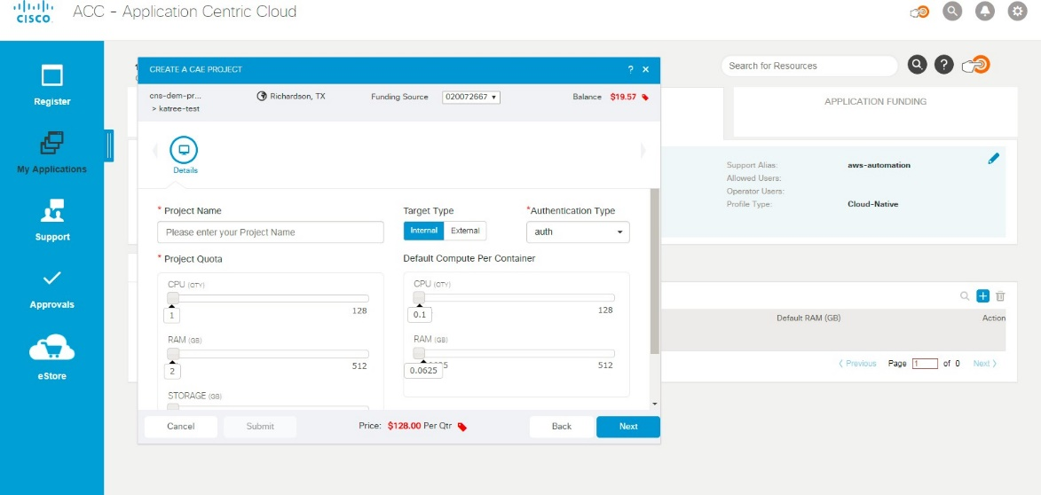

Click on submit to create your project. However, this will not create the “ingress quota” for your project for inter-cluster availability. Reach out to the [tig-core](mailto:tig-core@cisco.com) team for ingress quota creation.

###### Setting up InfluxDB

The first step is to create the secret to be able to pull image from container hub. Use the following file as it is to create the secret. Keep this file handy to be used later.

Now we need a YAML file for *Persistent Volume Claim*.

apiVersion: "v1"

kind: "PersistentVolumeClaim" metadata:

name: "influxdb-pv-claim" spec:

accessModes:

- "ReadWriteMany" resources:

requests:

storage: "<<5Gi>>"

* + Change the *storage* size as per your requirement.
  + Do not change the *accessModes*.
  + File

Write the YAML file for your configmap. You can edit the following sample file, or write your own one.

kind: ConfigMap apiVersion: v1 metadata:

name: "influxdb-config-map" data:

influxdb.conf: | [admin]

enabled = true

bind-address = ":8083"

[http]

enabled = true

bind-address = ":8086" auth-enabled = true

[retention] enabled = true

check-interval = "30m"

[monitor]

store-enabled = true

store-database = "\_internal" store-interval = "30s"

[meta]

dir = "/var/lib/influxdb/meta"

[data]

dir = "/var/lib/influxdb/data" engine = "tsm1"

wal-dir = "/var/lib/influxdb/wal"

* + Do not change the YAML file unless it reqiures addition of ports.
  + File

Use this YAML file for deployment config of the pod. Edit the following sample file at marked places.

kind: "DeploymentConfig" apiVersion: "v1" metadata:

name: "influxdb-deployment-config" spec:

template: metadata:

labels:

name: "influxdb-deployment-config" spec:

containers:

* + - name: "influxdb-container"

image: "contianers.cisco.com/it-gis-aws/tig-influxdb:1.3" ports:

* + - * containerPort: 8086
      * containerPort: 8083 volumeMounts:
      * name: influxdb-config-map mountPath: /etc/influxdb
      * name: influxdb-pvc mountPath: /var/lib/influxdb

securityContext: privileged: false runAsUser: 0

imagePullSecrets:

* + - name: it-gis-aws-basebot-pull-secret volumes:
    - name: influxdb-pvc persistentVolumeClaim:

claimName: influxdb-pv-claim

* + - name: influxdb-config-map configMap:

name: influxdb-container-pod-config-map defaultMode: 420

replicas: 1 selector:

name: "influxdb-deployment-config" triggers:

- type: "ConfigChange" strategy:

type: "Rolling"

* + Configure the number of replicas as per your requirement.
  + If any ports were added to the configmap, same should be reflected here under spec.containers.ports
  + Do not make any other changes to the DC. Write a YAML file for service.

kind: "Service" apiVersion: "v1" metadata:

name: "influxdb-svc" spec:

ports:

* + - name: client-port port: 8086 protocol: TCP targetPort: 8086
    - name: admin-port port: 8083 protocol: TCP targetPort: 8083

selector:

name: "selector-influxdb-svc" type: "ClusterIP" sessionAffinity: "None"

* + Do not remove or modify the existing ports. However, any additional ports added to ConfigMap and Dc should bre added.
  + All ports under a service should follow the same protocol, either all TCP or all UDP. If you require both protocols, create separate services.

Write YAML file for route creation.

...

Use oc client to log in into your project as follows

1. oc login <server URL>
2. Give your CEC credentials
3. (Switch to your TIG project)
4. oc project <project name>
5. oc create -f <complete path to secret.yaml>

<screen>

1. oc create –f <complete path to pvc yaml file>

<screen>

1. oc create –f <complete path to configmap yaml file>

<screen>

1. oc create –f <complete path to deployment config yaml file>

<screen>

1. oc create –f <complete path to service yaml file>

<screen>

i. oc create –f <complete path to route yaml file>

<screen>

**There should be no error at any of the above seven steps. Any quota related errors should be resolved using** [**citeis.cisco.com**](http://citeis.cisco.com/)**.**

Use *oc get pods* to get list of all running pods. Check that a part of a pod name contains the name mentioned in the metadata of your deployment config is running. This is your influxDB pod.

Use *oc rsh <pod name>* to log in into the pod. Type *bash* to get a basic bash interface.

Type *Influx*

Create user *admin* with password *influxdb* using -

*CREATE USER admin WITH PASSWORD ‘influxdb’ WITH ALL PRIVILEGES*

Login as admin using -

*auth admin/influxdb*

Create database cae-test using -

*CREATE DATABASE “cae-test”*

Create user *cae\_user1* with password *metrics* using-

*CREATE USER cae\_user1 WITH PASSWORD ‘metrics’*

List all the users using -

*SHOW USERS*

Use the database *cae-test* using -

*USE cae-test*

Grant privileges on database *cae-test* to user *cae\_user1* using -

*GRANT ALL ON "cae-test" TO cae\_user1*

Show the *data collections* in database *cae-test* using -

*Show measurements*

List the data in a data collection, using - *show series from <measurement name>* Show the *retention policies* using -

*SHOW RETENTION POLICIES ON “cae-test”*

To read more about retetion policies, click on [Retention Policy Management](https://docs.influxdata.com/influxdb/v1.3/query_language/database_management/#retention-policy-management).

If you want to create your own retention policies, use the following steps.

*DROP RETENTION POLICY autogen ON cae-test*

*CREATE RETENTION POLICY one\_week ON cae-test Duration 1w REPLICATION 1 DEFAULT*

###### Setting up Telegraf

Write a YAML file for *Persistent Volume Claim*. You can edit the following sample file, or write your own one.

apiVersion: "v1"

kind: "PersistentVolumeClaim" metadata:

name: "telegraf-pv-claim" spec:

accessModes:

- "ReadWriteMany" resources:

requests: storage: 5Gi"

* + Do not change the *YAML*.

Write a YAML file for *Config Map*. This is where you shall define the metrics Telegraf captures, the frequency of capturing, and the database to store the metrics.

A sample Config Map has been attached for reference. A few things to keep in mind. The start of the file would resemble -

kind: ConfigMap

apiVersion: v1 metadata:

name: "telegraf-config-map" data:

telegraf.conf: | [global\_tags]

tag1 = "<<value>>" tag2 = "<<value>>"

[agent]

interval = "30s" round\_interval = true metric\_batch\_size = 1000

metric\_buffer\_limit = 10000 collection\_jitter = "0s" flush\_interval = "30s" flush\_jitter = "0s" precision = ""

debug = false quiet = false logfile = "" hostname = ""

omit\_hostname = true

[[outputs.influxdb]]

urls = ["http://<<InfluxDB service URL>>:8086"] database = "cae-test"

write\_consistency = "any" timeout = "60s"

username = "cae\_user1" password = "metrics" user\_agent = "telegraf" udp\_payload = 512

* + The *agent* section contains control data for the Telegraf agent running on the particular host.

You can read more about the control information at <https://github.com/influxdata/telegraf/blob/master/docs/CONFIGURATION.md>under the *Agent Configuration* section.

* + The outputs section requires the following changes -
* The *URL* should match your InfluxDB service URL.

You can obtain your InfluxD B service URL by running *oc get services*, and checking the *CLUSTER-IP* for your InfluxDB service.

* The *database* should match the database you created inside the influxDB pod.
* The *username* and *password* should match those of the user you created for the database. Please do not add the admin credentials here.
  + Reach out to the [tig-core](mailto:tig-core@cisco.com) team for any clarifications regarding the configuration.

Followed by the initial configuration steps are the imetrics you want to capture. An example of the input metrics configuration is as follows -

[[inputs.http\_response]]

address = "<http://cae-ga2-01.cisco.com/proxy.html>" method = "GET"

response\_timeout = "15s"

[[inputs.http\_response]]

address = "<http://cae-ga2-02.cisco.com/proxy.html>" method = "GET"

response\_timeout = "15s"

* + Please add metrics using this [configuration file](https://github.com/influxdata/telegraf/blob/master/etc/telegraf.conf), which contains the full list of metrics Telegraf supports.

Write a YAML file for the *deployment config* of the pod. You can edit the following sample file, or write your own one.

kind: "DeploymentConfig" apiVersion: "v1" metadata:

name: "telegraf-deployment-config" spec:

template: metadata:

labels:

name: "telegraf-deployment-config" spec:

containers:

* + - name: "telegraf-container" image: "<<>>"

ports:

* + - * containerPort: 8125 protocol: "UDP"
      * containerPort: 8092 protocol: "UDP"
      * containerPort: 8094 volumeMounts:
      * name: telegraf-config-map mountPath: /etc/telegraf
      * name: telegraf-pvc

mountPath: /var/lib/telegraf/scripts imagePullSecrets:

* + - name: katree-tigtest-pull-secret volumes:
    - name: telegraf-pvc persistentVolumeClaim:

claimName: telegraf-pv-claim

* + - name: telegraf-config-map configMap:

name: telegraf-config-map defaultMode: 420

replicas: 1 selector:

name: "selector-telegraf-deployment-config" triggers:

- type: "ConfigChange" strategy:

type: "Rolling"

* Do not make additional changes to the deployment config.
* Configure the number of replicas as per your requirement.

###### Setting up Grafana

Create a PVC for grafana. Use the pvc template for the same.

In addition to a configmap, grafana will also be configured using Environment variables. Use the following grafana deployment config for deploying grafana.

Edit the environment variables as per your requirements:

1. - name: GF\_AUTH\_LDAP\_CONFIG\_FILE [LDAP CONFIG FILE PATH, AS IN DC] value: /etc/grafana/ldap/ldap.toml
2. - name: GF\_SECURITY\_ADMIN\_PASSWORD [ADMIN PASSWORD FOR LOGIN]

value: <admin password>

1. - name: GF\_SMTP\_ENABLED [SMTP SERVER ENABLE/DISABLE] value: 'true'
2. - name: GF\_SMTP\_FROM\_ADDRESS S
3. MTP SERVER ADDRESS] value: <server address to receive email notifications from>
4. - name: GF\_SMTP\_HOST [DO NOT CHANGE] value: '[outbound.cisco.com](http://outbound.cisco.com/):25'
5. - name: GF\_SERVER\_ROOT\_URL [URL TO HOST GRAFANA] value: <grafana url>
6. - name: GF\_ROOT\_URL [SAME AS SERVER ROOT URL] value: <grafana url>
7. - name: AUTH\_ANONYMOUS\_ENABLED [DO NOT CHANGE] value: 'false'
8. - name: GF\_USERS\_ALLOW\_SIGN\_UP [(DIS)ALLOW USERS TO SIGNUP] value: 'false'
9. - name: GF\_AUTH\_LDAP\_ENABLED [ENABLE/DISABLE AUTH] value: 'true'
10. - name: GF\_USERS\_AUTO\_ASSIGN\_ORG [AUTO ASSIG USERS TO MAIN ORG]

value: 'true'

Create your grafana pod and routes in CAE using oc client (same as influxdb and telegraf)

Wait for the route to get created. Refer the screenshots to verify route creation. Annotations mention the state of the route.

Once the route creation is successful, access the grafana dashboard on the [URL](file:///C:\Machine%20Learning\Test\PDF\ilovepdf_split-range\CAE%20Wiki%20Pages-1-150-121-150.docx#_bookmark7). To login use the credentials "admin" and [password](file:///C:\Machine%20Learning\Test\PDF\ilovepdf_split-range\CAE%20Wiki%20Pages-1-150-121-150.docx#_bookmark6). Two primary things required now are to setup a Data source to populate graphs and a Notification Channel to send alerts.

To setup datasource in grafana, use this [link](http://docs.grafana.org/features/datasources/influxdb/).

To setup notification channel, go to Notification channel page as shown in image.

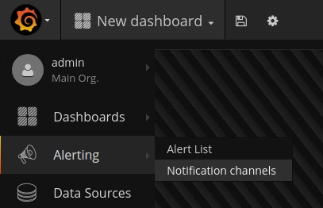

On the Notification Channels page hit the New Channel button to go the page where you can configure and setup a new Notification Channel. You specify name and type, and type specific options. You can also test the notification to make sure it’s working and setup correctly.

For an email notification channel, the changes have been made in Grafana environment variables. To setup Grafana dashboards, use the steps [here](http://docs.grafana.org/features/datasources/influxdb/#query-editor).

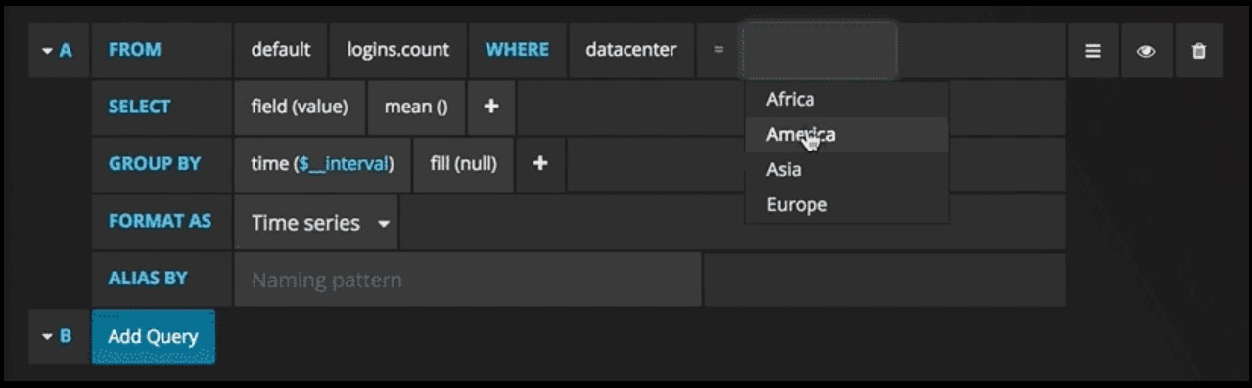

To setup alerts, follow these steps: To read more, refer [this link](http://docs.grafana.org/alerting/rules/#alerting-engine-rules-guide).

6. Setting up Chronograph

Create the Persistent Volume Claim using the following template as a reference

apiVersion: "v1"

kind: "PersistentVolumeClaim" metadata:

name: "chronograf-pvc-claim" spec:

accessModes:

- "ReadWriteMany" resources:

requests: storage: "5Gi"

Create the Service using the following template as reference

apiVersion: v1 kind: Service metadata:

creationTimestamp: null labels:

app: chronograf name: chronograf

spec:

ports:

- name: 8888-tcp port: 8888 protocol: TCP targetPort: 8888

selector:

app: chronograf deploymentconfig: chronograf

sessionAffinity: None type: ClusterIP

Create the Deployment Config using the following template as reference

apiVersion: v1

kind: DeploymentConfig metadata:

creationTimestamp: null generation: 1

labels:

app: chronograf name: chronograf

spec:

replicas: 1 selector:

app: chronograf deploymentconfig: chronograf

strategy: activeDeadlineSeconds: 21600

resources: {} rollingParams:

intervalSeconds: 1

maxSurge: 25%

maxUnavailable: 25%

timeoutSeconds: 600

updatePeriodSeconds: 1 type: Rolling

template: metadata:

creationTimestamp: null labels:

app: chronograf deploymentconfig: chronograf

spec:

containers:

* image: containers.cisco.com/sasharm4/chronograf:1.0 imagePullPolicy: IfNotPresent

name: chronograf ports:

- containerPort: 8888 protocol: TCP

resources: {}

terminationMessagePath: /dev/termination-log volumeMounts:

* mountPath: /var/lib/chronograf name: chronograf-volume

dnsPolicy: ClusterFirst restartPolicy: Always securityContext: {} terminationGracePeriodSeconds: 30 volumes:

* name: chronograf-volume persistentVolumeClaim:

claimName: "chronograf-pvc-claim" test: false

triggers:

- type: ConfigChange

Create the Route using the following template as reference

apiVersion: v1 kind: Route metadata:

creationTimestamp: null name: chronograf

spec:

host: [monitor-rtp-idev-cg.cisco.com](http://monitor-rtp-idev-cg.cisco.com/) port:

targetPort: 8888-tcp tls:

termination: edge to:

kind: Service name: chronograf weight: 100

wildcardPolicy: None

Open Chronograf UI and set InfluxDB IP address, username and password Set up Kapacitor instance, using your Chronograf UI

8. Links

Support Mailer - [tig-core](mailto:tig-core@cisco.com) ACC - [citeis.cisco.com](http://citeis.cisco.com/) ECH - [containers.cisco.com](http://containers.cisco.com/)

Telegraf Documentation - [github.com/influxdata/telegraf](https://wiki.cisco.com/github.com/influxdata/telegraf) InfluxDB Documentation - [github.com/influxdata/influxdb](https://github.com/influxdata/influxdb) Grafana Documentation - [github.com/influxdata/grafana](https://github.com/influxdata/grafana)

# User Roles and Bindings

Authorization policies determine whether a user is allowed to perform a given action within a project. This allows platform administrators to use the **cluster policy** to control who has various access levels to the OpenShift Container Platform platform itself and all projects. It also allows developers to use **local policy** to control who has access to their projects.

Authorization is managed using:

|  |  |
| --- | --- |
| **Rules** | Sets of permitted verbs on a set of objects. For example, whether something can create pods. |
| **Roles** | Collections of rules. Users and Groups can be associated with, or *bo und* to, multiple roles at the same time. |
| **Bindings** | Associations between users and/or groups with a role. |

There are two levels of authorization policy:

|  |  |
| --- | --- |
| **Cluster policy** | Roles and bindings that are applicable across all projects. Roles that exist in the cluster policy are considered *cluster roles*. Cluster bindings can only reference cluster roles. **Not available for CAE users.** |
| **Local policy** | Roles and bindings that are scoped to a given project. Roles that exist only in a local policy are considered *local roles*. Local bindings can reference both cluster and local roles. |

This two-level hierarchy allows re-usability over multiple projects through the cluster policy while allowing customization inside of individual projects through local policies.

### Important Roles

|  |  |  |  |  |
| --- | --- | --- | --- | --- |
| **Role** | **Type** | **Description** | **Assigned To** | **Example** |
| cluster-admin | default | A super-user that can perform any action in any project. When granted to a user within a local policy, they have full control over quota and roles and every action on every resource in the project. | **CAE Admins** |  |
| cluster-reader | default | A user that can get/list  /watch all resources in all projects. | **CAE Admins** |  |
| admin | default | A super-user that can perform any action in a particular project. **This role is granted to the ACC generic user only.** ACC uses this to create/delete projects and modify quota. | **ACC** | citeis-orchadm.gen |

|  |  |  |  |  |
| --- | --- | --- | --- | --- |
| project-admin | cae defined | This role grants the user complete access over a CAE project, except creation  /deletion, quota modification and access to the job resource. Use this role to grant your team members admin access on your project - oc policy add- role-to-user project- admin <username> -n  <projectname> | **CAE Users** | Project creator on ACC |
| project-admin-tp | cae defined | This role grants the user complete access over a CAE project, except creation  /deletion and quota modification. Use this role to grant your team members admin access on your project - oc policy add- role-to-user project- admin <username> -n  <projectname> | **CAE Users\*** | Projects currently using jobs\*\* |
| acc\_edit | cae defined | Same as project-admin. Assigned to ACC. | **ACC** |  |
| sdaas\_edit | cae defined | Provided for generic users from external SDaaS tools like ECH, uDeploy, CNM etc. Doesn't have access to the job resource. | **SDaaS Tools** | Udeploy, CNM etc. |
| view | default | A user who cannot make any modifications, but can see most objects in a project. They cannot view or modify roles or bindings. | **All** |  |

***\*Users in projects using jobs (jobs/cronjobs)***

***\*\*To be added (as of Jan 28th)***

### Important Commands

Running a simple oc policy --help you can view the authorization policy commands available.

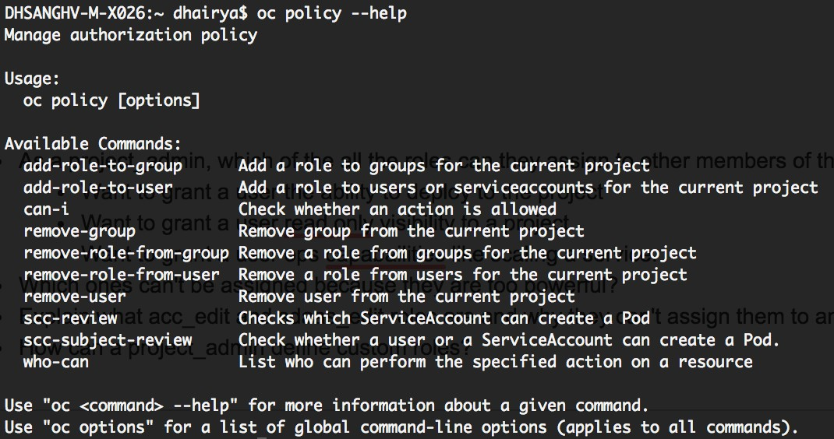

What can you do as an authenticated User:

oc policy can-i --list

Get Roles and Users for a Project:

oc get rolebindings -n <projectname>

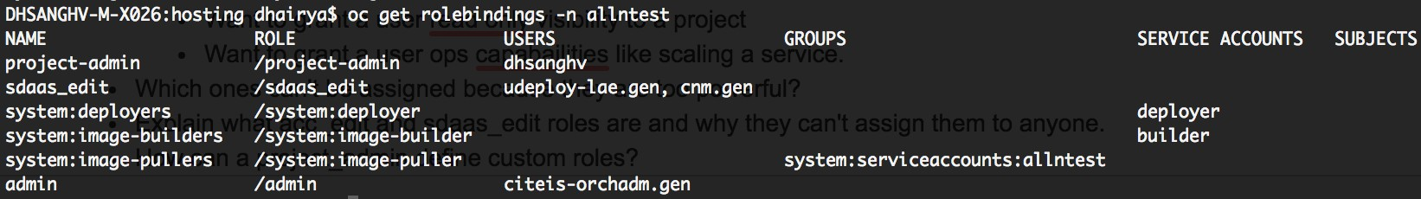

Assign Roles to Users:

oc policy add-role-to-user <role> <username>



You can verify this by running oc get rolebindings again.

Remove Roles from Users:

oc policy remove-role-from-user <role> <username>

**Note**

A rolebinding is a project level entity. Within a project, project administrators should be able to see rolebindings, not clusterr olebindings

Define Custom Roles in a Project:

Following is how a project-admin can define and assign custom roles within the local policy of a project. Since we are creating a new role from scratch, save the following snippet in a yaml file -

apiVersion: v1 kind: Role metadata:

name: viewsample rules:

* apiGroups: null attributeRestrictions: null resources:
  + pods
  + builds verbs:
  + get
    - list
    - watch

Create the role by using the following command -

oc create -f <filename>.yaml -n <projectname>

Once the role is created you can assign it to a user using the oc policy command.

# Native Memory Tracking on CAE JBoss/Tomcat

The Native Memory Tracking (NMT) is a Java HotSpot VM feature that tracks internal memory usage for a Java HotSpot VM. For details about NMT scope, how to enable NMT, and other additional usage details, see [Native Memory Tracking](https://docs.oracle.com/javase/8/docs/technotes/guides/vm/nmt-8.html).

Since NMT doesn't track memory allocations by non-JVM code, you may have to use tools supported by the operating system to detect memory leaks in native code.

### Enabling NMT on CAE JBoss/Tomcat

Native Memory tracking can be enabled by setting **JAVA\_OPTS** environment variable in the JBoss container.

Follow the below steps to enable NMT on a sample Java project.

**Step 1**: Create a deployment config(dc.yaml) file with below content.

Please note the environment variable **JAVA\_OPTS** set to value **-XX:+UnlockDiagnosticVMOptions -XX: NativeMemoryTracking=detail**

**dc.yaml**

###### apiVersion: v1

kind: DeploymentConfig metadata:

labels:

app: jbossews name: jbossews

spec:

replicas: 1 selector:

app: jbossews deploymentconfig: jbossews

strategy: activeDeadlineSeconds: 21600 resources: {}

rollingParams: intervalSeconds: 1

maxSurge: 25%

maxUnavailable: 25%

timeoutSeconds: 600

updatePeriodSeconds: 1 type: Rolling

template: metadata:

labels:

app: jbossews deploymentconfig: jbossews

spec:

containers:

* + - * image: containers.cisco.com/sujchinn/jbossews\_nmt:v1 imagePullPolicy: IfNotPresent

name: jbossews env:

* + - * + name: "JAVA\_OPTS"

value: "-XX:+UnlockDiagnosticVMOptions -XX: NativeMemoryTracking=detail"

ports:

* + - * + containerPort: 8080 protocol: TCP
        + containerPort: 8443 protocol: TCP
        + containerPort: 8778 protocol: TCP

resources: {}

terminationMessagePath: /dev/termination-log terminationMessagePolicy: File

dnsPolicy: ClusterFirst restartPolicy: Always schedulerName: default-scheduler securityContext: {} terminationGracePeriodSeconds: 30

**Image Info**

The base image used in the above docker is registry.access.redhat.com/jboss-webserver-3/webserver30-tomcat7-openshift. Please find the Dockerfile and sample application code in the [gitscm repo](https://gitscm.cisco.com/users/sujchinn/repos/java_nmt/browse).

**Step 2**: Create deployment config using the above file in your CAE project.

**SHELL**

oc create -f dc.yaml deploymentconfig "jbossews" created

**Step 3**: Verify that pod is created from deployment config.

STATUS RESTARTS AGE

Running 0 4m

oc get pods

NAME READY

jbossews-1-46c7w 1/1

**SHELL**

**Step 4**: Create service and route for the pod as needed. Below step shows how to create service.

**Info**

This step is optional for this exercise. We can verify NMT just with a pod created.

**service.yaml**

apiVersion: v1 kind: Service metadata:

creationTimestamp: null labels:

app: jbossews name: jbossews

spec:

ports:

* name: 8080-tcp port: 8080 protocol: TCP targetPort: 8080
* name: 8443-tcp port: 8443 protocol: TCP targetPort: 8443
* name: 8778-tcp port: 8778 protocol: TCP targetPort: 8778

selector:

app: jbossews deploymentconfig: jbossews

sessionAffinity: None type: ClusterIP

Step 5: Verfiy NMT is enabled using jcmd utility.

oc rsh jbossews-1-46c7w sh-4.2$ ps -ef

UID PID PPID C STIME TTY

jboss 1 0 0 13:08 ?

TIME CMD

00:00:10 /usr/lib/jvm/java-1.8.0

/bin/java -Dnop -Djava.util.logging.manager=org.apache.juli.

ClassLoaderLogManager -XX:+UnlockDiagnosticVMOptions -XX:NativeMemoryTr

sh-4.2$ jcmd 1 VM.native\_memory baseline

Picked up JAVA\_TOOL\_OPTIONS: -Duser.home=/home/jboss -Duser.name=jboss 1:

**SHELL**

**jcmd Utility Help**

1. Establish an early baseline - use NMT baseline feature to get a baseline to compare during development and maintenance by running: jcmd <pid> VM.native\_memory baseline.
2. Monitor memory changes using: jcmd <pid> VM.native\_memory detail.diff.
3. If the application leaks a small amount of memory, it make take a while to show up.

|  |  |  |  |  |  |
| --- | --- | --- | --- | --- | --- |
| jboss | 296 | 0 | 0 13:29 | ? | 00:00:00 /bin/sh |
| jboss | 302 | 296 | 0 13:29 | ? | 00:00:00 ps -ef |

###### Baseline succeeded

sh-4.2$ jcmd 1 VM.native\_memory detail.diff

Picked up JAVA\_TOOL\_OPTIONS: -Duser.home=/home/jboss -Duser.name=jboss 1:

Native Memory Tracking:

Total: reserved=18434057KB +25KB, committed=1672233KB +25KB

* Java Heap (reserved=16451584KB, committed=1030144KB) (mmap: reserved=16451584KB,

committed=1030144KB)

* Class (reserved=1074535KB, committed=26599KB) (classes #2634)

(malloc=9575KB #2886)

(mmap: reserved=1064960KB, committed=17024KB)

* Thread (reserved=29885KB, committed=29885KB) (thread #30)

(stack: reserved=29812KB, committed=29812KB) (malloc=38KB #155)

(arena=35KB #59)

* Code (reserved=251011KB, committed=8759KB) (malloc=1411KB #2266)

(mmap: reserved=249600KB, committed=7348KB)

* GC (reserved=611444KB, committed=561248KB) (malloc=10384KB #158)

(mmap: reserved=601060KB, committed=550864KB)

* Compiler (reserved=151KB, committed=151KB) (malloc=20KB #94)

(arena=131KB #3)

* Internal (reserved=9931KB, committed=9931KB) (malloc=9899KB #3997)

(mmap: reserved=32KB, committed=32KB)

* Symbol (reserved=4736KB, committed=4736KB) (malloc=2874KB #15224)

(arena=1862KB #1)

* Native Memory Tracking (reserved=584KB +25KB, committed=584KB +25KB)

(malloc=157KB +20KB #2465 +297)

(tracking overhead=428KB +5KB)

* Arena Chunk (reserved=196KB, committed=196KB) (malloc=196KB)

[0x00007f662b1ada09] [0x00007f662b1addee]

[0x00007f662b1ae451]

[0x00007f662b216170]

(malloc=1KB +1KB #18 +18)

[0x00007f662b1b1d0e] [0x00007f662b4406bd]

[0x00007f662b1adca6]

[0x00007f662b1ae451]

(malloc=4KB +4KB #44 +44)

[0x00007f662b1b1022] [0x00007f662b19601d] [0x00007f662b1adc18]

[0x00007f662b1ae451]

(malloc=18KB +11KB #281 +173)

[0x00007f662b1b1dda] [0x00007f662b4406bd]

[0x00007f662b1adca6]

[0x00007f662b1ae451]

(malloc=4KB +4KB #60 +60)

**Multi DC in CAE**

**What is MDC(Multi Data Center)?**

Multi Data Center (MDC) is a key capability that allows the distribution and seamless operation of applications across multiple distinct data centers.

Distribution of the application across distinct physical data centers provides increased resiliency against localised outages (scheduled or unscheduled). The distributed set of applications are treated as part of a virtual data center for all operations, including synchronous transactions.

MDC is active/active, means application instances will be equally distributed across multiple data centers(RCDN, ALLEN & RTP).

CAE is built across 3 DCs i.e RCDN,ALLEN & RTP.

Each DC (Availability zone) have its own OSE3(independent) installation.

Each installation will be treated as an isolated cluster and fully separated from other clusters.

Each data center will have 2 availability zones;One will host internal type apps and other will host external type apps.

These clusters are separate and isolated from each other (Internal Vs External) to provide control on security and isolation from communication perceptive.

**Why MDC(Multi Data Center)?**

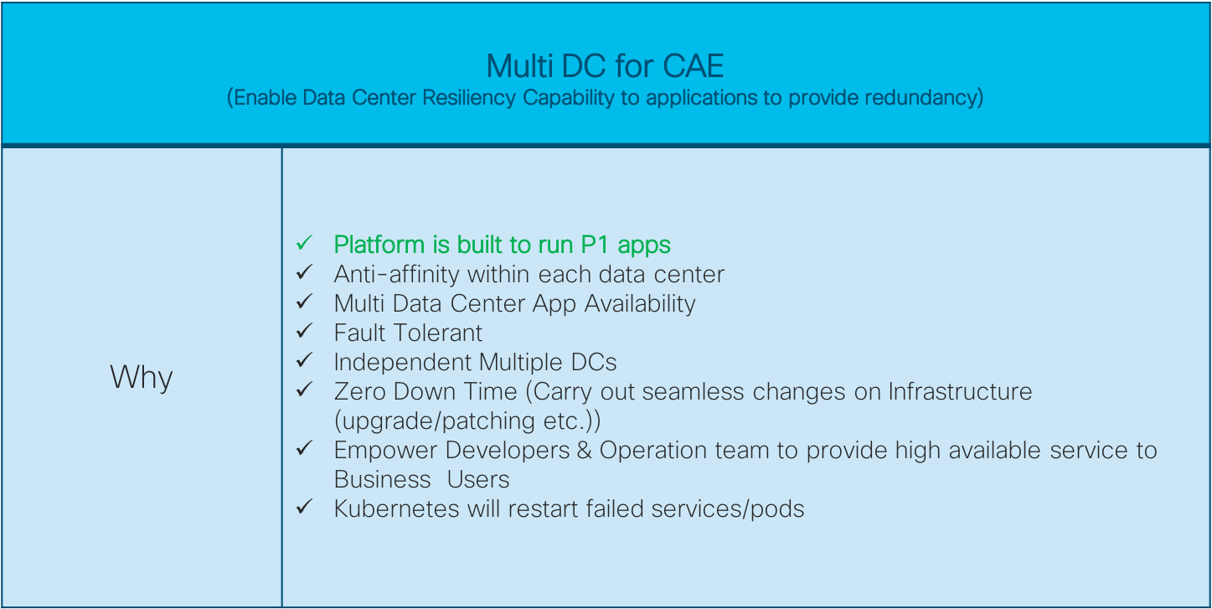

### How MDC(Multi Data Center)?

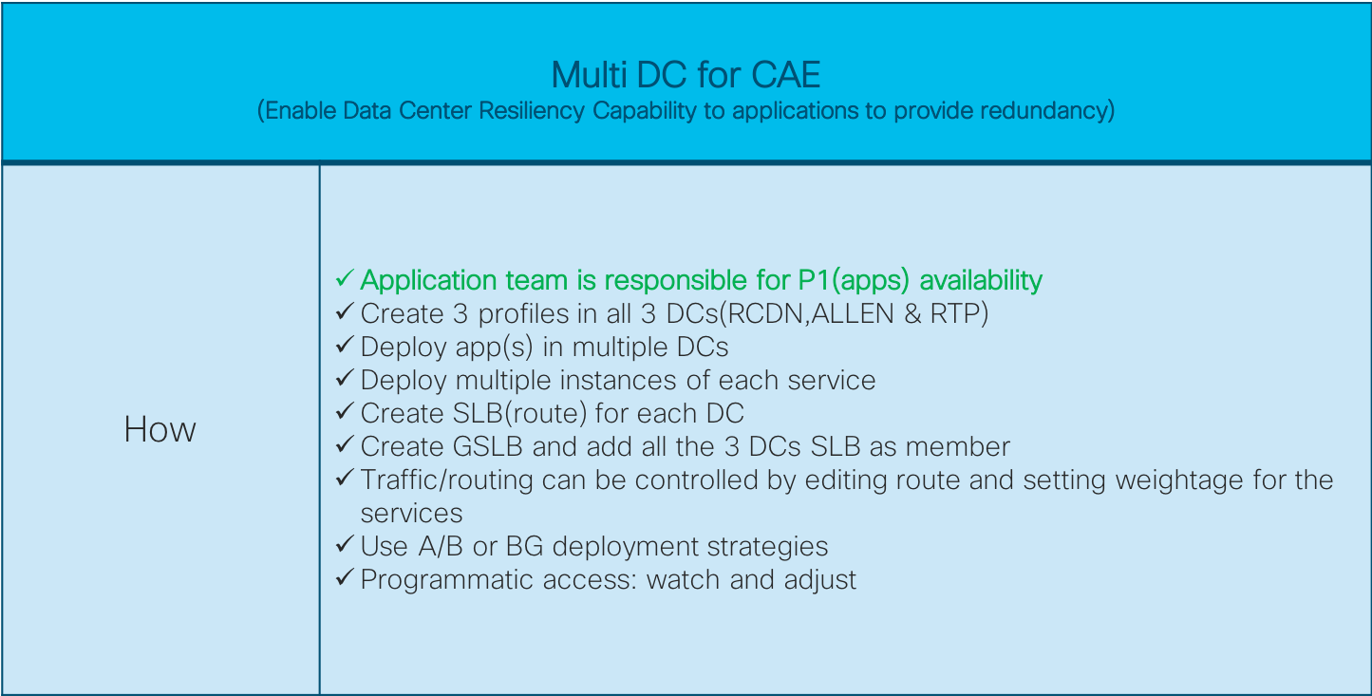

**Typical 2 DC HA Deployment**

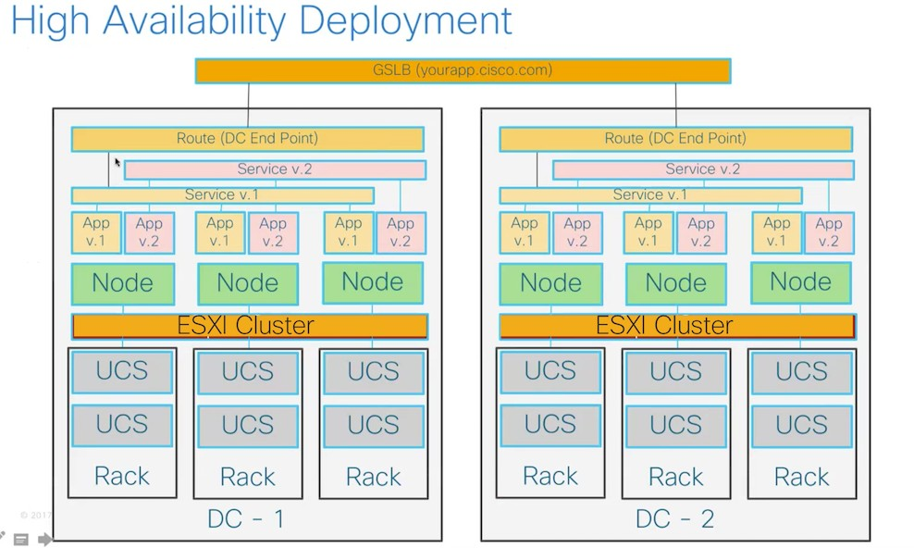

**What if my App cannot run with MDC?**

If you choose to run your App as non-MDC compliant, you must know the risks of possible outage when the DC where your app is running goes down due to scheduled or unschedules changes(upgrade/patching etc). As a non-MDC compliant app, your App will only be active in one datacenter, so there is no redundancy for your App in case of outage in the active datacenter.

## Are user requests equally distributed to Apps in all datacenters?

Yes. Your App will have redundant instances in all three RCDN , ALLEN & RTP datacenters. Users hitting your App URL may be directed to either RCDN or ALLEN or RTP instances.

## What happens if one datacenter has an outage?

There will be a session loss for the app that is located in the datacenter that is experiencing the outage. Existing sessions in that datacenter will be lost. Users will need to submit a new request (refresh).

New requests will be routed to the app in the other (active) datacenter.

If your existing session is in the active datacenter at the time of the outage, you will not lose your session.

**Note:** During failover there will not be any changes from Application Endpoint URLs.

## What is MDC App failover?

MDC App failover is a feature of MVDC that protects your apps with redundancy. Failover occurs when there is an outage in one datacenter or one stack and the redundant apps in the other stack or datacenter are still active. The active apps in the remaining stack or datacenter will continue to serve requests. Capacity will be limited to the available instances in the active datacenter or stack.

**Note**

During failover there will not be any changes from Application Endpoint URLs.

## High Availabilty within DC

The Kubernetes [replication controller](https://docs.openshift.com/container-platform/3.6/architecture/core_concepts/deployments.html#replication-controllers) ensures that the deployment requirements, in particular the number of replicas, are satisfied when the appropriate resources are available. When run with two or more replicas, the [router](https://docs.openshift.com/container-platform/3.6/architecture/networking/routes.html#routers) can be resilient to failures, providing a highly-available service. Depending on how the router instances are discovered (via a service, DNS entry, or IP addresses), this could impose operational requirements to handle failure cases when one or more router instances are "unreachable". This achieved using ***IP failover*** feature provided by Openshift.

#### IP failover

IP failover monitors a port on each VIP to determine whether the port is reachable on the node. If the port is not reachable, the VIP will not be assigned to the node

IP failover uses [**Keepalived**](http://www.keepalived.org/) to host a set of externally accessible VIP addresses on a set of hosts. Each VIP is only serviced by a single host at a time. **Keepalived** uses the VRRP protocol to determine which host (from the set of hosts) will service which VIP. If a host becomes unavailable or if the service that **Keepalived** is watching does not respond, the VIP is switched to another host from the set. Thus, a VIP is always serviced as long as a host is available.

Read more about IP failover [here](https://docs.openshift.com/container-platform/3.6/admin_guide/high_availability.html)

**Note**

IP failover is already set for you by platform administrators

## Deployment in Multiple DCs

[Deploy in multiple Data centres](https://wiki.cisco.com/display/CAEUSER/Deploy%2Bin%2Bmultiple%2BData%2Bcentres)

## Deployment Strategies

<https://docs.openshift.com/container-platform/3.6/dev_guide/deployments/deployment_strategies.html>

## Typical Blue-Green Deployment

[Blue/Green Deployment (B/G Deployment) Out of Box](https://wiki.cisco.com/pages/viewpage.action?pageId=86155337)

### Additional Details

Refer How To guide for more information: <https://wiki.cisco.com/display/CAEUSER/How-To>

\*\*\*\*\*\*\*\*\*\*\*\*\*\*\*\*\*\*\*\*\*\*\*\*\*\*\*\*\*\*\*\*\*\*\*\*\*\*\*\*\*\*\*\*\*\*\*\*\*\*\*\*\*\*\*\*\*\*\*\*\*\*\*

# Project Membership Management

Below modifications can only be performed by someone who can modify roles/rolebindings - a privilege given to the project-admin

/project-admin-tp roles.

Specific commands are available in the [User Roles and Bindings](https://wiki.cisco.com/display/CAEUSER/User%2BRoles%2Band%2BBindings) page

Membership in a project is controlled by users with the project-admin/project-admin-tp role assigned to them. To add someone, project admins assigns a role to the user and remove a role from the user to remove him/her from the project.

#### Custom Roles

**exampleview.yaml**

Custom roles can only grant as many privileges as the role assigned to the user creating the local role. So, a hypothetical user with 'view' access can't create a local role that gives it 'admin' privileges in the project since 'admin' grants more privileges than 'view'.

Project admins can create custom roles by creating objects of kind 'Role' and adding the appropriate rules to the role, like the following example:

apiVersion: v1 kind: Role metadata:

name: exampleview rules:

* apiGroups:

- ""

attributeRestrictions: null resources:

* + pods verbs:
  + get
  + list
  + watch

The above example creates a custom role, exampleview, allowing users to be able to list and watch pods only. Once you have the role definition, run the following command to add it to a specific project:



oc create -f <path\_to\_role.yaml> -n <project\_to\_add\_role\_to>

To list all the custom roles local to the project, run:

oc get roles -n <project\_role\_was\_added\_to>



In order to assign this role to a user within the project, project admins run the following command:



oc adm policy add-role-to-user <local\_role> <user> --role- namespace=<project\_name>

To remove a user assigned with the local role, run:



oc adm policy remove-role-from-user <local\_role> <user> --role- namespace=<project\_name>

# How to make application available externally in DMZ.

#### Use Case:

What I'm trying to do is build a Spark bot. This means the application needs to live in the DMZ so that it can accept a WebHook from the Spark cloud, but this request cannot be SSO authenticated because the Spark cloud is not going to authenticate against the app. There is a shared secret used to hash the request that my application will verify on its own.

Does CAE require SSO authentication on apps or is there a way to turn it off?

Do all apps get deployed to DMZ by default (therefore are reachable from the Internet) or is there something that needs to be configured to get external access?

I assume that would be somehow tied to the GSLB configuration, but looking at the screenshots for that, I don't see any internal/external options nor anything about enabling / disabling SSO

#### Solution:

1. Create an external prod application in CAE.That is reachable via internet
2. By default ping is protected every application. If you don't want or need Ping for your application due to legitimate business reasons, current policy is to go for InfoSec review and disable Ping authentication.
3. You can make your application as 'public' by using PMT tool provided by Ping team – [https://wampmtui.cloudapps.cisco.com](https://wampmtui.cloudapps.cisco.com/)

Steps:

To create an external prod project using ACC :-

* 1. you need to create your ACC app
  2. then create a profile of type "Prod"
  3. then create a project within it as type 'external'.

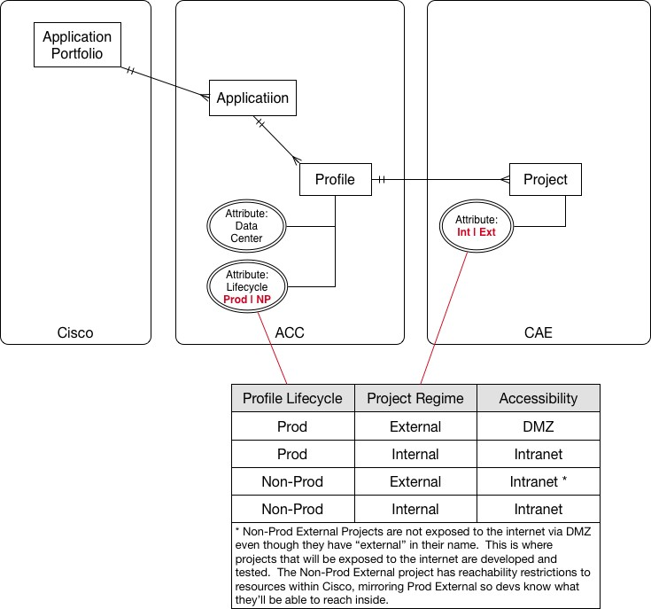

Here is documentation on Ping's Policy Management Tool for removing the default Ping SSO protection. This would be done after exposing your application via a Route.

<https://wiki.cisco.com/pages/viewpage.action?pageId=114767108>

# CronJob

A *cron job* builds on a regular [job](https://docs.openshift.com/container-platform/3.9/dev_guide/jobs.html#dev-guide-jobs) by allowing you to specifically schedule how the job should be run. Cron jobs are part of the [Kubernetes](http://kubernetes.io/docs/user-guide/cron-jobs) API, which can be managed with oc commands like other [object types](https://docs.openshift.com/container-platform/3.9/cli_reference/basic_cli_operations.html#object-types).

### Creating a Cron Job:

**CronJob.yml**

apiVersion: batch/v1beta1 kind: CronJob

metadata: name: pi

spec:

successfulJobsHistoryLimit: 1

failedJobsHistoryLimit: 1 schedule: "\*/1 \* \* \* \*" jobTemplate:

spec:

template: metadata:

labels:

parent: "cronjobpi" spec:

containers:

- name: pi

image: containers.cisco.com/sathepal/perl command: ["perl", "-e", "print 'Hello All!\n'"] resources:

limits: cpu: 60m

memory: 1Gi requests:

cpu: 60m memory: 1Gi

restartPolicy: OnFailure

#Make sure you are logged into one of the cae clouds, where your project exists.

#Make sure you are in correct project,verify it using oc project command #Using above CronJob.yml to create cronjob

(1)

#In this example, my project is in cae-np-rtp.cisco.com.

:>oc login cae-np-rtp.cisco.com

Authentication required for https://cae-np-rtp.cisco.com:443 (openshift) Username: sathepal

**How to create job**

###### Password:

Login successful

(2)

#I am using my appmgmprod-dev-int-rtp CAE project

:>oc project appmgmprod-dev-int-rtp

Now using project "appmgmprod-dev-int-rtp" on server "https://cae-rcdn. cisco.com:443".

(3)

#Using above CronJob.yml to create job

:>oc create -f CronJob.yml job "pi" created

#To check status (4)

:> oc get jobs

NAME DESIRED SUCCESSFUL AGE pi-1529020500 1 1 15s

(5)

:> oc describe jobs/pi-1529020500 Name: pi-1529020500

Namespace: appmgmprod-dev-int-rtp

Selector: controller-uid=5cda353c-702e-11e8-8861-fa163e463fb4 Labels: controller-uid=5cda353c-702e-11e8-8861-fa163e463fb4

job-name=pi-1529020500 parent=cronjobpi

Annotations: <none> Parallelism: 1

Completions: 1

Start Time: Thu, 14 Jun 2018 23:55:06 +0000 Pods Statuses: 0 Running / 1 Succeeded / 0 Failed Pod Template:

Labels: controller-uid=5cda353c-702e-11e8 8861-fa163e463fb4

job-name=pi-1529020500 parent=cronjobpi

Containers:

pi:

Image: containers.cisco.com/sathepal/perl Port:

Command: perl

-e

print 'Hello All!

'

Limits:

cpu: 60m

memory: 1Gi Requests:

cpu: 60m

memory: 1Gi

Environment: <none>

Mounts: Volumes:

Events: FirstSeen

Type

---------

--------

42s Normal

<none>

<none>

LastSeen Reason

--------

------

42s SuccessfulCreate

Count

-----

1

From Message

----

-------

job-controller

SubObjectPath

-------------

Created pod: pi-1529020500-gwqwb

#Deleting the pod that runs the CronJobs

oc delete -f CronJob.yaml

**Persistent Volume in Platform3**

**Overview**

In Platform3, **PersistentVolume** and its **PersistentVolumeClaim** objects can be provisioned dynamically at the same time by using a OpenShift **StorageClass**.

You can request storage by creating **PersistentVolumeClaim** objects in your projects. Right now, we only support ReadWriteOnce as accessModes. In the future, we will support other access modes.

**Storage Features in Platform3:**

1. Platform3 Storage is Cinder
2. The storage system is Ceph-Standard, a Block-Storage.
3. Unlike NFS, the Block-Storage is Read-Write-Once(RWO). The PV and PVC created on Platform3 is not sharable

#### Therefore, on Platform3, Please notice the following,

1. Cannot order PVC with RWX or ROX
2. An Application Pod with a RWO PVC can not scale
3. Use StatefulSets to deploy Scalable Application, the deployed pods will have Pod+PVC mode; each pod will have its own PVC
4. If application must need data share, Please contact storage team for assistance

# Create PVC via Console

1. Under your project, click "**Storage**" on the left panel
2. Click the button "**Create Storage**". In the prompted window, the parameters included in those red-marked boxes are mandatory
   1. Select Storage Class "standard"
   2. Select Access Mode Single User(RWO) . **Note:** up to now, this is the only option available
   3. Input the PVC name
   4. Input the storage size
   5. Click the button "Crate" to submit the request

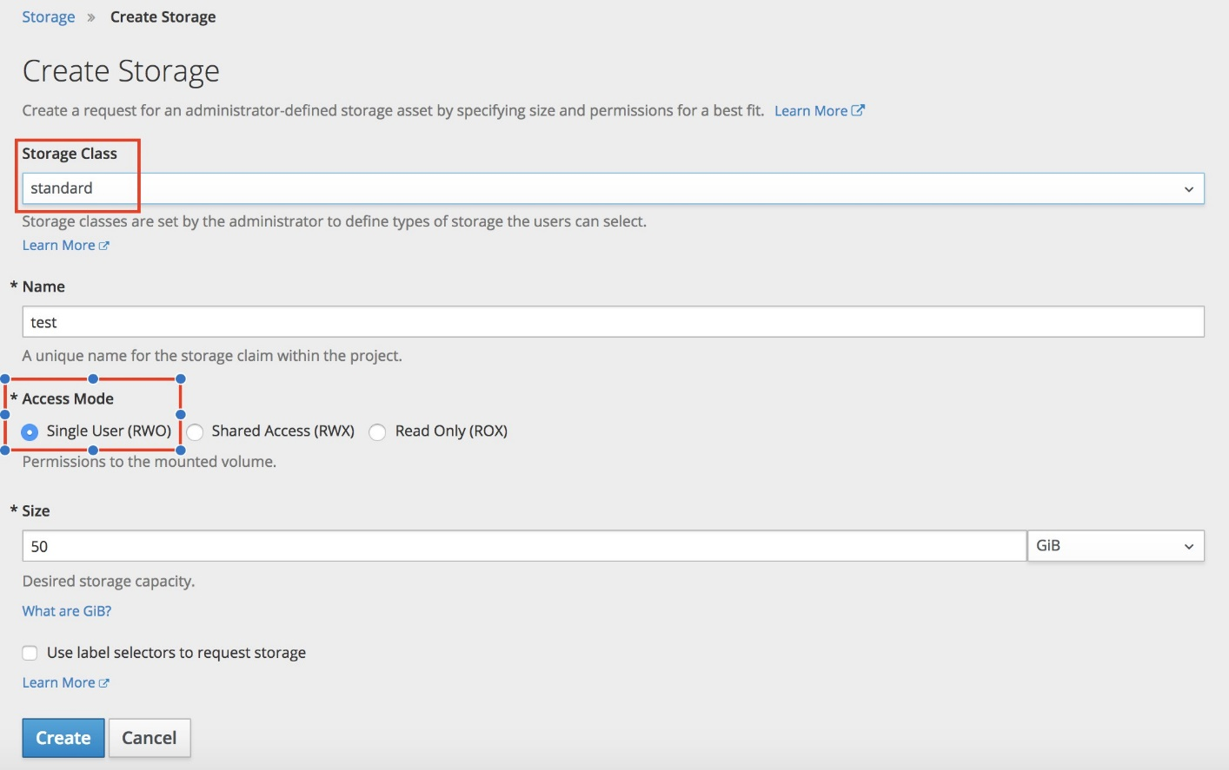

# Create PVC via yaml file

1. Create a pvc yaml file as the sample below. Red-Marked are Key-Words, and Blue-Marked are User Specific kind: PersistentVolumeClaim

apiVersion: v1 metadata:

name: <Name> spec:

accessModes:

- ReadWriteOnce resources:

requests:

storage: <Size> storageClassName: standard

1. run command "oc create -f <pvc yaml file>"
2. run command "oc get pvc " to verify

# Deploy a Scalable Application - statefulSets Application

Since Platform3 storage is a block-storage, which a RWO, an application's pod created with PVC will not be scalable.

**To deploy an application scalable on Platform3, you should deploy a StatefulSets application. There are two ways to create it.**

1. Create StatefulSets application via command line:
   1. **First, create a yaml file. A sample yaml shows below,**

**Note**: **a** red-marked word is the key-word, and the blue-marked words are application specific variables

Platform3 > cat statefulSets.yaml apiVersion: apps/v1

kind: StatefulSet metadata:

name: web spec:

selector: matchLabels:

app: nginx serviceName: "nginx" replicas: 2 template:

metadata: labels:

app: nginx spec:

terminationGracePeriodSeconds: 10 containers:

* name: nginx

image: [containers.cisco.com/qixie/qixie-nginx](http://containers.cisco.com/qixie/qixie-nginx):1.2 ports:

* + containerPort: 80

name: web volumeMounts:

* + name: www mountPath: /var/html

volumeClaimTemplates:

- metadata:

name: www spec:

accessModes: [ "ReadWriteOnce" ] storageClassName: "standard" resources:

requests: storage: 1Gi

* 1. run "oc create -f statefulSets.yaml -n <projectName>"

1. **Create StatefulSets Application via Openshift Console:**
   1. From OpenShift console left panel, click **"Application"** and select **"Stateful Sets"**
   2. Click **"Add to Project"** on the right corner, and select **"Import YAML/JSON"**

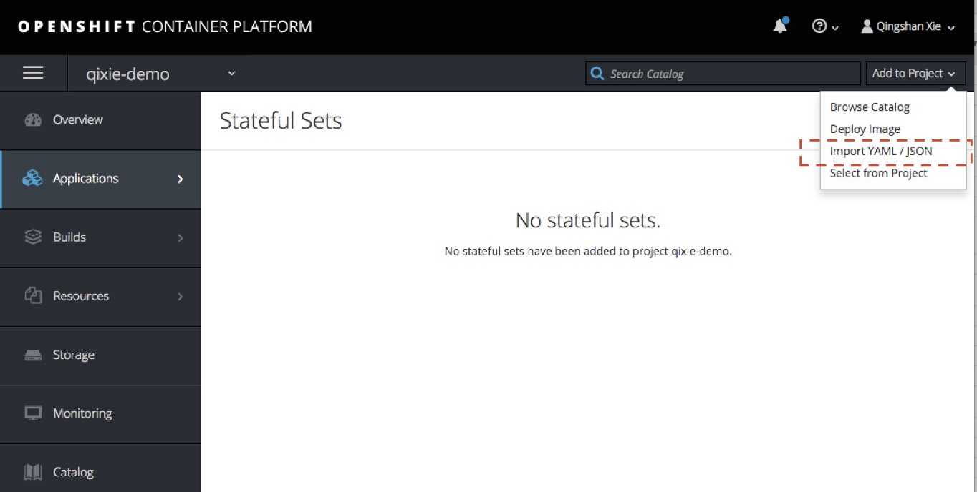

* 1. Click "Browser" to select pre-defined yaml file, or you can directly edit a yaml in side the clipboard. Example below,

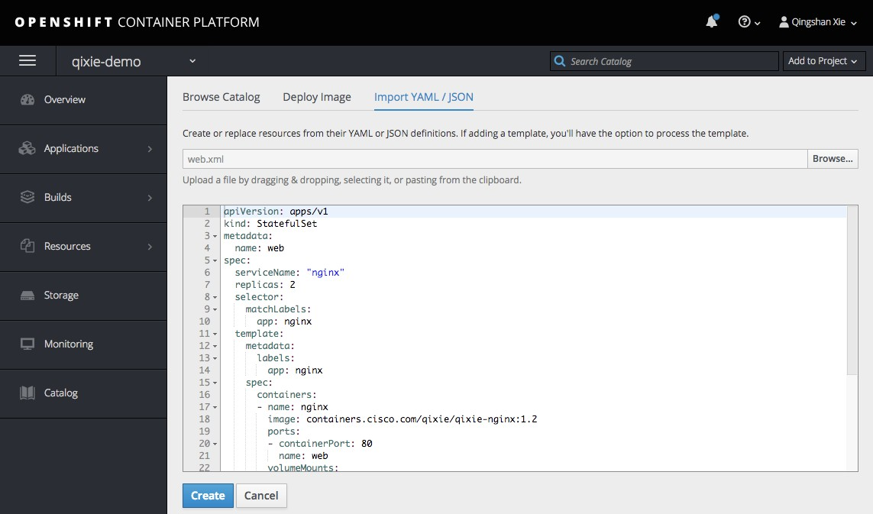

* 1. Click the button "Create". After a few min. a StatefulSets application will be created successfully.

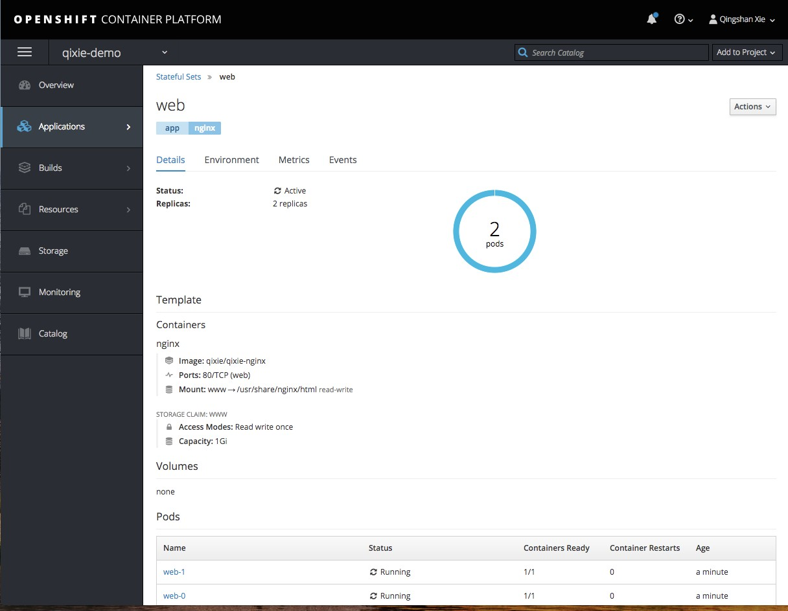

**Finally check the status of the StatefulSets application from command line,**

[qixie-mac17] ~/2018/Platform3 >**oc get all**

NAME DOCKER REPO TAGS UPDATED

is/qixie-nginx docker-registry.default.svc:5000/qixie-test/qixie-nginx 1.2 About an hour ago NAME REVISION DESIRED CURRENT TRIGGERED BY

dc/qixie-nginx 1 1 1 config,image(qixie-nginx:1.2) NAME DESIRED CURRENT READY AGE

rc/qixie-nginx-1 1 1 1 1h

NAME CLUSTER-IP EXTERNAL-IP PORT(S) AGE

svc/nginx None <none> 80/TCP 54m svc/qixie-nginx 172.30.154.224 <none> 80/TCP,8080/TCP 1h NAME KIND

statefulsets/web StatefulSet.v1.apps

NAME READY STATUS RESTARTS AGE

po/qixie-nginx-1-rvzvs 1/1 Running 0 1h

po/web-0 1/1 Running 0 54m

po/web-1 1/1 Running 0 52m

[qixie-mac18] ~/2018/Platform3 >oc get pvc

NAME STATUS VOLUME CAPACITY ACCESSMODES STORAGECLASS AGE

www-web-0

Bound

pvc-060b7fce-48c5-11e8-8a0b-fa163e00c19f

1Gi RWO

standard

58m

www-web-1

Bound

pvc-5d5b956e-48c5-11e8-8a0b-fa163e00c19f

1Gi RWO

standard 56m

**Notice**: In Platform3, the deployed apps with StatefulSets will have Pod+PVC style, means each pod will have its own dedicated PVC, created dynamically.

# View Container Logs

There are multiple ways to access CAE project logs and listing below different ways to access the project (application) logs.

[View Logs Using Enterprise Logging Services](https://wiki.cisco.com/display/CAEUSER/View%2BLogs%2BUsing%2BEnterprise%2BLogging%2BServices) [View Logs Using the CAE Kibana UI](https://wiki.cisco.com/display/CAEUSER/View%2BLogs%2BUsing%2Bthe%2BCAE%2BKibana%2BUI)

[View Logs Using the Console](https://wiki.cisco.com/display/CAEUSER/View%2BLogs%2BUsing%2Bthe%2BConsole) [View the multi-line logs in Splunk](https://wiki.cisco.com/display/CAEUSER/View%2Bthe%2Bmulti-line%2Blogs%2Bin%2BSplunk)

[CAE Logging Standard and Guidelines](https://wiki.cisco.com/display/CAEUSER/CAE%2BLogging%2BStandard%2Band%2BGuidelines) [Console logging message broken in chunks](https://wiki.cisco.com/display/CAEUSER/Console%2Blogging%2Bmessage%2Bbroken%2Bin%2Bchunks)

Enterprise Logging Services offers two tools - CLIP (Cisco Log Intelligence Platform) and Splunk.

# View Logs Using Enterprise Logging Services

The Enterprise Logging Services offers two tool, CLIP (Cisco Log Intelligence Platform) and Splunk for logs viewing. Please refer to below documents under this section for details:

View logs from CLIP View logs from Splunk

CAE sends one stream of logs to the enterprise logging bus and enterprise logging team would configure where the logs are sent among above the two tools listed above. Please work with them to set up the desired configuration.

Enterprise Logging Services contact: CLIP [(clip-support-team@cisco.com](http://cisco.com/))

Splunk [(code-splunk-support@cisco.com](mailto:code-splunk-support@cisco.com))

# View Logs Using the CAE Kibana UI

CAE Kibana UI also provides access to CAE project logs (container logs). However, it retains logs for last 1 week only. For longer retention and log analysis, please check the logs using Enterprise logging services (CLIP/Splunk).

The details/steps to access those are listed under "View Container logs" wiki page.

### Steps to access and search for the logs in the CAE Kibana UI:

1. Click on the below three urls to access logs for each DC respectively (RCDN, ALLN or RTP):

PROD NON-

PROD

|  |  |  |  |
| --- | --- | --- | --- |
| ALLN | <https://cae-prd-alln-logs.cisco.com/> | <https://cae-np-alln-logs.cisco.com/> |  |
| RCDN | <https://cae-prd-rcdn-logs.cisco.com/> | <https://cae-np-rcdn-logs.cisco.com/> |  |
| RTP | <https://cae-prd-rtp-logs.cisco.com/> | [https://cae-np-rtp-logs.cisco.com/](http://cae-np-rtp-logs.cisco.com/) |  |

1. Login with you CEC id and it will bring up logging UI:

One would be able to access the CAE app(s)/project(s) as per the access available for the project.

If there is multiple projects accessible, please see arrow key on the right side (see screenshot below) and click the drop down to view all the projects available.

The search results by default lists events from last 15 minutes. Click on the arrow on the left side (see screenshot below) to specify different search duration.

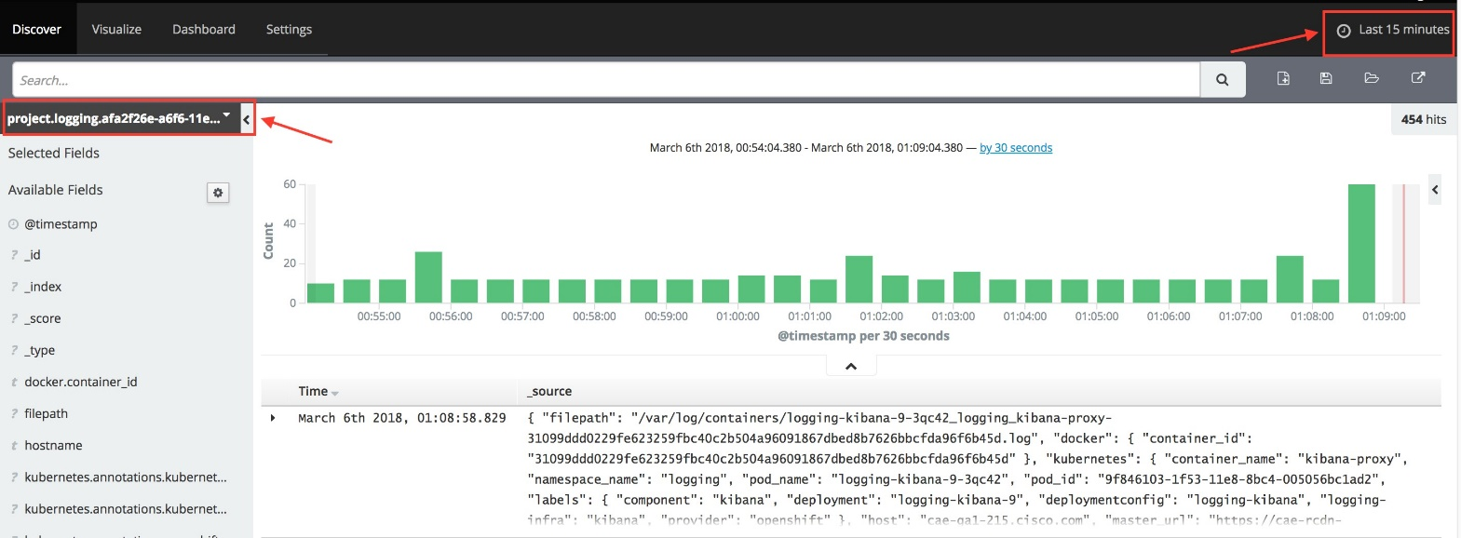

Below provides the option to select search time slots:

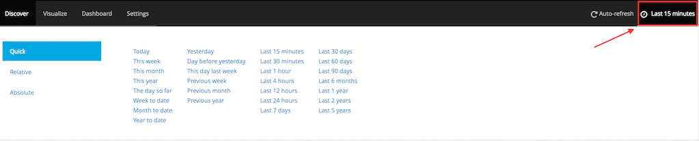

1. The search results gets listed in the logging UI as multiple rows. Click on error below to see the details of the event and metadata associated with it (see screenshot below):

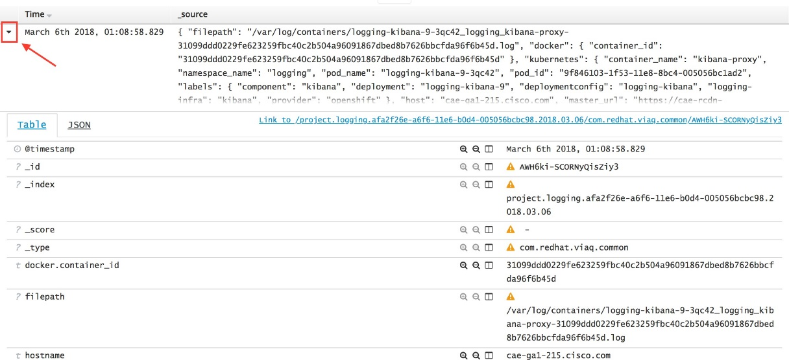

1. Few sample search queries:
   1. Specify project name (namespace), pod name and search string as per below query:

kubernetes.namespace\_name:logging AND kubernetes.pod\_name:logging-kibana-3-zwts8 AND message:\*unavailable\*

* 1. Search for “error” string coming from all logging-fluentd pods

kubernetes.pod\_name:logging-fluentd\* AND message:\*error\*

* 1. Search for logging events from two logging-fluentd pods:

kubernetes.pod\_name:logging-fluentd-wtwvj OR kubernetes.pod\_name:logging-fluentd-03qf8

* 1. Specify hostname and “error” string coming up from that host”

hostname:cae-ga1\* AND error

Below is the screenshot for one of the sample searches:

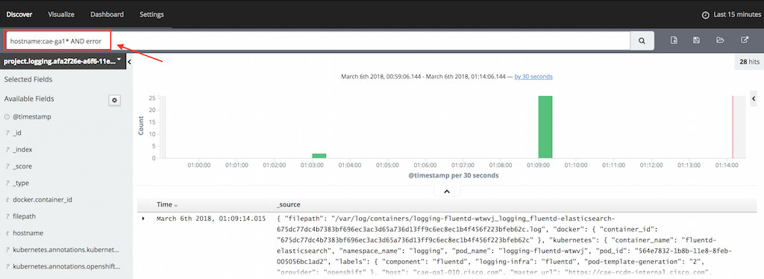

# View Logs Using the Console

This offers quick access to the container and/or pod logs while on the CAE console. However, it lists last 5000 lines of the logs only.

For more detailed log analysis, please check the logs using Enterprise logging services (CLIP/Splunk) or CAE Kibana UI. The details/steps to access those are listed under "View Container logs" wiki page.

### Steps to view CAE container logs through console

* + 1. Under the project pod, click on the "Logs" tab to view the logs:

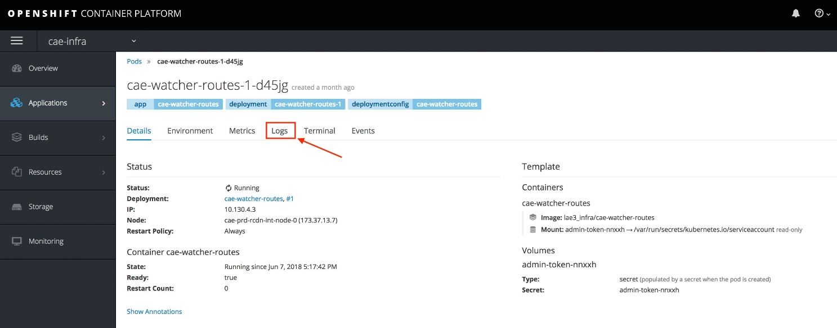

* + 1. The logs are listed on the console for a particular pod as listed below. Also there is an option to click on "View Archive" button ands this would open the CAE Kibana tool directly. As noted above, the console log lists last 5000 lines of logs:

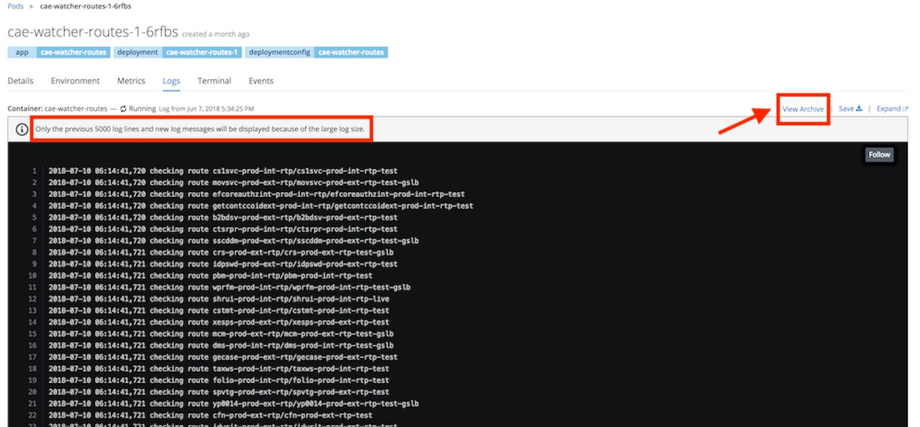

# View the multi-line logs in Splunk

Contents:

1. Multi-line issue
2. Solving the issue in application side
3. Workflow
4. Migration from log4j to log4j2
5. Conclusion
6. **What is the cause and the impact of the multi-line issue?**

The application logs are collected by CAE-Fluentd and forwarded to Splunk/CLIP. Application can insert multiple line breaks into one log message with discretion. However, when your application printout the multi-line stack trace or normal log message, the entire message can be splitted line by line which can become the junk and overhead for CAE, Splunk and CLIP. Since all the splitted log messages are not usable, the Application team cannot trace the errors from the junk data. It also takes out enormous amount of the storage space for Splunk and Clip. It also consumes a lot of resources in CAE to transform and ship the data out. The problem starts at the Docker level. Whether standard output from Docker processes ends up in [journald](https://docs.docker.com/config/containers/logging/journald/) or [json](https://docs.docker.com/config/containers/logging/json-file/) logs, they are handled line-by-line.

Solution can be done in several places by replacing the \n (new line) inside the message payload to some other characters. So, Fluentd can collapse the multi-line message into one message event instead of sending multiple log events to Splunk/CLIP. The change can be applied in CAE Fluentd or application side. However, it is very difficult to catch all the log format to properly replace the \n character. It is much easier to fix the issue in application side since the application has the control of the log format.

Example: The following is the original application stack trace log that create the multi-line issue.

2018-12-10 18:00:45,092 [ERROR] [jeprasad-sAnBJB29fB9nosSDGcD9FYGk] com.cisco.swtg.sasi.web.controller.landing.CaseController - Generate multiline exceptionjava.lang.RuntimeException: my multiline exception \n

com.cisco.swtg.sasi.web.controller.landing.CaseController.genAuthCode(CaseController.java:434) [classes:?] \n sun.reflect.NativeMethodAccessorImpl.invoke0(Native Method) ~[?:1.8.0\_191] \n

sun.reflect.NativeMethodAccessorImpl.invoke(NativeMethodAccessorImpl.java:62) ~[?:1.8.0\_191] \n sun.reflect.DelegatingMethodAccessorImpl. invoke(DelegatingMethodAccessorImpl.java:43) ~[?:1.8.0\_191] \n

java.lang.reflect.Method.invoke(Method.java:498) ~[?:1.8.0\_191] \n org.springframework.web.bind.annotation.support.HandlerMethodInvoker. invokeHandlerMethod(HandlerMethodInvoker.java:176) [spring-web-3.2.9.RELEASE.jar:3.2.9.RELEASE] \n ....................................

### Solving the issue in application side

Application normally uses either Log4j or Logback log utility tools backed by Spring Framework. You can either change the application.yml in Spring level or logback-spring.xml / log4j2.xml in log configuration file level. You need to execute the replace feature. The newer log4j2 has replace feature. Please make sure you use the log4j2 instead of version 1 for log4j.

Example in application.yml for logback:

logging.pattern.console: "%d{yyyy-MM-dd HH:mm:ss.SSS} %5p YML %-40.40logger{39}: %replace(%m%wEx)

{'\\n','\r'}%nopex%n"

Example in logback xml configuration: (The following pattern layout can be different from yours, please refer this [Logback Pattern Layout](https://logback.qos.ch/manual/layouts.html#xThrowable) doc)

<property name="logPattern" value="[%d{yyyy-MM-dd HH:mm:ss:SSS Z}] | %X{User} | STID=%X{STID} | %level | %logger{15}.%method:%line -

%replace(%m){'\n', '\\r'}%n%ex"/>

Similar pattern can be set in Logback configuration XML using the unicode value for CR :

<?xml version="1.0" encoding="UTF-8"?>

<configuration>

<!-- This conversionRule is required to make %wEx work. Instead %n%ex is good too -->

<conversionRule conversionWord="wEx" converterClass="org.springframework.boot.logging.logback.WhitespaceThrowableProxyConverter" />

<appender name="STDOUT" class="ch.qos.logback.core.ConsoleAppender">

<encoder>

<pattern>%d{yyyy-MM-dd HH:mm:ss.SSS} %5p XML %-40.40logger{39}: %replace(%m%wEx){'\n','&#x000D;'}%nopex%n</pattern>

</encoder>

</appender>

<root level="info">

<appender-ref ref="STDOUT" />

</root>

</configuration>

Example in log4j2.xml change:

<Console name="Console-Appender" target="SYSTEM\_OUT">

<PatternLayout>

<alwaysWriteExceptions>false</alwaysWriteExceptions>

<pattern>

%date{yyyy-MM-dd'T'HH:mm:ss.SSSZ}{UTC} %5p %t %c{5.}:%L %m MULTIEXCEPTION %replace{%rException}

{\n}{\\r}%n

</pattern>

</PatternLayout>

</Console>

</Appenders>

\*\* After you applied the changes, the logs will be folded into one as following screenshot. However, the display might not fit your requirement due to the bug in your xml configuration file. We can do the following as the workaround to trick the XML engine. In the following example, we use AS CII code 13 corresponds to a carriage return. In this case, the xml parser will treat it as carriage return code instead of String or Characters presentation.

<Appenders>

<Console name="Console-Appender" target="SYSTEM\_OUT">

<PatternLayout>

<alwaysWriteExceptions>false</alwaysWriteExceptions>

<pattern>

%date{yyyy-MM-dd'T'HH:mm:ss.SSSZ}{UTC} %5p %t %c{5.}:%L %m MULTIEXCEPTION %replace{%rException}

{\r?\n}{&#13;}%n

</pattern>

</PatternLayout>

</Console>

</Appenders>

\*\* Here is another sample configuration from SCM team in log4j2.xml that also fixed the display issue.

<PatternLayout alwaysWriteExceptions="false" pattern="%d [%-5p] [%X{sessionId}] %c - %replace{%m%rException}{\r?\n}{&#13;}%n" />

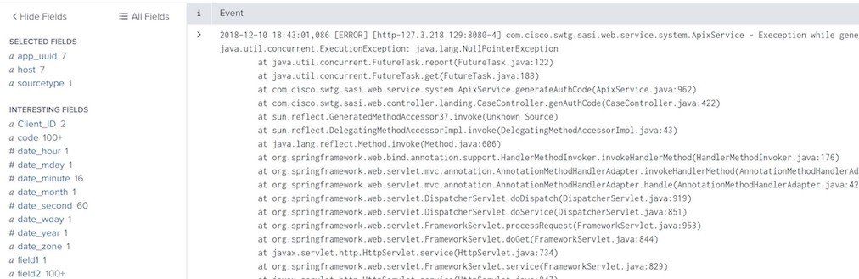

### Workflow

After the change is done, the application will generate the stack trace similar to the following. As you can see the entire stack trace message is collapsed into one message event.

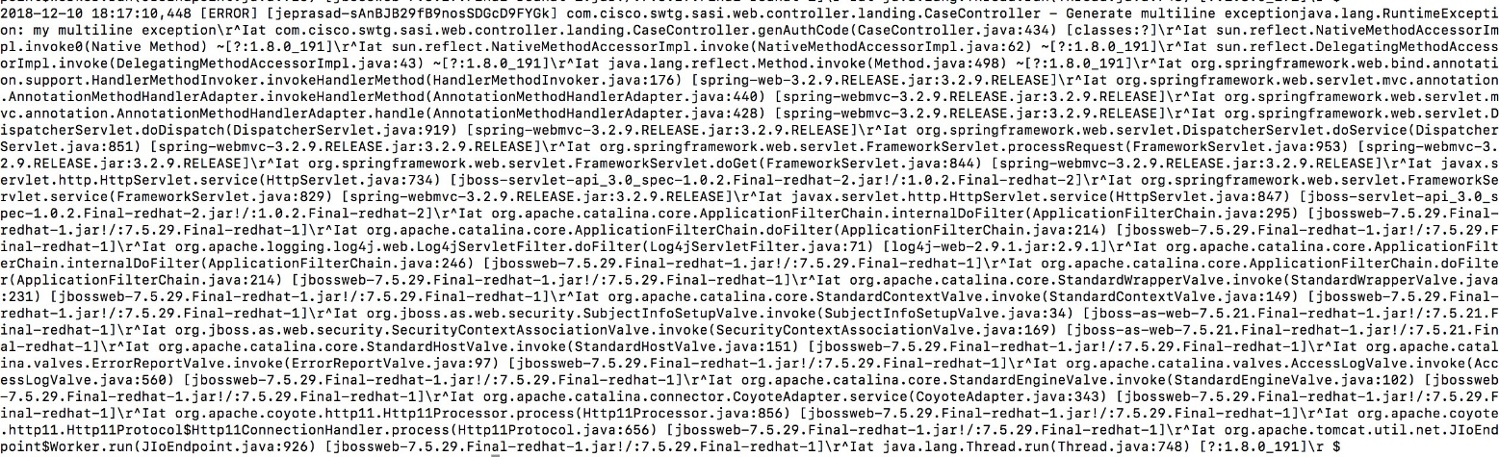

Then Fluentd forwards the message to Kafka first level. In this level, the message will be reformatted to the correct format for Splunk/CLIP.



The CR characters can cause the issue if you try to access the pod log with the Openshift oc command in your desktop. However, you can attach the simple perl or sed command to convert CR back to LF.

Please make sure you have the perl or sed installed in your desktop before run the following oc logs command:

oc logs -f your-pod-name | perl -pe 's/\R/\n/g'

### Migration from log4j to log4j2

If your application is using log4j, then it might require some change in your application to use log4j2. It is still fairly simple to migrate your application to use log4j2. Below is the steps to follow:

<https://www.docs4dev.com/docs/en/log4j2/2.x/all/manual-migration.html>

Some application teams might have the difficulty to migrate to log4j2 since the effort might be bigger. In this case, deploying the sidecar container in the application pod will also solve the issue.

The sidecar will be the log shipper that also replaces the \r and \n to &#13 inside one stacktrace message before it ships to Splunk.

### Conclusion

You should now have a basic idea of solving the multi-line logs in making the simple change in log configuration.

References:

<https://itnext.io/multiline-logs-in-openshift-efk-stack-7a7bda4ed055>

[https://medium.com/@martatatiana/aws-lambda-in-java-8-log4j2-and-scattered-stacktrace-in-cloudwatch-a4aea2e7bf2a](https://medium.com/%40martatatiana/aws-lambda-in-java-8-log4j2-and-scattered-stacktrace-in-cloudwatch-a4aea2e7bf2a) <https://fabianlee.org/2018/03/09/java-collapsing-multiline-stack-traces-into-a-single-log-event-using-spring-backed-by-logback-or-log4j2/>

# CAE Logging Standard and Guidelines

Contents:

* 1. Kubernetes logging architecture
  2. Using standard console log with pod metadata
  3. Custom log
  4. Conclusion

1. **Kubernetes logging architecture**

Kubernetes has the standard way to outputs data to the standard output stream (STDOUT / STDERR). So, in order to make the most of Kubernetes logging features, we need to change some logging configuration of the application to use stdout / stderr. Before we start changing our application, we might need to know Kubernetes logging architecture.

Let's write a pod spec with a application container and apply it to Openshift: oc apply -f myapplication.yaml

---

apiVersion: v1 kind: Pod metadata:

name: application1 spec:

containers:

- name: application1

image: containers.cisco.com/my-application1

If successful, you should see the message said pod "application1" created. You should be able to view the Pod's logs either from Openshift console or command: oc logs pod application1

By default, where did those logs go and come from? By default in Kubernetes, Docker is configured to write a container's stdout and stderr to a file under /var/log/containers on the host system like the followings:

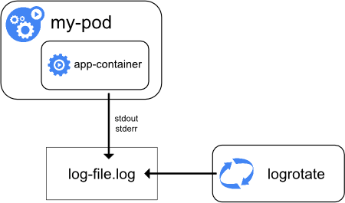

from: [https://kubernetes.io](https://kubernetes.io/)

Then Fluentd agent ships all logs under /var/log/containers to Kafka and then reaches to Splunk/Clip.

The logging workflow described above is the standard way in Kubernetes. Of course, the application can choose different way by writing the log to different location on the host system using EMPTYDIR volume. However, I strongly recommend using the Kubernetes standard way by making the simple change in log configuration in Application side.

### Using standard console log with pod metadata

Most of the Jave applications use either Log4j or Logback for logs. Most of the developers should be familiar with configuring log4j or logback to write the logs to a file on disk. By following the standard way, you should avoid writing the logs to a file inside the container. Instead, you should write logs to the standard output stream. In this case, you need to configure your log4j or logback:

Example of log configuration in log4j:

log4j.rootCategory=INFO, console log4j.appender.console=org.apache.log4j.ConsoleAppender log4j.appender.console.target=System.out log4j.appender.console.layout=org.apache.log4j.PatternLayout

.....

Example of log configuration in logback: please refer <https://logback.qos.ch/manual/configuration.html>for details.

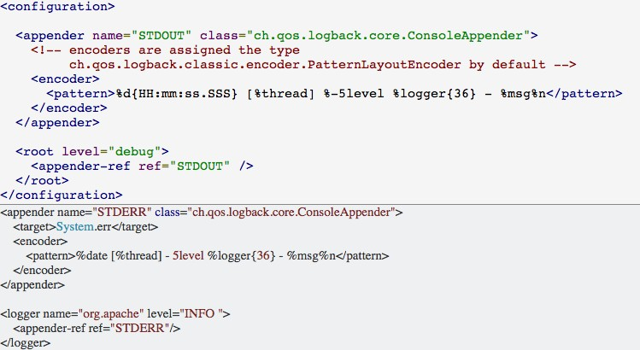

After that, the log will be in the standard output stream.

### Custom log

A lof of applications still use custom log. Instead of writing the log through standard output stream, the application write the log to the disk in container. If the application writes the log inside the container disk, then it can mount to Emptydir volume. So, the Fluentd agent can pick up the logs from host system. In the host system, the logs will go to

/var/lib/origin/openshift.local.volumes/pods/\*/volumes/kubernetes.io~empty-dir/\*/\*.log

Example in the deployment yaml file: volumeMounts:

- name: "software-prod-ext-alln" mountPath: "/opt/webserver/logs"

volumes:

* name: "software-prod-ext-alln" emptydir: {}

Example: the log path of the log:

/var/lib/origin/openshift.local.volumes/pods/e2a699fc-3553-11e9-a288-fa163e6c748f/volumes/[kubernetes.io](http://kubernetes.io/)~empty-dir/software-prod-ext-rcdn- ssmsvcs-legacy

/var/lib/origin/openshift.local.volumes/pods/a9e699hh-3952-14o8-p288-fa163e6d555j/volumes/[kubernetes.io](http://kubernetes.io/)~empty-dir/software-st1-np-int-rtp- ssmsvcs-legacy

**Important note:** In Splunk, we use sourcetype to support multi-tenancy. The sourcetype is Openshift project name, we have the standard naming convention:

<customer project name>-<lifecycle>-<ext | int>-<alln | rtp | rcdn>-<pod name> lifecycle: prod, np, dev, stg, lt

Custom log doesn't provide any Kubernetes metadata including the sourcetype, pod name, cluster info. In order to know the source type and

some basic info of the log, we need to use the source type as volumes name. If your sourcetype doesn't follow the naming convention, then the volume name should follow the naming in order for Splunk to know the information such as sourcetype, production or non-production log, external or internal log, location of the data center.

### Conclusion

Using standard console log is the recommended way to run the application logs in CAE Openshift P3.

References:

<https://cleverbuilder.com/articles/java-kubernetes-tips/> <https://kubernetes.io/docs/concepts/cluster-administration/logging/>

# Console logging message broken in chunks

1. What is the cause and the impact of logging Message broken in chunks?

Docker use this option: max-log-size to limit the log size.The default max-log-size is 16k. Once the log reaches the size, it will start chop the log into smaller one. It will display log details in multiple chunks based on timestamp. Docker locks the max-log-size and it does not allow to increase this value. The reason Docker locks the size is because it wants better performance and avoid too much memory consumption that may lead to OutOfMemory situation.

1. Solution for the issue.

As CAE platform cannot increase the setting to a higher value, to solve this problem, application team needs to reduce the message size in one log event.

# Fix Session Cookie missing "Secure" flag issue to pass the BAVA Scan

#### Issue Description:

=======================================================================================

Application could not pass the BAVA Scan because in its inserted Session Cookie does not have the "Secure" flag. The example is below,

Set-Cookie: e4e544b1d77500930044d07f21bd2d2f=7199f5b66b78953211b5a607b69eb008; path=/; HttpOnly; (Secure) There should be an attribute "Secure" in the cookie since our env only allow SSL security traffic not plain text.

#### The Root-Cause

The app's Route is configured to allow the Insecure Traffic. I pasted the route configuration yaml example below.

========================================================================================

apiVersion: v1 kind: Route metadata: annotations:

[citeis.cisco.com/comment](http://citeis.cisco.com/comment): Do not delete this route manually. It is part of a GSLB configuration.

[citeis.cisco.com/route\_event](http://citeis.cisco.com/route_event): 'true'

[citeis.cisco.com/route\_type](http://citeis.cisco.com/route_type): Generated

creationTimestamp: '2018-06-05T00:34:32Z' name: ui-framework-gslb

namespace: mcmp-rtp-stage resourceVersion: '833228966'

selfLink: /oapi/v1/namespaces/mcmp-rtp-stage/routes/ui-framework-gslb uid: 36e1e78a-6858-11e8-9f74-005056bc006b

spec:

host: [mcmp-stage.cisco.com](http://mcmp-stage.cisco.com/) port:

targetPort: http tls:

insecureEdgeTerminationPolicy: Allow

termination: edge to:

kind: Service

name: ui-framework weight: 100 wildcardPolicy: None

status:

……

====================================================================================

Notice the **tls** spec section “insecureEdgeTerminationPolicy: Allow”, which means the application allows HTTP traffic to access. That is why no flag “secure” in the session cookie insertion. The default is “None” which is HTTPS only. The solution is either modify the spec to “insecureEdgeTerminationPolicy: None” or delete this line completely, that will update your route with “secure” flag inserted.

#### How to fix the issue - Modify your route yaml from console

==================================================================================

* 1. Click your application's route
  2. Click the button “Action” at the right top corner, then select “Edit Yaml”
  3. It will prompt you a window with the route yaml. An example shows below

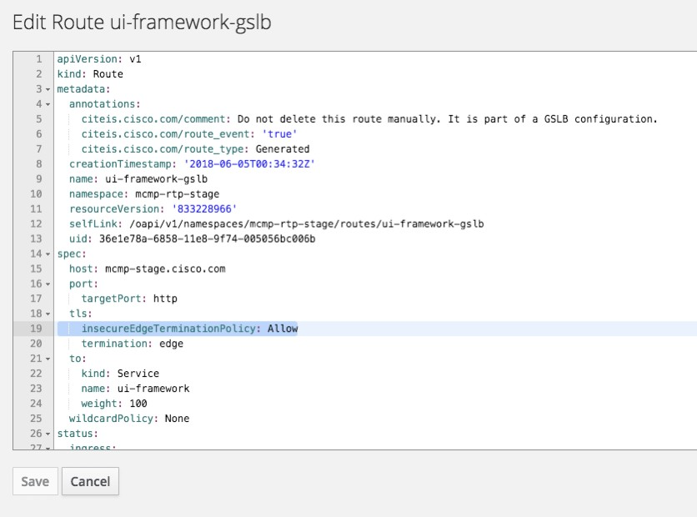

* 1. Remove the line ““insecureEdgeTerminationPolicy: Allow” or modify it as “insecureEdgeTerminationPolicy: None”
  2. Save it and check your route in console if you see the update “Insecure Traffic” from Allow to None

……

TLS Settings

Termination Type: **Edge**

**Insecure Traffic:** Allow

**Certificate:** *none*

**Key:** *none*

CA Certificate: ***none***

**Destination CA Cert:** *none*

**Capture Heap Dumps on CAE**

For Migrating applications , If you already have below java arguments in your pre\_start scripts , same will be available in CAE and heap dumps will be generated under $OPENSHIFT\_LOG\_DIR.

export JAVA\_OPTS\_EXT="${JAVA\_OPTS\_EXT} -XX:+HeapDumpOnOutOfMemoryError -XX:HeapDumpPath=$OPENSHIFT\_LOG\_DIR

For Greenfield applications,

1. Please add

-XX:+HeapDumpOnOutOfMemoryError to your JAVA arguments

-XX:HeapDumpPath= "{user\_defined\_path}"

Below example user\_defined\_path points to /opt/eap/standalone/log

1. Update your deployment config to use [emptydir](https://kubernetes.io/docs/concepts/storage/volumes/) to generate the heapdumps.

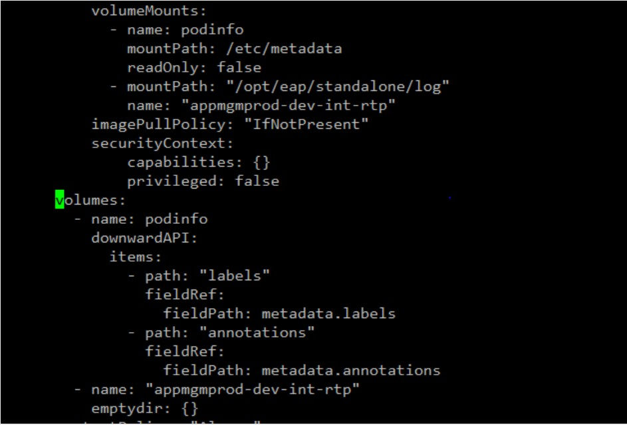

You should be able to see below log if your application generates heap dump on out of memory.

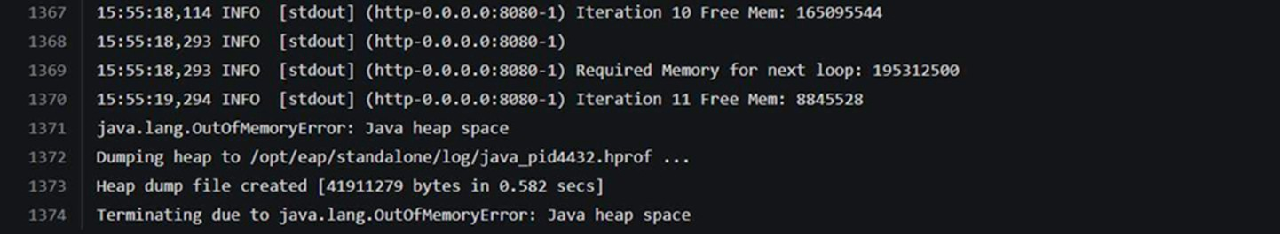

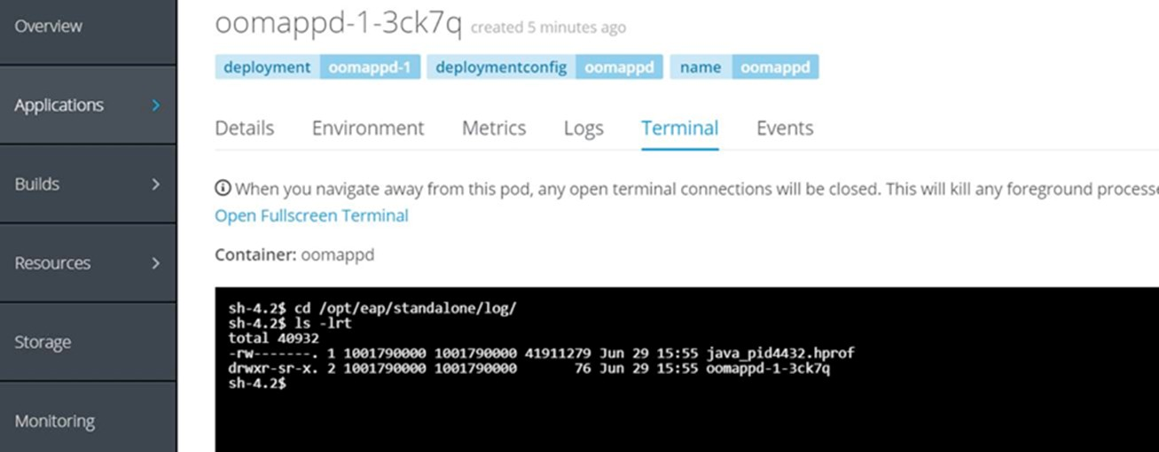

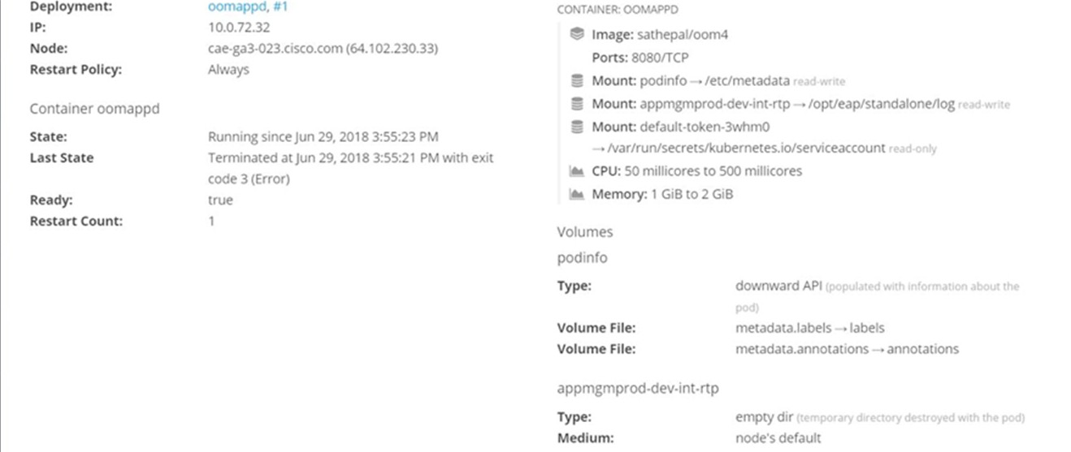

# Connect to RDAC DB from CAE

#### Restricted Database Access Control (RDAC) -

RDAC is an application which restricts and monitors database connections to databases containing financial data-Sox Databases. This is implemented by the use of ACLs (Access Control Lists). For access to be granted to connect to a SOX schema in a SOX database, an ACL needs to be registered in RDAC.

For more info : Please refer [RDAC](http://rdac.cloudapps.cisco.com/viewRdacHome.do)

You need to again register your DB in RDAC for CAE. An CAE ACL in RDAC require :

* 1. **Database Name -** Database to which the connection is being made.
  2. **Schema Name -** SOX Schema to which the connection is being made.
  3. **OS User -** Shared secret from a CAE host is passed (as v$session.osuser) by the application when establishing a connection to the database.

[Register your application for RDAC access](https://wiki.cisco.com/display/062509/RDAC%2BOperations%2B15-999-0) for new applications on CAE

##### Steps to create [Secret](https://kubernetes.io/docs/concepts/configuration/secret/) object in CAE Projects to hold the shared secret:

1. **CAE Secrets allows only encoded values. Find the below example to encode using base64 algorithm.**

Secret string should be anything, as it's a sensitive information for each application so there's no standard process suggested. To encode use following command :

echo -n '<OS\_USER>' | base64 Use the generated string in step 2. **Example:**

echo -n 'appmgm#2#access#rdac' | base64 YXBwbWdtIzIjYWNjZXNzI3JkYWM=

**Note:** CAE Secret should be less than 30 characters

1. Create secret using above generated value

**secret.yaml**

apiVersion: v1 kind: Secret metadata:

name: rdac-secret type: Opaque

data:

rdacosuser: YXBwbWdtIzIjYWNjZXNzI3JkYWM=

Login to the respective cluster and switch to your project [To perform below, you require [oc client](https://wiki.cisco.com/display/CAEUSER/Download%2Boc%2Bclient)]

oc login [cae-np-rtp.cisco.com](http://cae-np-rtp.cisco.com/) (for RTP) , cae-prd-alln.cisco.com (For ALLN) , cae-prd-rcdn.cisco.com (For RCDN)

oc project projectname( Project where you want to create secret) Copy the above content to yaml file

oc create -f secret.yaml ( from the location of secret.yaml)

1. Define the Deployment so that application can access the shared secret and CAE (Host IP) as environment variables

**Deployments**

spec:

containers:

- env:

- name: OPENSHIFT\_RDAC\_OSUSER

valueFrom: secretKeyRef:

name: rdac-secret key: rdacosuser

1. **Add the below entry in context.xml for the respective RDAC database in Tomcat**

connectionProperties="v$session.osuser=${OPENSHIFT\_RDAC\_OSUSER};"

For Jboss under datasources section you need to add the following entry

<connection-property name="v$session.osuser">${env.OPENSHIFT\_RDAC\_OSUSER}</connection-property>

1. Java Applications read the environment variables and set to connection properties.

**Example Code Snippet for DB Connectivity**

Properties props = new Properties(); props.setProperty("user", "newapp\_user"); props.setProperty("password", "xxxxxx"); props.setProperty("v$session.osuser", System.getenv ("OPENSHIFT\_RDAC\_OSUSER"));

connection = DriverManager.getConnection(

"jdbc:oracle:thin:@ (DESCRIPTION= (ADDRESS=(PROTOCOL=TCP)(HOST=dbc-prd-vm- 1019-vip)(PORT=1542)) (CONNECT\_DATA=(SERVICE\_NAME=CCIXPROD.cisco.com)))",

props);

Statement stmt = connection.createStatement(); ResultSet rs;

rs = stmt.executeQuery("select sysdate from dual");

while ( rs.next() ) { System.out.println(rs.getString("SYSDATE"));}

**Jolokia**

The xPaaS images deploy the Jolokia library providing a REST API fronting JMX. This can also be used with other Java applications. If the container has a port named “Jolokia” a link to the Java Console is displayed in the pod page of the OpenShift Web Console

Steps to configure jolokia agent:

* 1. Export the jolokia arguments to JVM arguments

export JAVA\_OPTS\_EXT="${JAVA\_OPTS\_EXT} -DLOG\_DIR=${OPENSHIFT\_LOG\_DIR} -javaagent:/opt/jolokia/jolokia.jar=port=8778, protocol=https,caCert=/var/run/secrets/kubernetes.io/serviceaccount/ca.crt,clientPrincipal=cn=system:master-proxy, useSslClientAuthentication=true,extraClientCheck=true,host=0.0.0.0,discoveryEnabled=false"

* 1. Update Deployment yaml file for jolokia port 8778

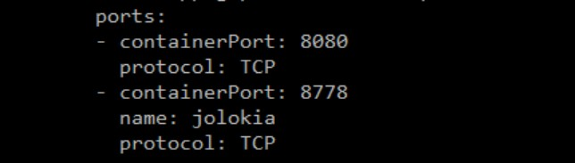

* 1. 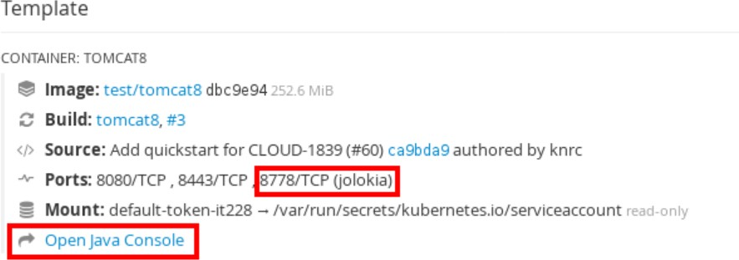Deploy the pod and access the jolokia console by clicking Open Java Console

1.

# Create Secret

The Secret object type provides a mechanism to hold sensitive information such as passwords, OpenShift Container Platform client configuration files, dockercfg files, private source repository credentials, and so on

Please refer below Openshift documentation for more information on Secrets. <https://docs.openshift.com/container-platform/3.9/dev_guide/secrets.html>

**secret.yaml**

apiVersion: v1

# https://docs.openshift.com/container-platform/3.9/dev\_guide/secrets.html kind: Secret

# Other Kubernetes objects in the cluster can reference values from our Secret

# using name: mysql-credentials and key: <somekey>, like key: user metadata:

name: mysql namespace: myproject

type: Opaque

# Encode secrets exactly like this from your command line

# if you use a different command, you will run into errors with newlines data:

# root password for MySQL

# the actual password is MyRootPass # echo -n MyRootPass | base64 password: dmFyTXlSb290UGFzcw==

# user for MySQL

# the actual username is MyDBUser

# echo -n MyDBUser | base64 ( Run it in from any Linux Host) username: dmFyTXlEQlVzZXI=

# Cronjob: Interaction with Application Pod

Problem statement:

Cronjob in Openshift will spin up a new container on every occasion as per the cron schedule with the specified image & perform the operation(s) in its own container and exit. The existing application pods are untouched and in most occasions one would like to interact with the existing application pod(s) – executing commands, scripts etc.

Below is one such example wherein a Cronjob will interact with an already running application POD by invoking a script inside the pod.

Sample cronjob.yaml:

*apiVersion: batch/v2alpha1 kind: CronJob*

*metadata:*

*name: jajaja # This is the name of the Cronjob spec:*

*schedule: "\*/10 \* \* \* \*" # Runs once every 10 minutes jobTemplate:*

*spec:*

*successfulJobsHistoryLimit: 3 # Good to limit, specify a small # failedJobsHistoryLimit: 1 # Good to limit, specify a small # template:*

*metadata: labels:*

*parent: "cronjobjaja" spec:*

*containers:*

*- name: jaja # Cronjob Pod is prefixed with this name*

*image: containers.cisco.com/rchoodan/oc:wow # This container has oc 3.9*

*client; Use this image only for POC, this is not intended for Production use*

*command: ["/bin/sh","-c","oc exec -it `oc get pods|grep jboss|awk '{print $1}'`*

*/tmp/runme.sh;"] # script executed inside the application POD restartPolicy: OnFailure*

**Note**: Modify the above appropriately; like name, schedule, Image, command;

!# `oc get pods|grep jboss|awk '{print $1}'`<- This command will dynamically identify the application pod where the oc exec should run, modify the grep pattern accordingly to uniquely select your application pod.

!# /tmp/runme.sh <- This is the script hosted on my application POD, invoked by oc exec.

Create a cronjob container with oc:

*[root@rchoodan6 cronjob]# ls -l total 212932*

*-rw-r--r--. 1 root root 565 Oct 17 09:11 cronjob.yaml*

*-rw-r--r--. 1 root root 69 Oct 16 18:13 Dockerfile*

*-rwxr-xr-x. 1 root root 218031504 Oct 16 14:51 oc [root@rchoodan6 cronjob]# ./oc version*

*oc v3.9.14*

*kubernetes v1.9.1+a0ce1bc657*

*features: Basic-Auth GSSAPI Kerberos SPNEGO Server https://cae-np-rtp.cisco.com:443*

*openshift v3.9.30*

*kubernetes v1.9.1+a0ce1bc657 [root@rchoodan6 cronjob]# cat Dockerfile FROM centos:latest*

*COPY ./oc /usr/bin*

*CMD ["sh", "-c", "oc version"] [root@rchoodan6 cronjob]#*

Grant ‘oc exec’ permission to serviceaccount by adding project-admin role:

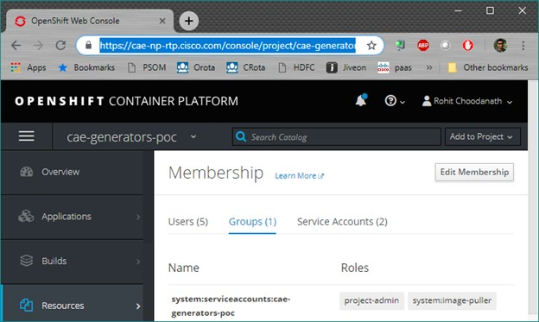

**Create and verify the Cron:**

*[root@rchoodan6 cronjob]# oc create -f cronjob.yaml cronjob "jajaja" created*

*[root@rchoodan6 cronjob]# oc get cronjob # Output after couple of hours NAME SCHEDULE SUSPEND ACTIVE LAST SCHEDULE AGE*

*jajaja \*/10 \* \* \* \* False 10 7m 15h [root@rchoodan6 cronjob]# oc get job*

|  |  |  |  |
| --- | --- | --- | --- |
| *NAME* | *DESIRED* | *SUCCESSFUL* | *AGE* |
| *jajaja-1539757800* | *1* | *0* | *2h* |
| *jajaja-1539758400* | *1* | *0* | *2h* |
| *jajaja-1539759600* | *1* | *0* | *2h* |
| *jajaja-1539760200* | *1* | *0* | *1h* |
| *jajaja-1539760800* | *1* | *0* | *1h* |
| *jajaja-1539762600* | *1* | *1* | *1h* |
| *jajaja-1539763200* | *1* | *0* | *1h* |
| *jajaja-1539763800* | *1* | *0* | *56m* |
| *jajaja-1539764400* | *1* | *0* | *46m* |
| *jajaja-1539765000* | *1* | *1* | *36m* |
| *jajaja-1539765600* | *1* | *1* | *26m* |
| *jajaja-1539766200* | *1* | *0* | *16m* |
| *jajaja-1539766800* | *1* | *0* | *6m* |

*[root@rchoodan6 cronjob]#*

**Note:** Ensure you clear the Jobs on a frequent basis (both Failed & Successful jobs); Openshift does not clear them for you; you can clear the jobs by running:

*[root@rchoodan6 ~]# oc delete job `oc get job |awk '{print "oc delete job "$1}'` job "jajaja-1539753000" deleted*

*job "jajaja-1539753600" deleted job "jajaja-1539754200" deleted job "jajaja-1539754800" deleted job "jajaja-1539755400" deleted job "jajaja-1539756000" deleted job "jajaja-1539756600" deleted job "jajaja-1539757200" deleted*

*. . .*

Cron Job Pod as seen on the UI Console:

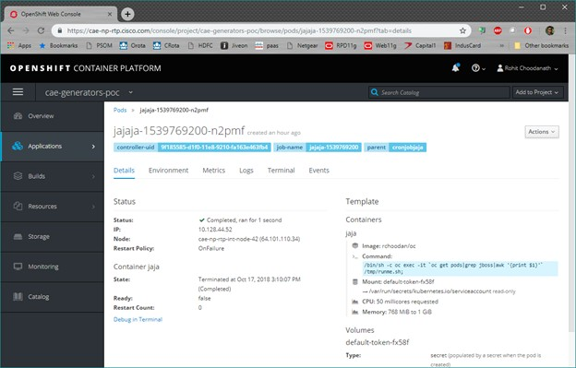

Sample cronjob.yaml+Dockerfile+oc

# AppDynamics

**JBoss 6.4**

#### [LAE to CAE Migration using AWS Managed Jboss6.4 custom image](file:///C:\Machine%20Learning\Test\PDF\ilovepdf_split-range\CAE%20Wiki%20Pages-151-403.docx#_bookmark0)

[**LAE to CAE Migration using AWS Managed Jboss6.4 redhat base image or OpenSource**](file:///C:\Machine%20Learning\Test\PDF\ilovepdf_split-range\CAE%20Wiki%20Pages-151-403.docx#_bookmark1)[**Jboss image**](file:///C:\Machine%20Learning\Test\PDF\ilovepdf_split-range\CAE%20Wiki%20Pages-151-403.docx#_bookmark1)

[**New CAE Application using AWS Managed Jboss6.4 custom image**](file:///C:\Machine%20Learning\Test\PDF\ilovepdf_split-range\CAE%20Wiki%20Pages-151-403.docx#_bookmark2)

[**New CAE Application using AWS Managed Jboss6.4 redhat base image or OpenSource**](file:///C:\Machine%20Learning\Test\PDF\ilovepdf_split-range\CAE%20Wiki%20Pages-151-403.docx#_bookmark3)[**Jboss image**](file:///C:\Machine%20Learning\Test\PDF\ilovepdf_split-range\CAE%20Wiki%20Pages-151-403.docx#_bookmark3)

[**Troubleshooting Issues**](file:///C:\Machine%20Learning\Test\PDF\ilovepdf_split-range\CAE%20Wiki%20Pages-151-403.docx#_bookmark6)

**LAE to CAE Migration using AWS Managed Jboss6.4 custom image**

Appdynamics enablement process is automated for the application migrating from lae to cae using AWS managed jboss6.4 custom image.

Generate the Deployment yaml and Dockerfile from [LAE2CAE.cisco.com](http://lae2cae.cisco.com/)

**Deployment yaml** generated from the [LAE2CAE.cisco.com](http://LAE2CAE.cisco.com/) will have the required appd environment variables by default for the applications enabled for appd in lae.

**AppDynamics APM Agent** binaries will be included by default in the AWS managed jboss custom Image([containers.cisco.com](http://containers.cisco.com/aws_managed/jboss6.4_custom)

[/aws\_managed/jboss6.4\_custom](http://containers.cisco.com/aws_managed/jboss6.4_custom))

**Dockerfile** - No change.

Application team responsibilities is to only verify the following ENV variable section of the [Deployment Yaml](file:///C:\Machine%20Learning\Test\PDF\ilovepdf_split-range\CAE%20Wiki%20Pages-151-403.docx#_bookmark5) are appropriate for their application(Refer the attached sample [Dockerfile](file:///C:\Machine%20Learning\Test\PDF\ilovepdf_split-range\CAE%20Wiki%20Pages-151-403.docx#_bookmark4) and [Deployment Yaml](file:///C:\Machine%20Learning\Test\PDF\ilovepdf_split-range\CAE%20Wiki%20Pages-151-403.docx#_bookmark5) for reference).

Steps for [AppDynamics testing with SdaaS Deployment](file:///C:\Machine%20Learning\Test\PDF\ilovepdf_split-range\CAE%20Wiki%20Pages-151-403.docx#_bookmark7) Steps for [AppDynamics testing with out SdaaS Deployment](file:///C:\Machine%20Learning\Test\PDF\ilovepdf_split-range\CAE%20Wiki%20Pages-151-403.docx#_bookmark8)

**LAE to CAE Migration using AWS Managed Jboss6.4 redhat base image or OpenSource Jboss image**

AppDynamics enablement for migrating application from lae to cae using AWS Managed Jboss6.4 redhat base image([containers.cisco.com](http://containers.cisco.com/aws_managed/jboss-6.4)

[/aws\_managed/jboss-6.4](http://containers.cisco.com/aws_managed/jboss-6.4)) or any open source jboss image requires changes to Dockerfile.

Generate the Deployment yaml and Dockerfile from [LAE2CAE.cisco.com](http://lae2cae.cisco.com/)

**Deployment yaml** generated from the [LAE2CAE.cisco.com](http://LAE2CAE.cisco.com/) will have the required appd environment variables by default for the applications enabled for appd in lae.

**AppDynamics APM Agent** binaries will NOT be included by default. To include the binaries follow the steps below.

SdaaS Deployment:

- Configure Jenkin job – Execute Shell as below

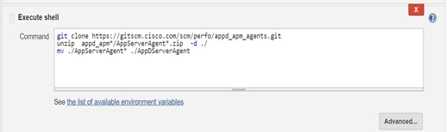

Without SdaaS Deployment:

* + - Download the latest Appdynamics APM Agent from following **GIT Link**: [https://gitscm.cisco.com/projects/PERFO/repos](https://gitscm.cisco.com/projects/PERFO/repos/appd_apm_agents/browse)

[/appd\_apm\_agents/browse](https://gitscm.cisco.com/projects/PERFO/repos/appd_apm_agents/browse)

* + - Unzip the downloaded agent, create a folder “AppDServerAgent” and copy the unzipped agent folder contents to this folder.

##### Dockerfile:

* + - * Add the below lines to [Dockerfile](file:///C:\Machine%20Learning\Test\PDF\ilovepdf_split-range\CAE%20Wiki%20Pages-151-403.docx#_bookmark4) file to embed Appdynamics Agent ( Refer sample attached [Dockerfile](file:///C:\Machine%20Learning\Test\PDF\ilovepdf_split-range\CAE%20Wiki%20Pages-151-403.docx#_bookmark4))

Application team responsibilities is to add changes to Dockerfile and include binaries as above and verify the following ENV variable section of the [Deployment Yaml](file:///C:\Machine%20Learning\Test\PDF\ilovepdf_split-range\CAE%20Wiki%20Pages-151-403.docx#_bookmark5) are appropriate for their application(Refer the attached sample [Dockerfile](file:///C:\Machine%20Learning\Test\PDF\ilovepdf_split-range\CAE%20Wiki%20Pages-151-403.docx#_bookmark4) and [Deployment Yaml](file:///C:\Machine%20Learning\Test\PDF\ilovepdf_split-range\CAE%20Wiki%20Pages-151-403.docx#_bookmark5) for reference)

Steps for [AppDynamics testing with SdaaS Deployment](file:///C:\Machine%20Learning\Test\PDF\ilovepdf_split-range\CAE%20Wiki%20Pages-151-403.docx#_bookmark7) Steps for [AppDynamics testing with out SdaaS Deployment](file:///C:\Machine%20Learning\Test\PDF\ilovepdf_split-range\CAE%20Wiki%20Pages-151-403.docx#_bookmark8)

**New CAE Application using AWS Managed Jboss6.4 custom image**

AppDynamics enablement for the New CAE application requires changes to Procedures, Dockerfile and YAMl files

Procedure:

* Raise a service now case with Performance team following steps @ [Create Maas Case](file:///C:\Machine%20Learning\Test\PDF\ilovepdf_split-range\CAE%20Wiki%20Pages-151-403.docx#_bookmark12)
* Fill in & Attach the following excel with the above created case.
* Based on the above onboarding details required workflow is initiated.
* Post completion of above onboarding workflow, Performance team would create required ADAM groups, Appdynamics Application Group, Tier Name & provide the required access as requested.
* Obtain Appdynamics Application group name, Tier Name, Access Key from above incident.

**Deployment yaml** generated from the ConfigUtility tool([Deploy on CAE without SDaaS](https://wiki.cisco.com/display/CAEUSER/Deploy%2Bon%2BCAE%2Bwithout%2BSDaaS)) will NOT have the required appd environment variables. Copy the AppDynamics environment variables from the below [Deployment Yaml](file:///C:\Machine%20Learning\Test\PDF\ilovepdf_split-range\CAE%20Wiki%20Pages-151-403.docx#_bookmark5) and update the Application group name, Tier Name, Access Key obtained from above incident to your Deployment yaml

**AppDynamics APM Agent** binaries will be included by default in the AWS managed jboss custom Image([containers.cisco.com](http://containers.cisco.com/aws_managed/jboss6.4_custom)

[/aws\_managed/jboss6.4\_custom](http://containers.cisco.com/aws_managed/jboss6.4_custom))

Dockerfile**:**

* Add the below lines to [Dockerfile](file:///C:\Machine%20Learning\Test\PDF\ilovepdf_split-range\CAE%20Wiki%20Pages-151-403.docx#_bookmark4) file to embed Appdynamics Agent ( Refer sample attached [Dockerfile](file:///C:\Machine%20Learning\Test\PDF\ilovepdf_split-range\CAE%20Wiki%20Pages-151-403.docx#_bookmark4) )

Application team responsibilities is to add changes to Dockerfile and include binaries as above and verify the following ENV variable section of the [Deployment Yaml](file:///C:\Machine%20Learning\Test\PDF\ilovepdf_split-range\CAE%20Wiki%20Pages-151-403.docx#_bookmark5) are appropriate for their application(Refer the attached sample [Dockerfile](file:///C:\Machine%20Learning\Test\PDF\ilovepdf_split-range\CAE%20Wiki%20Pages-151-403.docx#_bookmark4) and [Deployment Yaml](file:///C:\Machine%20Learning\Test\PDF\ilovepdf_split-range\CAE%20Wiki%20Pages-151-403.docx#_bookmark5) for reference)

Steps for [AppDynamics testing with SdaaS Deployment](file:///C:\Machine%20Learning\Test\PDF\ilovepdf_split-range\CAE%20Wiki%20Pages-151-403.docx#_bookmark7) Steps for [AppDynamics testing with out SdaaS Deployment](file:///C:\Machine%20Learning\Test\PDF\ilovepdf_split-range\CAE%20Wiki%20Pages-151-403.docx#_bookmark8)

**New CAE Application using AWS Managed Jboss6.4 redhat base image or OpenSource Jboss image**

AppDynamics enablement for the New CAE application requires changes to Procedures, Dockerfile and YAMl files

Procedure:

* Raise a service now case with Performance team following steps @ [Create Maas Case](file:///C:\Machine%20Learning\Test\PDF\ilovepdf_split-range\CAE%20Wiki%20Pages-151-403.docx#_bookmark12)
* Fill in & Attach the following excel with the above created case.
* Based on the above onboarding details required workflow is initiated.
* Post completion of above onboarding workflow, Performance team would create required ADAM groups, Appdynamics Application Group, Tier Name & provide the required access as requested.
* Obtain Appdynamics Application group name, Tier Name, Access Key from above incident.

**Deployment yaml** generated from the ConfigUtility tool([Deploy on CAE without SDaaS](https://wiki.cisco.com/display/CAEUSER/Deploy%2Bon%2BCAE%2Bwithout%2BSDaaS)) will NOT have the required appd environment variables. Copy the AppDynamics environment variables from the below [Deployment Yaml](file:///C:\Machine%20Learning\Test\PDF\ilovepdf_split-range\CAE%20Wiki%20Pages-151-403.docx#_bookmark5) and update the Application group name, Tier Name, Access Key obtained from above incident to your Deployment yaml

**AppDynamics APM Agent** binaries will NOT be included by default. To include the binaries follow the steps below.

SdaaS Deployment:

Configure Jenkin job – Execute Shell as below



Without SdaaS Deployment:

* + - Download the latest Appdynamics APM Agent from following **GIT Link**: [https://gitscm.cisco.com/projects/PERFO/repos](https://gitscm.cisco.com/projects/PERFO/repos/appd_apm_agents/browse)

[/appd\_apm\_agents/browse](https://gitscm.cisco.com/projects/PERFO/repos/appd_apm_agents/browse)

* + - Unzip the downloaded agent, create a folder “AppDServerAgent” and copy the unzipped agent folder contents to this folder.

Dockerfile**:**

* + - * Add the below lines to [Dockerfile](file:///C:\Machine%20Learning\Test\PDF\ilovepdf_split-range\CAE%20Wiki%20Pages-151-403.docx#_bookmark4) file to embed Appdynamics Agent ( Refer sample attached [Dockerfile](file:///C:\Machine%20Learning\Test\PDF\ilovepdf_split-range\CAE%20Wiki%20Pages-151-403.docx#_bookmark4) )

Application team responsibilities is to add changes to Dockerfile and include binaries as above and verify the following ENV variable section of the [Deployment Yaml](file:///C:\Machine%20Learning\Test\PDF\ilovepdf_split-range\CAE%20Wiki%20Pages-151-403.docx#_bookmark5) are appropriate for their application(Refer the attached sample [Dockerfile](file:///C:\Machine%20Learning\Test\PDF\ilovepdf_split-range\CAE%20Wiki%20Pages-151-403.docx#_bookmark4) and [Deployment Yaml](file:///C:\Machine%20Learning\Test\PDF\ilovepdf_split-range\CAE%20Wiki%20Pages-151-403.docx#_bookmark5) for reference)

Steps for [AppDynamics testing with SdaaS Deployment](file:///C:\Machine%20Learning\Test\PDF\ilovepdf_split-range\CAE%20Wiki%20Pages-151-403.docx#_bookmark7) Steps for [AppDynamics testing with out SdaaS Deployment](file:///C:\Machine%20Learning\Test\PDF\ilovepdf_split-range\CAE%20Wiki%20Pages-151-403.docx#_bookmark8)

##### Dockerfile

ADD AppDServerAgent /opt/AppDServerAgent RUN mkdir -p /opt/AppDServerAgent/logs && \ chmod -R 775 /opt/AppDServerAgent/logs

Dockerfile - AWS managed jboss custom Image

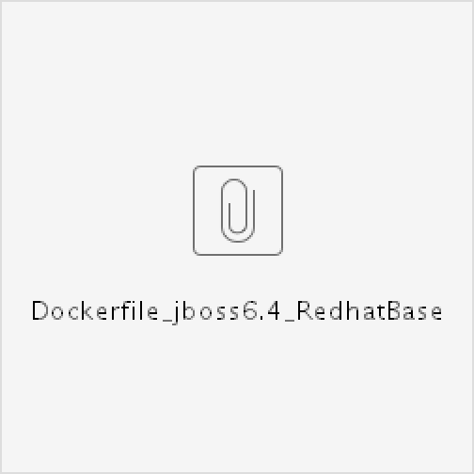

Dockerfile - AWS Managed Jboss6.4 redhat base image

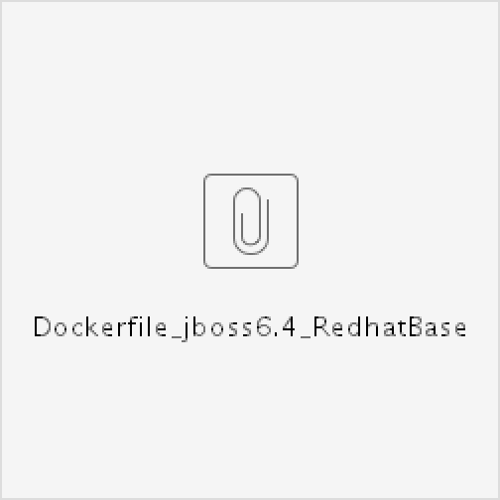

##### Deployment Yaml

Add the below to env:

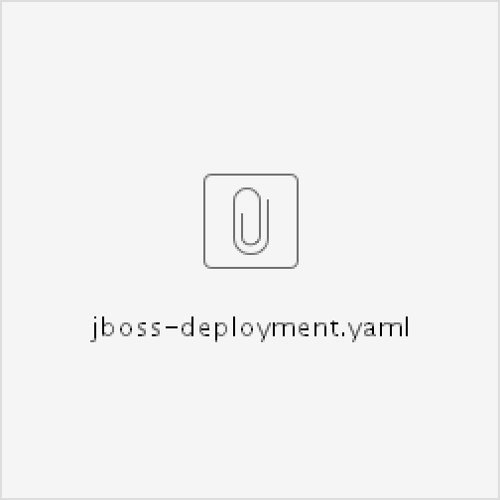

-

name: "JAVA\_OPTS\_APPEND"

value: "-javaagent:/opt/AppDServerAgent/javaagent.jar - Dappdynamics.agent.nodeName=$HOSTNAME"

-

name: "APPDYNAMICS\_CONTROLLER\_HOST\_NAME"

value: "cisco1nonprod.saas.appdynamics.com"

-

name: "APPDYNAMICS\_AGENT\_ACCOUNT\_NAME"

value: "cisco1nonprod"

-

name: "APPDYNAMICS\_AGENT\_APPLICATION\_NAME"

value: "AppMGM-n"

-

name: "APPDYNAMICS\_AGENT\_TIER\_NAME"

value: "AppMGM-n-cae"

-

name: "APPDYNAMICS\_CONTROLLER\_PORT"

value: "443"

-

name: "APPDYNAMICS\_CONTROLLER\_SSL\_ENABLED"

value: "true"

-

name: "APPDYNAMICS\_AGENT\_ACCOUNT\_ACCESS\_KEY"

value: "b29309a3-827a-423a-8e29-f5e91134d96f"

**Troubleshooting Issues**

In case JVM Arguments related to Application Group Name, Tier Name are not populated, use the VLAE name and follow steps @ [Get](file:///C:\Machine%20Learning\Test\PDF\ilovepdf_split-range\CAE%20Wiki%20Pages-151-403.docx#_bookmark9) [Appd group](file:///C:\Machine%20Learning\Test\PDF\ilovepdf_split-range\CAE%20Wiki%20Pages-151-403.docx#_bookmark9) to obtain Application group Name, Tier Name.

In case in the above generated arguments account Access Key is not populated, please obtain it by following steps @ [Get AccessKey](file:///C:\Machine%20Learning\Test\PDF\ilovepdf_split-range\CAE%20Wiki%20Pages-151-403.docx#_bookmark10) Above steps did not help resolving problem, please contact performance team following steps @ Create Maas Case

In case you expect more number of nodes to be reporting on CAE when compared to LAE , please contact performance team for increasing the Appdynamics License Quota following steps @[Increase Licenses](file:///C:\Machine%20Learning\Test\PDF\ilovepdf_split-range\CAE%20Wiki%20Pages-151-403.docx#_bookmark11)

##### Steps for AppDynamics testing with SdaaS Deployment

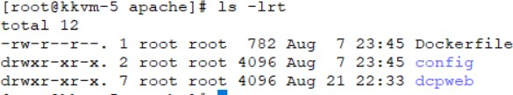Check in the Dockerfile under the root of the application git repo and deployment yamls under ./config

Trigger the Jenkins job

Verify the pod stdout logs for the message "Started AppDynamics Java Agent Successfully" Login to the appdynamics controller and verify the Tiers & Nodes

Non Prod: <https://cisco1nonprod.saas.appdynamics.com/controller/> Prod: [https://cisco1prod.saas.appdynamics.com/controller/](https://cisco1nonprod.saas.appdynamics.com/controller/)

##### Steps for AppDynamics testing with out SdaaS Deployment

Consider the above mentioned changes for Dockerfile, Deployment yaml and AppDynamcis APM agent binaries while proceeding with the steps from [Deploy on CAE without SDaaS](https://wiki.cisco.com/display/CAEUSER/Deploy%2Bon%2BCAE%2Bwithout%2BSDaaS)

Verify the pod stdout logs for the message "Started AppDynamics Java Agent Successfully" Login to the appdynamics controller and verify the Tiers & Nodes

Non Prod: <https://cisco1nonprod.saas.appdynamics.com/controller/> Prod: [https://cisco1prod.saas.appdynamics.com/controller/](https://cisco1nonprod.saas.appdynamics.com/controller/)

##### Steps for Obtaining Appdynamics Application Group details

Go to Jabber / Spark and search for “Performance” as shown below

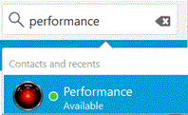

In the Performance BOT type in the following command “help show appd <VLAE Name>”

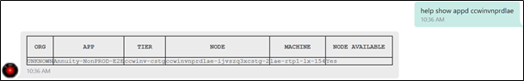

The above command would return Appdynamics Application group details as shown above.

##### Steps for Obtaining Appdynamics Account Access Key

Go to Jabber / Spark and search for “Performance” as shown below



In the Performance BOT type in the following command “help show appd acckey for app <AppD Application Group Name>@cisco1”

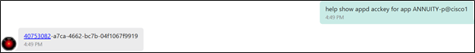

The above command would return Appdynamics Account Access Key for the Application Group requested as shown above.

##### Steps for Additional license Quota request

Note: **This situation is applicable only in case of LAE to CAE Migration** Raise a case with Performance team following the steps @ Create Maas Case Provide following details:

Existing Application Group Name in LAE Existing Tier Name in LAE

Current no of instances in LAE Additional no of Instances requested.

Once your Additional quota request is validated and approved your Application group name license rule is updated.

Once performance team confirms additional license quota, please start / scale up newer increased nodes

##### Steps for raising MAAS Case in Service Now

Navigate to ESP URL: <https://cisco.service-now.com/> Select the Create New option under **Incident** as below

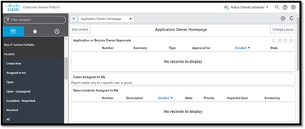

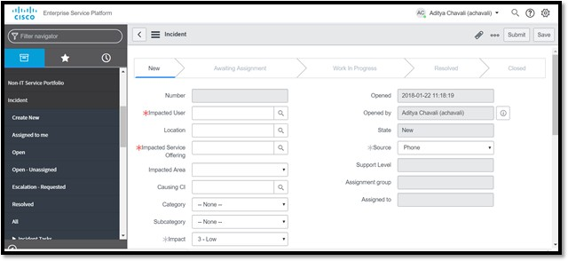

In the above, key in Impacted Service Offering as “Application Performance Management” Key in Impacted Area as “Maas” as shown below

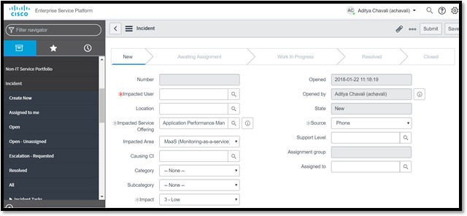

Provide other relevant details such as Summary & Description clearly mentioning the purpose of this case creation.

# Tomcat 7

#### LAE to CAE Migration using AWS Managed Tomcat7 custom image

**LAE to CAE Migration using AWS Managed Tomcat7 redhat base image or OpenSource Tomcat image**

**New CAE Application using AWS Managed Tomcat7 custom image**

**New CAE Application using AWS Managed Tomcat7 redhat base image or OpenSource Tomcat image**

[**Troubleshooting Issues**](file:///C:\Machine%20Learning\Test\PDF\ilovepdf_split-range\CAE%20Wiki%20Pages-151-403.docx#_bookmark15)

**LAE to CAE Migration using AWS Managed Tomcat7 custom image**

Appdynamics enablement process is automated for the application migrating from lae to cae using AWS managed Tomcat7 custom image.

Generate the Deployment yaml and Dockerfile from [LAE2CAE.cisco.com](http://lae2cae.cisco.com/)

**Deployment yaml** generated from the [LAE2CAE.cisco.com](http://lae2cae.cisco.com/) will have the required appd environment variables by default for the applications enabled for appd in lae.

**AppDynamics APM Agent** binaries will be included by default in the AWS managed tomcat custom Image([containers.cisco.com](https://containers.cisco.com/repository/aws_managed/tomcat-7-jws3.1_custom)

[/repository/aws\_managed/tomcat-7-jws3.1\_custom](https://containers.cisco.com/repository/aws_managed/tomcat-7-jws3.1_custom))

**Dockerfile** - No change.

Application team responsibilities is to only verify the following ENV variable section of the [Deployment Yaml](file:///C:\Machine%20Learning\Test\PDF\ilovepdf_split-range\CAE%20Wiki%20Pages-151-403.docx#_bookmark14) are appropriate for their application(Refer the attached sample [Dockerfile](file:///C:\Machine%20Learning\Test\PDF\ilovepdf_split-range\CAE%20Wiki%20Pages-151-403.docx#_bookmark13) and [Deployment Yaml](file:///C:\Machine%20Learning\Test\PDF\ilovepdf_split-range\CAE%20Wiki%20Pages-151-403.docx#_bookmark14) for reference).

Steps for [AppDynamics testing with SdaaS Deployment](file:///C:\Machine%20Learning\Test\PDF\ilovepdf_split-range\CAE%20Wiki%20Pages-151-403.docx#_bookmark16) Steps for [AppDynamics testing with out SdaaS Deployment](file:///C:\Machine%20Learning\Test\PDF\ilovepdf_split-range\CAE%20Wiki%20Pages-151-403.docx#_bookmark17)

**LAE to CAE Migration using AWS Managed Tomcat7 redhat base image or OpenSource Tomcat image**

AppDynamics enablement for migrating application from lae to cae using AWS Managed Tomcat7 redhat base image([containers.cisco.com](http://containers.cisco.com/aws_managed/tomcat-7-jws3.1)

[/aws\_managed/tomcat-7-jws3.1](http://containers.cisco.com/aws_managed/tomcat-7-jws3.1)) or any open source Tomcat image requires changes to Dockerfile.

Generate the Deployment yaml and Dockerfile from [LAE2CAE.cisco.com](http://lae2cae.cisco.com/)

**Deployment yaml** generated from the [LAE2CAE.cisco.com](http://lae2cae.cisco.com/) will have the required appd environment variables by default for the applications enabled for appd in lae.

**AppDynamics APM Agent** binaries will NOT be included by default. To include the binaries follow the steps below.

SdaaS Deployment:

- Configure Jenkin job – Execute Shell as below



Without SdaaS Deployment:

* + - Download the latest Appdynamics APM Agent from following **GIT Link**: [https://gitscm.cisco.com/projects/PERFO/repos](https://gitscm.cisco.com/projects/PERFO/repos/appd_apm_agents/browse)

[/appd\_apm\_agents/browse](https://gitscm.cisco.com/projects/PERFO/repos/appd_apm_agents/browse)

* + - Unzip the downloaded agent, create a folder “AppDServerAgent” and copy the unzipped agent folder contents to this folder.

##### Dockerfile:

* + - * Add the below lines to [Dockerfile](file:///C:\Machine%20Learning\Test\PDF\ilovepdf_split-range\CAE%20Wiki%20Pages-151-403.docx#_bookmark13) file to embed Appdynamics Agent ( Refer sample attached [Dockerfile](file:///C:\Machine%20Learning\Test\PDF\ilovepdf_split-range\CAE%20Wiki%20Pages-151-403.docx#_bookmark13))

Application team responsibilities is to add changes to Dockerfile and include binaries as above and verify the following ENV variable section of the [Deployment Yaml](file:///C:\Machine%20Learning\Test\PDF\ilovepdf_split-range\CAE%20Wiki%20Pages-151-403.docx#_bookmark14) are appropriate for their application(Refer the attached sample [Dockerfile](file:///C:\Machine%20Learning\Test\PDF\ilovepdf_split-range\CAE%20Wiki%20Pages-151-403.docx#_bookmark13) and [Deployment Yaml](file:///C:\Machine%20Learning\Test\PDF\ilovepdf_split-range\CAE%20Wiki%20Pages-151-403.docx#_bookmark14) for reference)

Steps for [AppDynamics testing with SdaaS Deployment](file:///C:\Machine%20Learning\Test\PDF\ilovepdf_split-range\CAE%20Wiki%20Pages-151-403.docx#_bookmark16) Steps for [AppDynamics testing with out SdaaS Deployment](file:///C:\Machine%20Learning\Test\PDF\ilovepdf_split-range\CAE%20Wiki%20Pages-151-403.docx#_bookmark17)

**New CAE Application using AWS Managed Tomcat7 custom image**

AppDynamics enablement for the New CAE application requires changes to Procedures, Dockerfile and YAMl files

Procedure:

* + - * Raise a service now case with Performance team following steps @ [Create Maas Case](file:///C:\Machine%20Learning\Test\PDF\ilovepdf_split-range\CAE%20Wiki%20Pages-151-403.docx#_bookmark21)
      * Fill in & Attach the following excel with the above created case.
      * Based on the above onboarding details required workflow is initiated.
      * Post completion of above onboarding workflow, Performance team would create required ADAM groups, Appdynamics Application Group, Tier Name & provide the required access as requested.
      * Obtain Appdynamics Application group name, Tier Name, Access Key from above incident.

**Deployment yaml** generated from the ConfigUtility tool([Deploy on CAE without SDaaS](https://wiki.cisco.com/display/CAEUSER/Deploy%2Bon%2BCAE%2Bwithout%2BSDaaS)) will NOT have the required appd environment variables. Copy the AppDynamics environment variables from the below [Deployment Yaml](file:///C:\Machine%20Learning\Test\PDF\ilovepdf_split-range\CAE%20Wiki%20Pages-151-403.docx#_bookmark14) and update the Application group name, Tier Name, Access Key obtained from above incident to your Deployment yaml

**AppDynamics APM Agent** binaries will be included by default in the AWS managed tomcat custom Image([containers.cisco.com](http://containers.cisco.com/aws_managed/tomcat-7-jws3.1_custom)

[/aws\_managed/tomcat-7-jws3.1\_custom](http://containers.cisco.com/aws_managed/tomcat-7-jws3.1_custom))

Dockerfile**:**

* + - * Add the below lines to [Dockerfile](file:///C:\Machine%20Learning\Test\PDF\ilovepdf_split-range\CAE%20Wiki%20Pages-151-403.docx#_bookmark13) file to embed Appdynamics Agent ( Refer sample attached [Dockerfile](file:///C:\Machine%20Learning\Test\PDF\ilovepdf_split-range\CAE%20Wiki%20Pages-151-403.docx#_bookmark13) )

Application team responsibilities is to add changes to Dockerfile and include binaries as above and verify the following ENV variable section of the [Deployment Yaml](file:///C:\Machine%20Learning\Test\PDF\ilovepdf_split-range\CAE%20Wiki%20Pages-151-403.docx#_bookmark14) are appropriate for their application(Refer the attached sample [Dockerfile](file:///C:\Machine%20Learning\Test\PDF\ilovepdf_split-range\CAE%20Wiki%20Pages-151-403.docx#_bookmark13) and [Deployment Yaml](file:///C:\Machine%20Learning\Test\PDF\ilovepdf_split-range\CAE%20Wiki%20Pages-151-403.docx#_bookmark14) for reference)

Steps for [AppDynamics testing with SdaaS Deployment](file:///C:\Machine%20Learning\Test\PDF\ilovepdf_split-range\CAE%20Wiki%20Pages-151-403.docx#_bookmark16) Steps for [AppDynamics testing with out SdaaS Deployment](file:///C:\Machine%20Learning\Test\PDF\ilovepdf_split-range\CAE%20Wiki%20Pages-151-403.docx#_bookmark17)

**New CAE Application using AWS Managed Tomcat7 redhat base image or OpenSource Tomcat image**

AppDynamics enablement for the New CAE application requires changes to Procedures, Dockerfile and YAMl files

Procedure:

* + - * Raise a service now case with Performance team following steps @ [Create Maas Case](file:///C:\Machine%20Learning\Test\PDF\ilovepdf_split-range\CAE%20Wiki%20Pages-151-403.docx#_bookmark21)
      * Fill in & Attach the following excel with the above created case.
      * Based on the above onboarding details required workflow is initiated.
      * Post completion of above onboarding workflow, Performance team would create required ADAM groups, Appdynamics Application Group, Tier Name & provide the required access as requested.
      * Obtain Appdynamics Application group name, Tier Name, Access Key from above incident.

**Deployment yaml** generated from the ConfigUtility tool([Deploy on CAE without SDaaS](https://wiki.cisco.com/display/CAEUSER/Deploy%2Bon%2BCAE%2Bwithout%2BSDaaS)) will NOT have the required appd environment variables. Copy the AppDynamics environment variables from the below [Deployment Yaml](file:///C:\Machine%20Learning\Test\PDF\ilovepdf_split-range\CAE%20Wiki%20Pages-151-403.docx#_bookmark14) and update the Application group name, Tier Name, Access Key obtained from above incident to your Deployment yaml

**AppDynamics APM Agent** binaries will NOT be included by default. To include the binaries follow the steps below.

SdaaS Deployment:

Configure Jenkin job – Execute Shell as below



Without SdaaS Deployment:

* + - Download the latest Appdynamics APM Agent from following **GIT Link**: [https://gitscm.cisco.com/projects/PERFO/repos](https://gitscm.cisco.com/projects/PERFO/repos/appd_apm_agents/browse)

[/appd\_apm\_agents/browse](https://gitscm.cisco.com/projects/PERFO/repos/appd_apm_agents/browse)

* + - Unzip the downloaded agent, create a folder “AppDServerAgent” and copy the unzipped agent folder contents to this folder.

Dockerfile**:**

* + - * Add the below lines to [Dockerfile](file:///C:\Machine%20Learning\Test\PDF\ilovepdf_split-range\CAE%20Wiki%20Pages-151-403.docx#_bookmark13) file to embed Appdynamics Agent ( Refer sample attached [Dockerfile](file:///C:\Machine%20Learning\Test\PDF\ilovepdf_split-range\CAE%20Wiki%20Pages-151-403.docx#_bookmark13) )

Application team responsibilities is to add changes to Dockerfile and include binaries as above and verify the following ENV variable section of the [Deployment Yaml](file:///C:\Machine%20Learning\Test\PDF\ilovepdf_split-range\CAE%20Wiki%20Pages-151-403.docx#_bookmark14) are appropriate for their application(Refer the attached sample [Dockerfile](file:///C:\Machine%20Learning\Test\PDF\ilovepdf_split-range\CAE%20Wiki%20Pages-151-403.docx#_bookmark13) and [Deployment Yaml](file:///C:\Machine%20Learning\Test\PDF\ilovepdf_split-range\CAE%20Wiki%20Pages-151-403.docx#_bookmark14) for reference)

Steps for [AppDynamics testing with SdaaS Deployment](file:///C:\Machine%20Learning\Test\PDF\ilovepdf_split-range\CAE%20Wiki%20Pages-151-403.docx#_bookmark16) Steps for [AppDynamics testing with out SdaaS Deployment](file:///C:\Machine%20Learning\Test\PDF\ilovepdf_split-range\CAE%20Wiki%20Pages-151-403.docx#_bookmark17)

##### Dockerfile

ADD AppDServerAgent /opt/AppDServerAgent RUN mkdir -p /opt/AppDServerAgent/logs && \ chmod -R 775 /opt/AppDServerAgent/logs

Dockerfile - AWS managed tomcat7 custom Image

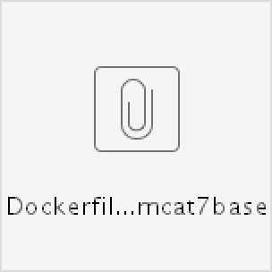

Dockerfile - AWS Managed Tomcat7 redhat base image

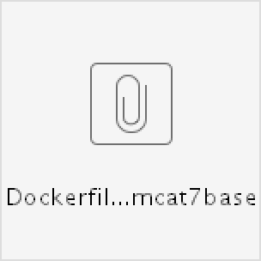

##### Deployment Yaml

Add the below to env:

-

name: "JAVA\_OPTS\_EXT"

value: "-javaagent:/opt/AppDServerAgent/javaagent.jar - Dappdynamics.agent.nodeName=$HOSTNAME"

-

name: "APPDYNAMICS\_CONTROLLER\_HOST\_NAME"

value: "cisco1nonprod.saas.appdynamics.com"

-

name: "APPDYNAMICS\_AGENT\_ACCOUNT\_NAME"

value: "cisco1nonprod"

-

name: "APPDYNAMICS\_AGENT\_APPLICATION\_NAME"

value: "AppMGM-n"

-

name: "APPDYNAMICS\_AGENT\_TIER\_NAME"

value: "AppMGM-n-cae"

-

name: "APPDYNAMICS\_CONTROLLER\_PORT"

value: "443"

-

name: "APPDYNAMICS\_CONTROLLER\_SSL\_ENABLED"

value: "true"

-

name: "APPDYNAMICS\_AGENT\_ACCOUNT\_ACCESS\_KEY"

value: "b29309a3-827a-423a-8e29-f5e91134d96f"



**Troubleshooting Issues**

In case JVM Arguments related to Application Group Name, Tier Name are not populated, use the VLAE name and follow steps @ [Get](file:///C:\Machine%20Learning\Test\PDF\ilovepdf_split-range\CAE%20Wiki%20Pages-151-403.docx#_bookmark18) [Appd group](file:///C:\Machine%20Learning\Test\PDF\ilovepdf_split-range\CAE%20Wiki%20Pages-151-403.docx#_bookmark18) to obtain Application group Name, Tier Name.

In case in the above generated arguments account Access Key is not populated, please obtain it by following steps @ [Get AccessKey](file:///C:\Machine%20Learning\Test\PDF\ilovepdf_split-range\CAE%20Wiki%20Pages-151-403.docx#_bookmark19) Above steps did not help resolving problem, please contact performance team following steps @ Create Maas Case

In case you expect more number of nodes to be reporting on CAE when compared to LAE , please contact performance team for increasing the Appdynamics License Quota following steps @[Increase Licenses](file:///C:\Machine%20Learning\Test\PDF\ilovepdf_split-range\CAE%20Wiki%20Pages-151-403.docx#_bookmark20)

##### Steps for AppDynamics testing with SdaaS Deployment

Check in the Dockerfile under the root of the application git repo and deployment yamls under ./config

Trigger the Jenkins job

Verify the pod stdout logs for the message "Started AppDynamics Java Agent Successfully" Login to the appdynamics controller and verify the Tiers & Nodes

Non Prod: <https://cisco1nonprod.saas.appdynamics.com/controller/> Prod: [https://cisco1prod.saas.appdynamics.com/controller/](https://cisco1nonprod.saas.appdynamics.com/controller/)

##### Steps for AppDynamics testing with out SdaaS Deployment

Consider the above mentioned changes for Dockerfile, Deployment yaml and AppDynamcis APM agent binaries while proceeding with the steps from [Deploy on CAE without SDaaS](https://wiki.cisco.com/display/CAEUSER/Deploy%2Bon%2BCAE%2Bwithout%2BSDaaS)

Verify the pod stdout logs for the message "Started AppDynamics Java Agent Successfully" Login to the appdynamics controller and verify the Tiers & Nodes

Non Prod: <https://cisco1nonprod.saas.appdynamics.com/controller/> Prod: [https://cisco1prod.saas.appdynamics.com/controller/](https://cisco1nonprod.saas.appdynamics.com/controller/)

##### Steps for Obtaining Appdynamics Application Group details

Go to Jabber / Spark and search for “Performance” as shown below



In the Performance BOT type in the following command “help show appd <VLAE Name>”



The above command would return Appdynamics Application group details as shown above.

##### Steps for Obtaining Appdynamics Account Access Key

Go to Jabber / Spark and search for “Performance” as shown below



In the Performance BOT type in the following command “help show appd acckey for app <AppD Application Group Name>@cisco1”



The above command would return Appdynamics Account Access Key for the Application Group requested as shown above.

##### Steps for Additional license Quota request

Note: **This situation is applicable only in case of LAE to CAE Migration** Raise a case with Performance team following the steps @ Create Maas Case Provide following details:

Existing Application Group Name in LAE Existing Tier Name in LAE

Current no of instances in LAE Additional no of Instances requested.

Once your Additional quota request is validated and approved your Application group name license rule is updated.

Once performance team confirms additional license quota, please start / scale up newer increased nodes

##### Steps for raising MAAS Case in Service Now

Navigate to ESP URL: <https://cisco.service-now.com/> Select the Create New option under **Incident** as below





In the above, key in Impacted Service Offering as “Application Performance Management” Key in Impacted Area as “Maas” as shown below



Provide other relevant details such as Summary & Description clearly mentioning the purpose of this case creation.

# Tomcat 8

#### LAE to CAE Migration using AWS Managed Tomcat8 custom image

**LAE to CAE Migration using AWS Managed Tomcat8 redhat base image or OpenSource Tomcat image**

**New CAE Application using AWS Managed Tomcat8 custom image**

**New CAE Application using AWS Managed Tomcat8 redhat base image or OpenSource Tomcat image**

[**Troubleshooting Issues**](file:///C:\Machine%20Learning\Test\PDF\ilovepdf_split-range\CAE%20Wiki%20Pages-151-403.docx#_bookmark24)

**LAE to CAE Migration using AWS Managed Tomcat8 custom image**

Appdynamics enablement process is automated for the application migrating from lae to cae using AWS managed Tomcat8 custom image.

Generate the Deployment yaml and Dockerfile from [LAE2CAE.cisco.com](http://lae2cae.cisco.com/)

**Deployment yaml** generated from the [LAE2CAE.cisco.com](http://lae2cae.cisco.com/) will have the required appd environment variables by default for the applications enabled for appd in lae.

**AppDynamics APM Agent** binaries will be included by default in the AWS managed tomcat custom Image([containers.cisco.com](https://containers.cisco.com/repository/aws_managed/tomcat-7-jws3.1_custom)

[/repository/aws\_managed/tomcat-8-jws3.1\_custom](https://containers.cisco.com/repository/aws_managed/tomcat-7-jws3.1_custom))

**Dockerfile** - No change.

Application team responsibilities is to only verify the following ENV variable section of the [Deployment Yaml](file:///C:\Machine%20Learning\Test\PDF\ilovepdf_split-range\CAE%20Wiki%20Pages-151-403.docx#_bookmark23) are appropriate for their application(Refer the attached sample [Dockerfile](file:///C:\Machine%20Learning\Test\PDF\ilovepdf_split-range\CAE%20Wiki%20Pages-151-403.docx#_bookmark22) and [Deployment Yaml](file:///C:\Machine%20Learning\Test\PDF\ilovepdf_split-range\CAE%20Wiki%20Pages-151-403.docx#_bookmark23) for reference).

Steps for [AppDynamics testing with SdaaS Deployment](file:///C:\Machine%20Learning\Test\PDF\ilovepdf_split-range\CAE%20Wiki%20Pages-151-403.docx#_bookmark25) Steps for [AppDynamics testing with out SdaaS Deployment](file:///C:\Machine%20Learning\Test\PDF\ilovepdf_split-range\CAE%20Wiki%20Pages-151-403.docx#_bookmark26)

**LAE to CAE Migration using AWS Managed Tomcat8 redhat base image or OpenSource Tomcat image**

AppDynamics enablement for migrating application from lae to cae using AWS Managed Tomcat8 redhat base image([containers.cisco.com](http://containers.cisco.com/aws_managed/tomcat-7-jws3.1)

[/aws\_managed/tomcat-8-jws3.1](http://containers.cisco.com/aws_managed/tomcat-7-jws3.1)) or any open source Tomcat image requires changes to Dockerfile.

Generate the Deployment yaml and Dockerfile from [LAE2CAE.cisco.com](http://lae2cae.cisco.com/)

**Deployment yaml** generated from the [LAE2CAE.cisco.com](http://lae2cae.cisco.com/) will have the required appd environment variables by default for the applications enabled for appd in lae.

**AppDynamics APM Agent** binaries will NOT be included by default. To include the binaries follow the steps below.

SdaaS Deployment:

- Configure Jenkin job – Execute Shell as below



Without SdaaS Deployment:

* + - Download the latest Appdynamics APM Agent from following **GIT Link**: [https://gitscm.cisco.com/projects/PERFO/repos](https://gitscm.cisco.com/projects/PERFO/repos/appd_apm_agents/browse)

[/appd\_apm\_agents/browse](https://gitscm.cisco.com/projects/PERFO/repos/appd_apm_agents/browse)

* + - Unzip the downloaded agent, create a folder “AppDServerAgent” and copy the unzipped agent folder contents to this folder.

##### Dockerfile:

* + - * Add the below lines to [Dockerfile](file:///C:\Machine%20Learning\Test\PDF\ilovepdf_split-range\CAE%20Wiki%20Pages-151-403.docx#_bookmark22) file to embed Appdynamics Agent ( Refer sample attached [Dockerfile](file:///C:\Machine%20Learning\Test\PDF\ilovepdf_split-range\CAE%20Wiki%20Pages-151-403.docx#_bookmark22))

Application team responsibilities is to add changes to Dockerfile and include binaries as above and verify the following ENV variable section of the [Deployment Yaml](file:///C:\Machine%20Learning\Test\PDF\ilovepdf_split-range\CAE%20Wiki%20Pages-151-403.docx#_bookmark23) are appropriate for their application(Refer the attached sample [Dockerfile](file:///C:\Machine%20Learning\Test\PDF\ilovepdf_split-range\CAE%20Wiki%20Pages-151-403.docx#_bookmark22) and [Deployment Yaml](file:///C:\Machine%20Learning\Test\PDF\ilovepdf_split-range\CAE%20Wiki%20Pages-151-403.docx#_bookmark23) for reference)

Steps for [AppDynamics testing with SdaaS Deployment](file:///C:\Machine%20Learning\Test\PDF\ilovepdf_split-range\CAE%20Wiki%20Pages-151-403.docx#_bookmark25) Steps for [AppDynamics testing with out SdaaS Deployment](file:///C:\Machine%20Learning\Test\PDF\ilovepdf_split-range\CAE%20Wiki%20Pages-151-403.docx#_bookmark26)

**New CAE Application using AWS Managed Tomcat8 custom image**

AppDynamics enablement for the New CAE application requires changes to Procedures, Dockerfile and YAMl files

Procedure:

* + - * Raise a service now case with Performance team following steps @ [Create Maas Case](file:///C:\Machine%20Learning\Test\PDF\ilovepdf_split-range\CAE%20Wiki%20Pages-151-403.docx#_bookmark30)
      * Fill in & Attach the following excel with the above created case.
      * Based on the above onboarding details required workflow is initiated.
      * Post completion of above onboarding workflow, Performance team would create required ADAM groups, Appdynamics Application Group, Tier Name & provide the required access as requested.
      * Obtain Appdynamics Application group name, Tier Name, Access Key from above incident.

**Deployment yaml** generated from the ConfigUtility tool([Deploy on CAE without SDaaS](https://wiki.cisco.com/display/CAEUSER/Deploy%2Bon%2BCAE%2Bwithout%2BSDaaS)) will NOT have the required appd environment variables. Copy the AppDynamics environment variables from the below [Deployment Yaml](file:///C:\Machine%20Learning\Test\PDF\ilovepdf_split-range\CAE%20Wiki%20Pages-151-403.docx#_bookmark23) and update the Application group name, Tier Name, Access Key obtained from above incident to your Deployment yaml

**AppDynamics APM Agent** binaries will be included by default in the AWS managed tomcat custom Image([containers.cisco.com](http://containers.cisco.com/aws_managed/tomcat-7-jws3.1_custom)

[/aws\_managed/tomcat-8-jws3.1\_custom](http://containers.cisco.com/aws_managed/tomcat-7-jws3.1_custom))

Dockerfile**:**

* + - * Add the below lines to [Dockerfile](file:///C:\Machine%20Learning\Test\PDF\ilovepdf_split-range\CAE%20Wiki%20Pages-151-403.docx#_bookmark22) file to embed Appdynamics Agent ( Refer sample attached [Dockerfile](file:///C:\Machine%20Learning\Test\PDF\ilovepdf_split-range\CAE%20Wiki%20Pages-151-403.docx#_bookmark22) )

Application team responsibilities is to add changes to Dockerfile and include binaries as above and verify the following ENV variable section of the [Deployment Yaml](file:///C:\Machine%20Learning\Test\PDF\ilovepdf_split-range\CAE%20Wiki%20Pages-151-403.docx#_bookmark23) are appropriate for their application(Refer the attached sample [Dockerfile](file:///C:\Machine%20Learning\Test\PDF\ilovepdf_split-range\CAE%20Wiki%20Pages-151-403.docx#_bookmark22) and [Deployment Yaml](file:///C:\Machine%20Learning\Test\PDF\ilovepdf_split-range\CAE%20Wiki%20Pages-151-403.docx#_bookmark23) for reference)

Steps for [AppDynamics testing with SdaaS Deployment](file:///C:\Machine%20Learning\Test\PDF\ilovepdf_split-range\CAE%20Wiki%20Pages-151-403.docx#_bookmark25) Steps for [AppDynamics testing with out SdaaS Deployment](file:///C:\Machine%20Learning\Test\PDF\ilovepdf_split-range\CAE%20Wiki%20Pages-151-403.docx#_bookmark26)

**New CAE Application using AWS Managed Tomcat8 redhat base image or OpenSource Tomcat image**

AppDynamics enablement for the New CAE application requires changes to Procedures, Dockerfile and YAMl files

Procedure:

* + - * Raise a service now case with Performance team following steps @ [Create Maas Case](file:///C:\Machine%20Learning\Test\PDF\ilovepdf_split-range\CAE%20Wiki%20Pages-151-403.docx#_bookmark30)
      * Fill in & Attach the following excel with the above created case.
      * Based on the above onboarding details required workflow is initiated.
      * Post completion of above onboarding workflow, Performance team would create required ADAM groups, Appdynamics Application Group, Tier Name & provide the required access as requested.
      * Obtain Appdynamics Application group name, Tier Name, Access Key from above incident.

**Deployment yaml** generated from the ConfigUtility tool([Deploy on CAE without SDaaS](https://wiki.cisco.com/display/CAEUSER/Deploy%2Bon%2BCAE%2Bwithout%2BSDaaS)) will NOT have the required appd environment variables. Copy the AppDynamics environment variables from the below [Deployment Yaml](file:///C:\Machine%20Learning\Test\PDF\ilovepdf_split-range\CAE%20Wiki%20Pages-151-403.docx#_bookmark23) and update the Application group name, Tier Name, Access Key obtained from above incident to your Deployment yaml

**AppDynamics APM Agent** binaries will NOT be included by default. To include the binaries follow the steps below.

SdaaS Deployment:

Configure Jenkin job – Execute Shell as below



Without SdaaS Deployment:

* + - Download the latest Appdynamics APM Agent from following **GIT Link**: [https://gitscm.cisco.com/projects/PERFO/repos](https://gitscm.cisco.com/projects/PERFO/repos/appd_apm_agents/browse)

[/appd\_apm\_agents/browse](https://gitscm.cisco.com/projects/PERFO/repos/appd_apm_agents/browse)

* + - Unzip the downloaded agent, create a folder “AppDServerAgent” and copy the unzipped agent folder contents to this folder.

Dockerfile**:**

* + - * Add the below lines to [Dockerfile](file:///C:\Machine%20Learning\Test\PDF\ilovepdf_split-range\CAE%20Wiki%20Pages-151-403.docx#_bookmark22) file to embed Appdynamics Agent ( Refer sample attached [Dockerfile](file:///C:\Machine%20Learning\Test\PDF\ilovepdf_split-range\CAE%20Wiki%20Pages-151-403.docx#_bookmark22) )

Application team responsibilities is to add changes to Dockerfile and include binaries as above and verify the following ENV variable section of the [Deployment Yaml](file:///C:\Machine%20Learning\Test\PDF\ilovepdf_split-range\CAE%20Wiki%20Pages-151-403.docx#_bookmark23) are appropriate for their application(Refer the attached sample [Dockerfile](file:///C:\Machine%20Learning\Test\PDF\ilovepdf_split-range\CAE%20Wiki%20Pages-151-403.docx#_bookmark22) and [Deployment Yaml](file:///C:\Machine%20Learning\Test\PDF\ilovepdf_split-range\CAE%20Wiki%20Pages-151-403.docx#_bookmark23) for reference)

Steps for [AppDynamics testing with SdaaS Deployment](file:///C:\Machine%20Learning\Test\PDF\ilovepdf_split-range\CAE%20Wiki%20Pages-151-403.docx#_bookmark25) Steps for [AppDynamics testing with out SdaaS Deployment](file:///C:\Machine%20Learning\Test\PDF\ilovepdf_split-range\CAE%20Wiki%20Pages-151-403.docx#_bookmark26)

##### Dockerfile

ADD AppDServerAgent /opt/AppDServerAgent RUN mkdir -p /opt/AppDServerAgent/logs && \ chmod -R 775 /opt/AppDServerAgent/logs

Dockerfile - AWS managed Tomcat8 custom Image

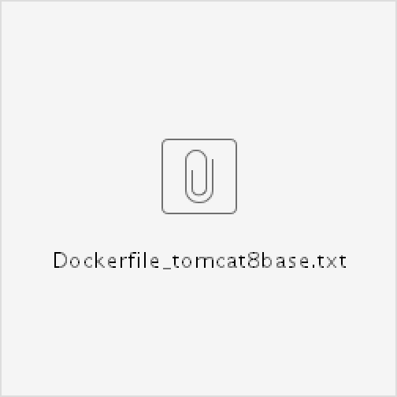

Dockerfile - AWS Managed Tomcat8 redhat base image



##### Deployment Yaml

Add the below to env:

-

name: "JAVA\_OPTS\_EXT"

value: "-javaagent:/opt/AppDServerAgent/javaagent.jar - Dappdynamics.agent.nodeName=$HOSTNAME"

-

name: "APPDYNAMICS\_CONTROLLER\_HOST\_NAME"

value: "cisco1nonprod.saas.appdynamics.com"

-

name: "APPDYNAMICS\_AGENT\_ACCOUNT\_NAME"

value: "cisco1nonprod"

-

name: "APPDYNAMICS\_AGENT\_APPLICATION\_NAME"

value: "AppMGM-n"

-

name: "APPDYNAMICS\_AGENT\_TIER\_NAME"

value: "AppMGM-n-cae"

-

name: "APPDYNAMICS\_CONTROLLER\_PORT"

value: "443"

-

name: "APPDYNAMICS\_CONTROLLER\_SSL\_ENABLED"

value: "true"

-

name: "APPDYNAMICS\_AGENT\_ACCOUNT\_ACCESS\_KEY"

value: "b29309a3-827a-423a-8e29-f5e91134d96f"

**Troubleshooting Issues**

In case JVM Arguments related to Application Group Name, Tier Name are not populated, use the VLAE name and follow steps @ [Get](file:///C:\Machine%20Learning\Test\PDF\ilovepdf_split-range\CAE%20Wiki%20Pages-151-403.docx#_bookmark27) [Appd group](file:///C:\Machine%20Learning\Test\PDF\ilovepdf_split-range\CAE%20Wiki%20Pages-151-403.docx#_bookmark27) to obtain Application group Name, Tier Name.

In case in the above generated arguments account Access Key is not populated, please obtain it by following steps @ [Get AccessKey](file:///C:\Machine%20Learning\Test\PDF\ilovepdf_split-range\CAE%20Wiki%20Pages-151-403.docx#_bookmark28) Above steps did not help resolving problem, please contact performance team following steps @ Create Maas Case

In case you expect more number of nodes to be reporting on CAE when compared to LAE , please contact performance team for increasing the Appdynamics License Quota following steps @[Increase Licenses](file:///C:\Machine%20Learning\Test\PDF\ilovepdf_split-range\CAE%20Wiki%20Pages-151-403.docx#_bookmark29)

##### Steps for AppDynamics testing with SdaaS Deployment

Check in the Dockerfile under the root of the application git repo and deployment yamls under ./config

Trigger the Jenkins job

Verify the pod stdout logs for the message "Started AppDynamics Java Agent Successfully" Login to the appdynamics controller and verify the Tiers & Nodes

Non Prod: <https://cisco1nonprod.saas.appdynamics.com/controller/> Prod: [https://cisco1prod.saas.appdynamics.com/controller/](https://cisco1nonprod.saas.appdynamics.com/controller/)

##### Steps for AppDynamics testing with out SdaaS Deployment

Consider the above mentioned changes for Dockerfile, Deployment yaml and AppDynamcis APM agent binaries while proceeding with the steps from [Deploy on CAE without SDaaS](https://wiki.cisco.com/display/CAEUSER/Deploy%2Bon%2BCAE%2Bwithout%2BSDaaS)

Verify the pod stdout logs for the message "Started AppDynamics Java Agent Successfully" Login to the appdynamics controller and verify the Tiers & Nodes

Non Prod: <https://cisco1nonprod.saas.appdynamics.com/controller/> Prod: [https://cisco1prod.saas.appdynamics.com/controller/](https://cisco1nonprod.saas.appdynamics.com/controller/)

##### Steps for Obtaining Appdynamics Application Group details

Go to Jabber / Spark and search for “Performance” as shown below



In the Performance BOT type in the following command “help show appd <VLAE Name>”



The above command would return Appdynamics Application group details as shown above.

##### Steps for Obtaining Appdynamics Account Access Key

Go to Jabber / Spark and search for “Performance” as shown below



In the Performance BOT type in the following command “help show appd acckey for app <AppD Application Group Name>@cisco1”



The above command would return Appdynamics Account Access Key for the Application Group requested as shown above.

##### Steps for Additional license Quota request

Note: **This situation is applicable only in case of LAE to CAE Migration** Raise a case with Performance team following the steps @ Create Maas Case Provide following details:

Existing Application Group Name in LAE Existing Tier Name in LAE

Current no of instances in LAE Additional no of Instances requested.

Once your Additional quota request is validated and approved your Application group name license rule is updated.

Once performance team confirms additional license quota, please start / scale up newer increased nodes

##### Steps for raising MAAS Case in Service Now

Navigate to ESP URL: <https://cisco.service-now.com/> Select the Create New option under **Incident** as below



In the above, key in Impacted Service Offering as “Application Performance Management” Key in Impacted Area as “Maas” as shown below



Provide other relevant details such as Summary & Description clearly mentioning the purpose of this case creation.

# Create a Service Account

Service accounts are helpful to access the API server and login to the project without providing user credentials. For service account you can assign a role what ever you want, depends on your requirement.

Default Service accounts on CAE are

|  |  |
| --- | --- |
| **Service Account** | **Usage** |
| **Builder** | Used by build pods. It is given the **system:image-builder** role, which allows  pushing images to any image stream in the project using the internal Docker  registry. |
| **deployer** | Used by deployment pods and is given the **system:deployer** role, which allows  viewing and modifying replication controllers and pods in the project. |
| **Default** | Used to run all other pods unless they specify a different service account. |

Every service account is also a member of two groups: system:serviceaccount Includes all service accounts in the system.

system:serviceaccount:<project> Includes all service accounts in the specified project.

**Create a Service Accounts on CAE**

1. First login to the data center and project as per below

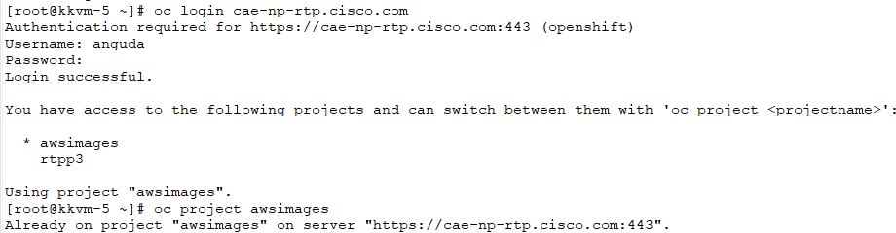

1. create a service account , other than default service accounts [root@kkvm-5 ~]# **oc create sa caeadmin**

[root@kkvm-5 ~]# **oc get sa**

NAME SECRETS AGE

builder 2 21h

**caeadmin** 2 37m

default 2 21h

deployer 2 21h

1. Assign a role to service account to perform operations

oc policy add-role-to-user project-admin system:serviceaccount:awsimages:caeadmin -n awsimages

1. As soon as Service account created you can see two secrets are created, one is for API and other for containers registry [root@kkvm-5 ~]# **oc describe sa caeadmin -n awsimages**

Name: caeadmin

Namespace: awsimages Labels: <none> Annotations: <none>

Image pull secrets: caeadmin-dockercfg-tfqdc Mountable secrets: caeadmin-token-5gjqk

caeadmin-dockercfg-tfqdc

Tokens: caeadmin-token-5gjqk caeadmin-token-vhg94

1. Describe the token which is pointed to mountable to get login token key.

[root@kkvm-5 ~]# **oc describe secret caeadmin-token-5gjqk -n awsimages**

Name: caeadmin-token-5gjqk Namespace: awsimages

Labels: <none>

Annotations: [kubernetes.io/service-account.name=caeadmin](http://kubernetes.io/service-account.name%3Dcaeadmin)

[kubernetes.io/service-account.uid=c89c7d7a-6517-11e8-8da7-fa163e463fb4](http://kubernetes.io/service-account.uid%3Dc89c7d7a-6517-11e8-8da7-fa163e463fb4) Type: [kubernetes.io/service-account-token](http://kubernetes.io/service-account-token)

Data

====

ca.crt: 5519 bytes

namespace: 9 bytes

service-ca.crt: 6635 bytes

token: eyJhbGciOiJSUzI1NiIsInR5cCI6IkpXVCJ9. eyJpc3MiOiJrdWJlcm5ldGVzL3NlcnZpY2VhY2NvdW50Iiwia3ViZXJuZXRlcy5pby9zZXJ2aWNlYWNjb3VudC9uYW1lc3BhY2UiOiJhd3Npb WFnZXMiLCJrdWJlcm5ldGVzLmlvL3NlcnZpY2VhY2NvdW50L3NlY3JldC5uYW1lIjoiY2FlYWRtaW4tdG9rZW4tW50L3NlcnZpY2UtYWYW RtaW4iLCJrdWJlcm5ldGVzLmlvL3NlcnZpY2VhY2NvdW50L3NlcnZpY2UtYWNjb3VudC51aWQiOiJjODljN2Q3YS02NTE3LTExZTgtOGR hNy1mYTWFkbWluIn0.g861alBRQAsbxYDo8KVrGK4ioWsO1yDsXpnJbxavNKF3- ko6A9fbzCkCJI2lufTK8YxMtPYg5FGEdvT1N7d8htr1aoQgR8TUAAAiAFRqy7ZRX43kBFCrXWtz2HeiOZBJBd\_QS3AjZTdyCpMI\_cHdu5L oFovn- VArncRPiztH76odrcl256BwYWH4wVRnTKHJYYOyr30XshZhFVx8peV6SjyNDqCOem7MeCJ4TCacPoDBxFrHQnK9T4Ro8sUIk6rtatnvb KkFgeenyoxsfjkTf3TrXYXoIp3uug0EQuWtkCYfbx1A

1. Now using the token key you can directly login to the project by providing server address.

oc login --server=[cae-np-rtp.cisco.com](http://cae-np-rtp.cisco.com/) --token="eyJhbGciOiJSUzI1NiIsInR5cCI6IkpXVCJ9. eyJpc3MiOiJrdWJlcm5ldGVzL3NlcnZpY2VhY2NvdW50Iiwia3ViZXJuZXRlcy5pby9zZXJ2aWNlYWNjb3VudC9uYW1lc3BhY2UiOiJhd3Npb WFnZXMiLCJrdWJlcm5ldGVzLmlvL3NlcnZpY2VhY2NvdW50L3NlY3JldC5uYW1lIjoiY2FlYWRtaW4tdG9rZW4tW50L3NlcnZpY2UtYWYW RtaW4iLCJrdWJlcm5ldGVzLmlvL3NlcnZpY2VhY2NvdW50L3NlcnZpY2UtYWNjb3VudC51aWQiOiJjODljN2Q3YS02NTE3LTExZTgtOGR hNy1mYTWFkbWluIn0.g861alBRQAsbxYDo8KVrGK4ioWsO1yDsXpnJbxavNKF3- ko6A9fbzCkCJI2lufTK8YxMtPYg5FGEdvT1N7d8htr1aoQgR8TUAAAiAFRqy7ZRX43kBFCrXWtz2HeiOZBJBd\_QS3AjZTdyCpMI\_cHdu5L oFovn- VArncRPiztH76odrcl256BwYWH4wVRnTKHJYYOyr30XshZhFVx8peV6SjyNDqCOem7MeCJ4TCacPoDBxFrHQnK9T4Ro8sUIk6rtatnvb KkFgeenyoxsfjkTf3TrXYXoIp3uug0EQuWtkCYfbx1A"

# Tibco JMS client library 8.4.0 upgrade

**JbossEAP6.4**

##### As part of the Tibco EMS 8.4.0 version upgrade on MMX server, need to update the Tibco EMS 8.4.0 client libraries.

**Also enforcement of black-listing vulnerable ciphers at MMX server, will result in ssl handshake failures for the applications depends on Tibco EMS 7.0 client libraries.**

**To address the impact, applications has to adhere to the below changes in CAE**

**Applicaitons depends on tibco jms client libraries and deployed in CAE using AWS Managed Jboss6.4 custom image**

No changes required from application team

Following changes were customized in the latest AWS Managed Jboss6.4 custom image

* Updated tibco 7.0 client libraries with 8.4 client libraries
* Overridden jbosseap6.4 jms-api-1.1 version with tibco provided jms-2.0 to be compatible with java8
* Removed tibco 7.0 client libraries and modified modules.xml file accordingly.

Application team responsiblities is to redeploy the application using latest AWS Managed Jboss6.4 custom image([containers.cisco.com](http://containers.cisco.com/aws_managed/jboss6.4_custom)

[/aws\_managed/jboss6.4\_custom](http://containers.cisco.com/aws_managed/jboss6.4_custom)) in non-prod, complete the testing and promote the deployment to Production.

**Applicaitons depends on tibco jms client libraries and deployed in CAE using (AWS Managed Jboss6.4 redhat base image -** [**containers.cisco.com/aws\_managed/jboss-6.4**](http://containers.cisco.com/aws_managed/jboss-6.4) **or OpenSource Jboss image) AND (using custom entry point script)**

Remove the tibco 7.0 client libraries and corresponding entries in modules.xml if used or WEB-INF/lib/ tibrvjms.jar,tibjmsufo.jar,tibjms.jar,tibjmsapps.jar,tibjmsadmin.jar

Copy the attached tibco 8.4 tibjms.jar to the required module section if used or WEB-INF/lib/

Override the below jbosseap6.4 jboss-jms-api\_1.1\_spec-1.0.1.Final-redhat-3.jar version with the attached tibco provided jms-2.0 Example- using Dockerfile:

RUN cp jms-2.0.jar /opt/eap/modules/system/layers/base/javax/jms/api/main/jboss-jms-api\_1.1\_spec-1.0.1.Final-redhat-3.jar Example using entrypoint script:

cp -r repo/jms-2.0.jar /opt/eap/modules/system/layers/base/javax/jms/api/main/jboss-jms-api\_1.1\_spec-1.0.1.Final-redhat-3.jar Do not refer jms-2.0.jar in modules.xml because dependency is already set to refer to jms-2.0.jar i.e. <module name="javax.jms.api"/>



# Tomcat7

##### As part of the Tibco EMS 8.4.0 version upgrade on MMX server, need to update the Tibco EMS 8.4.0 client libraries.

**Also enforcement of black-listing vulnerable ciphers at MMX server, will result in ssl handshake failures for the applications depends on Tibco EMS 7.0 client libraries.**

**To address the impact, applications has to adhere to the below changes in CAE**

**Applications depends on tibco jms client libraries and deployed in CAE using AWS Managed tomcat-7-jws3.1 custom image:**

If you are using JMS libraries from 'app-root/repo/required\_libs' or from 'WEB-INF/lib' (application libs), make sure to replace following attached libraries.

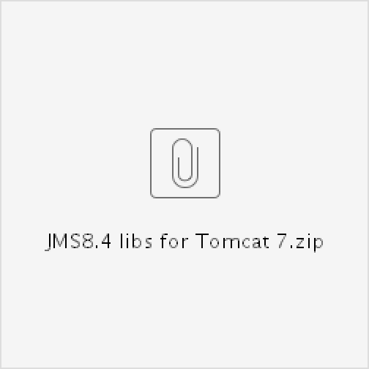jms.jar tibjms.jar

**Validation:**

1. Navigate to the app-root/repo/required\_libs or ../WEB-INF/lib
2. Run the command java -jar tibjms.jar
3. Make sure the version shows as 8.4

**Reach out to 'cae-ops(mailer list) <cae-ops@**[**cisco.com**](http://cisco.com/)**>' for any issues or get in touch via Webex Team** [**https://eurl.io/#rJr-vorxQ**](https://eurl.io/#rJr-vorxQ)

**Thread and Heap Dump**

**Thread Dump:**

**From pod terminal execute the below commands**

1. **Run the below command to to find the processid ps -ef | grep java**

2. **Run the jstack command to generate the thread dump**

**jstack -l processid > threaddump.txt**

3. **If noticed any permission issue with /tmp/.java\_pid<processid>, Run the below commands. Relace the text <processid> with actual processid**

**chgrp root /tmp/.java\_pid<processid> jstack -l processid > threaddump.txt**

**Heap Dump:**

**From pod terminal execute the below commands**

1. **jmap -dump:live,file=/tmp/heapdump.hprof 1**

**FTP-PROXY**

**FTP-PROXY Server**

This configuration allows the FTP client to make command and data connection with Passive mode FTP server via FTP-PROXY server.

**Provision VM:**

**Follow steps from** [**http://runon.cisco.com**](http://runon.cisco.com/) **to provision a VM from OpenStack.** [**http://runon.cisco.com/c/r/runon/Services/OpenStack/howto/os\_virtualmachine.html**](http://runon.cisco.com/c/r/runon/Services/OpenStack/howto/os_virtualmachine.html)[**http://runon.cisco.com/c/r/runon/Services/OpenStack/howto/os\_how-to-overview.html**](http://runon.cisco.com/c/r/runon/Services/OpenStack/howto/os_how-to-overview.html)

**Installation:**

**Complie and Build from source**

Download proxy-suite-1.9.2.1.tar.gz from [ftp.suse.com/pub/projects/proxy-suite/src](ftp://ftp.suse.com/pub/projects/proxy-suite/src) or attached proxy-suite-1.9.2.1.tar.gz to /opt or any custom directories

**Run as root to execute the below commands.**

* **yum update**
* **yum groupinstall "Development Tools"**
* **gunzip proxy-suite-1.9.2.1.tar.gz**
* **tar -xvf proxy-suite-1.9.2.1.tar**
* **cd proxy-suite-1.9.2.1**
* **./configure --without-libwrap**
* **make**
* **cd ftp-proxy**
* **make install**
* **make install.doc**
* **cp /usr/local/etc/proxy-suite/ftp-proxy.conf /usr/local/etc/proxy-suite/**[**ftp-proxy.conf.org**](http://ftp-proxy.conf.org/)

**Configuration:**

**Configure the attributes in the file /usr/local/etc/proxy-suite/ftp-proxy.conf as below. Note: - Make sure to update the Listen attribute with the IP of proxy server.**

**- DestinationAddress is the remote ftp server ip.**

AllowMagicUser no AllowTransProxy no DestinationAddress x.x.x.x Group root

User root

Listen 64.102.163.67

LogDestination /var/log/ftp-proxy.log PidFile /var/run/ftp-proxy.pid ServerType standalone

ValidCommands USER, PASS, PWD, CWD, CDUP, \

PORT, PASV, RETR, TYPE, REST, \ ABOR, LIST, NLST, STAT, QUIT, STOR

**Firewall Setup:**

* systemctl status firewalld
* **iptables -I INPUT -p tcp --dport 21 -j ACCEPT**
* **iptables -A INPUT -p tcp -m tcp --sport 1024: --dport 1024: -m conntrack --ctstate ESTABLISHED -j ACCEPT -m comment --comment "Allow passive inbound connections"**
* **iptables -A OUTPUT -p tcp -m tcp --sport 1024: --dport 1024: -m conntrack --ctstate ESTABLISHED,RELATED -j ACCEPT -m comment --comment "Allow passive outbound connections"**
* **modprobe ip\_conntrack\_ftp**

**Start ftp-proxy:**

* **ftp-proxy -f /usr/local/etc/proxy-suite/ftp-proxy.conf**

**Note:**

**Application team can fine tune the configuration in ftp-proxy.conf and also the firewall rules for better security/performance/process mode as required.**

**References:**

<https://www.linuxjournal.com/magazine/configuring-and-using-ftp-proxy>



# CAE JBoss and Tomcat Applicaitons - DSX Remediation for Anonymous Bind

As part for the DSX change to restrict anonymous connection to DSX for querying JMS connection details.

https://apps.na.collabserv.com/wikis/home?lang=en-us#!/wiki/W80b51708eb7b\_4ba1\_9f1a\_d77ccdccb126/page/DSX%20Remediation%20for% 20Anonymous%20Bind

JBoss and Tomcat applications JMS running in CAE need to make the following changes.

This change is applicable for the applications running in Jboss and Tomcat making JMS connections using the ldap dsxdev.cisco.com, dsxstage. cisco.com & dsx.cisco.com (prod change will be done in Q3 2020) and uses genbindings.sh to create .bindings for JMS.

1. Application team can use any existing adm generic id or

create new generic id as mentioned in the link https://apps.na.collabserv.com/wikis/home?lang=en-us#!/wiki

/W80b51708eb7b\_4ba1\_9f1a\_d77ccdccb126/page/Generic%20Account%20Q%26A's?section=ii11

**Note:** it is recommended to create same .gen account in ALL forests. If you are creating separate .gen accounts then it should be created in respective forest for respective lifecycle e.g. create .gen in dsxdev.cisco.com forest for dev lifecycle

1. Copy and Replace the attached createJNDISnapshot.class file to ../repo/ and commit the file to source code repository.
2. Add the additional 2 arguments -genid xxxx -genpwd xxxx to the end of java command in genbindings.sh as below

java createJNDISnapshot -foreign\_url ldap://dsxstage.cisco.com - destination xxjmss.sample.queue -appid xxjmsc -env dev -cfactory xxjmssSampleQueue -local\_url file:$OPENSHIFT\_REPO\_DIR -cert\_path "$OPENSHIFT\_REPO\_DIR/mmx\_cert/xxjmsc.p12" -genid xxxx -genpwd xxxx

**Note**: java command might be in genbindings.sh or pre\_start.sh on in lifecycle specific scripts depending on the application configuration



# Create a Service

To Access your deployment through route you need to create a service for your deployment and deploy on CAE project. Prerequisites:

1. Deploy deployment/pod object on CAE project Create service using yaml

1. Using Command Line
   1. Please use the below template to create a service with name helloworldsvc.yaml

kind: "Service" apiVersion: "v1" metadata:

name: "**helloworld"** spec:

ports:

- name: "web" protocol: "TCP"

(Name of the Service)

**port: 8080 (**port exposed on docker image) selector:

**name: "helloworld"** (Match this information with label on route and deployment yamls) type: "ClusterIP"

* 1. check which project are you in using oc project, switch to right project with oc project projectname
  2. Run oc apply -f helloworldsvc.yaml
  3. Check whether service got created or not with oc get svc

1. Using CAE console
   1. Login to CAE console for the respective cluster
   2. Go to the respective project where you want to deploy
   3. Add to project with import YAML/JSON

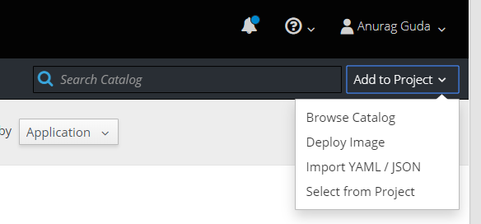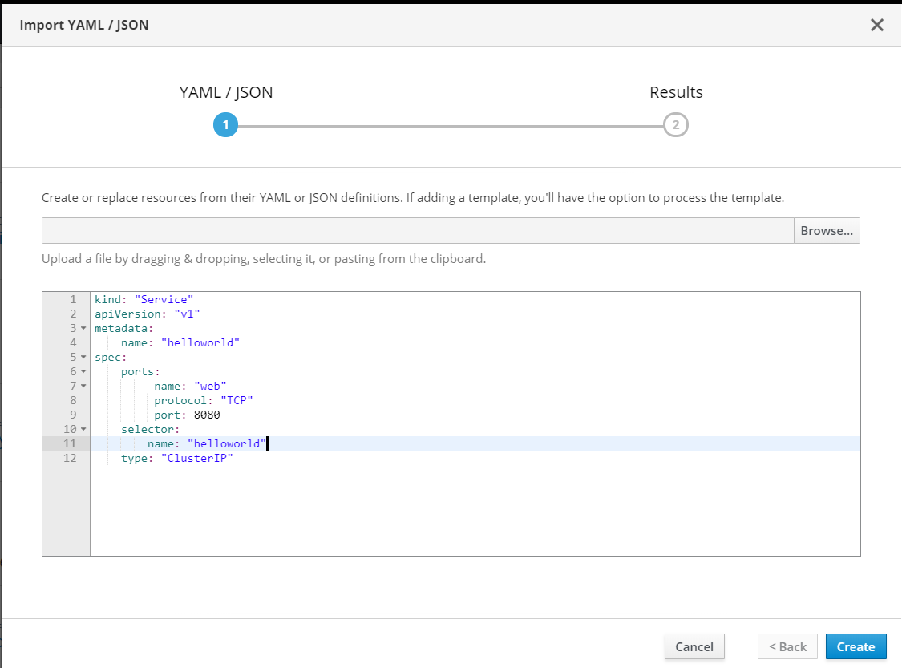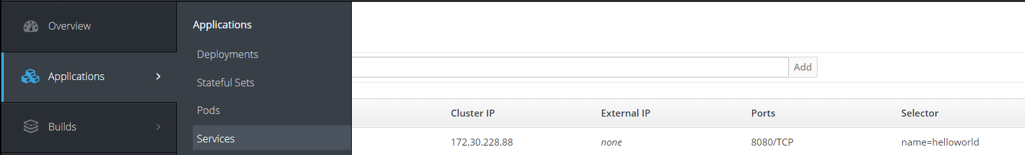

# Reference Materials

[Application Centric Cloud (ACC)](https://apps.na.collabserv.com/communities/service/html/communitystart?communityUuid=c7d56725-de0c-4b00-b388-8b9a9d1c3a76) [Enterprise Container Hub (ECH)](https://apps.na.collabserv.com/communities/service/html/communitystart?communityUuid=4d265bff-1544-441e-9d2c-d6eae0d0ef6f)

[Software Development Stack (SDaas) -Build the Reference Application in Jenkins](https://apps.na.collabserv.com/wikis/home/wiki/Wec86b581f692_476b_a8ec_932d42b08095/page/Build%20the%20Reference%20Application%20in%20Jenkins) [OpenShift 3.9 Documentation](https://docs.openshift.com/container-platform/3.9/welcome/index.html)

[Kubernetes](https://kubernetes.io/docs/concepts/overview/what-is-kubernetes/)

[Ping Policy Management Tool](https://wampmtui.cloudapps.cisco.com/loggedIn%23/applications/0/10) and its [WIKI](https://wiki.cisco.com/pages/viewpage.action?pageId=114767108) [CLIP Log Analysis](http://clip-prod-01/clip/home)

[Current CAE Version](https://wiki.cisco.com/display/CAEUSER/Current%2BCAE%2BVersion?src=contextnavpagetreemode) [CAE Cost](https://wiki.cisco.com/display/CAEUSER/CAE%2BCost)

# Current CAE Version

##### CAE on Platform 3 OpenShift Versions:

Prod:

RTP (3.10.139)

**RCDN (3.9.60)**

**ALLN (3.10.139)**

**Non-Prod:**

**RTP (3.10.119)**

**RCDN (3.10.111)**

**ALLN (3.9.60)**

Most recent upgrade has been from 3.9.60 to 3.10.111. 3.10 release notes can be viewed [here](https://docs.openshift.com/container-platform/3.10/release_notes/ocp_3_10_release_notes.html).

##### For apps that were deployed on CAE Platform 2 (prior to June 2018):

RTP (3.6)

**RCDN (3.6)**

**ALLN (3.6)**

**CAE on Platform 3 OpenShift Versions:**

**Prod:**

**RTP (3.9.60)**

**RCDN (3.9.60)**

**ALLN (3.9.60)**

**Non-Prod:**

**RTP (3.9.60)**

**RCDN (3.10)**

**ALLN (3.9.60)**

Most recent upgrade has been from 3.9.60 to 3.10.111. 3.10 release notes can be viewed [here](https://docs.openshift.com/container-platform/3.10/release_notes/ocp_3_10_release_notes.html).

##### For apps that were deployed on CAE Platform 2 (prior to June 2018):

RTP (3.6)

**RCDN (3.6)**

**ALLN (3.6)**

**Openshift Container Platform 3.10 Features**

This release is based on [OpenShift Origin 3.10](https://github.com/openshift/origin/releases/tag/v3.10.0-rc.0) and it uses Kubernetes 1.10. New features, changes, bug fixes, and known issues that pertain to OpenShift Container Platform 3.10 are included in this topic.

OpenShift Container Platform 3.10 is supported on RHEL 7.4 and 7.5 with the latest packages from Extras, including Docker 1.13. TLSV1.2 is the only supported security version in OpenShift Container Platform version 3.4 and later.

**Key New Features and Enhancements for App Team's Use**

##### ROUTE ANNOTATION LIMITS CONCURRENT CONNECTIONS

The route annotation [haproxy.router.openshift.io/pod-concurrent-connections](http://haproxy.router.openshift.io/pod-concurrent-connections) limits concurrent connections. See [Route-specific Annotations](https://docs.openshift.com/container-platform/3.10/architecture/networking/routes.html#route-specific-annotations) for more information.

##### WEB CONSOLE

**IMPROVED WAY TO SHOW AND CHOOSE ROUTES FOR APPLICATIONS**

There is now an improved way to show and choose routes for an application. There is now indication that there are multiple routes available.

Annotate the route that you would like to be primary: console.alpha.openshift.io/overview-app-route: ‘true’

##### CREATE GENERIC SECRETS

You can create generic secrets in the web console (secrets with any key / value pairs). You can already create secrets, but now you can create opaque secrets. This behaves like creating ConfigMaps.

##### MISCELLANEOUS CHANGES

The ***xterm.js*** dependency for pod terminal was updated with greatly improved performance. You can now create image pull secrets directly from the deploy image dialog.

Pod Flag Removed for oc port-forward

The deprecated -p <POD> flag for oc port-forward is removed. Use oc port-forward pod/<POD> inst ead.

Deprecated Web Console Support for Internet Explorer 11

**Deprecated oc rollout latest … --output=revision**

In OpenShift Container Platform 3.10, oc rollout latest … --output=revision is deprecated. Use oc rollout latest … --output jsonpath={.status.latestVersion} or oc rollout latest … --output go-template={{.status.latestVersion} instead.

### Major Changes to Cluster Architecture

[https://docs.openshift.com/container-platform/3.10/architecture/infrastructure\_components/kubernetes\_infrastructure.html#architecture-](https://docs.openshift.com/container-platform/3.10/architecture/infrastructure_components/kubernetes_infrastructure.html#architecture-infrastructure-components-kubernetes-infrastructure) [infrastructure-components-kubernetes-infrastructure](https://docs.openshift.com/container-platform/3.10/architecture/infrastructure_components/kubernetes_infrastructure.html#architecture-infrastructure-components-kubernetes-infrastructure)

**Technology Preview Features**

Some features in this release are currently in Technology Preview. These experimental features are not intended for production use. TP features will not be enabled.

<https://docs.openshift.com/container-platform/3.10/release_notes/ocp_3_10_release_notes.html#ocp-310-technology-preview>

# CAE Cost

A CAE Project's cost is determined based on its quota.

The project quota is set at initial provisioning time via ACC by the project owner.

A CAE project quota has multiple attributes including RAM limit, CPU request and storage limit. Only RAM and storage are used for costing. CPU quota is calculated based on the amount of RAM selected and is not used in the costing calculation.

CPU is given in a ratio of 1 CPU for every 20 GB of RAM.

As the project owner configures the quota in ACC, the cost will be automatically calculated and displayed in ACC. The cost shown in ACC is a quarterly cost.

The project owner can adjust the quota at anytime by returning to ACC and modifying the project. The cost will be adjusted accordingly.

**Quarterly Cost** = ($40 X GB RAM) + ($0.54 X GB Storage)

The costs listed in the table below are the examples of quarterly cost based on selected quota.

|  |  |  |  |
| --- | --- | --- | --- |
| **RAM Limit (GB)** | **CPU Core Request** | **Standard Block Storage Limit (GB)** | **Quarterly Cost** |
| 8 | 0.4 | 0 | $320 |
| 20 | 1.0 | 0 | $800 |
| 8 | 0.4 | 100 | $374 |

# Managed Images

The CAE team provides a set of supported base images.

Rather than downloading an image from the web, it is preferable to build your application from one of these images. These images are actively updated to be vulnerability free.

These images are supported by AWS and Red Hat.

The latest versions of these images can be found at [Enterprise Container Hub](https://containers.cisco.com/organization/aws_managed) repository.

See the documentation below for instructions on using a specific image.

[Apache2.4](https://wiki.cisco.com/display/CAEUSER/Apache2.4)

[Elastic Search 5.5.1](https://wiki.cisco.com/display/CAEUSER/Elastic%2BSearch%2B5.5.1) [HAProxy Redirect](https://wiki.cisco.com/display/CAEUSER/HAProxy%2BRedirect) [Jboss6.4](https://wiki.cisco.com/display/CAEUSER/Jboss6.4)

[MongoDB](https://wiki.cisco.com/display/CAEUSER/MongoDB) [MySQL](https://wiki.cisco.com/display/CAEUSER/MySQL)

[Node.js 4](https://wiki.cisco.com/display/CAEUSER/Node.js%2B4) [Perl5.24](https://wiki.cisco.com/display/CAEUSER/Perl5.24) [PHP5.6](https://wiki.cisco.com/display/CAEUSER/PHP5.6)

[PostgreSQL](https://wiki.cisco.com/display/CAEUSER/PostgreSQL) [Python](https://wiki.cisco.com/display/CAEUSER/Python) [Tomcat](https://wiki.cisco.com/display/CAEUSER/Tomcat) [Tomcat 12C](https://wiki.cisco.com/display/CAEUSER/Tomcat%2B12C) [Wildfly10.1.0](https://wiki.cisco.com/display/CAEUSER/Wildfly10.1.0)

# Apache2.4

#### [BASE IMAGES](file:///C:\Machine%20Learning\Test\PDF\ilovepdf_split-range\CAE%20Wiki%20Pages-151-403.docx#_bookmark31)

[**LAE-COMPATIBLE IMAGE**](file:///C:\Machine%20Learning\Test\PDF\ilovepdf_split-range\CAE%20Wiki%20Pages-151-403.docx#_bookmark32)

**HOW TO USE LAE-COMPATIBLE IMAGE**

**BASE IMAGES**

Apache 2.4 base images are pulled from Redhat registry and published in below ECH repositories.

[Apache 2.4](https://containers.cisco.com/repository/aws_managed/apache2.4) - Dockerfile

##### Base images are built from below Dockerfile by Redhat

**Dockerfile**

###### FROM rhscl/s2i-core-rhel7:1 # Apache HTTP Server image. #

# Volumes:

# \* /var/www - Datastore for httpd

# \* /var/log/httpd24 - Storage for logs when $HTTPD\_LOG\_TO\_VOLUME is set # Environment:

# \* $HTTPD\_LOG\_TO\_VOLUME (optional) - When set, httpd will log into /var

/log/httpd24

ENV HTTPD\_VERSION=2.4

ENV SUMMARY="Platform for running Apache httpd $HTTPD\_VERSION or building httpd-based application" \

DESCRIPTION="Apache httpd $HTTPD\_VERSION available as docker container, is a powerful, efficient, \

and extensible web server. Apache supports a variety of features, many implemented as compiled modules \

which extend the core functionality. \

These can range from server-side programming language support to authentication schemes. \

Virtual hosting allows one Apache installation to serve many different Web sites."

LABEL summary="$SUMMARY" \ description="$DESCRIPTION" \ io.k8s.description="$DESCRIPTION" \

io.k8s.display-name="Apache httpd $HTTPD\_VERSION" \ io.openshift.expose-services="8080:http,8443:https" \ io.openshift.tags="builder,httpd,httpd24" \ name="rhscl/httpd-24-rhel7" \

version="$HTTPD\_VERSION" \ com.redhat.component="httpd24-docker" \

usage="s2i build https://github.com/sclorg/httpd-container.git --context- dir=examples/sample-test-app/ rhscl/httpd-24-rhel7 sample-server" \ [maintainer="SoftwareCollections.org <sclorg@redhat.com>"](mailto:sclorg@redhat.com)

EXPOSE 8080

EXPOSE 8443

RUN yum install -y yum-utils && \

prepare-yum-repositories rhel-server-rhscl-7-rpms && \ INSTALL\_PKGS="gettext hostname nss\_wrapper bind-utils httpd24 httpd24- mod\_ssl" && \

yum install -y --setopt=tsflags=nodocs $INSTALL\_PKGS && \ rpm -V $INSTALL\_PKGS && \

yum clean all

ENV HTTPD\_CONTAINER\_SCRIPTS\_PATH=/usr/share/container-scripts/httpd/ \ HTTPD\_APP\_ROOT=${APP\_ROOT} \

HTTPD\_CONFIGURATION\_PATH=${APP\_ROOT}/etc/httpd.d \ HTTPD\_MAIN\_CONF\_PATH=/etc/httpd/conf \ HTTPD\_MAIN\_CONF\_D\_PATH=/etc/httpd/conf.d \ HTTPD\_VAR\_RUN=/var/run/httpd \ HTTPD\_DATA\_PATH=/var/www \ HTTPD\_DATA\_ORIG\_PATH=/opt/rh/httpd24/root/var/www \ HTTPD\_LOG\_PATH=/var/log/httpd24 \

HTTPD\_SCL=httpd24

# When bash is started non-interactively, to run a shell script, for example it

# looks for this variable and source the content of this file. This will enable

# the SCL for all scripts without need to do 'scl enable'. ENV BASH\_ENV=${HTTPD\_APP\_ROOT}/scl\_enable \ ENV=${HTTPD\_APP\_ROOT}/scl\_enable \

PROMPT\_COMMAND=". ${HTTPD\_APP\_ROOT}/scl\_enable"

COPY ./s2i/bin/ $STI\_SCRIPTS\_PATH COPY ./root /

# Reset permissions of filesystem to default values RUN /usr/libexec/httpd-prepare && rpm-file-permissions

USER 1001

# Not using VOLUME statement since it's not working in OpenShift Online: # https://github.com/sclorg/httpd-container/issues/30

# VOLUME ["${HTTPD\_DATA\_PATH}"]

# VOLUME ["${HTTPD\_LOG\_PATH}"]

CMD ["/usr/bin/run-httpd"

**LAE-COMPATIBLE IMAGE**

"LAE compatible" image helps you migrate your application from LAE to CAE. These images are built by modifying base images per LAE requirements.

[LAE Compatible Apache2.4](https://containers.cisco.com/repository/aws_managed/apache2.4_custom) Base images are modified with:

perl-CGI

perl-libwww-perl mod\_jk.so mod\_perl.so mod\_wl.so

##### Dockerfile used to build LAE Compatible image:

**Dockerfile**

# Base Image from Redhat

FROM registry.access.redhat.com/rhscl/httpd-24-rhel7 USER root

COPY redhat\_base.repo /etc/yum.repos.d/

RUN yum install -y perl-CGI perl-libwww-perl

# Copy Logrotation,httpd configuration file and custom modules COPY config-replace.sh \*.conf ${HTTPD\_APP\_ROOT}/

COPY modules/ /etc/httpd/modules/

COPY modules\_weblogic/ /opt/rh/httpd24/root/usr/lib64/

WORKDIR ${HTTPD\_APP\_ROOT}

RUN chmod g+rwX ${HOME} && \

mkdir ${HOME}/{htdocs,error} && \

chmod -R 777 /opt/rh/httpd24/root/usr/lib64 && \ chmod -R 777 ${HTTPD\_APP\_ROOT}/\* && \

${HTTPD\_APP\_ROOT}/config-replace.sh

WORKDIR ${HTTPD\_APP\_ROOT}/src

COPY error/ ${HOME}/error/

# Environment Variables

ENV OPENSHIFT\_APACHE\_LOG\_DIR=" ${HTTPD\_APP\_ROOT}/src/logs"

EXPOSE 8080

USER default

**HOW TO USE LAE-COMPATIBLE IMAGE**

You can use below Dockerfile template to deploy your application in CAE environment. Please replace "app-code" with your application code in COPY instruction.

**Dockefile**

###### FROM containers.cisco.com/aws\_managed/apache2.4\_custom USER root

EXPOSE 8080

# Copy apache application code into DocumentRoot Directory COPY app-code/ ${HOME}/

# Check if application code contains any line starting with SSL in proxy. conf or mod\_jk.so in custom.d directory.

# If line starts with SSL in proxy.conf , then add SSLProxyCheckPeerCN off and SSLProxyCheckPeerName off to the file.

# If mod\_jk.so contains, then replace it with mod\_jk.so 2.4 version.

RUN if [ `grep "^[S][S][L]" ${HOME}/custom.d/proxy.conf |wc -l` -gt 0 ]; then echo -e "SSLProxyCheckPeerCN off \nSSLProxyCheckPeerName off" >>

${HOME}/custom.d/proxy.conf ; fi && \

if [ `ls -ltr ${HOME}/custom.d/mod\_jk.so 2> /dev/null | wc -l` -gt 0

]; then cp /etc/httpd/modules/mod\_jk.so ${HOME}/custom.d/mod\_jk.so ; fi &&

\

if [ `ls -ltr ${HOME}/custom.d/mod\_wl.so 2> /dev/null | wc -l` -gt 0

]; then cp /etc/httpd/modules/mod\_wl.so ${HOME}/custom.d/mod\_wl.so; fi &&

\

echo "Include custom.d/\*.conf" >> ${HTTPD\_MAIN\_CONF\_PATH}/httpd.conf

&& \

ln -sf ${HOME}/custom.d /etc/httpd/custom.d USER default

**Elastic Search 5.5.1**

[**BASE IMAGES**](file:///C:\Machine%20Learning\Test\PDF\ilovepdf_split-range\CAE%20Wiki%20Pages-151-403.docx#_bookmark33)

[**LAE-COMPATIBLE IMAGE**](file:///C:\Machine%20Learning\Test\PDF\ilovepdf_split-range\CAE%20Wiki%20Pages-151-403.docx#_bookmark34)

[**HOW TO USE LAE-COMPATIBLE IMAGE**](file:///C:\Machine%20Learning\Test\PDF\ilovepdf_split-range\CAE%20Wiki%20Pages-151-403.docx#_bookmark35)

**BASE IMAGES**

Elastic Search base images are pulled from official docker registry and published in below ECH repositories.

ElasticSearch - [Docker](https://www.elastic.co/guide/en/elasticsearch/reference/5.5/docker.html)

##### Base images are built from below Dockerfile by Redhat

|  |
| --- |
| **Dockerfile** |

|  |
| --- |
| FROM openjdk:8-jre  # grab gosu for easy step-down from root ENV GOSU\_VERSION 1.10  RUN set -x \  && wget -O /usr/local/bin/gosu "[https://github.com/tianon/gosu/releases/download/$GOSU\_VERSION/gosu-$](https://github.com/tianon/gosu/releases/download/%24GOSU_VERSION/gosu-%24)(dpkg --print- architecture)" \  && wget -O /usr/local/bin/gosu.asc "[https://github.com/tianon/gosu/releases/download/$GOSU\_VERSION/gosu-$](https://github.com/tianon/gosu/releases/download/%24GOSU_VERSION/gosu-%24)(dpkg --print- architecture).asc" \  && export GNUPGHOME="$(mktemp -d)" \  && gpg --keyserver [ha.pool.sks-keyservers.net](http://ha.pool.sks-keyservers.net/) --recv-keys B42F6819007F00F88E364FD4036A9C25BF357DD4 \ && gpg --batch --verify /usr/local/bin/gosu.asc /usr/local/bin/gosu \  && rm -rf "$GNUPGHOME" /usr/local/bin/gosu.asc \ && chmod +x /usr/local/bin/gosu \  && gosu nobody true  RUN set -ex; \  # <https://artifacts.elastic.co/GPG-KEY-elasticsearch> key='46095ACC8548582C1A2699A9D27D666CD88E42B4'; \  export GNUPGHOME="$(mktemp -d)"; \  gpg --keyserver [ha.pool.sks-keyservers.net](http://ha.pool.sks-keyservers.net/) --recv-keys "$key"; \ gpg --export "$key" > /etc/apt/trusted.gpg.d/elastic.gpg; \  rm -rf "$GNUPGHOME"; \ apt-key list  # <https://www.elastic.co/guide/en/elasticsearch/reference/current/setup-repositories.html> # <https://www.elastic.co/guide/en/elasticsearch/reference/5.0/deb.html>  RUN set -x \  && apt-get update && apt-get install -y --no-install-recommends apt-transport-https && rm -rf /var/lib/apt/lists/\* \ && echo 'deb <https://artifacts.elastic.co/packages/5.x/apt>stable main' > /etc/apt/sources.list.d/elasticsearch.list  RUN set -x \  \  # don't allow the package to install its sysctl file (causes the install to fail)  # Failed to write '262144' to '/proc/sys/vm/max\_map\_count': Read-only file system && dpkg-divert --rename /usr/lib/sysctl.d/elasticsearch.conf \  \  && apt-get update \  && apt-get install -y --no-install-recommends "elasticsearch=$ELASTICSEARCH\_DEB\_VERSION" \ && rm -rf /var/lib/apt/lists/\*  ENV PATH /usr/share/elasticsearch/bin:$PATH WORKDIR /usr/share/elasticsearch  RUN set -ex \ && for path in \  ./data \  ./logs \  ./config \  ./config/scripts \  ; do \  mkdir -p "$path"; \  chown -R elasticsearch:elasticsearch "$path"; \ done  COPY config ./config  VOLUME /usr/share/elasticsearch/data COPY docker-entrypoint.sh /  EXPOSE 9200 9300  ENTRYPOINT ["/docker-entrypoint.sh"] CMD ["elasticsearch"] |

**LAE-COMPATIBLE IMAGE**

"LAE compatible" image helps you migrate your application from LAE to CAE. These images are built by modifying base images per LAE requirements.

[LAE-Compatible ElasticSearch 5.5.1](https://containers.cisco.com/repository/aws_managed/elasticsearch-5.5.1) Base images are modified with:

updated java version 1.8 Xpack.Security : Disabled. update Memory parameters.

##### Dockerfile used to build LAE Compatible image:

|  |
| --- |
| **Dockerfile** |
| FROM docker.elastic.co/elasticsearch/elasticsearch:5.5.1 MAINTAINER sramkish  USER root  ENV http.host=0.0.0.0  ENV transport.host=127.0.0.1 ENV xpack.security.enabled=false  RUN chmod -R 777 /usr/share/elasticsearch/data COPY jvm.options /usr/share/elasticsearch/config/  RUN chown 1000:1000 /usr/share/elasticsearch/config/jvm.options && chmod -R 777 /usr/share/elasticsearch/ EXPOSE 9200  EXPOSE 9300  USER 1000 |
|  |

**HOW TO USE LAE-COMPATIBLE IMAGE**

You can use below Dockerfile template to deploy your application in CAE environment. Please replace "app-code" with your application code in COPY instruction.

|  |
| --- |
| **Dockerfile** |
| FROM [containers.cisco.com/aws\_managed/](http://containers.cisco.com/aws_managed/apache2.4_custom)e[lasticsearch-5.5.1](https://containers.cisco.com/repository/aws_managed/elasticsearch-5.5.1) *# Copy apache application code into DocumentRoot Directory* COPY ${HOME}/repo  EXPOSE 9200  EXPOSE 9300  USER 1000 |

# HAProxy Redirect

1. deploy a haproxy pod in your project:

oc project <project\_name> please download [haproxy.yaml](https://wiki.cisco.com/download/attachments/175701752/haproxy.yaml?version=1&amp;modificationDate=1539367144000&amp;api=v2) oc apply -f [haproxy.yaml](https://wiki.cisco.com/download/attachments/175701752/haproxy.yaml?version=1&amp;modificationDate=1539367144000&amp;api=v2)

This will create a haproxy pod with a service

1. Create a ConfigMap in your project with haproxy.cfg

Resources > Config Maps > Create Config Map

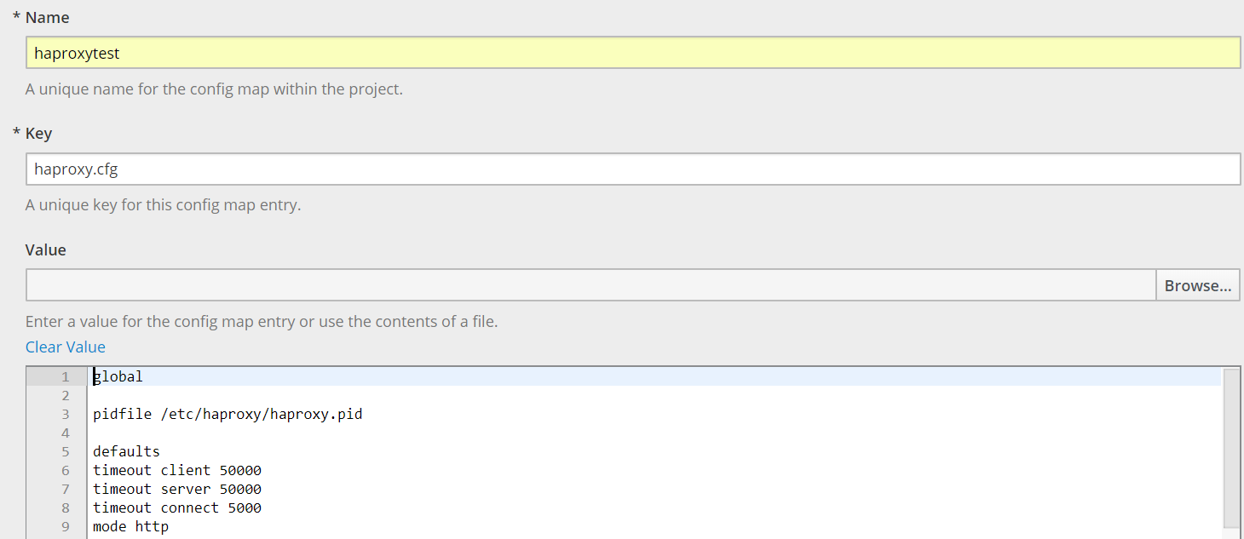

\*\*add below entry in the value according to your application requirement ###haproxy-start###

global

pidfile /etc/haproxy/haproxy.pid defaults

timeout client 50000

timeout server 50000

timeout connect 5000 mode http

backend **ProjectName-BACK**

#destination url

redirect prefix [**https://abc.cloudapps.cisco.com/phone**](https://tnm-dev.cloudapps.cisco.com/phone) code 301

frontend stats bind \*:8080

#contextpath

acl **ProjectName** path\_reg **^/**

use\_backend **ProjectName-BACK** if **ProjectName**

####haproxy-end###

1. Add Config Map to the haproxy pod

Applications>pods> haproxy pod, and click



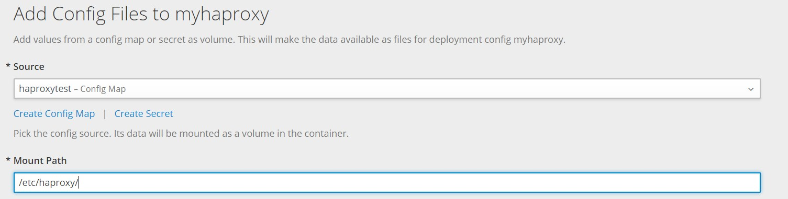

click Add

1. Map the haproxy service to the source hostname, while creating the source route

Please update the serivce name and port by edit route oc get routes

NAME HOST/PORT PATH SERVICES PORT TERMINATION WILDCARD

abc-stg-int-rtp-cname abc.cisco.com

abc-stg-int-rtp-svc web

edge/Allow None

abc-stg-int-rtp-live [abc.cloudapps.cisco.com](http://tnm-stage.cloudapps.cisco.com/) abc-stg-int-rtp-test [cae-abc-stage.cisco.com](http://cae-tnm-stage.cisco.com/)

oc edit route tnm-stg-int-rtp-cname

update the below entries in route and save

spec:

host: abc[.cisco.com](http://phone-stage.cisco.com/) port:

targetPort: **8080**

tls:

insecureEdgeTerminationPolicy: Allow termination: edge

to:

kind: Service

name: **cae-haproxy** weight: 100 wildcardPolicy: None

Please validate the test cases and perform cutover

abc-stg-int-rtp-svc web edge/None None abc-stg-int-rtp-svc web edge/Allow None

# Jboss6.4

#### [BASE IMAGES](file:///C:\Machine%20Learning\Test\PDF\ilovepdf_split-range\CAE%20Wiki%20Pages-151-403.docx#_bookmark36)

[**LAE-COMPATIBLE IMAGE**](file:///C:\Machine%20Learning\Test\PDF\ilovepdf_split-range\CAE%20Wiki%20Pages-151-403.docx#_bookmark37)

[**HOW TO USE LAE-COMPATIBLE IMAGE**](file:///C:\Machine%20Learning\Test\PDF\ilovepdf_split-range\CAE%20Wiki%20Pages-151-403.docx#_bookmark38)

**BASE IMAGES**

Jboss 6.4 base images from Redhat registry are published in below ECH repositories.

[Jboss 6.4](https://containers.cisco.com/repository/aws_managed/jboss-6.4) - Dockerfile

##### Base images are built from below Dockerfile by Redhat

|  |
| --- |
| **Dockerfile** |
| # Copyright 2017 Red Hat #  # Licensed under the Apache License, Version 2.0 (the "License"); # you may not use this file except in compliance with the License. # You may obtain a copy of the License at  #  # <http://www.apache.org/licenses/LICENSE-2.0> #  # Unless required by applicable law or agreed to in writing, software # distributed under the License is distributed on an "AS IS" BASIS,  # WITHOUT WARRANTIES OR CONDITIONS OF ANY KIND, either express or implied. # See the License for the specific language governing permissions and  # limitations under the License. #  # ------------------------------------------------------------------------ #  # This is a Dockerfile for the jboss-eap-6/eap64-openshift:1.7 image.  FROM jboss-eap-6/eap64:latest # Environment variables  ENV JBOSS\_IMAGE\_NAME="jboss-eap-6/eap64-openshift" \ JBOSS\_IMAGE\_VERSION="1.7" \  STI\_BUILDER="jee" \  JBOSS\_MODULES\_SYSTEM\_PKGS="org.jboss.logmanager,jdk.nashorn.api" \ AB\_JOLOKIA\_PASSWORD\_RANDOM="true" \ AB\_JOLOKIA\_AUTH\_OPENSHIFT="true" \  AB\_JOLOKIA\_HTTPS="true" \  DEFAULT\_ADMIN\_USERNAME="eapadmin"  # Labels  LABEL name="$JBOSS\_IMAGE\_NAME" \  version="$JBOSS\_IMAGE\_VERSION" \ architecture="x86\_64" \  com.redhat.component="jboss-eap-6-eap64-openshift-docker" \  io.k8s.description="Platform for building and running JavaEE applications on JBoss EAP 6.4" \ io.k8s.display-name="JBoss EAP 6.4" \  io.openshift.expose-services="8080:http" \ io.openshift.tags="builder,javaee,eap,eap6" \ io.openshift.s2i.scripts-url="[image:///usr/local/s2i](image://wiki.cisco.com/usr/local/s2i)" \ org.concrt.version="1.4.0" \  description="Red Hat JBoss Enterprise Application Platform 6.4 OpenShift container image" \ summary="Red Hat JBoss Enterprise Application Platform 6.4 OpenShift container image" \ io.fabric8.s2i.version.jolokia="1.3.6-redhat-1"  # Exposed ports EXPOSE 8443 8778  USER root |

|  |
| --- |
| # Add custom repo files  COPY repos/\*.repo /etc/yum.repos.d/  # Install required RPMs and ensure that the packages were installed  RUN yum install -y --disablerepo=\\* --enablerepo=jboss-rhel-os --enablerepo=jboss-rhel-rhscl rh-m ongodb32-mongo-java-driver postgresql-jdbc mysql-connector-java rh-maven33 hostname python-reques ts python-enum34 PyYAML \  && yum clean all && \  rpm -q rh-mongodb32-mongo-java-driver postgresql-jdbc mysql-connector-java rh-maven33 hostname python-requests python-enum34 PyYAML  # Remove custom repo files  RUN rm /etc/yum.repos.d/jboss-rhel-os.repo /etc/yum.repos.d/jboss-rhel-rhscl.repo  # Add all artifacts to the /tmp/artifacts # directory  COPY \  jolokia-jvm-1.3.6.redhat-1-agent.jar \ javax.json-1.0.4.jar \  jboss-logmanager-ext-1.0.0.Alpha2-redhat-1.jar \ oauth-20100527.jar \  activemq-rar-5.11.0.redhat-630262.rar \  hawkular-javaagent-1.0.0.CR5-redhat-1-shaded.jar \ rh-sso-7.1.0-eap6-adapter.zip \  rh-sso-7.1.2-saml-eap6-adapter.zip \ tomcat-7-valves-1.0.3.Final-redhat-1.jar \  openshift-ping-common-1.1.6.Final-redhat-1.jar \ openshift-ping-dns-1.1.6.Final-redhat-1.jar \ openshift-ping-kube-1.1.6.Final-redhat-1.jar \  /tmp/artifacts/  # Add scripts used to configure the image COPY modules /tmp/scripts  # Custom scripts USER root  RUN [ "bash", "-x", "/tmp/scripts/dynamic-resources/install.sh" ]  USER root  RUN [ "bash", "-x", "/tmp/scripts/s2i-common/install.sh" ]  USER root  RUN [ "bash", "-x", "/tmp/scripts/java-alternatives/run.sh" ]  USER root  RUN [ "bash", "-x", "/tmp/scripts/os-eap64-openshift/prepare.sh" ]  USER 185  RUN [ "bash", "-x", "/tmp/scripts/os-eap64-openshift/configure.sh" ]  USER root  RUN [ "bash", "-x", "/tmp/scripts/os-eap-s2i/prepare.sh" ]  USER root  RUN [ "bash", "-x", "/tmp/scripts/os-java-jolokia/install\_as\_root" ]  USER 185  RUN [ "bash", "-x", "/tmp/scripts/jolokia/configure.sh" ]  USER 185  RUN [ "bash", "-x", "/tmp/scripts/os-eap64-modules/configure.sh" ]  USER 185  RUN [ "bash", "-x", "/tmp/scripts/os-eap64-ping/configure.sh" ]  USER root  RUN [ "bash", "-x", "/tmp/scripts/os-java-run/install\_as\_root" ]  USER 185  RUN [ "bash", "-x", "/tmp/scripts/os-eap-launch/configure.sh" ]  USER 185  RUN [ "bash", "-x", "/tmp/scripts/os-eap-node-name/configure.sh" ] |

|  |
| --- |
| USER 185  RUN [ "bash", "-x", "/tmp/scripts/os-eap64-launch/configure.sh" ]  USER root  RUN [ "bash", "-x", "/tmp/scripts/os-partition/install\_as\_root" ]  USER 185  RUN [ "bash", "-x", "/tmp/scripts/os-eap-migration/configure.sh" ]  USER 185  RUN [ "bash", "-x", "/tmp/scripts/os-eap-logging/configure.sh" ]  USER 185  RUN [ "bash", "-x", "/tmp/scripts/os-eap-probes/configure.sh" ]  USER 185  RUN [ "bash", "-x", "/tmp/scripts/jboss-maven/configure.sh" ]  USER 185  RUN [ "bash", "-x", "/tmp/scripts/os-eap-db-drivers/configure.sh" ]  USER 185  RUN [ "bash", "-x", "/tmp/scripts/os-eap-activemq-rar/configure.sh" ]  USER 185  RUN [ "bash", "-x", "/tmp/scripts/os-eap-sso/configure.sh" ]  USER 185  RUN [ "bash", "-x", "/tmp/scripts/os-eap64-sso/configure.sh" ]  USER root  RUN [ "bash", "-x", "/tmp/scripts/os-java-hawkular/install\_as\_root" ]  USER root  RUN [ "bash", "-x", "/tmp/scripts/os-eap64-hawkular/install\_as\_root" ]  USER 185  RUN [ "bash", "-x", "/tmp/scripts/os-eap-hawkular/configure.sh" ]  USER 185  RUN [ "bash", "-x", "/tmp/scripts/os-eap-deployment-scanner/configure.sh" ]  USER 185  RUN [ "bash", "-x", "/tmp/scripts/os-eap-extensions/configure.sh" ]  USER 185  RUN [ "bash", "-x", "/tmp/scripts/openshift-layer/configure\_layers.sh" ]  USER root  RUN [ "bash", "-x", "/tmp/scripts/openshift-passwd/configure\_passwd.sh" ]  USER root  RUN rm -rf /tmp/scripts  USER root  RUN rm -rf /tmp/artifacts  USER 185  CMD ["/opt/eap/bin/openshift-launch.sh"] |

**LAE-COMPATIBLE IMAGE**

"LAE-compatible" image helps you migrate your application from LAE to CAE. These images are built by modifying base images per LAE requirements.

[LAE Compatible Jboss 6.4](https://containers.cisco.com/repository/aws_managed/jboss6.4_custom) Base images are modified with:

oracle-instantclient11.2 mmx modules

AppD

##### Dockerfile used to build LAE-Compatible image:

|  |
| --- |
| **Dockerfile** |
| FROM [registry.access.redhat.com/jboss-eap-6/eap64-openshift](http://registry.access.redhat.com/jboss-eap-6/eap64-openshift)  USER root  ADD \*.rpm /tmp/  ADD network /usr/lib/oracle/11.2/network  ADD provider $JBOSS\_HOME/modules/system/layers/base/org/jboss/genericjms/ ADD custom $JBOSS\_HOME/modules/  ADD AppDServerAgent /opt/AppDServerAgent  ENV JAVA\_OPTS\_EXT="${JAVA\_OPTS\_EXT} -Djava.library.path=/usr/lib/oracle/11.2/client64/lib" \ OPENSHIFT\_LOG\_DIR="$JBOSS\_HOME/app-root/logs/" \ OPENSHIFT\_JBOSSEAP\_LOG\_DIR="$JBOSS\_HOME/standalone/log/" \ JBOSS\_LOG\_DIR="$JBOSS\_HOME/standalone/log/" \ OPENSHIFT\_DEPLOYMENTS\_DIR=$JBOSS\_HOME/standalone/deployments \ OPENSHIFT\_TMP\_DIR=/tmp/ \  TMPDIR=/tmp/ \ OPENSHIFT\_HOMEDIR=$JBOSS\_HOME \  REPO=/app-root/runtime/repo \ OPENSHIFT\_REPO\_DIR=$JBOSS\_HOME/app-root/runtime/repo/ \  OPENSHIFT\_DEPENDENCIES\_DIR=$JBOSS\_HOME/app-root/runtime/dependencies \ OPENSHIFT\_DATA\_DIR=$JBOSS\_HOME/app-root/data \ PATH=$[PATH:/usr/lib/oracle/11.2/client64/bin](http://PATH/usr/lib/oracle/11.2/client64/bin) \ LD\_LIBRARY\_PATH=/usr/lib/oracle/11.2/client64/lib:$LD\_LIBRARY\_PATH \ TNS\_ADMIN=/usr/lib/oracle/11.2/network/admin  RUN rpm -ivh /tmp/\*.rpm && \ rm -f /tmp/\*.rpm && \  ln -s /usr/lib/oracle/11.2/client64/lib/[libocijdbc11.so](http://libocijdbc11.so/) /usr/lib/oracle/11.2/client64/[libocijdbc11.so](http://libocijdbc11.so/) && \ echo /usr/lib/oracle/11.2/client64/lib > /etc/[ld.so](http://ld.so/).conf.d/oracle-instantclient11.2.conf && \  ldconfig && \  mkdir -p $JBOSS\_HOME/app-root/data && \ mkdir -p $JBOSS\_HOME/app-root/logs \ mkdir -p $OPENSHIFT\_REPO\_DIR && \ mkdir -p /opt/AppDServerAgent/logs && \  mkdir -p $JBOSS\_HOME/app-root/runtime/dependencies/jbosseap && \ chmod -R 775 /opt/AppDServerAgent/ && \  rm -rf /deployments/activemq-rar.rar && \  ln -fs /usr/share/zoneinfo/America/Los\_Angeles /etc/localtime && \  ln -s $JBOSS\_HOME/app-root/runtime/repo $JBOSS\_HOME/app-root/repo && \ ln -s $JBOSS\_HOME/app-root $HOME/app-root && \  ln -s $JBOSS\_HOME/standalone/deployments $JBOSS\_HOME/app-root/runtime/dependencies/jbosseap/deployments  #COPY config-replace $JBOSS\_HOME/app-root/runtime/repo/config-replace COPY serverStart.sh $JBOSS\_HOME/bin/  #COPY redhat\_base.repo /etc/yum.repos.d/  RUN chown -R jboss:jboss $JBOSS\_HOME && \ chmod -R 777 $JBOSS\_HOME  EXPOSE 8080 8443  #RUN chmod -R 775 $JBOSS\_HOME/standalone/configuration && \ # chmod -R 775 $OPENSHIFT\_REPO\_DIR  #COPY repo $OPENSHIFT\_REPO\_DIR #ENV OPENSHIFT\_APP\_NAME=caedev  USER jboss  ENTRYPOINT ["/opt/eap/bin/serverStart.sh"] |

**HOW TO USE LAE-COMPATIBLE IMAGE**

You can use below Dockerfile template to deploy your application in CAE environment. Please replace "repo" with your application code in COPY instruction.

|  |
| --- |
| **Dockerfile** |
| FROM [containers.cisco.com/aws\_managed/jboss6.4\_custom](http://containers.cisco.com/aws_managed/jboss6.4_custom) USER root  COPY repo $OPENSHIFT\_REPO\_DIR  COPY \*.war $JBOSS\_HOME/standalone/deployments/  RUN chown -R jboss:jboss $JBOSS\_HOME RUN chmod -R 777 $JBOSS\_HOME  USER jboss  ENTRYPOINT $JBOSS\_HOME/bin/serverStart.sh |

# MongoDB

#### [BASE IMAGES](file:///C:\Machine%20Learning\Test\PDF\ilovepdf_split-range\CAE%20Wiki%20Pages-151-403.docx#_bookmark39)

[**LAE-COMPATIBLE IMAGE**](file:///C:\Machine%20Learning\Test\PDF\ilovepdf_split-range\CAE%20Wiki%20Pages-151-403.docx#_bookmark40)

**BASE IMAGES**

MongoDB base image are pulled from Redhat registry and published in below ECH repositories.

[MongoDB](https://containers.cisco.com/repository/aws_managed/mongodb-2.6) - Dockerfile

##### Base images are built from below Dockerfile by Redhat

|  |
| --- |
| **Dockerfile** |

|  |
| --- |
| FROM rhscl/s2i-core-rhel7  ENV SUMMARY="MongoDB NoSQL database server" \ DESCRIPTION="MongoDB (from humongous) is a free and open-source \ cross-platform document-oriented database program. Classified as a NoSQL \ database program, MongoDB uses JSON-like documents with schemas. This \ container image contains programs to run mongod server."  LABEL summary="$SUMMARY" \ description="$DESCRIPTION" \ io.k8s.description="$DESCRIPTION" \ io.k8s.display-name="MongoDB 2.6" \ io.openshift.expose-services="27017:mongodb" \  io.openshift.tags="database,mongodb,rh-mongodb26" \ com.redhat.component="rh-mongodb26-docker" \ name="rhscl/mongodb-26-rhel7" \  usage="docker run -d -e MONGODB\_ADMIN\_PASSWORD=my\_pass rhscl/mongodb-26-rhel7" \ version="2.6" \  maintainer="[SoftwareCollections.org](http://SoftwareCollections.org/) <sclorg@[redhat.com](http://redhat.com/)>"  ENV MONGODB\_VERSION=2.6 \  # Set paths to avoid hard-coding them in scripts. APP\_DATA=/opt/app-root/src \ HOME=/var/lib/mongodb \  CONTAINER\_SCRIPTS\_PATH=/usr/share/container-scripts/mongodb \ # Incantations to enable Software Collections on `bash` and `sh -i`.  ENABLED\_COLLECTIONS=rh-mongodb26 \ BASH\_ENV="\${CONTAINER\_SCRIPTS\_PATH}/scl\_enable" \ ENV="\${CONTAINER\_SCRIPTS\_PATH}/scl\_enable" \ PROMPT\_COMMAND=". \${CONTAINER\_SCRIPTS\_PATH}/scl\_enable"  EXPOSE 27017  ENTRYPOINT ["container-entrypoint"] CMD ["run-mongod"]  RUN yum install -y yum-utils && \  prepare-yum-repositories rhel-server-rhscl-7-rpms && \  INSTALL\_PKGS="bind-utils gettext iproute rsync tar hostname shadow-utils v8314 rh-mongodb26-mongodb rh-mongodb26 groff- base" && \  yum install -y --setopt=tsflags=nodocs $INSTALL\_PKGS && \ rpm -V $INSTALL\_PKGS && \  yum clean all  COPY s2i/bin/ $STI\_SCRIPTS\_PATH COPY root /  # Container setup  RUN touch /etc/mongod.conf && \ mkdir -p ${HOME}/data && \  # Set owner 'mongodb:0' and 'g+rw(x)' permission - to avoid problems running container with arbitrary UID  /usr/libexec/fix-permissions /etc/mongod.conf ${CONTAINER\_SCRIPTS\_PATH}/mongod.conf.template \  ${HOME} ${APP\_DATA}/.. && \  usermod -a -G root mongodb && \ rpm-file-permissions  VOLUME ["/var/lib/mongodb/data"] USER 184 |

**LAE-COMPATIBLE IMAGE**

Base MongoDB images are pulled and available in [ECH](https://containers.cisco.com/repository/aws_managed/mongodb-2.6?tab=tags) and are not customized.

For migrating applications , if your application has MongoDB addon , please follow [MongoDB](https://wiki.cisco.com/display/GISCONT/MongoDB) instructions to configure and setup.

# MySQL

#### [BASE IMAGES](file:///C:\Machine%20Learning\Test\PDF\ilovepdf_split-range\CAE%20Wiki%20Pages-151-403.docx#_bookmark41)

[**LAE-COMPATIBLE IMAGE**](file:///C:\Machine%20Learning\Test\PDF\ilovepdf_split-range\CAE%20Wiki%20Pages-151-403.docx#_bookmark42)

**BASE IMAGES**

MySQL base images are pulled from Redhat registry and published in below ECH repositories.

[MySQL](https://containers.cisco.com/repository/aws_managed/mysql-5.6) [- Dockerfile](https://containers.cisco.com/repository/aws_managed/mongodb-2.6)

##### Base images are built from below Dockerfile by Redhat

|  |
| --- |
| **Dockerfile** |
| FROM rhscl/s2i-core-rhel7  # MySQL image for OpenShift. #  # Volumes:  # \* /var/lib/mysql/data - Datastore for MySQL # Environment:  # \* $MYSQL\_USER - Database user name  # \* $MYSQL\_PASSWORD - User's password  # \* $MYSQL\_DATABASE - Name of the database to create  # \* $MYSQL\_ROOT\_PASSWORD (Optional) - Password for the 'root' MySQL account  ENV MYSQL\_VERSION=5.6 \  APP\_DATA=/opt/app-root/src \ HOME=/var/lib/mysql  ENV SUMMARY="MySQL 5.6 SQL database server" \  DESCRIPTION="MySQL is a multi-user, multi-threaded SQL database server. The container \ image provides a containerized packaging of the MySQL mysqld daemon and client application. \ The mysqld server daemon accepts connections from clients and provides access to content from \ MySQL databases on behalf of the clients."  LABEL summary="$SUMMARY" \ description="$DESCRIPTION" \ io.k8s.description="$DESCRIPTION" \ io.k8s.display-name="MySQL 5.6" \ io.openshift.expose-services="3306:mysql" \  io.openshift.tags="database,mysql,mysql56,rh-mysql56" \ com.redhat.component="rh-mysql56-docker" \ name="rhscl/mysql-56-rhel7" \  version="5.6" \  usage="docker run -d -e MYSQL\_USER=user -e MYSQL\_PASSWORD=pass -e MYSQL\_DATABASE=db -p 3306:3306 rhscl  /mysql-56-rhel7" \  maintainer="[SoftwareCollections.org](http://SoftwareCollections.org/) <sclorg@[redhat.com](http://redhat.com/)>"  EXPOSE 3306  # This image must forever use UID 27 for mysql user so our volumes are # safe in the future. This should \*never\* change, the last test is there  # to make sure of that.  RUN yum install -y yum-utils && \  prepare-yum-repositories rhel-server-rhscl-7-rpms && \  INSTALL\_PKGS="rsync tar gettext hostname bind-utils groff-base shadow-utils rh-mysql56" && \ yum install -y --setopt=tsflags=nodocs $INSTALL\_PKGS && \  rpm -V $INSTALL\_PKGS && \ yum clean all && \  mkdir -p /var/lib/mysql/data && chown -R mysql.0 /var/lib/mysql && \ test "$(id mysql)" = "uid=27(mysql) gid=27(mysql) groups=27(mysql)" |

|  |
| --- |
| # Get prefix path and path to scripts rather than hard-code them in scripts ENV CONTAINER\_SCRIPTS\_PATH=/usr/share/container-scripts/mysql \ MYSQL\_PREFIX=/opt/rh/rh-mysql56/root/usr \ ENABLED\_COLLECTIONS=rh-mysql56  # When bash is started non-interactively, to run a shell script, for example it # looks for this variable and source the content of this file. This will enable # the SCL for all scripts without need to do 'scl enable'.  ENV BASH\_ENV=${CONTAINER\_SCRIPTS\_PATH}/scl\_enable \ ENV=${CONTAINER\_SCRIPTS\_PATH}/scl\_enable \ PROMPT\_COMMAND=". ${CONTAINER\_SCRIPTS\_PATH}/scl\_enable"  COPY 5.6/root-common /  COPY 5.6/s2i-common/bin/ $STI\_SCRIPTS\_PATH COPY 5.6/root /  # this is needed due to issues with squash  # when this directory gets rm'd by the container-setup # script.  RUN rm -rf /etc/my.cnf.d/\*  # Reset permissions of filesystem to default values  RUN /usr/libexec/container-setup && rpm-file-permissions VOLUME ["/var/lib/mysql/data"]  USER 27  ENTRYPOINT ["container-entrypoint"] CMD ["run-mysqld"] |

**LAE-COMPATIBLE IMAGE**

Base MySQL images are pulled and available in [ECH](https://containers.cisco.com/repository/aws_managed/mysql-5.6) and are not customized.

For migrating applications , if your application has MySQL addon , please follow [MySQL](https://wiki.cisco.com/display/GISCONT/MySQL) instructions to configure and setup.

# Node.js 4

#### [BASE IMAGES](file:///C:\Machine%20Learning\Test\PDF\ilovepdf_split-range\CAE%20Wiki%20Pages-151-403.docx#_bookmark43)

[**LAE-COMPATIBLE IMAGE**](file:///C:\Machine%20Learning\Test\PDF\ilovepdf_split-range\CAE%20Wiki%20Pages-151-403.docx#_bookmark44)

[**HOW TO USE LAE-COMPATIBLE IMAGE**](file:///C:\Machine%20Learning\Test\PDF\ilovepdf_split-range\CAE%20Wiki%20Pages-151-403.docx#_bookmark45)

**BASE IMAGES**

Node.js 4 base images from the Redhat registry are published in below ECH repositories.

[Node.js 4](https://containers.cisco.com/repository/aws_managed/nodejs-4) - Dockerfile

##### Base images are built from below Dockerfile by Redhat

|  |
| --- |
| **Dockerfile** |
| FROM rhscl/s2i-base-rhel7:1  # This image provides a Node.JS environment you can use to run your Node.JS # applications.  EXPOSE 8080  # Add $HOME/node\_modules/.bin to the $PATH, allowing user to make npm scripts # available on the CLI without using npm's --global installation mode  # This image will be initialized with "npm run $NPM\_RUN"  # See <https://docs.npmjs.com/misc/scripts>, and your repo's package.json # file for possible values of NPM\_RUN  # Description # Environment:  # \* $NPM\_RUN - Select an alternate / custom runtime mode, defined in your package.json files' scripts section (default: npm run "start").  # Expose ports:  # \* 8080 - Unprivileged port used by nodejs application  ENV NODEJS\_VERSION=4 \  NPM\_RUN=start \ NAME=nodejs \  NPM\_CONFIG\_PREFIX=$HOME/.npm-global \ PATH=$HOME/node\_modules/.bin/:$HOME/.npm-global/bin/:$PATH  ENV SUMMARY="Platform for building and running Node.js $NODEJS\_VERSION applications" \ DESCRIPTION="Node.js $NODEJS\_VERSION available as docker container is a base platform for \ building and running various Node.js $NODEJS\_VERSION applications and frameworks. \ Node.js is a platform built on Chrome's JavaScript runtime for easily building \  fast, scalable network applications. Node.js uses an event-driven, non-blocking I/O model \ that makes it lightweight and efficient, perfect for data-intensive real-time applications \ that run across distributed devices."  LABEL summary="$SUMMARY" \ description="$DESCRIPTION" \ io.k8s.description="$DESCRIPTION" \ io.k8s.display-name="Node.js $NODEJS\_VERSION" \ io.openshift.expose-services="8080:http" \  io.openshift.tags="builder,$NAME,${NAME}${NODEJS\_VERSION}" \ io.openshift.s2i.scripts-url="[image:///usr/libexec/s2i](image://wiki.cisco.com/usr/libexec/s2i)" \ io.s2i.scripts-url="[image:///usr/libexec/s2i](image://wiki.cisco.com/usr/libexec/s2i)" \ com.redhat.dev-mode="DEV\_MODE:false" \ com.redhat.deployments-dir="${APP\_ROOT}/src" \ com.redhat.dev-mode.port="DEBUG\_PORT:5858" \ com.redhat.component="rh-${NAME}${NODEJS\_VERSION}-docker" \ name="rhscl/$NAME-$NODEJS\_VERSION-rhel7" \ version="$NODEJS\_VERSION" \ maintainer="[SoftwareCollections.org](http://SoftwareCollections.org/) <sclorg@[redhat.com](http://redhat.com/)>" \  help="For more information visit <https://github.com/sclorg/s2i-nodejs-container>" \ usage="s2i build <SOURCE-REPOSITORY> rhscl/$NAME-$NODEJS\_VERSION-rhel7:latest <APP-NAME>" |

|  |
| --- |
| RUN yum install -y yum-utils && \  prepare-yum-repositories rhel-server-rhscl-7-rpms && \ yum remove -y rh-nodejs6\\* && \  INSTALL\_PKGS="rh-nodejs4 rh-nodejs4-npm rh-nodejs4-nodejs-nodemon nss\_wrapper" && \ ln -s /usr/lib/node\_modules/nodemon/bin/nodemon.js /usr/bin/nodemon && \  yum install -y --setopt=tsflags=nodocs $INSTALL\_PKGS && \ rpm -V $INSTALL\_PKGS && \  yum clean all -y  # Copy the S2I scripts from the specific language image to $STI\_SCRIPTS\_PATH COPY ./s2i/bin/ $STI\_SCRIPTS\_PATH  # Copy extra files to the image.  COPY ./root/ /  # Drop the root user and make the content of /opt/app-root owned by user 1001 RUN chown -R 1001:0 ${APP\_ROOT} && chmod -R ug+rwx ${APP\_ROOT} && \  rpm-file-permissions USER 1001  # Set the default CMD to print the usage of the language image CMD $STI\_SCRIPTS\_PATH/usage |

**LAE-COMPATIBLE IMAGE**

"LAE compatible" image helps you migrate your application from LAE to CAE. These images are built by modifying base images per LAE requirements.

[LAE-Compatible Node.js 4](https://containers.cisco.com/repository/aws_managed/nodejs-4_custom) Base images are modified with:

Oracle instant client rpms

oracle-instantclient11.2-basic-11.2.0.3.0-1.x86\_64.rpm oracle-instantclient11.2-sqlplus-11.2.0.3.0-1.x86\_64.rpm oracle-instantclient11.2-devel-11.2.0.3.0-1.x86\_64.rpm

##### Dockerfile used to build LAE-Compatible image:

|  |
| --- |
| **Dockerfile** |

|  |
| --- |
| FROM [registry.access.redhat.com/rhscl/nodejs-4-rhel7](http://registry.access.redhat.com/rhscl/nodejs-4-rhel7) USER root  RUN mkdir ${HOME}/data \  ${HOME}/repo/  #ADD files  COPY repo ${HOME}/repo  COPY startup.sh log ${APP\_ROOT}/  ENV OPENSHIFT\_NODEJS\_PORT=8080 \  OPENSHIFT\_TMP\_DIR=/tmp/ \ OPENSHIFT\_HOMEDIR=$HOME \  OPENSHIFT\_LOG\_DIR=$HOME/logs \ OPENSHIFT\_REPO\_DIR=$HOME/repo \ OPENSHIFT\_NODEJS\_LOG\_DIR=$HOME/logs \  OPENSHIFT\_DATA\_DIR=$HOME/data/ \ OPENSHIFT\_DEPLOYMENTS\_DIR=$HOME/repo  RUN chmod -R 777 ${HOME}/\* \  ${APP\_ROOT}/startup.sh  #PORT EXPOSE 8080  USER default  WORKDIR ${HOME}/repo  CMD ${HOME}/repo/server.js |
|  |

**HOW TO USE LAE-COMPATIBLE IMAGE**

You can use below Dockerfile template to deploy your application in CAE environment. Please replace "repo" with your application code in COPY instruction.

|  |
| --- |
| **Dockerfile** |
| FROM [containers.cisco.com/aws\_managed/nodejs-4\_custom](http://containers.cisco.com/aws_managed/nodejs-4_custom)  USER root  MAINTAINER CECEUSERID  **#ADD files**  COPY repo/ ${HOME}/repo/  RUN chmod -R 777 ${APP\_ROOT}/\* WORKDIR ${HOME}/repo  **#To install custom modules**  RUN /bin/bash -c 'npm install -g grunt-cli;npm install -g grunt;npm install winston'  **#PORT**  EXPOSE 8080  USER default  CMD ["/opt/app-root/startup.sh"] |

# Perl5.24

#### [BASE IMAGES](https://wiki.cisco.com/display/CAEUSER/Node.js%2B4#Node.js4-BASEIMAGES)

[**LAE-COMPATIBLE IMAGE**](https://wiki.cisco.com/display/CAEUSER/Node.js%2B4#Node.js4-LAE-COMPATIBLEIMAGE)

[**HOW TO USE LAE-COMPATIBLE IMAGE**](https://wiki.cisco.com/display/CAEUSER/Node.js%2B4#Node.js4-HOWTOUSELAE-COMPATIBLEIMAGE)

**BASE IMAGES**

Perl 5.24 base images from the Redhat registry are published in below ECH repositories. perl 5.24 - Dockerfile

##### Base images are built from below Dockerfile by Redhat

|  |
| --- |
| **Dockerfile** |

|  |
| --- |
| FROM rhscl/s2i-base-rhel7:1  # This image provides a Perl 5.24 environment you can use to run your Perl applications.  **3.** EXPOSE 8080  # Image metadata  ENV PERL\_VERSION=5.24 \ PERL\_SHORT\_VER=524 \  **7.** NAME=perl  ENV SUMMARY="Platform for building and running Perl $PERL\_VERSION applications" \ DESCRIPTION="Perl $PERL\_VERSION available as container is a base platform for \ building and running various Perl $PERL\_VERSION applications and frameworks. \  **11.** Perl is a high-level programming language with roots in C, sed, awk and shell scripting. \  Perl is good at handling processes and files, and is especially good at handling text. \ Perl's hallmarks are practicality and efficiency. While it is used to do a lot of \ different things, Perl's most common applications are system administration utilities \ and web programming."  LABEL summary="$SUMMARY" \ description="$DESCRIPTION" \ io.k8s.description="$DESCRIPTION" \  io.k8s.display-name="Apache 2.4 with mod\_perl/$PERL\_VERSION" \  **20.** io.openshift.expose-services="8080:http" \ io.openshift.tags="builder,${NAME},${NAME}${PERL\_SHORT\_VER}" \ io.openshift.s2i.scripts-url="[image:///usr/libexec/s2i](image://wiki.cisco.com/usr/libexec/s2i)" \ io.s2i.scripts-url="[image:///usr/libexec/s2i](image://wiki.cisco.com/usr/libexec/s2i)" \ name="rhscl/${NAME}-${PERL\_SHORT\_VER}-rhel7" \  **25.** com.redhat.component="rh-${NAME}${PERL\_SHORT\_VER}-docker" \  version="$PERL\_VERSION" \ maintainer="[SoftwareCollections.org](http://SoftwareCollections.org/) <sclorg@[redhat.com](http://redhat.com/)>" \  help="For more information visit [https://github.com/sclorg/s2i-${NAME}-container](https://github.com/sclorg/s2i-%24%7BNAME%7D-container)" \ usage="s2i build <SOURCE-REPOSITORY> rhscl/${NAME}-${PERL\_SHORT\_VER}-rhel7:latest <APP-NAME>"  RUN yum install -y yum-utils && \  prepare-yum-repositories rhel-server-rhscl-7-rpms && \  INSTALL\_PKGS="rh-perl524 rh-perl524-perl-devel rh-perl524-mod\_perl rh-perl524-perl-CPAN rh- perl524-perl-App-cpanminus" && \  yum install -y --setopt=tsflags=nodocs $INSTALL\_PKGS && \  **34.** rpm -V $INSTALL\_PKGS && \ yum clean all  # Copy the S2I scripts from the specific language image to $STI\_SCRIPTS\_PATH COPY ./s2i/bin/ $STI\_SCRIPTS\_PATH  # Copy extra files to the image.  COPY ./root/ /  # In order to drop the root user, we have to make some directories world  **41.** # writeable as OpenShift default security model is to run the container under # random UID.  RUN mkdir -p ${APP\_ROOT}/etc/httpd.d && \  sed -i -f ${APP\_ROOT}/etc/httpdconf.sed /opt/rh/httpd24/root/etc/httpd/conf/httpd.conf && \ chmod -R og+rwx /opt/rh/httpd24/root/var/run/httpd ${APP\_ROOT}/etc/httpd.d && \  **46.** chown -R 1001:0 ${APP\_ROOT} && chmod -R ug+rwx ${APP\_ROOT} && \  rpm-file-permissions USER 1001  **49.** # Enable the SCL for all bash scripts.  ENV BASH\_ENV=${APP\_ROOT}/etc/scl\_enable \ ENV=${APP\_ROOT}/etc/scl\_enable \ PROMPT\_COMMAND=". ${APP\_ROOT}/etc/scl\_enable"  **53.** # Set the default CMD to print the usage of the language image  CMD $STI\_SCRIPTS\_PATH/usage |

**LAE-COMPATIBLE IMAGE**

"LAE compatible" image helps you migrate your application from LAE to CAE. These images are built by modifying base images per LAE requirements.

[LAE-Compatible perl 5.24](https://containers.cisco.com/repository/aws_managed/perl-5.24)

Base images are modified with:

Oracle instant client rpms

oracle-instantclient11.2-basic-11.2.0.3.0-1.x86\_64.rpm

oracle-instantclient11.2-sqlplus-11.2.0.3.0-1.x86\_64.rpm oracle-instantclient11.2-devel-11.2.0.3.0-1.x86\_64.rpm

##### Dockerfile used to build LAE-Compatible image:

|  |
| --- |
| **Dockerfile** |
| **#Base Image**  FROM [registry.access.redhat.com/rhscl/perl-524-rhel7](http://registry.access.redhat.com/rhscl/perl-524-rhel7):latest USER 0  MAINTAINER sramkish  RUN mkdir /opt/app-root/src/repo/ RUN mkdir /opt/app-root/src/data/  RUN mkdir /opt/app-root/src/logs/  **## Install the CGI and Oracle modules**  ADD oracle-instantclient\*.rpm /opt/app-root/src/  COPY Q3FY16-cel-patchbundle-nonreboot-prod.repo Q3FY17-cel-patchbundle-nonreboot-prod.repo perl-DBI-1.618-1.el6.rfx.x86\_64.rpm  /etc/yum.repos.d/  RUN yum install perl-CGI -y && \  yum --nogpgcheck localinstall perl-DBI-1.618-1.el6.rfx.x86\_64.rpm -y && \ yum install perl-Error -y && \  yum install oracle-instantclient11.2-basic-11.2.0.3.0-1.x86\_64.rpm -y && \ yum install oracle-instantclient11.2-devel-11.2.0.3.0-1.x86\_64.rpm -y && \ yum install oracle-instantclient11.2-sqlplus-11.2.0.3.0-1.x86\_64.rpm -y && \ yum clean all -y && \  ln -s /usr/lib/oracle/11.2/client64/lib/[libocijdbc11.so](http://libocijdbc11.so/) /usr/lib/oracle/11.2/client64/[libocijdbc11.so](http://libocijdbc11.so/) && \ echo /usr/lib/oracle/11.2/client64/lib > /etc/[ld.so](http://ld.so/).conf.d/oracle-instantclient11.2.conf && \  ldconfig && \  rm -f oracle-instantclient\*.rpm  **#Copy application code**  COPY repo/ /opt/app-root/src/repo/  **#DATABASE**  RUN mkdir -p /opt/oracle/product/current && \  ln -s /usr/lib/oracle/11.2/client64 /opt/oracle/product/current  **#Load custom configuraion**  ADD network /usr/lib/oracle/11.2/  COPY httpd.conf /opt/rh/httpd24/root/etc/httpd/conf/  **#Environment Variables**  ENV  OPENSHIFT\_REPO\_DIR=/opt/app-root/src/repo LD\_LIBRARY\_PATH=/usr/lib/oracle/11.2/client64/lib:$LD\_LIBRARY\_PATH TNS\_ADMIN=/usr/lib/oracle/11.2/network/admin ORACLE\_HOME=/usr/lib/oracle/11.2/client64 PATH=$PATH:/usr/share/perl5/vendor\_perl/CGI.pm:/usr/share/perl5/vendor\_perl/CGI/Util.pm  TMPDIR=/tmp/ OPENSHIFT\_DATA\_DIR=/opt/app-root/src/data/ |

|  |
| --- |
| OPENSHIFT\_DATA\_DIR=/opt/app-root/src/data/ HOME=/opt/app-root/src/  OPENSHIFT\_PRIMARY\_CARTRIDGE\_DIR=/opt/app-root/src/repo/ OPENSHIFT\_PERL\_DIR=/opt/app-root/src OPENSHIFT\_DEPLOYMENTS\_DIR=/opt/app-root/src/repo OPENSHIFT\_TMP\_DIR=/tmp/  OPENSHIFT\_MAX\_LOG\_FILES=10 OPENSHIFT\_ROTATE\_LOG\_SIZE=10M  **#Permissions**  RUN chown -R default:root /usr/share/perl5/ && \ chown -R default:root /opt/rh/rh-perl524/root/usr && \  chmod -R 755 /opt/app-root/delete\_logs.sh && chown -R default:root /opt/app-root/delete\_logs.sh && \ chmod -R 755 /opt/app-root/src/\* && chown -R default:root /opt/app-root/src/\* && \  chmod -R 755 /var/log/httpd24  **#Port Expose**  EXPOSE 8080  USER default |
|  |

**HOW TO USE LAE-COMPATIBLE IMAGE**

You can use below Dockerfile template to deploy your application in CAE environment. Please replace "repo" with your application code in COPY instruction.

|  |
| --- |
| **Dockerfile** |
| FROM [containers.cisco.com/aws\_managed/](http://containers.cisco.com/aws_managed/nodejs-4)perl-5.24  USER root  MAINTAINER lae2cae-operation  COPY lae-app-codes /opt/app-root/src/repo RUN chmod -R 777 /opt/app-root/src/\* EXPOSE 8080  USER default  CMD ["/opt/rh/httpd24/root/usr/sbin/httpd","-D","FOREGROUND"]  RUN /bin/bash -c "/opt/rh/rh-perl524/root/usr/bin/cpanm --notest Storable && /opt/rh/rh-perl524/root/usr/bin/cpanm Test::Simple && /opt/rh  /rh-perl524/root/usr/bin/cpanm DBI && /opt/rh/rh-perl524/root/usr/bin/cpanm --notest DBD::Oracle && /opt/rh/rh-perl524/root/usr/bin/cpanm DBD::mysql --force && /opt/rh/rh-perl524/root/usr/bin/cpanm --notest HTML::Entities && /opt/rh/rh-perl524/root/usr/bin/cpanm Test::Warn -- force && /opt/rh/rh-perl524/root/usr/bin/cpanm CGI" |

# PHP5.6

#### [BASE IMAGES](file:///C:\Machine%20Learning\Test\PDF\ilovepdf_split-range\CAE%20Wiki%20Pages-151-403.docx#_bookmark46)

[**LAE-COMPATIBLE IMAGE**](file:///C:\Machine%20Learning\Test\PDF\ilovepdf_split-range\CAE%20Wiki%20Pages-151-403.docx#_bookmark47)

[**HOW TO USE LAE-COMPATIBLE IMAGE**](file:///C:\Machine%20Learning\Test\PDF\ilovepdf_split-range\CAE%20Wiki%20Pages-151-403.docx#_bookmark48)

**BASE IMAGES**

PHP 5.6 base images from the Redhat registry are published in below ECH repositories.

[PHP 5.6](https://containers.cisco.com/repository/aws_managed/php5.6) - Dockerfile

##### Base images are built from below Dockerfile by Redhat

|  |
| --- |
| **Dockerfile** |
| FROM rhscl/s2i-base-rhel7:1  # This image provides an Apache+PHP environment for running PHP # applications.  EXPOSE 8080  EXPOSE 8443  # Description # This image provides an Apache 2.4 + PHP 5.6 environment for running PHP applications.  # Exposed ports:  # \* 8080 - alternative port for http  ENV PHP\_VERSION=5.6 \ PHP\_VER\_SHORT=56 \  NAME=php \  PATH=$[PATH:/opt/rh/rh-php56/root/usr/bin](http://PATH/opt/rh/rh-php56/root/usr/bin)  ENV SUMMARY="Platform for building and running PHP $PHP\_VERSION applications" \ DESCRIPTION="PHP $PHP\_VERSION available as docker container is a base platform for \ building and running various PHP $PHP\_VERSION applications and frameworks. \  PHP is an HTML-embedded scripting language. PHP attempts to make it easy for developers \ to write dynamically generated web pages. PHP also offers built-in database integration \ for several commercial and non-commercial database management systems, so writing \  a database-enabled webpage with PHP is fairly simple. The most common use of PHP coding \ is probably as a replacement for CGI scripts."  LABEL summary="${SUMMARY}" \ description="${DESCRIPTION}" \ io.k8s.description="${DESCRIPTION}" \  io.k8s.display-name="Apache 2.4 with PHP ${PHP\_VERSION}" \ io.openshift.expose-services="8080:http" \  io.openshift.tags="builder,${NAME},${NAME}${PHP\_VER\_SHORT},rh-${NAME}${PHP\_VER\_SHORT}" \ io.openshift.s2i.scripts-url="[image:///usr/libexec/s2i](image://wiki.cisco.com/usr/libexec/s2i)" \  io.s2i.scripts-url="[image:///usr/libexec/s2i](image://wiki.cisco.com/usr/libexec/s2i)" \ name="rhscl/${NAME}-${PHP\_VER\_SHORT}-rhel7" \ com.redhat.component="rh-${NAME}${PHP\_VER\_SHORT}-docker" \ version="${PHP\_VERSION}" \  help="For more information visit [https://github.com/sclorg/s2i-${NAME}-container](https://github.com/sclorg/s2i-%24%7BNAME%7D-container)" \ usage="s2i build <https://github.com/sclorg/s2i-php-container.git>--context-dir=${PHP\_VERSION}  /test/test-app rhscl/${NAME}-${PHP\_VER\_SHORT}-rhel7 sample-server" \ maintainer="[SoftwareCollections.org](http://SoftwareCollections.org/) <sclorg@[redhat.com](http://redhat.com/)>"  # Install Apache httpd and PHP RUN yum install -y yum-utils && \  prepare-yum-repositories rhel-server-rhscl-7-rpms && \  INSTALL\_PKGS="rh-php56 rh-php56-php rh-php56-php-mysqlnd rh-php56-php-pgsql rh-php56-php-bcmath  \  rh-php56-php-gd rh-php56-php-intl rh-php56-php-ldap rh-php56-php-mbstring rh-php56-php-pdo \ |

|  |
| --- |
| rh-php56-php-pecl-memcache rh-php56-php-process rh-php56-php-soap rh-php56-php-opcache rh-php56- php-xml \  rh-php56-php-pecl-xdebug rh-php56-php-gmp httpd24-mod\_ssl" && \ yum install -y --setopt=tsflags=nodocs $INSTALL\_PKGS && \  rpm -V $INSTALL\_PKGS && \ yum clean all -y  ENV PHP\_CONTAINER\_SCRIPTS\_PATH=/usr/share/container-scripts/php/ \ APP\_DATA=${APP\_ROOT}/src \  PHP\_DEFAULT\_INCLUDE\_PATH=/opt/rh/rh-php56/root/usr/share/pear \ PHP\_SYSCONF\_PATH=/etc/opt/rh/rh-php56 \  PHP\_HTTPD\_CONF\_FILE=rh-php56-php.conf \ HTTPD\_CONFIGURATION\_PATH=${APP\_ROOT}/etc/conf.d \ HTTPD\_MAIN\_CONF\_PATH=/etc/httpd/conf \ HTTPD\_MAIN\_CONF\_D\_PATH=/etc/httpd/conf.d \ HTTPD\_VAR\_RUN=/var/run/httpd \ HTTPD\_DATA\_PATH=/var/www \ HTTPD\_DATA\_ORIG\_PATH=/opt/rh/httpd24/root/var/www \ HTTPD\_VAR\_PATH=/opt/rh/httpd24/root/var \ SCL\_ENABLED=rh-php56  # Copy the S2I scripts from the specific language image to $STI\_SCRIPTS\_PATH COPY ./s2i/bin/ $STI\_SCRIPTS\_PATH  # Copy extra files to the image.  COPY ./root/ /  # Reset permissions of filesystem to default values  RUN /usr/libexec/container-setup && rpm-file-permissions USER 1001  # Set the default CMD to print the usage of the language image CMD $STI\_SCRIPTS\_PATH/usage  /s2i-base-rhel7:1  # This image provides a Node.JS environment you can use to run your Node.JS # applications. |

|  |
| --- |
| EXPOSE 8080  # Add $HOME/node\_modules/.bin to the $PATH, allowing user to make npm scripts # available on the CLI without using npm's --global installation mode  # This image will be initialized with "npm run $NPM\_RUN"  # See <https://docs.npmjs.com/misc/scripts>, and your repo's package.json # file for possible values of NPM\_RUN  # Description # Environment:  # \* $NPM\_RUN - Select an alternate / custom runtime mode, defined in your package.json files' scripts section (default: npm run "start").  # Expose ports:  # \* 8080 - Unprivileged port used by nodejs application  ENV NODEJS\_VERSION=4 \  NPM\_RUN=start \ NAME=nodejs \  NPM\_CONFIG\_PREFIX=$HOME/.npm-global \ PATH=$HOME/node\_modules/.bin/:$HOME/.npm-global/bin/:$PATH  ENV SUMMARY="Platform for building and running Node.js $NODEJS\_VERSION applications" \ DESCRIPTION="Node.js $NODEJS\_VERSION available as docker container is a base platform for \ building and running various Node.js $NODEJS\_VERSION applications and frameworks. \ Node.js is a platform built on Chrome's JavaScript runtime for easily building \  fast, scalable network applications. Node.js uses an event-driven, non-blocking I/O model \ that makes it lightweight and efficient, perfect for data-intensive real-time applications \ that run across distributed devices."  LABEL summary="$SUMMARY" \ description="$DESCRIPTION" \ io.k8s.description="$DESCRIPTION" \ io.k8s.display-name="Node.js $NODEJS\_VERSION" \ io.openshift.expose-services="8080:http" \  io.openshift.tags="builder,$NAME,${NAME}${NODEJS\_VERSION}" \ io.openshift.s2i.scripts-url="[image:///usr/libexec/s2i](image://wiki.cisco.com/usr/libexec/s2i)" \ io.s2i.scripts-url="[image:///usr/libexec/s2i](image://wiki.cisco.com/usr/libexec/s2i)" \ com.redhat.dev-mode="DEV\_MODE:false" \ com.redhat.deployments-dir="${APP\_ROOT}/src" \ com.redhat.dev-mode.port="DEBUG\_PORT:5858" \ com.redhat.component="rh-${NAME}${NODEJS\_VERSION}-docker" \ name="rhscl/$NAME-$NODEJS\_VERSION-rhel7" \ version="$NODEJS\_VERSION" \ maintainer="[SoftwareCollections.org](http://SoftwareCollections.org/) <sclorg@[redhat.com](http://redhat.com/)>" \  help="For more information visit <https://github.com/sclorg/s2i-nodejs-container>" \ usage="s2i build <SOURCE-REPOSITORY> rhscl/$NAME-$NODEJS\_VERSION-rhel7:latest <APP-NAME>"  RUN yum install -y yum-utils && \  prepare-yum-repositories rhel-server-rhscl-7-rpms && \ yum remove -y rh-nodejs6\\* && \  INSTALL\_PKGS="rh-nodejs4 rh-nodejs4-npm rh-nodejs4-nodejs-nodemon nss\_wrapper" && \ ln -s /usr/lib/node\_modules/nodemon/bin/nodemon.js /usr/bin/nodemon && \  yum install -y --setopt=tsflags=nodocs $INSTALL\_PKGS && \ rpm -V $INSTALL\_PKGS && \  yum clean all -y  # Copy the S2I scripts from the specific language image to $STI\_SCRIPTS\_PATH COPY ./s2i/bin/ $STI\_SCRIPTS\_PATH  # Copy extra files to the image.  COPY ./root/ /  # Drop the root user and make the content of /opt/app-root owned by user 1001 RUN chown -R 1001:0 ${APP\_ROOT} && chmod -R ug+rwx ${APP\_ROOT} && \  rpm-file-permissions  15. USER 1001  # Set the default CMD to print the usage of the language image CMD $STI\_SCRIPTS\_PATH/usage |

**LAE-COMPATIBLE IMAGE**

"LAE compatible" image helps you migrate your application from LAE to CAE. These images are built by modifying base images per LAE requirements.

[LAE Compatible Php 5.6](https://containers.cisco.com/repository/aws_managed/php5.6_custom) Base images are modified with:

oci8.so

oracle-instantclient11.2 php56-php-devel-5.6.25

##### Dockerfile used to build LAE Compatible image:

|  |
| --- |
| **Dockerfile** |
| **#Base Image**  FROM [registry.access.redhat.com/rhscl/php-56-rhel7](http://registry.access.redhat.com/rhscl/php-56-rhel7) USER root  COPY rpm /tmp/rpm  RUN yum install -y /tmp/rpm/\*.rpm && \ rm -rf /tmp/rpm/\*.rpm && \  echo /usr/lib/oracle/11.2/client64/lib > /etc/[ld.so](http://ld.so/).conf.d/oracle-instantclient11.2.conf && \ ldconfig  COPY network /usr/lib/oracle/11.2/network  RUN mkdir ${HOME}/data && \  ${HOME}/repo  ADD oci8-1.4.10 ${APP\_ROOT}/oci8-1.4.10 WORKDIR ${APP\_ROOT}  RUN pecl install oci8-1.4.10 mongodb COPY \*.ini /etc/opt/rh/rh-php56/php.d/  COPY config-replace ${APP\_ROOT}/config-replace.sh  **#Environment Variables**  ENV PHP\_ACCESS\_LOG=access\_log \ PHP\_ERROR\_LOG=php.log \ OPENSHIFT\_PHP\_LOG\_DIR=${HOME}/logs \ OPENSHIFT\_LOG\_DIR=${HOME}/logs \  TMPDIR=/tmp/ \ OPENSHIFT\_DATA\_DIR=${HOME}/data/ \  OPENSHIFT\_PRIMARY\_CARTRIDGE\_DIR=${HOME}/repo/ \ OPENSHIFT\_PHP\_DIR=${HOME} \ OPENSHIFT\_REPO\_DIR=${HOME}/repo \ OPENSHIFT\_DEPLOYMENTS\_DIR=${HOME}/repo \  OPENSHIFT\_TMP\_DIR=/tmp/ \ PATH=$[PATH:/usr/lib/oracle/11.2/client64/bin](http://path/usr/lib/oracle/11.2/client64/bin) \ LD\_LIBRARY\_PATH=/usr/lib/oracle/11.2/client64/lib:$LD\_LIBRARY\_PATH \ TNS\_ADMIN=/usr/lib/oracle/11.2/network/admin  **#File Permissions**  RUN chmod -R 777 ${APP\_ROOT}/\* && \  ${APP\_ROOT}/config-replace.sh  **#Port Expose** EXPOSE 8080 WORKDIR ${HOME}  USER default  CMD ["/opt/rh/httpd24/root/usr/sbin/httpd","-D","FOREGROUND"] |
|  |

**HOW TO USE LAE-COMPATIBLE IMAGE**

You can use below Dockerfile template to deploy your application in CAE environment. Please replace "repo" with your application code in COPY instruction.

|  |
| --- |
| **Dockerfile** |
| FROM [containers.cisco.com/aws\_managed/php5.6\_custom](http://containers.cisco.com/aws_managed/php5.6_custom)  USER root  MAINTAINER CECUSERID  COPY repo/ ${HOME}/repo/  RUN chmod -R 777${APP\_ROOT}/\* #If PHP directory exists  RUN if [[ -d ${HOME}/repo/php ]] ; then sed -i 's/\/opt\/app-root\/src\/repo/\/opt\/app-root\/src\/repo\/php\//g' /opt/rh/httpd24/root/etc/httpd/conf  /httpd.conf; fi  EXPOSE 8080  USER default  CMD ["/opt/rh/httpd24/root/usr/sbin/httpd","-D","FOREGROUND"] |

# PostgreSQL

#### [BASE IMAGES](file:///C:\Machine%20Learning\Test\PDF\ilovepdf_split-range\CAE%20Wiki%20Pages-151-403.docx#_bookmark49)

[**LAE-COMPATIBLE IMAGE**](file:///C:\Machine%20Learning\Test\PDF\ilovepdf_split-range\CAE%20Wiki%20Pages-151-403.docx#_bookmark50)

**BASE IMAGES**

PostGreSQL base images are pulled from Redhat registry and published in below ECH repositories.

[PostgreSQL](https://containers.cisco.com/repository/aws_managed/postgresql-9.4) [- Dockerfile](https://containers.cisco.com/repository/aws_managed/mongodb-2.6)

##### Base images are built from below Dockerfile by Redhat

|  |
| --- |
| **Dockerfile** |
| FROM rhscl/s2i-core-rhel7  # PostgreSQL image for OpenShift. # Volumes:  # \* /var/lib/psql/data - Database cluster for PostgreSQL # Environment:  # \* $POSTGRESQL\_USER - Database user name  # \* $POSTGRESQL\_PASSWORD - User's password  # \* $POSTGRESQL\_DATABASE - Name of the database to create  # \* $POSTGRESQL\_ADMIN\_PASSWORD (Optional) - Password for the 'postgres' # PostgreSQL administrative account  ENV POSTGRESQL\_VERSION=9.4 \ POSTGRESQL\_PREV\_VERSION=9.2 \  HOME=/var/lib/pgsql \ PGUSER=postgres \ APP\_DATA=/opt/app-root  ENV SUMMARY="PostgreSQL is an advanced Object-Relational database management system" \ DESCRIPTION="PostgreSQL is an advanced Object-Relational database management system (DBMS). \ The image contains the client and server programs that you'll need to \  create, run, maintain and access a PostgreSQL DBMS server."  LABEL summary="$SUMMARY" \ description="$DESCRIPTION" \ io.k8s.description="$DESCRIPTION" \ io.k8s.display-name="PostgreSQL 9.4" \ io.openshift.expose-services="5432:postgresql" \  io.openshift.tags="database,postgresql,postgresql94,rh-postgresql94" \ name="rhscl/postgresql-94-rhel7" \  com.redhat.component="rh-postgresql94-docker" \ version="9.4" \  usage="docker run -d --name postgresql\_database -e POSTGRESQL\_USER=user -e POSTGRESQL\_PASSWORD=pass -e POSTGRESQL\_DATABASE=db -p 5432:5432 rhscl/postgresql-94-rhel7" \  maintainer="[SoftwareCollections.org](http://SoftwareCollections.org/) <sclorg@[redhat.com](http://redhat.com/)>" EXPOSE 5432  COPY root/usr/libexec/fix-permissions /usr/libexec/fix-permissions |

|  |
| --- |
| # This image must forever use UID 26 for postgres user so our volumes are # safe in the future. This should \*never\* change, the last test is there  # to make sure of that.  # rhel-7-server-ose-3.2-rpms is enabled for nss\_wrapper until this pkg is # in base RHEL  RUN yum install -y yum-utils gettext && \  prepare-yum-repositories rhel-server-rhscl-7-rpms && \  INSTALL\_PKGS="rsync tar gettext bind-utils nss\_wrapper rh-postgresql94 rh-postgresql94-postgresql-contrib postgresql92- postgresql-server rh-postgresql94-postgresql-upgrade" && \  yum -y --setopt=tsflags=nodocs install $INSTALL\_PKGS && \ rpm -V $INSTALL\_PKGS && \  yum clean all && \  localedef -f UTF-8 -i en\_US en\_US.UTF-8 && \  test "$(id postgres)" = "uid=26(postgres) gid=26(postgres) groups=26(postgres)" && \ mkdir -p /var/lib/pgsql/data && \  /usr/libexec/fix-permissions /var/lib/pgsql && \  /usr/libexec/fix-permissions /var/run/postgresql  # Get prefix path and path to scripts rather than hard-code them in scripts ENV CONTAINER\_SCRIPTS\_PATH=/usr/share/container-scripts/postgresql \ ENABLED\_COLLECTIONS=rh-postgresql94  COPY root /  COPY ./s2i/bin/ $STI\_SCRIPTS\_PATH  # When bash is started non-interactively, to run a shell script, for example it # looks for this variable and source the content of this file. This will enable # the SCL for all scripts without need to do 'scl enable'.  ENV BASH\_ENV=${CONTAINER\_SCRIPTS\_PATH}/scl\_enable \ ENV=${CONTAINER\_SCRIPTS\_PATH}/scl\_enable \ PROMPT\_COMMAND=". ${CONTAINER\_SCRIPTS\_PATH}/scl\_enable"  VOLUME ["/var/lib/pgsql/data"]  # {APP\_DATA} needs to be accessed by postgres user while s2i assembling # postgres user changes permissions of files in APP\_DATA during assembling RUN /usr/libexec/fix-permissions ${APP\_DATA} && \  usermod -a -G root postgres USER 26  ENTRYPOINT ["container-entrypoint"] CMD ["run-postgresql"] |

**LAE-COMPATIBLE IMAGE**

Base PostgreSQL images are pulled and available in [ECH](https://containers.cisco.com/repository/aws_managed/postgresql-9.4?tab=tags) and are not customized.

For migrating applications , if your application has PostgreSQL addon , please follow [PostgreSQL](https://wiki.cisco.com/display/GISCONT/PostgreSQL) instructions to configure and setup.

# Python

#### [BASE IMAGES](file:///C:\Machine%20Learning\Test\PDF\ilovepdf_split-range\CAE%20Wiki%20Pages-151-403.docx#_bookmark51)

[**LAE-COMPATIBLE IMAGE**](file:///C:\Machine%20Learning\Test\PDF\ilovepdf_split-range\CAE%20Wiki%20Pages-151-403.docx#_bookmark52)

[**HOW TO USE LAE-COMPATIBLE IMAGE**](file:///C:\Machine%20Learning\Test\PDF\ilovepdf_split-range\CAE%20Wiki%20Pages-151-403.docx#_bookmark53)

**BASE IMAGES**

Python2.7 and Python3.6 base images are pulled from Redhat registry and published in below ECH repositories.

[Python27](https://containers.cisco.com/repository/aws_managed/python-2.7) - Dockerfile [Python36](https://containers.cisco.com/repository/aws_managed/python-3.6) - Dockerfile

##### Base images are built from below Dockerfile by Redhat

**Dockerfile**

###### # This image provides a Python 3.6 environment you can use to run your Python

# applications.

FROM rhscl/s2i-base-rhel7:1

EXPOSE 8080

ENV PYTHON\_VERSION=3.6 \

PATH=$HOME/.local/bin/:$PATH \ PYTHONUNBUFFERED=1 \ PYTHONIOENCODING=UTF-8 \ LC\_ALL=en\_US.UTF-8 \ LANG=en\_US.UTF-8 \ PIP\_NO\_CACHE\_DIR=off

ENV SUMMARY="Platform for building and running Python $PYTHON\_VERSION applications" \

DESCRIPTION="Python $PYTHON\_VERSION available as docker container is a base platform for \

building and running various Python $PYTHON\_VERSION applications and frameworks. \

Python is an easy to learn, powerful programming language. It has efficient high-level \

data structures and a simple but effective approach to object-oriented programming. \

Python's elegant syntax and dynamic typing, together with its interpreted nature, \

make it an ideal language for scripting and rapid application development in many areas \

on most platforms."

LABEL summary="$SUMMARY" \ description="$DESCRIPTION" \ io.k8s.description="$DESCRIPTION" \ io.k8s.display-name="Python 3.6" \ io.openshift.expose-services="8080:http" \

io.openshift.tags="builder,python,python36,rh-python36" \ com.redhat.component="rh-python36-docker" \ name="rhscl/python-36-rhel7" \

version="1" \

usage="s2i build https://github.com/sclorg/s2i-python-container.git -- context-dir=3.6/test/setup-test-app/ rhscl/python-36-rhel7 python-sample- app" \

[maintainer="SoftwareCollections.org <sclorg@redhat.com>"](mailto:sclorg@redhat.com)

RUN yum install -y yum-utils && \

prepare-yum-repositories rhel-server-rhscl-7-rpms && \ INSTALL\_PKGS="rh-python36 rh-python36-python-devel rh-python36-python-

setuptools rh-python36- python-pip \

nss\_wrapper httpd24 httpd24-httpd-devel httpd24-mod\_ssl httpd24- mod\_auth\_kerb httpd24-mod\_ldap httpd24-mod\_session \

atlas-devel gcc-gfortran libffi-devel libtool-ltdl enchant" && \ yum install -y --setopt=tsflags=nodocs $INSTALL\_PKGS && \

rpm -V $INSTALL\_PKGS && \

# Remove redhat-logos (httpd dependency) to keep image size smaller. rpm -e --nodeps redhat-logos && \

yum clean all -y

# Copy the S2I scripts from the specific language image to

$STI\_SCRIPTS\_PATH.

COPY ./s2i/bin/ $STI\_SCRIPTS\_PATH

# Copy extra files to the image.

COPY ./root/ /

# - Create a Python virtual environment for use by any application to avoid # potential conflicts with Python packages preinstalled in the main Python # installation.

# - In order to drop the root user, we have to make some directories world # writable as OpenShift default security model is to run the container

# under random UID.

RUN source scl\_source enable rh-python36 && \ virtualenv ${APP\_ROOT} && \

chown -R 1001:0 ${APP\_ROOT} && \ fix-permissions ${APP\_ROOT} && \ rpm-file-permissions

USER 1001

# Set the default CMD to print the usage of the language image.

CMD $STI\_SCRIPTS\_PATH/usage

**LAE-COMPATIBLE IMAGE**

"LAE compatible" image helps you migrate your application from LAE to CAE. These images are built by modifying base images per LAE requirements.

[LAE Compatible Python27](https://containers.cisco.com/repository/aws_managed/python-2.7_custom)

[LAE Compatible Python36](https://containers.cisco.com/repository/aws_managed/python-3.6_custom) - Use this image ONLY if your application is migrating from LAE and is running Python 3.3 in LAE. For applications that are not migrating from LAE and on-boarding directly on CAE, please use the base image from above.

Base images are modified with:

Oracle instant client rpms

oracle-instantclient11.2-basic-11.2.0.3.0-1.x86\_64.rpm oracle-instantclient11.2-sqlplus-11.2.0.3.0-1.x86\_64.rpm oracle-instantclient11.2-devel-11.2.0.3.0-1.x86\_64.rpm

mod\_wsgi

##### Dockerfile used to build LAE Compatible image:

**Dockerfile**

###### FROM registry.access.redhat.com/rhscl/python-27-rhel7 USER 0

COPY \*.rpm /opt/app-root/src/

COPY redhat\_base.repo /etc/yum.repos.d/redhat\_base.repo

RUN yum install /opt/app-root/src/\*.rpm mod\_wsgi nss\_wrapper gettext -y &&

\

rm -rf /opt/app-root/src/\*.rpm && \ yum clean all -y && \

mkdir -p /opt/app-root/src/python && mkdir -p /opt/app-root/logs && mkdir -p /root/buildinfo/Cisco.Dockerfile && mkdir -p /opt/app-root/src

/config

ENV APPDIR=${HOME} OPENSHIFT\_DATA\_DIR=/opt/app-root/logs OPENSHIFT\_REPO\_DIR=${HOME} TERM=xterm OPENSHIFT\_LOG\_DIR=/opt/app-root/logs # Expose ports

EXPOSE 8080

COPY wsgi.conf python-cae.conf /opt/rh/httpd24/root/etc/httpd/conf.modules. d/

COPY passwd.template /opt/app-root/src/config/passwd.template COPY pythonStart.sh /opt/app-root/src/config/pythonStart.sh COPY config.sh /opt/app-root/src/config/config.sh

COPY Dockerfile /root/buildinfo/Cisco.Dockerfile/Dockerfile

RUN chmod 777 /var/log/httpd24 && chmod 644 /etc/pki/tls/certs/localhost. crt && \

chmod 644 /etc/pki/tls/private/localhost.key && chown -R default:root

/opt && chmod -R 777 /opt && \

/bin/bash -c "/opt/app-root/src/config/config.sh" USER 1001

CMD ["/opt/app-root/src/config/pythonStart.sh"]

**HOW TO USE LAE-COMPATIBLE IMAGE**

You can use below Dockerfile template to deploy your application in CAE environment. Please replace "repo" with your application code in COPY instruction.

**Dockerfile**

FROM containers.cisco.com/aws\_managed/python-2.7\_custom USER root

SHELL ["/bin/bash", "-c"] MAINTAINER CECUSERID

COPY repo/ /opt/app-root/src/

RUN chmod -R 777 /opt/app-root/src/\* EXPOSE 8080

USER default

# Tomcat

#### [BASE IMAGES](file:///C:\Machine%20Learning\Test\PDF\ilovepdf_split-range\CAE%20Wiki%20Pages-151-403.docx#_bookmark54)

[**LAE-COMPATIBLE IMAGE**](file:///C:\Machine%20Learning\Test\PDF\ilovepdf_split-range\CAE%20Wiki%20Pages-151-403.docx#_bookmark55)

[**HOW TO USE LAE-COMPATIBLE IMAGE**](file:///C:\Machine%20Learning\Test\PDF\ilovepdf_split-range\CAE%20Wiki%20Pages-151-403.docx#_bookmark56)

**BASE IMAGES**

Tomcat 7 and Tomcat 8 base images are pulled from Redhat registry and published in below ECH repositories.

[Tomcat 7](https://containers.cisco.com/repository/aws_managed/tomcat-7-jws3.1) - Dockerfile [Tomcat 8](https://containers.cisco.com/repository/aws_managed/tomcat-8-jws3.1) - Dockerfile

##### Base images are built from below Dockerfile by Redhat

|  |
| --- |
| **Dockerfile** |
| # Copyright 2017 Red Hat #  # Licensed under the Apache License, Version 2.0 (the "License"); # you may not use this file except in compliance with the License. # You may obtain a copy of the License at  #  # <http://www.apache.org/licenses/LICENSE-2.0> #  # Unless required by applicable law or agreed to in writing, software # distributed under the License is distributed on an "AS IS" BASIS,  # WITHOUT WARRANTIES OR CONDITIONS OF ANY KIND, either express or implied. # See the License for the specific language governing permissions and  # limitations under the License. #  # ------------------------------------------------------------------------ #  # This is a Dockerfile for the jboss-webserver-3/webserver31-tomcat7-openshift:1.1 image.  FROM jboss-webserver-3/webserver31-tomcat7:latest # Environment variables  ENV JBOSS\_IMAGE\_NAME="jboss-webserver-3/webserver31-tomcat7-openshift" \ JBOSS\_IMAGE\_VERSION="1.1" \  STI\_BUILDER="jee" \ AB\_JOLOKIA\_PASSWORD\_RANDOM="true" \ AB\_JOLOKIA\_AUTH\_OPENSHIFT="true" \ AB\_JOLOKIA\_HTTPS="true"  # Labels  LABEL name="$JBOSS\_IMAGE\_NAME" \  version="$JBOSS\_IMAGE\_VERSION" \ architecture="x86\_64" \  com.redhat.component="jboss-webserver-3-webserver31-tomcat7-openshift-docker" \ io.k8s.description="Platform for building and running web applications on JBoss Web Server 3.1 - Tomcat v7" \ io.k8s.display-name="JBoss Web Server 3.1" \  io.openshift.expose-services="8080:http" \ io.openshift.tags="builder,java,tomcat7" \ io.openshift.s2i.scripts-url="[image:///usr/local/s2i](image://wiki.cisco.com/usr/local/s2i)" \ org.concrt.version="1.4.0" \  description="Red Hat JBoss Web Server 3.1 - Tomcat 7 OpenShift container image" \ summary="Red Hat JBoss Web Server 3.1 - Tomcat 7 OpenShift container image" \ io.fabric8.s2i.version.jolokia="1.3.6-redhat-1"  # Exposed ports EXPOSE 8443 8778  USER root  # Add custom repo files  COPY repos/\*.repo /etc/yum.repos.d/ |

|  |
| --- |
| # Install required RPMs and ensure that the packages were installed  RUN yum install -y --disablerepo=\\* --enablerepo=jboss-rhel-os --enablerepo=jboss-rhel-rhscl rh-maven33 rh-mongodb32-mongo- java-driver postgresql-jdbc mysql-connector-java PyYAML \  && yum clean all && \  rpm -q rh-maven33 rh-mongodb32-mongo-java-driver postgresql-jdbc mysql-connector-java PyYAML # Remove custom repo files  RUN rm /etc/yum.repos.d/jboss-rhel-os.repo /etc/yum.repos.d/jboss-rhel-rhscl.repo  # Add all artifacts to the /tmp/artifacts # directory  COPY \  jolokia-jvm-1.3.6.redhat-1-agent.jar \ json-smart-1.1.1.jar \  commons-lang-2.6.0.redhat-4.jar \ jsonevent-layout-1.7-redhat-1.jar \ tomcat-7-valves-1.0.3.Final-redhat-1.jar \  /tmp/artifacts/  # Add scripts used to configure the image COPY modules /tmp/scripts  # Custom scripts USER root  RUN [ "bash", "-x", "/tmp/scripts/dynamic-resources/install.sh" ]  USER root  RUN [ "bash", "-x", "/tmp/scripts/s2i-common/install.sh" ]  USER root  RUN [ "bash", "-x", "/tmp/scripts/java-alternatives/run.sh" ]  USER root  RUN [ "bash", "-x", "/tmp/scripts/os-jws-s2i/install\_as\_root" ]  USER 185  RUN [ "bash", "-x", "/tmp/scripts/os-jws7-conffiles/run" ]  USER root  RUN [ "bash", "-x", "/tmp/scripts/os-jws-deployments/run" ]  USER 185  RUN [ "bash", "-x", "/tmp/scripts/os-jws-deployments/run\_as\_jboss" ]  USER root  RUN [ "bash", "-x", "/tmp/scripts/os-java-jolokia/install\_as\_root" ]  USER 185  RUN [ "bash", "-x", "/tmp/scripts/os-jws-jolokia/run" ]  USER 185  RUN [ "bash", "-x", "/tmp/scripts/os-jws-db-drivers/run" ]  USER 185  RUN [ "bash", "-x", "/tmp/scripts/os-jws-logging/run" ]  USER root  RUN [ "bash", "-x", "/tmp/scripts/os-java-run/install\_as\_root" ]  USER 185  RUN [ "bash", "-x", "/tmp/scripts/os-jws-launch/run" ]  USER 185  RUN [ "bash", "-x", "/tmp/scripts/os-jws-https/run" ]  USER 185  RUN [ "bash", "-x", "/tmp/scripts/os-jws-secure-mgmt-console/run" ]  USER 185  RUN [ "bash", "-x", "/tmp/scripts/os-jws-rm-root/run" ]  USER 185  RUN [ "bash", "-x", "/tmp/scripts/os-jws-rm-defaults/run" ] |

|  |
| --- |
| USER 185  RUN [ "bash", "-x", "/tmp/scripts/jboss-maven/configure.sh" ]  USER root  RUN [ "bash", "-x", "/tmp/scripts/os-jws-chmod/run" ]  USER root  RUN [ "bash", "-x", "/tmp/scripts/openshift-passwd/configure\_passwd.sh" ]  USER root  RUN rm -rf /tmp/scripts USER root  RUN rm -rf /tmp/artifacts USER 185  CMD ["/opt/webserver/bin/launch.sh"] |

**LAE-COMPATIBLE IMAGE**

"LAE compatible" image helps you migrate your application from LAE to CAE. These images are built by modifying base images per LAE requirements.

[LAE Compatible Tomcat 7](https://containers.cisco.com/repository/aws_managed/tomcat-7-jws3.1_custom) [LAE Compatible Tomcat 8](https://containers.cisco.com/repository/aws_managed/tomcat-8-jws3.1_custom)

Base images are modified with:

Oracle instant client rpms

oracle-instantclient11.2-basic-11.2.0.3.0-1.x86\_64.rpm oracle-instantclient11.2-sqlplus-11.2.0.3.0-1.x86\_64.rpm oracle-instantclient11.2-devel-11.2.0.3.0-1.x86\_64.rpm

##### Dockerfile used to build LAE Compatible image:

|  |
| --- |
| **Dockerfile** |

|  |
| --- |
| FROM [registry.access.redhat.com/jboss-webserver-3/webserver31-tomcat7-openshift](http://registry.access.redhat.com/jboss-webserver-3/webserver31-tomcat7-openshift) USER root  ADD \*.rpm /tmp/  #COPY redhat\_base.repo /etc/yum.repos.d/ RUN yum install -y /tmp/\*.rpm && \  rm -f /tmp/\*.rpm && \  echo /usr/lib/oracle/11.2/client64/lib > /etc/[ld.so](http://ld.so/).conf.d/oracle-instantclient11.2.conf && \ ldconfig  COPY network /usr/lib/oracle/11.2/network ADD AppDServerAgent /opt/AppDServerAgent  COPY remoteuservalve.jar TomEncrypt.jar log4j.properties ${JWS\_HOME}/lib/  ENV JAVA\_OPTS\_EXT="-Djboss.server.log.dir=$JWS\_HOME/logs/ -Djava.library.path=/usr/lib/oracle/11.2/client64/lib" \ OPENSHIFT\_LOG\_DIR=${HOME}/lae-home/app-root/logs/ \  OPENSHIFT\_HOMEDIR=${JWS\_HOME} \  OPENSHIFT\_REPO\_DIR=${HOME}/lae-home/app-root/repo \ OPENSHIFT\_JBOSSEWS\_DIR=${JWS\_HOME} \  TMP\_DIR=/tmp \ OPENSHIFT\_JBOSSEWS\_LOG\_DIR=${JWS\_HOME}/logs/ \ OPENSHIFT\_DATA\_DIR=${HOME}/data \  PATH=$[PATH:/usr/lib/oracle/11.2/client64/bin](http://PATH/usr/lib/oracle/11.2/client64/bin) \ LD\_LIBRARY\_PATH=/usr/lib/oracle/11.2/client64/lib:$LD\_LIBRARY\_PATH \ TNS\_ADMIN=/usr/lib/oracle/11.2/network/admin \ PATH=$PATH:${JWS\_HOME}  COPY setenv.sh ${JWS\_HOME}/bin  RUN mkdir ${HOME}/{data,lae-home} && \ mkdir ${HOME}/lae-home/jbossews && \  mkdir -p ${HOME}/lae-home/app-root/runtime/repo && \ mkdir -p ${HOME}/lae-home/app-root/logs && \  mkdir -p /opt/AppDServerAgent/logs && \ mkdir -p ${JWS\_HOME}/app-root/repo && \  mkdir -p ${JWS\_HOME}/app-deployments/current/dependencies/jbossews/webapps && \ mkdir -p ${JWS\_HOME}/app-root/runtime/dependencies/jbossews/webapps && \  ln -fs /usr/share/zoneinfo/America/Los\_Angeles /etc/localtime && \ ln -s $HOME/lae-home/app-root $HOME/app-root && \  ln -s $HOME/lae-home/app-root /home/app-root && \ chmod +x ${JWS\_HOME}/bin/setenv.sh  WORKDIR ${HOME}/lae-home/app-root RUN ln -s runtime/repo repo  WORKDIR ${HOME}  #COPY config-replace ${JWS\_HOME}/infrascripts/config-replace COPY serverStart ${JWS\_HOME}/bin/serverStart.sh  RUN chmod -R 777 ${JWS\_HOME} && \ chmod -R 777 ${HOME} && \  chmod -R 775 /opt/AppDServerAgent/logs && \ rm -rf ${JWS\_HOME}/webapps/manager  EXPOSE 8080  RUN echo "Building Application Image!" CMD ${JWS\_HOME}/bin/serverStart.sh |

**HOW TO USE LAE-COMPATIBLE IMAGE**

You can use below Dockerfile template to deploy your application in CAE environment. Please replace "repo" with your application code in COPY instruction.

|  |
| --- |
| **Dockerfile** |

|  |
| --- |
| FROM [containers.cisco.com/aws\_managed/tomcat-7-jws3.1\_custom](http://containers.cisco.com/aws_managed/tomcat-7-jws3.1_custom) ## Maintainer ##  MAINTAINER Lae2Cae-Operations  USER root EXPOSE 8080  COPY repo ${HOME}/lae-home/app-root/runtime/repo  RUN chmod -R 777 ${HOME}/lae-home/app-root/runtime/repo  # Add Deployment WAR  COPY \*.war ${JWS\_HOME}/webapps/ ENV OPENSHIFT\_APP\_NAME=caeidev RUN echo "Building Application Image!"  USER default  # Main Command  CMD ${JWS\_HOME}/bin/serverStart.sh |

# Tomcat 12C

#### [Tomcat 12C#BASE IMAGES](file:///C:\Machine%20Learning\Test\PDF\ilovepdf_split-range\CAE%20Wiki%20Pages-151-403.docx#_bookmark57)

[**Tomcat 12C#LAE-COMPATIBLE IMAGE**](file:///C:\Machine%20Learning\Test\PDF\ilovepdf_split-range\CAE%20Wiki%20Pages-151-403.docx#_bookmark58)

[**Tomcat 12C#HOW TO USE LAE-COMPATIBLE IMAGE**](file:///C:\Machine%20Learning\Test\PDF\ilovepdf_split-range\CAE%20Wiki%20Pages-151-403.docx#_bookmark59)

**BASE IMAGES**

Tomcat 7 and Tomcat 8 base images are pulled from Redhat registry and published in below ECH repositories.

[Tomcat 7](https://containers.cisco.com/repository/aws_managed/tomcat-7-jws3.1) - Dockerfile [Tomcat 8](https://containers.cisco.com/repository/aws_managed/tomcat-8-jws3.1) - Dockerfile

##### Base images are built from below Dockerfile by Redhat

|  |
| --- |
| **Dockerfile** |
| # Copyright 2017 Red Hat #  # Licensed under the Apache License, Version 2.0 (the "License"); # you may not use this file except in compliance with the License. # You may obtain a copy of the License at  #  # <http://www.apache.org/licenses/LICENSE-2.0> #  # Unless required by applicable law or agreed to in writing, software # distributed under the License is distributed on an "AS IS" BASIS,  # WITHOUT WARRANTIES OR CONDITIONS OF ANY KIND, either express or implied. # See the License for the specific language governing permissions and  # limitations under the License. #  # ------------------------------------------------------------------------ #  # This is a Dockerfile for the jboss-webserver-3/webserver31-tomcat7-openshift:1.1 image.  FROM jboss-webserver-3/webserver31-tomcat7:latest # Environment variables  ENV JBOSS\_IMAGE\_NAME="jboss-webserver-3/webserver31-tomcat7-openshift" \ JBOSS\_IMAGE\_VERSION="1.1" \  STI\_BUILDER="jee" \ AB\_JOLOKIA\_PASSWORD\_RANDOM="true" \ AB\_JOLOKIA\_AUTH\_OPENSHIFT="true" \ AB\_JOLOKIA\_HTTPS="true"  # Labels  LABEL name="$JBOSS\_IMAGE\_NAME" \  version="$JBOSS\_IMAGE\_VERSION" \ architecture="x86\_64" \  com.redhat.component="jboss-webserver-3-webserver31-tomcat7-openshift-docker" \ io.k8s.description="Platform for building and running web applications on JBoss Web Server 3.1 - Tomcat v7" \ io.k8s.display-name="JBoss Web Server 3.1" \  io.openshift.expose-services="8080:http" \ io.openshift.tags="builder,java,tomcat7" \ io.openshift.s2i.scripts-url="[image:///usr/local/s2i](image://wiki.cisco.com/usr/local/s2i)" \ org.concrt.version="1.4.0" \  description="Red Hat JBoss Web Server 3.1 - Tomcat 7 OpenShift container image" \ summary="Red Hat JBoss Web Server 3.1 - Tomcat 7 OpenShift container image" \ io.fabric8.s2i.version.jolokia="1.3.6-redhat-1"  # Exposed ports EXPOSE 8443 8778  USER root  # Add custom repo files  COPY repos/\*.repo /etc/yum.repos.d/ |

|  |
| --- |
| # Install required RPMs and ensure that the packages were installed  RUN yum install -y --disablerepo=\\* --enablerepo=jboss-rhel-os --enablerepo=jboss-rhel-rhscl rh-maven33 rh-mongodb32-mongo- java-driver postgresql-jdbc mysql-connector-java PyYAML \  && yum clean all && \  rpm -q rh-maven33 rh-mongodb32-mongo-java-driver postgresql-jdbc mysql-connector-java PyYAML # Remove custom repo files  RUN rm /etc/yum.repos.d/jboss-rhel-os.repo /etc/yum.repos.d/jboss-rhel-rhscl.repo  # Add all artifacts to the /tmp/artifacts # directory  COPY \  jolokia-jvm-1.3.6.redhat-1-agent.jar \ json-smart-1.1.1.jar \  commons-lang-2.6.0.redhat-4.jar \ jsonevent-layout-1.7-redhat-1.jar \ tomcat-7-valves-1.0.3.Final-redhat-1.jar \  /tmp/artifacts/  # Add scripts used to configure the image COPY modules /tmp/scripts  # Custom scripts USER root  RUN [ "bash", "-x", "/tmp/scripts/dynamic-resources/install.sh" ]  USER root  RUN [ "bash", "-x", "/tmp/scripts/s2i-common/install.sh" ]  USER root  RUN [ "bash", "-x", "/tmp/scripts/java-alternatives/run.sh" ]  USER root  RUN [ "bash", "-x", "/tmp/scripts/os-jws-s2i/install\_as\_root" ]  USER 185  RUN [ "bash", "-x", "/tmp/scripts/os-jws7-conffiles/run" ]  USER root  RUN [ "bash", "-x", "/tmp/scripts/os-jws-deployments/run" ]  USER 185  RUN [ "bash", "-x", "/tmp/scripts/os-jws-deployments/run\_as\_jboss" ]  USER root  RUN [ "bash", "-x", "/tmp/scripts/os-java-jolokia/install\_as\_root" ]  USER 185  RUN [ "bash", "-x", "/tmp/scripts/os-jws-jolokia/run" ]  USER 185  RUN [ "bash", "-x", "/tmp/scripts/os-jws-db-drivers/run" ]  USER 185  RUN [ "bash", "-x", "/tmp/scripts/os-jws-logging/run" ]  USER root  RUN [ "bash", "-x", "/tmp/scripts/os-java-run/install\_as\_root" ]  USER 185  RUN [ "bash", "-x", "/tmp/scripts/os-jws-launch/run" ]  USER 185  RUN [ "bash", "-x", "/tmp/scripts/os-jws-https/run" ]  USER 185  RUN [ "bash", "-x", "/tmp/scripts/os-jws-secure-mgmt-console/run" ]  USER 185  RUN [ "bash", "-x", "/tmp/scripts/os-jws-rm-root/run" ]  USER 185  RUN [ "bash", "-x", "/tmp/scripts/os-jws-rm-defaults/run" ] |

|  |
| --- |
| USER 185  RUN [ "bash", "-x", "/tmp/scripts/jboss-maven/configure.sh" ]  USER root  RUN [ "bash", "-x", "/tmp/scripts/os-jws-chmod/run" ]  USER root  RUN [ "bash", "-x", "/tmp/scripts/openshift-passwd/configure\_passwd.sh" ]  USER root  RUN rm -rf /tmp/scripts USER root  RUN rm -rf /tmp/artifacts USER 185  CMD ["/opt/webserver/bin/launch.sh"] |

**LAE-COMPATIBLE IMAGE**

"LAE compatible" image helps you migrate your application from LAE to CAE. These images are built by modifying base images per LAE requirements.

[LAE Compatible Tomcat 7 with 12C](https://containers.cisco.com/repository/aws_managed/tomcat-7-jws3.1_12c_custom) [LAE Compatible Tomcat 8 with 12C](https://containers.cisco.com/repository/aws_managed/tomcat-8-jws3.1_12c_custom)

Base images are modified with:

Oracle instant client rpms

oracle-instantclient12.1-basic-12.1.0.2.0-1.x86\_64.rpm oracle-instantclient12.1-devel-12.1.0.2.0-1.x86\_64.rpm oracle-instantclient12.1-sqlplus-12.1.0.2.0-1.x86\_64.rpm libaio-0.3.109-13.el7.x86\_64.rpm

##### Dockerfile used to build LAE Compatible image:

|  |
| --- |
| **Dockerfile** |

|  |
| --- |
| FROM [registry.access.redhat.com/jboss-webserver-3/webserver31-tomcat7-openshift](http://registry.access.redhat.com/jboss-webserver-3/webserver31-tomcat7-openshift) USER root  ADD \*.rpm /tmp/  #COPY redhat\_base.repo /etc/yum.repos.d/ RUN yum install -y /tmp/\*.rpm && \  rm -f /tmp/\*.rpm && \  echo /usr/lib/oracle/12.1/client64/lib > /etc/[ld.so](http://ld.so/).conf.d/oracle-instantclient12.1.conf && \ ldconfig  COPY network /usr/lib/oracle/12.1/network  COPY ojdbc7.jar /usr/lib/oracle/12.1/client64/lib/ ADD AppDServerAgent /opt/AppDServerAgent  COPY remoteuservalve.jar TomEncrypt.jar log4j.properties ${JWS\_HOME}/lib/  ENV JAVA\_OPTS\_EXT="-Djboss.server.log.dir=$JWS\_HOME/logs/ -Djava.library.path=/usr/lib/oracle/12.1/client64/lib" \ OPENSHIFT\_LOG\_DIR=${HOME}/lae-home/app-root/logs/ \  OPENSHIFT\_HOMEDIR=${JWS\_HOME} \  OPENSHIFT\_REPO\_DIR=${HOME}/lae-home/app-root/repo \ OPENSHIFT\_JBOSSEWS\_DIR=${JWS\_HOME} \  TMP\_DIR=/tmp \ OPENSHIFT\_JBOSSEWS\_LOG\_DIR=${JWS\_HOME}/logs/ \ OPENSHIFT\_DATA\_DIR=${HOME}/data \  PATH=$[PATH:/usr/lib/oracle/12.1/client64/bin](http://PATH/usr/lib/oracle/11.2/client64/bin) \ LD\_LIBRARY\_PATH=/usr/lib/oracle/12.1/client64/lib:$LD\_LIBRARY\_PATH \ TNS\_ADMIN=/usr/lib/oracle/12.1/network/admin \ PATH=$PATH:${JWS\_HOME}  COPY setenv.sh ${JWS\_HOME}/bin  RUN mkdir ${HOME}/{data,lae-home} && \ mkdir ${HOME}/lae-home/jbossews && \  mkdir -p ${HOME}/lae-home/app-root/runtime/repo && \ mkdir -p ${HOME}/lae-home/app-root/logs && \  mkdir -p /opt/AppDServerAgent/logs && \ mkdir -p ${JWS\_HOME}/app-root/repo && \  mkdir -p ${JWS\_HOME}/app-deployments/current/dependencies/jbossews/webapps && \ mkdir -p ${JWS\_HOME}/app-root/runtime/dependencies/jbossews/webapps && \  ln -fs /usr/share/zoneinfo/America/Los\_Angeles /etc/localtime && \ ln -s $HOME/lae-home/app-root $HOME/app-root && \  ln -s $HOME/lae-home/app-root /home/app-root && \ chmod +x ${JWS\_HOME}/bin/setenv.sh  WORKDIR ${HOME}/lae-home/app-root RUN ln -s runtime/repo repo  WORKDIR ${HOME}  #COPY config-replace ${JWS\_HOME}/infrascripts/config-replace COPY serverStart ${JWS\_HOME}/bin/serverStart.sh  RUN chmod -R 777 ${JWS\_HOME} && \ chmod -R 777 ${HOME} && \  chmod -R 775 /opt/AppDServerAgent/logs && \ rm -rf ${JWS\_HOME}/webapps/manager  EXPOSE 8080  RUN echo "Building Application Image!" CMD ${JWS\_HOME}/bin/serverStart.sh |

**HOW TO USE LAE-COMPATIBLE IMAGE**

You can use below Dockerfile template to deploy your application in CAE environment. Please replace "repo" with your application code in COPY instruction.

|  |
| --- |
| **Dockerfile** |

|  |
| --- |
| FROM [containers.cisco.com/aws\_managed/tomcat-7-jws3.1\_12c\_custom](http://containers.cisco.com/aws_managed/tomcat-7-jws3.1_custom) ## Maintainer ##  MAINTAINER Lae2Cae-Operations  USER root EXPOSE 8080  COPY repo ${HOME}/lae-home/app-root/runtime/repo  RUN chmod -R 777 ${HOME}/lae-home/app-root/runtime/repo  # Add Deployment WAR  COPY \*.war ${JWS\_HOME}/webapps/ ENV OPENSHIFT\_APP\_NAME=caeidev RUN echo "Building Application Image!"  # Main Command  CMD ${JWS\_HOME}/bin/serverStart.sh |

# Wildfly10.1.0

#### [BASE IMAGES](file:///C:\Machine%20Learning\Test\PDF\ilovepdf_split-range\CAE%20Wiki%20Pages-151-403.docx#_bookmark60)

[**LAE-COMPATIBLE IMAGE**](file:///C:\Machine%20Learning\Test\PDF\ilovepdf_split-range\CAE%20Wiki%20Pages-151-403.docx#_bookmark61)

**HOW TO USE LAE-COMPATIBLE IMAGE**

**BASE IMAGES**

Wildfly10.1.0 images from Docker Hub are published in below ECH repositories [Wildfly10.1.0](https://containers.cisco.com/repository/aws_staged/wildfly10.1.0) - [Dockerfile](https://hub.docker.com/r/jboss/wildfly/%7E/dockerfile/)

##### Base images are built from below Dockerfile

|  |
| --- |
| **Dockerfile** |
| # Use latest jboss/base-jdk:8 image as the base FROM jboss/base-jdk:8  # Set the WILDFLY\_VERSION env variable ENV WILDFLY\_VERSION 12.0.0.Final  ENV WILDFLY\_SHA1 b2039cc4979c7e50a0b6ee0e5153d13d537d492f  ENV JBOSS\_HOME /opt/jboss/wildfly  USER root  # Add the WildFly distribution to /opt, and make wildfly the owner of the extracted tar content # Make sure the distribution is available from a well-known place  RUN cd $HOME \  && curl -O [https://download.jboss.org/wildfly/$WILDFLY\_VERSION/wildfly-$WILDFLY\_VERSION.tar.gz](https://download.jboss.org/wildfly/%24WILDFLY_VERSION/wildfly-%24WILDFLY_VERSION.tar.gz) \ && sha1sum wildfly-$WILDFLY\_VERSION.tar.gz | grep $WILDFLY\_SHA1 \  && tar xf wildfly-$WILDFLY\_VERSION.tar.gz \  && mv $HOME/wildfly-$WILDFLY\_VERSION $JBOSS\_HOME \ && rm wildfly-$WILDFLY\_VERSION.tar.gz \  && chown -R jboss:0 ${JBOSS\_HOME} \ && chmod -R g+rw ${JBOSS\_HOME}  # Ensure signals are forwarded to the JVM process correctly for graceful shutdown ENV LAUNCH\_JBOSS\_IN\_BACKGROUND true  USER jboss  # Expose the ports we're interested in EXPOSE 8080  # Set the default command to run on boot  # This will boot WildFly in the standalone mode and bind to all interface CMD ["/opt/jboss/wildfly/bin/standalone.sh", "-b", "0.0.0.0"] |

**LAE-COMPATIBLE IMAGE**

"LAE-compatible" image helps you migrate your application from LAE to CAE. These images are built by modifying base images per LAE requirements.

[LAE Compatible Wildfly10.1.0](https://containers.cisco.com/repository/aws_managed/wildfly10.1.0_custom) Base images are modified with:

oracle-instantclient11.2 mmx modules

AppD

##### Dockerfile used to build LAE-Compatible image:

|  |
| --- |
| **Dockerfile** |
| FROM [containers.cisco.com](http://containers.cisco.com/)/aws\_staged/wildfly10.1.0 USER root  ADD \*.rpm /tmp/  ADD network /usr/lib/oracle/11.2/network ADD custom $JBOSS\_HOME/modules/  ADD AppDServerAgent /opt/AppDServerAgent COPY redhat\_base.repo /etc/yum.repos.d/  ENV PREPEND\_JAVA\_OPTS="-Djboss.server.log.dir=$JBOSS\_HOME/standalone/log/\$HOSTNAME -Dappdynamics.controller. hostName=[cisco1nonprod.saas.appdynamics.com](http://cisco1nonprod.saas.appdynamics.com/) -Dappdynamics.controller.port=443 -Dappdynamics.agent.reuse.nodeName=true - Dappdynamics.controller.ssl.enabled=true -Dappdynamics.agent.accountName=cisco1nonprod -Djava.library.path=/usr/lib/oracle/11.2  /client64/lib" \ OPENSHIFT\_LOG\_DIR="$JBOSS\_HOME/standalone/log/\$HOSTNAME" \  OPENSHIFT\_JBOSSEAP\_LOG\_DIR="$JBOSS\_HOME/standalone/log/\$HOSTNAME" \ JBOSS\_LOG\_DIR="$JBOSS\_HOME/standalone/log/\$HOSTNAME" \ OPENSHIFT\_DEPLOYMENTS\_DIR=$JBOSS\_HOME/standalone/deployments \ OPENSHIFT\_TMP\_DIR=/tmp/ \  TMPDIR=/tmp/ \ OPENSHIFT\_HOMEDIR=$JBOSS\_HOME \  REPO=/app-root/runtime/repo \ OPENSHIFT\_REPO\_DIR=$JBOSS\_HOME/app-root/runtime/repo/ \  OPENSHIFT\_DEPENDENCIES\_DIR=$JBOSS\_HOME/app-root/runtime/dependencies \ OPENSHIFT\_DATA\_DIR=$JBOSS\_HOME/data \  PATH=$[PATH:/usr/lib/oracle/11.2/client64/bin](http://path/usr/lib/oracle/11.2/client64/bin) \ LD\_LIBRARY\_PATH=/usr/lib/oracle/11.2/client64/lib:$LD\_LIBRARY\_PATH \ TNS\_ADMIN=/usr/lib/oracle/11.2/network/admin  RUN rpm -ivh /tmp/\*.rpm && \ rm -f /tmp/\*.rpm && \  ln -s /usr/lib/oracle/11.2/client64/lib/[libocijdbc11.so](http://libocijdbc11.so/) /usr/lib/oracle/11.2/client64/[libocijdbc11.so](http://libocijdbc11.so/) && \ echo /usr/lib/oracle/11.2/client64/lib > /etc/[ld.so](http://ld.so/).conf.d/oracle-instantclient11.2.conf && \  ldconfig && \  mkdir -p $JBOSS\_HOME/data && \ mkdir -p $OPENSHIFT\_REPO\_DIR && \ mkdir -p /opt/AppDServerAgent/logs && \  mkdir -p $JBOSS\_HOME/app-root/runtime/dependencies/jbosseap && \ chmod -R 775 /opt/AppDServerAgent/logs && \  rm -rf /deployments/activemq-rar.rar && \  ln -fs /usr/share/zoneinfo/America/Los\_Angeles /etc/localtime && \  ln -s $JBOSS\_HOME/app-root/runtime/repo $JBOSS\_HOME/app-root/repo && \  ln -s $JBOSS\_HOME/standalone/deployments $JBOSS\_HOME/app-root/runtime/dependencies/jbosseap/deployments  COPY config-replace $JBOSS\_HOME/app-root/runtime/repo/config-replace COPY serverStart.sh $JBOSS\_HOME/bin/  RUN chmod -R 775 $JBOSS\_HOME EXPOSE 8080  EXPOSE 8443  ENTRYPOINT $JBOSS\_HOME/bin/serverStart.sh |

**HOW TO USE LAE-COMPATIBLE IMAGE**

You can use below Dockerfile template to deploy your application in CAE environment. Please replace "repo" with your application code in COPY instruction.

|  |
| --- |
| **Dockerfile** |
| FROM [containers.cisco.com/aws\_managed/wildfly10.1.0\_custom](http://containers.cisco.com/aws_managed/jboss6.4_custom)  COPY repo $OPENSHIFT\_REPO\_DIR  COPY \*.war \*.ear /opt/eap/standalone/deployments/  RUN chmod -R 775 $JBOSS\_HOME/standalone/configuration && \ chmod -R 775 $JBOSS\_HOME/app-root/runtime/repo  ENV OPENSHIFT\_APP\_NAME=caedev  ENTRYPOINT $JBOSS\_HOME/bin/serverStart.sh |

# Tomcat 12C

#### [Tomcat 12C#BASE IMAGES](file:///C:\Machine%20Learning\Test\PDF\ilovepdf_split-range\CAE%20Wiki%20Pages-151-403.docx#_bookmark62)

[**Tomcat 12C#LAE-COMPATIBLE IMAGE**](file:///C:\Machine%20Learning\Test\PDF\ilovepdf_split-range\CAE%20Wiki%20Pages-151-403.docx#_bookmark63)

[**Tomcat 12C#HOW TO USE LAE-COMPATIBLE IMAGE**](file:///C:\Machine%20Learning\Test\PDF\ilovepdf_split-range\CAE%20Wiki%20Pages-151-403.docx#_bookmark64)

**BASE IMAGES**

Tomcat 7 and Tomcat 8 base images are pulled from Redhat registry and published in below ECH repositories.

[Tomcat 7](https://containers.cisco.com/repository/aws_managed/tomcat-7-jws3.1) - Dockerfile [Tomcat 8](https://containers.cisco.com/repository/aws_managed/tomcat-8-jws3.1) - Dockerfile

##### Base images are built from below Dockerfile by Redhat

|  |
| --- |
| **Dockerfile** |
| # Copyright 2017 Red Hat #  # Licensed under the Apache License, Version 2.0 (the "License"); # you may not use this file except in compliance with the License. # You may obtain a copy of the License at  #  # <http://www.apache.org/licenses/LICENSE-2.0> #  # Unless required by applicable law or agreed to in writing, software # distributed under the License is distributed on an "AS IS" BASIS,  # WITHOUT WARRANTIES OR CONDITIONS OF ANY KIND, either express or implied. # See the License for the specific language governing permissions and  # limitations under the License. #  # ------------------------------------------------------------------------ #  # This is a Dockerfile for the jboss-webserver-3/webserver31-tomcat7-openshift:1.1 image.  FROM jboss-webserver-3/webserver31-tomcat7:latest # Environment variables  ENV JBOSS\_IMAGE\_NAME="jboss-webserver-3/webserver31-tomcat7-openshift" \ JBOSS\_IMAGE\_VERSION="1.1" \  STI\_BUILDER="jee" \ AB\_JOLOKIA\_PASSWORD\_RANDOM="true" \ AB\_JOLOKIA\_AUTH\_OPENSHIFT="true" \ AB\_JOLOKIA\_HTTPS="true"  # Labels  LABEL name="$JBOSS\_IMAGE\_NAME" \  version="$JBOSS\_IMAGE\_VERSION" \ architecture="x86\_64" \  com.redhat.component="jboss-webserver-3-webserver31-tomcat7-openshift-docker" \ io.k8s.description="Platform for building and running web applications on JBoss Web Server 3.1 - Tomcat v7" \ io.k8s.display-name="JBoss Web Server 3.1" \  io.openshift.expose-services="8080:http" \ io.openshift.tags="builder,java,tomcat7" \ io.openshift.s2i.scripts-url="[image:///usr/local/s2i](image://wiki.cisco.com/usr/local/s2i)" \ org.concrt.version="1.4.0" \  description="Red Hat JBoss Web Server 3.1 - Tomcat 7 OpenShift container image" \ summary="Red Hat JBoss Web Server 3.1 - Tomcat 7 OpenShift container image" \ io.fabric8.s2i.version.jolokia="1.3.6-redhat-1"  # Exposed ports EXPOSE 8443 8778  USER root  # Add custom repo files  COPY repos/\*.repo /etc/yum.repos.d/ |

|  |
| --- |
| # Install required RPMs and ensure that the packages were installed  RUN yum install -y --disablerepo=\\* --enablerepo=jboss-rhel-os --enablerepo=jboss-rhel-rhscl rh-maven33 rh-mongodb32-mongo- java-driver postgresql-jdbc mysql-connector-java PyYAML \  && yum clean all && \  rpm -q rh-maven33 rh-mongodb32-mongo-java-driver postgresql-jdbc mysql-connector-java PyYAML # Remove custom repo files  RUN rm /etc/yum.repos.d/jboss-rhel-os.repo /etc/yum.repos.d/jboss-rhel-rhscl.repo  # Add all artifacts to the /tmp/artifacts # directory  COPY \  jolokia-jvm-1.3.6.redhat-1-agent.jar \ json-smart-1.1.1.jar \  commons-lang-2.6.0.redhat-4.jar \ jsonevent-layout-1.7-redhat-1.jar \ tomcat-7-valves-1.0.3.Final-redhat-1.jar \  /tmp/artifacts/  # Add scripts used to configure the image COPY modules /tmp/scripts  # Custom scripts USER root  RUN [ "bash", "-x", "/tmp/scripts/dynamic-resources/install.sh" ]  USER root  RUN [ "bash", "-x", "/tmp/scripts/s2i-common/install.sh" ]  USER root  RUN [ "bash", "-x", "/tmp/scripts/java-alternatives/run.sh" ]  USER root  RUN [ "bash", "-x", "/tmp/scripts/os-jws-s2i/install\_as\_root" ]  USER 185  RUN [ "bash", "-x", "/tmp/scripts/os-jws7-conffiles/run" ]  USER root  RUN [ "bash", "-x", "/tmp/scripts/os-jws-deployments/run" ]  USER 185  RUN [ "bash", "-x", "/tmp/scripts/os-jws-deployments/run\_as\_jboss" ]  USER root  RUN [ "bash", "-x", "/tmp/scripts/os-java-jolokia/install\_as\_root" ]  USER 185  RUN [ "bash", "-x", "/tmp/scripts/os-jws-jolokia/run" ]  USER 185  RUN [ "bash", "-x", "/tmp/scripts/os-jws-db-drivers/run" ]  USER 185  RUN [ "bash", "-x", "/tmp/scripts/os-jws-logging/run" ]  USER root  RUN [ "bash", "-x", "/tmp/scripts/os-java-run/install\_as\_root" ]  USER 185  RUN [ "bash", "-x", "/tmp/scripts/os-jws-launch/run" ]  USER 185  RUN [ "bash", "-x", "/tmp/scripts/os-jws-https/run" ]  USER 185  RUN [ "bash", "-x", "/tmp/scripts/os-jws-secure-mgmt-console/run" ]  USER 185  RUN [ "bash", "-x", "/tmp/scripts/os-jws-rm-root/run" ]  USER 185  RUN [ "bash", "-x", "/tmp/scripts/os-jws-rm-defaults/run" ] |

|  |
| --- |
| USER 185  RUN [ "bash", "-x", "/tmp/scripts/jboss-maven/configure.sh" ]  USER root  RUN [ "bash", "-x", "/tmp/scripts/os-jws-chmod/run" ]  USER root  RUN [ "bash", "-x", "/tmp/scripts/openshift-passwd/configure\_passwd.sh" ]  USER root  RUN rm -rf /tmp/scripts USER root  RUN rm -rf /tmp/artifacts USER 185  CMD ["/opt/webserver/bin/launch.sh"] |

**LAE-COMPATIBLE IMAGE**

"LAE compatible" image helps you migrate your application from LAE to CAE. These images are built by modifying base images per LAE requirements.

[LAE Compatible Tomcat 7 with 12C](https://containers.cisco.com/repository/aws_managed/tomcat-7-jws3.1_12c_custom) [LAE Compatible Tomcat 8 with 12C](https://containers.cisco.com/repository/aws_managed/tomcat-8-jws3.1_12c_custom)

Base images are modified with:

Oracle instant client rpms

oracle-instantclient12.1-basic-12.1.0.2.0-1.x86\_64.rpm oracle-instantclient12.1-devel-12.1.0.2.0-1.x86\_64.rpm oracle-instantclient12.1-sqlplus-12.1.0.2.0-1.x86\_64.rpm libaio-0.3.109-13.el7.x86\_64.rpm

##### Dockerfile used to build LAE Compatible image:

|  |
| --- |
| **Dockerfile** |

|  |
| --- |
| FROM [registry.access.redhat.com/jboss-webserver-3/webserver31-tomcat7-openshift](http://registry.access.redhat.com/jboss-webserver-3/webserver31-tomcat7-openshift) USER root  ADD \*.rpm /tmp/  #COPY redhat\_base.repo /etc/yum.repos.d/ RUN yum install -y /tmp/\*.rpm && \  rm -f /tmp/\*.rpm && \  echo /usr/lib/oracle/12.1/client64/lib > /etc/[ld.so](http://ld.so/).conf.d/oracle-instantclient12.1.conf && \ ldconfig  COPY network /usr/lib/oracle/12.1/network  COPY ojdbc7.jar /usr/lib/oracle/12.1/client64/lib/ ADD AppDServerAgent /opt/AppDServerAgent  COPY remoteuservalve.jar TomEncrypt.jar log4j.properties ${JWS\_HOME}/lib/  ENV JAVA\_OPTS\_EXT="-Djboss.server.log.dir=$JWS\_HOME/logs/ -Djava.library.path=/usr/lib/oracle/12.1/client64/lib" \ OPENSHIFT\_LOG\_DIR=${HOME}/lae-home/app-root/logs/ \  OPENSHIFT\_HOMEDIR=${JWS\_HOME} \  OPENSHIFT\_REPO\_DIR=${HOME}/lae-home/app-root/repo \ OPENSHIFT\_JBOSSEWS\_DIR=${JWS\_HOME} \  TMP\_DIR=/tmp \ OPENSHIFT\_JBOSSEWS\_LOG\_DIR=${JWS\_HOME}/logs/ \ OPENSHIFT\_DATA\_DIR=${HOME}/data \  PATH=$[PATH:/usr/lib/oracle/12.1/client64/bin](http://PATH/usr/lib/oracle/11.2/client64/bin) \ LD\_LIBRARY\_PATH=/usr/lib/oracle/12.1/client64/lib:$LD\_LIBRARY\_PATH \ TNS\_ADMIN=/usr/lib/oracle/12.1/network/admin \ PATH=$PATH:${JWS\_HOME}  COPY setenv.sh ${JWS\_HOME}/bin  RUN mkdir ${HOME}/{data,lae-home} && \ mkdir ${HOME}/lae-home/jbossews && \  mkdir -p ${HOME}/lae-home/app-root/runtime/repo && \ mkdir -p ${HOME}/lae-home/app-root/logs && \  mkdir -p /opt/AppDServerAgent/logs && \ mkdir -p ${JWS\_HOME}/app-root/repo && \  mkdir -p ${JWS\_HOME}/app-deployments/current/dependencies/jbossews/webapps && \ mkdir -p ${JWS\_HOME}/app-root/runtime/dependencies/jbossews/webapps && \  ln -fs /usr/share/zoneinfo/America/Los\_Angeles /etc/localtime && \ ln -s $HOME/lae-home/app-root $HOME/app-root && \  ln -s $HOME/lae-home/app-root /home/app-root && \ chmod +x ${JWS\_HOME}/bin/setenv.sh  WORKDIR ${HOME}/lae-home/app-root RUN ln -s runtime/repo repo  WORKDIR ${HOME}  #COPY config-replace ${JWS\_HOME}/infrascripts/config-replace COPY serverStart ${JWS\_HOME}/bin/serverStart.sh  RUN chmod -R 777 ${JWS\_HOME} && \ chmod -R 777 ${HOME} && \  chmod -R 775 /opt/AppDServerAgent/logs && \ rm -rf ${JWS\_HOME}/webapps/manager  EXPOSE 8080  RUN echo "Building Application Image!" CMD ${JWS\_HOME}/bin/serverStart.sh |

**HOW TO USE LAE-COMPATIBLE IMAGE**

You can use below Dockerfile template to deploy your application in CAE environment. Please replace "repo" with your application code in COPY instruction.

|  |
| --- |
| **Dockerfile** |

|  |
| --- |
| FROM [containers.cisco.com/aws\_managed/tomcat-7-jws3.1\_12c\_custom](http://containers.cisco.com/aws_managed/tomcat-7-jws3.1_custom) ## Maintainer ##  MAINTAINER Lae2Cae-Operations  USER root EXPOSE 8080  COPY repo ${HOME}/lae-home/app-root/runtime/repo  RUN chmod -R 777 ${HOME}/lae-home/app-root/runtime/repo  # Add Deployment WAR  COPY \*.war ${JWS\_HOME}/webapps/ ENV OPENSHIFT\_APP\_NAME=caeidev RUN echo "Building Application Image!"  # Main Command  CMD ${JWS\_HOME}/bin/serverStart.sh |

# Wildfly10.1.0

#### [BASE IMAGES](file:///C:\Machine%20Learning\Test\PDF\ilovepdf_split-range\CAE%20Wiki%20Pages-151-403.docx#_bookmark65)

[**LAE-COMPATIBLE IMAGE**](file:///C:\Machine%20Learning\Test\PDF\ilovepdf_split-range\CAE%20Wiki%20Pages-151-403.docx#_bookmark66)

**HOW TO USE LAE-COMPATIBLE IMAGE**

**BASE IMAGES**

Wildfly10.1.0 images from Docker Hub are published in below ECH repositories [Wildfly10.1.0](https://containers.cisco.com/repository/aws_staged/wildfly10.1.0) - [Dockerfile](https://hub.docker.com/r/jboss/wildfly/%7E/dockerfile/)

##### Base images are built from below Dockerfile

|  |
| --- |
| **Dockerfile** |
| # Use latest jboss/base-jdk:8 image as the base FROM jboss/base-jdk:8  # Set the WILDFLY\_VERSION env variable ENV WILDFLY\_VERSION 12.0.0.Final  ENV WILDFLY\_SHA1 b2039cc4979c7e50a0b6ee0e5153d13d537d492f  ENV JBOSS\_HOME /opt/jboss/wildfly  USER root  # Add the WildFly distribution to /opt, and make wildfly the owner of the extracted tar content # Make sure the distribution is available from a well-known place  RUN cd $HOME \  && curl -O [https://download.jboss.org/wildfly/$WILDFLY\_VERSION/wildfly-$WILDFLY\_VERSION.tar.gz](https://download.jboss.org/wildfly/%24WILDFLY_VERSION/wildfly-%24WILDFLY_VERSION.tar.gz) \ && sha1sum wildfly-$WILDFLY\_VERSION.tar.gz | grep $WILDFLY\_SHA1 \  && tar xf wildfly-$WILDFLY\_VERSION.tar.gz \  && mv $HOME/wildfly-$WILDFLY\_VERSION $JBOSS\_HOME \ && rm wildfly-$WILDFLY\_VERSION.tar.gz \  && chown -R jboss:0 ${JBOSS\_HOME} \ && chmod -R g+rw ${JBOSS\_HOME}  # Ensure signals are forwarded to the JVM process correctly for graceful shutdown ENV LAUNCH\_JBOSS\_IN\_BACKGROUND true  USER jboss  # Expose the ports we're interested in EXPOSE 8080  # Set the default command to run on boot  # This will boot WildFly in the standalone mode and bind to all interface CMD ["/opt/jboss/wildfly/bin/standalone.sh", "-b", "0.0.0.0"] |

**LAE-COMPATIBLE IMAGE**

"LAE-compatible" image helps you migrate your application from LAE to CAE. These images are built by modifying base images per LAE requirements.

[LAE Compatible Wildfly10.1.0](https://containers.cisco.com/repository/aws_managed/wildfly10.1.0_custom) Base images are modified with:

oracle-instantclient11.2 mmx modules

AppD

##### Dockerfile used to build LAE-Compatible image:

|  |
| --- |
| **Dockerfile** |
| FROM [containers.cisco.com](http://containers.cisco.com/)/aws\_staged/wildfly10.1.0 USER root  ADD \*.rpm /tmp/  ADD network /usr/lib/oracle/11.2/network ADD custom $JBOSS\_HOME/modules/  ADD AppDServerAgent /opt/AppDServerAgent COPY redhat\_base.repo /etc/yum.repos.d/  ENV PREPEND\_JAVA\_OPTS="-Djboss.server.log.dir=$JBOSS\_HOME/standalone/log/\$HOSTNAME -Dappdynamics.controller. hostName=[cisco1nonprod.saas.appdynamics.com](http://cisco1nonprod.saas.appdynamics.com/) -Dappdynamics.controller.port=443 -Dappdynamics.agent.reuse.nodeName=true - Dappdynamics.controller.ssl.enabled=true -Dappdynamics.agent.accountName=cisco1nonprod -Djava.library.path=/usr/lib/oracle/11.2  /client64/lib" \ OPENSHIFT\_LOG\_DIR="$JBOSS\_HOME/standalone/log/\$HOSTNAME" \  OPENSHIFT\_JBOSSEAP\_LOG\_DIR="$JBOSS\_HOME/standalone/log/\$HOSTNAME" \ JBOSS\_LOG\_DIR="$JBOSS\_HOME/standalone/log/\$HOSTNAME" \ OPENSHIFT\_DEPLOYMENTS\_DIR=$JBOSS\_HOME/standalone/deployments \ OPENSHIFT\_TMP\_DIR=/tmp/ \  TMPDIR=/tmp/ \ OPENSHIFT\_HOMEDIR=$JBOSS\_HOME \  REPO=/app-root/runtime/repo \ OPENSHIFT\_REPO\_DIR=$JBOSS\_HOME/app-root/runtime/repo/ \  OPENSHIFT\_DEPENDENCIES\_DIR=$JBOSS\_HOME/app-root/runtime/dependencies \ OPENSHIFT\_DATA\_DIR=$JBOSS\_HOME/data \  PATH=$[PATH:/usr/lib/oracle/11.2/client64/bin](http://path/usr/lib/oracle/11.2/client64/bin) \ LD\_LIBRARY\_PATH=/usr/lib/oracle/11.2/client64/lib:$LD\_LIBRARY\_PATH \ TNS\_ADMIN=/usr/lib/oracle/11.2/network/admin  RUN rpm -ivh /tmp/\*.rpm && \ rm -f /tmp/\*.rpm && \  ln -s /usr/lib/oracle/11.2/client64/lib/[libocijdbc11.so](http://libocijdbc11.so/) /usr/lib/oracle/11.2/client64/[libocijdbc11.so](http://libocijdbc11.so/) && \ echo /usr/lib/oracle/11.2/client64/lib > /etc/[ld.so](http://ld.so/).conf.d/oracle-instantclient11.2.conf && \  ldconfig && \  mkdir -p $JBOSS\_HOME/data && \ mkdir -p $OPENSHIFT\_REPO\_DIR && \ mkdir -p /opt/AppDServerAgent/logs && \  mkdir -p $JBOSS\_HOME/app-root/runtime/dependencies/jbosseap && \ chmod -R 775 /opt/AppDServerAgent/logs && \  rm -rf /deployments/activemq-rar.rar && \  ln -fs /usr/share/zoneinfo/America/Los\_Angeles /etc/localtime && \  ln -s $JBOSS\_HOME/app-root/runtime/repo $JBOSS\_HOME/app-root/repo && \  ln -s $JBOSS\_HOME/standalone/deployments $JBOSS\_HOME/app-root/runtime/dependencies/jbosseap/deployments  COPY config-replace $JBOSS\_HOME/app-root/runtime/repo/config-replace COPY serverStart.sh $JBOSS\_HOME/bin/  RUN chmod -R 775 $JBOSS\_HOME EXPOSE 8080  EXPOSE 8443  ENTRYPOINT $JBOSS\_HOME/bin/serverStart.sh |

**HOW TO USE LAE-COMPATIBLE IMAGE**

You can use below Dockerfile template to deploy your application in CAE environment. Please replace "repo" with your application code in COPY instruction.

|  |
| --- |
| **Dockerfile** |
| FROM [containers.cisco.com/aws\_managed/wildfly10.1.0\_custom](http://containers.cisco.com/aws_managed/jboss6.4_custom)  COPY repo $OPENSHIFT\_REPO\_DIR  COPY \*.war \*.ear /opt/eap/standalone/deployments/  RUN chmod -R 775 $JBOSS\_HOME/standalone/configuration && \ chmod -R 775 $JBOSS\_HOME/app-root/runtime/repo  ENV OPENSHIFT\_APP\_NAME=caedev  ENTRYPOINT $JBOSS\_HOME/bin/serverStart.sh |

# CAE Production Support

**Operations (Production requests only)**

The below are the support channels available for client teams to engage with CAE team.

|  |  |  |
| --- | --- | --- |
| Category | Mode of engagement | Remarks |
| **Non P1/P2 requests** | Instantaneously engage with our Engineer via [Click to Spark](https://clicktospark.cloudapps.cisco.com/)  Enter Service Offering Name as “CAE” Click on “Chat” option | CAE SMEs are available 24 x 5 to work with clients on production issues. |
| Non P1/P2 requests | Cisco Spark  For Production only requests, clients are also encouraged to join into the below **Spark rooms** (Manned by CAE SMEs)   * COI-GIS-Team [ Exclusively for OneID team] – Being consolidated\* * CNT MVP Support [OneID, CCRC, CNT etc) – Being consolidated\* * ECH Support[ Exclusively for ECH requests ] – Being consolidated\* | \*The listed spark rooms will be consolidated into unified spark room.  Please watch out for specific instructions on the spark rooms itself. |
| **P1/P2 Requests** | All P1/P2 incidents will be handled via OCC. | CAE On-call team is available 24x7 to address any issues reported.  Please engage via Operations Command Centre(OCC) in case you need to raise a P1  /P2 incident. |

# CCIX to CAE

Use the procedures documented in the following link to convert CCIX applications and to host them in CAE CAE Onboarding

# ccix to cae migration retaining tools url

This document covers an example application (<https://tools-dev.cisco.com/BDApps/QManager.qm>)

^/BDApps$|^/BDApps/

1. Should be done by application team.

**PMT pre-reqsuisites (can be done before the cutover).**

Add tools url in PMT with context: [https://wampmtui.cloudapps.cisco.com/loggedIn#/applications/0/10/bdapps-dev](https://wampmtui.cloudapps.cisco.com/loggedIn%23/applications/0/10/bdapps-dev) click on your application url,

General Section

add tools url and context root as shown below

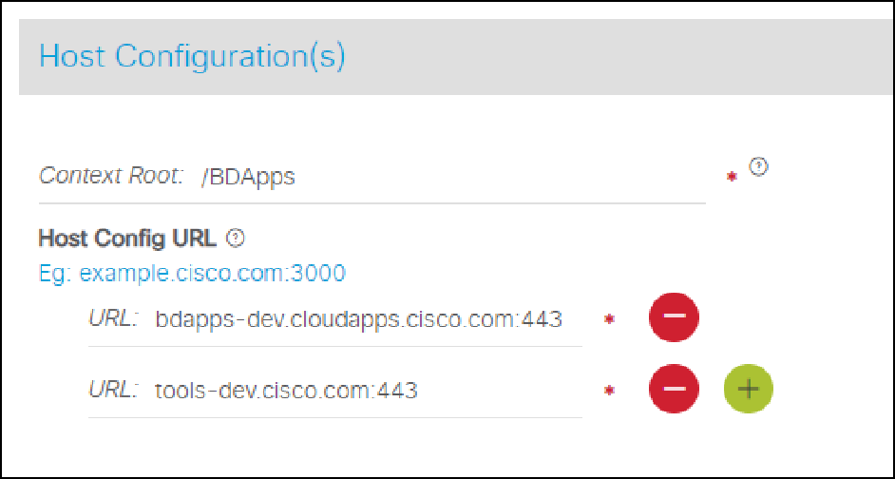

Policies Section:

If there are any custom policies like,

/BDApps/QManager.qm

Since /BDApps is already added as context root in previous step under General Section, add just /QManager.qm in the policies

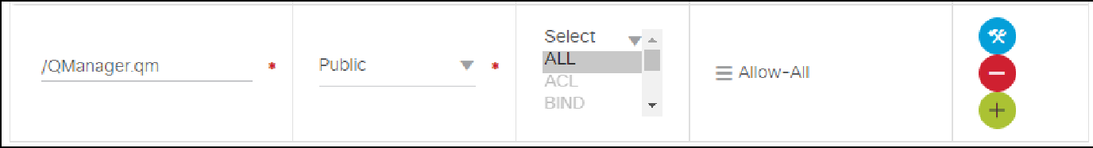

Similarly add for any other custom policies

If there are no custom policies you can skip Policies Section.

If application team is not sure on the context, please reach out to CAE team

[ccxrp-nprd3-01 l7]$ cat /opt/httpd/etc/l7/ccx-stage-proxy-https | grep BDApps

^/BDApps$|^/BDApps/

1. Reach out to CAE team to implement below CCIX to CAE proxy steps with infra CR. After the application is cutover from LAE to CAE:

**l**ogin to: ccxrp-nprd3-01

Make sure we have the application details as below

cat /opt/httpd/etc/proxy/cae-ccx-dev-proxy-https.conf | grep BDA RewriteRule ^/BDApps$ /BDApps/ [R]

ProxyPass /BDApps https://bdapps-dev.cloudapps.cisco.com/BDApps ProxyPassReverse /BDApps https://bdapps-dev.cloudapps.cisco.com/BDApps

and check for CAE migration section entry at the end of the file

/opt/httpd/etc/proxy/cae-ccx-dev-proxy-https.conf

# for CAE migration

<Location "/pa/oidc/cb">

RequestHeader set X-Forwarded-Host tools-dev.cisco.com

</Location>

ProxyPass /pa/oidc/cb https://cae-np-rtp-ext-rp-vip.cisco.com/pa/oidc/cb ProxyPassReverse /pa/oidc/cb https://cae-np-rtp-ext-rp-vip.cisco.com/pa

/oidc/cb

Add the application details to L7 file.

sudo cvi -norcs /opt/httpd/etc/l7/cae-ccx-stage-proxy add the context , **^/BDApps$|^/BDApps/**

[ccxrp-nprd3-01 l7]$ cat /opt/httpd/etc/l7/cae-ccx-stage-proxy

^/SWIFT/Licensing$|^/SWIFT/Licensing/

^/BDApps$|^/BDApps/

^/security/center$|^/security/center/

^/pa/oidc/cb$|^/pa/oidc/cb/

\*\*\*\*\*\*\*\*\*\*\*\*\*\*\*\*\*\*\*\*Do Not Remove\*\*\*\*\*\*\*\*\*\*\*\*\*\*\*

**^/pa/oidc/cb$|^/pa/oidc/cb/**

Reload HAProxy on each RP servers sudo /etc/init.d/haproxy.sh sf haproxy-stage

# SDaaS Integration with CAE

For all migrating applications SDaaS stacks are pre provisioned based on LAE data.

You can also refer [https://apps.na.collabserv.com/wikis/home/wiki/W11720840ac2d\_407c\_b32c\_cb4af0404633/page/Provision%20Software%](https://apps.na.collabserv.com/wikis/home/wiki/W11720840ac2d_407c_b32c_cb4af0404633/page/Provision%20Software%20Development%20Stack%20%28SDaaS%29%20for%20Cloud%20Application%20Environment%20%28CAE%29%20-%20Standard%20Deployment) [20Development%20Stack%20%28SDaaS%29%20for%20Cloud%20Application%20Environment%20%28CAE%29%20-%20Standard%](https://apps.na.collabserv.com/wikis/home/wiki/W11720840ac2d_407c_b32c_cb4af0404633/page/Provision%20Software%20Development%20Stack%20%28SDaaS%29%20for%20Cloud%20Application%20Environment%20%28CAE%29%20-%20Standard%20Deployment) [20Deployment](https://apps.na.collabserv.com/wikis/home/wiki/W11720840ac2d_407c_b32c_cb4af0404633/page/Provision%20Software%20Development%20Stack%20%28SDaaS%29%20for%20Cloud%20Application%20Environment%20%28CAE%29%20-%20Standard%20Deployment) to understand the step by step process of how to create the SDaaS stack for CAE .

1. In Order to create SDaaS stacks , SDaaS team queries the ACC DB to get list of respective DC projects( and the target clusters) owned by the Application team.
2. For all other manual provisions , when a user selects ACC Application Name , SDaaS team will run the query against ACC DB to get the projects and target clusters associated with that specific user.

All this information along with user provided inputs will be sent to all the underlying components ( Jenkins , ECH , Udeploy) that are integrated with the stack.

1. As part of the stack creation , a new Jenkins pipeline , ECH Repository and Udeploy pipeline will be created for CAE deployments.

User can see both LAE and CAE pipelines as below. ( Always use \*-Container to deploy to CAE. )

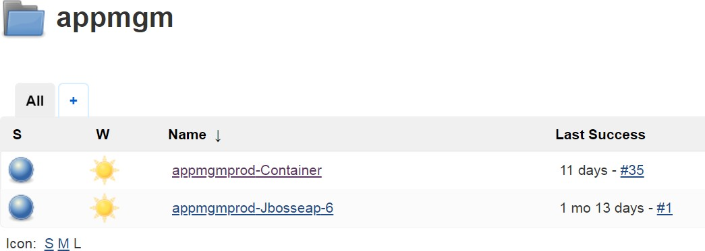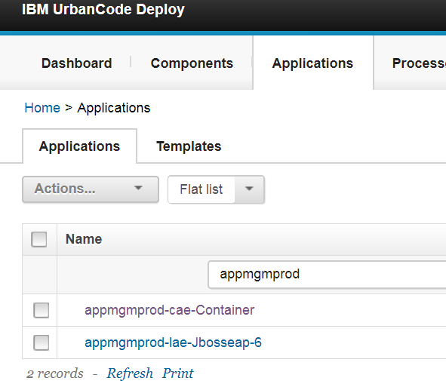

1. Before Jenkins build , you need to download the config files from <https://lae2cae.cisco.com/>and checkin to your source code repository .
2. When you trigger build from jenkins , it will build the source code and also Docker image which will be pushed to ECH ( Containers.cisco.com)
3. Udeploy will Checkout config files from your GIT repository to replace the latest image tag ( from ECH) in config files and it will login to the cluster ( it get all the information from SDaaS) and starts the deploy orchestration.

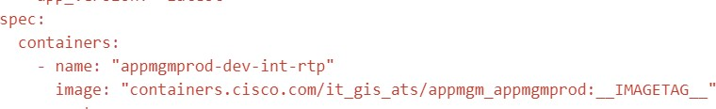

1. Promoting code from one lifecycle to another can be done by Urelease ( same process as LAE)

Please reach out to below Service Teams in case if you have any issues.

|  |  |
| --- | --- |
| **Service Team** | **Alias** |
| **ACC** | [cloud-ops@cisco.com](mailto:cloud-ops@cisco.com) |
| **SDaaS** | [itdt-sdaas-support@cisco.com](mailto:citeis-paas-support@cisco.com) |
| **CoDE (GIT and Jenkins)** | [dft-ci@cisco.com](mailto:dft-help@cisco.com) |
| **Udeploy** | [sra-sdaas-support@cisco.com](mailto:sra-sdaas-support@cisco.com) |
| **CAE** | [lae2cae-operations@cisco.com](mailto:lae2cae-operations@cisco.com)  **Spark Room** : <https://eurl.io/#rJr-vorxQ> |

# Deploy your application

There are many ways to deploy your code or image. One way is to deploy using json/yaml file. Please refer to the [Deployment section](https://wiki.cisco.com/display/CAEUSER/Deployment) for other deployment options.

Openshift runs containers inside Kubenetes pods, and to create a pod from a container image, OSE needs a pod resource definiton. This can be provided either as a json or yaml file. A minimum pod resource definition using json syntax:

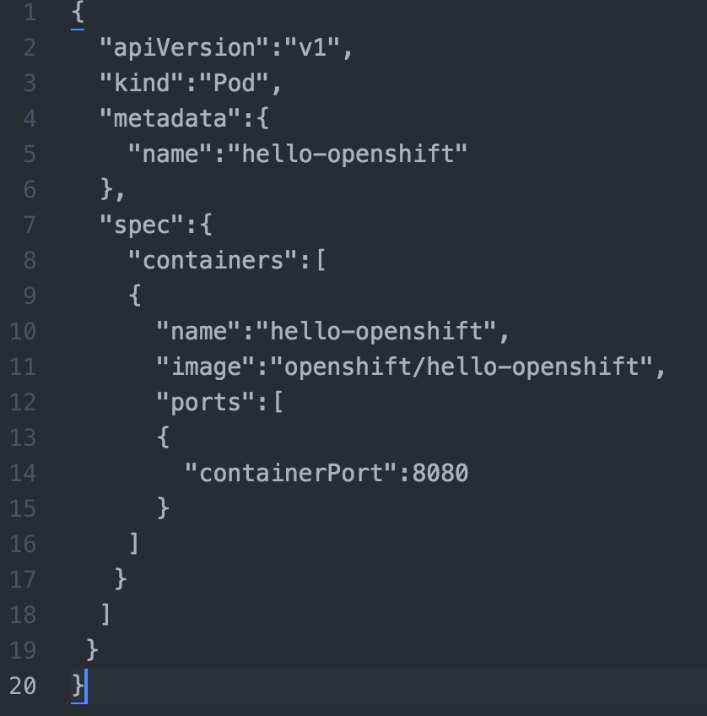

A JSON object is a pod resource definition because it has attribute **"kind"** with value **"Pod"**. It contains a single **"container"**whose name is **"hell o-openshift"** and that references the **"image"** named **"openshift/hello-openshift"**. The container also contains a single **"ports"**, which listens to TCP port **8080**.

Deploy Pod using json

Step 1: Login to the cluster.



Step 2: Select the project.



Step 3: Generate Pod resource json file : *"hello-world.json"*

{

"apiVersion":"v1",

"kind":"Pod", "metadata":{

"name":"hello-openshift"

},

"spec":{

"containers":[

{

"name":"hello-openshift", "image":"openshift/hello-openshift", "ports":[

{

"containerPort":8080

}

]

}

]

}

}

Step 4: Spin up using oc create command.

**oc create -f <json/yaml file>**



Step 5: Create a route to access your app

Once you have your application deployed, you can create a route to access your application. Here's how you can navigate to create routes.

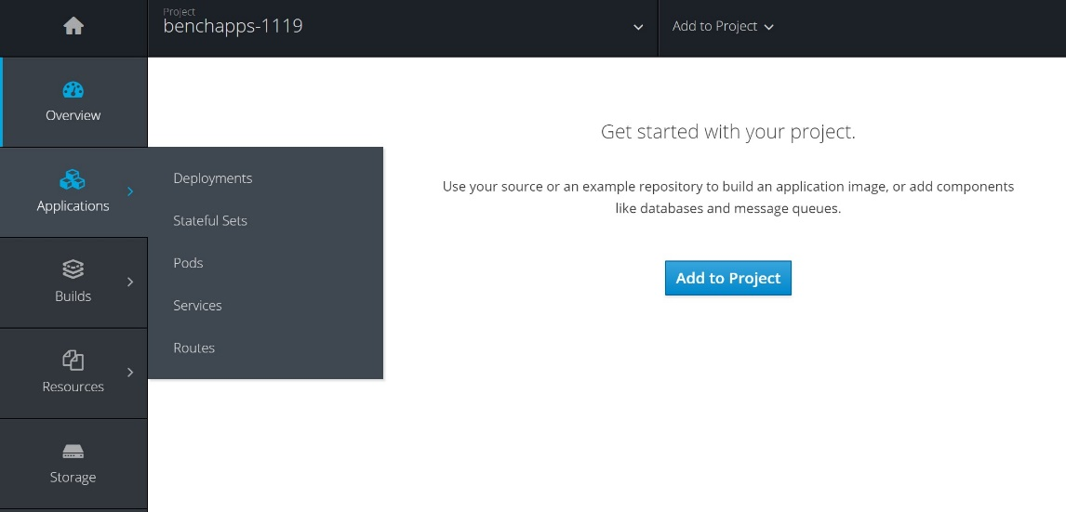

# Understand Quotas Before Ordering Projects

[How to select CPU and memory quota's for your project:](file:///C:\Machine%20Learning\Test\PDF\ilovepdf_split-range\CAE%20Wiki%20Pages-151-403.docx#_bookmark67) [During Project creation time:](file:///C:\Machine%20Learning\Test\PDF\ilovepdf_split-range\CAE%20Wiki%20Pages-151-403.docx#_bookmark68)

[During Modify Project:](file:///C:\Machine%20Learning\Test\PDF\ilovepdf_split-range\CAE%20Wiki%20Pages-151-403.docx#_bookmark69) [Summary:](file:///C:\Machine%20Learning\Test\PDF\ilovepdf_split-range\CAE%20Wiki%20Pages-151-403.docx#_bookmark70)

[FAQ's](file:///C:\Machine%20Learning\Test\PDF\ilovepdf_split-range\CAE%20Wiki%20Pages-151-403.docx#_bookmark71)

When many teams share a cluster with a fixed number of resources, there is a concern that one team could use more than its fair share of resources. This is often called the "Noisy Neighbor" problem.

Resource quotas are one tool in Kubernetes used to provide multi-tenancy, while at the same time providing the required resources to each tenant.

RAM and CPU are two important resources limited by quotas in CAE. As a client you have the ability to choose how much RAM and CPU you want for your projects. Keep in mind, quotas are enabled on a per project basis. You can have as many projects as you want and each project has its own quota as defined during project creation. You have the flexibility to modify the project's quota, by selecting modify from the ACC UI.

When you deploy Pods within your project you will allocate appropriate RAM and CPU for each Pod. The sum of RAM and CPU for all deployed Pods will be deducted from the project's quota. A Pod will not start if the project does not have enough quota remaining.

## How to select CPU and memory quota's for your project:

### During Project creation time:

* 1. Login to <https://citeis.cisco.com/>
  2. Click on MyApplications
  3. Select your IT application

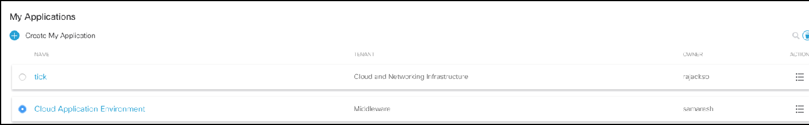

* 1. Select existing profile or create a new profile

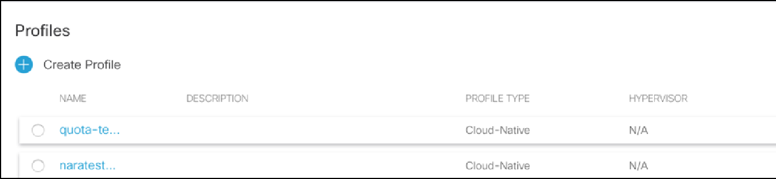

* 1. Click "[**Cloud Application Environment**](https://citeis.cisco.com/mycloud/%23/home/d99ef96e-4175-4585-9925-bd6346e3ce26/profile/001b5a16-9227-4e48-9648-33b711948b83/caeproject)"

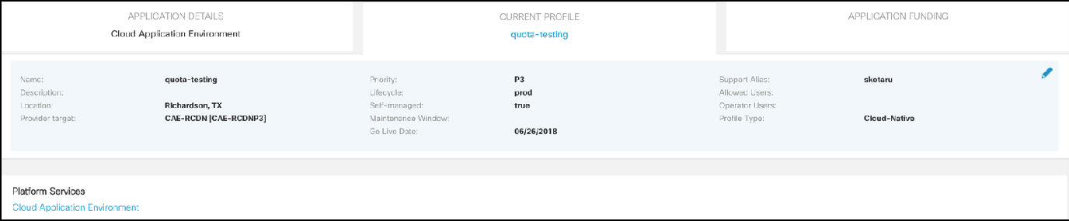

* 1. It will take you to CAE projects home page

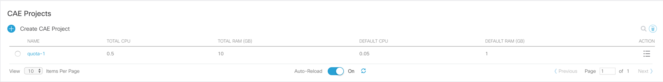

* 1. Click on CAE Projects  button to create a new project. This is important screen to pay attention

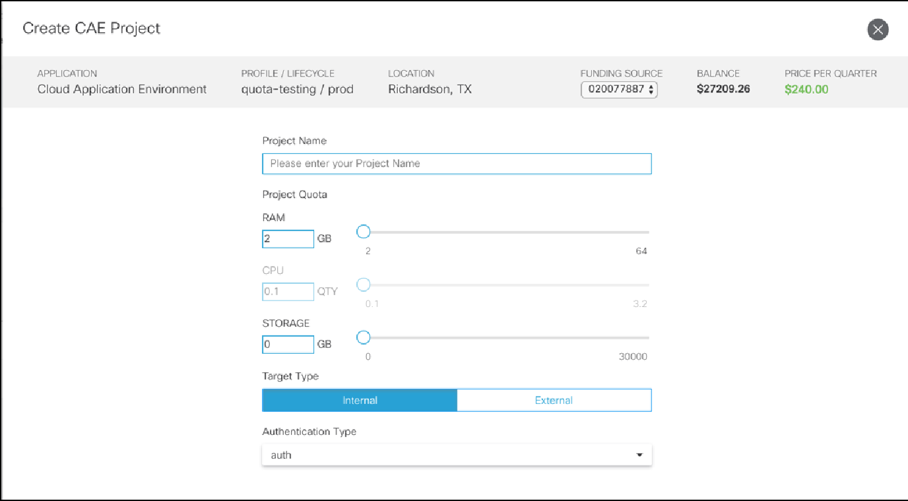

Enter project name you decided for your work

Drag the slider or enter how much memory you need for your project. You can order max of 64 GB for new projects. If you need more than 64 GB then you can modify the project once it gets created. Modify also let you add another maximum of 64 GB to existing memory quota. You will be able to add a maximum of 64GB with any single order up to the maximum of 400 GB. The 400 GB maximum was designed to prevent projects from consuming more resources than the platform can provide and to aid in capacity planning.

CPU quota is auto calculated based on RAM quota. CPU is allocated at a ratio of 1 CPU for every 20 GB of RAM. You are not able to directly select how many CPU's you want. CPU's are not involved in cost calculation and given as free if you order memory based on 1/20 formula. This was designed based on node sizes and our capacity planning purpose. if you order 64 GB memory, you get 3.2 CPU's.

Refer [costing page](https://wiki.cisco.com/display/CAEUSER/CAE%2BCost) for CAE cost details.

Note: If you need more CPU's then you need to adjust memory quota accordingly. For 10 CPU's you need total of 200 GB memory (200

/20 = 10 CPUs). 1 CPU will be given as free for every 20 GB

### During Modify Project:

* + 1. Follow same steps as above except select existing project in step 6 and click action button on extreme right hand side

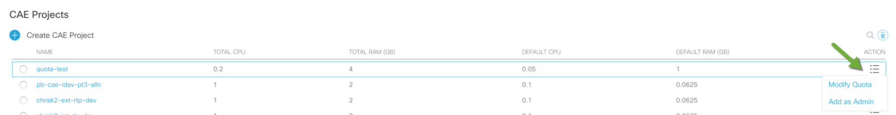

* + 1. It open modify project screen as below

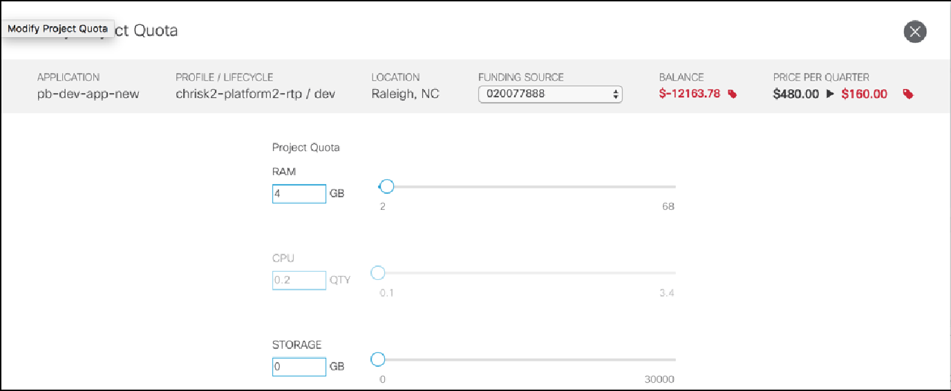

* + 1. You can add max of 64 GB to existing memory quota. For example, if you already have 4 GB quota and add another 64 GB, total of 68 GB you will get
    2. CPU is auto calculated based on new memory quota. In this example ( 64/20 = 3.4 CPU cores)

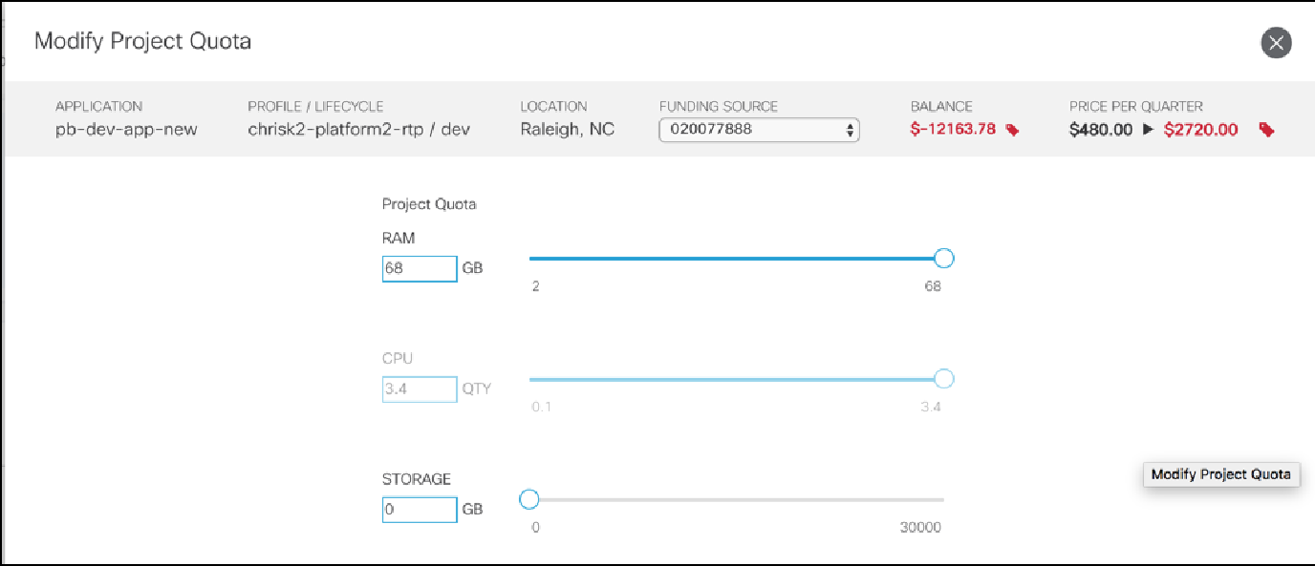

* + 1. You can modify and add memory as many times as you want till you reach limit of 400 GB upper limit
    2. If you reduce your memory quota, CPU also auto calculated and reduced as per formula mentioned

### Summary:

* + - 1. You can order max of 400 GB memory as a quota. Each order only allow max of 64 GB
      2. CPU is not part of cost calculation. We offer 1 CPU for every 20 GB memory ordered
      3. CPU quotas are based on requests and guarantee for you. use wisely and put reasonable CPU request in your pods definition. If no apps using CPU then your apps allowed to use free CPU power with guarantee CPU requests you put.
      4. Don't put CPU limits to your pod definition and leave it blank to allow your pods to use free CPU's cycles available on the node
      5. Always put memory requests and limits to your pods definition.
      6. Since your apps would be able to use free CPU cycles available if other pods not using on the node, always use balanced cpu requests as it provides guaranteed CPU cycles for your pods.

## FAQ's

1. What happens if we don't specify resource limits for our pods?

Answer: It is strongly recommended to set resource limits as per application requirements to pods. This improve stability of your application, also place on right node which has sufficient resources to host your pods. If you don't mention proper resource limits, your PODS will be placed on wrong nodes and move frequently.

1. I heard about defaults resources limits, what does it mean?

Answer: As part of project creation, we placing defaults at project scope to prevent untuned pods ( pods don't have resource limits) using all available resources and cause noisy neighbor problem. These defaults are very minimum to run a POD but might terminate if it start using more then defaults allowed.

The defaults are 1 GB RAM limit ( 75 % you get as memory.requests = 750 MB) and 50 millli cores as cpu.requests. no limit for CPU since it is compressed resource.

1. What is recommended approach to set resource limits to avoid noise neighbor problem or to improve stability of my application?

Answer : always follow below best practices

Set request.memory & limits.memory

Set only request.cpu. limits.cpu is not strictly necessary since your pods will use free CPU cycles if available. requests.cpu is guaranteed CPU cycles without throttling

Don't put high memory and CPU although your application don't require. use wisely your quota resources and properly distribute among pods within pod.

Monitor quota usage periodically to avoid last minute surprise or problems during production deployments . if Quota is not sufficient your pods won't be scale more then sum of memory and CPU

1. Quotas, resources and limits are complicated topic. i want to better educated on this topic. Where to go further study?

Answer: Below links will help.

[Kubernetes best practices: Resource requests and limits](https://cloudplatform.googleblog.com/2018/05/Kubernetes-best-practices-Resource-requests-and-limits.html) [Resource Quotas](https://kubernetes.io/docs/concepts/policy/resource-quotas/)

[Assign Memory Resources to Containers and Pods](https://kubernetes.io/docs/tasks/configure-pod-container/assign-memory-resource/) [Assign CPU Resources to Containers and Pods](https://kubernetes.io/docs/tasks/configure-pod-container/assign-cpu-resource/)

# Signing into ECH

While the ECH browser UI (https://containers.cisco.com) only requires CEC user name and password, connecting via a docker client requires an encrypted password.

An encrypted password can be generated in the ECH UI, by visiting the 'Account Settings' page.

The 'Account Settings' page is found by clicking on your user name in the top-right corner of the ECH UI. Note: The encrypted password needs to be regenerated when you change your CEC password.

To sign into [containers.cisco.com](http://containers.cisco.com/) from docker, execute the docker login [containers.cisco.com](http://containers.cisco.com/) command:

$ docker login containers.cisco.com Username: <cec\_userid>

Password: <encrypted password>

# Creating a repository

There are two ways to create a repository in [containers.cisco.com](http://Quay.io/): via a docker push and via the [containers.cisco.com](http://Quay.io/) UI.

#### Creating an image repository via the UI

To create a repository in the [containers.cisco.com](http://Quay.io/) UI, click the + icon in the top right of the header on any [containers.cisco.com](http://Quay.io/) page and choose ‘New Repository’. Select ‘Container Image Repository’ on the next page, choose a namespace (only applies to organizations), enter a repository name and then click the ‘Create Repository’ button. The repository will start out empty unless a Dockerfile is uploaded as well.

#### Creating an image repository via docker

First, tag the repository:

$ docker tag 0u123imageid containers.cisco.com/namespace/repo\_name

Then push to [containers.cisco.com](http://Quay.io/):

$ docker push containers.cisco.com/namespace/repo\_name

#### Creating an application repository via the UI

To create a repository in the [containers.cisco.com](http://Quay.io/) UI, click the + icon in the top right of the header on any [containers.cisco.com](http://Quay.io/) page and choose ‘New Repository’. Select ‘Application Repository’ on the next page, choose a namespace (only applies to organizations), enter a repository name and then click the ‘Create Repository’ button. The repository will start out empty.

# Pushing and Pulling Repositories

Pushing a repository to [containers.cisco.com](http://Quay.io/)

Note: pushing to a repository requires Repository Write Access. Note: you should have a name for the image before you push it

In order to push a repository to [containers.cisco.com](http://Quay.io/), run the following command:

$ sudo docker push containers.cisco.com/namespace/repository:tag

Pulling a repository from [containers.cisco.com](http://Quay.io/)

Note: pulling from a repository requires Repository Read Access for private repositories.

To pull a repository from [containers.cisco.com](http://Quay.io/), run the following command:

$ sudo docker pull [containers.cisco.com/namespace/repository](http://quay.io/namespace/repository)

# Repository permissions

Repository permissions define which users, [robot accounts](https://docs.quay.io/glossary/robot-accounts.html) and [teams](https://docs.quay.io/glossary/teams.html) have access to a repository for pulling, pushing and administrating. To view and modify permissions for a repository, click the Settings tab in the [Repository View](https://docs.quay.io/guides/repo-view.html).

Note: viewing and changing permissions requires **repository admin permission**.

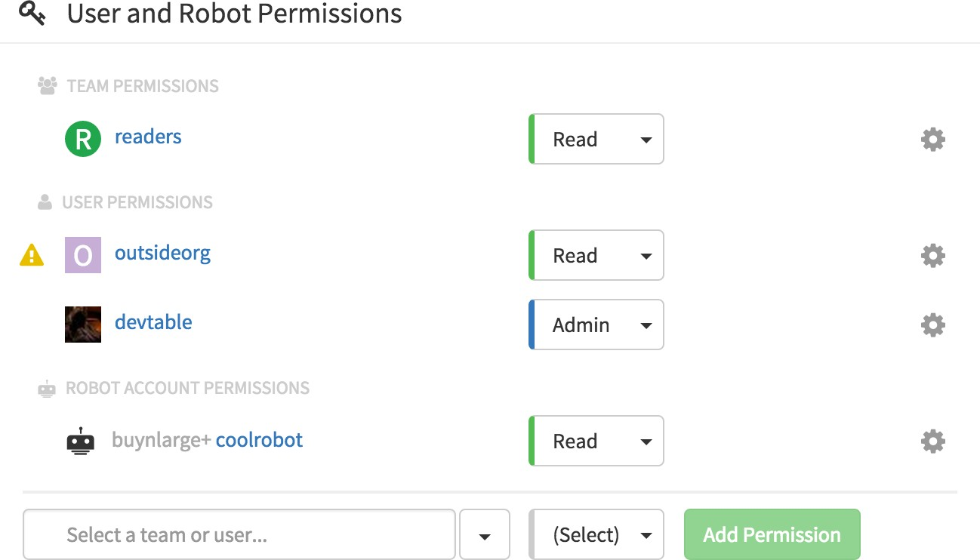

#### Adding a new permission

A new permission can be added to the repository by choosing an entity (user, robot, team) on the bottom row, choosing the permission for the new entity, and then clicking the “Add Permission” button.

#### Changing a permission

To change the permission for an existing entity (user, robot, team) on the repository, click the permission button to the right of the entity, and choose the new permission.

#### Revoking permission

To remove a permission for an entity (user, robot, team), click the icon next to the entity and choose “Delete Permission”.

#### Why does a icon appear next to a user?

The triangle icon means that the user has permission on the repository, but is not a member of that repository’s [Organization](https://docs.quay.io/glossary/organizations.html).

# Working with repositories in the browser

The repository view provides access to the full information for a given repository. It is divided into a number of tabs, each provides specific information and tools.

#### Repository View Tabs

Information: A basic overview of the repository, including its current builds and the repository’s description [Tags](https://docs.quay.io/guides/tag-operations.html): Allows for viewing a repository’s tags and performing operations on it.

History: Shows a chronological history for how the repository tags have been mutated through pushes, pulls, and UI actions, with the ability to revert operations which changed the image to which a tag points

[Builds](https://docs.quay.io/guides/building.html): Allows for viewing and starting repository builds, and defining [Build Triggers](https://docs.quay.io/glossary/build-trigger.html). Logs: Shows the usage logs for the repository.

Settings: Shows all the repository settings, including [Repository Permissions](https://docs.quay.io/guides/repo-permissions.html), [Repository Notifications](https://docs.quay.io/guides/notifications.html) and whether the repository is public or private.

# Working with tags

### Viewing and modifying tags

The tags of a repository can be viewed and modified in the tags panel of the repository page, found by clicking on the Tags tab.

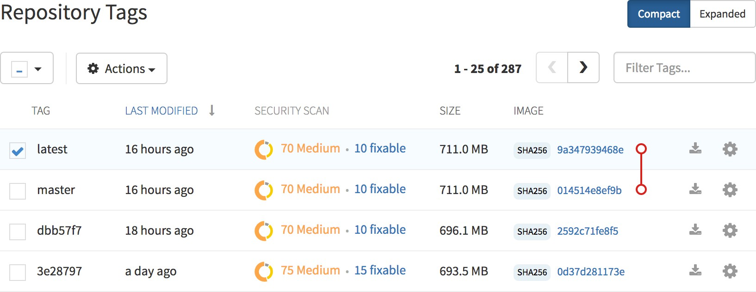

#### Adding a new tag to a tagged image

A new tag can be added to a tagged image by clicking on the icon next to the tag and choosing Add New Tag. [containers.cisco.com](http://Quay.io/) will confirm the addition of the new tag to the image.

#### Moving a tag

Moving a tag to a different image is accomplished by performing the same operation as adding a new tag, but giving an existing tag name. [contain](http://Quay.io/) [ers.cisco.com](http://Quay.io/) will confirm that you want the tag moved, rather than added.

#### Deleting a tag

A specific tag and all its images can be deleted by clicking on the icon and choosing Delete Tag. This will delete the tag and any images unique to it. Images will not be deleted until no tag references them either directly or indirectly through a parent child relationship.

#### Viewing tag history and going back in time

##### Viewing tag history

To view the image history for a tag, click on the View Tags History menu item located under the Actions menu. The page shown will display each image to which the tag pointed in the past and when it pointed to that image.

##### Going back in time

To revert the tag to a previous image, find the history line where your desired image was overwritten, and click on the Restore link.

#### Security scanning

By clicking the on the vulnerability or fixable count next to a tab you can jump into the security scanning information for that tag. There you can find which CVEs your image is susceptible to, and what remediation options you may have available.

# Downloading Squashed Docker Images

Docker images are composed of image layers which include all of the intermediary data used to reach their current state. When iterating on a solution locally on a developer’s machine, layers provide an efficient workflow. However, there are scenarios in which the layers cease to be efficient. For example, when deploying software to an ephemeral machine, that machine doesn’t care about the whole layer history, it just needs the end state of the image. This is why [containers.cisco.com](http://Quay.io/) supports *Squashed Images*.

#### Downloading a Squashed Image

Navigate to the Tags tab of a [Repository View](https://docs.quay.io/guides/repo-view.html) ([https://containers.cisco.com/repository/YOURORG/YOURREPO?tab=tags](https://quay.io/repository/YOURORG/YOURREPO?tab=tags)). On left side of the table, click on the *Fetch Tag* icon () for the tag you wish to download. A modal dialog will appear with a dropdown for specifying the desired format of the download. Select Squashed Docker Image from the dropdown and then select a robot that has *read* permission to be able to pull the repository. Click on the Copy Command button and paste this command into the shell of the machine you wish to download.

#### Caveats & Warnings

##### Prime the cache!

When the first pull of a squashed image occurs, the registry streams the image as it is being flattened in real time. Afterwards, the end result is cached and served directly. Thus, it is recommended to pull the first squashed image on a developer machine before deploying, so that all of the production machines can pull the cached result.

##### Isn’t piping curl insecure?

You may be familiar with installers that pipe curl into bash (curl [website.com/installer](http://website.com/installer) | /bin/bash). These scripts are insecure because they allow arbitrary code execution. Our script to download squashed images uses curl to download a tarball that is streamed into doc ker load. This is just as secure as running docker pull because it never executes anything we’ve downloaded from the internet.

# Robot Accounts: Pull from Secured Repositories

1. Create a robot account in ECH.
   1. Navigate to your personal or organization directory in ECH
      1. <https://containers.cisco.com/user/><your\_userid>
      2. <https://containers.cisco.com/organization/><your\_org>
   2. Click on this robot icon  on the left side of the screen
   3. Click on the 'Create Robot Account' button on the top right of the screen
   4. Give your robot account a name and description and Click 'Create robot account' button
   5. (Optional) Select the Repositories you want the robot account to have access to and assign the Read Permission, Click 'Add Permission' button.
2. Assign the robot account, read access to your repository
   1. If you skipped the optional step e above, or if you come back later, you can grant your robot account access to repositories
   2. Navigate to a specific repository
   3. Click on the  icon on the left side of the screen
   4. Under the User and Robot Permissions section of the page, give your robot account Read access to the repository
3. Retrieve the robot account's Secret. There are several forms available depending on your deployment environment.
   1. Return to your organization or user directory in ECH
   2. Click on the robot icon again . 
   3. Click on your robot account's name
   4. Select the format appropriate to your runtime environment from the pop-up window (Kubernetes Secret for CAE)
   5. Follow the instructions provided for the format you chose

#### For use in CAE:

**Download or copy the robot-name-secret.yaml file.** It will look something like:

apiVersion: v1 kind: Secret metadata:

name: org-wally-pull-secret data:

.dockerconfigjson: asdfasdfasdfasdfHsKICAgICJjb250YWluasdfCAgICAgImF1dGgiOiACB9Cn0=... type: [kubernetes.io/dockerconfigjson](http://kubernetes.io/dockerconfigjson)

Create the Secret in your OpenShift Project

via oc command line:

oc login cae-<cluster>.cisco.com

oc create -f robot-name-secret.yaml --namespace=<your-project-name>

**Reference the Secret in the spec section of your deployment file.** It will look something like:

apiVersion: v1 kind: Pod

metadata:

name: somepod spec:

containers:

- name: web

image: containers.cisco.com/<org-or-user>/somerepo

imagePullSecrets:

- name: org-walle-pull-secret

Now when CAE deploys your Pod, it will use the secret to authenticate against ECH and have access to pull your images.

# LAE to CAE Migration

We have organized webinars with the teams to go thru LAE2CAE Migrations.

Presented materials are available on BOX**:**

Folder Location: <https://cisco.app.box.com/folder/47866268827> Presentation: <https://cisco.box.com/s/5oac5hm0amk4soq90k3zi8k6kxs97f6r> Wave 1 Apps List:

in BOX: <https://cisco.box.com/s/fu8j7t5ndzvwb9nt14igb9fnma79otrw>

in Spreadsheet: <https://app.smartsheet.com/b/publish?EQBCT=fb3f9844806a482b897bbf370934de9b>

Wave 2 Apps List :

<https://app.smartsheet.com/b/home?lx=zweQW_KVygsDfFUbzKb4Rg>

Non-Registered apps list: <https://app.smartsheet.com/b/home?lx=mqqqE1iQrH9kOaG3wajXbA>

Webinar Recordings**:**

Session 1: June 5th 10:30am-12pm pst: <https://cisco.webex.com/cisco/onstage/playback.php?RCID=a8502a34a5ba00089b3c95baabe2c67c> Session 2: June 5th 8:30pm-10pm pst: <https://cisco.webex.com/cisco/onstage/playback.php?RCID=a6ba3d3e7420d7903d234149084e20b3>

# Apps in Waves

Wave-1 Applications - <https://app.smartsheet.com/b/home?lx=4CaQj_443EZud82xYm3Hmg>

<https://app.smartsheet.com/b/publish?EQBCT=fb3f9844806a482b897bbf370934de9b>

Wave 2 Applications:

<https://app.smartsheet.com/b/home?lx=zweQW_KVygsDfFUbzKb4Rg>

# B2X

B2X service helps clients to expose an internal application to external partners for testing. Some clients have this special requirement and take sign off from external business partners before code was pushed to production. These business partners are external to Cisco and not part of Cisco network, thus they won't be able to access client internal application from internet.

B2X service comes handy during these situations and securely expose internal application via internet, so partners should be able to test it although they are not part of Cisco network.

Only stage life cycle is exposed to internet via B2X service. No other life cycles including dev, LT, prod or custom life cycles part of B2X Only External Stage applications eligible for this service.

NOTE: In order to test SSO for B2X applications, external partner used to synch PROD account to stage Cisco directory. Going forward users are NOT REQUIRED to synch their account to stage, rather continue testing with PROD credentials, as B2X applications will be hosted in PROD lifecycle.

As part of Migration , B2X profiles and projects are created under PRD-RTP ( cae-prd-rtp.cisco.com)

Go to estore.cisco.com and search for SDaaS create

select Create New Stack as No and from the drop down select the stack you want to use. select ACC App Name , LifeCycle ( prod) and CAE Project Name

Ignore the pop ups which says

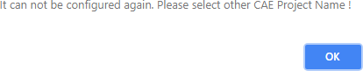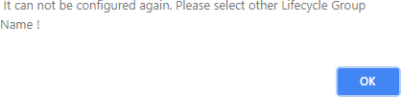

change the Lifecycle Group Name to B2X as below.

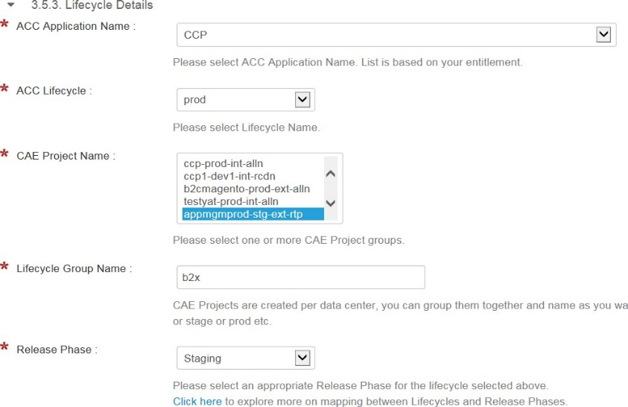

Submit the request

Once after request is successful , you can see b2x is added to your stage pipeline in Urelease.

Generate yaml files from [webui](https://lae2cae.cisco.com/) and check-in to your source code config directory before jenkins build. ( You should see two new yaml's with b2x)

Go to Jenkins and trigger new build

Once after dev deployment , create a snapshot and push it to b2x.

Login to cae-prd-rtp.cisco.com and check the deployment status and access the route to validate the application.

# CAE Load Balancing FAQs

### What are my site load balancing options within CAE?

Cisco IT’s CAE (Cloud Application Environment) offers three GSLB configurations. CAE was designed as a cloud native platform, therefore none of these options provides *cross-data-center* session affinity.

Active/Active

Incoming traffic is split between two data centers in either a *round-robin or round-trip-time (RTT)* fashion.

*Round-robin* splits traffic most evenly between the data centers and is the recommended option.

*RTT* is used for client proximity-based routing but since the RCDN and ALLN data centers are so close together, this does not work well. When used between ALLN or RCDN and RTP, RTT could be ok.

Provides no session affinity – i.e. app traffic will not consistently be sent to the same DC/CAE cluster This is recommended for [stateless](https://stackoverflow.com/questions/5436069/what-are-the-differences-between-stateless-and-stateful-systems-and-how-do-they) (aka cloud native) applications that don’t require session affinity

Active/Passive

Incoming traffic is always sent to one primary data center. If the application in that data center or the entire data center becomes unresponsive, all traffic is sent to the backup data center.

Provides session affinity: while traffic goes to the primary data center, client requests will hit the same CAE cluster (to ensure requests arrive at the same instance of an application, the CAE Route must be configured to support session affinity).

Note: this provides unbalanced load distribution between the data centers. Resources in the passive data center will be unused during normal operations.

This is recommended for [stateful](https://stackoverflow.com/questions/5436069/what-are-the-differences-between-stateless-and-stateful-systems-and-how-do-they) apps that that require session affinity

# CAE Migration P2 Environment to P3 Environment.

* 1. Create CAE P3 profiles for your application
     1. Login to Application Centric Cloud (ACC) @ <http://acc.cisco.com/>
     2. Click on My Applications to view the list of available applications
     3. Click on the application you want to migrate in order to view the current profiles associated with your application
     4. Click on 'Create Profile' to create CAE P3 profiles for your migrating application
     5. On 'Create Application Profile' pop up window
        1. Select 'Cloud-Native' profile type
        2. Provide a unique profile name
        3. Remaining attributes should be the same as your P2 profiles (Lifecyle, Location, Priority, Support Alias, etc.).
  2. Provision CAE P3 projects
     1. Within the new profile, create CAE projects
     2. All attributes, including project name, can match your P2 project attributes
     3. Deploy your application to the P3 projects
        1. Your deployment pipelines will require modification in order to reference new projects as targets. If you use SDaaS, see ‘Updating SDaaS Deployment Pipelines’ section below
        2. Routes require special handling.
           1. You can’t create a Route in P3 with the same hostname without first deleting the route from P2. See ‘Retaining Route Hostname’ section below
           2. You can have different hostname for your routes, If your application is accessed through a GSLB. Using a new hostname for P3 routes is the recommended. It is an easier option, when possible
           3. Custom Ping Policies will also have to be recreated whether you retain the hostname or not. See ‘Retrieving Custom Ping Policies’ section below
           4. GSLB Cutover

GSLB cutover to CAE P3 will require application downtime

Login to ACC

Navigate to the migrating application

Select the 'Global Resources' tab

Click Global SLB section to view the GSLB resources

Select the GSLB by clicking on radio button and proceed to click 'Modify Members' under Actions

Delete the members from GSLB. It requires at least 10-15 mins to complete the member deletion

Map GSLB Resource from P2 to P3 Ping Policy

Login to PMT Tool [here](https://wampmtui.cloudapps.cisco.com/)

Click on current GSLB and Modify the config URL at bottom of page from <<yourappname>>.[cisco.com](http://cisco.com/) to

<<yourappname>>-[p2.cisco.com](http://p2.cisco.com/)

Click Update to save changes

Click clone from Action Drop Down to clone the GSLB resource

On Clone Application Page, change the Config URL back to orginal <<yourappname>>.cisco.com

Select the P3 Policy from platform drop down

Select **CAEAX**<lifecyclehere> for external application. Example CAEAXprod for production. CAEAXnprd for non-production environment.

Select **CAEAI**<<lifecyclehere>> for internal application. Example CAEAIprod for production. CAEAInprd for non- production environment.

GSLB resources status should be moved to provisioned for changes to take effect.

On ACC, Add CAE P3 routes as members. It requires at least 10-15 minutes to complete

* + - * 1. This will complete your application cut over.
        2. Verify and test the application functionality in CAE P3
        3. After successful cut over and normalization period, Decommission and Delete the P2 application objects in CAE P2, PMT, ACC

### Retaining Route Hostname:

Retaining the same hostname for your CAE P3 Route will require downtime for your application. Production cutover should be performed during a downtime window.

1. Application using custom Ping Policy will require to record the custom policies as described in next section
2. Delete the existing P2 route.
3. Make sure that route is fully deleted by doing "nslookup <<route-name-here>>". It requires at least 10-15 minutes for successful route deletion. In case of any issue with route deletion automation, please out to CAE client engagement group <https://eurl.io/#rJr-vorxQ>.
4. Create the route in CAE P3. Route creation requires 10-15 minutes
5. Verify the successful route creation by doing "nslookup <<route-name-here>>"
6. Application that require custom Ping Policy, create the same ping policies you recorded in step 1 using the Policy Management Tool [here](https://wampmtui.cloudapps.cisco.com/)

### Retrieving Custom Ping Policies:

1. Login to Policy Management Tool [here](https://wampmtui.cloudapps.cisco.com/) and click on existing routes
2. Note down the information under General (API, Response Headers and Host Configuration) and Policies Tabs

### SDaaS Deployment Pipeline Updates:

1. Request modify SDaaS stack from estore here
2. Fill in all the required information in pop up window including newly created P3 project under lifecycle details section and submit the request
3. Modify the application YAML files with new profile name
   1. Deployment file: <SDaaS\_NAME\_HERE>-<PROFILE\_NAME\_HERE>.yaml
   2. Route file: <SDaaS\_NAME\_HERE>-<PROFILE\_NAME\_HERE>-route.yaml

For a CAE P3 Profile testappp3 and existing SDaaS stack name mysdaasstack, YAML file names would be mysdaasstack- testappp3.yaml and mysdaasstack-testappp3-route.yaml

# Cutover Checklist

Make sure all the below four routes are created in [ALLN](https://cae-prd-alln.cisco.com/console/) , [RCDN](https://cae-prd-rcdn.cisco.com/console/) , [RTP](https://cae-prd-rtp.cisco.com/console/). ( RTP is applicable only if your application has DR setup).

1. \*-test-gslb : Test GSLB to test your application before cutover
2. \*-test : Member of Test GSLB
3. \*-tmplive-gslb : Live GSLB
4. \*-tmplive : Member of Live GSLB
   1. :

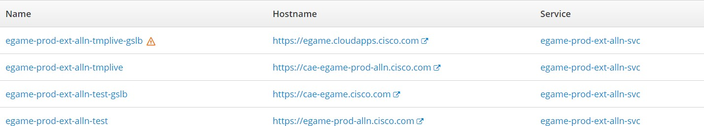

If your application has a CNAME , then you should see additional GSLB and Member in each DC.

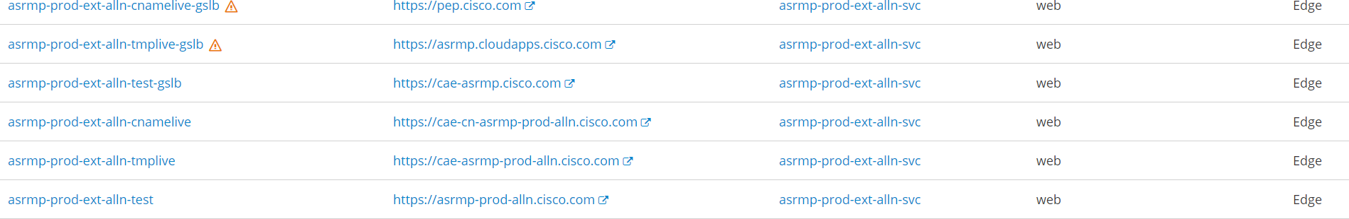

**nslookup on each route and make sure all the urls are resolvable to cae-\* except the Live GSLB ( \*.cloudapps.cisco.com)**

e.g:

1. nslookup [cae-appmgm-prod-alln.cisco.com](http://cae-egame-prod-alln.cisco.com/) Server: 64.101.6.3

Address: 64.101.6.3#53

[cae-appmgm-prod-alln.cisco.com](http://cae-egame-prod-alln.cisco.com/) canonical name = [cae-iprp-alln-vip.cisco.com](http://cae-xprp-alln-vip.cisco.com/). Name: [cae-iprp-alln-vip.cisco.com](http://cae-xprp-alln-vip.cisco.com/)

Address: 173.37.149.105

1. nslookup appmgm.cloudapps.cisco.com Server: 64.101.6.3

Address: 64.101.6.3#53

[appmgm.cloudapps.cisco.com](http://asrmp.cloudapps.cisco.com/) canonical name = [lae-lb-tx-dr-int.cloudapps.cisco.com](http://lae-lb-tx-dr-ext.cloudapps.cisco.com/). Name: [lae-lb-tx-dr-int.cloudapps.cisco.com](http://lae-lb-tx-dr-ext.cloudapps.cisco.com/)

Address: 173.36.104.10

**NOTE :** If you have both LAE FQDN( \*.Cloudapps.cisco.com) and CNAME URL ( \*.cisco.com) has same name , is not allowed in CAE. (ACC has limitation of having same name with Multiple domains )

Ex: LAE FQDN : myapp.cloudapps.cisco.com CNAME URL : myapp.cisco.com

You can have only one in CAE. Please work with lae2cae-operations team to provision the required URL before Cutover.

Before cut over, your application should be accessible using Test GSLB and make sure all the below validations are completed.

* 1. ACL's are opened to all the required endpoints.
  2. Performance
  3. DB Connectivity
  4. MMX ( If applicable)
  5. Validate and compare Ping Policies from [PMT](https://wampmtui.cloudapps.cisco.com/) tool for both TEST and LIVE GSLB and also make sure verify the custom polices and perform sso policy cutover fom lae2cae.cisco.com

for more information, please go through the [Migrate MyApps](https://wiki.cisco.com/pages/viewpage.action?pageId=127130261)

* 1. Check the SDaaS and Udeploy Configurations ( Make sure all 3 DC's are added to the stack for Udeploy)
  2. SSL Certificates are configured ( If applicable)
  3. AppDynamics Configuration ( If applicable)
  4. Crons and Schedulers are running as expected ( If applicable)
  5. Storage/Persistent Volume are provisioned and configured ( If applicable)
  6. Make sure app logs (standard out/custom) are available in either splunk or clip
  7. External Partner Testing ( Timeouts and Hard coded IPs) ( If applicable)

Also, please validate the ACLs are open to below VIPs and Reverse Proxy from extranet.

For CAE Platform3 Subnets (Nodes, Routers, RP, VIP) [CAE on Platform 3 Subnets](https://wiki.cisco.com/display/GISCONT/CAE%2Bon%2BPlatform%2B3%2BSubnets)

VIP details:

|  |  |  |  |  |
| --- | --- | --- | --- | --- |
| **DC -NPRD/PRD** | **VIP TYPE** | **Hostname** | **IP address** | **Subnet** |
| NPRD - RTP | VIP Internal | [cae-np-rtp-int-rp-vip.cisco.](http://cae-np-rtp-int-rp-vip.cisco.com/) [com](http://cae-np-rtp-int-rp-vip.cisco.com/) | 64.102.178.139 | 64.102.178.0/23 |
| NPRD - RTP | VIP External | [cae-np-rtp-ext-rp-vip.cisco.](http://cae-np-rtp-ext-rp-vip.cisco.com/) [com](http://cae-np-rtp-ext-rp-vip.cisco.com/) | 64.102.178.45 | 64.102.178.0/23 |
| PRD - RTP | VIP Internal | [cae-prd-rtp-int-rp-vip.cisco.](http://cae-prd-rtp-int-rp-vip.cisco.com/) [com](http://cae-prd-rtp-int-rp-vip.cisco.com/) | 64.102.179.147 | 64.102.178.0/23 |
| PRD - RTP | VIP External | [cae-xprp-rtp-vip.cisco.com](http://cae-xprp-rtp-vip.cisco.com/) | 64.101.38.11 | 64.101.38.0/28 |
| PRD -ALLN | VIP Internal | [cae-prd-alln-int-rp-vip.cisco.](http://cae-prd-alln-int-rp-vip.cisco.com/) [com](http://cae-prd-alln-int-rp-vip.cisco.com/) | 173.37.26.133 | 173.37.26.0/23 |
| PRD - ALLN | VIP External | [cae-xprp-alln-vip.cisco.com](http://cae-xprp-alln-vip.cisco.com/) | 173.37.149.105 | 173.37.149.96/27 |
| PRD - RCDN | VIP Internal | [cae-prd-rcdn-int-rp-vip.cisco.](http://cae-prd-rcdn-int-rp-vip.cisco.com/) [com](http://cae-prd-rcdn-int-rp-vip.cisco.com/) | 72.163.24.60 | 72.163.24.0/23 |
| PRD - RCDN | VIP External | [cae-xprp-rcdn-vip.cisco.com](http://cae-xprp-rcdn-vip.cisco.com/) | 72.163.10.105 | 72.163.10.96/27 |
| NPRD - RTP | VIP Internal | [cae-np-rtp-int-dedicated0-rp-](http://cae-np-rtp-int-dedicated0-rp-vip-0.cisco.com/) [vip-0.cisco.com](http://cae-np-rtp-int-dedicated0-rp-vip-0.cisco.com/) | 64.102.186.246 | 64.102.188.0/23 |
| NPRD - RTP | VIP Internal | [cae-np-rtp-int-dedicated1-rp-](http://cae-np-rtp-int-dedicated1-rp-vip-0.cisco.com/) [vip-0.cisco.com](http://cae-np-rtp-int-dedicated1-rp-vip-0.cisco.com/) | 64.102.187.28 | 64.102.188.0/23 |
| NPRD - RTP | VIP Internal | [cae-np-rtp-int-dedicated2-rp-](http://cae-np-rtp-int-dedicated2-rp-vip-0.cisco.com/) [vip-0.cisco.com](http://cae-np-rtp-int-dedicated2-rp-vip-0.cisco.com/) | 64.102.187.39 | 64.102.188.0/23 |
| NPRD - RTP | VIP Internal | [cae-np-rtp-int-dedicated3-rp-](http://cae-np-rtp-int-dedicated3-rp-vip-0.cisco.com/) [vip-0.cisco.com](http://cae-np-rtp-int-dedicated3-rp-vip-0.cisco.com/) | 64.102.187.23 | 64.102.188.0/23 |
| NPRD - RTP | VIP Internal | [cae-np-rtp-int-dedicated4-rp-](http://cae-np-rtp-int-dedicated4-rp-vip-0.cisco.com/) [vip-0.cisco.com](http://cae-np-rtp-int-dedicated4-rp-vip-0.cisco.com/) | 64.102.187.34 | 64.102.188.0/23 |
| NPRD - RTP | VIP Internal | [cae-np-rtp-int-dedicated5-rp-](http://cae-np-rtp-int-dedicated5-rp-vip-0.cisco.com/) [vip-0.cisco.com](http://cae-np-rtp-int-dedicated5-rp-vip-0.cisco.com/) | 64.102.187.27 | 64.102.188.0/23 |
| NPRD - RTP | VIP Internal | [cae-np-rtp-int-dedicated6-rp-](http://cae-np-rtp-int-dedicated6-rp-vip-0.cisco.com/) [vip-0.cisco.com](http://cae-np-rtp-int-dedicated6-rp-vip-0.cisco.com/) | 64.102.188.33 | 64.102.188.0/23 |

|  |  |  |  |  |
| --- | --- | --- | --- | --- |
| NPRD - RTP | VIP Internal | [cae-np-rtp-int-dedicated7-rp-](http://cae-np-rtp-int-dedicated7-rp-vip-0.cisco.com/) [vip-0.cisco.com](http://cae-np-rtp-int-dedicated7-rp-vip-0.cisco.com/) | 64.102.188.10 | 64.102.188.0/23 |
| NPRD - RTP | VIP Internal | [cae-np-rtp-int-dedicated8-rp-](http://cae-np-rtp-int-dedicated8-rp-vip-0.cisco.com/) [vip-0.cisco.com](http://cae-np-rtp-int-dedicated8-rp-vip-0.cisco.com/) | 64.102.188.35 | 64.102.188.0/23 |
| NPRD - RTP | VIP Internal | [cae-np-rtp-int-dedicated9-rp-](http://cae-np-rtp-int-dedicated9-rp-vip-0.cisco.com/) [vip-0.cisco.com](http://cae-np-rtp-int-dedicated9-rp-vip-0.cisco.com/) | 64.102.188.36 | 64.102.188.0/23 |
| NPRD - RTP | VIP External | [cae-np-rtp-ext-dedicated0-rp-](http://cae-np-rtp-ext-dedicated0-rp-vip-0.cisco.com/) [vip-0.cisco.com](http://cae-np-rtp-ext-dedicated0-rp-vip-0.cisco.com/) | 64.102.186.180 | 64.102.186.0/23 |
| NPRD - RTP | VIP External | [cae-np-rtp-ext-dedicated1-rp-](http://cae-np-rtp-ext-dedicated1-rp-vip-0.cisco.com/) [vip-0.cisco.com](http://cae-np-rtp-ext-dedicated1-rp-vip-0.cisco.com/) | 64.102.187.36 | 64.102.186.0/23 |
| NPRD - RTP | VIP External | [cae-np-rtp-ext-dedicated2-rp-](http://cae-np-rtp-ext-dedicated2-rp-vip-0.cisco.com/) [vip-0.cisco.com](http://cae-np-rtp-ext-dedicated2-rp-vip-0.cisco.com/) | 64.102.187.12 | 64.102.186.0/23 |
| NPRD - RTP | VIP External | [cae-np-rtp-ext-dedicated3-rp-](http://cae-np-rtp-ext-dedicated3-rp-vip-0.cisco.com/) [vip-0.cisco.com](http://cae-np-rtp-ext-dedicated3-rp-vip-0.cisco.com/) | 64.102.187.8 | 64.102.186.0/23 |
| NPRD - RTP | VIP External | [cae-np-rtp-ext-dedicated4-rp-](http://cae-np-rtp-ext-dedicated4-rp-vip-0.cisco.com/) [vip-0.cisco.com](http://cae-np-rtp-ext-dedicated4-rp-vip-0.cisco.com/) | 64.102.186.242 | 64.102.186.0/23 |
| NPRD - RTP | VIP External | [cae-np-rtp-ext-dedicated5-rp-](http://cae-np-rtp-ext-dedicated5-rp-vip-0.cisco.com/) [vip-0.cisco.com](http://cae-np-rtp-ext-dedicated5-rp-vip-0.cisco.com/) | 64.102.187.7 | 64.102.186.0/23 |
| NPRD - RTP | VIP External | [cae-np-rtp-ext-dedicated6-rp-](http://cae-np-rtp-ext-dedicated6-rp-vip-0.cisco.com/) [vip-0.cisco.com](http://cae-np-rtp-ext-dedicated6-rp-vip-0.cisco.com/) | 64.102.188.32 | 64.102.186.0/23 |
| NPRD - RTP | VIP External | [cae-np-rtp-ext-dedicated7-rp-](http://cae-np-rtp-ext-dedicated7-rp-vip-0.cisco.com/) [vip-0.cisco.com](http://cae-np-rtp-ext-dedicated7-rp-vip-0.cisco.com/) | 64.102.188.18 | 64.102.186.0/23 |
| NPRD - RTP | VIP External | [cae-np-rtp-ext-dedicated8-rp-](http://cae-np-rtp-ext-dedicated8-rp-vip-0.cisco.com/) [vip-0.cisco.com](http://cae-np-rtp-ext-dedicated8-rp-vip-0.cisco.com/) | 64.102.179.59 | 64.102.186.0/23 |
| NPRD - RTP | VIP External | [cae-np-rtp-ext-dedicated9-rp-](http://cae-np-rtp-ext-dedicated9-rp-vip-0.cisco.com/) [vip-0.cisco.com](http://cae-np-rtp-ext-dedicated9-rp-vip-0.cisco.com/) | 64.102.188.31 | 64.102.186.0/23 |
| PRD - ALLN | VIP External | [cae-prd-alln-ext-dedicated0-](http://cae-prd-alln-ext-dedicated0-rp-vip-0.cisco.com/) [rp-vip-0.cisco.com](http://cae-prd-alln-ext-dedicated0-rp-vip-0.cisco.com/) | 173.37.149.124 | 173.37.149.96/27 |
| PRD - ALLN | VIP External | [cae-prd-alln-ext-dedicated1-](http://cae-prd-alln-ext-dedicated1-rp-vip-0.cisco.com/) [rp-vip-0.cisco.com](http://cae-prd-alln-ext-dedicated1-rp-vip-0.cisco.com/) | 173.37.149.125 | 173.37.149.96/27 |
| PRD - ALLN | VIP External | [cae-prd-alln-ext-dedicated2-](http://cae-prd-alln-ext-dedicated2-rp-vip-0.cisco.com/) [rp-vip-0.cisco.com](http://cae-prd-alln-ext-dedicated2-rp-vip-0.cisco.com/) | 173.37.149.126 | 173.37.149.96/27 |
| PRD - ALLN | VIP Internal | [cae-prd-alln-int-dedicated0-](http://cae-prd-alln-int-dedicated0-rp-vip-0.cisco.com/) [rp-vip-0.cisco.com](http://cae-prd-alln-int-dedicated0-rp-vip-0.cisco.com/) | 173.37.20.38 | 173.37.20.0/23 |
| PRD - ALLN | VIP Internal | [cae-prd-alln-int-dedicated1-](http://cae-prd-alln-int-dedicated1-rp-vip-0.cisco.com/) [rp-vip-0.cisco.com](http://cae-prd-alln-int-dedicated1-rp-vip-0.cisco.com/) | 173.37.20.44 | 173.37.20.0/23 |
| PRD - ALLN | VIP Internal | [cae-prd-alln-int-dedicated2-](http://cae-prd-alln-int-dedicated2-rp-vip-0.cisco.com/) [rp-vip-0.cisco.com](http://cae-prd-alln-int-dedicated2-rp-vip-0.cisco.com/) | 173.37.20.33 | 173.37.20.0/23 |
| PRD - ALLN | VIP Internal | [cae-prd-alln-int-dedicated3-](http://cae-prd-alln-int-dedicated3-rp-vip-0.cisco.com/) [rp-vip-0.cisco.com](http://cae-prd-alln-int-dedicated3-rp-vip-0.cisco.com/) | 173.37.20.30 | 173.37.20.0/23 |
| PRD - ALLN | VIP Internal | [cae-prd-alln-int-dedicated4-](http://cae-prd-alln-int-dedicated4-rp-vip-0.cisco.com/) [rp-vip-0.cisco.com](http://cae-prd-alln-int-dedicated4-rp-vip-0.cisco.com/) | 173.37.20.37 | 173.37.20.0/23 |
| PRD - ALLN | VIP Internal | [cae-prd-alln-int-dedicated5-](http://cae-prd-alln-int-dedicated5-rp-vip-0.cisco.com/) [rp-vip-0.cisco.com](http://cae-prd-alln-int-dedicated5-rp-vip-0.cisco.com/) | 173.37.20.34 | 173.37.20.0/23 |
| PRD - ALLN | VIP Internal | [cae-prd-alln-int-dedicated6-](http://cae-prd-alln-int-dedicated6-rp-vip-0.cisco.com/) [rp-vip-0.cisco.com](http://cae-prd-alln-int-dedicated6-rp-vip-0.cisco.com/) | 173.37.20.39 | 173.37.20.0/23 |
| PRD - ALLN | VIP Internal | [cae-prd-alln-int-dedicated7-](http://cae-prd-alln-int-dedicated7-rp-vip-0.cisco.com/) [rp-vip-0.cisco.com](http://cae-prd-alln-int-dedicated7-rp-vip-0.cisco.com/) | 173.37.20.41 | 173.37.20.0/23 |
| PRD - ALLN | VIP Internal | [cae-prd-alln-int-dedicated8-](http://cae-prd-alln-int-dedicated8-rp-vip-0.cisco.com/) [rp-vip-0.cisco.com](http://cae-prd-alln-int-dedicated8-rp-vip-0.cisco.com/) | 173.37.20.35 | 173.37.20.0/23 |
| PRD - ALLN | VIP Internal | [cae-prd-alln-int-dedicated9-](http://cae-prd-alln-int-dedicated9-rp-vip-0.cisco.com/) [rp-vip-0.cisco.com](http://cae-prd-alln-int-dedicated9-rp-vip-0.cisco.com/) | 173.37.20.40 | 173.37.20.0/23 |
| PRD - RCDN | VIP External | [cae-prd-rcdn-ext-dedicated0-](http://cae-prd-rcdn-ext-dedicated0-rp-vip-0.cisco.com/) [rp-vip-0.cisco.com](http://cae-prd-rcdn-ext-dedicated0-rp-vip-0.cisco.com/) | 72.163.10.124 | 72.163.10.96/27 |
| PRD - RCDN | VIP External | [cae-prd-rcdn-ext-dedicated1-](http://cae-prd-rcdn-ext-dedicated1-rp-vip-0.cisco.com/) [rp-vip-0.cisco.com](http://cae-prd-rcdn-ext-dedicated1-rp-vip-0.cisco.com/) | 72.163.10.125 | 72.163.10.96/27 |
| PRD - RCDN | VIP External | [cae-prd-rcdn-ext-dedicated2-](http://cae-prd-rcdn-ext-dedicated2-rp-vip-0.cisco.com/) [rp-vip-0.cisco.com](http://cae-prd-rcdn-ext-dedicated2-rp-vip-0.cisco.com/) | 72.163.10.126 | 72.163.10.96/27 |

|  |  |  |  |  |
| --- | --- | --- | --- | --- |
| PRD - RCDN | VIP Internal | [cae-prd-rcdn-int-dedicated0-](http://cae-prd-rcdn-int-dedicated0-rp-vip-0.cisco.com/) [rp-vip-0.cisco.com](http://cae-prd-rcdn-int-dedicated0-rp-vip-0.cisco.com/) | 72.163.25.172 | 72.163.24.0/23 |
| PRD - RCDN | VIP Internal | [cae-prd-rcdn-int-dedicated1-](http://cae-prd-rcdn-int-dedicated1-rp-vip-0.cisco.com/) [rp-vip-0.cisco.com](http://cae-prd-rcdn-int-dedicated1-rp-vip-0.cisco.com/) | 72.163.25.144 | 72.163.24.0/23 |
| PRD - RCDN | VIP Internal | [cae-prd-rcdn-int-dedicated2-](http://cae-prd-rcdn-int-dedicated2-rp-vip-0.cisco.com/) [rp-vip-0.cisco.com](http://cae-prd-rcdn-int-dedicated2-rp-vip-0.cisco.com/) | 72.163.25.146 | 72.163.24.0/23 |
| PRD - RCDN | VIP Internal | [cae-prd-rcdn-int-dedicated3-](http://cae-prd-rcdn-int-dedicated3-rp-vip-0.cisco.com/) [rp-vip-0.cisco.com](http://cae-prd-rcdn-int-dedicated3-rp-vip-0.cisco.com/) | 72.163.25.157 | 72.163.24.0/23 |
| PRD - RCDN | VIP Internal | [cae-prd-rcdn-int-dedicated4-](http://cae-prd-rcdn-int-dedicated4-rp-vip-0.cisco.com/) [rp-vip-0.cisco.com](http://cae-prd-rcdn-int-dedicated4-rp-vip-0.cisco.com/) | 72.163.25.136 | 72.163.24.0/23 |
| PRD - RCDN | VIP Internal | [cae-prd-rcdn-int-dedicated5-](http://cae-prd-rcdn-int-dedicated5-rp-vip-0.cisco.com/) [rp-vip-0.cisco.com](http://cae-prd-rcdn-int-dedicated5-rp-vip-0.cisco.com/) | 72.163.25.168 | 72.163.24.0/23 |
| PRD - RCDN | VIP Internal | [cae-prd-rcdn-int-dedicated6-](http://cae-prd-rcdn-int-dedicated6-rp-vip-0.cisco.com/) [rp-vip-0.cisco.com](http://cae-prd-rcdn-int-dedicated6-rp-vip-0.cisco.com/) | 72.163.25.156 | 72.163.24.0/23 |
| PRD - RCDN | VIP Internal | [cae-prd-rcdn-int-dedicated7-](http://cae-prd-rcdn-int-dedicated7-rp-vip-0.cisco.com/) [rp-vip-0.cisco.com](http://cae-prd-rcdn-int-dedicated7-rp-vip-0.cisco.com/) | 72.163.25.170 | 72.163.24.0/23 |
| PRD - RCDN | VIP Internal | [cae-prd-rcdn-int-dedicated8-](http://cae-prd-rcdn-int-dedicated8-rp-vip-0.cisco.com/) [rp-vip-0.cisco.com](http://cae-prd-rcdn-int-dedicated8-rp-vip-0.cisco.com/) | 72.163.25.179 | 72.163.24.0/23 |
| PRD - RCDN | VIP Internal | [cae-prd-rcdn-int-dedicated9-](http://cae-prd-rcdn-int-dedicated9-rp-vip-0.cisco.com/) [rp-vip-0.cisco.com](http://cae-prd-rcdn-int-dedicated9-rp-vip-0.cisco.com/) | 72.163.25.174 | 72.163.24.0/23 |

**Reverse Proxy Details:**

|  |  |  |  |  |
| --- | --- | --- | --- | --- |
| **DC PRD/PRD** | **VIP Type** | **Hostname** | **IP Address** | **Subnet** |
| NPRD RTP | Internal | [cae-np-rtp-int-rp-0.cisco.com](http://cae-np-rtp-int-rp-0.cisco.com/) | 64.102.178.52 | 64.102.178.0/23 |
| NPRD RTP | Internal | [cae-np-rtp-int-rp-1.cisco.com](http://cae-np-rtp-int-rp-1.cisco.com/) | 64.102.178.168 | 64.102.178.0/23 |
| NPRD RTP | Internal | [cae-np-rtp-int-rp-2.cisco.com](http://cae-np-rtp-int-rp-2.cisco.com/) | 64.102.178.156 | 64.102.178.0/23 |
| NPRD RTP | External | [cae-np-rtp-ext-rp-0.cisco.](http://cae-np-rtp-ext-rp-0.cisco.com/) [com](http://cae-np-rtp-ext-rp-0.cisco.com/) | 64.102.178.118 | 64.102.178.0/23 |
| NPRD RTP | External | [cae-np-rtp-ext-rp-1.cisco.](http://cae-np-rtp-ext-rp-1.cisco.com/) [com](http://cae-np-rtp-ext-rp-1.cisco.com/) | 64.102.178.180 | 64.102.178.0/23 |
| NPRD RTP | External | [cae-np-rtp-ext-rp-2.cisco.](http://cae-np-rtp-ext-rp-2.cisco.com/) [com](http://cae-np-rtp-ext-rp-2.cisco.com/) | 64.102.178.138 | 64.102.178.0/23 |
| NPRD RTP | Internal | cae-np-rtp-int-dedicated0-rp- 0 | 64.102.186.76 | 64.102.186.0/23 |
| NPRD RTP | Internal | cae-np-rtp-int-dedicated1-rp- 0 | 64.102.187.77 | 64.102.186.0/23 |
| NPRD RTP | Internal | cae-np-rtp-int-dedicated2-rp- 0 | 64.102.187.71 | 64.102.186.0/23 |
| NPRD RTP | Internal | cae-np-rtp-int-dedicated3-rp- 0 | 64.102.187.78 | 64.102.186.0/23 |
| NPRD RTP | Internal | cae-np-rtp-int-dedicated4-rp- 0 | 64.102.187.10 | 64.102.186.0/23 |
| NPRD RTP | Internal | cae-np-rtp-int-dedicated5-rp- 0 | 64.102.187.66 | 64.102.186.0/23 |
| NPRD RTP | Internal | cae-np-rtp-int-dedicated6-rp- 0 | 64.102.188.48 | 64.102.186.0/23 |
| NPRD RTP | Internal | cae-np-rtp-int-dedicated7-rp- 0 | 64.102.188.54 | 64.102.186.0/23 |
| NPRD RTP | Internal | cae-np-rtp-int-dedicated8-rp- 0 | 64.102.188.24 | 64.102.186.0/23 |
| NPRD RTP | Internal | cae-np-rtp-int-dedicated9-rp- 0 | 64.102.188.34 | 64.102.186.0/23 |
| NPRD RTP | Internal | cae-np-rtp-int-dedicated0-rp- 1 | 64.102.187.76 | 64.102.186.0/23 |

|  |  |  |  |  |
| --- | --- | --- | --- | --- |
| NPRD RTP | Internal | cae-np-rtp-int-dedicated1-rp- 1 | 64.102.187.47 | 64.102.186.0/23 |
| NPRD RTP | Internal | cae-np-rtp-int-dedicated2-rp- 1 | 64.102.187.59 | 64.102.186.0/23 |
| NPRD RTP | Internal | cae-np-rtp-int-dedicated3-rp- 1 | 64.102.187.72 | 64.102.186.0/23 |
| NPRD RTP | Internal | cae-np-rtp-int-dedicated4-rp- 1 | 64.102.187.43 | 64.102.186.0/23 |
| NPRD RTP | Internal | cae-np-rtp-int-dedicated5-rp- 1 | 64.102.187.75 | 64.102.186.0/23 |
| NPRD RTP | Internal | cae-np-rtp-int-dedicated6-rp- 1 | 64.102.188.40 | 64.102.186.0/23 |
| NPRD RTP | Internal | cae-np-rtp-int-dedicated7-rp- 1 | 64.102.188.52 | 64.102.186.0/23 |
| NPRD RTP | Internal | cae-np-rtp-int-dedicated8-rp- 1 | 64.102.188.41 | 64.102.186.0/23 |
| NPRD RTP | Internal | cae-np-rtp-int-dedicated9-rp- 1 | 64.102.188.49 | 64.102.186.0/23 |
| NPRD RTP | External | cae-np-rtp-ext-dedicated0-rp- 0 | 64.102.186.87 | 64.102.186.0/23 |
| NPRD RTP | External | cae-np-rtp-ext-dedicated1-rp- 0 | 64.102.187.61 | 64.102.186.0/23 |
| NPRD RTP | External | cae-np-rtp-ext-dedicated2-rp- 0 | 64.102.187.56 | 64.102.186.0/23 |
| NPRD RTP | External | cae-np-rtp-ext-dedicated3-rp- 0 | 64.102.187.57 | 64.102.186.0/23 |
| NPRD RTP | External | cae-np-rtp-ext-dedicated4-rp- 0 | 64.102.187.64 | 64.102.186.0/23 |
| NPRD RTP | External | cae-np-rtp-ext-dedicated5-rp- 0 | 64.102.187.40 | 64.102.186.0/23 |
| NPRD RTP | External | cae-np-rtp-ext-dedicated6-rp- 0 | 64.102.188.37 | 64.102.186.0/23 |
| NPRD RTP | External | cae-np-rtp-ext-dedicated7-rp- 0 | 64.102.188.29 | 64.102.186.0/23 |
| NPRD RTP | External | cae-np-rtp-ext-dedicated8-rp- 0 | 64.102.188.5 | 64.102.186.0/23 |
| NPRD RTP | External | cae-np-rtp-ext-dedicated9-rp- 0 | 64.102.188.38 | 64.102.186.0/23 |
| NPRD RTP | External | cae-np-rtp-ext-dedicated0-rp- 1 | 64.102.187.24 | 64.102.186.0/23 |
| NPRD RTP | External | cae-np-rtp-ext-dedicated1-rp- 1 | 64.102.187.58 | 64.102.186.0/23 |
| NPRD RTP | External | cae-np-rtp-ext-dedicated2-rp- 1 | 64.102.186.184 | 64.102.186.0/23 |
| NPRD RTP | External | cae-np-rtp-ext-dedicated3-rp- 1 | 64.102.187.38 | 64.102.186.0/23 |
| NPRD RTP | External | cae-np-rtp-ext-dedicated4-rp- 1 | 64.102.187.65 | 64.102.186.0/23 |
| NPRD RTP | External | cae-np-rtp-ext-dedicated5-rp- 1 | 64.102.187.67 | 64.102.186.0/23 |
| NPRD RTP | External | cae-np-rtp-ext-dedicated6-rp- 1 | 64.102.188.16 | 64.102.186.0/23 |
| NPRD RTP | External | cae-np-rtp-ext-dedicated7-rp- 1 | 64.102.188.43 | 64.102.186.0/23 |
| NPRD RTP | External | cae-np-rtp-ext-dedicated8-rp- 1 | 64.102.188.39 | 64.102.186.0/23 |
| NPRD RTP | External | cae-np-rtp-ext-dedicated9-rp- 1 | 64.102.188.20 | 64.102.186.0/23 |

|  |  |  |  |  |
| --- | --- | --- | --- | --- |
| PRD RTP | Internal | [cae-prd-rtp-int-rp-0.cisco.](http://cae-prd-rtp-int-rp-0.cisco.com/) [com](http://cae-prd-rtp-int-rp-0.cisco.com/) | 64.102.179.160 | 64.102.178.0/23 |
| PRD RTP | Internal | [cae-prd-rtp-int-rp-1.cisco.](http://cae-prd-rtp-int-rp-1.cisco.com/) [com](http://cae-prd-rtp-int-rp-1.cisco.com/) | 64.102.179.158 | 64.102.178.0/23 |
| PRD RTP | Internal | [cae-prd-rtp-int-rp-2.cisco.](http://cae-prd-rtp-int-rp-2.cisco.com/) [com](http://cae-prd-rtp-int-rp-2.cisco.com/) | 64.102.179.166 | 64.102.178.0/23 |
| PRD RTP | External | [cae-ga3-35.cisco.com](http://cae-ga3-35.cisco.com/) | 64.101.38.12 | 64.101.38.0/28 |
| PRD RTP | External | [cae-ga3-36.cisco.com](http://cae-ga3-36.cisco.com/) | 64.101.38.13 | 64.101.38.0/28 |
| PRD RTP | External | [cae-ga3-37.cisco.com](http://cae-ga3-37.cisco.com/) | 64.101.38.14 | 64.101.38.0/28 |
| NPRD ALLN | Internal | [cae-np-alln-int-rp-0.cisco.](http://cae-np-alln-int-rp-0.cisco.com/) [com](http://cae-np-alln-int-rp-0.cisco.com/) | 173.37.26.156 | 173.37.26.0/23 |
| NPRD ALLN | Internal | [cae-np-alln-int-rp-1.cisco.](http://cae-np-alln-int-rp-1.cisco.com/) [com](http://cae-np-alln-int-rp-1.cisco.com/) | 173.37.26.116 | 173.37.26.0/23 |
| NPRD ALLN | Internal | [cae-np-alln-int-rp-2.cisco.](http://cae-np-alln-int-rp-2.cisco.com/) [com](http://cae-np-alln-int-rp-2.cisco.com/) | 173.37.26.134 | 173.37.26.0/23 |
| NPRD ALLN | External | [cae-np-alln-ext-rp-0.cisco.](http://cae-np-alln-ext-rp-0.cisco.com/) [com](http://cae-np-alln-ext-rp-0.cisco.com/) | 173.37.26.106 | 173.37.26.0/23 |
| NPRD ALLN | External | [cae-np-alln-ext-rp-1.cisco.](http://cae-np-alln-ext-rp-1.cisco.com/) [com](http://cae-np-alln-ext-rp-1.cisco.com/) | 173.37.26.132 | 173.37.26.0/23 |
| NPRD ALLN | External | [cae-np-alln-ext-rp-2.cisco.](http://cae-np-alln-ext-rp-2.cisco.com/) [com](http://cae-np-alln-ext-rp-2.cisco.com/) | 173.37.26.131 | 173.37.26.0/23 |
| PRD ALLN | Internal | [cae-prd-alln-int-rp-0.cisco.](http://cae-prd-alln-int-rp-0.cisco.com/) [com](http://cae-prd-alln-int-rp-0.cisco.com/) | 173.37.26.135 | 173.37.26.0/23 |
| PRD ALLN | Internal | [cae-prd-alln-int-rp-2.cisco.](http://cae-prd-alln-int-rp-2.cisco.com/) [com](http://cae-prd-alln-int-rp-2.cisco.com/) | 173.37.26.104 | 173.37.26.0/23 |
| PRD ALLN | Internal | [cae-prd-alln-int-rp-1.cisco.](http://cae-prd-alln-int-rp-1.cisco.com/) [com](http://cae-prd-alln-int-rp-1.cisco.com/) | 173.37.26.47 | 173.37.26.0/23 |
| PRD ALLN | Internal | [cae-prd-alln-int-dedicated0-](http://cae-prd-alln-int-dedicated0-rp-0.cisco.com/) [rp-0.cisco.com](http://cae-prd-alln-int-dedicated0-rp-0.cisco.com/) | 173.37.20.17 | 173.37.20.0/23 |
| PRD ALLN | Internal | [cae-prd-alln-int-dedicated1-](http://cae-prd-alln-int-dedicated1-rp-0.cisco.com/) [rp-0.cisco.com](http://cae-prd-alln-int-dedicated1-rp-0.cisco.com/) | 173.37.20.60 | 173.37.20.0/23 |
| PRD ALLN | Internal | [cae-prd-alln-int-dedicated2-](http://cae-prd-alln-int-dedicated2-rp-0.cisco.com/) [rp-0.cisco.com](http://cae-prd-alln-int-dedicated2-rp-0.cisco.com/) | 173.37.20.61 | 173.37.20.0/23 |
| PRD ALLN | Internal | [cae-prd-alln-int-dedicated3-](http://cae-prd-alln-int-dedicated3-rp-0.cisco.com/) [rp-0.cisco.com](http://cae-prd-alln-int-dedicated3-rp-0.cisco.com/) | 173.37.20.57 | 173.37.20.0/23 |
| PRD ALLN | Internal | [cae-prd-alln-int-dedicated4-](http://cae-prd-alln-int-dedicated4-rp-0.cisco.com/) [rp-0.cisco.com](http://cae-prd-alln-int-dedicated4-rp-0.cisco.com/) | 173.37.20.50 | 173.37.20.0/23 |
| PRD ALLN | Internal | [cae-prd-alln-int-dedicated5-](http://cae-prd-alln-int-dedicated5-rp-0.cisco.com/) [rp-0.cisco.com](http://cae-prd-alln-int-dedicated5-rp-0.cisco.com/) | 173.37.20.45 | 173.37.20.0/23 |
| PRD ALLN | Internal | [cae-prd-alln-int-dedicated6-](http://cae-prd-alln-int-dedicated6-rp-0.cisco.com/) [rp-0.cisco.com](http://cae-prd-alln-int-dedicated6-rp-0.cisco.com/) | 173.37.20.10 | 173.37.20.0/23 |
| PRD ALLN | Internal | [cae-prd-alln-int-dedicated7-](http://cae-prd-alln-int-dedicated7-rp-0.cisco.com/) [rp-0.cisco.com](http://cae-prd-alln-int-dedicated7-rp-0.cisco.com/) | 173.37.20.51 | 173.37.20.0/23 |
| PRD ALLN | Internal | [cae-prd-alln-int-dedicated8-](http://cae-prd-alln-int-dedicated8-rp-0.cisco.com/) [rp-0.cisco.com](http://cae-prd-alln-int-dedicated8-rp-0.cisco.com/) | 173.37.20.65 | 173.37.20.0/23 |
| PRD ALLN | Internal | [cae-prd-alln-int-dedicated9-](http://cae-prd-alln-int-dedicated9-rp-0.cisco.com/) [rp-0.cisco.com](http://cae-prd-alln-int-dedicated9-rp-0.cisco.com/) | 173.37.20.5 | 173.37.20.0/23 |
| PRD ALLN | Internal | [cae-prd-alln-int-dedicated0-](http://cae-prd-alln-int-dedicated0-rp-1.cisco.com/) [rp-1.cisco.com](http://cae-prd-alln-int-dedicated0-rp-1.cisco.com/) | 173.37.20.47 | 173.37.20.0/23 |
| PRD ALLN | Internal | [cae-prd-alln-int-dedicated1-](http://cae-prd-alln-int-dedicated1-rp-1.cisco.com/) [rp-1.cisco.com](http://cae-prd-alln-int-dedicated1-rp-1.cisco.com/) | 173.37.20.56 | 173.37.20.0/23 |
| PRD ALLN | Internal | [cae-prd-alln-int-dedicated2-](http://cae-prd-alln-int-dedicated2-rp-1.cisco.com/) [rp-1.cisco.com](http://cae-prd-alln-int-dedicated2-rp-1.cisco.com/) | 173.37.20.13 | 173.37.20.0/23 |
| PRD ALLN | Internal | [cae-prd-alln-int-dedicated3-](http://cae-prd-alln-int-dedicated3-rp-1.cisco.com/) [rp-1.cisco.com](http://cae-prd-alln-int-dedicated3-rp-1.cisco.com/) | 173.37.20.48 | 173.37.20.0/23 |
| PRD ALLN | Internal | [cae-prd-alln-int-dedicated4-](http://cae-prd-alln-int-dedicated4-rp-1.cisco.com/) [rp-1.cisco.com](http://cae-prd-alln-int-dedicated4-rp-1.cisco.com/) | 173.37.20.55 | 173.37.20.0/23 |

|  |  |  |  |  |
| --- | --- | --- | --- | --- |
| PRD ALLN | Internal | [cae-prd-alln-int-dedicated5-](http://cae-prd-alln-int-dedicated5-rp-1.cisco.com/) [rp-1.cisco.com](http://cae-prd-alln-int-dedicated5-rp-1.cisco.com/) | 173.37.20.53 | 173.37.20.0/23 |
| PRD ALLN | Internal | [cae-prd-alln-int-dedicated6-](http://cae-prd-alln-int-dedicated6-rp-1.cisco.com/) [rp-1.cisco.com](http://cae-prd-alln-int-dedicated6-rp-1.cisco.com/) | 173.37.20.42 | 173.37.20.0/23 |
| PRD ALLN | Internal | [cae-prd-alln-int-dedicated7-](http://cae-prd-alln-int-dedicated7-rp-1.cisco.com/) [rp-1.cisco.com](http://cae-prd-alln-int-dedicated7-rp-1.cisco.com/) | 173.37.20.43 | 173.37.20.0/23 |
| PRD ALLN | Internal | [cae-prd-alln-int-dedicated8-](http://cae-prd-alln-int-dedicated8-rp-1.cisco.com/) [rp-1.cisco.com](http://cae-prd-alln-int-dedicated8-rp-1.cisco.com/) | 173.37.20.52 | 173.37.20.0/23 |
| PRD ALLN | Internal | [cae-prd-alln-int-dedicated9-](http://cae-prd-alln-int-dedicated9-rp-1.cisco.com/) [rp-1.cisco.com](http://cae-prd-alln-int-dedicated9-rp-1.cisco.com/) | 173.37.20.36 | 173.37.20.0/23 |
| PRD ALLN | External | [cae-ga2-35.cisco.com](http://cae-ga2-35.cisco.com/) | 173.37.149.114 | 173.37.149.96/27 |
| PRD ALLN | External | [cae-ga2-36.cisco.com](http://cae-ga2-36.cisco.com/) | 173.37.149.115 | 173.37.149.96/27 |
| PRD ALLN | External | [cae-ga2-37.cisco.com](http://cae-ga2-37.cisco.com/) | 173.37.149.116 | 173.37.149.96/27 |
| PRD ALLN | External | [cae-ga2-38.cisco.com](http://cae-ga2-38.cisco.com/) | 173.37.149.103 | 173.37.149.96/27 |
| PRD ALLN | External | [cae-ga2-39.cisco.com](http://cae-ga2-39.cisco.com/) | 173.37.149.104 | 173.37.149.96/27 |
| PRD ALLN | External | [cae-ga2-40.cisco.com](http://cae-ga2-40.cisco.com/) | 173.37.149.117 | 173.37.149.96/27 |
| PRD ALLN | External | [cae-ga2-41.cisco.com](http://cae-ga2-41.cisco.com/) | 173.37.149.118 | 173.37.149.96/27 |
| PRD ALLN | External | [cae-ga2-42.cisco.com](http://cae-ga2-42.cisco.com/) | 173.37.149.119 | 173.37.149.96/27 |
| PRD ALLN | External | [cae-ga2-43.cisco.com](http://cae-ga2-43.cisco.com/) | 173.37.149.120 | 173.37.149.96/27 |
| PRD ALLN | External | [cae-ga2-44.cisco.com](http://cae-ga2-44.cisco.com/) | 173.37.149.121 | 173.37.149.96/27 |
| PRD ALLN | External | [cae-ga2-45.cisco.com](http://cae-ga2-45.cisco.com/) | 173.37.149.122 | 173.37.149.96/27 |
| PRD ALLN | External | [cae-ga2-46.cisco.com](http://cae-ga2-46.cisco.com/) | 173.37.149.123 | 173.37.149.96/27 |
| NPRD RCDN | Internal | [cae-np-rcdn-int-rp-0.cisco.](http://cae-np-rcdn-int-rp-0.cisco.com/) [com](http://cae-np-rcdn-int-rp-0.cisco.com/) | 72.163.24.75 | 72.163.24.0/23 |
| NPRD RCDN | Internal | [cae-np-rcdn-int-rp-1.cisco.](http://cae-np-rcdn-int-rp-1.cisco.com/) [com](http://cae-np-rcdn-int-rp-1.cisco.com/) | 72.163.24.89 | 72.163.24.0/23 |
| NPRD RCDN | Internal | [cae-np-rcdn-int-rp-2.cisco.](http://cae-np-rcdn-int-rp-2.cisco.com/) [com](http://cae-np-rcdn-int-rp-2.cisco.com/) | 72.163.24.94 | 72.163.24.0/23 |
| NPRD RCDN | External | [cae-np-rcdn-ext-rp-0.cisco.](http://cae-np-rcdn-ext-rp-0.cisco.com/) [com](http://cae-np-rcdn-ext-rp-0.cisco.com/) | 72.163.24.104 | 72.163.24.0/23 |
| NPRD RCDN | External | [cae-np-rcdn-ext-rp-1.cisco.](http://cae-np-rcdn-ext-rp-1.cisco.com/) [com](http://cae-np-rcdn-ext-rp-1.cisco.com/) | 72.163.24.102 | 72.163.24.0/23 |
| NPRD RCDN | External | [cae-np-rcdn-ext-rp-2.cisco.](http://cae-np-rcdn-ext-rp-2.cisco.com/) [com](http://cae-np-rcdn-ext-rp-2.cisco.com/) | 72.163.24.108 | 72.163.24.0/23 |
| PRD RCDN | Internal | [cae-prd-rcdn-int-rp-0.cisco.](http://cae-prd-rcdn-int-rp-0.cisco.com/) [com](http://cae-prd-rcdn-int-rp-0.cisco.com/) | 72.163.24.77 | 72.163.24.0/23 |
| PRD RCDN | Internal | [cae-prd-rcdn-int-rp-1.cisco.](http://cae-prd-rcdn-int-rp-1.cisco.com/) [com](http://cae-prd-rcdn-int-rp-1.cisco.com/) | 72.163.24.82 | 72.163.24.0/23 |
| PRD RCDN | Internal | [cae-prd-rcdn-int-rp-2.cisco.](http://cae-prd-rcdn-int-rp-2.cisco.com/) [com](http://cae-prd-rcdn-int-rp-2.cisco.com/) | 72.163.24.87 | 72.163.24.0/23 |
| PRD RCDN | Internal | [cae-prd-rcdn-int-dedicated0-](http://cae-prd-rcdn-int-dedicated0-rp-0.cisco.com/) [rp-0.cisco.com](http://cae-prd-rcdn-int-dedicated0-rp-0.cisco.com/) | 72.163.25.175 | 72.163.24.0/23 |
| PRD RCDN | Internal | [cae-prd-rcdn-int-dedicated1-](http://cae-prd-rcdn-int-dedicated1-rp-0.cisco.com/) [rp-0.cisco.com](http://cae-prd-rcdn-int-dedicated1-rp-0.cisco.com/) | 72.163.25.187 | 72.163.24.0/23 |
| PRD RCDN | Internal | [cae-prd-rcdn-int-dedicated2-](http://cae-prd-rcdn-int-dedicated2-rp-0.cisco.com/) [rp-0.cisco.com](http://cae-prd-rcdn-int-dedicated2-rp-0.cisco.com/) | 72.163.25.197 | 72.163.24.0/23 |
| PRD RCDN | Internal | [cae-prd-rcdn-int-dedicated3-](http://cae-prd-rcdn-int-dedicated3-rp-0.cisco.com/) [rp-0.cisco.com](http://cae-prd-rcdn-int-dedicated3-rp-0.cisco.com/) | 72.163.25.194 | 72.163.24.0/23 |
| PRD RCDN | Internal | [cae-prd-rcdn-int-dedicated4-](http://cae-prd-rcdn-int-dedicated4-rp-0.cisco.com/) [rp-0.cisco.com](http://cae-prd-rcdn-int-dedicated4-rp-0.cisco.com/) | 72.163.25.178 | 72.163.24.0/23 |
| PRD RCDN | Internal | [cae-prd-rcdn-int-dedicated5-](http://cae-prd-rcdn-int-dedicated5-rp-0.cisco.com/) [rp-0.cisco.com](http://cae-prd-rcdn-int-dedicated5-rp-0.cisco.com/) | 72.163.25.148 | 72.163.24.0/23 |
| PRD RCDN | Internal | [cae-prd-rcdn-int-dedicated6-](http://cae-prd-rcdn-int-dedicated6-rp-0.cisco.com/) [rp-0.cisco.com](http://cae-prd-rcdn-int-dedicated6-rp-0.cisco.com/) | 72.163.25.189 | 72.163.24.0/23 |

|  |  |  |  |  |
| --- | --- | --- | --- | --- |
| PRD RCDN | Internal | [cae-prd-rcdn-int-dedicated7-](http://cae-prd-rcdn-int-dedicated7-rp-0.cisco.com/) [rp-0.cisco.com](http://cae-prd-rcdn-int-dedicated7-rp-0.cisco.com/) | 72.163.25.186 | 72.163.24.0/23 |
| PRD RCDN | Internal | [cae-prd-rcdn-int-dedicated8-](http://cae-prd-rcdn-int-dedicated8-rp-0.cisco.com/) [rp-0.cisco.com](http://cae-prd-rcdn-int-dedicated8-rp-0.cisco.com/) | 72.163.25.191 | 72.163.24.0/23 |
| PRD RCDN | Internal | [cae-prd-rcdn-int-dedicated9-](http://cae-prd-rcdn-int-dedicated9-rp-0.cisco.com/) [rp-0.cisco.com](http://cae-prd-rcdn-int-dedicated9-rp-0.cisco.com/) | 72.163.25.182 | 72.163.24.0/23 |
| PRD RCDN | Internal | [cae-prd-rcdn-int-dedicated0-](http://cae-prd-rcdn-int-dedicated0-rp-1.cisco.com/) [rp-1.cisco.com](http://cae-prd-rcdn-int-dedicated0-rp-1.cisco.com/) | 72.163.25.183 | 72.163.24.0/23 |
| PRD RCDN | Internal | [cae-prd-rcdn-int-dedicated1-](http://cae-prd-rcdn-int-dedicated1-rp-1.cisco.com/) [rp-1.cisco.com](http://cae-prd-rcdn-int-dedicated1-rp-1.cisco.com/) | 72.163.25.185 | 72.163.24.0/23 |
| PRD RCDN | Internal | [cae-prd-rcdn-int-dedicated2-](http://cae-prd-rcdn-int-dedicated2-rp-1.cisco.com/) [rp-1.cisco.com](http://cae-prd-rcdn-int-dedicated2-rp-1.cisco.com/) | 72.163.25.200 | 72.163.24.0/23 |
| PRD RCDN | Internal | [cae-prd-rcdn-int-dedicated3-](http://cae-prd-rcdn-int-dedicated3-rp-1.cisco.com/) [rp-1.cisco.com](http://cae-prd-rcdn-int-dedicated3-rp-1.cisco.com/) | 72.163.25.192 | 72.163.24.0/23 |
| PRD RCDN | Internal | [cae-prd-rcdn-int-dedicated4-](http://cae-prd-rcdn-int-dedicated4-rp-1.cisco.com/) [rp-1.cisco.com](http://cae-prd-rcdn-int-dedicated4-rp-1.cisco.com/) | 72.163.25.202 | 72.163.24.0/23 |
| PRD RCDN | Internal | [cae-prd-rcdn-int-dedicated5-](http://cae-prd-rcdn-int-dedicated5-rp-1.cisco.com/) [rp-1.cisco.com](http://cae-prd-rcdn-int-dedicated5-rp-1.cisco.com/) | 72.163.25.184 | 72.163.24.0/23 |
| PRD RCDN | Internal | [cae-prd-rcdn-int-dedicated6-](http://cae-prd-rcdn-int-dedicated6-rp-1.cisco.com/) [rp-1.cisco.com](http://cae-prd-rcdn-int-dedicated6-rp-1.cisco.com/) | 72.163.25.199 | 72.163.24.0/23 |
| PRD RCDN | Internal | [cae-prd-rcdn-int-dedicated7-](http://cae-prd-rcdn-int-dedicated7-rp-1.cisco.com/) [rp-1.cisco.com](http://cae-prd-rcdn-int-dedicated7-rp-1.cisco.com/) | 72.163.25.188 | 72.163.24.0/23 |
| PRD RCDN | Internal | [cae-prd-rcdn-int-dedicated8-](http://cae-prd-rcdn-int-dedicated8-rp-1.cisco.com/) [rp-1.cisco.com](http://cae-prd-rcdn-int-dedicated8-rp-1.cisco.com/) | 72.163.25.190 | 72.163.24.0/23 |
| PRD RCDN | Internal | [cae-prd-rcdn-int-dedicated9-](http://cae-prd-rcdn-int-dedicated9-rp-1.cisco.com/) [rp-1.cisco.com](http://cae-prd-rcdn-int-dedicated9-rp-1.cisco.com/) | 72.163.25.203 | 72.163.24.0/23 |
| PRD RCDN | External | [cae-ga1-35.cisco.com](http://cae-ga1-35.cisco.com/) | 72.163.10.114 | 72.163.10.96/27 |
| PRD RCDN | External | [cae-ga1-36.cisco.com](http://cae-ga1-36.cisco.com/) | 72.163.10.115 | 72.163.10.96/27 |
| PRD RCDN | External | [cae-ga1-37.cisco.com](http://cae-ga1-37.cisco.com/) | 72.163.10.116 | 72.163.10.96/27 |
| PRD RCDN | External | [cae-ga1-38.cisco.com](http://cae-ga1-38.cisco.com/) | 72.163.10.104 | 72.163.10.96/27 |
| PRD RCDN | External | [cae-ga1-39.cisco.com](http://cae-ga1-39.cisco.com/) | 72.163.10.103 | 72.163.10.96/27 |
| PRD RCDN | External | [cae-ga1-40.cisco.com](http://cae-ga1-40.cisco.com/) | 72.163.10.117 | 72.163.10.96/27 |
| PRD RCDN | External | [cae-ga1-41.cisco.com](http://cae-ga1-41.cisco.com/) | 72.163.10.118 | 72.163.10.96/27 |
| PRD RCDN | External | [cae-ga1-42.cisco.com](http://cae-ga1-42.cisco.com/) | 72.163.10.119 | 72.163.10.96/27 |
| PRD RCDN | External | [cae-ga1-43.cisco.com](http://cae-ga1-43.cisco.com/) | 72.163.10.121 | 72.163.10.96/27 |
| PRD RCDN | External | [cae-ga1-44.cisco.com](http://cae-ga1-44.cisco.com/) | 72.163.10.120 | 72.163.10.96/27 |
| PRD RCDN | External | [cae-ga1-45.cisco.com](http://cae-ga1-45.cisco.com/) | 72.163.10.122 | 72.163.10.96/27 |
| PRD RCDN | External | [cae-ga1-46.cisco.com](http://cae-ga1-46.cisco.com/) | 72.163.10.123 | 72.163.10.96/27 |

**For application on dedicated stack, reach out to CAE team to move and/or confirm app on dedicated stack. Without proper validation of TEST GSLB ,it is not at all recommended to cutover to LIVE GSLB.**

**Please make sure all the routes registered with EMAN has right support or alias group associated.**

**Please make sure all the GSLB routes in ACC are created in the correct ACC profile as per the** [**https://scoreboardui.cisco.com**](https://scoreboardui.cisco.com/) **for your application.**

**In ACC, please make sure to enable the members under GSLB before proceeding with the cutover.**

Example to enable the ALLN member:

Enable the ALLN GSLB member via these steps

Go to [acc.cisco.com](http://acc.cisco.com/) >My Applications > Select your app > Select Global Resources tab > Select Global SLB Select the GSLB, click on ACTION > Manage Members and then "ENABLE" ALLN member listed > Save

The Cutover is an expected outage, please send email to cst-team@[cisco.com](http://cisco.com/) with the CR details ahead of Cut over to align the support.

**Deletion of P2 Routes and Projects after Migration to P3**

Once the application is migrated successfully from P2 to P3, below are the steps to clean up the P2 application details from ACC/CAE :

1. Delete the routes from CAE console project of P2 in all the DCs:

Login to P2 CAE console w.r.t DC Search Project Applications Routes Click on routname Actions Delete ok Example : <https://cae-alln.cisco.com/console/project/ngfcst-prod/browse/routes>

**Note :** Before deletion, please makesure the apps in PMT do not have any decommissioned/ready-to-provision/provision-update or any groups . If exists, delete them and submit delete request of route.

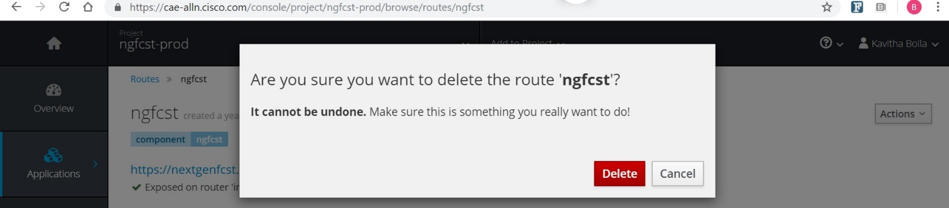

P2 CAE np/prd clusters : <https://cae-alln.cisco.com/console/>(ALLN) , [https://cae-rcdn.cisco.com/console/](https://cae-alln.cisco.com/console/) (RCDN) and [https://cae-RTP.cisco.com](https://cae-alln.cisco.com/console/)

[/console/](https://cae-alln.cisco.com/console/) (RTP)

Route deletetion takes 10-15min which has to cleanup in console,AM/ESP record,PMT and RP,etc .

Verify : Make sure routes are deleted by doing "nslookup <route>" should results in NXDOMAIN. If not deleted properly, please reach-out to CAE team by opening a case [https://cisco.service-now.com/sp?](https://cisco.service-now.com/sp?id=sc_cat_item&amp;sys_id=a9860b89dbd9a640cb5772fc0f96191d&amp;u_business_service=a8e036a9db95c34063339c26db961903) [id=sc\_cat\_item&sys\_id=a9860b89dbd9a640cb5772fc0f96191d&u\_business\_service=a8e036a9db95c34063339c26db961903](https://cisco.service-now.com/sp?id=sc_cat_item&amp;sys_id=a9860b89dbd9a640cb5772fc0f96191d&amp;u_business_service=a8e036a9db95c34063339c26db961903) Or go to atyourservice.cisco.comand search for "CAE"

[kabolla@lae-rtp1-brk01 ~]$ nslookup [extcis-prod-rcdn.cisco.com](http://extcis-prod-rcdn.cisco.com/) Server: 64.102.6.247

Address: 64.102.6.247#53

\*\* server can't find [extcis-prod-rcdn.cisco.com](http://extcis-prod-alln.cisco.com/): NXDOMAIN

1. Delete the P2 Project from ACC UI :

Once the routes are deleted successfully , Login to ACC UI [http://acc.cisco.com/mycloud/#/home/applications](http://acc.cisco.com/mycloud/%23/home/applications) search application "Cisco Digital

Forecasting System (CDFS)" Profile (ALLNPROD01) [Cloud Application Environment](http://acc.cisco.com/mycloud/%23/home/2ce3fbd0-c874-4a28-875f-d02e07abd359/profile/3801ba52-2cf8-45a3-a74d-c1beb7d08ed5/caeproject) select the project (ngfcst-prod) select the radio button and click on trash icon to delete the project.

If the routes are deleted successfully , Project will be deleted without any issues. If not , you will get a message "**Routes** are associated to project and selected project cannot be deleted" as below. Please reach-out to CAE team.

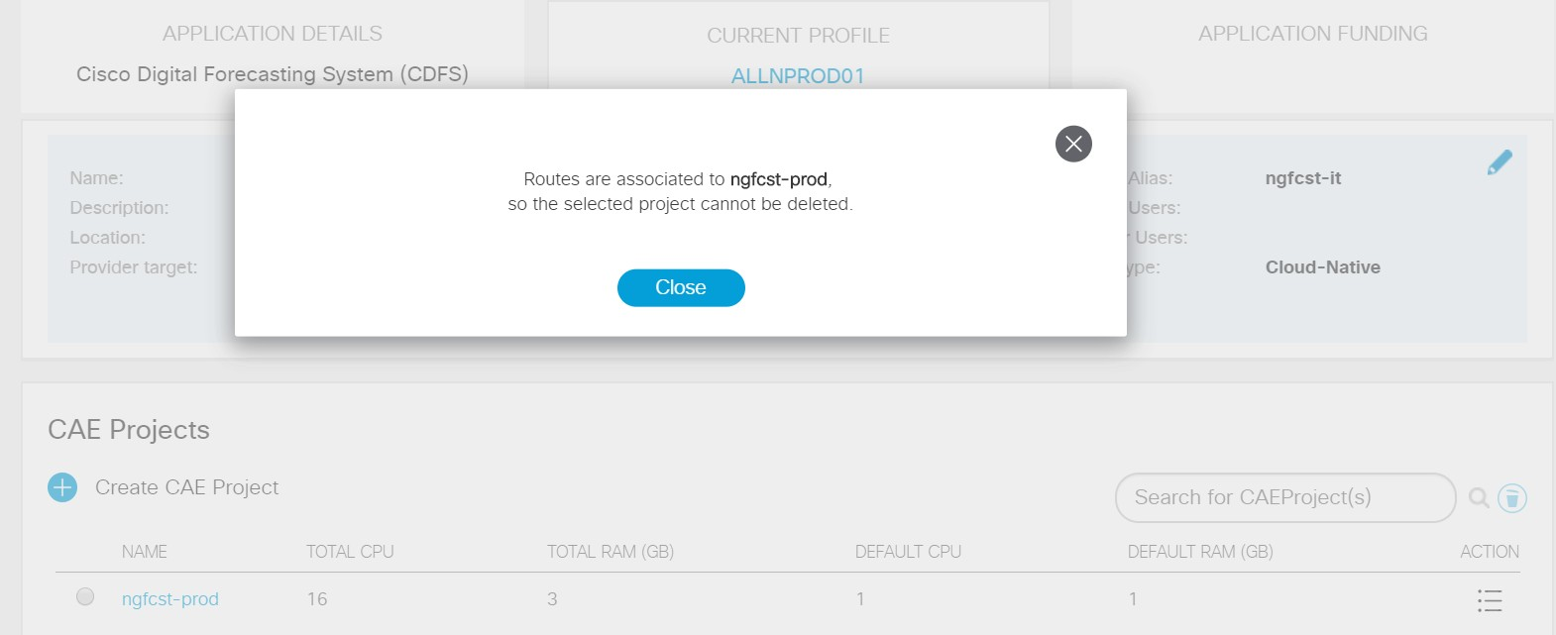

1. Delete the ACC P2 profile :

Once the routes are deleted successfully , Login to ACC UI [http://acc.cisco.com/mycloud/#/home/applications](http://acc.cisco.com/mycloud/%23/home/applications) search application "Cisco Digital

Forecasting System (CDFS)" Profile (ALLNPROD01) select the radio button and click on trash icon to delete the profile.

If the projects are deleted successfully , profile will be deleted without any issues. If not , you will get a message "**extcis-prod-rcdn** is associated to resources and cannot be deleted". Please reach-out to CAE Team.

If the migration not completed from P2 to P3 , please refer to [CAE Migration P2 Environment to P3 Environment.](https://wiki.cisco.com/pages/viewpage.action?pageId=230631652)

# Deploy on CAE without SDaaS

This document walks you through the steps to deploy your application on CAE without SDaaS.

##### Prerequisites:

Prerequisites should be installed on your local machine.

Install [Docker](https://docs.docker.com/docker-for-windows/install/) for windows or Install [Docker](https://docs.docker.com/docker-for-mac/install/) for Mac Install [OC](https://wiki.cisco.com/display/CAEUSER/Download%2Boc%2Bclient)

Create a repository in [ECH](https://containers.cisco.com/) to push your Docker image

e.g - [containers.cisco.com/anguda/apache2.4](http://containers.cisco.com/anguda/apache2.4)

##### Deploying on CAE:

* + 1. If you are migrating your application from LAE to CAE which has source code repository(**gitscm, svn-repo**), continue with step 2. For new applications on-boarding on CAE and LAE applications which doesn't have any repository(gitscm, svn-repo) go to step 3
    2. Generate Yaml files and Dockerfile using [lae2cae](https://lae2cae.cisco.com/software/home) tool

**How to use lae2cae**

Refer to [Migrate My App(s)](https://wiki.cisco.com/pages/viewpage.action?pageId=127130261) on how to generate files using lae2cae tool

* + 1. For new applications, generate yaml files and Dockerfile using [CAEConfigFileUtilityNew.zip](https://wiki.cisco.com/download/attachments/160177319/CAEConfigFileUtilityNew.zip?version=3&amp;modificationDate=1537308726000&amp;api=v2)

Select Technology, default is for New CAE Applications

ACC Profile Name Should be your ACC Application profile name

Please get access to ACC application to see acc profile name, [LAE to CAE Migration](https://wiki.cisco.com/display/CAEUSER/LAE%2Bto%2BCAE%2BMigration%2BFAQs#LAEtoCAEMigrationFAQs-HowcanigetaccesstomyACCapplication) [FAQs#HowcanigetaccesstomyACCapplication](https://wiki.cisco.com/display/CAEUSER/LAE%2Bto%2BCAE%2BMigration%2BFAQs#LAEtoCAEMigrationFAQs-HowcanigetaccesstomyACCapplication)?

Application Component name can be anything like a project name, if you're trying to deploy with SDaaS please use application name in SDaaS order

Container Repository URL should be the url of the ECH ( containers.cisco.com) repository you created as part of prerequisites

No. of pods - 1 pod (you can change this later in your deployment yaml) Container Port - 8080

Route URL, for new application on cae: should be your application URL; for migrating application provide the cae-test url.

LAE Memory should be get it from scoreboardui.cisco.com, append **Gi** to the value in yaml file. **example 1Gi**

LAE CPU should be get it from [scoreboardui.cisco.com](http://scoreboardui.cisco.com/)

OPENSHIFT APP NAME for migrating application should be like <lae\_appname><int><rtp><dev>; for new app can be anything you call your application

* + 1. Create a directory with your source code, Config and create a Dockerfile please choose the Dockerfile based on the technology from [Managed Images](https://wiki.cisco.com/display/CAEUSER/Managed%2BImages)



* + 1. Create Docker Image on your local machine using the Dockerfile generated in above steps



1. Dockerfile is different for each technology, please refer to [wiki](https://wiki.cisco.com/display/CAEUSER/Managed%2BImages) for all technologies
2. For more information on how to write Dockerfiles, please see [Dockerfile](https://wiki.cisco.com/display/CAEUSER/Write%2BDockerfiles)
   * 1. Verify the image is built successfully



* + 1. Push the Docker Image to ECH, While the ECH browser UI (https://containers.cisco.com) only requires CEC user name and password to login, connecting via a docker client requires an encrypted password.
       1. Generate Encrypted password on ECH
          1. Login to <https://containers.cisco.com/>
          2. Click on your user name in the top-right corner and click on "Account settings"
          3. Click on "Generate Encrypted Password"

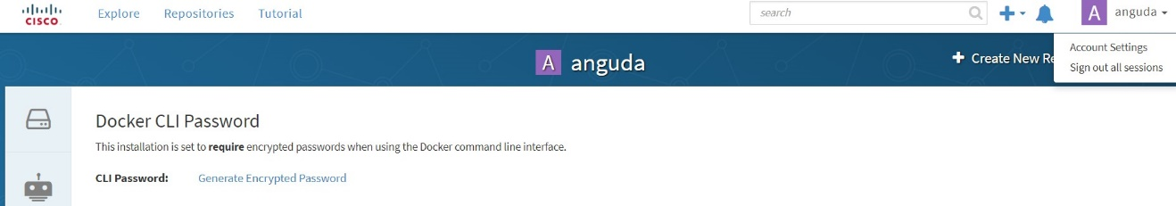

* + - * 1. Login to ECH from your local machine where your built the Docker image

docker login -u="anguda" -p="&encrypted\_paasword%" containers.cisco.com

* + - 1. Push the latest Docker Image to ECH

docker push containers.cisco.com/anguda/apache2.4:v1

* + - 1. If you want to make ECH repo as private and deployment available on CAE, please check Step 4 and 5 of [Deploy on CAE using SDaaS Pipeline and Image Pull Secrets](https://wiki.cisco.com/display/CAEUSER/Deploy%2Bon%2BCAE%2Busing%2BSDaaS%2BPipeline%2Band%2BImage%2BPull%2BSecrets)
    1. Deploy to CAE
       1. Update the deployment config yaml with Docker image you pushed to ECH

spec:

containers:

-

name: "container\_name"

image: "containers.cisco.com/anguda/apache2.4:v1"

* + - 1. Login to the CAE cluster using OC client. (Replace the cluster name in below command with the cluster you want to login to)

oc login cae-np-rtp.cisco.com

* + - 1. switch to your project

oc project apachetest

* + - 1. create route and deploy the pod

oc apply -f dcpwebp-dcplite-dev-rtp.yaml

oc apply -f dcpwebp-dcplite-dev-rtp-route.yaml

Note: Do not apply route.yaml for migration application, as CAE team provisioning routes for you.

* + - 1. To verify the deployment and route, you can check either from CAE Web console or using oc tool

oc get all

Once the deployment is successful and pods are up and running, you can access your application with the route you created.

# Disaster Recovery (DR) for CAE Apps

**If you are migrating from LAE** and you have a DR instances in LAE, your application will be provisioned in [PRD RTP console](https://cae-prd-rtp.cisco.com/console/catalog)

## Changes required in LAE code

1. Note down the OPENSHIFT\_APP\_NAME in deployemnt yaml for PRD\_RTP DR instance

Example :

env:

* name: "OPENSHIFT\_APP\_NAME"

value: "**testrtpprod**"

1. Add a **first case** in pre\_start\* script to handle database connection for this "OPENSHIFT\_APP\_NAME"

Location of pre\_start file : package/repo/.openshift/action-hooks/pre\_start\*

Example **:**

appname=`echo $OPENSHIFT\_APP\_NAME` case "$appname" in

**testrtpprod**) export OPENSHIFT\_DB\_URL="jdbc:oracle:thin:@ldap://ldap-ld3prd.cisco.com:5000/cn=OracleContext,dc=cisco,dc=com/CCIXNP" export OPENSHIFT\_DB\_USERNAME="newapp\_user"

export OPENSHIFT\_DB\_PASSWORD="user4dev"

;;

1. For **OPENSHIFT\_DB\_URL** in pre\_start file,

For external apps change ocm-prod to **ocm-prod3**

For Internal apps change [ldap-ldprd.cisco.com](http://ldap-ldprd.cisco.com/) to **ldap-ld3prd.cisco.com**

## How to test application only in DR ?

You can individually test ONLY DR application using test routes for it's functionality (you can see routes on console under Applications routes) Test route is in the form of :

Route name : <application\_name>-prod-int/ext-rtp-test Hostname : https://<application\_name>prod-rtp.cisco.com

### How to test failover ?

* 1. Make sure GSLB is configured as 'active' for ALLN and RCDN and 'passive' for RTP from [ACC](http://acc.cisco.com/)
  2. Scale down pods to 0 in both ALLN and RCDN. ([Scale Up/Down Pods](https://wiki.cisco.com/pages/viewpage.action?pageId=85091674))
  3. Hit GSLB url and verify if requests are reaching to PRD RTP application by checking application logs ([LAE to CAE Migration FAQs#Howcaniaccessthecontainerlogs](https://wiki.cisco.com/display/CAEUSER/LAE%2Bto%2BCAE%2BMigration%2BFAQs#LAEtoCAEMigrationFAQs-Howcaniaccessthecontainerlogs)?)

Reference:

[**LAE to CAE Migration FAQs**](https://wiki.cisco.com/display/CAEUSER/LAE%2Bto%2BCAE%2BMigration%2BFAQs)

[**Disaster Recovery (DR) for LAE Apps**](https://wiki.cisco.com/display/LAEDOCS/Disaster%2BRecovery%2B%28DR%29%2Bfor%2BLAE%2BApps)

**ESP Registration**

All LAE applications **(Both PROD and NPROD**) are mandated to register in ESP in order to migrate to CAE. Follow the steps below to successfully register your application.

Register Apps in ESP steps:

1.) Click on the ’[ESP Applications portfolio](https://cisco.service-now.com/nav_to.do?uri=%2Fcom.glideapp.servicecatalog_cat_item_view.do%3Fv%3D1%26sysparm_id%3D5fd7d700dbf672443800f5331d96199d)” link.

2.) Fill in all the text boxes (Make sure all the text boxes are filled out) 3.) Click Submit

If ESP Application Portfolio already exists, go back and check to make sure all the text boxes are filled (this applies to business application modules as well). If these boxes are empty, the SYS ID will not update.

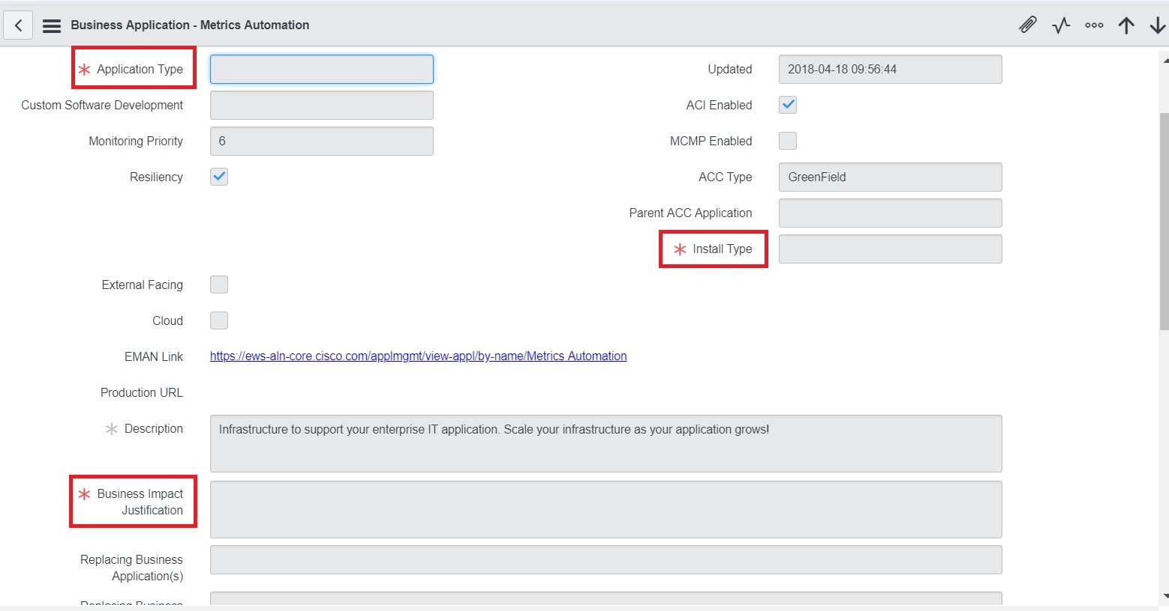

In addition, these two fields must also be filled for both IT and Non-IT applications

1.) Security Prime Name and Partner Security Advocate (contact ESP team or ertong) 2.) Update the application alias

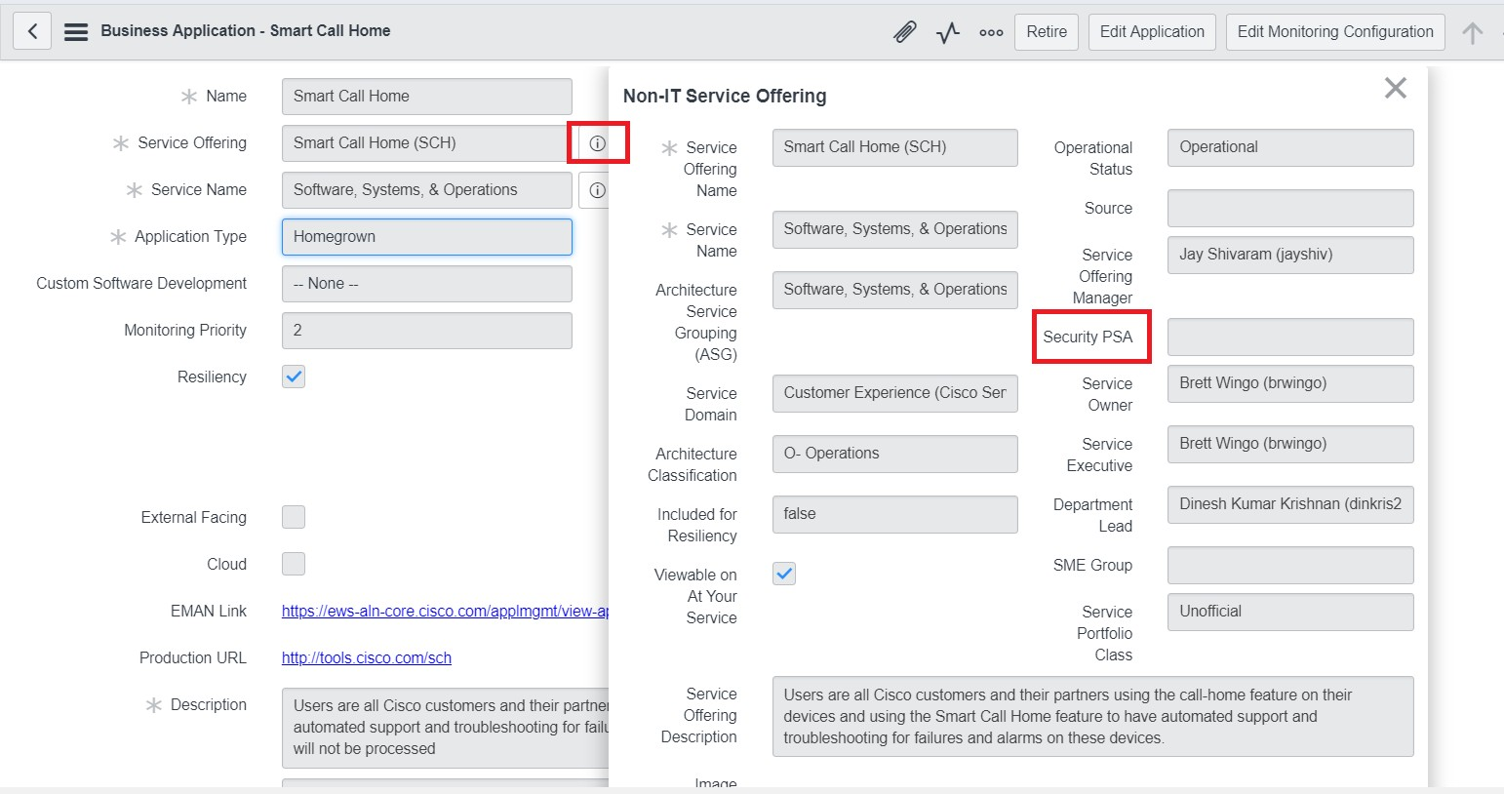

If you do not know what to put in any of the empty fields, please contact the ESP team <https://clicktospark.cloudapps.cisco.com/home>(Go to search in service offering and search for ESp-Application Portfolio to open a case)

Update SYS ID steps:

When your ESP portfolio has been created or updated, follow the steps to update the SYS ID 1.) Goto <http://ccp.cloudapps.cisco.com/portal/SDMLAE.vm>

2.) Select the vLAE that it is missing ESP data(Business Application name) 3.) Select the LAE Application Name

4.) Type in application name in “Application Portfolio Name” box and then click search (If your app is under a business application module, search for the parent business application and use that to update the SYS ID)

5.) Application Portfolio ME ID will populate automatically 6.) Submit the request

# Invalid Mailer correction

Steps to update the “Group mailer Alias” in eStore.

1.) Go to http://estore.cisco.com/RequestCenter/website/ServiceCatalog/index.html?/services/655

2.) Click on "Order"

3.) Select your app in "**Stack Name**"

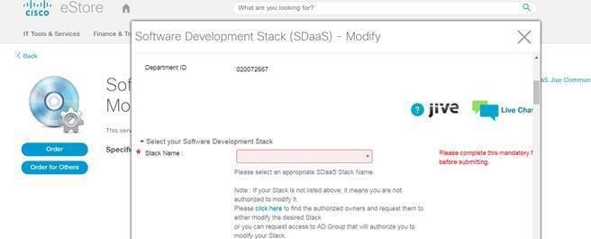

4.) Update the correct “**Group Mailer Alias**”.

Make sure all Email Ids in the mailer are active and valid.

The mailer should not have any external members and set the flag “**Allow external addresses in list “ to false.**

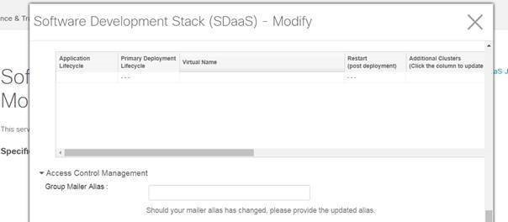

5.) Click Submit

# LAE2CAE Migration - POCs

|  |  |  |  |  |  |
| --- | --- | --- | --- | --- | --- |
| **Application Group** | **No of Apps** | **POC** | **CSM** | **Status** | **Comment** |
| Supply Chain | 190 | Latha Krishna and Arul Natarajan | Umashankar Meda | Checklist in prepared and committed for Dec Delivery | More apps are being tracked, need to follow |
| Commerce | 203 | Anamika, Mahesh Chittru, Paul Bernardo, Aushall Franklin | Sarabjit Singh | Commerce Services are Committed for Nov Release; Need to followup with all rest of services teams to get the commitment | Actual number will be different after we close on the discussions with the team |
| Customer Care | 119 | Vivianne Volyles | Samara Ramos-Brown | Got a committed dates for multiple services |  |
| Order to cash | 39 | Victor Aguliar | Sarabjit Singh | Waiting to get the committed dates |  |
| Core Financial | 43 | Victor Aguilar | Sarabjit Singh | Waiting to get the committed date |  |
| Employee Experience and Collaboration | 256 | Ajith Shah | Rita Budakoti | NA |  |
| xRM and Customer Care |  | Karen Liu, Mani Kasiviswanthan | Rita Budakot |  |  |
| Employee Experience and Collaboation |  | Sujith Joseph, Majoj Faira | Rita Budakoti |  |  |
| CPP & Sales Coverage Credit and Comp |  | Jace Rose | Rita Budakoti |  |  |

**LAE to CAE Migration FAQs**

[Migration Process](file:///C:\Machine%20Learning\Test\PDF\ilovepdf_split-range\CAE%20Wiki%20Pages-151-403.docx#_bookmark72)

[Webinar Recordings for LAE2CAE](file:///C:\Machine%20Learning\Test\PDF\ilovepdf_split-range\CAE%20Wiki%20Pages-151-403.docx#_bookmark73)

[Will there be any one time or recurring cost if I migrated my LAE apps to CAE?](file:///C:\Machine%20Learning\Test\PDF\ilovepdf_split-range\CAE%20Wiki%20Pages-151-403.docx#_bookmark74) [Why does my LAE app need to migrate?](file:///C:\Machine%20Learning\Test\PDF\ilovepdf_split-range\CAE%20Wiki%20Pages-151-403.docx#_bookmark75)

[Is migration to CAE mandatory?](file:///C:\Machine%20Learning\Test\PDF\ilovepdf_split-range\CAE%20Wiki%20Pages-151-403.docx#_bookmark76)

[If i don't want to migrate my application to CAE and want to stay on LAE , what is the impact to my application?](file:///C:\Machine%20Learning\Test\PDF\ilovepdf_split-range\CAE%20Wiki%20Pages-151-403.docx#_bookmark77) [Is there a deadline to migrate?](file:///C:\Machine%20Learning\Test\PDF\ilovepdf_split-range\CAE%20Wiki%20Pages-151-403.docx#_bookmark78)

[If I missed the wave 1 timelines, can I get help with it?](file:///C:\Machine%20Learning\Test\PDF\ilovepdf_split-range\CAE%20Wiki%20Pages-151-403.docx#_bookmark79) [How do I know when is my app getting migrated ?](file:///C:\Machine%20Learning\Test\PDF\ilovepdf_split-range\CAE%20Wiki%20Pages-151-403.docx#_bookmark80)

[Is there a roadmap for Migration?](file:///C:\Machine%20Learning\Test\PDF\ilovepdf_split-range\CAE%20Wiki%20Pages-151-403.docx#_bookmark81)

[What is the engagement process to get help with CAE migration?](file:///C:\Machine%20Learning\Test\PDF\ilovepdf_split-range\CAE%20Wiki%20Pages-151-403.docx#_bookmark82) [Where can I get detail information on the migration?](file:///C:\Machine%20Learning\Test\PDF\ilovepdf_split-range\CAE%20Wiki%20Pages-151-403.docx#_bookmark83)

[When can we start working on CAE migration?](file:///C:\Machine%20Learning\Test\PDF\ilovepdf_split-range\CAE%20Wiki%20Pages-151-403.docx#_bookmark84)

[Our applications are ECMO protected, what is the process to migrate?](file:///C:\Machine%20Learning\Test\PDF\ilovepdf_split-range\CAE%20Wiki%20Pages-151-403.docx#_bookmark85)

[Do I need to re-certify my application for resiliency after migrating to CAE?](file:///C:\Machine%20Learning\Test\PDF\ilovepdf_split-range\CAE%20Wiki%20Pages-151-403.docx#_bookmark86) [What are the feature difference between LAE and CAE?](file:///C:\Machine%20Learning\Test\PDF\ilovepdf_split-range\CAE%20Wiki%20Pages-151-403.docx#_bookmark87)

[Where can I find more documentation about CAE?](file:///C:\Machine%20Learning\Test\PDF\ilovepdf_split-range\CAE%20Wiki%20Pages-151-403.docx#_bookmark88)

[For RESTservices, after migration to CAE, will they still be routed through Layer 7?](file:///C:\Machine%20Learning\Test\PDF\ilovepdf_split-range\CAE%20Wiki%20Pages-151-403.docx#_bookmark89)

[We are having b2x url in stage environment, is it going to be same after migration. i.e can we able to access stage instance from](file:///C:\Machine%20Learning\Test\PDF\ilovepdf_split-range\CAE%20Wiki%20Pages-151-403.docx#_bookmark90) [outside cisco network.](file:///C:\Machine%20Learning\Test\PDF\ilovepdf_split-range\CAE%20Wiki%20Pages-151-403.docx#_bookmark90)

[My application is not ready for the migration right now due to other deliverables. Please move us to a later Wave.](file:///C:\Machine%20Learning\Test\PDF\ilovepdf_split-range\CAE%20Wiki%20Pages-151-403.docx#_bookmark91) [What I should do if my application is getting decommissioned?](file:///C:\Machine%20Learning\Test\PDF\ilovepdf_split-range\CAE%20Wiki%20Pages-151-403.docx#_bookmark92)

[Are there images with a variety of technologies ?](file:///C:\Machine%20Learning\Test\PDF\ilovepdf_split-range\CAE%20Wiki%20Pages-151-403.docx#_bookmark93)

[Does CAE use the same ACI environment that LAE was using?](file:///C:\Machine%20Learning\Test\PDF\ilovepdf_split-range\CAE%20Wiki%20Pages-151-403.docx#_bookmark94)

[Do we have a POC environment to try things out? If not, is there a possibility to get one?](file:///C:\Machine%20Learning\Test\PDF\ilovepdf_split-range\CAE%20Wiki%20Pages-151-403.docx#_bookmark95) [Do you have a list of steps required to complete the migration activities ?](file:///C:\Machine%20Learning\Test\PDF\ilovepdf_split-range\CAE%20Wiki%20Pages-151-403.docx#_bookmark96)

[Can i migrate my existing vLAE to CAE?](file:///C:\Machine%20Learning\Test\PDF\ilovepdf_split-range\CAE%20Wiki%20Pages-151-403.docx#_bookmark97)

[I see that our application is listed as Not-In-CDA in lae2cae.cisco.com. how to move application from not-in-CDA to CDA.](file:///C:\Machine%20Learning\Test\PDF\ilovepdf_split-range\CAE%20Wiki%20Pages-151-403.docx#_bookmark98) [Generate yaml files for new applications on CAE or migrating applications without gitscm repo, using Config Utility Tool.](file:///C:\Machine%20Learning\Test\PDF\ilovepdf_split-range\CAE%20Wiki%20Pages-151-403.docx#_bookmark99)

[My application is not ready to be migrated due to "SYS\_ID\_EMPTY: SysId blank in CCP" or "SYS\_ID\_NOT\_IN\_SERVICENOW:](file:///C:\Machine%20Learning\Test\PDF\ilovepdf_split-range\CAE%20Wiki%20Pages-151-403.docx#_bookmark100) [Sys Id is not a Business Application or not found in Service Now" error](file:///C:\Machine%20Learning\Test\PDF\ilovepdf_split-range\CAE%20Wiki%20Pages-151-403.docx#_bookmark100)

[What is the estimated effort in hours required, for the application team to complete the migration activities ?](file:///C:\Machine%20Learning\Test\PDF\ilovepdf_split-range\CAE%20Wiki%20Pages-151-403.docx#_bookmark101) [During migration, what deployment steps need to be taken care by application team? (deployment from scratch)](file:///C:\Machine%20Learning\Test\PDF\ilovepdf_split-range\CAE%20Wiki%20Pages-151-403.docx#_bookmark102) [Does the Scoreboard show only the Prod env or does it show non-prod as well?](file:///C:\Machine%20Learning\Test\PDF\ilovepdf_split-range\CAE%20Wiki%20Pages-151-403.docx#_bookmark103)

[Does migration involve any downtime? If so, how much would be the downtime?](file:///C:\Machine%20Learning\Test\PDF\ilovepdf_split-range\CAE%20Wiki%20Pages-151-403.docx#_bookmark104) [Is there any plan to migrate non prod prior to prod?](file:///C:\Machine%20Learning\Test\PDF\ilovepdf_split-range\CAE%20Wiki%20Pages-151-403.docx#_bookmark105)

[Does the scoreboard show all the applications to everyone or only to the owner/concerned team?](file:///C:\Machine%20Learning\Test\PDF\ilovepdf_split-range\CAE%20Wiki%20Pages-151-403.docx#_bookmark106) [Does the migration of Prod applications, need to be aligned with any ERMO release ?](file:///C:\Machine%20Learning\Test\PDF\ilovepdf_split-range\CAE%20Wiki%20Pages-151-403.docx#_bookmark107)

[Is the required hardware for migration already in place or would be it allocated once the team commits for migration?](file:///C:\Machine%20Learning\Test\PDF\ilovepdf_split-range\CAE%20Wiki%20Pages-151-403.docx#_bookmark108) [Has anyone committed for migration? if so, is it available anywhere?](file:///C:\Machine%20Learning\Test\PDF\ilovepdf_split-range\CAE%20Wiki%20Pages-151-403.docx#_bookmark109)

[I see different memory values on LAE and CAE, Why is it different and how is the total application memory and cpu is calculated on CAE?](file:///C:\Machine%20Learning\Test\PDF\ilovepdf_split-range\CAE%20Wiki%20Pages-151-403.docx#_bookmark110)

[How can i get access to my ACC application?](file:///C:\Machine%20Learning\Test\PDF\ilovepdf_split-range\CAE%20Wiki%20Pages-151-403.docx#_bookmark111)

[Provisioning](file:///C:\Machine%20Learning\Test\PDF\ilovepdf_split-range\CAE%20Wiki%20Pages-151-403.docx#_bookmark112)

[Do we need to create/provision Application manually ?](file:///C:\Machine%20Learning\Test\PDF\ilovepdf_split-range\CAE%20Wiki%20Pages-151-403.docx#_bookmark113) [Is CAE cloud based?](file:///C:\Machine%20Learning\Test\PDF\ilovepdf_split-range\CAE%20Wiki%20Pages-151-403.docx#_bookmark114)

[Is auto-scale available or is there any way we can enable this by providing a default set of APIs?](file:///C:\Machine%20Learning\Test\PDF\ilovepdf_split-range\CAE%20Wiki%20Pages-151-403.docx#_bookmark115) [How do I know my IT Application Name/ACC Application Name using LAE vlae/domain name?](file:///C:\Machine%20Learning\Test\PDF\ilovepdf_split-range\CAE%20Wiki%20Pages-151-403.docx#_bookmark116) [How can I know the list of applications , profiles and projects that are under my IT Application ?](file:///C:\Machine%20Learning\Test\PDF\ilovepdf_split-range\CAE%20Wiki%20Pages-151-403.docx#_bookmark117) [How do I know if my application is already registered/provisioned ?](file:///C:\Machine%20Learning\Test\PDF\ilovepdf_split-range\CAE%20Wiki%20Pages-151-403.docx#_bookmark118)

[Do I get the same number of instances and resources ( CPU and Memory) that I have in LAE?](file:///C:\Machine%20Learning\Test\PDF\ilovepdf_split-range\CAE%20Wiki%20Pages-151-403.docx#_bookmark119)

[If I want to increase the number of instances or modify the quota ( CPU and Memory) , how can I do it ?](file:///C:\Machine%20Learning\Test\PDF\ilovepdf_split-range\CAE%20Wiki%20Pages-151-403.docx#_bookmark120) [If I have custom lifecycles in LAE , do I get the same custom lifecycles/profiles in CAE ?](file:///C:\Machine%20Learning\Test\PDF\ilovepdf_split-range\CAE%20Wiki%20Pages-151-403.docx#_bookmark121)

[If I want to create additional custom lifecycles/profiles in CAE how do I create ?](file:///C:\Machine%20Learning\Test\PDF\ilovepdf_split-range\CAE%20Wiki%20Pages-151-403.docx#_bookmark122) [Can I use same project for multiple applications/services?](file:///C:\Machine%20Learning\Test\PDF\ilovepdf_split-range\CAE%20Wiki%20Pages-151-403.docx#_bookmark123)

[Is DR provisioned automatically? Or do we have to request it?](file:///C:\Machine%20Learning\Test\PDF\ilovepdf_split-range\CAE%20Wiki%20Pages-151-403.docx#_bookmark124) [Can I request more memory/Quota ? How can I?](file:///C:\Machine%20Learning\Test\PDF\ilovepdf_split-range\CAE%20Wiki%20Pages-151-403.docx#_bookmark125)

[Is MVDC available?](file:///C:\Machine%20Learning\Test\PDF\ilovepdf_split-range\CAE%20Wiki%20Pages-151-403.docx#_bookmark126)

[Client is not able to see the application in ACC, why ?](file:///C:\Machine%20Learning\Test\PDF\ilovepdf_split-range\CAE%20Wiki%20Pages-151-403.docx#_bookmark127) [How do I create a CAE Project?](file:///C:\Machine%20Learning\Test\PDF\ilovepdf_split-range\CAE%20Wiki%20Pages-151-403.docx#_bookmark128)

[How do I access and manage my CAE Project?](file:///C:\Machine%20Learning\Test\PDF\ilovepdf_split-range\CAE%20Wiki%20Pages-151-403.docx#_bookmark129) [What is a route and how to create one?](file:///C:\Machine%20Learning\Test\PDF\ilovepdf_split-range\CAE%20Wiki%20Pages-151-403.docx#_bookmark130)

[What is GSLB?](file:///C:\Machine%20Learning\Test\PDF\ilovepdf_split-range\CAE%20Wiki%20Pages-151-403.docx#_bookmark131)

[How to create GSLB?](file:///C:\Machine%20Learning\Test\PDF\ilovepdf_split-range\CAE%20Wiki%20Pages-151-403.docx#_bookmark132)

[For my GSLB I see probe as lae2cae.html and response code as 404. But i don't have that page in my application , what should](file:///C:\Machine%20Learning\Test\PDF\ilovepdf_split-range\CAE%20Wiki%20Pages-151-403.docx#_bookmark133) [i do ?](file:///C:\Machine%20Learning\Test\PDF\ilovepdf_split-range\CAE%20Wiki%20Pages-151-403.docx#_bookmark133)

[Is DR available on CAE?](file:///C:\Machine%20Learning\Test\PDF\ilovepdf_split-range\CAE%20Wiki%20Pages-151-403.docx#_bookmark134)

[When LAE is migrated to CAE, how does the capacity of the CAE pod is determined?](file:///C:\Machine%20Learning\Test\PDF\ilovepdf_split-range\CAE%20Wiki%20Pages-151-403.docx#_bookmark135)

[My Application has a cron running on LAE. I want to know how it will work after migrating to CAE](file:///C:\Machine%20Learning\Test\PDF\ilovepdf_split-range\CAE%20Wiki%20Pages-151-403.docx#_bookmark136)

[Will CAE team auto provision the required number of containers ( based on LAE environment setup ) on CAE platform? If not,](file:///C:\Machine%20Learning\Test\PDF\ilovepdf_split-range\CAE%20Wiki%20Pages-151-403.docx#_bookmark137) [then do we need to reach out to CAE team to run the LAE2CAE MIGRATION tool for our application?](file:///C:\Machine%20Learning\Test\PDF\ilovepdf_split-range\CAE%20Wiki%20Pages-151-403.docx#_bookmark137)

[I am the admin for ACC applciation, but I do not see my application list in scoreboard UI or I am not able to see my projects in CAE console. Why ?](file:///C:\Machine%20Learning\Test\PDF\ilovepdf_split-range\CAE%20Wiki%20Pages-151-403.docx#_bookmark138)

[Since the 'acc\_cae\_project\_name' is in RTP, we will include only the YAML file for RTP?](file:///C:\Machine%20Learning\Test\PDF\ilovepdf_split-range\CAE%20Wiki%20Pages-151-403.docx#_bookmark139)

[As per Migrate My App(s) Step 5, Dockerfile and YAML files are generated. After downloading we see, the YAML files are](file:///C:\Machine%20Learning\Test\PDF\ilovepdf_split-range\CAE%20Wiki%20Pages-151-403.docx#_bookmark140) [generated only for PROD environment for different data centers. Do we need to create the YAML files for Dev & Stage by](file:///C:\Machine%20Learning\Test\PDF\ilovepdf_split-range\CAE%20Wiki%20Pages-151-403.docx#_bookmark140) [ourselves?](file:///C:\Machine%20Learning\Test\PDF\ilovepdf_split-range\CAE%20Wiki%20Pages-151-403.docx#_bookmark140)

[How to provide access to other team members?](file:///C:\Machine%20Learning\Test\PDF\ilovepdf_split-range\CAE%20Wiki%20Pages-151-403.docx#_bookmark141)

[As there would be 3 DC's, does deployment need to be done thrice on each DC?](file:///C:\Machine%20Learning\Test\PDF\ilovepdf_split-range\CAE%20Wiki%20Pages-151-403.docx#_bookmark142) [How do i select CPU and memory quota for my project?](file:///C:\Machine%20Learning\Test\PDF\ilovepdf_split-range\CAE%20Wiki%20Pages-151-403.docx#_bookmark143)

[Can i get both LAE FQDN URL and CNAME URL in CAE?](file:///C:\Machine%20Learning\Test\PDF\ilovepdf_split-range\CAE%20Wiki%20Pages-151-403.docx#_bookmark144)

[Configuration](file:///C:\Machine%20Learning\Test\PDF\ilovepdf_split-range\CAE%20Wiki%20Pages-151-403.docx#_bookmark145)

[If i want to define any custom environment variables how do i configure?](file:///C:\Machine%20Learning\Test\PDF\ilovepdf_split-range\CAE%20Wiki%20Pages-151-403.docx#_bookmark146)

[On LAE we can deploy lifecycle specific jars. (For example if I were to deploy cisco.dev.jar and cisco.stage.jar in .ear/.war, then](file:///C:\Machine%20Learning\Test\PDF\ilovepdf_split-range\CAE%20Wiki%20Pages-151-403.docx#_bookmark147) [on dev lifecycle the contents of cisco.dev.jar would be exploded and on stage cisco.stage.jar would be exploded). How this can](file:///C:\Machine%20Learning\Test\PDF\ilovepdf_split-range\CAE%20Wiki%20Pages-151-403.docx#_bookmark147) [be done on CAE?](file:///C:\Machine%20Learning\Test\PDF\ilovepdf_split-range\CAE%20Wiki%20Pages-151-403.docx#_bookmark147)

[Is there any way to associate a CAE environment with a given lifecycle (which may allow customization of DB dependencies for](file:///C:\Machine%20Learning\Test\PDF\ilovepdf_split-range\CAE%20Wiki%20Pages-151-403.docx#_bookmark148) [instance)?](file:///C:\Machine%20Learning\Test\PDF\ilovepdf_split-range\CAE%20Wiki%20Pages-151-403.docx#_bookmark148)

[How to troubleshoot Database Connection Failures?](file:///C:\Machine%20Learning\Test\PDF\ilovepdf_split-range\CAE%20Wiki%20Pages-151-403.docx#_bookmark149)

[Is it allowed to upload the latest certs without app deployment?](file:///C:\Machine%20Learning\Test\PDF\ilovepdf_split-range\CAE%20Wiki%20Pages-151-403.docx#_bookmark150)

[I'm seeing different CN(Common Name) for my application certificate , how do i fix it?](file:///C:\Machine%20Learning\Test\PDF\ilovepdf_split-range\CAE%20Wiki%20Pages-151-403.docx#_bookmark151) [Is Cert management(like WSG) same as LAE?](file:///C:\Machine%20Learning\Test\PDF\ilovepdf_split-range\CAE%20Wiki%20Pages-151-403.docx#_bookmark152)

[Is CAE environment accessible from other environments like CCIX , LAE ?](file:///C:\Machine%20Learning\Test\PDF\ilovepdf_split-range\CAE%20Wiki%20Pages-151-403.docx#_bookmark153) [How do I use Log4J with the cisco.logdir property?](file:///C:\Machine%20Learning\Test\PDF\ilovepdf_split-range\CAE%20Wiki%20Pages-151-403.docx#_bookmark154)

[What if we need to add any additional libraries in the container? How ACLs are managed at the port level?](file:///C:\Machine%20Learning\Test\PDF\ilovepdf_split-range\CAE%20Wiki%20Pages-151-403.docx#_bookmark155) [Can we use \*.cisco.com for my route? (ex. directory.cisco.com)](file:///C:\Machine%20Learning\Test\PDF\ilovepdf_split-range\CAE%20Wiki%20Pages-151-403.docx#_bookmark156)

[Can we have vanity URLs external facing?](file:///C:\Machine%20Learning\Test\PDF\ilovepdf_split-range\CAE%20Wiki%20Pages-151-403.docx#_bookmark157)

[How can I configure my application to terminate gracefully? How 'terminationGracePeriodSeconds' works in Kubernetes? Why](file:///C:\Machine%20Learning\Test\PDF\ilovepdf_split-range\CAE%20Wiki%20Pages-151-403.docx#_bookmark158) [do I see 503 with rolling restarts of my containers?](file:///C:\Machine%20Learning\Test\PDF\ilovepdf_split-range\CAE%20Wiki%20Pages-151-403.docx#_bookmark158)

[Is CAE recommended for Production which is subject to SOX compliance?](file:///C:\Machine%20Learning\Test\PDF\ilovepdf_split-range\CAE%20Wiki%20Pages-151-403.docx#_bookmark159)

[Does CAE come with Splunk installed? Or do you give non IT teams access to install on agent themselves?](file:///C:\Machine%20Learning\Test\PDF\ilovepdf_split-range\CAE%20Wiki%20Pages-151-403.docx#_bookmark160) [How do I enable and generate Heap Dump in CAE?](file:///C:\Machine%20Learning\Test\PDF\ilovepdf_split-range\CAE%20Wiki%20Pages-151-403.docx#_bookmark161)

[How to enable GC log for CAE application?](file:///C:\Machine%20Learning\Test\PDF\ilovepdf_split-range\CAE%20Wiki%20Pages-151-403.docx#_bookmark162)

[Any setup or config changes required for external LAE Applications, so that users can access the application without using VPN](file:///C:\Machine%20Learning\Test\PDF\ilovepdf_split-range\CAE%20Wiki%20Pages-151-403.docx#_bookmark163) [or Cisco network?](file:///C:\Machine%20Learning\Test\PDF\ilovepdf_split-range\CAE%20Wiki%20Pages-151-403.docx#_bookmark163)

[How do i integrate with SOX DB's ( RDAC)](file:///C:\Machine%20Learning\Test\PDF\ilovepdf_split-range\CAE%20Wiki%20Pages-151-403.docx#_bookmark164) [How can i access the container logs ?](file:///C:\Machine%20Learning\Test\PDF\ilovepdf_split-range\CAE%20Wiki%20Pages-151-403.docx#_bookmark165)

[How do I check logs of a terminated pod?](file:///C:\Machine%20Learning\Test\PDF\ilovepdf_split-range\CAE%20Wiki%20Pages-151-403.docx#_bookmark166)

[How do I attach a previous PVC to the existing project?](file:///C:\Machine%20Learning\Test\PDF\ilovepdf_split-range\CAE%20Wiki%20Pages-151-403.docx#_bookmark167) [Will AppD be enabled by default?](file:///C:\Machine%20Learning\Test\PDF\ilovepdf_split-range\CAE%20Wiki%20Pages-151-403.docx#_bookmark168)

[Will OAM still be available at the beginning of migration? or this is LAE+OAM => CAE+ PingID?](file:///C:\Machine%20Learning\Test\PDF\ilovepdf_split-range\CAE%20Wiki%20Pages-151-403.docx#_bookmark169)

[So if I don't see my app in the SSO PMT, it's because I'm not registered in App Portfolio as an owner?](file:///C:\Machine%20Learning\Test\PDF\ilovepdf_split-range\CAE%20Wiki%20Pages-151-403.docx#_bookmark170) [What if my application doesn’thave POM.xml and is not maven based?](file:///C:\Machine%20Learning\Test\PDF\ilovepdf_split-range\CAE%20Wiki%20Pages-151-403.docx#_bookmark171)

[We are having all our REST END POINTS configured on MASHERY which points to LAE jvms. Will this be done by MASHERY](file:///C:\Machine%20Learning\Test\PDF\ilovepdf_split-range\CAE%20Wiki%20Pages-151-403.docx#_bookmark172) [team or as part of LAE2CAE migration it will be taken care.](file:///C:\Machine%20Learning\Test\PDF\ilovepdf_split-range\CAE%20Wiki%20Pages-151-403.docx#_bookmark172)

[Why am i unable to modify CPU in ACC for my project?](file:///C:\Machine%20Learning\Test\PDF\ilovepdf_split-range\CAE%20Wiki%20Pages-151-403.docx#_bookmark173) [Why is the log4j configuration not working?](file:///C:\Machine%20Learning\Test\PDF\ilovepdf_split-range\CAE%20Wiki%20Pages-151-403.docx#_bookmark174)

[HAPROXY customization](file:///C:\Machine%20Learning\Test\PDF\ilovepdf_split-range\CAE%20Wiki%20Pages-151-403.docx#_bookmark175)

[SSH Trust Configuration from POD to Remote Host](file:///C:\Machine%20Learning\Test\PDF\ilovepdf_split-range\CAE%20Wiki%20Pages-151-403.docx#_bookmark176) [How do I setup Hadoop client to work in CAE?](file:///C:\Machine%20Learning\Test\PDF\ilovepdf_split-range\CAE%20Wiki%20Pages-151-403.docx#_bookmark177)

[Deployment](file:///C:\Machine%20Learning\Test\PDF\ilovepdf_split-range\CAE%20Wiki%20Pages-151-403.docx#_bookmark178)

[Once the Application is migrated from LAE to CAE, will there be any change in the LAE code deployment process?](file:///C:\Machine%20Learning\Test\PDF\ilovepdf_split-range\CAE%20Wiki%20Pages-151-403.docx#_bookmark179) [Is there a Image File Size Restriction?](file:///C:\Machine%20Learning\Test\PDF\ilovepdf_split-range\CAE%20Wiki%20Pages-151-403.docx#_bookmark180)

[Is it only one war/ear for Container?](file:///C:\Machine%20Learning\Test\PDF\ilovepdf_split-range\CAE%20Wiki%20Pages-151-403.docx#_bookmark181)

[Can we have multiple process running within a container?](file:///C:\Machine%20Learning\Test\PDF\ilovepdf_split-range\CAE%20Wiki%20Pages-151-403.docx#_bookmark182) [Can we use the existing SDaaS Stack for CAE Deployments?](file:///C:\Machine%20Learning\Test\PDF\ilovepdf_split-range\CAE%20Wiki%20Pages-151-403.docx#_bookmark183)

[Is there rollback in CAE deployment, instead of redeploy old version?](file:///C:\Machine%20Learning\Test\PDF\ilovepdf_split-range\CAE%20Wiki%20Pages-151-403.docx#_bookmark184) [Is SVN supported in CAE?](file:///C:\Machine%20Learning\Test\PDF\ilovepdf_split-range\CAE%20Wiki%20Pages-151-403.docx#_bookmark185)

[Where can I find CAE SDaaS stack information?](file:///C:\Machine%20Learning\Test\PDF\ilovepdf_split-range\CAE%20Wiki%20Pages-151-403.docx#_bookmark186) [How B/G work in CAE?](file:///C:\Machine%20Learning\Test\PDF\ilovepdf_split-range\CAE%20Wiki%20Pages-151-403.docx#_bookmark187)

[How can I migrate Add-Ons to CAE?](file:///C:\Machine%20Learning\Test\PDF\ilovepdf_split-range\CAE%20Wiki%20Pages-151-403.docx#_bookmark188)

[What is the benefit of using containers.cisco.com/aws\_managed vs the images from hub.docker.com?](file:///C:\Machine%20Learning\Test\PDF\ilovepdf_split-range\CAE%20Wiki%20Pages-151-403.docx#_bookmark189)

[Is there a way to possibly skip Jenkins pipeline and deploy the Docker Images directly?? (This is intended for some quick testing](file:///C:\Machine%20Learning\Test\PDF\ilovepdf_split-range\CAE%20Wiki%20Pages-151-403.docx#_bookmark190) [of images prior we go to dev pipeline)](file:///C:\Machine%20Learning\Test\PDF\ilovepdf_split-range\CAE%20Wiki%20Pages-151-403.docx#_bookmark190)

[Deployment Failed with None in yaml file?](file:///C:\Machine%20Learning\Test\PDF\ilovepdf_split-range\CAE%20Wiki%20Pages-151-403.docx#_bookmark191)

[How can i deploy my Non Java Appli/cation on CAE ?](file:///C:\Machine%20Learning\Test\PDF\ilovepdf_split-range\CAE%20Wiki%20Pages-151-403.docx#_bookmark192)

[How can I deploy my Applications on CAE without SDaaS?](file:///C:\Machine%20Learning\Test\PDF\ilovepdf_split-range\CAE%20Wiki%20Pages-151-403.docx#_bookmark193) [How to stop/start/restart a pod?](file:///C:\Machine%20Learning\Test\PDF\ilovepdf_split-range\CAE%20Wiki%20Pages-151-403.docx#_bookmark194)

["Context namespace element 'annotation-config' and its parser class" message by Spring Framework](file:///C:\Machine%20Learning\Test\PDF\ilovepdf_split-range\CAE%20Wiki%20Pages-151-403.docx#_bookmark195) [What changes are required for Tomcat and JBoss images for optimal performance in CAE?](file:///C:\Machine%20Learning\Test\PDF\ilovepdf_split-range\CAE%20Wiki%20Pages-151-403.docx#_bookmark196)

[How to launch CrashLoopBackOff pod in debug mode ?](file:///C:\Machine%20Learning\Test\PDF\ilovepdf_split-range\CAE%20Wiki%20Pages-151-403.docx#_bookmark197)

[How to generate Thread and Heap Dump on CAE](file:///C:\\Machine%20Learning\\Test\\PDF\\ilovepdf_split-range\\CAE%20Wiki%20Pages-151-403.docx" \l "_bookmark198) [How to take a back up of my application data?](file:///C:\Machine%20Learning\Test\PDF\ilovepdf_split-range\CAE%20Wiki%20Pages-151-403.docx#_bookmark199)

[Go - Live](file:///C:\Machine%20Learning\Test\PDF\ilovepdf_split-range\CAE%20Wiki%20Pages-151-403.docx#_bookmark200)

[After the Go-live on CAE, would it change the URL (existing application)?](file:///C:\Machine%20Learning\Test\PDF\ilovepdf_split-range\CAE%20Wiki%20Pages-151-403.docx#_bookmark201) [Does application need to follow any checklist for cutover ?](file:///C:\Machine%20Learning\Test\PDF\ilovepdf_split-range\CAE%20Wiki%20Pages-151-403.docx#_bookmark202)

[Our app is business critical and bring used worldwide by thousands of users, will help if have the same URL.](file:///C:\Machine%20Learning\Test\PDF\ilovepdf_split-range\CAE%20Wiki%20Pages-151-403.docx#_bookmark203) [Can we do cutover in just dev and stage before doing prod cutover?](file:///C:\Machine%20Learning\Test\PDF\ilovepdf_split-range\CAE%20Wiki%20Pages-151-403.docx#_bookmark204)

[How do I register FQDN in EMAN?](file:///C:\Machine%20Learning\Test\PDF\ilovepdf_split-range\CAE%20Wiki%20Pages-151-403.docx#_bookmark205)

[What are the changes we are expected to do in EMAN setup for LAE applications?](file:///C:\Machine%20Learning\Test\PDF\ilovepdf_split-range\CAE%20Wiki%20Pages-151-403.docx#_bookmark206) [How do I register my URL in Akamai?](file:///C:\Machine%20Learning\Test\PDF\ilovepdf_split-range\CAE%20Wiki%20Pages-151-403.docx#_bookmark207)

[How will my app cutover/rollback? Will there be downtime during the process ?](file:///C:\Machine%20Learning\Test\PDF\ilovepdf_split-range\CAE%20Wiki%20Pages-151-403.docx#_bookmark208)

[Decommission on CAE](file:///C:\Machine%20Learning\Test\PDF\ilovepdf_split-range\CAE%20Wiki%20Pages-151-403.docx#_bookmark209)

**Migration Process**

##### Webinar Recordings for LAE2CAE

[LAE2CAE Meeting Recordings](https://wiki.cisco.com/pages/viewpage.action?pageId=150795885)

**Will there be any one time or recurring cost if I migrated my LAE apps to CAE?**

There is no migration cost as such, however there will be a one time cost for new projects and recurring costs. Please refer to [CAE Cost](https://wiki.cisco.com/display/CAEUSER/CAE%2BCost)

##### Why does my LAE app need to migrate?

LAE will be soon end-of-support by the vendor.

##### Is migration to CAE mandatory?

Yes. LAE will be soon end-of-support by the vendor.

##### If i don't want to migrate my application to CAE and want to stay on LAE , what is the impact to my application?

LAE environment will be decommissioned once after all the apps are migrated to CAE. So , application has to be either decommissioned or move to CAE.

##### Is there a deadline to migrate?

Yes, we need all migrations to be completed in Q1(End of October)

##### If I missed the wave 1 timelines, can I get help with it?

Difference between Wave 1 and Wave2 is only 6 weeks and LAE will be soon end-of-support , so you need Migrate your app either in Wave1 or no later than Wave2.

##### How do I know when is my app getting migrated ?

Applications are migrated based on priority during wave1 and wave2. If your application priority falls under P[1-4] it will be migrated as part of Wave1 , if it has P5 or P6 it will be covered as part of Wave2

##### Is there a roadmap for Migration?

Yes, Wave 1 consist all P1-P4 applications (June 15th - End of August). Wave 2 consist of remaining applications (Early Aug - End of Oct.)

##### What is the engagement process to get help with CAE migration?

You can reach out to lae2cae-operations or please Join our Webex teams at [CAE-Client-Engagement](https://eurl.io/#rJr-vorxQ)

##### Where can I get detail information on the migration?

[Migrate My App(s)](https://wiki.cisco.com/pages/viewpage.action?pageId=127130261)

##### When can we start working on CAE migration?

All P1-P4 Eman Priority applications will be provisioned as part of wave1 and rest in wave2. Once your application is provisioned on CAE you can start working on the migration.

For more details about profile/project status please check <https://scoreboardui.cisco.com/>

##### Our applications are ECMO protected, what is the process to migrate?

Please reach out to [oam2pa-migration-support@cisco.com](mailto:oam2pa-migration-support@cisco.com) for any questions regarding OAM to Ping migration.

SSO Migration Overview – [https://wiki.cisco.com/display/GISIAM/LAE2CAE+SSO+Migration](https://wiki.cisco.com/display/GISIAM/LAE2CAE%2BSSO%2BMigration)

##### Do I need to re-certify my application for resiliency after migrating to CAE?

CAE platform itself is resilient but if you want to get your application to be re-certified on CAE please reach out to Risk-management.

##### What are the feature difference between LAE and CAE?

Below are some of the key features but are not limited to :

Cloud Native, Opensource , Micro-services all are possible on CAE App sizing limitations are not enforced by Infrastructure

No MVDC, you deploy your app to multiple DC's if you want. Bring your own tech of any versions, no limitations.

##### Where can I find more documentation about CAE?

CAE Onboarding

##### For RESTservices, after migration to CAE, will they still be routed through Layer 7?

There is no dependency between CAE and the messaging layer (Layer 7, Mulesoft, Mashery/Tibco.). There are concurrent efforts in the Enterprise Architecture team to consolidate those offerings to an API-driven standard.

##### We are having b2x url in stage environment, is it going to be same after migration. i.e can we able to access stage instance from outside cisco network.

**My application is not ready for the migration right now due to other deliverables. Please move us to a later Wave.**

Applications with EMAN priority P1-P4 will be provisioned(Profiles and Projects) on CAE. You can deploy your code when your are ready to migrate.

This will not impact any of your current LAE application URL(s).

Only after you cutover from LAE to CAE your LAE URL(s) will be pointing to CAE environment.

There are 2 parts, provisioning which is done by CAE team and deployment/dns cutover which application team need to do. Please refer [Migrate My App(s)](https://wiki.cisco.com/pages/viewpage.action?pageId=127130261)

##### What I should do if my application is getting decommissioned?

LAE end of life time period will be communicated, please plan decommissioning your application accordingly.

##### Are there images with a variety of technologies ?

Please refer to CAE [Managed Images](https://wiki.cisco.com/display/CAEUSER/Managed%2BImages)

##### Does CAE use the same ACI environment that LAE was using?

No.

What's the URL for the new Ping-based SSO policy management tool ?

[https://wampmtui.cloudapps.cisco.com/](https://wampmtui.cloudapps.cisco.com/%C2%AC)

##### Do we have a POC environment to try things out? If not, is there a possibility to get one?

we are deploying an eval environment similar to what was available via CITEIS as LAE Express. Details will be included in follow-up communications.

##### Do you have a list of steps required to complete the migration activities ?

Application Team need to follow below wiki which has complete steps on deploying and cutover process. [Migrate My App(s)](https://wiki.cisco.com/pages/viewpage.action?pageId=127130261)

##### Can i migrate my existing vLAE to CAE?

vLAE is specific to LAE and cannot be migrated to CAE.

CAE has different infra components and services compared to LAE .

Does CAE use the same ACI environment that LAE was using?

No.

##### I see that our application is listed as Not-In-CDA in lae2cae.cisco.com. how to move application from not-in-CDA to CDA.

To get your application in CDA , application SDAAS Stack should be in CI/CD pipeline which can be done thru SDAAS modify from estore.

How to generate the Yaml files if my application is listed as Not-in-CDA in lae2cae.cisco.com ?

Provide your SCM URL in CAE APP Manifests and generate yaml files.( for your application , not in CDA ---> Application(software-name) --

* Migration process --> CAE App Manifest paste SCM URL ---> Generate Files) .

##### Generate yaml files for new applications on CAE or migrating applications without gitscm repo, using Config Utility Tool.

[CAEConfigFileUtilityNew.zip](https://wiki.cisco.com/download/attachments/127666699/CAEConfigFileUtilityNew.zip?version=1&amp;modificationDate=1546973130000&amp;api=v2)

##### My application is not ready to be migrated due to "SYS\_ID\_EMPTY: SysId blank in CCP" or "SYS\_ID\_NOT\_IN\_SERVICENOW: Sys Id is not a Business Application or not found in Service Now" error

Make sure your application is registered in ESP. If it is not registered in ESP, follow the below instructions to register your application in ESP. Smartsheet — <https://app.smartsheet.com/b/publish?EQBCT=bca043c77b3a4284b74174480265692b>

Register Apps in ESP steps:

1.) Click on the ’[ESP Applications portfolio](https://cisco.service-now.com/nav_to.do?uri=%2Fcom.glideapp.servicecatalog_cat_item_view.do%3Fv%3D1%26sysparm_id%3D5fd7d700dbf672443800f5331d96199d)” link.

2.) Fill in all the text boxes.

3.) Click Submit

4.) Once registration is done, update “**complete**” in the “**Registered in ESP**” column and paste the ESP link in “**ESP Link** “column that associate with your app in the Smartsheet.

If you have already registered your application in ESP, please update the Smartsheet with the ESP link or send an email to [lae2cae-](mailto:lae2cae-operations@cisco.com) [operations@cisco.com](mailto:lae2cae-operations@cisco.com) with the data.

For more information, please refer to - [**ESP Registration**](https://wiki.cisco.com/display/CAEUSER/ESP%2BRegistration)

##### What is the estimated effort in hours required, for the application team to complete the migration activities ?

Generate the yaml/docker files, commit the files to your repo, trigger jenkins build, wait for udeploy to deploy on CAE Ideally should not be more than an hour.

##### During migration, what deployment steps need to be taken care by application team? (deployment from scratch)

Generate yamls --> commit yamls to repo --> Trigger jenkins build selecting the cae pipeline

##### Does the Scoreboard show only the Prod env or does it show non-prod as well?

Both

##### Does migration involve any downtime? If so, how much would be the downtime?

Yes, we recommended to have a CR as DNS switch might take sometime

##### Is there any plan to migrate non prod prior to prod?

Yes CAE team provisioned all prod and non prod apps on CAE, but it is application teams decision to migrate their prod/non-prod application

##### Does the scoreboard show all the applications to everyone or only to the owner/concerned team?

By default, logged in users will see only applications specific to them. However, you can use filters to search for any/all applications.

##### Does the migration of Prod applications, need to be aligned with any ERMO release ?

It is application team choice. But yes, the cutover can part of ERMO release

##### Is the required hardware for migration already in place or would be it allocated once the team commits for migration?

Yes, hardware is already in place

If my service uses basic authentication for clients to call APIs in LAE, after my service migrating to CAE, will both http and https still be supported?

On CAE, there's no http request. client should have to use only https call. Please check [LAE2CAE SSO Migration](https://wiki.cisco.com/display/GISIAM/LAE2CAE%2BSSO%2BMigration) , if you have further questions.

For the clients which use https to connect to my service in LAE, after my service migrating to CAE, is there any impact to client side? E.

**g. does client need to import new certificate?**

Yes, clients should use CAE certs inplace of LAE certs after migration.

##### Has anyone committed for migration? if so, is it available anywhere?

<https://lae2cae.cisco.com/analytics/home>

##### I see different memory values on LAE and CAE, Why is it different and how is the total application memory and cpu is calculated on CAE?

Your application memory is allocated based on cgroup data from your LAE instances, the below example is for one of the LAE application and how it is calculated:

Eg:

[kpolthal@lae-rtp1-mx-118 ~]$ cat /cgroup/memory/openshift/asrmpnprdlae-l5gccf3xdev-1/memory.max\_usage\_in\_bytes

1361502208

[kpolthal@lae-rtp1-mx-124 ~]$ cat /cgroup/memory/openshift/asrmpnprdlae-l5gccf3xdev-2/memory.max\_usage\_in\_bytes 708202496

The above number is max usage of memory ever recorded in LAE (lifetime of your LAE application) for Dev asrmp application, which is roughly 1350 MB and its added with 0.5 G (rounded up to 2 Gi), since this application has two Max lae gears, on CAE the total no of instances are equal to total number of LAE instances plus 25% (2 + 0.5), which here will be rounded to 3 instances . Now, the total ACC memory Quota for your application boils down to ((3+1 (additional 25%)) \* 2Gi + 0.5G) - which is rounded up to 8.5G.

For CPU allocation please refer [Understand Quotas Before Ordering Projects](https://wiki.cisco.com/display/CAEUSER/Understand%2BQuotas%2BBefore%2BOrdering%2BProjects)

##### How can i get access to my ACC application?

Please work with your ESP application responsible manager. To know your Responsible manager, please search your application [here](https://cisco.service-now.com/nav_to.do?uri=%2Fcmdb_ci_business_app_list.do%3Fsysparm_userpref_module%3D7f772e65dbb212002e1a7a1ebf96195f%26sysparm_view%3DBusiness_Application%26sysparm_query%3D%26sysparm_fixed_query%3Dsys_class_name%3Dcmdb_ci_business_app%26operational_statusIN6%2C1%26sysparm_clear_stack%3Dtrue)

If your responsible manager doesn't have access to ACC application, please drop an email to [cloud-ops@cisco.com](mailto:cloud-ops@cisco.com)

**Provisioning**

##### Do we need to create/provision Application manually ?

No. For migrating applications, CAE team will take care of provisioning. For new application on CAE, please follow below wiki

Getting Started

**Is CAE cloud based?**

Yes.

##### Is auto-scale available or is there any way we can enable this by providing a default set of APIs?

You can scale up/down the replicas using the command line tools or Openshift Console. All the default API's are allowed in CAE.

##### How do I know my IT Application Name/ACC Application Name using LAE vlae/domain name?

You can use <https://scoreboardui.cisco.com/>

##### How can I know the list of applications , profiles and projects that are under my IT Application ?

You can use <https://scoreboardui.cisco.com/>

##### How do I know if my application is already registered/provisioned ?

If your application priority is P[1-4] it comes under Wave1 and will be automatically provisioned . You can also get the status of your application from <https://scoreboardui.cisco.com/>

##### Do I get the same number of instances and resources ( CPU and Memory) that I have in LAE?

Yes. You will get same number of instances and resources.

##### If I want to increase the number of instances or modify the quota ( CPU and Memory) , how can I do it

**?**

You can modify the quota from ACC tool, [http://citeis.cisco.com/mycloud/#/home/applications](http://citeis.cisco.com/mycloud/%23/home/applications)

My Applications(select your application) > Click on profile > Click on Cloud Application Environment > Under CAE Project, Under Action Select Modify Quota

##### If I have custom lifecycles in LAE , do I get the same custom lifecycles/profiles in CAE ?

Yes

##### If I want to create additional custom lifecycles/profiles in CAE how do I create ?

Yes. You can use ACC to create more custom profiles.

##### Can I use same project for multiple applications/services?

Yes , You can use same project to deploy multiple services.

##### Is DR provisioned automatically? Or do we have to request it?

If you have DR on LAE, it will be provisioned in CAE.

##### Can I request more memory/Quota ? How can I?

Yes, from ACC tool at your own funding [http://citeis.cisco.com/mycloud/#/home/applications](http://citeis.cisco.com/mycloud/%23/home/applications)

##### Is MVDC available?

MVDC is not supported for add-on cartridges, any add-on cartridge will have to be provisioned as single DC Otherwise CAE supports MVDC model same as LAE.

##### Client is not able to see the application in ACC, why ?

Please check the application owner in ESP and application owner can add members in ACC.

##### How do I create a CAE Project?

[Register App and Create CAE Projects in ACC](https://wiki.cisco.com/display/CAEUSER/Register%2BApp%2Band%2BCreate%2BCAE%2BProjects%2Bin%2BACC)

##### How do I access and manage my CAE Project?

[Accessing Your CAE Project](https://wiki.cisco.com/display/CAEUSER/Accessing%2BYour%2BCAE%2BProject)

##### What is a route and how to create one?

[Creating Route](https://wiki.cisco.com/display/CAEUSER/Creating%2BRoute)

##### What is GSLB?

[Understanding GSLB](https://wiki.cisco.com/display/CAEUSER/Understanding%2BGSLB)

##### How to create GSLB?

[Create GSLB](https://wiki.cisco.com/display/CAEUSER/Create%2BGSLB)

##### For my GSLB I see probe as lae2cae.html and response code as 404. But i don't have that page in my application , what should i do ?

In order to provision GSLB we need to configure probe .But not all applications might have probe or it is hard to reach out to individual teams to find out the probe .

So, as part of GSLB provisioning , CAE team configures a probe lae2cae.html with response code 404 and Application teams can change this probe to any valid page and response code from ACC.

##### Is DR available on CAE?

If you have DR on LAE, DR on CAE will be provisioned

##### When LAE is migrated to CAE, how does the capacity of the CAE pod is determined?

We have taken LAE runtime capacity based on cgroups and calculated the capacity needed for CAE pod.

##### My Application has a cron running on LAE. I want to know how it will work after migrating to CAE

CAE environment allows to run [CronJob](https://wiki.cisco.com/display/CAEUSER/CronJob) as standalone scheduled jobs.

##### Will CAE team auto provision the required number of containers ( *based on LAE environment setup* ) on CAE platform? If not, then do we need to reach out to CAE team to run the LAE2CAE MIGRATION tool for our application?

LAE2CAE migration tool generates deployment yamls, pre-configured with replica count, that spins up containers based on your Max LAE gears. [http://lae2cae.cisco.com](http://lae2cae.cisco.com/)

The 'acc\_application\_status' in Scoreboard UI says 'PROVISIONED'. But in the ACC tool, we are not seeing the Application, Profile and the Project. When will the application list in ACC?

Please check whether you’re part of admin for that ACC application.

##### I am the admin for ACC applciation, but I do not see my application list in scoreboard UI or I am not able to see my projects in CAE console. Why ?

Please make sure you are ADMIN for VLAE to list your application in scoreboard UI or view project on CAE console.

##### Since the 'acc\_cae\_project\_name' is in RTP, we will include only the YAML file for RTP?

Yes ACC project will represents data center as crrseg-stage-int-rtp(appname-lifecycle-regime)

##### As per [Migrate My App(s)](https://wiki.cisco.com/pages/viewpage.action?pageId=127130261) Step 5, Dockerfile and YAML files are generated. After downloading we see, the YAML files are generated only for PROD environment for different data centers. Do we need to create the YAML files for Dev & Stage by ourselves?

WebUi Plugin supposed to generate yaml files for all environments, please select non prod app and vlae name to generate yaml files.

##### How to provide access to other team members?

From console select your project – > Resources – Membership Once you see Membership view, perform below steps

Edit Membership on right Side enter CECID - select role to add(usually as project-admin) Done Editing

##### As there would be 3 DC's, does deployment need to be done thrice on each DC?

Deploy on primary lifecycle ( dev), create snapshot in udeploy, urelease drag n drop snapshot for stage/lt/prod

##### How do i select CPU and memory quota for my project?

[Understand Quotas Before Ordering Projects](https://wiki.cisco.com/display/CAEUSER/Understand%2BQuotas%2BBefore%2BOrdering%2BProjects)

##### Can i get both LAE FQDN URL and CNAME URL in CAE?

Yes. But, only if LAE FQDN and CNAME has different names. In CAE, we have limitation of having same name with multiple domains. Ex: **myapp.cloudapps.cisco.com , myapp.cisco.com ( Not Possible)**

myapp.cloudapps.cisco.com , demoapp.cisco.com ( Possible)

**Configuration**

**Do we still have the environment variable like "OPENSHIFT\_\* " in CAE? and how do i make use of it ?**

No. But to make the migration seamless, we are creating those environment variables on CAE to make application work as expected.

##### If i want to define any custom environment variables how do i configure?

You can define it in Yaml file which can be modified during runtime or after deployment . If you want static environment variables you can update it in your Docker file and build your own image.

##### On LAE we can deploy lifecycle specific jars. (For example if I were to deploy cisco.dev.jar and cisco. stage.jar in .ear/.war, then on dev lifecycle the contents of cisco.dev.jar would be exploded and on stage cisco.stage.jar would be exploded). How this can be done on CAE?

Deployment process will be same.

##### Is there any way to associate a CAE environment with a given lifecycle (which may allow customization of DB dependencies for instance)?

Yes. By using environment Variables. You can also define environment variable in docker file.

##### How to troubleshoot Database Connection Failures?

ACLs to DB are open same as in LAE. Similar to LAE troubleshooting.

##### Is it allowed to upload the latest certs without app deployment?

Yes, to make it effective, pods need to be restarted which will in turn trigger a deployment.

##### I'm seeing different CN(Common Name) for my application certificate , how do i fix it?

For all the browser based calls , it automatically pass right SNI header during TLS handshake. If it is non browser, (API or DB Call), application team have to explicitly pass -servername header. If they don’t pass, Haproxy pickup cert from cache and usually 1st in the alphabetical order. If app teams failed to pass/add -servername to their configuration it will lead to errors due to the certificate validity of the wrong certificate.

##### Is Cert management(like WSG) same as LAE?

Yes

How to fix the vulnerability 'INSECURE Traffic is permitted' in CSB IT Security Health Report ?

Run following command for ALL the routes which have been reported,

Log in with 'oc login' to appropriate cluster and run :

oc patch route <route\_name> -n <project\_name> -p '{"spec":{"tls":{"insecureEdgeTerminationPolicy": "None"}}}'

##### Is CAE environment accessible from other environments like CCIX , LAE ?

Yes, through https service of your application but you will have to maintain your own ssl certs.

##### How do I use Log4J with the cisco.logdir property?

Same as LAE.

##### What if we need to add any additional libraries in the container? How ACLs are managed at the port level?

You can add application libraries in your code. ACLs are managed same way like in LAE.

##### Can we use \*.cisco.com for my route? (ex. directory.cisco.com)

Yes, as long as the route exists.

##### Can we have vanity URLs external facing?

Yes

##### How can I configure my application to terminate gracefully? How 'terminationGracePeriodSeconds' works in Kubernetes? Why do I see 503 with rolling restarts of my containers?

It’s important that your application handle termination gracefully so that there is minimal impact on the end user and the time-to-recovery is as fast as possible. Your application needs to handle the SIGTERM message and begin shutting down when it receives it.

Once the pod is terminated, below series of events takes place. What happens during each step is explained [here](https://cloud.google.com/blog/products/gcp/kubernetes-best-practices-terminating-with-grace).

Pod is set to the “Terminating” State and removed from the endpoints list of all Services preStop Hook is executed

SIGTERM signal is sent to the pod Kubernetes waits for a grace period

SIGKILL signal is sent to pod, and the pod is removed More information on SIGTERM and SIGKILL [here](https://www.gnu.org/software/libc/manual/html_node/Termination-Signals.html).

Refer below links for more information:

<https://dzone.com/articles/tomcats-graceful-shutdown> <https://kubernetes.io/docs/concepts/containers/container-lifecycle-hooks/#hook-details>

In addition to the above, you can use preStop hook in the container spec of the deployment yaml to allow the existing requests to complete before the pod is terminated. A simple preStop hook is shown below:

apiVersion: extensions/v1beta1 kind: Deployment

metadata: name: nginx

spec:

template: metadata:

labels:

app: nginx spec:

containers:

- name: nginx image: nginx ports:

- containerPort: 80 lifecycle:

preStop: exec:

command: ["/bin/sleep","300"]

##### Is CAE recommended for Production which is subject to SOX compliance?

Yes

##### Does CAE come with Splunk installed? Or do you give non IT teams access to install on agent themselves?

By default all the logs will be forwarded to Clip. If you want to use Splunk for logging please work with Splunk team. Yes, since this is a customized request please reach out to CAE team.

##### How do I enable and generate Heap Dump in CAE?

For migrating applications , if you have added -XX:+HeapDumpOnOutOfMemoryError in your pre\_start scripts , it will be available in CAE and heap dumps will be generated under OPENSHIFT\_LOG\_DIR.

For Green field application , please add -XX:+HeapDumpOnOutOfMemoryError to your java arguments and point -XX:HeapDumpPath to [emptyDi](https://kubernetes.io/docs/concepts/storage/volumes/) [r](https://kubernetes.io/docs/concepts/storage/volumes/)

For more details , please refer [Capture Heap Dumps on CAE](https://wiki.cisco.com/display/CAEUSER/Capture%2BHeap%2BDumps%2Bon%2BCAE)

##### How to enable GC log for CAE application?

Can be configured in docker file.

##### Any setup or config changes required for external LAE Applications, so that users can access the application without using VPN or Cisco network?

Please deploy your application as external application and should be able to access outside cisco network

##### How do i integrate with SOX DB's ( RDAC)

Please refer [Connect to RDAC DB from CAE](https://wiki.cisco.com/display/CAEUSER/Connect%2Bto%2BRDAC%2BDB%2Bfrom%2BCAE)

##### How can i access the container logs ?

You can access logs in four different ways, please check below wiki's for more information.

1. View logs from CLIP
2. [View logs from Splunk](https://wiki.cisco.com/display/CAEUSER/View%2Blogs%2Bfrom%2BSplunk)
3. [View Logs Using the CAE Kibana UI](https://wiki.cisco.com/display/CAEUSER/View%2BLogs%2BUsing%2Bthe%2BCAE%2BKibana%2BUI)
4. [View Logs Using the Console](https://wiki.cisco.com/display/CAEUSER/View%2BLogs%2BUsing%2Bthe%2BConsole)

##### How do I check logs of a terminated pod?

1. Your project/namespace should be annotated with "[citeis.cisco.com/not-clip-logs=True](http://citeis.cisco.com/not-clip-logs%3DTrue)" . This is done by default when a project is provisioned. You can check from OC cli with below command. If the below command doesn't return anything, please reach out to CAE team for help.

"oc describe namespace <your project name> | grep [citeis.cisco.com/not-clip-logs](http://citeis.cisco.com/not-clip-logs)

1. If the above command returns "[citeis.cisco.com/not-clip-logs=True](http://citeis.cisco.com/not-clip-logs%3DTrue)". Check this [wiki](https://wiki.cisco.com/display/CAEUSER/View%2Blogs%2Bfrom%2BCLIP) to view your logs in CLIP.

##### How do I attach a previous PVC to the existing project?

1. Make sure you have the VolumeName before you delete the PVC or please reach out to CAE team for the VolumeName.
2. Use below yaml format to create the PVC and make sure to update the name , namespace and volumeName ( Which is your old PVC VolumeName)

apiVersion: v1

kind: PersistentVolumeClaim metadata:

name: testretainstorage namespace: testbg-prod-int-alln

spec:

accessModes:

- ReadWriteOnce resources:

requests: storage: 2Gi

storageClassName: standard

volumeName: pvc-570bc87d-7e46-11e9-81f8-fa163e3eff7b

Please refer below for detailed explanation.

[https://www.humblec.com/how-to-reattach-a-pvc-to-an-existing-pv-or-migrate-pvc-from-one-namespace-to-another-in-kubernetes-openshift-](https://www.humblec.com/how-to-reattach-a-pvc-to-an-existing-pv-or-migrate-pvc-from-one-namespace-to-another-in-kubernetes-openshift-cluster/) [cluster/](https://www.humblec.com/how-to-reattach-a-pvc-to-an-existing-pv-or-migrate-pvc-from-one-namespace-to-another-in-kubernetes-openshift-cluster/)

##### Will AppD be enabled by default?

Appd will be configured by default, application team need to verify the configuration and enable while deploying Wiki : [AppDynamics](https://wiki.cisco.com/display/CAEUSER/AppDynamics)

##### Will OAM still be available at the beginning of migration? or this is LAE+OAM => CAE+ PingID?

CAE is available with PingAccess only.

[How to verify to-be-migrated PingAccess policies](https://wiki.cisco.com/display/GISIAM/How%2Bto%2Bverify%2Bto-be-migrated%2BPingAccess%2Bpolicies)

##### So if I don't see my app in the SSO PMT, it's because I'm not registered in App Portfolio as an owner?

It means you are Not registered as a SSO policy owner in app portfolio for your app.

##### What if my application doesn’thave POM.xml and is not maven based?

You can create a freestyle job but you will be responsible for all the project deps and it's consistency.

##### We are having all our REST END POINTS configured on MASHERY which points to LAE jvms. Will this be done by MASHERY team or as part of LAE2CAE migration it will be taken care.

Policies will be same on CAE, but please check with PING team for more information. [https://wiki.cisco.com/display/GISIAM](https://wiki.cisco.com/display/GISIAM/How%2Bto%2Bcreate%2BMashery%2Bapplication%2Bpolicy%2Busing%2BPMT)

[/How+to+create+Mashery+application+policy+using+PMT](https://wiki.cisco.com/display/GISIAM/How%2Bto%2Bcreate%2BMashery%2Bapplication%2Bpolicy%2Busing%2BPMT)

##### Why am i unable to modify CPU in ACC for my project?

We are matching RAM to CPU ratio with the underlying hardware. Switched from CPU limit to CPU request, allowing you to guarantee that you get a smaller amount of CPU but burstable.

##### Why is the log4j configuration not working?

If you're using relative path in log4j.xml or log4j.properties as below or with any relative path - modify it to {OPENSHIFT\_LOG\_DIR}/test.log: Eg: ../../app-root/logs/test.log

##### HAPROXY customization

[**https://docs.openshift.com/container-platform/3.9/architecture/networking/routes.html**](https://docs.openshift.com/container-platform/3.9/architecture/networking/routes.html)you can customize haproxy configuration by adding annotations to the \*route.yaml file as below kind: "Route"

apiVersion: "v1"

metadata:

name: "appmgm-anand" labels:

component: "awsimages"

annotations: [haproxy.router.openshift.io/timeout](http://haproxy.router.openshift.io/timeout): 60s [haproxy.router.openshift.io/balance](http://haproxy.router.openshift.io/balance): roundrobin

**SSH Trust Configuration from POD to Remote Host**

Copy yum.repos.d directory in the attached [[yum.repos.d.zip](https://wiki.cisco.com/download/attachments/127666699/yum.repos.d.zip?version=1&amp;modificationDate=1538367430000&amp;api=v2) ] into repo directory in your project in Eclipse. Create **ssh** directory under **config**

directory in Eclipse and create file named **ssh\_config** under that and add the content below.

Host \*

**StrictHostKeyChecking no UserKnownHostsFile=/dev/null**

Create **bin** directory under **config** directory in your Eclipse and create a file named **uid\_entrypoint** (**format of the file should be Unix format**) with the below entry.

#!/bin/sh

**# Dynamically create a passwd file entry with the container's user ID if whoami returns error.**

**if ! whoami &> /dev/null; then if [ -w /etc/passwd ]; then**

**echo "${USER\_NAME:-default}:x:$(id -u):0:${USER\_NAME:-default} user:${HOME}:/sbin/nologin" >> /etc/passwd fi**

**fi**

**exec "$@"**

Add the below entries in your docker file. Below entry should be added after the Maintainer section

### Add a yum repo and install ssh client package. COPY config/yum.repos.d /etc/yum.repos.d/

**RUN yum update && \**

**yum install openssh-clients -y**

**# Disable SSH Host Key Checking for all users COPY config/ssh /etc/ssh**

Add the below entry after RUN echo "Building Application Image!" **### Setup user for build execution and application runtime ENV PATH=${HOME}/bin:${PATH}**

COPY config/bin ${HOME}/bin/

**RUN chmod -R u+x ${HOME}/bin && \ chgrp -R 0 ${HOME} && \**

**chmod -R g=u ${HOME} /etc/passwd**

**### Containers should NOT run as root as a good practice USER 10001**

**### User name recognition at runtime without arbitrary uid ENTRYPOINT [ "uid\_entrypoint" ]**

Create dev, stage,lt and prod directories in the repo directory of your Eclipse and copy your respective id\_rsa files respectively in each of these directories to the destination host you are connecting.

Following entries should be added in your prestart and prerestart files in the respective lifecycle case statements.

**For dev**

**cp $OPENSHIFT\_REPO\_DIR/stage/id\_rsa $OPENSHIFT\_DATA\_DIR chmod 400 $OPENSHIFT\_DATA\_DIR/id\_rsa**

**For stage**

**cp $OPENSHIFT\_REPO\_DIR/stage/id\_rsa $OPENSHIFT\_DATA\_DIR chmod 400 $OPENSHIFT\_DATA\_DIR/id\_rsa**

**For lt**

**cp $OPENSHIFT\_REPO\_DIR/lt/id\_rsa $OPENSHIFT\_DATA\_DIR chmod 400 $OPENSHIFT\_DATA\_DIR/id\_rsa**

**For prod**

**cp $OPENSHIFT\_REPO\_DIR/prod/id\_rsa $OPENSHIFT\_DATA\_DIR chmod 400 $OPENSHIFT\_DATA\_DIR/id\_rsa**

**How do I setup Hadoop client to work in CAE?**

* 1. Create repos directory in Eclipse where the Dockerfile exists and copy the yum repo files underneath it which are in the attached zip directory. [[repos.zip](https://wiki.cisco.com/download/attachments/127666699/repos.zip?version=1&amp;modificationDate=1536304717000&amp;api=v2)]
  2. Copy the files under nprd and prod zip files in the package/repo directory in Eclipse with nprd and prod folder. [[nprd.zip](https://wiki.cisco.com/download/attachments/127666699/nprd.zip?version=1&amp;modificationDate=1536304797000&amp;api=v2), [prod.zip](https://wiki.cisco.com/download/attachments/127666699/prod.zip?version=1&amp;modificationDate=1536304798000&amp;api=v2)]
  3. Copy the directories under Hadoop zip file (dev,stage,lt and prod directories) in Eclipse under package/repo directory. [[hadoop.zip]](https://wiki.cisco.com/download/attachments/127666699/Hadoop.zip?version=4&amp;modificationDate=1538658788000&amp;api=v2)
  4. Add the entries below in your Dockerfile after the USER root entry.

#Install MAPR client

RUN mkdir -p /etc/yum.repos.d/ COPY repos/ /etc/yum.repos.d/ RUN yum -y install syslinux RUN yum -y install hostname RUN yum -y install net-tools

RUN rpm -ivh <http://package.mapr.com/releases/v6.0.1/redhat/mapr-librdkafka-0.11.3.201803231414-1.noarch.rpm> RUN rpm -ivh <http://package.mapr.com/releases/v6.0.1/redhat/mapr-client-6.0.1.20180404222005.GA-1.x86_64.rpm> RUN yum clean all

#Configuring MapR client to connect to Hadoop servers #Configure Hadoop dev servers

RUN /opt/mapr/server/configure.sh -forceSecurityDefaults -c -secure -N hadoopDev -Z [hdnprd-c01-r03-02.cisco.com](http://hdnprd-c01-r03-02.cisco.com/),[hdnprd-c01-r04-02.](http://hdnprd-c01-r04-02.cisco.com/) [cisco.com](http://hdnprd-c01-r04-02.cisco.com/),[hdnprd-c01-r05-02.cisco.com](http://hdnprd-c01-r05-02.cisco.com/) -C [hdnprd-c01-r03-01.cisco.com](http://hdnprd-c01-r03-01.cisco.com/),[hdnprd-c01-r04-01.cisco.com](http://hdnprd-c01-r04-01.cisco.com/),[hdnprd-c01-r05-01.cisco.com](http://hdnprd-c01-r05-01.cisco.com/) -HS [h](http://hdnprd-c01-r03-01.cisco.com/) [dnprd-c01-r03-01.cisco.com](http://hdnprd-c01-r03-01.cisco.com/)

#Configure Hadoop stage servers

RUN /opt/mapr/server/configure.sh -secure -c -N hadoopStg -Z [hdstg-c01-r02-02.cisco.com](http://hdstg-c01-r02-02.cisco.com/),[hdstg-c01-r03-02.cisco.com](http://hdstg-c01-r03-02.cisco.com/),[hdstg-c01-r04-02.](http://hdstg-c01-r04-02.cisco.com/) [cisco.com](http://hdstg-c01-r04-02.cisco.com/) -C [hdstg-c01-r02-01.cisco.com](http://hdstg-c01-r02-01.cisco.com/),[hdstg-c01-r04-01.cisco.com](http://hdstg-c01-r04-01.cisco.com/),[hdstg-c01-r03-01.cisco.com](http://hdstg-c01-r03-01.cisco.com/) -HS [hdstg-c01-r01-01.cisco.com](http://hdstg-c01-r01-01.cisco.com/) -TL [hd](http://hdstg-c01-r02-01.cisco.com/) [stg-c01-r02-01.cisco.com](http://hdstg-c01-r02-01.cisco.com/)

#Configure Hadoop prod servers

RUN /opt/mapr/server/configure.sh -secure -c -N hadoopProd1 -Z [hdprd-c01-r01-02.cisco.com](http://hdprd-c01-r01-02.cisco.com/),[hdprd-c01-r02-02.cisco.com](http://hdprd-c01-r02-02.cisco.com/),[hdprd-c01-r03-](http://hdprd-c01-r03-02.cisco.com/) [02.cisco.com](http://hdprd-c01-r03-02.cisco.com/) -C [hdprd-c01-r02-01.cisco.com](http://hdprd-c01-r02-01.cisco.com/),[hdprd-c01-r03-01.cisco.com](http://hdprd-c01-r03-01.cisco.com/),[hdprd-c01-r01-01.cisco.com](http://hdprd-c01-r01-01.cisco.com/) -HS [hdprd-c01-r01-01.cisco.com](http://hdprd-c01-r01-01.cisco.com/) RUN chmod -R 777 /opt/mapr

* 1. In the pre\_start and pre\_restart scripts

**For dev, stage and lt add the below entries**

cp ${HOME}/lae-home/app-root/runtime/repo/nprd/maprlogin /opt/mapr/bin/

cp ${HOME}/lae-home/app-root/runtime/repo/nprd/ssl\_truststore /opt/mapr/conf/

**For dev statement add the below entry**

**For stage statement add the below entry**

cp ${HOME}/lae-home/app-root/runtime/repo/stage/mapr-clusters.conf /opt/mapr/conf

**For lt statement add the below entry**

cp ${HOME}/lae-home/app-root/runtime/repo/lt/mapr-clusters.conf /opt/mapr/conf

**For production add the below entries**

cp ${HOME}/lae-home/app-root/runtime/repo/prod/maprlogin /opt/mapr/bin/

cp ${HOME}/lae-home/app-root/runtime/repo/prod/ssl\_truststore /opt/mapr/conf/ cp ${HOME}/lae-home/app-root/runtime/repo/prd/mapr-clusters.conf /opt/mapr/conf

In the application code where you are connecting to the Hadoop database you need to add the below lines

UserGroupInformation.setLoginUser (UserGroupInformation.createRemoteUser("**hdpdfgcs**"));

Above highlighted bold entry will vary according to your application userid which you connect to the Hadoop DB and this needs to be changed. Sample code below in line number 44 where the code is added to get the connection

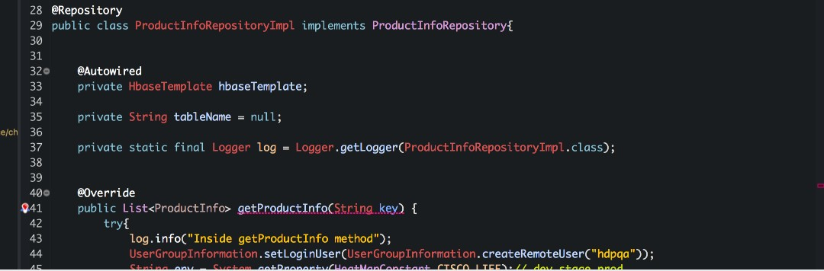

**Deployment**

##### Once the Application is migrated from LAE to CAE, will there be any change in the LAE code deployment process?

Similar to LAE SDaaS pipeline, there will be a separate SDaaS pipeline for CAE. Deployment procedure will be same.

[https://apps.na.collabserv.com/wikis/home/wiki/Wec86b581f692\_476b\_a8ec\_932d42b08095/page/Configure%20Application%20for%20CAE%](https://apps.na.collabserv.com/wikis/home/wiki/Wec86b581f692_476b_a8ec_932d42b08095/page/Configure%20Application%20for%20CAE%20Deployment) [20Deployment](https://apps.na.collabserv.com/wikis/home/wiki/Wec86b581f692_476b_a8ec_932d42b08095/page/Configure%20Application%20for%20CAE%20Deployment)

[Migrate My App(s)](https://wiki.cisco.com/pages/viewpage.action?pageId=127130261)

For applications not using SDaaS, can be deployed with yaml file or docker images using oc commands. [Deploy your application](https://wiki.cisco.com/display/CAEUSER/Deploy%2Byour%2Bapplication)

##### Is there a Image File Size Restriction?

No

##### Is it only one war/ear for Container?

We can have multiple war/ear in each container, it should work same way as in LAE.

##### Can we have multiple process running within a container?

Yes, you can run multiple services in a container. You need to build your own docker image with multiple processes.

##### Can we use the existing SDaaS Stack for CAE Deployments?

Yes, you can use existing SDaaS stack . We will pre-provision seperate pipeline for CAE. You can also check the status/Details of SDaaS stack from scoreboardui.cisco.com.

##### Is there rollback in CAE deployment, instead of redeploy old version?

Yes,

You can rollback from the command line with "oc rollback <deployment\_config> --to-version=<version\_number>"

Or

from CAE console navigate to Applications > Deployments > Select the name > deployment number > Click on 'Roll Back'

##### Is SVN supported in CAE?

Yes, but recommend to migrate to GIT.

##### Where can I find CAE SDaaS stack information?

<https://scoreboardui.cisco.com/>

##### How B/G work in CAE?

<https://wiki.cisco.com/pages/viewpage.action?pageId=125702570>

##### How can I migrate Add-Ons to CAE?

Important Read : Add-On DB's are not recommended for CAE because of below limitations.

1. Cross Cluster communication is not allowed in CAE (Data in one DC will not be accessible by other DC)
2. Application teams are recommended to use PV instead of writing data to Pod since pods are ephemeral and data will be lost in case of pod scale up/down but the limitation of using PV storage is RWO.
3. With RWO , Rolling deployments are not possible , you need to stop and start the pod for deployments which will cause downtime.

Below wiki links explains how to provision the base images for add-on's and perform the backup and restore of data from LAE to CAE. <https://wiki.cisco.com/display/GISCONT/MongoDB>

<https://wiki.cisco.com/display/GISCONT/MySQL> <https://wiki.cisco.com/display/GISCONT/PostgreSQL>

It is recommeded to go with Managed Cloud DB. Please refer below.

[https://cisco.service-now.com/sp?id=search&bt=t&q=\*&filter\_string=serviceoffering:%27Cloud%20DB%27](https://cisco.service-now.com/sp?id=search&amp;bt=t&amp;q=%2A&amp;filter_string=serviceoffering%3A%27Cloud%20DB%27)

##### What is the benefit of using [containers.cisco.com/aws\_managed](http://containers.cisco.com/aws_managed) vs the images from [hub.docker.com?](https://cisco.service-now.com/sp?id=search&amp;bt=t&amp;q=%2A&amp;filter_string=serviceoffering%3A%27Cloud%20DB%27)

Images from [containers.cisco.com/aws\_managed](http://containers.cisco.com/aws_managed) are from Redhat registry and are supported by Redhat. While you can use images from docker hub or any other repository, it is your responsibility to make sure the image does not have any vulnerabilities etc. However, you have to push your images first to Cisco repository [containers.cisco.com](http://containers.cisco.com/). We don't support directly pulling images from docker hub, gcr, etc.

##### Is there a way to possibly skip Jenkins pipeline and deploy the Docker Images directly?? (This is intended for some quick testing of images prior we go to dev pipeline)

Yes. You can install OC Client and login to your respective cluster and project to deploy the docker image. However you need to push the docker image to [containers.cisco.com](http://containers.cisco.com/) ( ECH) before you deploy it to CAE.

##### Deployment Failed with None in yaml file?

Check whether you have a CAE SDaaS Stack on scoreboardui.cisco.com. If it's not, please create a new SDaaS Stack from estore and map it to CAE project, and then check again to see if stack is provisioned on scoreboard. Once it's provisioned, generate yaml files again and do the deployment.

##### How can i deploy my Non Java Appli/cation on CAE ?

If your application is migrating from LAE to CAE, you can deploy on CAE with SDaaS without any changes. Please make sure that you have directory structure in source code as per below,

If it's a Free Style SDaaS type ,

DockerFile

config (which should have yaml files for deployment)

app-code (LAE repo directory, and directory name based on non java technology DockerFile) If it's a Maven Style SDaaS Type

DockerFile

config (which should have yaml files for deployment)

app-code (LAE repo directory, and directory name based on non java technology DockerFile) pom.xml ([sample pom.xml](https://wiki.cisco.com/download/attachments/14196476/pom.xml?version=1&amp;modificationDate=1459068642000&amp;api=v2) for Maven build)

assembly.xml ( [sample assembly.xml](https://wiki.cisco.com/download/attachments/14196476/assembly.xml?version=1&amp;modificationDate=1459068641000&amp;api=v2) for Maven build)

##### How can I deploy my Applications on CAE without SDaaS?

[Deploy on CAE without SDaaS](https://wiki.cisco.com/display/CAEUSER/Deploy%2Bon%2BCAE%2Bwithout%2BSDaaS)

##### How to stop/start/restart a pod?

[Scale Up/Down Pods](https://wiki.cisco.com/pages/viewpage.action?pageId=85091674)

##### "Context namespace element 'annotation-config' and its parser class" message by Spring Framework

[JBoss](https://wiki.cisco.com/display/GISCONT/JBoss)

##### What changes are required for Tomcat and JBoss images for optimal performance in CAE?

[OpenJDK 1.8.0\_191 for Tomcat and Jboss](https://wiki.cisco.com/display/CAEUSER/OpenJDK%2B1.8.0_191%2Bfor%2BTomcat%2Band%2BJboss)

##### How to launch CrashLoopBackOff pod in debug mode ?

Please login to CAE respective cluster and then click Applications --> Pods, click on Debug in Terminal. it will popup a pod startup window with bash terminal. Please get server start up command at the end of Dockerfile and try to run on debug terminal pod and check logs.

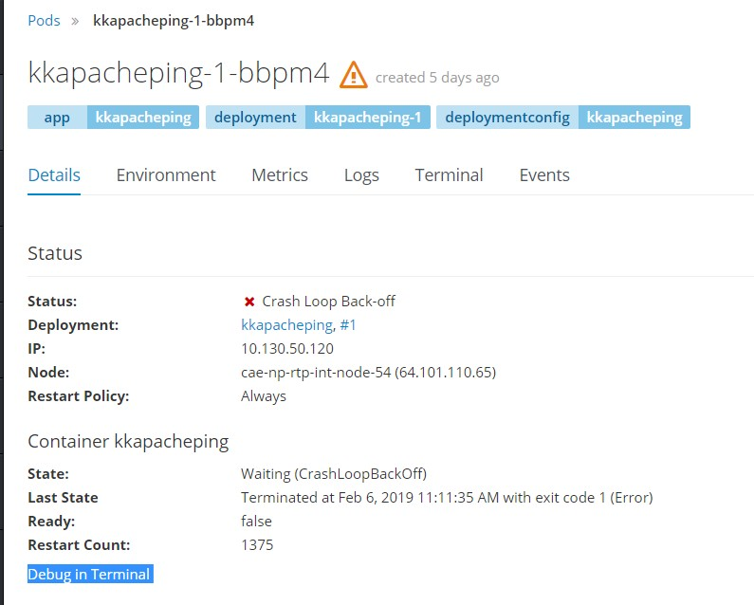

if you didn't found server start up command from Dockerfile then Run the original Command in terminal and see the logs, Please reach out CAE Client Engagement if you're facing any issue.

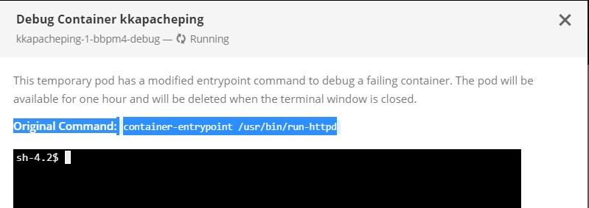

##### How to generate Thread and Heap Dump on CAE

[Generate thread dump](https://wiki.cisco.com/display/CAEUSER/Thread%2BDump)

##### How to take a back up of my application data?

When you scale up or scale down pods you will loose your data on container world. To avoid this you need to take a backup of your application data with help of persistent volumes. Please go through the wiki to create PV on openshift. [Persistent Volume in Platform3](https://wiki.cisco.com/display/CAEUSER/Persistent%2BVolume%2Bin%2BPlatform3)

**Go - Live**

##### After the Go-live on CAE, would it change the URL (existing application)?

No, we are retaining the same LAE URL's as part of cutover. Once after cutover you have option to use same (old) or create new URL's. You can continue using existing LAE URL.

##### Does application need to follow any checklist for cutover ?

Yes. Please refer [Cutover Checklist](https://wiki.cisco.com/display/CAEUSER/Cutover%2BChecklist)

##### Our app is business critical and bring used worldwide by thousands of users, will help if have the same URL.

Yes, All LAE URL(s) will continue to work after DNS cutover to CAE

##### Can we do cutover in just dev and stage before doing prod cutover?

Yes

##### How do I register FQDN in EMAN?

You don't have to register in EMAN, it's taken care of

##### What are the changes we are expected to do in EMAN setup for LAE applications?

As long as your app and it's hosts are registered in ESP/App Portfolio you should be good

##### How do I register my URL in Akamai?

**How will my app cutover/rollback? Will there be downtime during the process ?**

DNS propagation may take few minutes, please make sure downtime is covered under CR.

Please follow below wiki for Step8 for DNS cutover <https://wiki.cisco.com/pages/viewpage.action?pageId=127130261>

**Decommission on CAE**

[Decommission CAE Application](https://wiki.cisco.com/display/GISCONT/Decommission%2BCAE%2BApplication)

**Configuration**

In CAE , all the deployments are handled through Docker Images and Templates Yaml(s) generated using [Web Tool](https://lae2cae.cisco.com/).

When Migrating applications, [LAE Compatible Image](https://containers.cisco.com/organization/aws_managed) will import all the existing configurations from LAE to CAE.

If you want to change any existing configurations (from LAE) and deploy to CAE , Please refer below links

For Tomcat apps**:**

[Root-Context Config](https://wiki.cisco.com/display/GISCONT/Root-Context%2Bconfig) [Database Setup](https://wiki.cisco.com/display/GISCONT/Database%2Bsetup%2Bfor%2BTomcat) [LDAP Setup](https://wiki.cisco.com/display/GISCONT/LDAP%2Bsetup%2Bfor%2BTomcat)

[SSL certificate Setup](https://wiki.cisco.com/display/GISCONT/SSL%2BCertificates)

[System property and environment variable Setup](https://wiki.cisco.com/display/GISCONT/System%2Bproperty%2Band%2Benvironment%2Bvariables%2Bsetup%2Bfor%2BTomcat) [TIBCO JMS Setup](https://wiki.cisco.com/display/GISCONT/TIBCO%2BJMS%2Bfor%2BTomcat)

[ACL](https://wiki.cisco.com/display/GISCONT/ACL) [RDAC](https://wiki.cisco.com/display/GISCONT/Request%2BRDAC%2Bfor%2Byour%2Bapplication)

[Log4j](https://wiki.cisco.com/display/GISCONT/Steps%2Bto%2BConfiguring%2Blog4j%2Bfor%2BTomcat%2Band%2BJboss)

For JBoss apps**:**

[Root-Context Config](https://wiki.cisco.com/display/GISCONT/Root-Context%2Bconfig) [Database Setup](https://wiki.cisco.com/display/GISCONT/Database%2Bsetup%2Bfor%2BJBoss) [LDAP Setup](https://wiki.cisco.com/display/GISCONT/LDAP%2Bsetup%2Bfor%2BJBoss)

[SSL certificate Setup](https://wiki.cisco.com/display/GISCONT/SSL%2BCertificates)

[System property and environment variable Setup](https://wiki.cisco.com/display/GISCONT/System%2Bproperty%2Band%2Benvironment%2Bvariables%2Bsetup%2Bfor%2BTomcat) [WSG Setup](https://wiki.cisco.com/pages/createpage.action?spaceKey=GISCONT&amp;title=WSG%2Bsetup)

[TIBCO JMS Setup](https://wiki.cisco.com/display/GISCONT/TIBCO%2BJMS%2Bfor%2BJBoss) [ACL](https://wiki.cisco.com/display/GISCONT/ACL)

[RDAC](https://wiki.cisco.com/display/GISCONT/Request%2BRDAC%2Bfor%2Byour%2Bapplication)

[Log4j](https://wiki.cisco.com/display/GISCONT/Steps%2Bto%2BConfiguring%2Blog4j%2Bfor%2BTomcat%2Band%2BJboss)

If you encountered any config errors, visit the FAQs: [LAE to CAE Migration FAQs](https://wiki.cisco.com/display/CAEUSER/LAE%2Bto%2BCAE%2BMigration%2BFAQs)

# Add-Ons FAQ's

1. What all Add-Ons are Migrated to CAE?

In LAE , supported Add-On's are MongoDB , MySQL and Postgresql . All these Add-Ons are available in CAE

1. Do we get the same versions of Add-ons ?

Current LAE , supports below versions MongoDB : 2.4

MySQL : 5.5

PostGreSQL : 9.2

In CAE , we are supporting below versions MongoDB : 2.6

MySQL : 5.6

PostGreSQL : 9.4

1. If i want to get same version of Add-on, Is it possible?

Currently , we are pulling the images from [RH repository](https://access.redhat.com/containers/) . If required version is available in repository then it can be pulled but sometimes RH deprecates lower versions and only supports latest versions.

1. In LAE , my application is MVDC and has a Add-on . Do we get the same setup in CAE ?

In CAE , cross cluster communication is not supported yet and core team is working towards solution.

So , if your application is MVDC ( Alln+RCDN) with Addon in LAE then your application will be provisioned only in single DC in CAE.

1. Does the data in my Add-On DB will also be Migrated to CAE?

No. We have documented the Backup and Restore process of Data from LAE to CAE . Please follow below wiki links [MongoDB](https://wiki.cisco.com/display/GISCONT/MongoDB)

[MySQL](https://wiki.cisco.com/display/GISCONT/MySQL)

[PostgreSQL](https://wiki.cisco.com/display/GISCONT/PostgreSQL)

1. In LAE , we are not using any Add-On and connecting to external Mongo , how do we achieve it in CAE?

As part of Migration , we are collecting all the extranet ACL's and working with N/W team to open ACL's from CAE . In case , if you are not able to connect to your DB please reach out to [lae2cae-aws-team@cisco.com](mailto:lae2cae-aws-team@cisco.com)

1. What is the default storage available in CAE?

Default is 3 GB. If your application requires more than 3 GB or it has more storage in LAE then you can increase storage anytime after provisioning your application.

# Apache FAQ's

* 1. What versions of Apache image are available in CAE

[Apache 2.4\_Custom\_Image](https://containers.cisco.com/repository/aws_managed/apache2.4_custom), which supports LAE Apache version 2.2.15 [Apache 2.4\_Base\_image](https://containers.cisco.com/repository/aws_managed/apache2.4)

* 1. How to use Apache Dockerfile on CAE

**Dockerfile**

FROM [containers.cisco.com/aws\_managed/apache2.4\_custom](http://containers.cisco.com/aws_managed/apache2.4_custom) USER root

EXPOSE 8080

*# Copy apache application code into DocumentRoot Directory*

COPY app-code/ ${HOME}/

*# Check if application code contains any line starting with SSL in proxy.conf or mod\_jk.so in custom.d directory . If line starts with SSL in proxy.conf , then add SSLProxyCheckPeerCN off and SSLProxyCheckPeerName off to the file. If mod\_jk.so contains, then replace it with mod\_jk.so 2.4 version.*

RUN if [ `grep "^[S][S][L]" ${HOME}/custom.d/proxy.conf |wc -l` -gt 0 ]; then echo -e "SSLProxyCheckPeerCN off

\nSSLProxyCheckPeerName off" >> ${HOME}/custom.d/proxy.conf ; fi && \

if [ `ls -ltr ${HOME}/custom.d/mod\_jk.so 2> /dev/null | wc -l` -gt 0 ]; then cp /etc/httpd/modules/mod\_jk.so ${HOME}/custom.d/mod\_jk

.so ; fi && \

if [ `ls -ltr ${HOME}/custom.d/mod\_wl.so 2> /dev/null | wc -l` -gt 0 ]; then cp /etc/httpd/modules/mod\_wl.so ${HOME}/custom.d/mod\_ wl.so; fi && \

echo "Include custom.d/\*.conf" >> ${HTTPD\_MAIN\_CONF\_PATH}/httpd.conf && \ ln -sf ${HOME}/custom.d /etc/httpd/custom.d

USER default

* 1. **What are the default packages/modules included on CAE apache image?**

CAE Apache custom image is bundled with below modules/packages for LAE 2 CAE migration. mod\_jk module

mode\_perl module for Perl dependencies mod\_wl module for WebLogic dependencies

LoadModule status\_module modules/mod\_status.so LoadModule version\_module modules/mod\_version.so

LoadModule unixd\_module modules/mod\_unixd.so LoadModule authz\_core\_module modules/mod\_authz\_core.so LoadModule authn\_alias\_module modules/mod\_authn\_alias.so

LoadModule authn\_default\_module modules/mod\_authn\_default.so LoadModule authz\_default\_module modules/mod\_authz\_default.so LoadModule auth\_basic\_module modules/mod\_auth\_basic.so LoadModule auth\_digest\_module modules/mod\_auth\_digest.so LoadModule authn\_file\_module modules/mod\_authn\_file.so LoadModule authn\_anon\_module modules/mod\_authn\_anon.so LoadModule authn\_dbm\_module modules/mod\_authn\_dbm.so LoadModule authz\_host\_module modules/mod\_authz\_host.so LoadModule authz\_user\_module modules/mod\_authz\_user.so LoadModule authz\_groupfile\_module modules/mod\_authz\_groupfile.so LoadModule authz\_dbm\_module modules/mod\_authz\_dbm.so LoadModule include\_module modules/mod\_include.so

LoadModule log\_config\_module modules/mod\_log\_config.so LoadModule logio\_module modules/mod\_logio.so LoadModule env\_module modules/mod\_env.so

LoadModule mime\_magic\_module modules/mod\_mime\_magic.so LoadModule expires\_module modules/mod\_expires.so LoadModule deflate\_module modules/mod\_deflate.so LoadModule headers\_module modules/mod\_headers.so LoadModule setenvif\_module modules/mod\_setenvif.so LoadModule mime\_module modules/mod\_mime.so

LoadModule info\_module modules/mod\_info.so

LoadModule negotiation\_module modules/mod\_negotiation.so

LoadModule dir\_module modules/mod\_dir.so LoadModule actions\_module modules/mod\_actions.so LoadModule alias\_module modules/mod\_alias.so LoadModule rewrite\_module modules/mod\_rewrite.so LoadModule proxy\_module modules/mod\_proxy.so

LoadModule proxy\_balancer\_module modules/mod\_proxy\_balancer.so LoadModule proxy\_http\_module modules/mod\_proxy\_http.so LoadModule proxy\_connect\_module modules/mod\_proxy\_connect.so LoadModule cgi\_module modules/mod\_cgi.so

LoadModule cgid\_module modules/mod\_cgid.so LoadModule perl\_module modules/mod\_perl.so

* 1. How can we configure the pod logs?

You can configure pod logs by using ENV

/var/log/httpd24

OPENSHIFT\_APACHE\_LOG\_DIR

* 1. **What is the Apache latest version available over the internet other than CAE? https://access.redhat.com/containers/?tab=overview#/registry.access.redhat.com/rhscl/httpd-24-rhel7** <https://hub.docker.com/_/httpd/>
  2. **What are the environmental variables available on CAE Apache image?**

|  |  |  |
| --- | --- | --- |
| **ENVIRONMENT VARIABLE** | **DEFAULT VALUE** | **COMMENTS** |
| HTTPD\_APP\_ROOT | /opt/app-root |  |
| HTTPD\_MAIN\_CONF\_PATH | /etc/httpd/conf |  |
| HOME | /opt/app-root/src |  |
| number\_log\_files\_keep | 11 | Change this value to keep more/less number of log files . Default value is 10. |
| OPENSHIFT\_APACHE\_LOG\_DIR | /var/log/httpd24 | Change this value to use different log directory |

**Nodejs FAQ's**

1. **What versions are available on CAE?**

[Nodejs - 4.6](https://wiki.cisco.com/display/GISCONT/NodeJs%2B4.6%2BImage) - documentation on how to use 4.6 version [Nodejs - 6.0](https://wiki.cisco.com/display/GISCONT/NodeJs%2B6%2BImage) documentation on how to use 6.0 version

1. What are the default modules/packages available with Node.js on CAE?

On CAE, Nodejs doesn't come with any default packages but you can specify any modules that needs to be installed as below In Dockerfile:

#To install custom modules

#RUN /bin/bash -c 'npm install -g grunt-cli;npm install -g grunt;npm install winston'

1. How do I troubleshoot a node.js application on CAE?

Application teams can install their own logging modules to write log files - the logs will write to below location if mentioned in application. In Dockerfile:

ENV OPENSHIFT\_HOMEDIR=$HOME \

OPENSHIFT\_LOG\_DIR=$HOME/logs \ Details:

|  |  |  |
| --- | --- | --- |
| OPENSHIFT\_HOMEDIR | /opt/app-root/src/ | Home directory of Pod |

1. What are the ENV's enabled on CAE as compared to LAE?

ENV's enabled on CAE base image:

ENV OPENSHIFT\_NODEJS\_PORT=8080 \

OPENSHIFT\_TMP\_DIR=/tmp/ \ OPENSHIFT\_HOMEDIR=$HOME \

OPENSHIFT\_LOG\_DIR=$HOME/logs \ OPENSHIFT\_REPO\_DIR=$HOME/repo \ OPENSHIFT\_NODEJS\_LOG\_DIR=$HOME/logs \

OPENSHIFT\_DATA\_DIR=$HOME/data/ \ OPENSHIFT\_DEPLOYMENTS\_DIR=$HOME/repo

|  |  |  |
| --- | --- | --- |
| **Environment Variable** | **Default Value** | **Comments** |
| OPENSHIFT\_DATA\_DIR | /opt/app-root/src/data/ | to store the any application data |
| OPENSHIFT\_DEPLOYMENTS\_DIR | /opt/app-root/src/repo | default deployment directory to deploy the code |
| OPENSHIFT\_HOMEDIR | /opt/app-root/src/ | Home directory of Pod |
| OPENSHIFT\_NODEJS\_DIR | /opt/app-root/src | NodeJs main directory on CAE |
| OPENSHIFT\_REPO\_DIR | /opt/app-root/src/repo | Openshift repo directory to copy the code |

1. What if I need versions latest versions of Nodejs other than provided CAE base versions(4.6 & 6.0)?

Goto below link and search for the Nodejs: <https://access.redhat.com/containers/>

Example latest version of Nodejs offered by RedHat: https://access.redhat.com/containers/?tab=overview#/registry.access.redhat.com/rhscl/nodejs-8-rhel7

The above link can be used to build your own custom image.

# PHP FAQ's

* 1. What PHP versions are available on CAE?

[**PHP 5.6**](https://wiki.cisco.com/display/GISCONT/PHP%2B5.6%2BImage)**,** which supports LAE PHP versions 5.3 and 5.4.

* 1. How to use PHP image on CAE?

EXPOSE 8080

USER default

CMD ["/opt/rh/httpd24/root/usr/sbin/httpd","-D","FOREGROUND"]

FROM [containers.cisco.com/aws\_managed/php5.6\_custom](http://containers.cisco.com/aws_managed/php5.6_custom)

USER root

MAINTAINER CECUSERID

COPY repo/ ${HOME}/repo/

RUN chmod -R 777${APP\_ROOT}/\* #If PHP directory exist

RUN if [[ -d ${HOME}/repo/php ]] ; then sed -i 's/\/opt\/app-root\/src\/repo/\/opt\/app-root\/src\/repo\/php\//g' /opt/rh/httpd24/root/etc

/httpd/conf/httpd.conf; fi

**DokcerFile**

* 1. **What are the modules/packages are including with Php on CAE?**

currently we're installed the **oracle instant client** and **mongodb** module's, if you want to install any custom modules you need to specify in the Docker file.

* + 1. If you want to install any custom modules on Php image, include as per below in docker file RUN pecl install redis
  1. How can check pod logs on CAE?

There are two ways, you can check the logs

* + 1. From console
       1. login to Data Center (**cae-rtp/alln/rcdn.cisco.com**)
       2. select your project and select application pods Logs
       3. Logs tab shows the pod startup and error logs

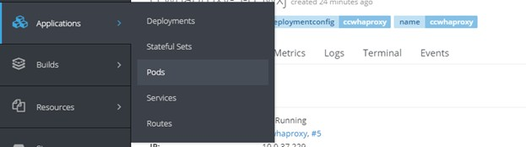

* + 1. From Command Line
       1. oc login **cae-rtp/alln/**[**rcdn.cisco.com**](http://rcdn.cisco.com/)
       2. select project oc project abc-rtp-int-rtp
       3. oc get pods and then select the pod to see the logs
       4. oc logs php56-x1eza

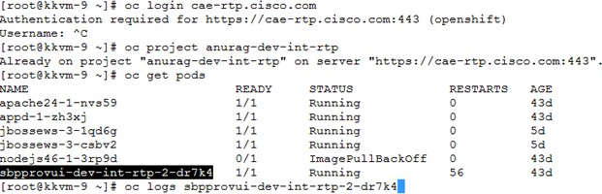

* + - 1. How can we configure the CAE pod logs?

you can configure the pod logs by defining Environmental variable, as per below ENV PHP\_ACCESS\_LOG=access\_log \

PHP\_ERROR\_LOG=php.log \ OPENSHIFT\_LOG\_DIR=${HOME}/logs \

* + - 1. What are the latest versions of PHP available over internet other than CAE?

[https://access.redhat.com/containers/#/search/php](https://access.redhat.com/containers/%23/search/php) [https://hub.docker.com/search/?isAutomated=0&isOfficial=0&page=1&pullCount=0&q=php&starCount=0](https://access.redhat.com/containers/%23/search/php)

* + - 1. what are the Environmental variable on CAE when compared to LAE

|  |  |  |
| --- | --- | --- |
| **Environment Variable** | **Default Value** | **Comments** |
| PHP\_ERROR\_LOG | php.log | Startup logs appended to this log. |
| PHP\_ACCESS\_LOG | access\_log | Application access logs are append to this log, |
| OPENSHIFT\_PHP\_LOG\_DIR | /opt/app-root/src/logs | default log directory, change this value to use different directory |
| OPENSHIFT\_DATA\_DIR | /opt/app-root/src/data/ | to store the any application data |
| HOME | /opt/app-root/src/ | Home directory of Pod |
| OPENSHIFT\_PHP\_DIR | /opt/app-root/src | Php main directory on CAE |
| OPENSHIFT\_REPO\_DIR | /opt/app-root/src/repo | Openshift repo directory to copy the code |
| OPENSHIFT\_DEPLOYMENTS\_DIR | /opt/app-root/src/repo | default deployment directory to deploy the code |

**Migrate My App(s)**

This Document walks you through the steps to migrate your applications from LAE to CAE.

[Pre-requistes](file:///C:\Machine%20Learning\Test\PDF\ilovepdf_split-range\CAE%20Wiki%20Pages-151-403.docx#_bookmark210) [Prep work](file:///C:\Machine%20Learning\Test\PDF\ilovepdf_split-range\CAE%20Wiki%20Pages-151-403.docx#_bookmark211)

[Initiate the migration](file:///C:\Machine%20Learning\Test\PDF\ilovepdf_split-range\CAE%20Wiki%20Pages-151-403.docx#_bookmark212)

[How to use WebUI tool](file:///C:\Machine%20Learning\Test\PDF\ilovepdf_split-range\CAE%20Wiki%20Pages-151-403.docx#_bookmark213) [CD Pipeline Status](file:///C:\Machine%20Learning\Test\PDF\ilovepdf_split-range\CAE%20Wiki%20Pages-151-403.docx#_bookmark214) [CAE APP Manifests](file:///C:\Machine%20Learning\Test\PDF\ilovepdf_split-range\CAE%20Wiki%20Pages-151-403.docx#_bookmark215)

[Build and Deployment Prerequisites](file:///C:\Machine%20Learning\Test\PDF\ilovepdf_split-range\CAE%20Wiki%20Pages-151-403.docx#_bookmark216) [Policy verification](file:///C:\Machine%20Learning\Test\PDF\ilovepdf_split-range\CAE%20Wiki%20Pages-151-403.docx#_bookmark217)

[DNS Cutover Prerequisites](file:///C:\Machine%20Learning\Test\PDF\ilovepdf_split-range\CAE%20Wiki%20Pages-151-403.docx#_bookmark218) [DNS Cutover](file:///C:\Machine%20Learning\Test\PDF\ilovepdf_split-range\CAE%20Wiki%20Pages-151-403.docx#_bookmark219)

[DNS Rollback(Only if required to rollback to LAE)](file:///C:\Machine%20Learning\Test\PDF\ilovepdf_split-range\CAE%20Wiki%20Pages-151-403.docx#_bookmark220)

[FAQs](file:///C:\Machine%20Learning\Test\PDF\ilovepdf_split-range\CAE%20Wiki%20Pages-151-403.docx#_bookmark221)

**Pre-requistes**

ESP registration

Check [**here**](https://app.smartsheet.com/b/publish?EQBCT=bca043c77b3a4284b74174480265692b&amp;ss_v=66.1.16) to verify if your application is registered in ESP. If not, please follow the [**wiki**](https://wiki.cisco.com/display/CAEUSER/ESP%2BRegistration) to register your application.

Mailer group should be OnRamp mailer group for proper SDaaS provisioning.

Go through this [**wiki**](https://wiki.cisco.com/display/CAEUSER/Invalid%2BMailer%2Bcorrection) to correct the mailer group if needed.

### Prep work

In order to migrate the applications from LAE to CAE you need to use [lae2cae](http://lae2cae.cisco.com/) WebUI tool. This tool will generate the configuration files that are required for migration.

CAE deployment requires:

1. Dockerfile
2. DeploymentConfig yaml
3. Route yaml

**Dockerfile** : A Dockerfile is a text document that contains all the commands/instructions a user could call on the command line to assemble an image. Using docker build users can create an automated build that executes several command-line instructions in succession.

Click [here](https://docs.docker.com/engine/reference/builder/) for more information about Docker File.

**DeploymentConfig** : A deployment configuration, which is a template for deployments. Triggers that drive automated deployments in response to events.

Click [here](https://docs.openshift.com/container-platform/3.9/dev_guide/deployments/how_deployments_work.html) for more information about DeploymentConfig.

**Routes**: An OpenShift route exposes a service at a host name, like [www.myapp.cisco.com](http://www.myapp.cisco.com/), so that external clients can reach it by name

Click [here](https://docs.openshift.com/container-platform/3.9/dev_guide/routes.html) for more information about Routes.

Dockerfile - WebUI tool clones your SVN/GIT repository to get the required information to generate a Dockerfile.

Below is a sample docker file generated by WebUIplugin for a tomcat application. To generate this file, WEBUI plugin looks for Pom.xml from source code repository for war/ear file name

Repo directory from source code repository

**Dockerfile**

FROM containers.cisco.com/aws\_managed/tomcat-7-jws3.0\_custom:latest ## This Image is built based on LAE Configurations which includes Environment Variables , action\_hooks , packages required for DB , JMS and security.

## Maintainer ##

MAINTAINER Lae2Cae-Operations USER root

EXPOSE 8080

COPY package/repo ${HOME}/lae-home/app-root/runtime/repo ## Startup scripts to Mimic the LAE configurations on CAE.

# Add Deployment WAR

COPY package/repo/deployments/\*.\* ${JWS\_HOME}/webapps/ ## Copies the war

/ear file to target directory

RUN echo "Building Application Image!" # Main Command

CMD ${JWS\_HOME}/bin/serverStart.sh ## Starts the server

DeploymentConfig and Route Yaml - WebUI tool will generate yaml templates for deployment based on LAE application data in [scoreboard](https://wiki.cisco.com/display/CAEUSER/Scoreboard%2BUI%2BGuide) .You can then manually add these yamls to the repository or have it done automatically.

Once the Dockerfile and Yamls are generated , add these to your application source code repository and use your CAE SDaaS Stack for deployment on CAE.

**Initiate the migration**

**How to use WebUI tool**

Login to [lae2cae.cisco.com](http://lae2cae.cisco.com/) with your CEC credentials

You will see the list of applications that are owned and managed by you. This list is pulled based on your existing LAE application data.

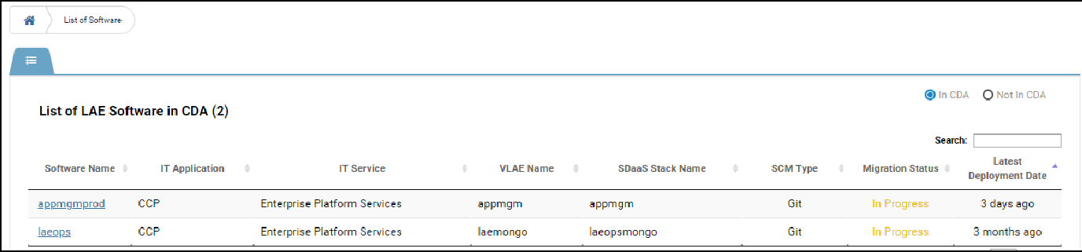

Click on the application that you want to migrate, it will navigate you to below screen.

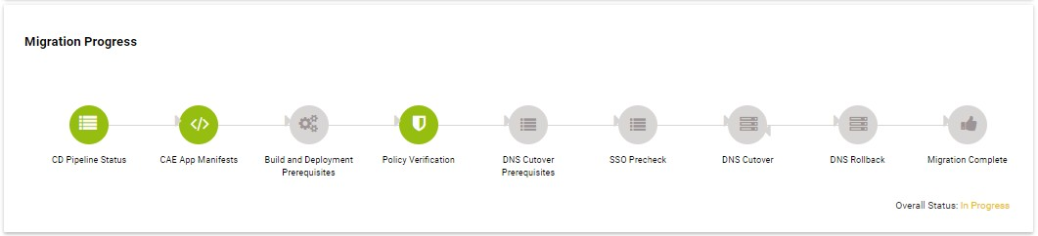

**CD Pipeline Status**

'CD Pipeline status' gives you the information about your CAE CI Job, uD Run, etc.

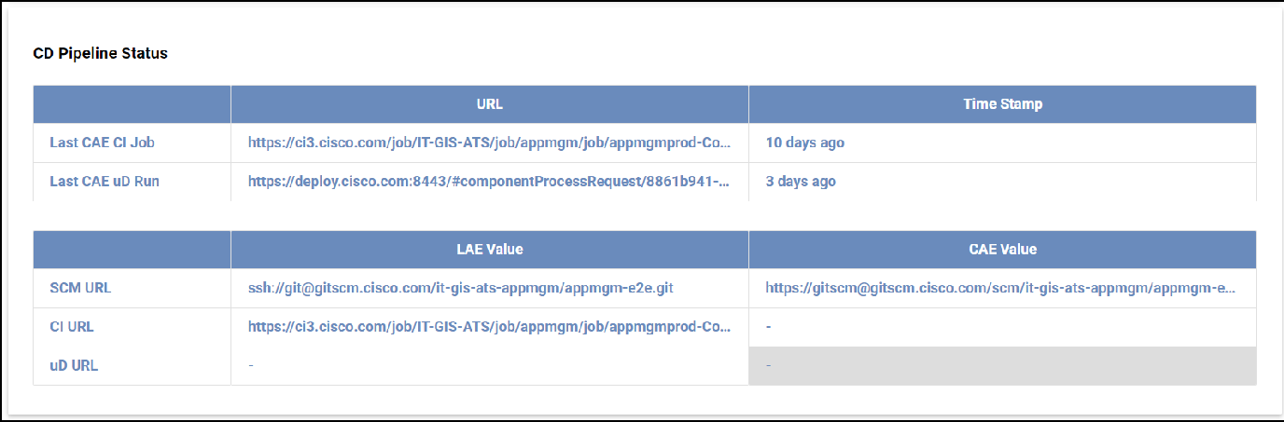

#### CAE APP Manifests

Click on 'CAE App Manifests' to generate Dockerfile and yaml files required for the deployment.

Here you can enter the branch you want to generate config files, select the branch and click on 'Generate Files'

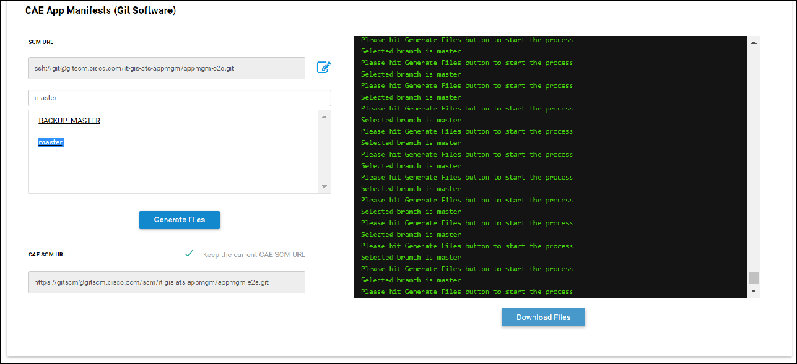

**NOTE: If you want to change/update the GIT URL from default , make sure to do the same changes in your SDaaS Stack( In Jenkins) using estore SDaaS Modify.**

Once you see the status as SUCCESS , files are ready to download. Click on 'Download Files' to download config files to your local machine

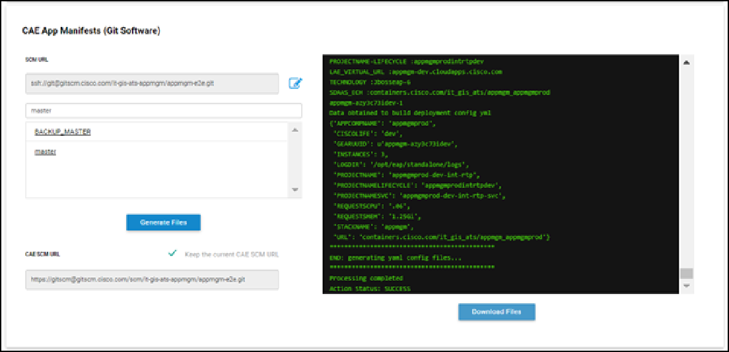

Create 'config' directory and copy all the \*yaml files to the config directory and copy Dockerfile outside of config directory to your source code as shown below.

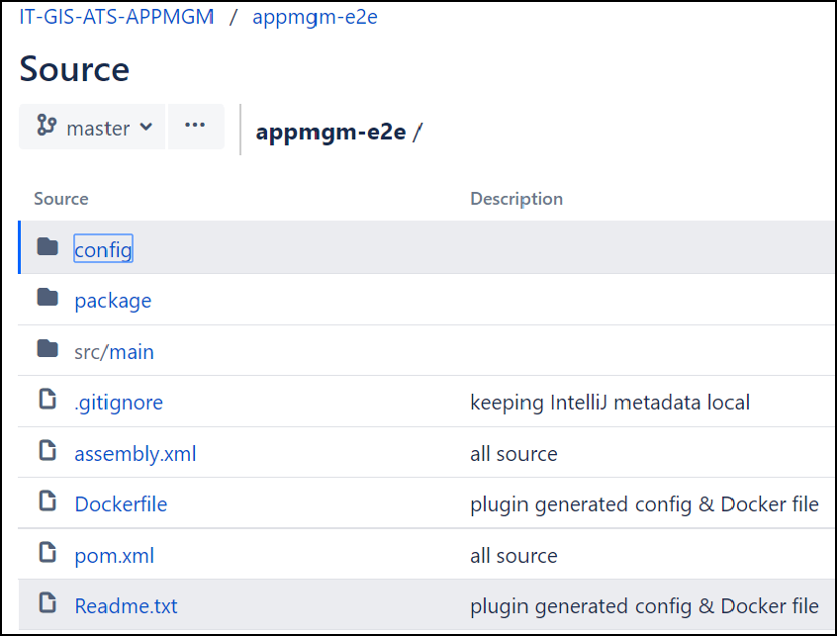

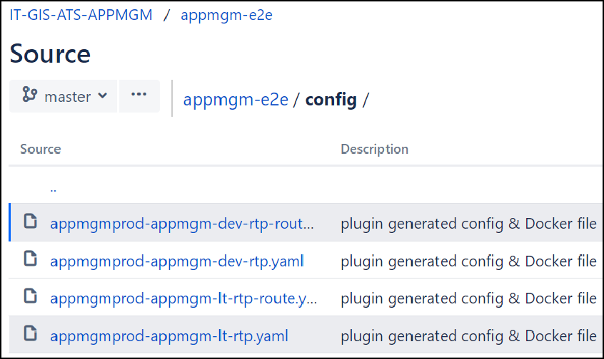

#### Build and Deployment Prerequisites

Click on 'Build and Deployment Prerequisites'

Before you use your Jenkins pipeline from SDaaS stack to proceed with the deployments, please make sure each of the prerequisites are provisioned.

In order to test your application all the Routes need to be created. You can **ignore** "GSLB Test Routes" for **non-prod**

environment.

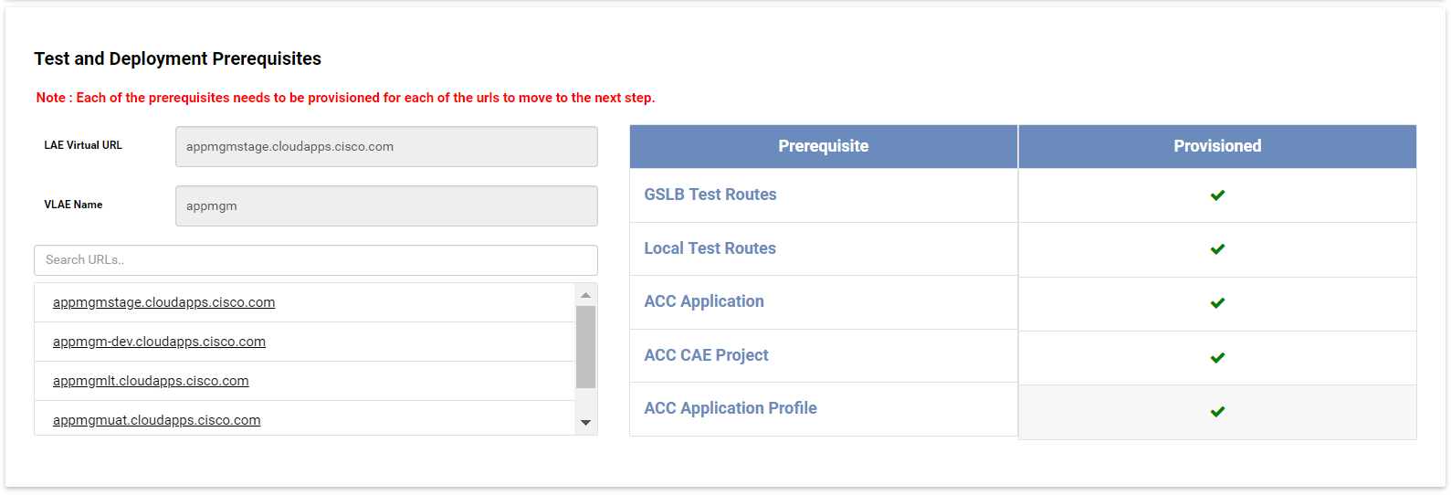

#### Policy verification

\*\*\*\* Please follow all the steps in this [Wiki](https://wiki.cisco.com/display/GISIAM/How%2Bto%2Bverify%2Bto-be-migrated%2BPingAccess%2Bpolicies) to verify the policy. \*\*\*\*\*

**Here is a summary of the steps:**

Click on 'Policy Verification'

\*\*\*Only ADMIN for VLAE can verify policy \*\*\*

Make sure Policy Verification Statuses are 'verified' as shown below.

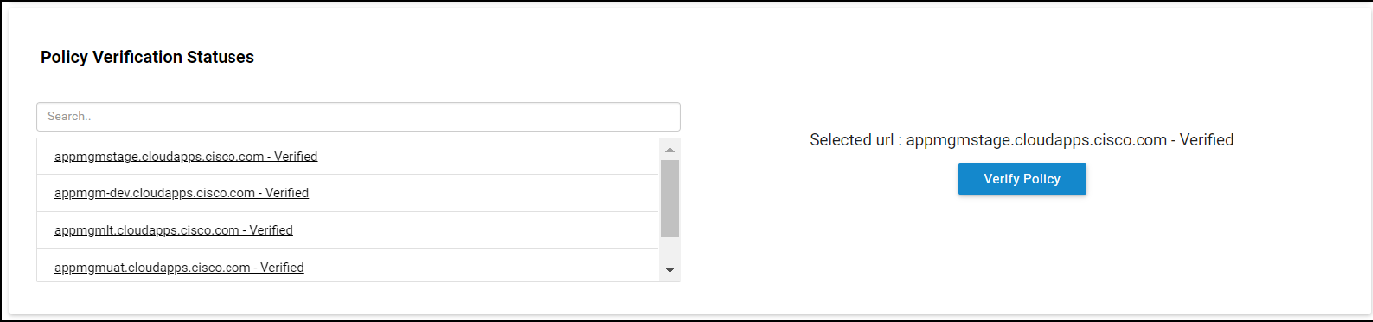

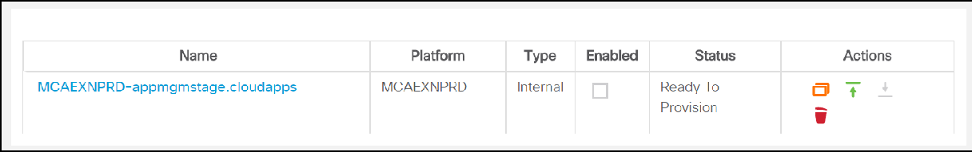If policies are not verified, select the URL and click 'Verify Policy' on the right, which will navigate you to [Policy Verification Tool](https://wampmt-ui-dev.cloudapps.cisco.com/) On Policy Verification Tool, click on your application, verify all the policies and hit 'Confirm Import' as shown below.



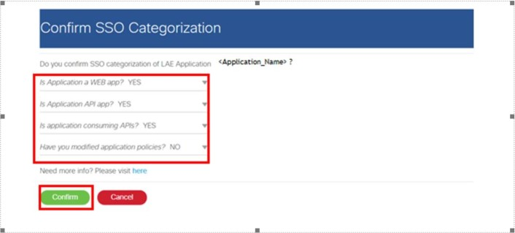

Once the deployment is successful in CAE, please test your application using the test URL and ensure your application is working as expected.

\*\*\*\*DO NOT PROCEED WITH NEXT STEPS IF YOUR APPLICATION IS NOT UP AND RUNNING IN CAE\*\*\*

**DNS Cutover Prerequisites**

**At this point, you should have tested your application already in CAE using test URL. DO NOT PROCEED if your application is not working in CAE.**

Click on 'DNS Cutover Prerequisites'

Select the application URL you want to cutover and make sure DNS Cutover Prerequisites are completed before going for the DNS Cutover.

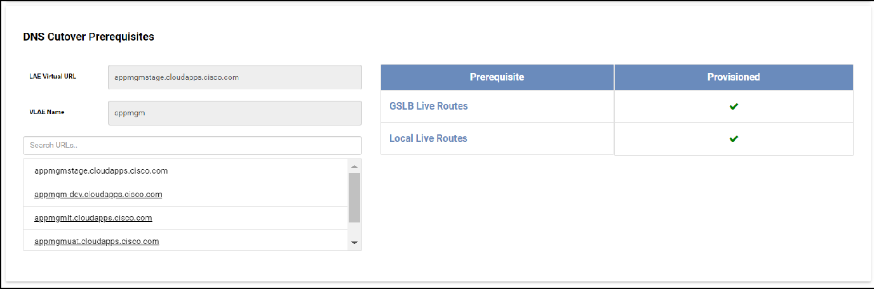

SSO Precheck and Policy Cutover:

At this step, please click on the application URL for the SSO pre-check script to run. Upon the completion of the SSO pre-check run, the SSO policies will get copied from test routes to live routes. Please complete this step before moving on to the DNS Cutover step

#### DNS Cutover

It is recommended to schedule a CR to perform DNS Cutover. Please engage CAE team before you perform DNS cutover to assist you with any support required.

Click on 'Perform DNS Cutover'

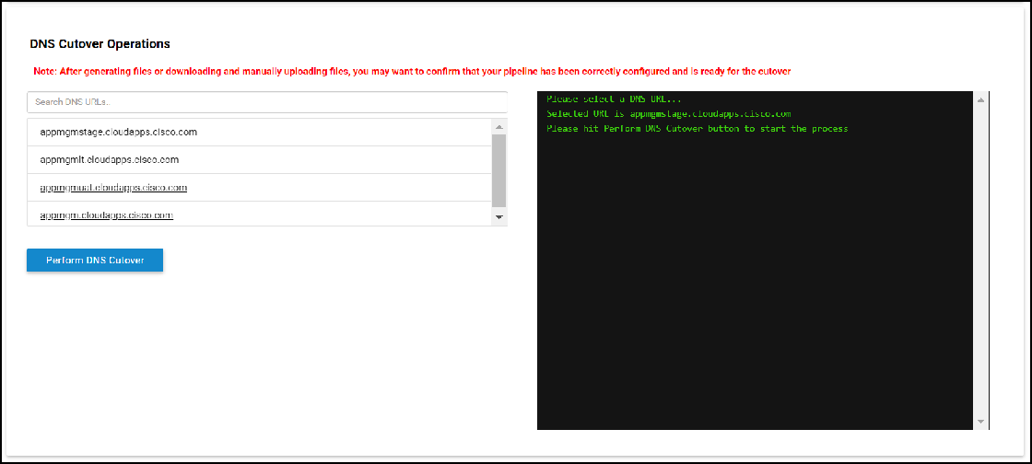

You will see a SUCCESS message once the Cutover is completed.

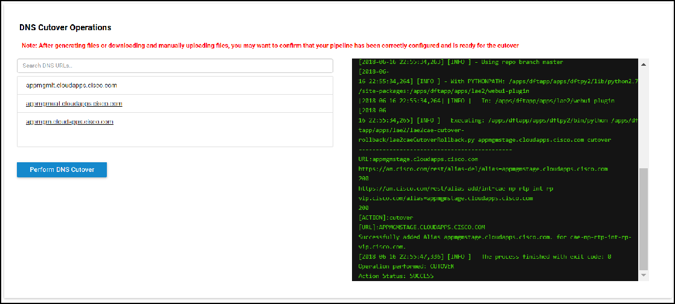

Verify the application is Cutover to CAE.

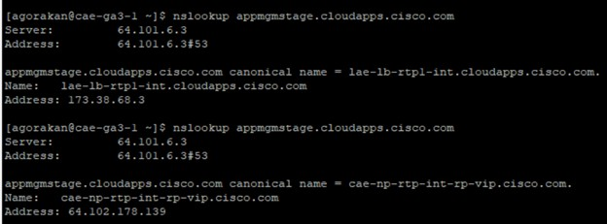

Please go to the [Scoreboard](https://scoreboardui.cisco.com/) and paste your app URL in Virtual URL field to check the status of your application. It should say "cutover" under "Cutover/Rollback" column.

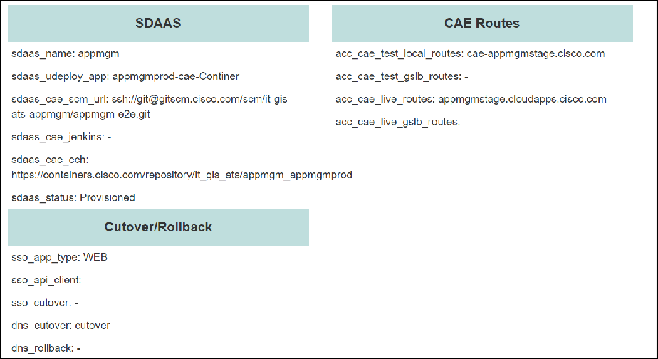

##### DNS Rollback(Only if required to rollback to LAE)

If the DNS cutover is not success, please rollback

Click on 'DNS RollBack'

Select the URL you want to Rollback and click 'Perform DNS Rollback' as shown below.

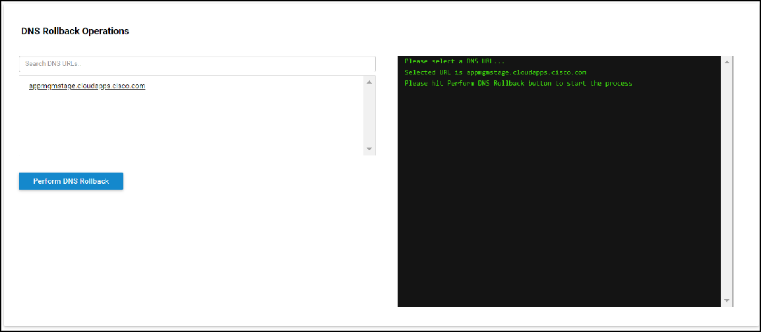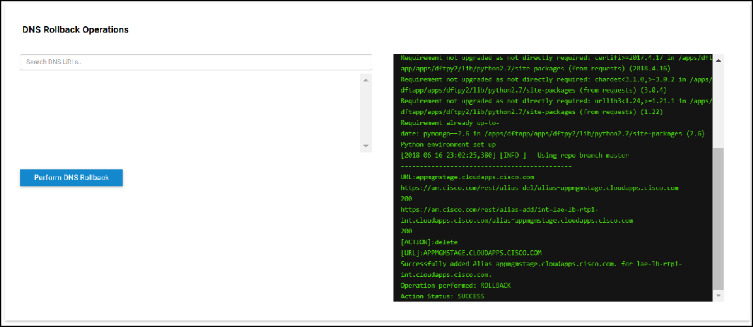

You will see a SUCCESS message once the Rollback is completed. Verify the application is Rolled Back to LAE.

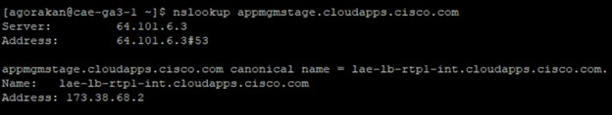

You can verify the DNS RollBack Status from scoreboard UI, which shows 'dns\_rollback: rollback'

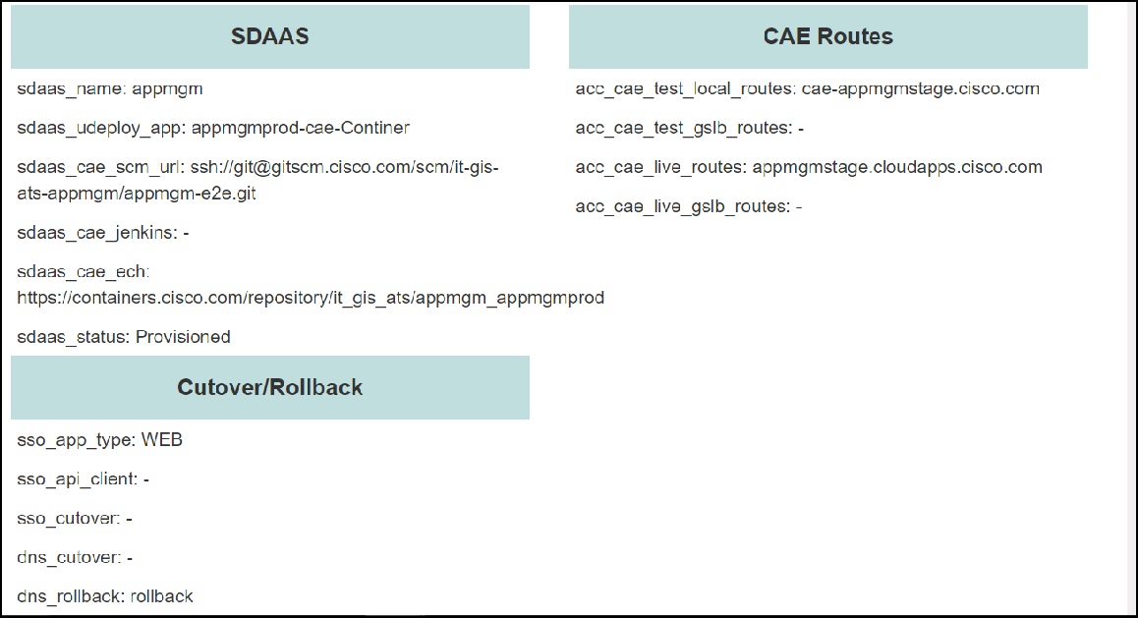

\*\*\*\*\*Please reach out to CAE Team if you encounter any issues with WEBUI Tool\*\*\*\*\*

**[FAQs](https://wiki.cisco.com/display/CAEUSER/LAE%2Bto%2BCAE%2BMigration%2BFAQs)**

**OpenJDK 1.8.0\_191 for Tomcat and Jboss**

**For Tomcat make sure ActiveProcessorCount is appended to JAVA\_OPTS\_EXT**

The AWS team has recently released new versions of the Tomcat and JBoss managed base images.

If you are currently using any of the following managed base images for your CAE applications, it is recommended that you rebuild and redeploy your applications with the latest version.

##### Affected Images:

[**containers.cisco.com/aws\_managed/tomcat-7-jws3.1\_custom**](http://containers.cisco.com/aws_managed/tomcat-7-jws3.1_custom)[**containers.cisco.com/aws\_managed/tomcat-8-jws3.1\_custom**](http://containers.cisco.com/aws_managed/tomcat-8-jws3.1_custom)[**containers.cisco.com/aws\_managed/jboss6.4\_custom**](http://containers.cisco.com/aws_managed/jboss6.4_custom)

The latest versions of these images include a fix for JDK bug [8146115](https://bugs.java.com/view_bug.do?bug_id=8146115). This enhancement improves Java's ability to operate in a containerized environment and allows the developer to tune additional start up options.

##### Issue:

In the previous versions of these images, Java's auto detection logic set the number of available processors based on the Pod's CPU request value. This meant that resources like GC threads, JIT compiler threads, threads in fork-join pool and the GC algorithm were usually getting set to just one. This resulted in serial garbage collection that slowed down the applications.

##### Fix:

For optimal performance in CAE you are required to override and set the value of the 'ActiveProcessorCount' java option to a value greater than one to enable parallel garbage collection. For applications migrating from LAE, an appropriate number would be 8.

To leverage this new capability, before rebuilding your application image, you must also change your Deployment yamls to include the 'ActiveProcessorCount' start-up option as shown below:

##### Option 1: Edit attached(bottom of the page) 'Deployment yamls' manually with below mentioned changes

**For JBoss add the following env variable**

- name: "JAVA\_OPTS\_APPEND"

value: "-XX:ActiveProcessorCount=<SOME-NUMBER>"

- name: "JAVA\_OPTS\_EXT"

value: "-XX:MaxMetaspaceSize=512m -XX:+AggressiveOpts -XX: MinHeapFreeRatio=20 -XX:MaxHeapFreeRatio=40 -XX:GCTimeRatio=4 -XX: AdaptiveSizePolicyWeight=90 -Djava.net.preferIPv4Stack=true -Dfile. encoding=UTF-8 -Djava.net.preferIPv4Stack=true -Dorg.apache.jasper.runtime. BodyContentImpl.LIMIT\_BUFFER=true -Dorg.apache.jasper.runtime.

JspFactoryImpl.USE\_POOL=false -Dorg.apache.tomcat.util.http.ServerCookie. ALLOW\_EQUALS\_IN\_VALUE=true -XX:+DisableExplicitGC -Xss512k -XX:

+HeapDumpOnOutOfMemoryError -XX:HeapDumpPath=${OPENSHIFT\_LOG\_DIR} -verbose: gc -XX:+PrintGCDateStamps -XX:+PrintGCDetails -XX:

+PrintGCApplicationStoppedTime -XX:+UseGCLogFileRotation -XX: GCLogFileSize=5M -XX:NumberOfGCLogFiles=4 -Xloggc:${OPENSHIFT\_LOG\_DIR}gc. log -XX:+PrintTenuringDistribution -XX:ActiveProcessorCount=<SOME-NUMBER>"

**Option 2: Regenerate yaml files**

You can regenrate the yamls from [lae2cae](http://lae2cae.cisco.com/) and redeploy. The generation script has already been updated.

You can verify your changes by logging in to the container terminal and running the following command:

# java -version

openjdk version "1.8.0\_191"

OpenJDK Runtime Environment (build 1.8.0\_191-b12) OpenJDK 64-Bit Server VM (build 25.191-b12, mixed mode)



# Scoreboard UI Guide

**Description -** Scoreboard UI is a user friendly tool which has the inventory related to Migration.It has the following filter fields. Clients can get their respective application information related to migration.

<https://scoreboardui.cisco.com/>

**USE CASE 1 :** Once the User Hits the URL <https://scoreboardui.cisco.com/>, he gets those records where he belongs either of lae\_view , lae\_edit and lae\_adm groups. The home page differs from user to user.If the user doenst belongs to any of these groups then the Home page is blank.

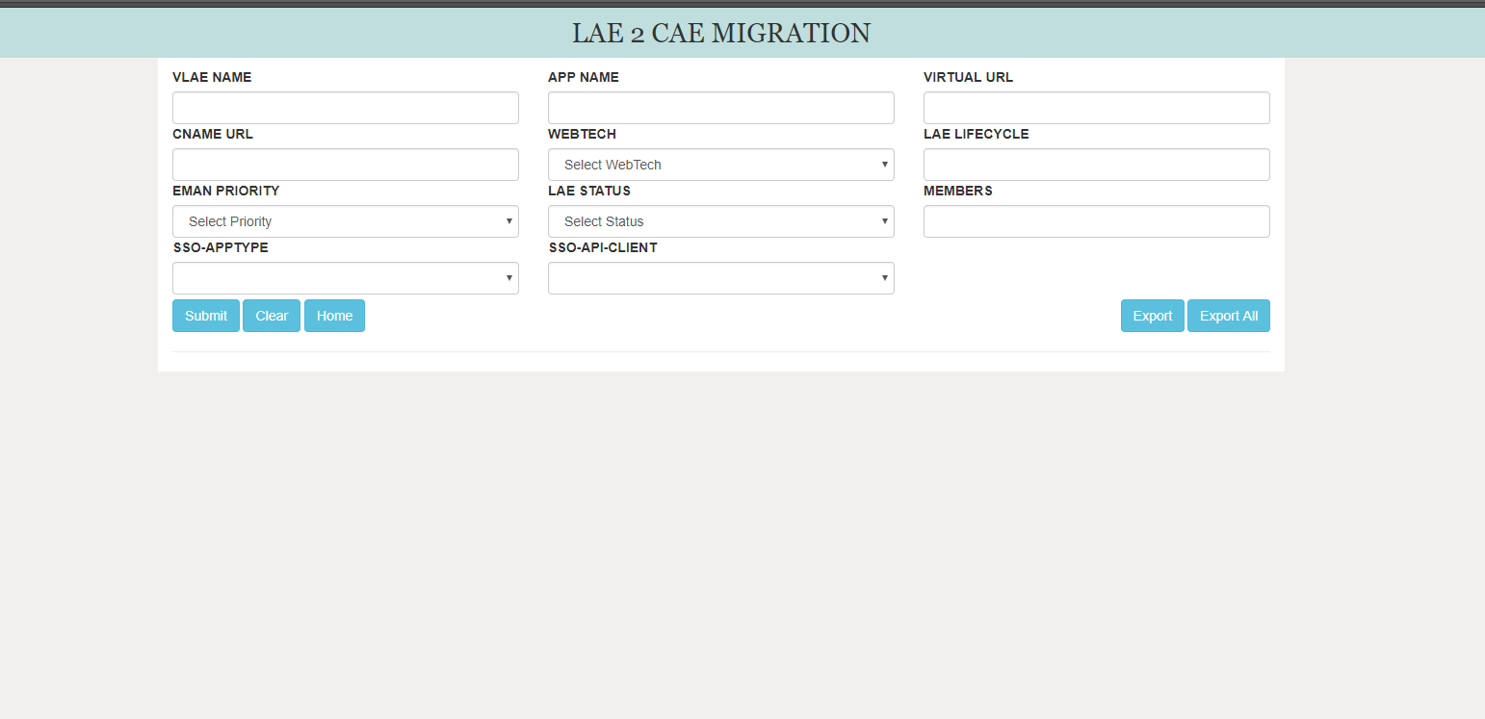

**USE CASE 2 -** In order to get the application specific information from the scoreboard, the user has to enter either of the fields related to the application. Vlae name which is Domain name , Application Name , Virtual URL, Cname URL ,

technology, Lifecycle, Eman Priority, Lae Status, Members.

Once either of the above fields are entered and when the user Hits Submit button.The data is Displayed.

**Test Case1**: Consider the Vlae Name for **appmgm**

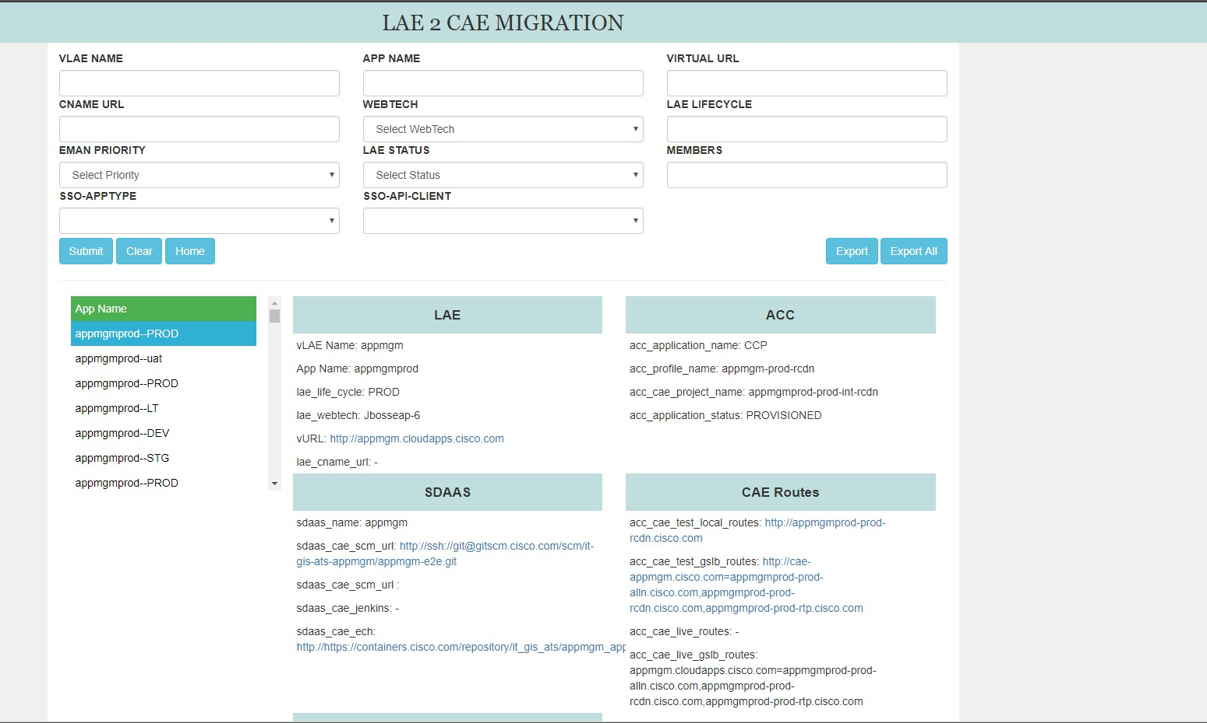

As shown above , The LAE, ACC SDAAS CAE Routes, Cutover/Rollback information related to Domain **appmgm** is displayed.

**Test Case 2:** The application related Sdaas information is displayed in the Sdaas Column. The user need not to login to ACC to get the Acc related information lile app name, Project Name.Once the scoreboard is updated the UI reads it from the scoreboard.

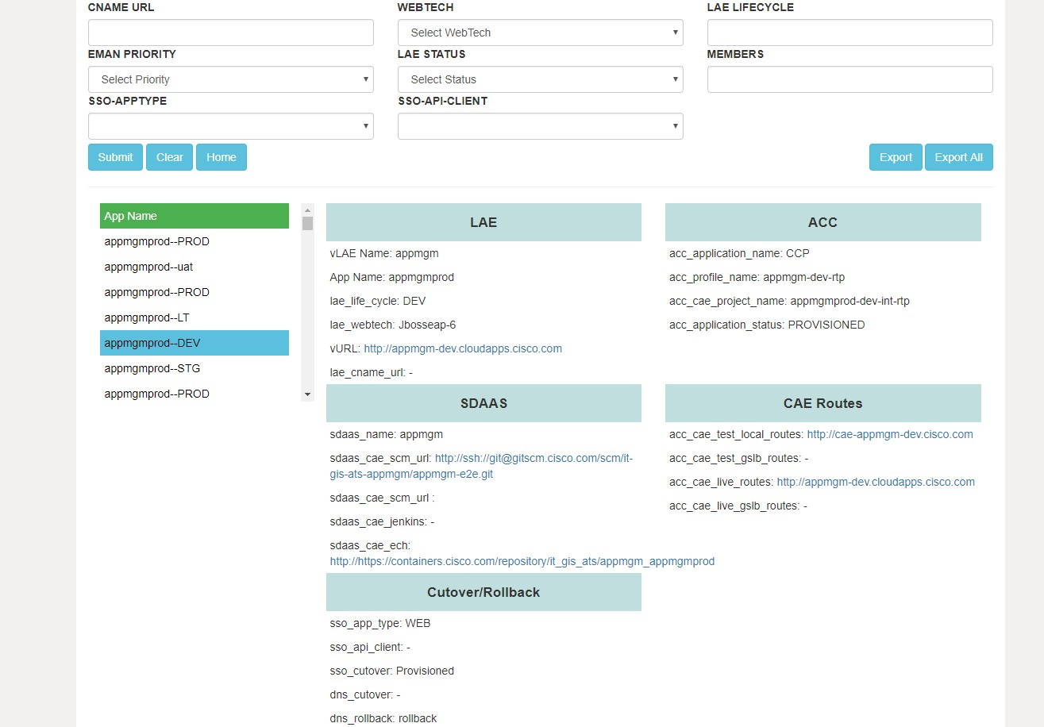

**Test Case 3:** Once after successfull deployment of application into CAE. The dns\_cutover is updated in the ScoreBoard. The cut cover column is enabled only for applications whose dns\_cutover is cutover.

for instance 'appmgm' vlae STG is migrated. Hence the status is seen as shown below.

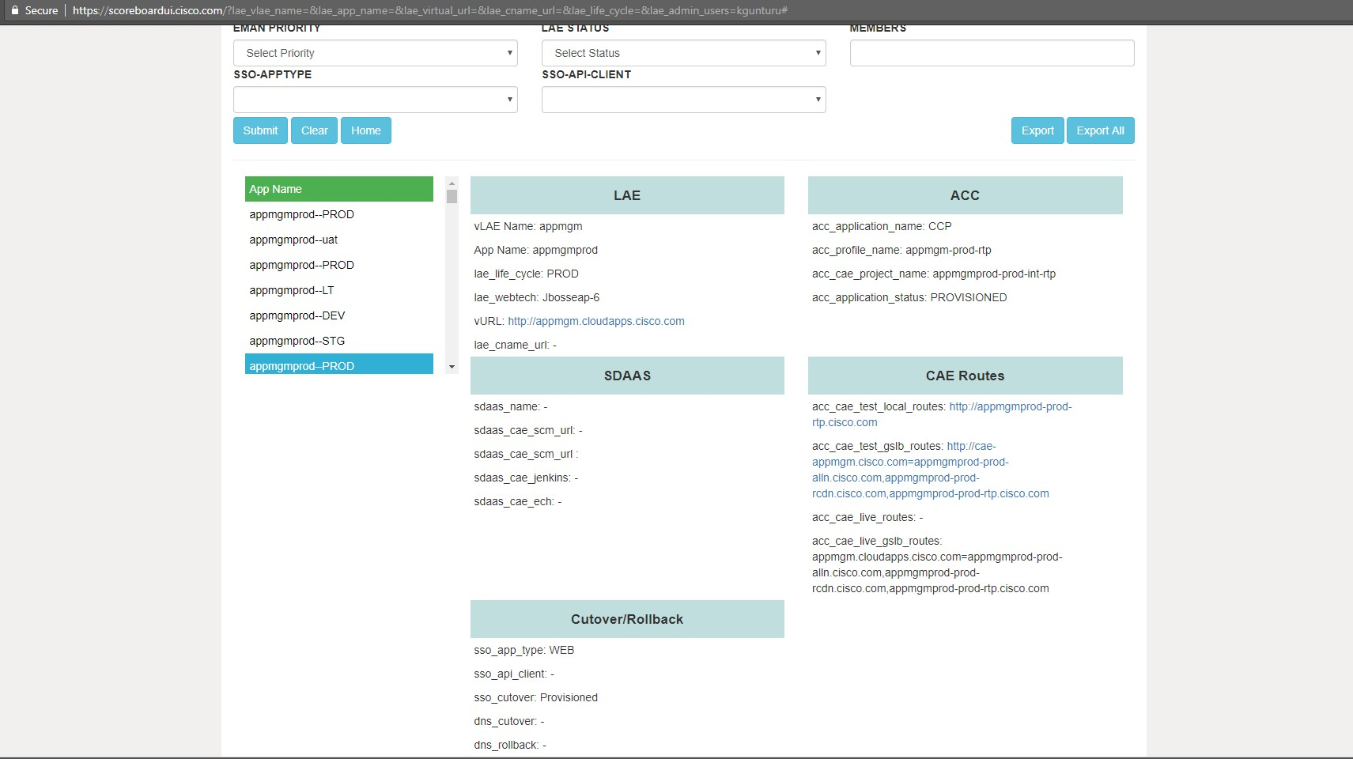

**Test Case 4** : The user has the option to go back to the page where he can see the applications which he has the access for , as shown below.

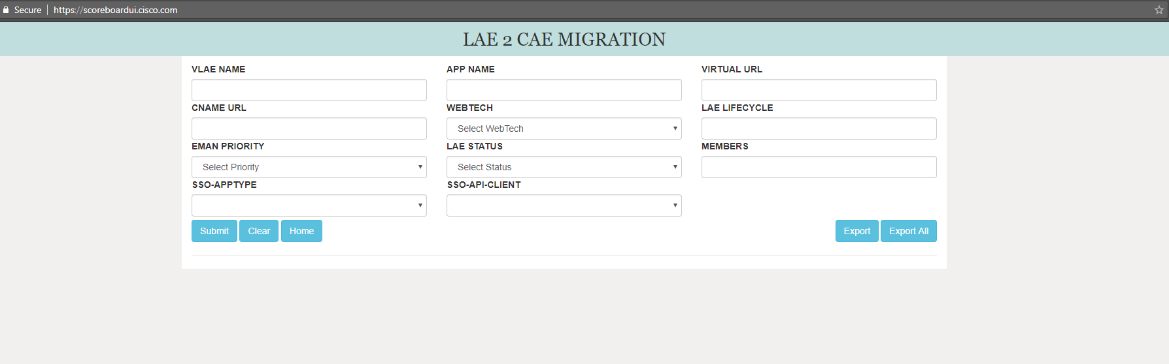

**Test Case 5** : The user can look for the applications of other members who as the access. as shown below.

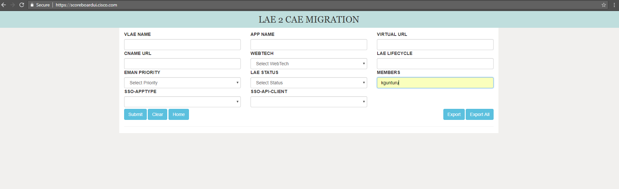

**Test Case 6** : The user can download a copy of all the application details into an Excel using Export and Export All Buttons as shown below.

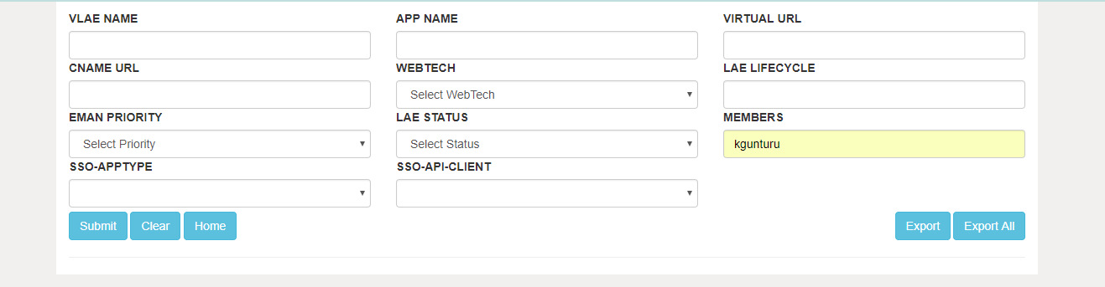

# Verify ESP registeration

1.) Go to [https://scoreboardui.cisco.com](https://scoreboardui.cisco.com/)

2.) Type your app\_name into the APP NAME box. 3.) Click Submit

4.) Click on the appname with lifecycle and see if all data show. Make sure you don't see any error message. Example for app ciscoone:

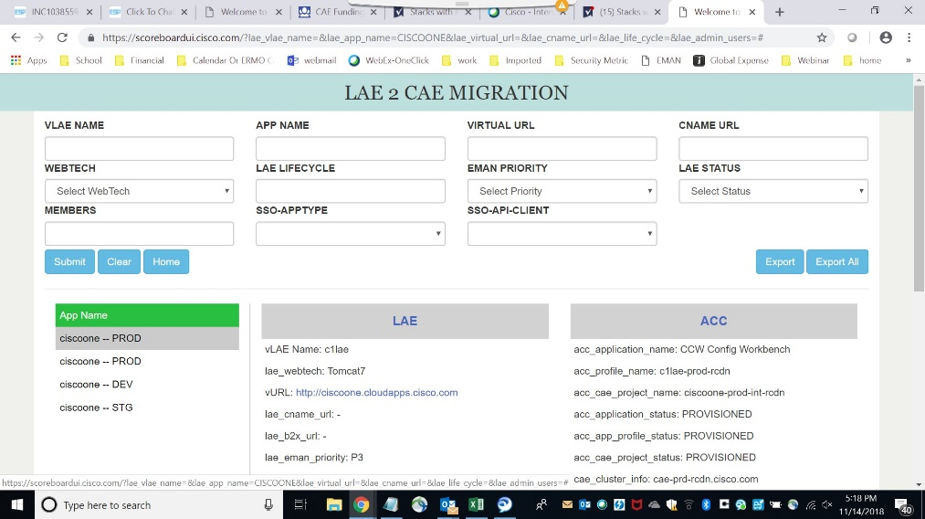

5.) If you see SYS\_ID errors.

"Your application is not ready to be migrated due to below error.Please refer to wiki for next steps SYS\_ID\_NOT\_IN\_SERVICENOW: Sys Id is not a Business Application or not found in Service Now. "

Please follow the below steps to update the Sys\_ID. Update SYS ID steps:

When your ESP portfolio has been created or updated, follow the steps to update the SYS ID 1.) Goto <http://ccp.cloudapps.cisco.com/portal/SDMLAE.vm>

2.) Select the vLAE that it is missing ESP data(Business Application name) 3.) Select the LAE Application Name

4.) Type in application name in “Application Portfolio Name” box and then click search (If your app is under a business application module, search for the parent business application and use that to update the SYS ID)

5.) Application Portfolio ME ID will populate automatically 6.) Submit the request

# WEBUI PLUGIN

CAE is a platform designed to support application architectures and technologies consistent with today's industry trends.

The CAE platform will offer capabilities that differ significantly from previous GIS platform offerings like CCIX and the current LAE platform.

In order to **Migrate applications from LAE to CAE you need to use** [**lae2cae.cisco.com**](http://lae2cae.cisco.com/) **WebUI tool,** which will help the user to generate the configuration files that are required for deployments on CAE.

CAE deployments requires:

1. **Docker File**
2. **Deploymentconfig yaml**
3. **RouterConfig yaml**

**Docker File** : A Dockerfile is a text document that contains all the commands/instructions a user could call on the command line to assemble an image. Using docker build users can create an automated build that executes several command-line instructions in succession.

For more information about Docker File , please refer <https://docs.docker.com/engine/reference/builder/>

**Deploymentconfig** : A deployment configuration, which is a template for deployments. Triggers that drive automated deployments in response to events.

For more information about Deploymentconfig , Please refer <https://docs.openshift.com/enterprise/3.0/dev_guide/deployments.html#overview>

**RouterConfig**: An OpenShift route exposes a service at a host name, like [www.myapp.cisco.com](http://www.myapp.cisco.com/), so that external clients can reach it by name

For more information about RouterConfig , Please refer <https://docs.openshift.com/enterprise/3.0/dev_guide/routes.html>

As part of LAE to CAE migration any application needs these 3 files to be added in the sourcecode for continuous deployments.

Based on LAE application configurations , this tool will generate the equivalent configuration files that are required for successful CAE Deployment.

Docker File: WebUI tool will run against the SVN/GIT repositories to get the required information to build a docker file.

Ex: Below is a sample docker file generated by webui plugin for a tomcat application . Inorder to generate this file , webui plugin looks for,

1. Pom.xml from source code repository for war/ear file name
2. Repo directory from source code repository

FROM containers.cisco.com/aws\_managed/tomcat-7-jws3.0\_custom:latest **## This Image is built based on LAE Configurations which includes Environment Variables , action\_hooks , packages required for DB , JMS and security**.

## Maintainer ##

MAINTAINER Lae2Cae-Operations USER root

EXPOSE 8080

COPY package/repo ${HOME}/lae-home/app-root/runtime/repo **## Startup scripts to Mimic the LAE configurations on CAE.**

# Add Deployment WAR

COPY package/repo/deployments/\*.\* ${JWS\_HOME}/webapps/ **## Copies the war/ear file to target directory**

RUN echo "Building Application Image!" # Main Command

CMD ${JWS\_HOME}/bin/serverStart.sh **## Starts the server**

**DeploymentConfig/RouterConfig Yaml** : WebUI tool will generate yaml configuration template files for deployments based on LAE application data in [scoreboard](https://wiki.cisco.com/display/CAEUSER/Scoreboard%2BUI%2BGuide) .You can then manually add it to the repository, or have it done automatically.

Once the Docker File and Yaml is generated , add it to application source code repository and use your CAE SDaaS Stack for deploymentson CAE.

**How to use WEBUI tool for deployment?**

1. **Login to lae2cae.cisco.com with your cec credentials**
2. **You can see the list of applications that you are owned/managed . This list is pulled based on your existing LAE application data.**

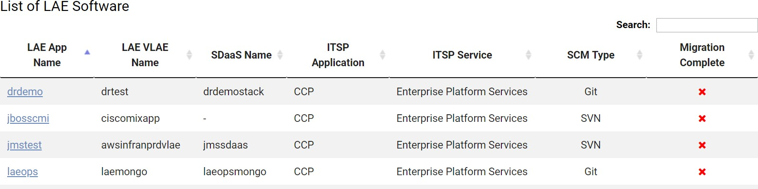

1. **Click on the application that you want to generate config files for deployment.**

You can see Git URL for your application (which is pulled from your existing SDaaS Stack in LAE ) , if you want to change the Url click on Edit Url and update with different repositories.

Select the Branch from where your LAE application is being built.

**NOTE: If you want to change/update the GIT URL from default , make sure to do the same changes in your SDaaS Stack( In Jenkins) using estore SDaaS Modify.**

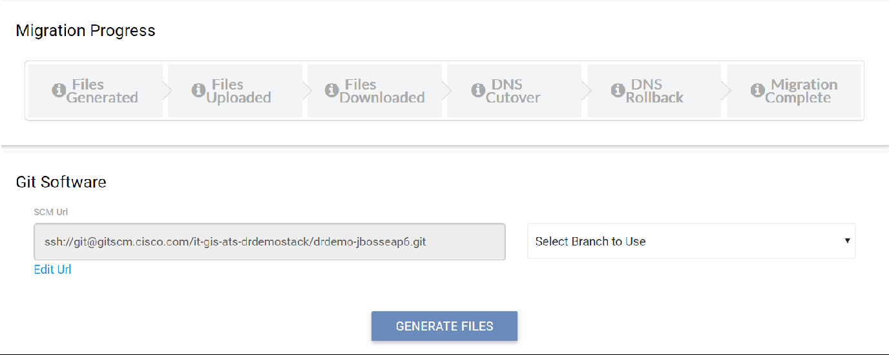

1. **Click on Generate Files . Once you see the status as SUCCESS , files are ready to download**

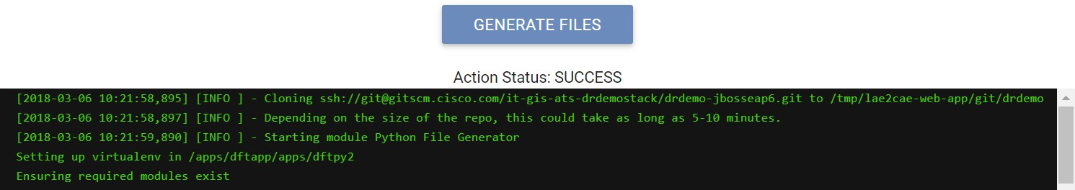



You can download the Files and create config directory and copy it to your source code as below and copy Docker file outside of config directory.

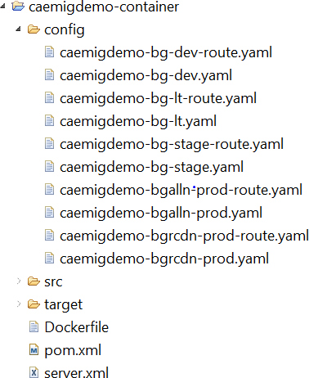

or Click on PUSH FILES , so WEBUI will take care of adding the generated config files to your selected repository branch and you can see the status as below.

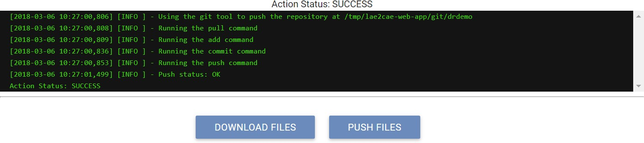

1. Based on your action , you can see the updated Migration Progress as below.

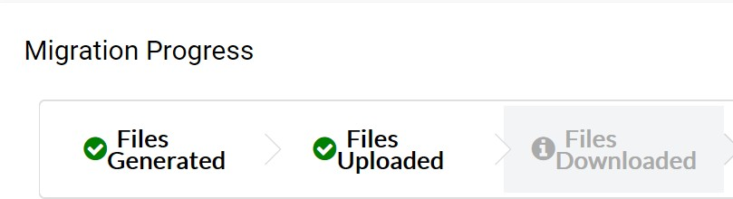

OR

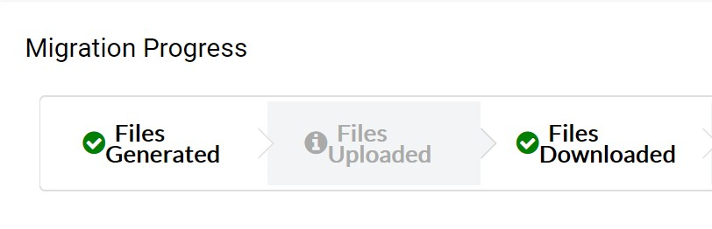

1. Use your Jenkins pipeline from SDaaS stack to proceed with the deployments.
2. **You can validate your application authentication/authorization policies from PMT tool. Click on Policy Verification button , it will redirect you to tool**

**where you can validate the policies that are migrated from LAE.**

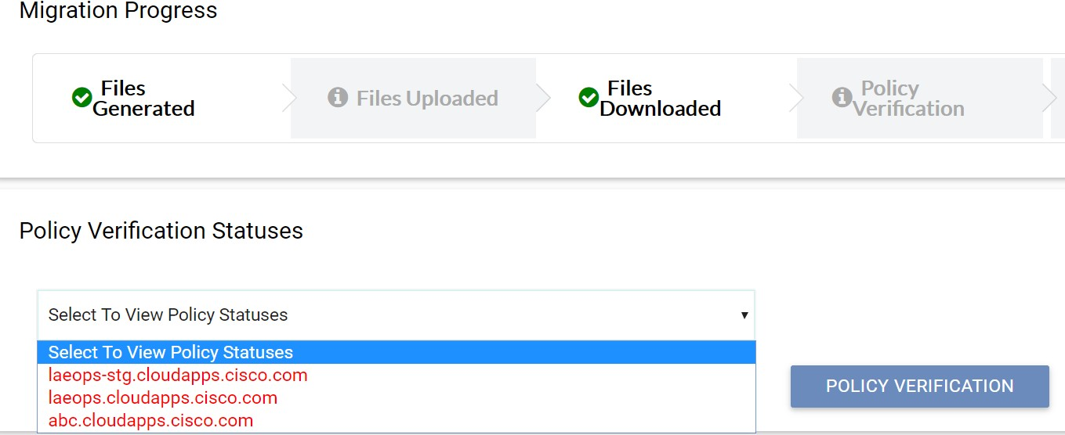

1. **Once after successful deployment to CAE and after validating PING policies, you can use WEBUI tool to do DNS Cutover to retain LAE URL.**

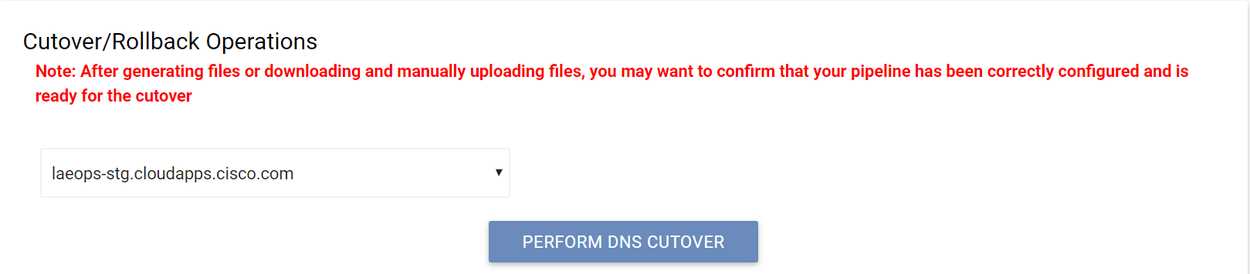

1. **Please reach out to lae2cae-operations if you encounter any issues with WEBUI Tool.**

**Delete LAE app in eStore**

* 1. Go to http://estore.cisco.com/RequestCenter/website/ServiceCatalog/index.html?/services/856
  2. Click Order
  3. Fill in app info in each Text Box.

